Supplementary Information
Effect of electric field frequency on phytoremediation efficiency and properties of Cd-contaminated soil

Xiaolan Xu^{1,2}, Chuikang Zhou^{1,2}, Jiaqing Mei^{1,2}, Jiawei Ma³, Zhengqian Ye^{1,2}, Dan Liu^{1,2}, Keli Zhao^{1,2}, Xianzhi Fang^{1,2, *}

¹ Key Laboratory of Soil Remediation and Quality Improvement in Zhejiang Province Hangzhou 311300, Zhejiang, China
² Key Laboratory of Soil Development and Utilization of Forest Food Resources Improvement in Zhejiang Province Hangzhou 311300, Zhejiang, China
* Correspondence: Xianzhi Fang, Zhejiang A & F University, Zhejiang, Hangzhou 311300, China, fangxz@zafu.edu.cn
Supplementary Fig. S1
Supplementary Figure 1. Effect of AC electric field frequency on the above-ground biomass of willow. CK: No electric field; 50 Hz: 0.5 V·cm⁻¹ AC with frequency of 50 Hz; 300 Hz: 0.5 V·cm⁻¹ AC with frequency of 300 Hz. The analyses were performed after 2 months treatment. Data are means ± standard error of three biological replicates. Different letters above the column indicate significant differences among different frequency treatments as determined by one-way ANOVA with Duncan (P < 0.05).
Supplementary Fig. S2
Supplementary Figure 2. Effect of AC electric field frequency on root morphology of willow. (a) Root volume; (b) root surface area; (c) root diameter; (d) root tip; (e) root length. CK: No electric field; 50 Hz: 0.5 V·cm⁻¹ AC with frequency of 50 Hz; 300 Hz: 0.5 V·cm⁻¹ AC with frequency of 300 Hz. The analyses were performed after 2 months treatment. Data are means ± standard error of three biological replicates. Different letters above the column indicate significant differences among different frequency treatments as determined by one-way ANOVA with Duncan (P < 0.05).
Supplementary Fig. S3
Supplementary Figure 3. Effect of AC electric field frequency on Cd concentrations in different parts of willow. (a) Cd concentrations of leaves; (b) Cd concentrations of branches; (c) Cd concentrations of stems; (d) Cd concentrations of roots. CK: No electric field; 50 Hz: 0.5 V·cm⁻¹ AC with frequency of 50 Hz; 300 Hz: 0.5 V·cm⁻¹ AC with frequency of 300 Hz. The analyses were performed after 2 months treatment. Data are means ± standard error of three biological replicates. Different letters above the column indicate significant differences among different frequency treatments as determined by one-way ANOVA with Duncan (P < 0.05).
Supplementary Fig. S4
Supplementary Figure 4. Effect of AC electric field frequency on total nitrogen concentrations of willow. (a) Total nitrogen concentrations of leaves; (b) total nitrogen concentrations of branches; (c) total nitrogen concentrations of stems; (d) total nitrogen concentrations of rooks. CK: No electric field; 50 Hz: 0.5 V·cm⁻¹ AC with frequency of 50 Hz; 300 Hz: 0.5 V·cm⁻¹ AC with frequency of 300 Hz. The analyses were performed after 2 months treatment. Data are means ± standard error of three biological replicates. Different letters above the column indicate significant differences among different frequency treatments as determined by one-way ANOVA with Duncan (P < 0.05).
Supplementary Fig. S5
Supplementary Figure 5. Effect of AC electric field frequency on total phosphorus concentrations of willow. (a) Total phosphorus concentrations of leaves; (b) total phosphorus concentrations of branches; (c) total phosphorus concentrations of stems; (d) total phosphorus concentrations of rooks. CK: No electric field; 50 Hz: 0.5 V·cm-1 AC with frequency of 50 Hz; 300 Hz: 0.5 V·cm-1 AC with frequency of 300 Hz. The analyses were performed after 2 months treatment. Data are means ± standard error of three biological replicates. Different letters above the column indicate significant differences among different frequency treatments as determined by one-way ANOVA with Duncan (P < 0.05).

Supplementary Fig. S6
Supplementary Figure 6. Effect of AC electric field frequency on total potassium concentrations of willow. (a) Total potassium concentrations of leaves; (b) total potassium concentrations of branches; (c) total potassium concentrations of stems; (d) total potassium concentrations of rooks. CK: No electric field; 50 Hz: 0.5 V·cm-1 AC with frequency of 50 Hz; 300 Hz: 0.5 V·cm-1 AC with frequency of 300 Hz. The analyses were performed after 2 months treatment. Data are means ± standard error of three biological replicates. Different letters above the column indicate significant differences among different frequency treatments as determined by one-way ANOVA with Duncan (P < 0.05).

Supplementary Fig. S7
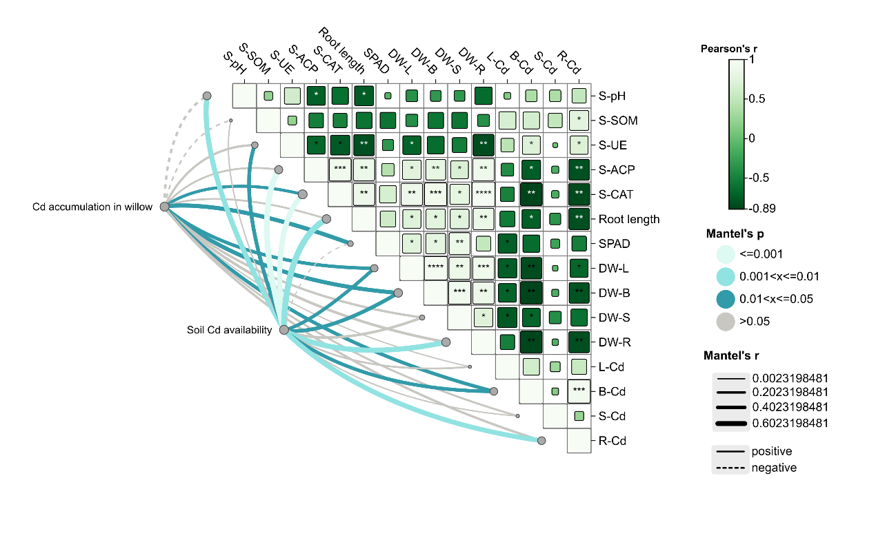
Supplementary Figure 7. Results of Mantel correlation analysis between soil Cd availability and Cd accumulation in willow. S-pH: pH value of the soil; S-SOM: soil organic matter content; S-UE: urease activity in the soil; S-ACP: activity of acid phosphatase in the soil; S-CAT: peroxidase activity in the soil; Root length: length of willow roots; SPAD: willow leaf SPAD values; DW-L: dry weight of willow leaves; DW-B: dry weight of willow branches; DW-S: dry weight of willow stems; DW-R: dry weight of willow roots; L-Cd: accumulation of Cd in willow leaves; B-Cd: accumulation of Cd in willow branches; S-Cd: accumulation of Cd in willow stems; R-Cd: accumulation of Cd in willow roots. The curve plot on the left connects various variables, which display the strength and significance level of their correlations. Different colors and line thicknesses represent varying correlation coefficients and significance levels. Thicker lines indicate stronger correlations. The matrix plot on the right shows the Pearson correlation coefficients and significance levels among various variables. The colors within the matrix represent the correlation coefficients, with green indicating positive correlations. Symbols within the matrix indicate the significance levels, with different numbers of asterisks denoting varying degrees of significance.
Supplementary Table 1. Basic physical and chemical properties of soil
pH | Available K  （mg·kg⁻¹） | Alkali-hydrolysable N  （mg kg⁻¹） | Available P  （mg kg⁻¹） | Organic matter（g·kg⁻¹）
7.27±0.03 | 176±2.54 | 202.39±2.21 | 15.25±0.02 | 40.12±1.54
Data in the table are expressed as average ± standard error of the three replicates. Different letters above the column indicate significant differences among different frequency treatments as determined by one-way ANOVA with Duncan (P < 0.05).

Supplementary Table 2. Total metal content in soil
Cd (mg kg⁻¹) | Pb (mg kg⁻¹) | Cu (mg kg⁻¹) | Zn (mg kg⁻¹) | Ni (mg kg⁻¹) | Hg (mg kg⁻¹) | Cr (mg kg⁻¹)
1.68±0.01 | 3.50±3.02 | 24.88±1.07 | 124.74±1.13 | 28.21±52 | 0.06±0.02 | 78.43±2.43
Data in the table are expressed as average ± standard error of the three replicates. Different letters above the column indicate significant differences among different frequency treatments as determined by one-way ANOVA with Duncan (P < 0.05).

Supplementary Table 3. Effects of different treatments on basic physical and chemical properties of soil
Treatment | pH | Available K  （mg kg⁻¹） | Alkali-hydrolysable N（mg kg⁻¹） | Available P  （mg kg⁻¹） | Organic matter  （g kg⁻¹）
CK | 7.33±0.06a | 50.33±2.67a | 171.88±4.95a | 14.82±0.99a | 50.81±1.94a
50Hz | 7.31±0.03a | 49.00±4.16a | 168.27±1.85a | 17.10±2.34a | 46.33±3.12a
300Hz | 7.12±0.03b | 52.00±0.58a | 171.43±1.41a | 13.82±0.38a | 46.09±1.45a
Data in the table are expressed as average ± standard error of the three replicates. Different letters above the column indicate significant differences among different frequency treatments as determined by one-way ANOVA with Duncan (P < 0.05).

