EphB2-mediated ephrin-B reverse signaling on microglia drives an inflammatory, but anti-viral response to HIV.
Jeffrey Koury¹, Hina Singh^{1,2}, Samantha N. Sutley-Koury¹, Dominic Fok¹, Xinru Qiu^{1,3}, Ricky Maung^{1,2}, Benjamin B. Gelman^{4,5}, Iryna M. Ethell¹, Marcus Kaul^{1,2}*

¹Division of Biomedical Sciences, School of Medicine, University of California, Riverside, 900 University Ave, Riverside, CA, 92521, USA
²Infectious and Inflammatory Disease Center, Sanford Burnham Prebys Medical Discovery Institute, 10901 North Torrey Pines Road, La Jolla, CA, 92037, USA
³Division of Genetics, Genomics and Bioinformatics, University of California, Riverside, 900 University Ave, Riverside, CA, 92521, USA
⁴Department of Pathology, University of Texas Medical Branch, 301 University Blvd, 77555-0419 Galveston, TX USA
⁵Department of Neuroscience and Cell Biology, University of Texas Medical Branch, 301 University Blvd, 77555-0419 Galveston, TX USA

*Corresponding author: Marcus Kaul, Division of Biomedical Sciences, School of Medicine, University of California, Riverside, 900 University Ave, Riverside, CA, 92521, USA. Tel: (951) 827-7774. E-mail: marcus.kaul@medsch.ucr.edu

SUPPLEMENTARY FIGURES
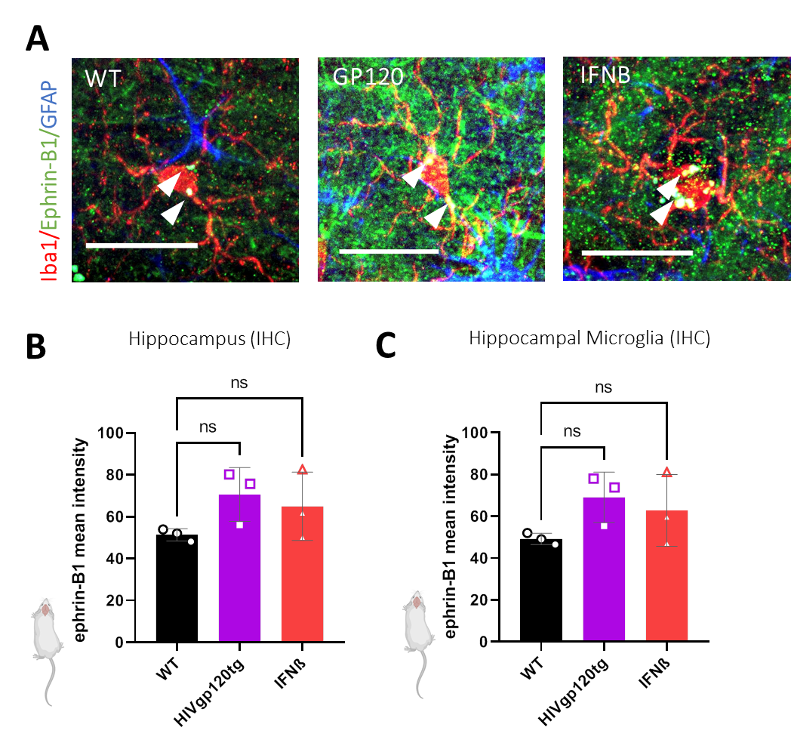
Supplementary Figure 1. HIVgp120 and IFNβ regulate total and microglial specific ephrin-B1 expression in hippocampus. (A) Sagittal brain section stained for astrocytic GFAP (blue), microglial Iba1 (Red) and ephrin-B1 (Green). Scale bar = 20um. Values are Mean Intensity of ephrin-B1 fluorescence in total CA1 (B) or microglia gated (C). All mice for IHC were male, aged 3 – 4 months. IFNβ indicates intranasal treatment with the cytokine. Each data point represents an image, n = 3 animals per experimental condition,. Values are Mean ± SD; FC = Fold Change; n.s. = non-significant (P > 0.05), Two Way ANOVA followed by Tukey’s post hoc test.
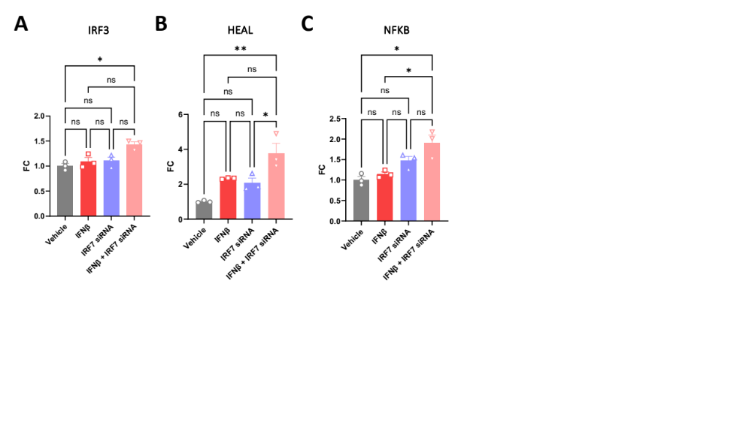
Supplementary Figure 2. IRF7 knockdown potentiates IFNβ induced IRF3, long non-coding RNA HEAL and NFKB mRNA expression. Relative RNA expression of (A) IRF3, (B) HEAL and (C) NFKB in HMC3 microglia following 48-hour IRF7 siRNA knockdown followed by IFNB treatment (3000U/ml). Expression normalized to GAPDH; n = 3 biological replicates per treatment. Values are Mean + SEM; FC = Fold Change; n.s. = non-significant, * P < 0.05, ** P < 0.01, *** P < 0.001, **** P < 0.0001, Two Way ANOVA followed by Tukey’s post hoc test.

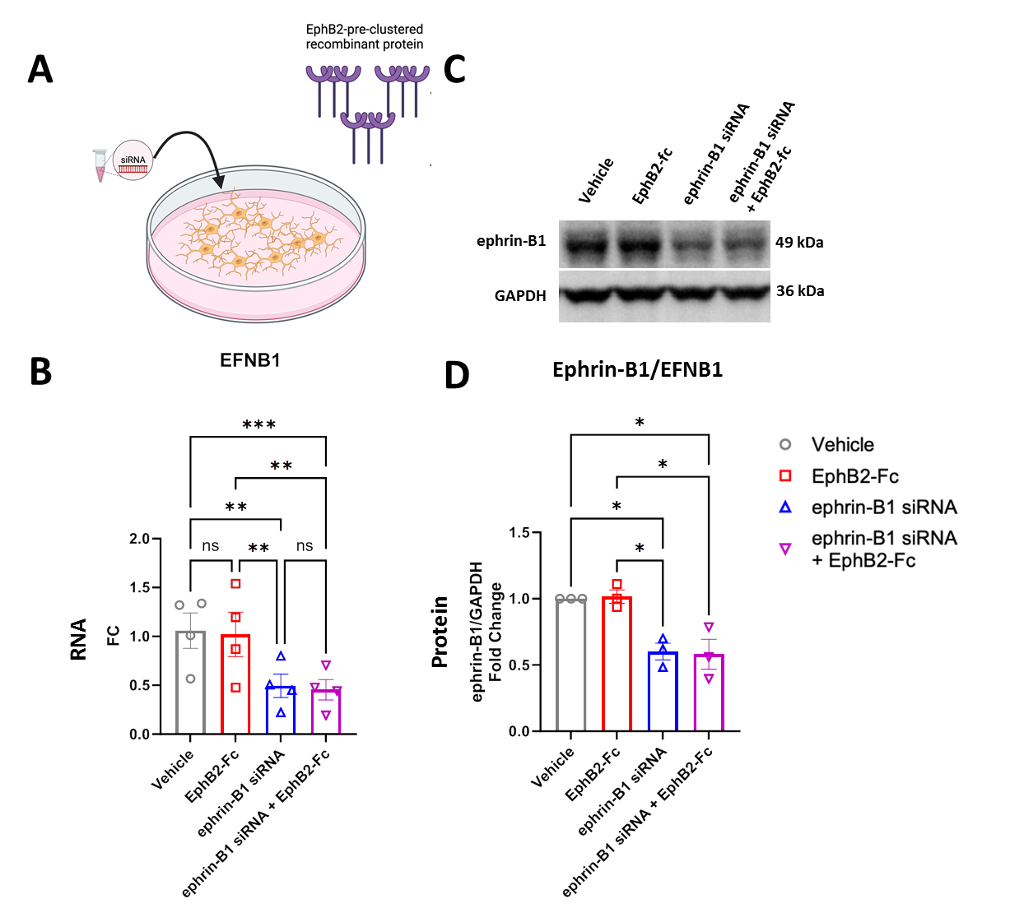
Supplementary Figure 3. Ephrin-B1 siRNA downregulates ephrin-B1 at the mRNA and protein level. (A) Schematic. (B) QRT-PCR analysis of EFNB1 using isolated RNA of human microglial HMC3 cells following 48-hour treatment with ephrin-B1 siRNA or scramble siRNA + 24-hour ephB2-Fc (2ug/ml) or control-Fc (2ug/ml) treatment. Fold change of EFNB1 transcript levels. (C) Western blot and (D) quantification of ephrin-B1 protein expression normalized to GAPDH; n = 3-4 biological replicates. 6-8 total technical replicates. Values are Mean + SEM; FC = Fold Change; n.s. = non-significant, * P < 0.05, ** P < 0.01, *** P < 0.001, **** P < 0.0001, Two-Way ANOVA followed by Tukey’s Post Hoc.

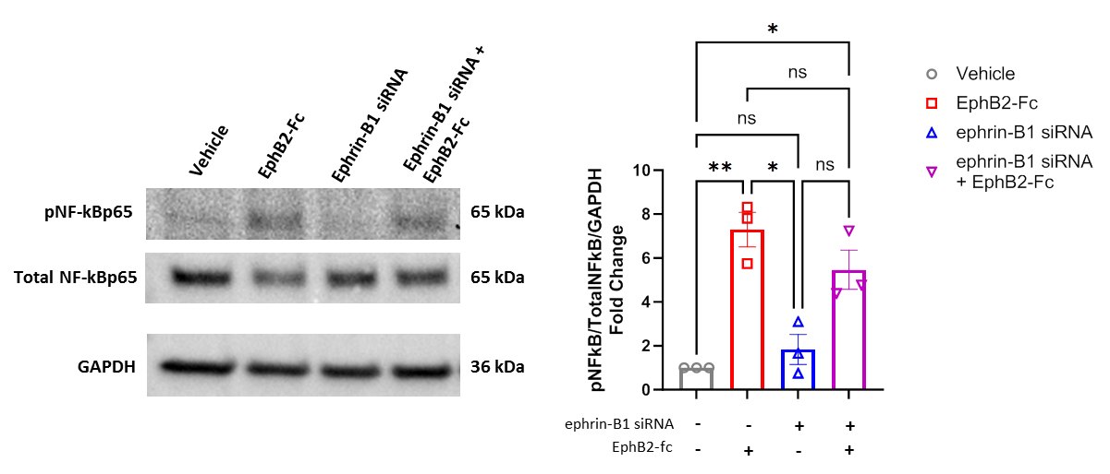
Supplementary Figure 4. EphB2 treatment activates NF-kB signaling. Representative western blot of phospho-NF-kB, total NF-kB and GAPDH. The graph shows fold change normalized to vehicle control of phospho-NF-kB normalized to Total NF-kB then to GAPDH; n = 3 biological replicates per treatment. Values are Mean + SEM with * P < 0.05, ** P < 0.01, *** P < 0.001, **** P < 0.0001, Two Way ANOVA followed by Tukey’s post hoc test.

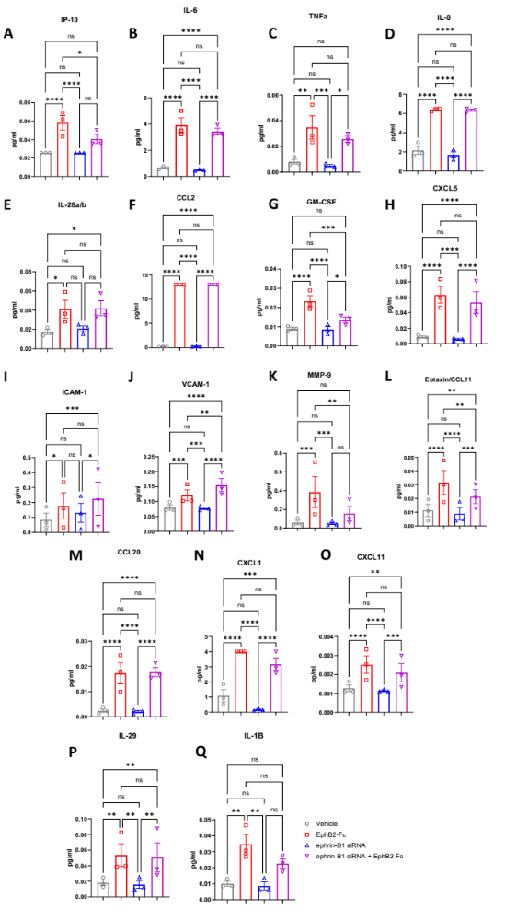
Supplementary Figure 5. Concentrations of secreted microglial proteins significantly differentially regulated by the ephrin-B1/EphB2 axis detected with LegendPlex assays. Multiplexed analysis of supernatants following 48-hour treatment of ephrin-B1 siRNA or scramble siRNA + 24-hour ephB2-Fc (2ug/ml) or control-Fc (2ug/ml) treatment of human HMC3 microglia using a LegendPlex bead assay. Panels (A-Q) include pro-inflammatory cytokines, pro-inflammatory chemokines, and antiviral markers that were statistically significant when comparing EphB2 vs vehicle-treated cells; n = 3 biological replicates. 2 technical replicates per biological replicate averaged. Representative protein concentrations are Mean + SEM, * P < 0.05, ** P < 0.01, *** P < 0.001, **** P < 0.0001, n.s. = non-significant, Two-Way ANOVA followed by Tukey’s Post Hoc.

