Supplementary Materials
Materials and Methods
Figs. S1 to S3
Tables S1 to S5
References (51-62)
Blue nitrogen burial follows the fate of tidal wetlands

Authors: J. Adam Langley, Samantha K. Chapman, Le Wang, Tania L. Maxwell, Phillip Rivera, M.F. Adame, Ariane Arias-Ortiz, Christina Asanopolous, J.F. Blanco, Josh L. Breithaupt, Steve W.J. Canty, Lisa G. Chambers, Jeffrey C. Cornwell, Christopher Craft, Sandra Cross, Ilka C. Feller, Daniel A. Friess, Glenn R. Guntenspergen, James Holmquist, Scott F. Jones, Johanna LJ Jupin, Brian P. Kelleher, Anthony Grey, Jeffrey J. Kelleway, Matthew L. Kirwan, Ken W. Krauss, Catherine E. Lovelock, S. Alex McClellan, J. Patrick Megonigal, James T. Morris, Scott C. Neubauer, Melissa A. Pastore, Kerrilee Rogers, Andre S. Rovai, A.C. Ruiz-Fernandez, Neil Saintilan, Joan-Albert Sanchez-Cabeza, Loraé T. Simpson, Craig Smeaton, Amanda C. Spivak, Havalend E. Steinmuller, Nathaniel B. Weston.

Corresponding author: adam.langley@villanova.edu

The PDF file includes:

- Methods
- Figure S1. Map of soil C, N profile sites
- Figure S2. Predicted soil N (%) versus actual soil N (%) using leave-one-out cross-validation.
- Figure S3. Violin plots of soil C:N ratio by bulk density class
- Figure S4. Soil C:N and soil N density by depth
- Figure S5. Historical reconstructions and future scenarios of sea level rise and wetland area change.
- Figure S6. Schematic of information flow
- Table S1. Model results for [N]
- Table S2. Model results for C:N
- Table S3 Model results for N density
- Table S4. Definition of scenarios and resulting net N change
- Table S5. Supplementary table of values and references to support Fig. 4

Methods
We gathered data from several sources to generate this synthesis (Fig. S6). Our approach centered on collating a soil nitrogen (N) concentration database in tidal marsh and mangrove soils. We collected data from two existing databases, additional individual papers, and unpublished datasets. The Coastal Carbon Library and Atlas (CCLA) has depth interval soil C concentration data from several thousand cores ⁵¹. We identified individual studies that submitted soil N concentration data to the CCLA that were not included in the primary database and merged the depth-specific N data with the existing metadata of each core. This included studies from the database published by Maxwell et al. (2023), which has been incorporated into the CCLA, again selecting only studies that included N concentration data. We also included other tidal wetland soil core studies for which we could obtain soil C and N concentrations, bulk density, core location, and habitat type. We unified all the data into a single database (available on GitHub). We calculated the center depth of each core segment as the average of the upper and lower depths. In studies that distinguished organic from total or inorganic, we used organic C. While some inorganic N may contribute to bulk soil N measurements, we estimate that >99% of soil N occurs in organic form ³⁴. Data were only included where habitats were characterized as tidal marsh or mangrove. We did not restrict by salinity class.

Predictive models for soil [N], C:N and N density
Our primary goal was to use models to predict N concentration, N stocks, and N accumulation for extrapolations and other situations where predictors may be limited. We first aimed to determine the relationship between soil [N] and soil [C]. For this purpose, we sought the best model that considered only habitat type and soil [C], and their interaction while adjusting for the data structure, as other factors may not be known for all wetlands. We included 31 studies, each comprising between 1 and 32 different sites. At each site, measurements were taken from soil cores at various depths, ranging from 0 to 4 m. We restricted data to soil segments with center depth <1 m because relatively few studies included deeper samples, and we intended to extrapolate to only the top meter of soil. We filtered a subset of analytical outliers by selecting only core segments with a C:N ratio between 5 and 100; samples outside of this range likely result from analytical error in either [C] or [N] ⁵². These outliers (both high and low C:N) tended to have very low [C], suggesting that measurements were possibly near the detection limit for N measurements, leading to erroneous C:N values. We omitted 330 soil samples, representing 4% of the database. We fit a linear mixed-effects model to predict soil [N], using organic C, habitat (marsh vs. mangrove), and the interaction of organic C with habitat as a fixed effect. Soil cores in sites nested within each study were treated as random effects to account for the hierarchical data structure. This allowed the model to appropriately account for variability at the study, site, and soil core levels, leading to more robust estimates of the fixed effects. To evaluate the prediction accuracy of the model, we conducted leave-one-out cross-validation. For each observation in the dataset, we fit the mixed-effects model using the remaining data and predicted soil [N] for the excluded observation. We then calculated the correlation coefficient between the predicted and actual soil [N] values to assess the strength of the linear relationship, where a higher correlation coefficient indicates greater prediction accuracy.
To convert existing soil C stock and flux estimates into N, we built a second linear mixed-effects model to estimate C:N ratios for marsh and mangrove soils, because C:N ratio remains consistent regardless of the measurement units of C and N. This model used C:N as the response variable, habitat (marsh or mangrove) as the fixed effect, and the same random effects as in the first model to account for the hierarchical data structure. We also included the center depth of each soil segment and bulk density as additional fixed effects to determine how other factors may influence soil C:N, Finally, to estimate the mean N density for tidal wetland soils to allow calculation of net N changes in the projections described below, we built a simple mixed-effects model of N density versus habitat while accounting for the hierarchical data structure using the same random effects as in the first model. For all three response variables, including depth slightly improved the Bayesian Information Criterion (Tables S1-S3), but we report on the simpler models so that predictions can be made for cases in which all predictors are not available. In all models, we excluded predictors that were not independent of the response variable. For instance, we excluded soil [C] as a predictor from the models predicting C:N ratio. In each model, continuous predictors were linearly related to responses and variances. Although model residuals deviated from normality, linear mixed-effects models are robust to such deviations, particularly with large sample sizes^{53,54}.

Global N accumulation stocks and rates
We relied on recently reported estimates of C accumulation and stocks in marshes and mangroves to use our C:N ratios for each habitat type to estimate N accumulation and stocks. To estimate current N stocks in marsh and mangrove soils, we applied our habitat-specific C:N estimates to published estimates of C stocks in marsh and mangrove soils ²², multiplied by the area of each habitat and summed for a global total (Table S4). To estimate the distribution of N accumulation rates per unit area, we applied our model predictions to a database of individual estimates of C accumulation rates that used radio-isotopes to determine soil accumulation rates ²⁴. To estimate the a global rates of N accumulation, we applied the marsh and mangrove soil C:N estimates to the results of a wetland C database ²². That study used environmental variables such as mean annual temperature, precipitation, and local rSLR to account for geographically biased sampling in wetland C accumulation measurements in estimating C accumulation for total wetland area by country ²⁴. Because we focus on N, the error in all estimates reflects the model error for the N parameter we used in each case, not the error associated with the C parameters.

Projections
We considered six future scenarios as combinations of projections for SLR and for wetland area gain or loss (Table S4) to envelop the range of future possibilities. SLR and wetland area varied independently (Fig. S5), despite known linkages, because there is considerable uncertainty about the relationship between SLR and wetland area that involves social variables such as coastal development ^{32,38,55}.
To estimate future wetland elevation gain, we made the simplifying assumption that patterns in local isostatic rSLR will follow global eustatic SLR on the decadal and centennial time scales relevant for management and decision-making. We also assumed that the global mean wetland elevation gain would match the global mean rSLR up to a threshold. Yet, we recognize that the rSLR varies enormously based on local sea level trends and vertical land adjustment. Though using one global mean rSLR minimizes this geographic heterogeneity in individual sites, the global average trends in rSLR broadly follow long-term trends in global mean SLR, especially for the temperate zones that have not been glaciated and the passive margins of continents where the greatest portion of coastal wetland area occur ⁵⁶.
To estimate future sea level scenarios, we chose a low- and high-end estimate ³⁶. We assume that sea level rise will occur exponentially as SLR_{y} = SLR₂₀₂₀*e^{k(y-2020)} where y is the year and k is the growth constant determined as log(SLR₂₁₀₀/SLR₂₀₂₀)/(2100-2020) with a SLR₂₁₀₀ determined by each scenario (Table S2). Low SLR is defined as the mid-range (50th percentile) estimate from the best-case climate scenario (1.5 ºC warming) by 2100, and high SLR is defined as a mid-range estimate from the IPCC RCP 8.5 (4 ºC warming, Jevereva et al. 2019). Gross wetland area loss is based on 1.5 °C and 3 °C warming scenarios ³⁷, and high gain is based on net area gain for RCP 8.5 in the high-density threshold ³⁸ (Table S1). Increasing rSLR has been linked to higher rates of soil accumulation and higher proportions of C in accumulating soil ². Accelerating rSLR could also increase the N concentration of accumulating soil, though our simple model did not assume this.
Thus to project future wetland area, we chose stable, high-loss, and high-gain scenarios. We generated logistic relationships in which rates of change begin close to present-day rates and peak midcentury: A_{y} = (A₂₁₀₀- A₂₀₂₀)/ (1+ e^{(2060 – y)})/8) where A_{y} = marsh or mangrove area in year y, A₂₀₂₀ = area in the year 2020 with a unique A₂₁₀₀ for each scenario according to Table S5. The inflection point was defined as 2060 as midway between 2020 and 2100.
Future net N change was estimated as the sum of gross N gain in surviving wetlands and gross N released from erosion of lost marsh area. Gross N gain was estimated as the product of mean elevation gain, wetland area at the time of gain, and separate mean N densities of marsh (1.75 mg N cm⁻³) and mangrove soil (1.98 mg N cm⁻³). N densities are the product of soil bulk density and soil [N]. Increases in wetland area are included in the soil vertical gain calculations and are assumed to match the vertical gain rate of existing marshes starting from 0 cm depth. To estimate losses, we assumed that wetland area loss results in an erosive release of 50 vertical cm of soil, the approximate difference in elevation between a salt marsh and mudflat over a retreating margin in an estuary with an average tidal range ⁵⁷. The amount of N represented by this loss was calculated using the N densities above. Net N change is the sum of gross N losses from gross area losses and N gains from elevation and area gains.
The histories of SLR and wetland area change were reconstructed to estimate the change in N budgets relative to the present day. Reconstructions of SLR were taken from a combination of satellite data and gauge records (Table S4). We applied a linear increase in the rate of SLR from 2.1 mm yr⁻¹ in 1970 to 3.5 mm yr⁻¹ in 2019. Historical wetland area loss was interpolated from three separate analyses focusing on three historical time intervals ^{27,58,59}. Taken together, the historical record shows slow loss peaking during the 20th century and slowing more recently. We fit 4-parameter Gompertz models to represent this sigmoidal pattern.

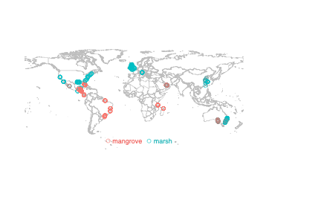

Fig. S1. Map of soil core sites included in tidal wetland C:N database.

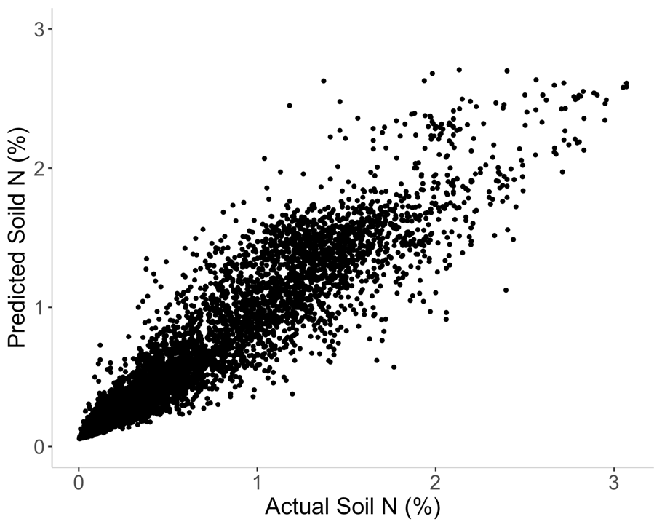
Predicted soil N (%)
Fig. S2. Predicted soil N (%) versus actual soil N (%) for model 1 using leave-one-out cross-validation. The correlation coefficient r = 0.94.

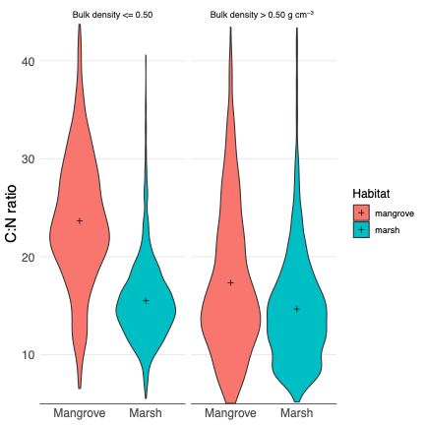

Fig. S3. Violin plots of the soil C:N of each habitat type according to bulk density (g cm⁻³) class. For each group left to right, the sample mean C:N = 23.9, 15.6, 17.5 and 15.1. The number of replicates = 1538, 2417, 1371, 2632.

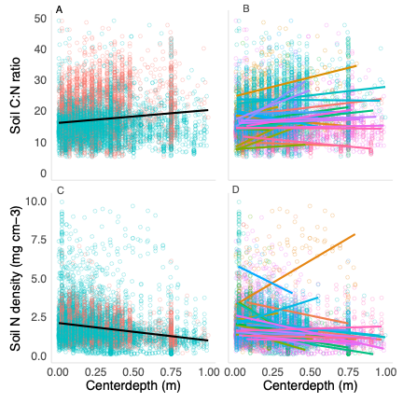
A

Fig. S4. (A) Relationship of soil C:N with depth and (B) separated by study; (C) relationship of N density with depth and (D) separated by study.

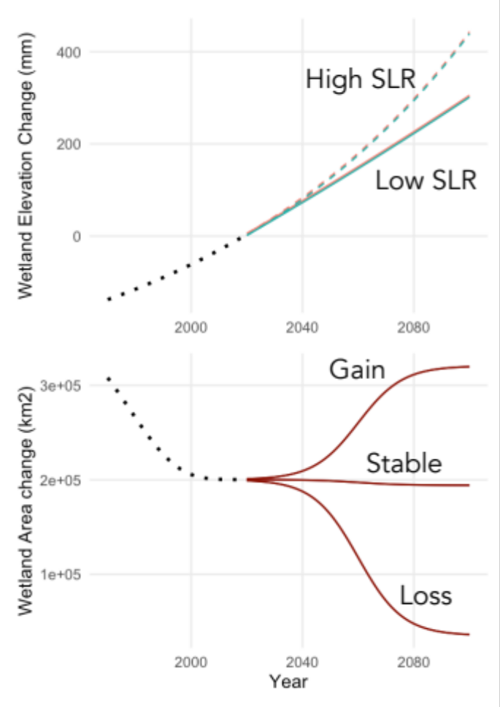

Fig. S5. Historical reconstructions and future scenarios of sea level rise and wetland area change.

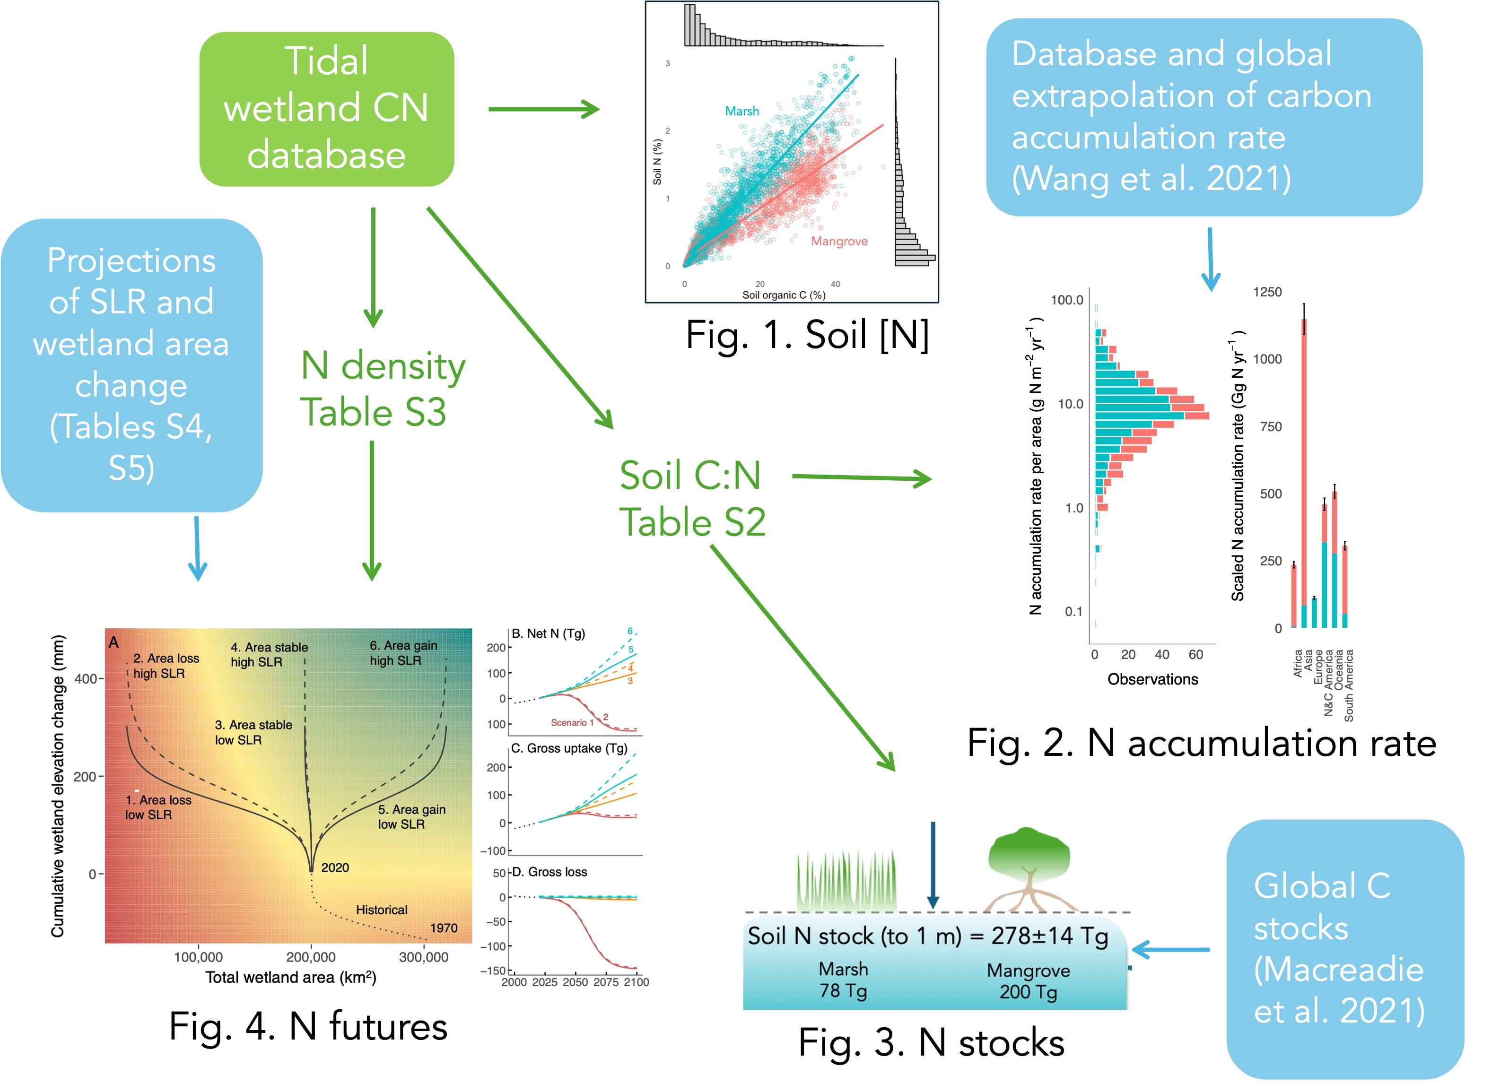

Fig. S6. Schematic of information flow.

Table S1. Fixed effects in a linear mixed effects model to predict soil %N.

 | Predictor | Estimate◊ | Standard Error | t* | p-value
 | Intercept | 0.1158 | 0.0170 | 6.83 | <0.0001
Model 1 | % organic C | 0.0408 | 0.0005 | 89.99 | <0.0001
BIC= -8216.31 | Habitat (marsh) | -0.0613 | 0.0116 | -5.29 | <0.0001
 | %OC*Habitat | 0.0166 | 0.0006 | 28.47 | <0.0001
 | Intercept | 0.1564 | 0.0159 | 9.85 | <0.0001
Model 2 | % organic C | 0.0394 | 0.0005 | 86.19 | <0.0001
BIC= -8438.712 | Habitat (marsh) | -0.0572 | 0.0114 | -5.03 | <0.0001
 | %OC*Habitat | 0.0166 | 0.0006 | 28.76 | <0.0001
 | Depth | -0.1221 | 0.0078 | -15.61 | <0.0001
* Degrees of freedom are estimated using the Kenward-Roger method, and all values are large.
◊ The estimated slope of N versus C for model 1 is 0.0408 (SE=0.0005) for mangrove and 0.0574 (SE=0.0004) for marsh. The estimated slope of N versus C is 0.0394 (SE=0.0005) for mangrove and 0.0560 (SE=0.0004) for marsh adjusting for depth in model 2.

Table S2. Fixed effects in a linear mixed effects model to predict soil C:N ratio.

 | Predictor | Estimate◊ | SE | t* | p-value
Model 1  BIC= 49216.37
  (Intercept)
  Habitat (marsh)
  16.76
  -0.40
  0.81
  0.42
  20.62
  -0.96
  <0.0001
  0.34
 | Intercept | 18.75 | 0.84 | 22.32 | <0.0001
Model 2 | Habitat (marsh) | -2.46 | 0.51 | -4.81 | <0.0001
BIC= 48601.01 | Bulk Density (>0.5) | -2.56 | 0.32 | -7.88 | <0.0001
 | BD (>0.5)*Habitat (marsh) | 2.60 | 0.38 | 6.86 | <0.0001
 | Intercept | 18.20 | 0.81 | 22.49 | <0.0001
Model 3 | Habitat (marsh) | -2.49 | 0.50 | -4.94 | <0.0001
BIC= 48438.91 | Bulk Density (>0.5) | -3.09 | 0.32 | -9.55 | <0.0001
 | BD (>0.5)*Habitat (marsh) | 2.48 | 0.37 | 6.61 | <0.0001
 | Depth | 3.64 | 0.28 | 13.18 | <0.0001
* Degrees of freedom are estimated using the Kenward-Roger method, and all values are large.
◊ For model 1, the estimated mean C:N ratio is 16.76 (SE=0.81) in mangrove and 16.36 (SE=0.77) in marsh.
For model 2, the estimated mean C:N ratio is 18.75 (SE=0.84) in mangrove and 16.29 (SE=0.78) in marsh for low bulk density, 16.19 (SE=0.81) in mangrove and 16.33 (SE=0.78) in marsh for high bulk density.
For model 3, the estimated mean C:N ratio is 18.20 (SE=0.81) in mangrove and 15.71 (SE=0.75) in marsh for low bulk density, 15.11 (SE=0.78) in mangrove and 15.09 (SE=0.75) in marsh for high bulk density at depth of 0.

Table S3. Fixed effects in a linear mixed effects model to predict soil N density.

 | Predictor | Estimate◊ | SE | t* | p-value
Model 1  BIC= 19764.58 | Intercept | 1.939 | 0.190 | 10.22 | <0.0001
Model 1  BIC= 19764.58 | Habitat(marsh) | 0.007 | 0.069 | 0.10 | 0.921
Model 2  BIC= 19410.61 | Intercept | 2.118 | 0.184 | 11.49 | <0.0001
Model 2  BIC= 19410.61 | Habitat (marsh) | 0.046 | 0.068 | 0.67 | 0.501
Model 2  BIC= 19410.61 | Depth | -0.811 | 0.042 | -19.40 | <0.0001

* Degrees of freedom are estimated using the Kenward-Roger method, and all values are large.
◊ The estimated mean N density is 1.939 (SE=0.190) for mangrove and 1.946 (SE=0.185) for marsh in model 1. The estimated mean N density is 2.118 (SE=0.184) in mangrove and 2.164 (SE=0.180) in marsh at depth of 0 in model 2.

Table S4. Scenario definitions and resulting net N change corresponding to Figure 4.

Scenario | Tidal wetland area change by 2100 (km²) | Rate of SLR by 2100  (mm yr ⁻¹) | Net N change by 2100 (Tg)
- Area loss, low SLR | -165,035 | 4 | -138
- Area loss, high SLR | -165,035 | 8 | -128
- Stable area, low SLR | -5,989 | 4 | 109
- Stable area, high SLR | -5,989 | 8 | 161
- Area gain, low SLR | 120,399 | 4 | 188
- Area gain, high SLR | 120,399 | 8 | 274

Table S5. Data sources to support extrapolations, reconstructions, and future scenarios.

Period | Variable | Marsh + Mangrove | Marsh | Mangrove | Approach, assumptions, and references
Present | Area (km²) | 200,239 | 52,880 | 147,359 | ^{60,61}
Present | Soil C stock per area to 1 m depth (Mg C ha⁻¹) | NA | 226 | 286 | ²²
Present | Soil N stock per area to 1 m depth (Mg N ha⁻¹) |  | 14.8 | 13.6 | Soil C stock divided by C:N of marsh and mangrove
Present | Global soil N stock to 1 m depth (Tg) | 278 | 78 | 200 | Present study, using estimates of global N stock x area of marsh and mangrove
Present | Mean rate of elevation gain (mm yr⁻¹) | 3.5 | 3.5 | 3.5 | Assuming that mean global tidal wetland elevation gain matches recent global average rate of sea level rise from satellite records https://sealevel.colorado.edu/
Past | Preindustrial area (km²) | 402,086 | 106,183 | 295,896 | Total long-term global loss of tidal wetlands, 49.8% ⁵⁸
Past | Area in 1970 (km²) | 308,068 | 81,356 | 226,712 | 35% loss from 1970 to 2015 ²⁷
Past | SLR 1900 (mm yr⁻¹) | 1.2 | 1.2 | 1.2 | ⁶²
Past | Gross area gain 1999-2019 (km²) | 2992 | 1164 | 1828 | ⁵⁹
Past | Gross area loss 1999-2019 (km²) | 6625 | 1064 | 5561 | ⁵⁹
Past | Net area change 1999-2019 (km²) | -3633 | -719 to 100 | -3733 | ^{59,63}
Future | Max rate of mean elevation gain rate (mm yr⁻¹) | NA | 5.0 | 7.9 | Highest rate for marshes ⁶⁴ and mangroves ³⁷
Future | Low rate of mean elevation gain (mm yr⁻¹) | 4.1 | 4.1 | 4.1 | Assuming tidal wetlands match 50th percentile SLR estimate in low-emission scenario ³⁶
Future | High net area gain projection (km²) | 120,339 | 20,905 | 99,434 | Based on IPCC RCP 8.5 with high population density threshold for coastal adaptation ³⁸
Future | High gross area loss (km²) | 165,035  (89.6%) | 20,623 (39%) | 144,412 (98%) | Based on portion of wetland very likely exposed to >7 mm yr⁻¹ SLR by 2100 in 3°C warming scenario (%) ³⁷
Future | Low gross loss projection | 6,007 | 1,586  (3%) | 4,421  (3%) | Based on portion of wetland exposed to >7 mm yr⁻¹ SLR by 2100 in 1.5°C warming scenario (%) ³⁷

References
51. Holmquist, J. R. et al. The Coastal Carbon Library and Atlas: Open source soil data and tools supporting blue carbon research and policy. Global Change Biology 30, e17098 (2024).
52. Amorim, H. C., Hurtarte, L. C., Souza, I. F. & Zinn, Y. L. C: N ratios of bulk soils and particle-size fractions: Global trends and major drivers. Geoderma 425, 116026 (2022).
53. Gelman, A. Data Analysis Using Regression and Multilevel/Hierarchical Models. (Cambridge university press, 2007).
54. Schielzeth, H. et al. Robustness of linear mixed-effects models to violations of distributional assumptions. Methods in Ecology and Evolution 11, 1141–1152 (2020).
55. Kirwan, M. L., Temmerman, S., Skeehan, E. E., Guntenspergen, G. R. & Fagherazzi, S. Overestimation of marsh vulnerability to sea level rise. Nature Climate Change 6, 253–260 (2016).
56. Oelsmann, J. et al. Regional variations in relative sea-level changes influenced by nonlinear vertical land motion. Nature Geoscience 17, 137–144 (2024).
57. Goodwin, G. C. & Mudd, S. M. Detecting the morphology of prograding and retreating marsh margins—Example of a mega-tidal bay. Remote Sensing 12, 13 (2019).
58. Davidson, N. C. How much wetland has the world lost? Long-term and recent trends in global wetland area. Marine and Freshwater Research 65, 934–941 (2014).
59. Murray, N. J. et al. High-resolution mapping of losses and gains of Earth’s tidal wetlands. Science 376, 744–749 (2022).
60. Bunting, P. et al. Global mangrove extent change 1996–2020: Global mangrove watch version 3.0. Remote Sensing 14, 3657 (2022).
61. Worthington, T. A. et al. The distribution of global tidal marshes from earth observation data. BioRxiv 2023–05 (2023).
62. Church, J. A. & White, N. J. Sea-Level Rise from the Late 19th to the Early 21st Century. Surv Geophys 32, 585–602 (2011).
63. Campbell, A. D., Fatoyinbo, L., Goldberg, L. & Lagomasino, D. Global hotspots of salt marsh change and carbon emissions. Nature 612, 701–706 (2022).
64. Morris, J. T. et al. Contributions of organic and inorganic matter to sediment volume and accretion in tidal wetlands at steady state. Earth’s Future 4, 110–121 (2016).

