Supplementary Information
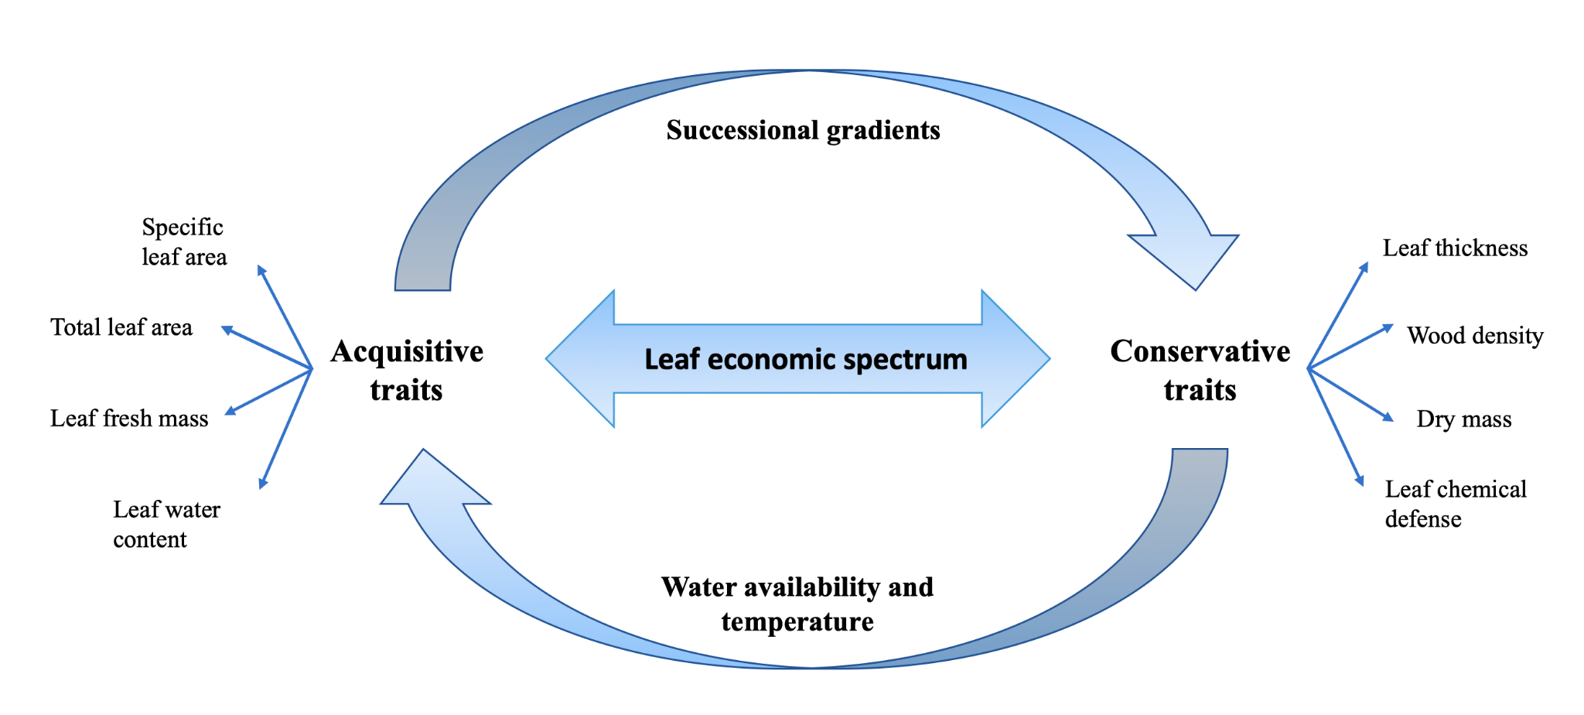
Fig. S1 Diagram adapted from Aguilar-Peralta et al. (2022) of the leaf economic spectrum occurring along a spectrum of acquisitive resource use and conservative resource use plant traits. This continuum is environmentally filtered through ecological succession gradients, water availability, and temperature.

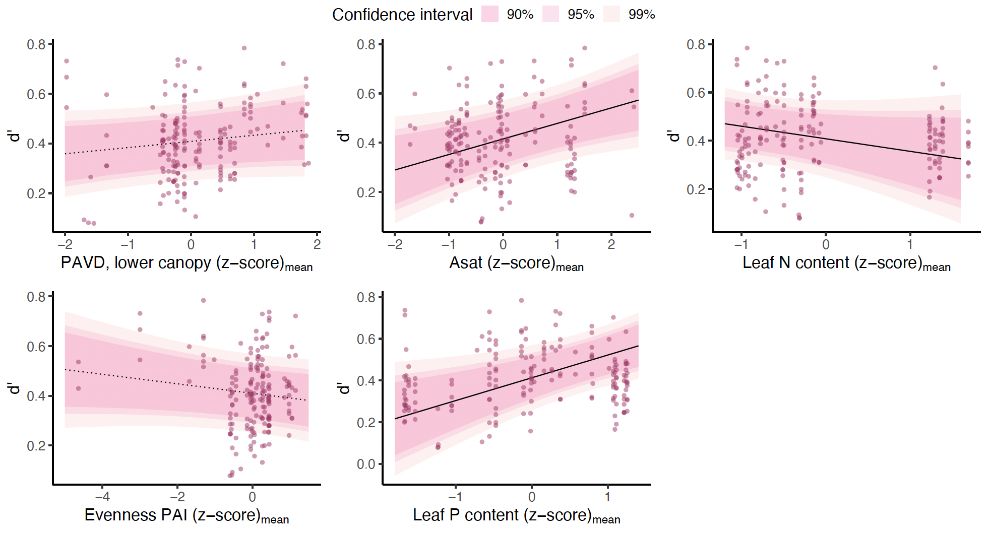
Fig. S2 Effect of plant traits on species-level specialisation (d’). Model results for species-level specialisation (d’; Y axis) as a function of vegetation structure and plant trait variables (X axis: plant area volume density (PAVD) in the lower canopy, saturated assimilation rate (A_{sat}), leaf nitrogen (N) content, evenness of the plant area index (PAI), and leaf phosphorus (P) content), generated from the selected statistical model (see methods, Table S1). Black fitted lines show the slope of the linear response, while the colour gradient corresponds to the 0.90, 0.95 and 0.99 confidence intervals. Dotted fitted lines indicate vegetation structure variable, while solid lines indicate plant functional trait variable. It can be seen here that there are similar plant trait relationships explaining the pollination metrics d’ and H2’, with the exception of evenness of PAI.

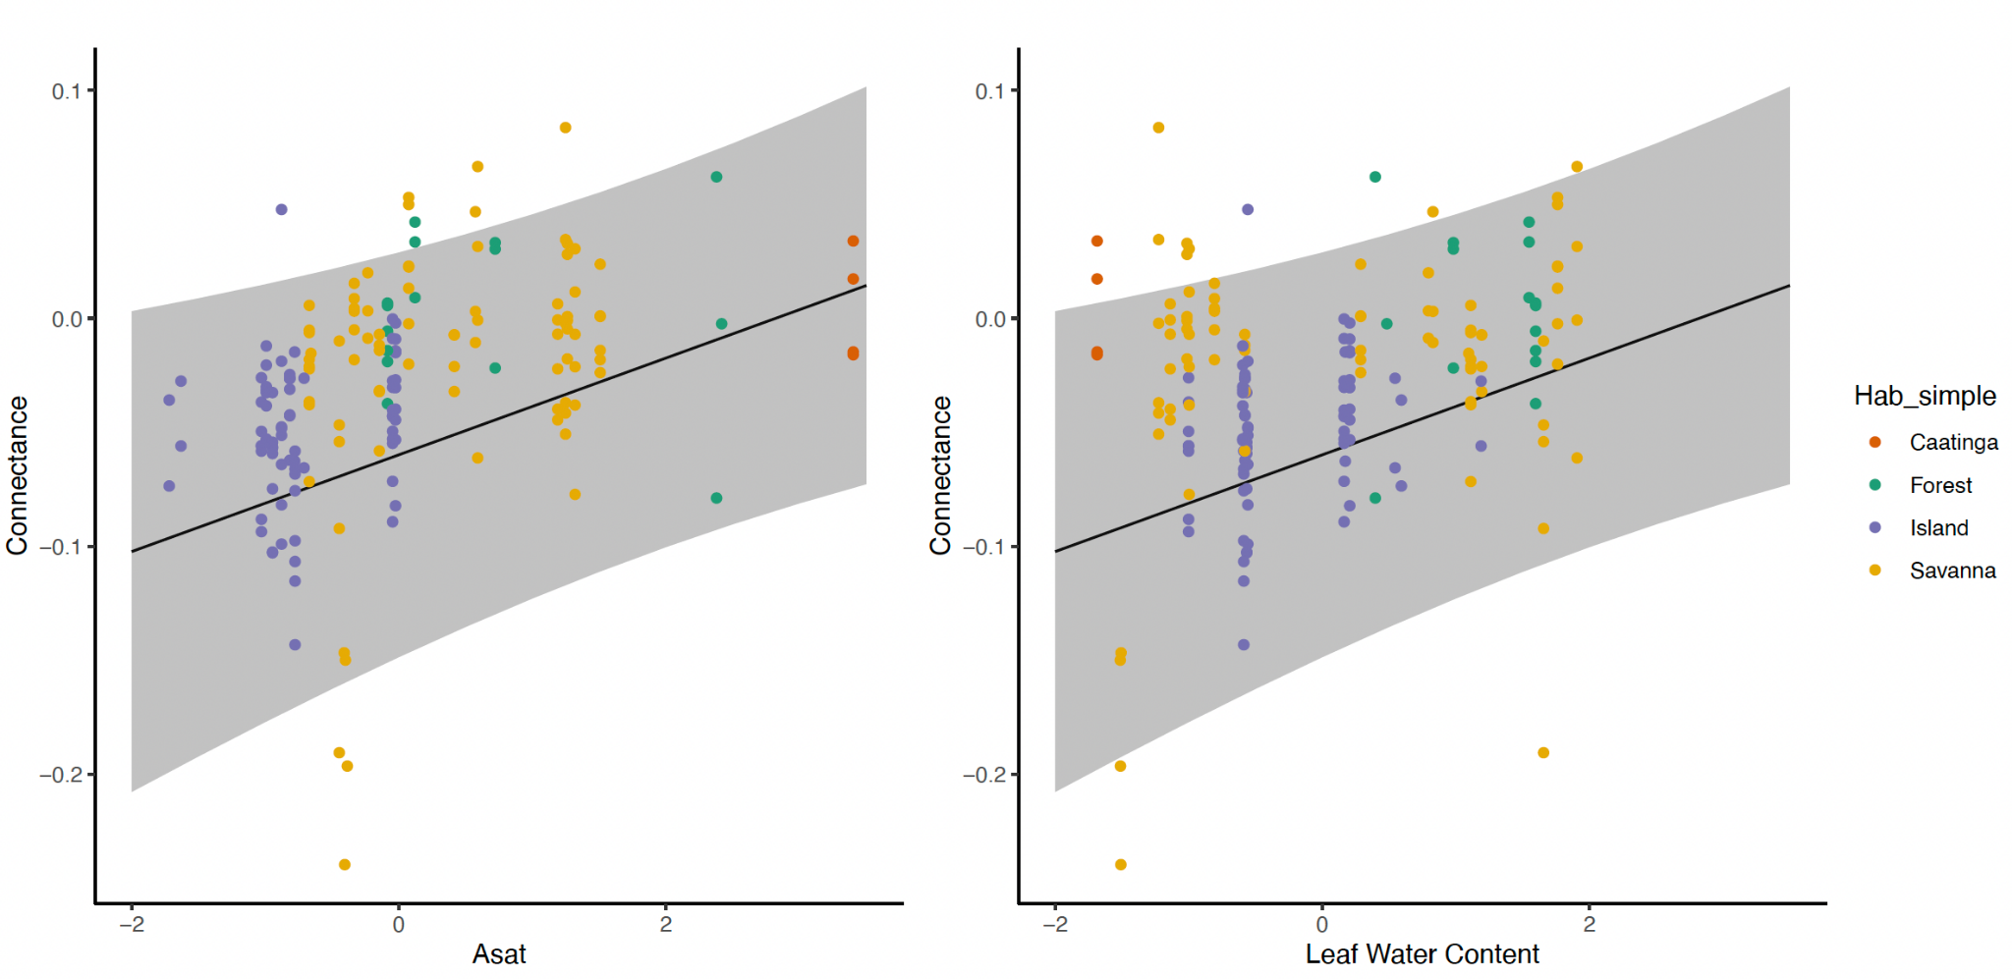
Fig. S3 Effect of plant traits on network connectance by habitat. Model results for pollination network connectance (Y axis) as a function of plant trait variables (X axis: saturated assimilation rate, A_{sat,} and leaf water content), generated from the selected statistical model (see methods; Table S1). Black fitted lines show the slope of the linear response, while the grey ribbon represents the 95% confidence interval. Data points are coloured by habitat types (red: caatinga, green: forest, blue: island, yellow: savanna).

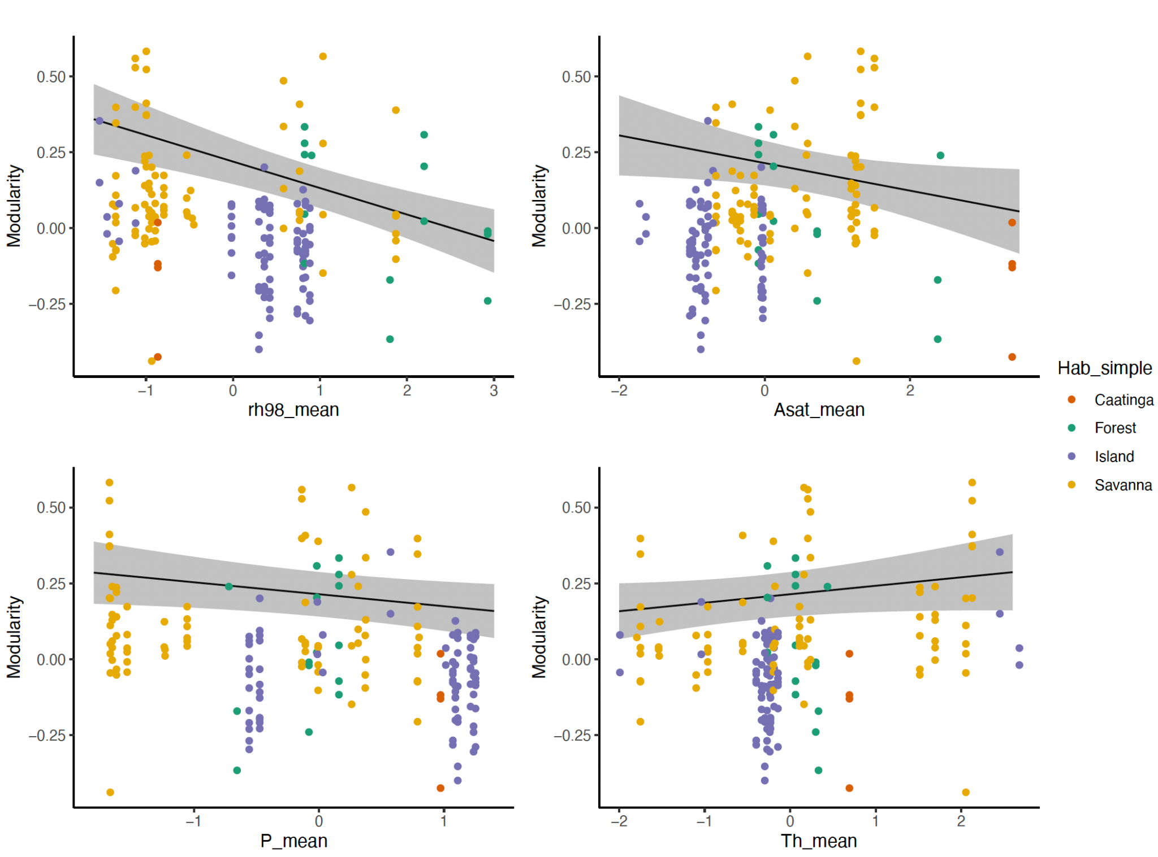

Fig. S4 Effect of plant traits on network modularity by habitat. Model results for pollination network modularity (Y axis) as a function of vegetation structure and plant trait variables (X axis: canopy height (rh98), saturated assimilation rate (A_{sat}), leaf phosphorus (P) content, and leaf thickness (Th)), generated from the selected statistical model (see methods section, Table S1). Black fitted lines show the slope of the linear response, while the grey ribbon represents the 95% confidence interval. Data points are coloured by habitat types (red: caatinga, green: forest, blue: island, yellow: savanna).

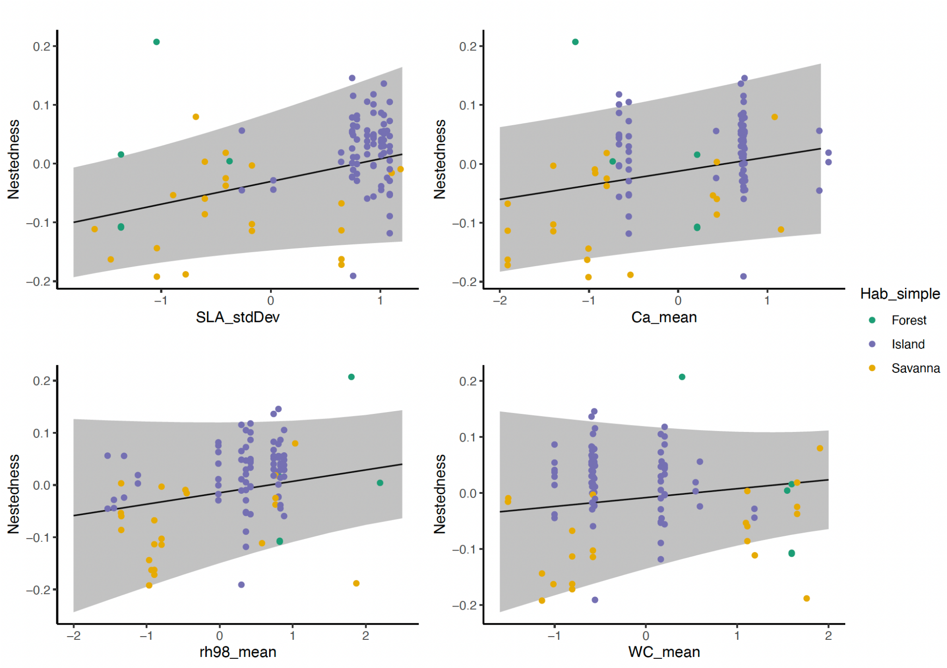Fig. S5 Effects of plant traits on network nestedness by habitat. Model results for pollination network nestedness (Y axis) as a function of vegetation structure and plant trait variables (X axis: standard deviations (SD) in specific leaf area (SLA), leaf calcium (Ca) content, canopy height (rh98), leaf water content (WC)), generated from the selected statistical model (see methods, Table S1). Black fitted lines show the slope of the linear response, while the grey ribbon represents the 95% confidence interval. Data points are coloured by habitat types (red: caatinga, green: forest, blue: island, yellow: savanna).

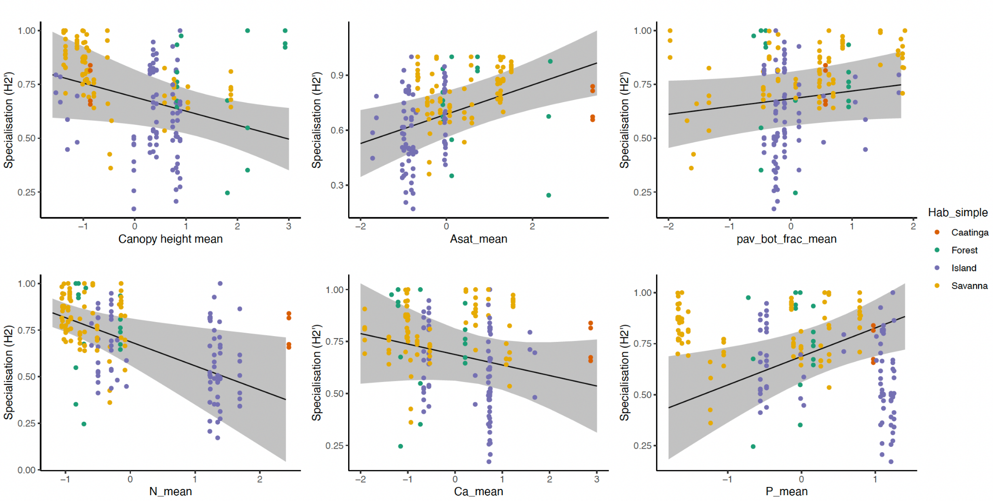
Fig. S6 Effect of plant traits on network specialisation (H₂’) by habitat. Model results for pollination network specialisation (H₂’; Y axis) as a function of vegetation structure and plant trait variables (X axis: plant area volume density in the lower canopy (pav_bot_frac), saturated assimilation rate (A_{sat}), leaf nitrogen (N) content, canopy height, leaf calcium (Ca) content, leaf phosphorus (P) content), generated from the selected statistical model (see methods, Table S1). Black fitted lines show the slope of the linear response, while the grey ribbon represents the 95% confidence interval. Data points are coloured by habitat types (red: caatinga, green: forest, blue: island, yellow: savanna).

