Supporting Information
Table of Contents
Experimental Procedures
Supplementary Figures
References
Author Contributions

Experimental Procedures
Materials
All chemicals were used as received without further purification. Pentaerythritol tetrakis(3-mercaptopropionate) (PETMP) was donated from Bruno Bock GmbH (Marschacht, Germany). All other chemicals were purchased from Sigma-Aldrich (St. Louis, USA).
Light Sources
For kinetics measurements (FTIR and Photo-Rheology) and masking experiments a LED Control 5S from Opsytec Dr. Gröbel (Germany) was used with different UV-LEDs (365 nm and 450 nm). The emission spectra and intensities of the used light sources were determined with an Ocean Optics (USA) Ocean Insight STS-UV Miniature Spectrometer. For data processing, Spectragryph optical spectroscopy software (version v1.2.16.1.) was used.
Resin preparation
Pentaerythrit-tetrakis-(3-mercapto-propionate) and 1,3,5-triallyl-1,3,5-triazin-2,4,6-(1H,3H,5H)-trione were added into a brown glass vial in stoichiometric amounts. Pyrogallol (0.1 wt%), camphorquinone (CQ, 4 wt%) and 2-(2-nitrophenyl)-propyloxycarbonyl-1,1,3,3-tetramethylguanidine (NPPOC-TMG, 3.6 wt%) were added to the liquid resin and stirred on a magnetic stirrer at room temperature until all solid components were dissolved. For masking and grayscale experiments 0.05 wt% avobenzone was added to improve the resolution.
Synthesis of NPPOC-TMG
The synthesis of NPPOC-TMG was done according to literature protocol.^{[1]}
¹H-NMR (400 MHz, chloroform-d): δ 7.75-7.68 (m, 1H), 7.61-7.45 (m, 2H), 7.39-7.22 (m, 1H), 4.26 (d, J=6.8Hz, 2H), 3.83-3.60 (m, 1H), 2.80 (s, 12H), 1.34 (d, J=7.2 Hz, 3H)
¹³C NMR (XX MHz, chloroform-d): δ 165.95, 159.93, 159.93, 150.29, 138.26, 132.49, 128.47, 126.94, 124.04, 68.42, 67.71, 50.74, 39.73, 36.34, 33.84, 18.52, 17.56
NMR-Spectroscopy
For characterization of the synthesized compound 1H-NMR and 13C-NMR spectra were recorded with a Varian 400-NMR spectrometer. Data analysis was done with MestReNova version 14.2.0.
UV-Vis-Spectroscopy
UV-Vis spectra of CQ (concentration = 3mmol/l) and NPPOC-TMG (concentration = 0.05 mmol/l) were recorded in acetonitrile with an Varian Cary 50 UV-Vis spectrophotometer (Agilent Technologies Inc, Santa Clara, USA; software: CaryWinUV Scan version 3.00(182)).
FTIR-Spectroscopy
Curing kinetics of the resin were measured between two CaF₂ platelets on a VERTEX 70 FTIR spectrometer from Bruker (USA) in transmission mode. Spectra were recorded from 4000 cm⁻¹ to 800 cm⁻¹ with a resolution of 4 cm⁻¹ and a total of 16 scans. Measurements were taken of the unilluminated sample and after stepwise illumination with 450 nm (4 cm, 22 mWcm⁻²) and 365 nm (3 cm, 43.5 mWcm⁻²). SpectraGryph optical spectroscopy software (version v1.2.16.1.) was used for baseline correction of the spectra as well as normalizing (area of CO-peak, 1655-1790 cm⁻¹) them. The CO₂ absorption bands were removed manually to improve clarity of the shown spectra. Integration of the absorption bands of the C=C double bond (3055-3110 cm⁻¹), the thiol
(2530-2605 cm⁻¹) and the bond between 1513 and 1550 cm⁻¹, relating to the cleavage of the photobase, was used to follow the respective curing reactions.
Photo-Rheology
Photo-rheology measurements were performed on an Anton Paar (Austria) Modular Compact Rheometer 102 with a parallel-plate measuring system (diameter = 25 mm) with a constant gap of 0.1 mm. The resin was illuminated from below through a quartz plate with LED light sources (450 nm and 365 nm, LED Control 5S, see Light Sources) at 25 °C.
Masking Experiments
Masking experiments were performed between a fluorinated ethylene propylene film and a glass slide. During illumination with 365 nm (7.84 Jcm⁻²) the mask was placed on top of the film and removed before curing the whole film with 450 nm (146.40 Jcm⁻²). After curing, the film on the glass slide was washed with isopropanol.
Laser Writing Experiments
In the laser writing experiment, two lasers were used. Functioning as the curing laser was a multiple wavelength continuous wave gas laser (Innova 70C, Coherent, USA, with main peak at 488 nm). The second laser was the inhibition laser – a pulsed diode-pumped, passively Q-switched solid-state laser (1Q 355-2, CryLaS GmbH, Germany, λ = 355 nm, t_{pulse} = 1 ns, f_{rep} = 10kHz). Figure S 5 shows the full emission spectra of both lasers. Both lasers were coupled into an inverted microscope (Zeiss Axiovert 200, Carl Zeiss AG, Germany) and focused on the sample plane by a 40x objective lens (NA = 0.95). The lateral and axial positions of the laser beams were aligned to fully overlap at the focal plane. The positioning (line writing) was achieved using a motorized stage (SCAN IM, Märzhäuser Wetzlar GmbH, Germany) with a typical speed of 0.2 mm/s. The images of written lines (Figure 4a and b in the main text) were taken in reflection mode on the same Zeiss microscope.
Greyscale Experiments
A custom-built printer (Luxinergy GmbH, Austria) with two different light sources (365 nm and 460 nm) was used to create the structured layer that was analyzed in the grey scale experiments. First three stripes (4 mm x 10 mm) were illuminated with 365 nm with varying intensity (288 mJcm⁻², 864 mJcm⁻², 1440 mJcm⁻²). After that, the whole sample (20 mm x 10 mm) was illuminated with 450 nm to cure the layer (1050 Jcm⁻²). For measuring the height profile of the sample, a Keyence (Japan) laser confocal microscope VKX 1100 was used with 20x magnification. 30 pictures were stitched in X direction to create a picture over the length of the sample.

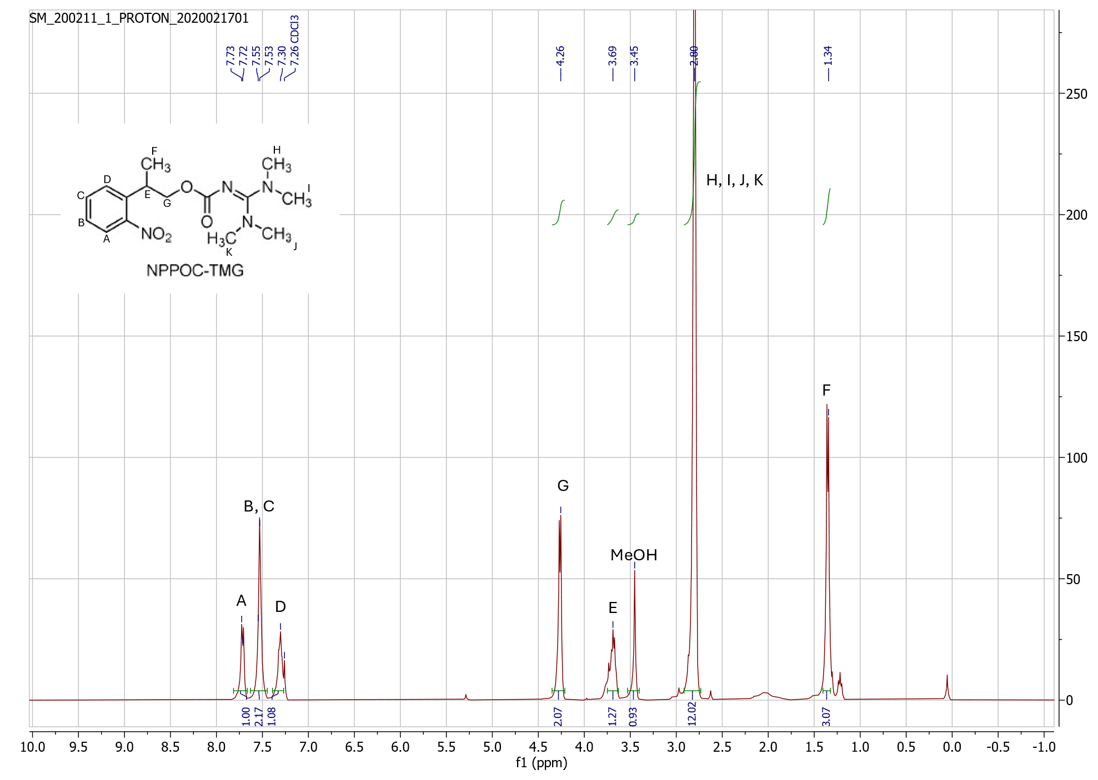
Supplementary Figures
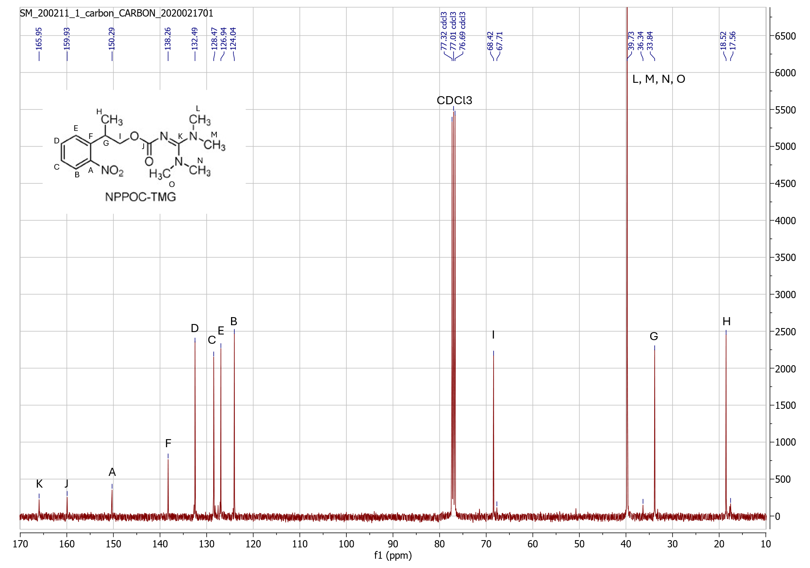
Figure S 1. H-NMR spectrum of NPPOC-TMG
Figure S 2. C-NMR spectrum of NPPOC-TMG

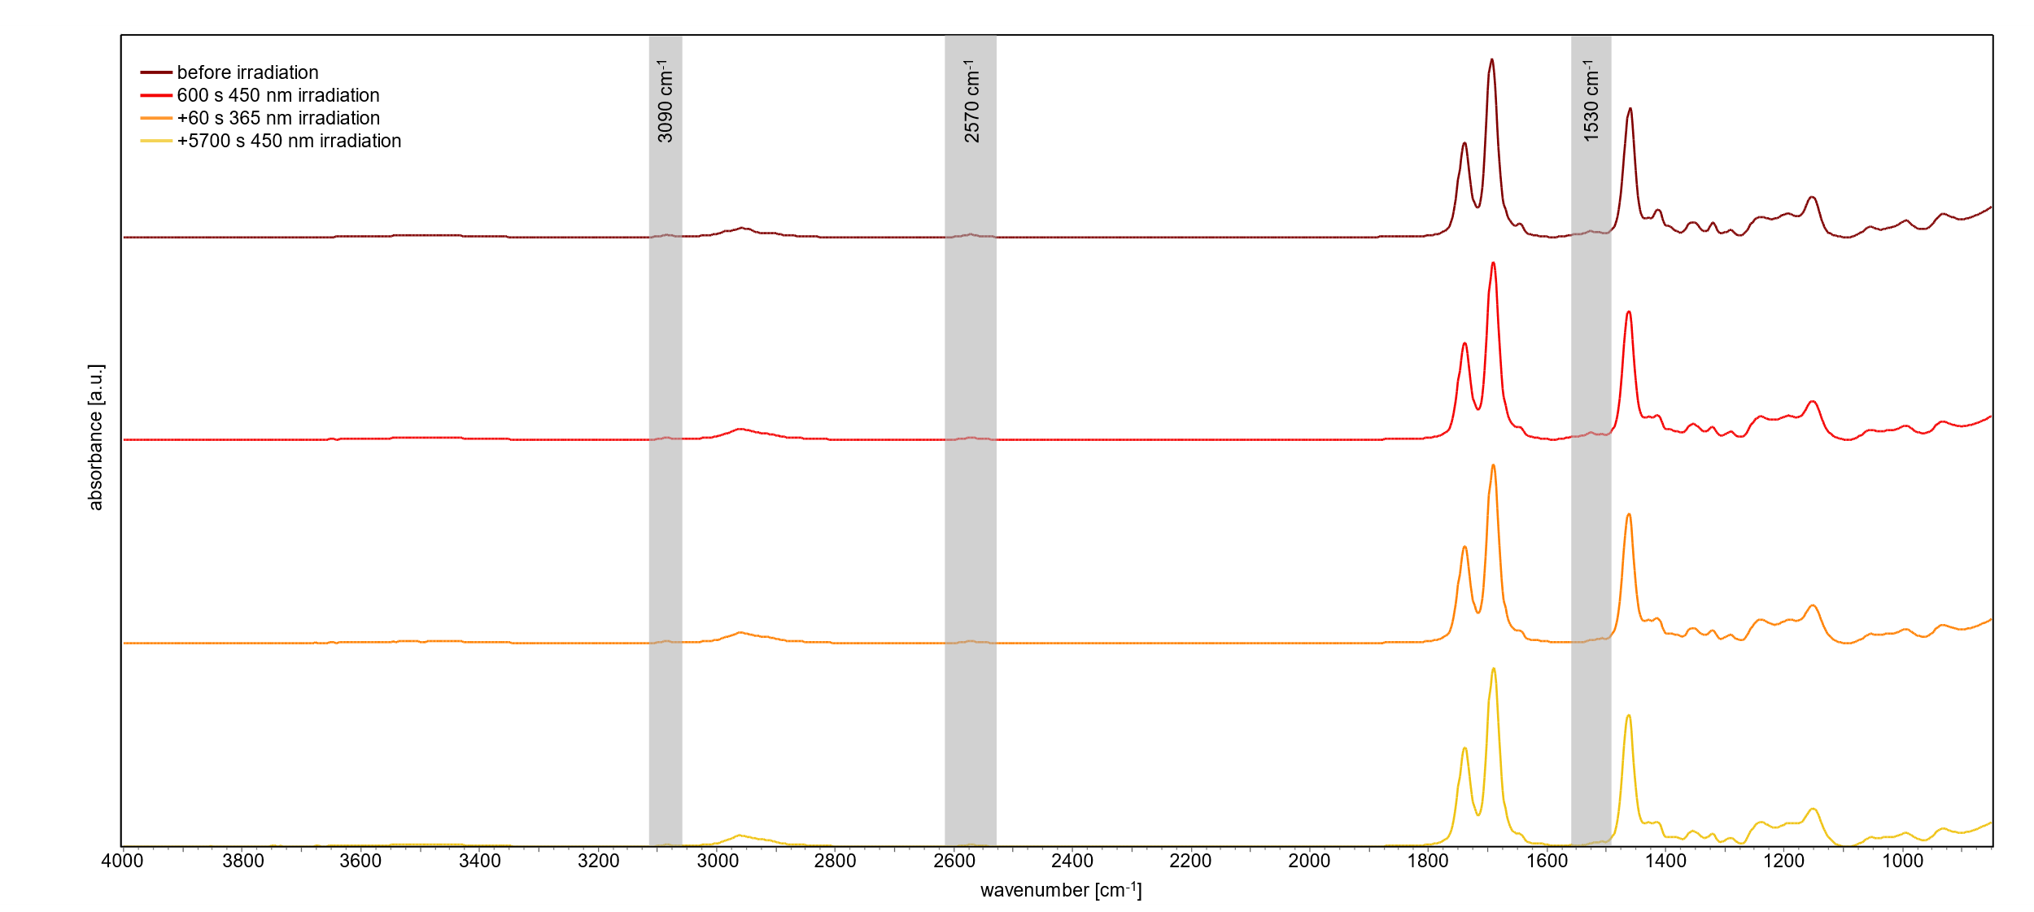
Figure S 3. overview of investigated FTIR peaks (C=C double bond, thiol bond, photobase) during curing, photobase activation and 450 nm illumination after photobase activation
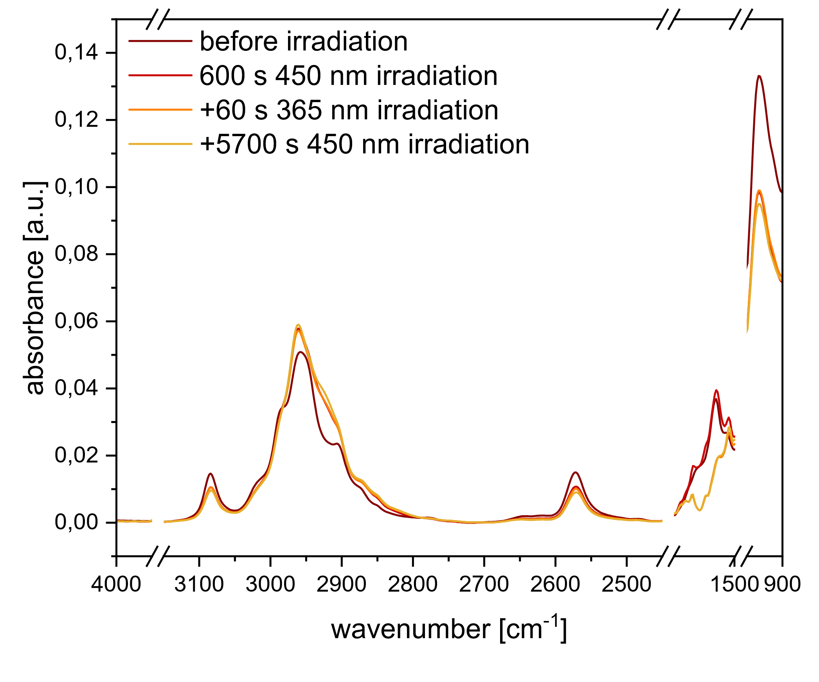
Figure S 4. spectral changes during curing, photobase activation and 450 nm illumination after photobase activation

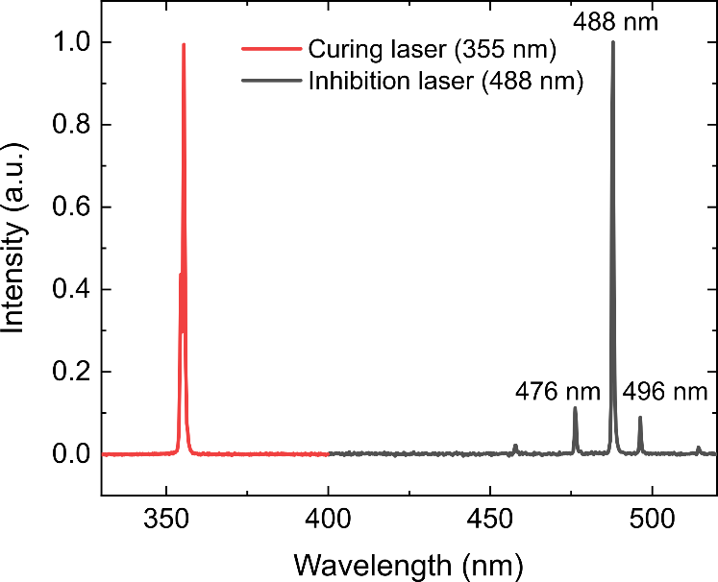
Figure S 5. spectra of the two lasers used in the laser writing experiments
References
[1] X. Zhang, W. Xi, G. Gao, X. Wang, J. W. Stansbury, C. N. Bowman, ACS Macro Lett. 2018, 7, 852.
Author Contributions
Rita Johanna Höller: conceptualization, experimental work, data analysis, scientific discussion, writing of original draft.
Dmitry Sivun: experimental work, data analysis, scientific discussion.
Stefanie Monika Müller: experimental work, scientific discussion
Jaroslaw Jacak: scientific discussion
Sandra Schlögl: conceptualization, scientific discussion, reviewing and editing.
Thomas Griesser: funding acquisition, conceptualization, scientific discussion, reviewing and editing.

