Methane emission from different rice cultivation systems in Bangladesh: A model-based approach
Milton Kumar Saha^{1¥}, Shamim Mia^{2,3,¥,*}, AKM Abdul Ahad Biswas¹, Md. Abdus Sattar¹ and Feike A. Dijkstra³
¹Department of Disaster Risk Management,
²Department of Agronomy
Patuakhali Science and Technology University, Dumki, Patuakhali.
³Centre for Carbon, Water and Soil, School of Life and Environmental Sciences, The University of Sydney.
¥ Authors contributed equally.
*Corresponding Author’s Email: smia_agr@pstu.ac.bd

Supporting information
Sl. No. | Item | Page No.
1 | S1. Climate and rice cropping systems in Bangladesh | 3-4
2 | S2. Default CH₄ emission scaling factors for water regime during and before the cultivation period relative to continuous flooded fields | 4
3 | Table S1: Default CH₄ emission scaling factors for water regime during and before the cultivation period relative to continuously flooded fields | 5
4 | Table S2: Description of the selected variables controlling CH₄ emissions from rice fields | 5
5 | S3. Scaling factor for organic amendment | 6
6 | Table S3: Default conversion factor for different types of organic amendment | 6
7 | Table S4: Consideration of conversion factor for straw and compost/FYM in this study | 6
8 | S3.1. Calculation of straw incorporation rate | 6
9 | Fig. S1: Non-linear fitted line for local rice varieties | 7
10 | Fig. S2: Non-linear fitted line for HYV rice varieties | 8
11 | Fig. S3: Non-linear fitted line for Hybrid rice varieties | 9
12 | S3.2. Fraction of straw left in the rice field | 9
13 | Table S5: Predicted straw left after rice harvest from different land types | 10
14 | Table S6. Validation of scaling factors | 10-14
15 | Fig. S4: Actual (A) and predicted (B) change in rice acreage of different rice types in Bangladesh from 1977 to 2060 | 15
16 | Fig. S5: Projection on annual methane emissions from Aus, Aman and Boro rice production during the year of 1977 to 2060, excluding land migration (A, C, E) and including 0.5% land migration (B, D, F). | 16
17 | S4. Spatial distribution of annual CH₄ emissions from different rice types | 17
18 | Fig. S6: Spatial variation of emission rates (Gg CH₄ yr⁻¹) for local rice varieties and HYV during Aus from different districts of Bangladesh. | 18
19 | Fig. S7: Spatial variation of emission rates (Gg CH₄ yr⁻¹) for local rice varieties, HYV, and hybrid varieties during Aman from different districts of Bangladesh. | 19
20 | Fig. S8: Spatial variation of emission rates (Gg CH₄ yr⁻¹) for local rice varieties, HYV, and hybrid varieties during Boro from different districts of Bangladesh. | 20
21 | Fig. S9: Graphical summary of 20 calculated estimates of the annual CH₄ emission from Bangladesh. | 21
22 | Fig. S10. Comparison of model and GIS based estimates | 22
23 | Table S6: Annual CH₄ emission for different rice types from different districts | 23-24

S1. Climate and rice cropping systems in Bangladesh
Bangladesh has 8.44 million ha of arable land and 7.81 million ha of net cropped area. Rice is the staple food crop, covering about 79% of net cultivated area (BBS 2018). Bangladesh experiences a tropical humid climate with wide seasonal variations in rainfall, warm temperature, and high humidity (Shahid 2010). Four climatic seasons are recognized: (i) dry winter (December–February), (ii) pre-monsoon (March–May), (iii) monsoon (June–September), and (iv) post monsoon (October–November) (Alamgir et al. 2015). The three possible rice cultivation seasons in Bangladesh are known Aus, Aman, and Boro. Aus is the pre-monsoon upland rice growing season when rice is usually cultivated under rainfed conditions. The Aus rice is broadcast seeded (in case of local) or transplanted (as in case of HYV) during March and April after the pre-monsoon shower and harvested between July and August. This period experiences higher temperature with minimum diurnal fluctuation, moderate humidity during the reproductive stage, but with occasional scanty rainfall during the early vegetative growth period. The monsoon-season rainfed rice is the Aman, which is the most widespread, including along the coastal areas. Aman is planted in two ways: broadcasted or transplanted between the month of July and August. Both types are harvested from November through December. This season experiences high rainfall and temperature during the vegetative stage and low temperature often associated with drought during the reproductive stage. Boro is the dry-season irrigated rice planted from December to early February and harvested between April and June. This season experiences low temperature during the early vegetative stage and thus, growth period is a bit longer (Mosleh and Hassan 2014; Sarker et al. 2017).
The rice types grown in different seasons are categorised as local land races (hence after local rice), inbred modern varieties known as HYV (high yielding varieties) and, heterosis exploring rice, the hybrid. Moreover, crop establishment methods are also different. The three different rice types are grown during all three seasons, except for hybrid varieties that are usually not grown during Aus. Among the different rice types, local land races in Aus season are usually cultivated under rainfed conditions during the months of March to June when soil moisture is less than required. The preseason water regime is long drainage since November to Aprils receives minimal rainfall accompanied with high temperature. The in season water regime is drought prone since it is grown as rainfed and rainfall is sporadic (Table S2). Similarly, the HYV in Aus are generally cultivated as transplanted in rainfed lowland areas during the months of April to August while the water regime before the cultivation is short drainage and during the cultivation it is regular rainfed (Table S2). On the other hand, local, HYV, and Hybrid varieties in Aman are mostly cultivated in rainfed lowland areas and, tidal wetland areas during the months of July to December where the water regime before the cultivation is regular rainfed and during the cultivation it is flooded (Table S2). In constrast, local land races grown in Boro are usually cultivated in low-lying lands where flood water accumulates during the rainy season and standing water depth varies from 50 cm to more than 3 m during the months of November to May. Therefore, the water regime before the cultivation is flooded while in season water regime is deep-water (Table S2). On the other hand, the HYV and hybrid varieties in Boro are grown in medium highland to very lowland with irrigation during the months of December to June, whereas the preseason water regime of those types of land are either short drainage (if rice cultivated in highland to medium lowland) or flooded (if rice cultivated in low land and very lowland) (Table S2). Although the preseason of HYV and hybrid Boro rice cultivation is varied due to diverse land type, for this, we have developed the following scheme (Eq. 1S) according to experts' opinion to calculate pre-season cultivation status.
$$Water regime before the rice cultivation=\sum_{i=1}^{n}{\left(\frac{Water regime ×Land area}{Land area}\right)}$$
S2. Default CH₄ emission scaling factors for water regime during and before the cultivation period relative to continuous flooded fields
Default scaling factors and error ranges for water regime during and before the rice cultivation period SF_{w} are available in the IPCC 2019 guidelines for two complex cases, the aggregated case and disaggregated case (IPCC 2019). The aggregated case SF_{w} values are available only for specific rice ecosystems; for instance, irrigated rice field and rainfed rice field, without considering flooding patterns. In the disaggregated case, SF_{w} for irrigated rice is further distinguished between continuous flooding, single drainage, and multiple drainages. Additionally, for a rainfed rice SF_{w} varies between regular rainfed, drought-prone and deep-water rice fields (Table S1). On the other hand, before rice cultivation, a single ${SF}_{p }$ is considered in case of the aggregated case whereas flooded, short drainage, and long drainage conditions were taken into account in case of the disaggregated case (Table S1). The water regimes during and before the rice cultivation were considered based on the studies from IPCC (2019).
Table S1: Default CH₄ emission scaling factors for water regime during and before the cultivation period relative to continuously flooded fields (adopted from IPCC 2019 guidelines)
Water regime during the cultivation |  |  | Disaggregated case
 |  |  | Scaling factor (${SF}_{w}$) | Error range
 |  | Upland | 0 | -
Irrigated | Continuously flooded |  | 1 | 0.73–1.27
Irrigated | Single drainage period |  | 0.71 | 0.53–0.94
Irrigated | Multiple drainage period |  | 0.55 | 0.41–0.72
Rainfed and deep water | Regular rainfed |  | 0.54 | 0.39–0.74
Rainfed and deep water | Drought prone |  | 0.16 | 0.11–0.24
Rainfed and deep water | Deep water |  | 0.06 | 0.03–0.12
Water regime before the rice cultivation |  |  | Scaling factor ${(SF}_{p })$ | Error range
Non-flooded preseason <180 days |  |  | 1 | 0.88–1.12
Non-flooded preseason >180 days |  |  | 0.89 | 2.13–2.73
Flooded preseason >30 days |  |  | 2.41 | 1.65-2.18
Non-flooded preseason >365 days |  |  | 0.59 | 0.41–0.84
Table S2: Description of the selected variables controlling CH₄ emissions from rice fields (adopted from IPCC 2019 guidelines)
Water regime during the rice-growing season
Irrigated | Continuous flooding | Rice is cultivated under continuously flooded condition but sometimes an end-season drainage before rice harvest included.
Irrigated | Single drainage | One mid-season drainage and an end-season drainage are adopted over the entire rice-growing season.
Irrigated | Multiple drainage | Multiple drainage refers to the management water regime, also called 'intermittent irrigation', in which the number of drainage events was not clear, but there are more than one events during the growing season.
Rainfed and Deep water | Rainfed, wet season (regular rainfed) | Rice cultivation that relies on rainfall for water, in this case the field is flood prone during the rice-growing season.
Rainfed and Deep water | Rainfed, dry season (drought prone) | Rice cultivation that relies on rainfall for water, in this case the field is drought prone during the rice-growing season.
Rainfed and Deep water | Deep water | Rice grown in flooded conditions with water depth more than 50 cm deep.
Water regime before the rice cultivation
Non-flooded preseason <180 days |  | If rice is planted once a year and the field is not flooded in the non-rice growing season, the preseason water regime is classified as ‘non flooded pre-season >180 days’.
Non-flooded pre-season >180 days |  | Rice is planted more than once a year, but there is more than one month of fallow time between the two seasons, ‘non-flooded pre-season <180 days’ usually implies preseason drainage.
Flooded pre-season (>30 days) |  | Permanently flooded rice fields are assumed to have a preseason water regime of ‘flooded pre-season’. Late rice is usually planted immediately after early rice on the same field and is therefore regarded as having a preseason water regime of ‘flooded pre-season’.
Non-flooded pre-season >365 days |  | For measurements conducted on rice fields that are preceded by two upland crops or an upland crop and a drained fallow season, the preseason water regime of such experiments is classified as ‘non-flooded pre-season >365 days’.
Organic amendment
Straw incorporation shortly (<30 days) before cultivation |  | Straw applied just before rice transplanting as on-season; straw that is left on the soil surface in the fallow season and incorporated into the soil before the next rice transplanting is also categorized as ‘straw incorporated shortly (<30 days) before cultivation’. The amount of straw return is expressed in dry weight (t ha⁻¹).
Straw incorporation shortly (>30 days) before cultivation |  | Straw incorporated into soils in the previous season (upland crop or fallow) is categorized as ‘straw incorporated long (>30 days) before cultivation’. The amount of straw return is expressed in dry weight (t ha⁻¹).
Compost, farmyard manure, green manure |  | The amount of organic materials is expressed in fresh weight (t ha⁻¹).

S3. Scaling factor for organic amendment
Table S3: Default conversion factor for different types of organic (adopted from IPCC 2019 guidelines)
Organic amendment | Conversion factor (CFOA) | Error range
Straw incorporation shortly (<30 days) before cultivation | 1.00 | 0.85–1.17
Straw incorporation shortly (>30 days) before cultivation | 0.19 | 0.11–0.28
Compost | 0.17 | 0.09–0.29
Farm yard manure | 0.21 | 0.15–0.28
Green manure | 0.45 | 0.36–0.57
Table S4: Consideration of conversion factor for straw and compost/FYM in this study
Organic amendment | Conversion factor (CFOA) | Error range
Straw incorporation shortly (<30 days) before cultivation | 1 | 0.85–1.17
Compost/FYM | 0.19 | 0.12-0.57

S3.1. Calculation of straw incorporation rate
Since the amount of rice straw incorporation is one of the important sources of CH₄ emission, it needs to be taken into account for CH₄ emission estimation. Although, these data exist in the literature for other regions in the world, such information was not available in the Department of Agricultural Extension (DAE) or non-governmental agencies in Bangladesh. Therefore, we estimated the straw production rate from the yield data using Eq. 2S
$$Straw Yield=\frac{\left(100×Grain Yield\right)-(HI×Grain Yield)}{HI}$$
Where, Straw yield is the straw yield of rice cultivars in t ha⁻¹, Grain yield is the grain yield of rice cultivars in t ha⁻¹, and HI is the harvest index in (%).
The yield data were collected from DAE while the HI was projected using available literature. We reviewed 30 recently published articles which cover 121 cultivars/varieties grown in Bangladesh (Table S5). After analysing HI values of these rice cultivars, we developed a fitted non-linear line between grain yield and HI aiming to get a general HI value for a group of rice cultivars (Figure 1S-3S).
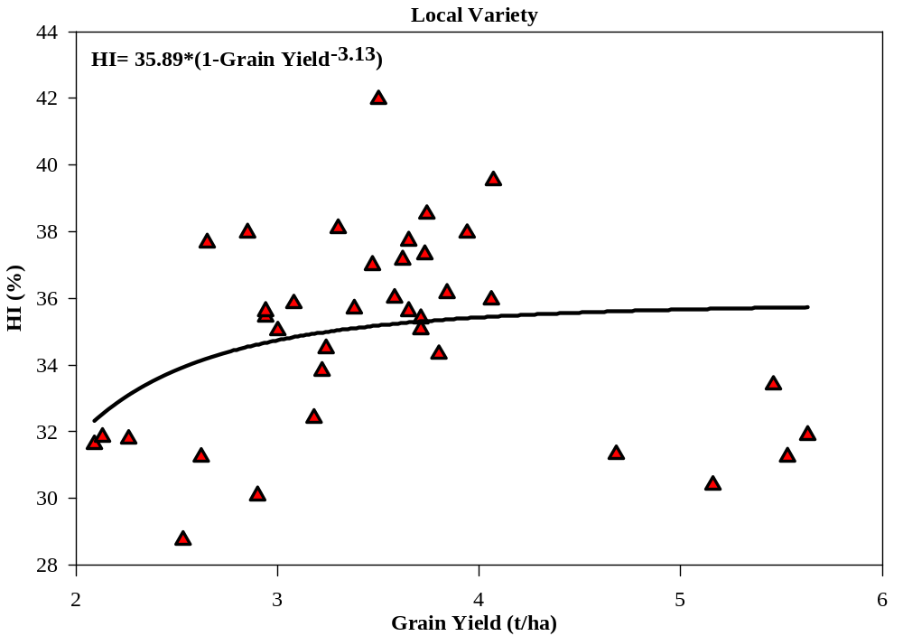 Fig. S1: Non-linear fitted line for local rice varieties. The graph was made using the data from Kabir et al. (2004); Rahman et al. (2008, 2009); Nahida et al. (2013); Roy et al. (2014); Begum et al. (2015); Sarker et al. (2015); Dey et al. (2015); Isa et al. (2015); Mamun et al. (2016); Halder et al. (2016); Chowhan et al. (2017)
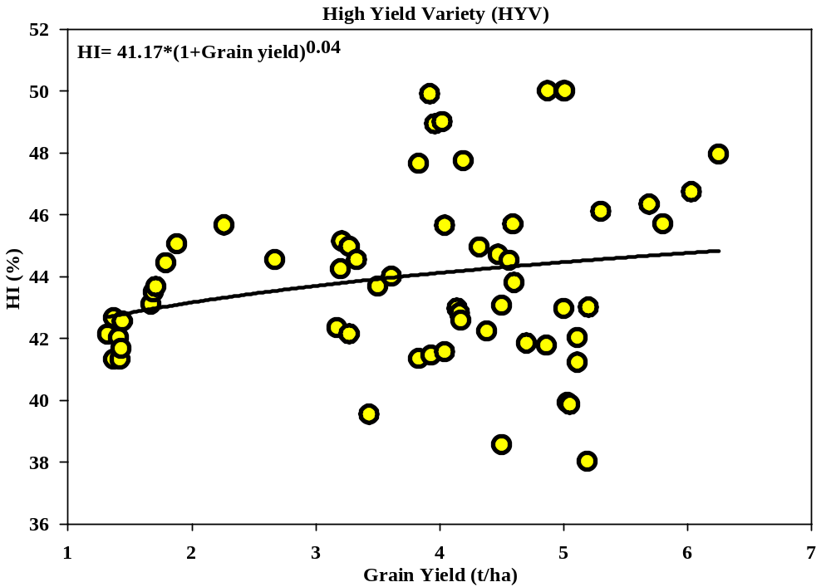 Fig. S2: Non-linear fitted line for HYV rice varieties. The graph was made using the data from Ashrafuzzaman et al. (2009); Kirttania et al. (2013); Hosain et al. (2018); Islam et al. (2014); Karmakar et al. (2014); Haque and Biswash (2014); Hosain et al. (2014); Begum et al. (2015); Isa et al. (2015); Sarker et al. (2015); Dey et al. (2015); Hamid et al. (2015); Das et al. (2015); Jewel et al. (2016); Reza et al. (2016); Hazra et al. (2016); Rashid et al. (2017); Chowhan et al. (2017); Tahsin et al. (2017); Mahmud et al. (2017); Ghosh et al. (2018)

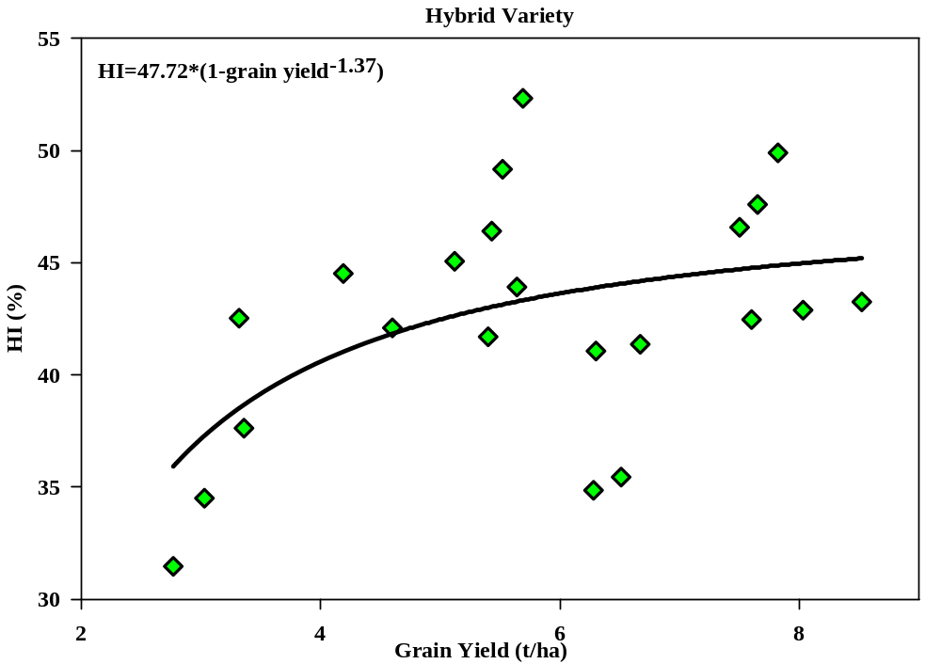 Fig. S3: Non-linear fitted line for Hybrid rice varieties. The graph was made using the data from Haque and Biswash (2014); Hosain et al. (2014, 2018); Jewel et al. (2016); Rashid et al. (2017); Mahmud et al. (2017)

S3.2. Fraction of straw left in the rice field
Rice is cultivated in varying environmental and physiographic conditions in Bangladesh. Rice has the ability to adapt under different agro-ecological niches of Bangladesh. Rice is usually cultivated in high lands to the very lowlands in Bangladesh. It was based on the experts’ opinions that the fraction of straw left after the rice harvest varies with land types. Since there are no measurements of the left-over straw fraction remaining in the field after rice harvest, we developed a scheme for predicting those straw fractions (Table S6). Therefore, the straw retention rate in the rice field was calculated using following Eq. 3S
Straw Retained $=\sum_{i=1}^{n}{\left(\frac{Land area of land type×Straw left for that land type in fraction}{Total land area}\right)}×Straw Yield$

Table S5: Predicted straw left after rice harvest from different land types (based on expert judgement)
Land Type | Predicted straw left after rice harvest (%)
High land | 0.15
Medium high land | 0.25
Medium low land | 0.30
Low land | 0.50
Very low land | 0.60

S3.3 Validation of model-based estimate with a survey
A structured questionnaire both English and Bengali versions was developed to collect necessary information on scaling factors related to methane gas emission in rice field in Bangladesh. A pre-trial was made to check whether the language of the questionnaire suits to get authentic data. Apart from paper-based questionnaire, we developed an online-based data collection system like Google form to collect the data easily. Authors together with four data collectors collected data from 120 farmers from 6 districts in four different regions of Bangladesh (South-East- Cox’s Bazar, South-Central-Barishal and Patuakhali, South-West-Bagerhat, and North Bengal-Rangpur) during 20 May 2020 to 9 June 2020. Data collectors were selected from master’s students of Patuakhali Science and Technology University. Prior to data collection, an online training session was organized to get an in-depth understanding of the research concept and how to collect data from farmer level. After collecting the data, we calculated the emission rate based on the surveyed data for different rice types (local, HYV and hybrid) grown in different growing seasons. Next, survey-based estimates was plotted against IPCC Trier 1 model-based estimates to examine the goodness of fit.
Questionnaire-2020
Greenhouse gas (GHG) emissions from agriculture sectors are highly responsible for global warming and climate change, which is affecting human welfare in many ways. CH₄ is one of the dominant gases, largely generated from agricultural sectors, including rice production. However, there are no studies that examined nationwide CH₄ emission in our country. I am Milton Kumar Saha, a master degree student at the Department of Disaster Risk Management in Patuakhali Science and Technology University, aiming at conducting a research entitled “Methane emission from different rice cultivation systems in Bangladesh: A model-based approach”. I would be very happy if you would kindly provide some valuable information that will help us to accomplish the research. It will need 15-20 minutes to complete the whole questionnaire. I assure you that your provided information will be treated as strictly confidential and will not be shared with anyone except for the purpose of this research.
Name of respondent: ----------------------------------------------------District: ---------------------------------------------
Methane emission from different rice cultivation systems in Bangladesh: A model-based approach
1. Which season rice is cultivated in your area?
a. Aus
b. Aman
c. Boro

2. In how much area you have cultivated rice?
------------------------------------------------------------------------------------------------------------------------------------------------------------------------------
3. What is the land type of your cultivable land?
a. High Land- Land, which is above the normal flooding level
b. Medium High Land- Land, which is flooded up to about 90 cm deep during the flooding season
c. Medium Low Land- Land, which is flooded between 90 cm to 180 cm deep during the flooding season
d. Low Land- Land, which is normally flooded up to 180 cm and 300cm deep during the flooding season
e. Very Low Land- Land, which is normally flooded deeper than 300 cm during the flooding season
4. Which season you have cultivated the rice?
a. Aus
b. Aman
c. Boro

5. Aus Season
5.1 During Aus season, which rice varieties do you cultivate in your farm? (Please give a tick mark (√) in the following box)
Land type | High Land | Medium High Land | Medium Low Land | Low Land | Very Low Land
Cultivar | a. Local  b. HYV  c. Hybrid | a. Local  b. HYV  c. Hybrid | a. Local  b. HYV  c. Hybrid | a. Local  b. HYV  c. Hybrid | a. Local  b. HYV  c. Hybrid
5.2 What is the condition of the water regime during the rice cultivation in your farm? (Please give a tick mark (√) in the following box)
Land type | High Land | Medium High Land | Medium Low Land | Low Land | Very Low Land
Water regime during the rice cultivation | a. Continuous flooding  b. Single drainage  c. Multiple drainage  d. Regular rainfed  e. Drought prone  f. Deep water | a. Continuous flooding  b. Single drainage  c. Multiple drainage  d. Regular rainfed  e. Drought prone  f. Deep water | a. Continuous flooding  b. Single drainage  c. Multiple drainage  d. Regular rainfed  e. Drought prone  f. Deep water | a. Continuous flooding  b. Single drainage  c. Multiple drainage  d. Regular rainfed  e. Drought prone  f. Deep water | a. Continuous flooding  b. Single drainage  c. Multiple drainage  d. Regular rainfed  e. Drought prone  f. Deep water
5.3 What is the condition of the water regime before the rice cultivation in your farm? (Please give tick mark (√) in the following box)
Land type | High Land | Medium High Land | Medium Low Land | Low Land | Very Low Land
Water regime before the rice cultivation | a. Short drainage  b. Long drainage  c. Flooded | a. Short drainage  b. Long drainage  c. Flooded | a. Short drainage  b. Long drainage  c. Flooded | a. Short drainage  b. Long drainage  c. Flooded | a. Short drainage  b. Long drainage  c. Flooded
5.4 What is the cultivation duration (in days) of different rice varieties?
Land type | High Land | Medium High Land | Medium Low Land | Low Land | Very Low Land
Lifespan (months/days)
5.5 When you have harvested the rice, how much straw generally you left on your farm? (Please give a tick mark (√) in the following box)
Land type | High Land | Medium High Land | Medium Low Land | Low Land | Very Low Land
Straw left | a. 1/10  b. 1.5/10  c. 2.5/10  d. 3/10  e. 5/10  f. 6/10 | a. 1/10  b. 1.5/10  c. 2.5/10  d. 3/10  e. 5/10  f. 6/10 | a. 1/10  b. 1.5/10  c. 2.5/10  d. 3/10  e. 5/10  f. 6/10 | a. 1/10  b. 1.5/10  c. 2.5/10  d. 3/10  e. 5/10  f. 6/10 | a. 1/10  b. 1.5/10  c. 2.5/10  d. 3/10  e. 5/10  f. 6/10
5.6 Generally, when you incorporate the straw in your farm? (Please give a tick mark (√) in the following box)
Land type | High Land | Medium High Land | Medium Low Land | Low Land | Very Low Land
Straw incorporation | a. Straw incorporation shortly (<30 days) before cultivation  b. Straw incorporation shortly (>30 days) before cultivation | a. Straw incorporation shortly (<30 days) before cultivation  b. Straw incorporation shortly (>30 days) before cultivation | a. Straw incorporation shortly (<30 days) before cultivation  b. Straw incorporation shortly (>30 days) before cultivation | a. Straw incorporation shortly (<30 days) before cultivation  b. Straw incorporation shortly (>30 days) before cultivation | a. Straw incorporation shortly (<30 days) before cultivation  b. Straw incorporation shortly (>30 days) before cultivation
5.7 How much organic matter (kg/decimal) you have applied in your farm during different rice cultivation times?
Land type | High Land (Kg/decimal) | Medium High Land (Kg/decimal) | Medium Low Land (Kg/decimal) | Low Land (Kg/decimal) | Very Low Land (Kg/decimal)
Compost
Farmyard manure
Green manure
Thank you so much filling in the questionnaire. We do appreciate your contribution to our research.

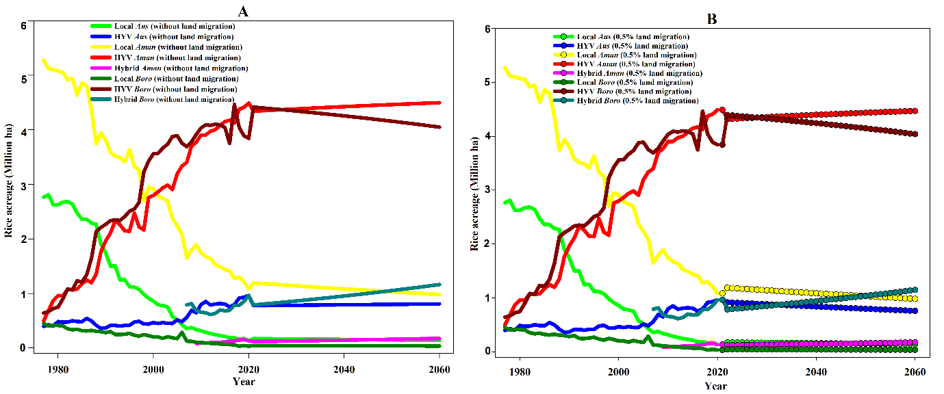
Fig. S4: Actual (A) and predicted (B) change in rice acreage of different rice types in Bangladesh from 1977 to 2060
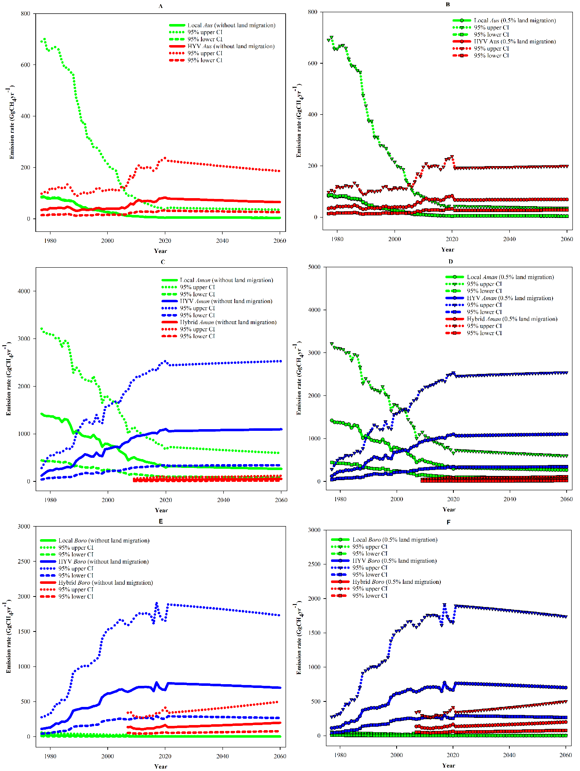
Fig. S5: Projection on annual methane emissions from Aus, Aman and Boro rice production during the year of 1977 to 2060, excluding land migration (A, C, E) and including 0.5% land migration (B, D, F).

S4. Spatial distribution of annual CH₄ emissions from different rice types
Annual emission rates of individual rice varieties are shown in Figs. S6-8 (for details see Table S8). Among rice types, emissions from local varieties during Aus were the highest in Bhola district followed by Barisal, Faridpur, Pabna, Patuakhali, Shariatpur districts (Fig. S6). Similarly, emissions were much higher from HYV rice production during Aus in Bhola, Comilla, Maulvibazar, Naogaon, and Sylhet districts (Fig. S6).
The methane emissions due to the production of local Aman varieties was estimated at the highest for Barisal and Patuakhali districts, followed by Bagerhat, Bhola, Barguna, Chandpur, Jhalakati, Mymensingh, Pirojpur, and Sylhet districts (Fig. S7), whilst the highest emissions came from HYV Aman was from Bogra, Dinajpur, Mymensingh and Rangpur districts (Fig. S7). Likewise, the methane emissions from hybrid rice cultivated during Aman was estimated to be relatively higher in the Dinajpur, Kurigram, Nilphamari, Panchagar, Rangpur, Sherpur, and Thakurgaon districts, followed by Jamalpur, Joypurhat, Lalmonirhat, Mymensingh, Narail, Jessore, and Kushtia districts (Fig. S7).
Methane emission from local varieties cultivated during Boro was estimated at relatively higher for Sylhet district, followed by Faridpur district (Fig. S8). Similarly, this emissiom from HYV during Boro was larger in Kishoreganj, Netrakona, Naogaon, Sunamganj district followed by Bogra, Brahmanbaria, Comilla, Dinajpur, Jessore, Mymensingh, Siraganj, and Tangail districts (Fig. S8). The highest emission of CH₄ from hybrid varieties during Boro was in Gopalganj, Habiganj, and Sunamganj districts, followed by Bagerhat, Jamalpur, Khulna, Kishoreganj, Mymensingh, Naogaon, Noakhali, Nilphamari, Rajshai, Rangpur and Sherpur districts (Fig. S8).

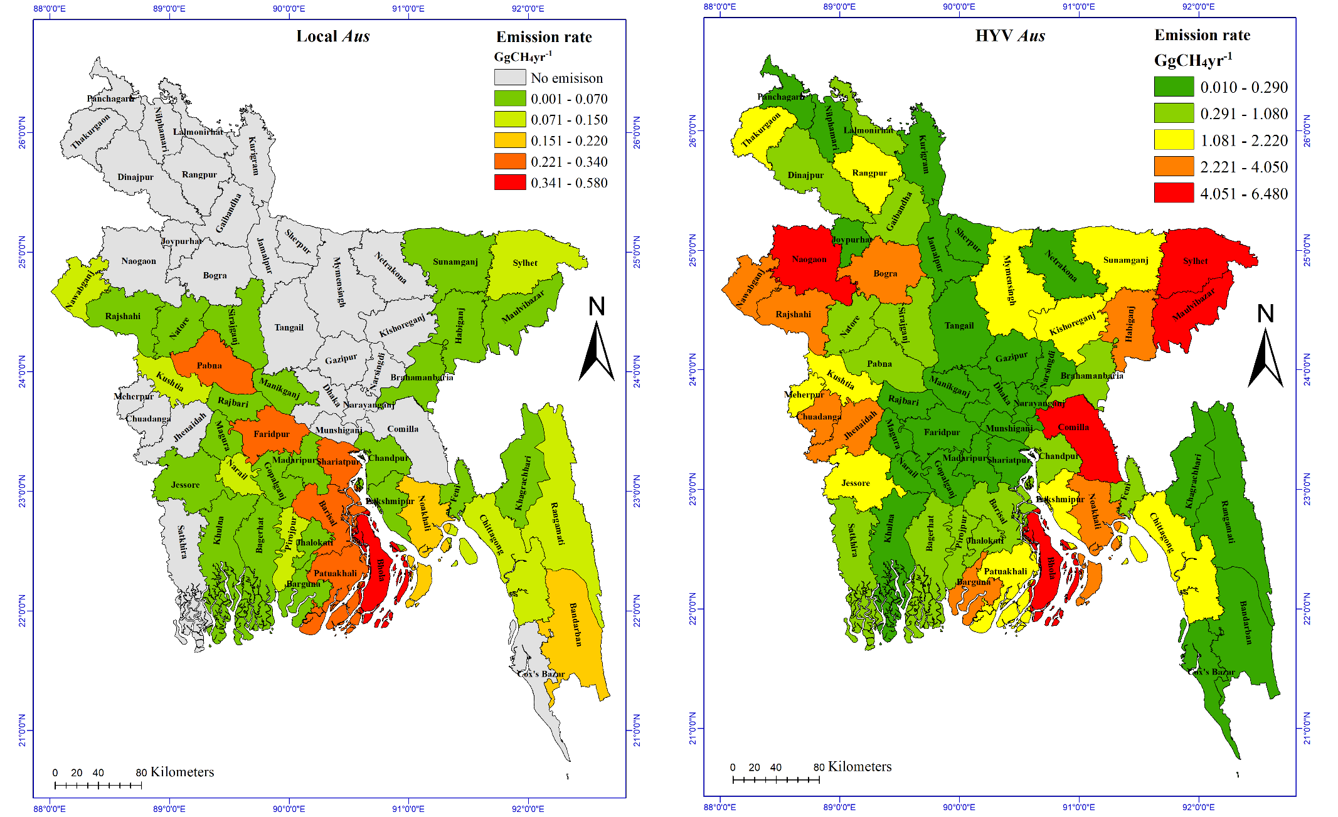
Fig. S6: Spatial variation of emission rates (Gg CH₄ yr⁻¹) for local rice varieties and HYV during Aus from different districts of Bangladesh.
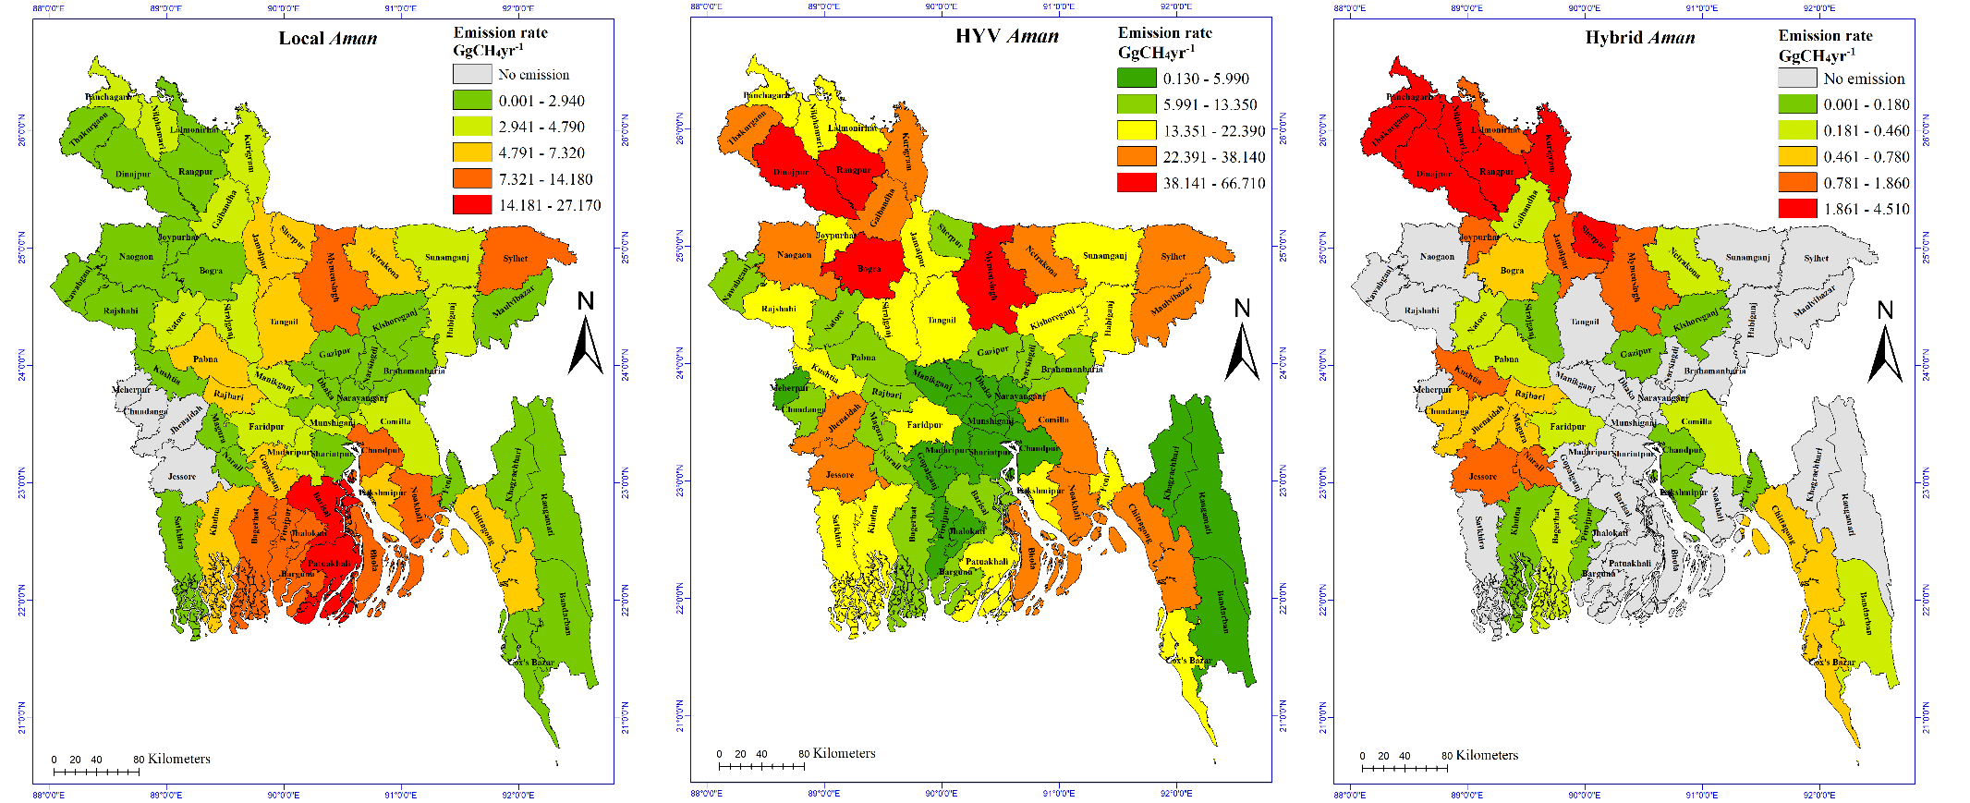
Fig. S7: Spatial variation of emission rates (Gg CH₄ yr⁻¹) for local rice varieties, HYV, and hybrid varieties during Aman from different districts of Bangladesh.

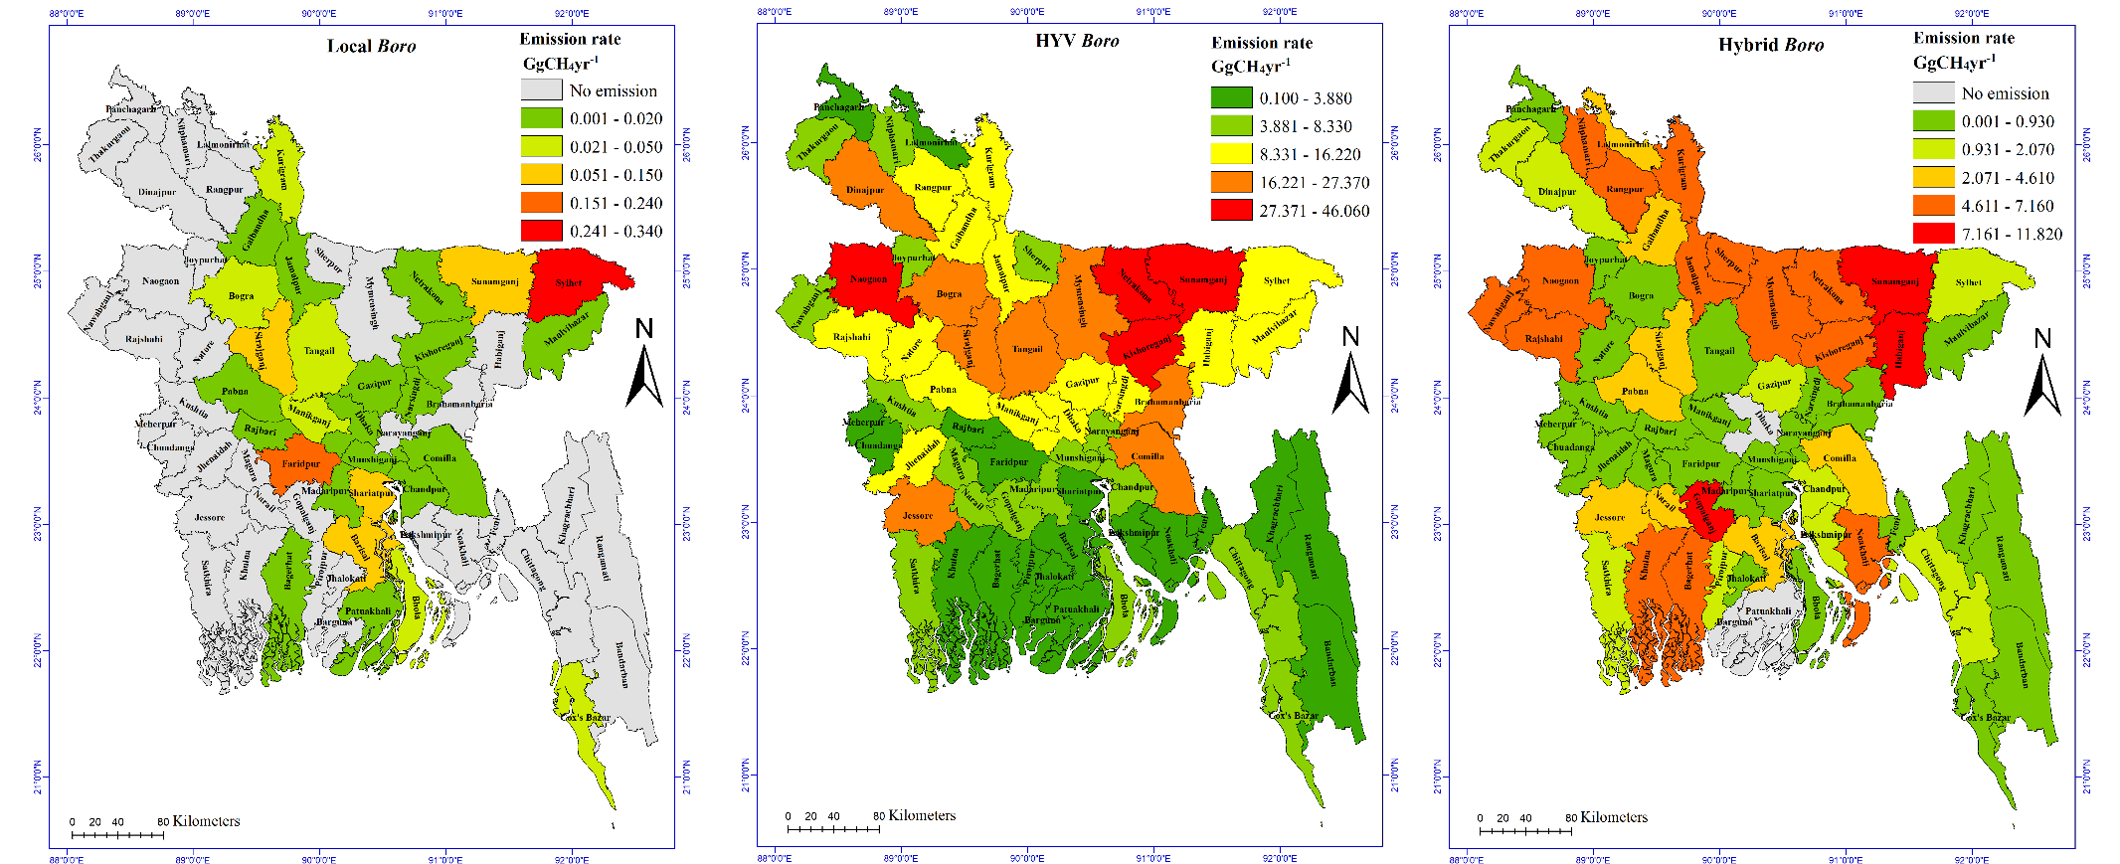
Fig. S8: Spatial variation of emission rates (Gg CH₄ yr⁻¹) for local rice varieties, HYV, and hybrid varieties during Boro from different districts of Bangladesh.
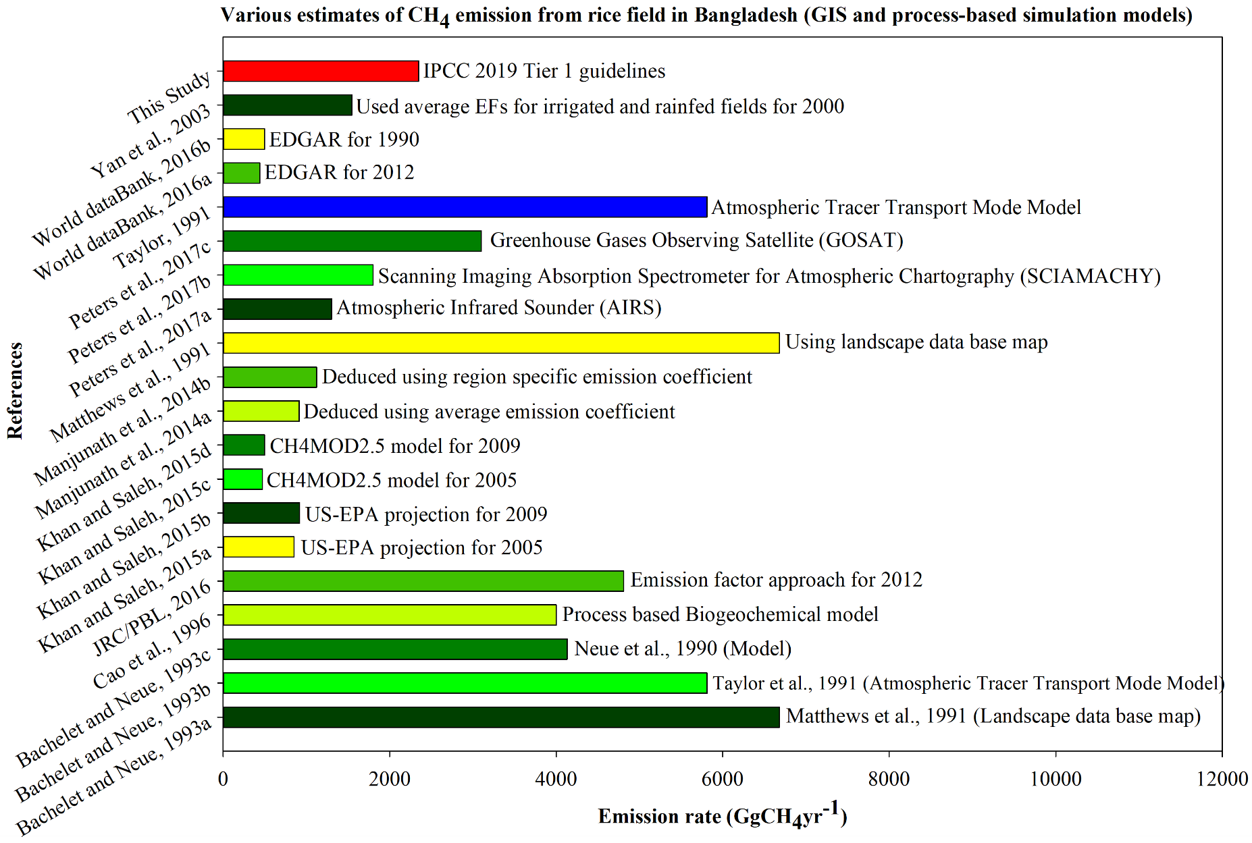
Fig. S9: Graphical summary of 20 calculated estimates of the annual CH₄ emission from Bangladesh. Estimates range varied from 438 to 6680 Gg CH₄ yr⁻¹ with a median value of 1673 Gg CH₄ yr⁻¹. Next to each bar, the research method is displayed (Matthews et al. 1991; Taylor et al. 1991; Bachelet and Neue 1993; Minami and Neue 1994; Cao et al. 1996; Yan et al. 2003; Manjunath et al. 2014; Khan and Saleh 2015; JRC/PBL 2016; Peters et al. 2017; World DataBank 2018)

S5. Comparison between IPCC model and GIS based estimates
To get a good estimate of the mean CH₄ emission rate, we fitted log-normal distribution on the emission estimates of different studies. Then, we calculated log-normal mean value of the process and GIS based methane emission rates (Fig. S10) and compared the results. The IPCC process-based estimation seems less diverse with a mean of 3.01 and dispersion of 0.30 compared to GIS based estimation (mean=3.25, dispersion=0.43). Since the mean methane emission rate of measurement-based estimates is 0.10, the estimate with IPCC method-based calculation is relatively closer to the measurement-based estimates.
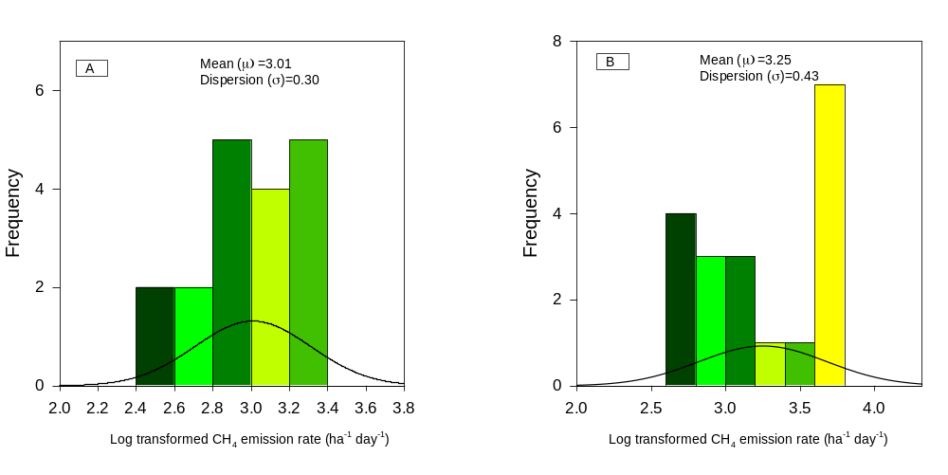
Fig. S10. Log-normal distribution of model based (panel A) and GIS based (panel B) estimate of methane emission rates from rice field in Bangladesh

Table S6: Annual CH₄ emission for different rice types from different districts
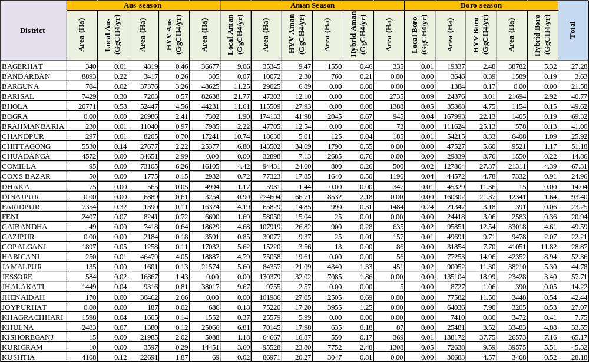
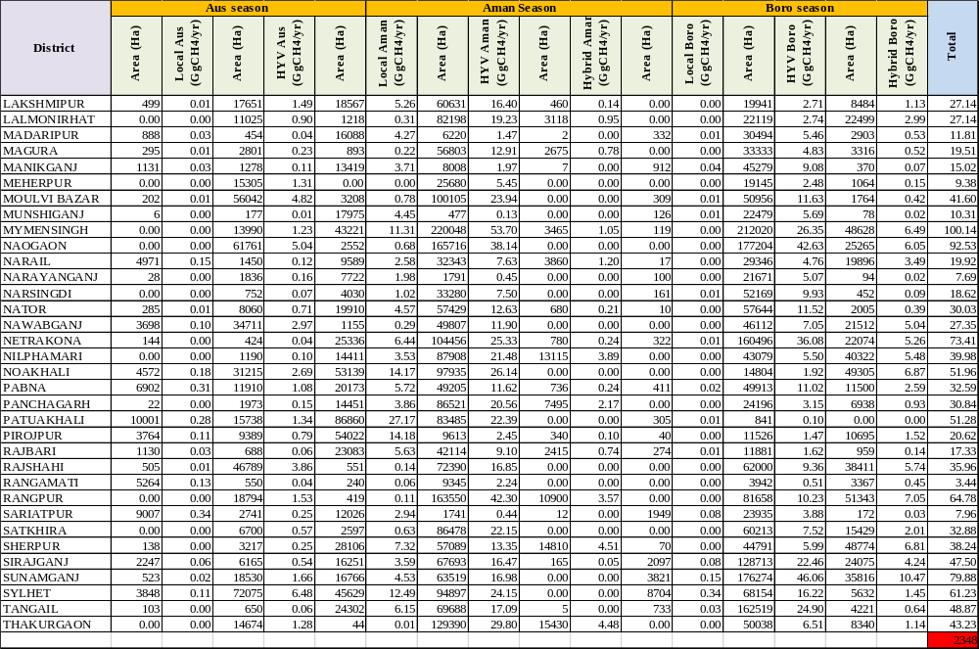

References
Alamgir M, Shahid S, Hazarika MK, et al (2015) Analysis of meteorological drought pattern during different climatic and cropping seasons in Bangladesh. JAWRA J Am Water Resour Assoc 51:794–806. doi: 10.1111/jawr.12276
Ashrafuzzaman M, Rafiqul Islam MD, Ismail MR, et al (2009) Evaluation of six aromatic rice varieties for yield and yield contributing characters. Int J Agric Biol 11:616–620
Bachelet D, Neue HU (1993) Methane emissions from wetland rice areas of Asia. Chemosphere 26:219–237. doi: 10.1016/0045-6535(93)90423-3
Bangladesh Bureau of Statistics (BBS) (2018) Yearbook of agricultural statistics-2017. Ministry of planning, Government of the People’s Republic of Bangladesh, Dhaka, Bangladesh
Begum M, Hossain MA, Hossain FMM, Hasan AK (2015) Genetic variability for grain yield and yield associated traits in transplant Aman rice (Oryza sativa L.). Res Agric Livest Fish 2:207. doi: 10.3329/ralf.v2i2.25000
Cao M, Gregson K, Marshall S, et al (1996) Global methane emissions from rice paddies. Chemosphere 33:879–897. doi: 10.1016/0045-6535(96)00231-7
Chowhan S, Haider MR, Hasan AFMF, et al (2017) Comparative on farm performance of five modern rice varieties with two local cultivars. J Biosci Agric Res 13:1074–1086. doi: 10.18801/jbar.130117.131
Das B, Haque M, Mannan M, Mazumder S (2015) Performance study of Koshihikari rice variety and its economic prospect in comparison with three popular rice varieties of Bangladesh. Asian J Agric Extension, Econ Sociol 5:147–157. doi: 10.9734/AJAEES/2015/15990
Dey R, Biswas M, Miah MNH, Mandal P (2015) Agronomic performances of rice varieties at different transplanting ages. Int J Plant Soil Sci 6:124–139. doi: 10.9734/IJPSS/2015/13371
Ghosh UK, Khan MAR, Karim MA, Haque MA (2018) Yield response of direct seeded Aus rice varieties under rainfed condition. Am J Plant Sci 09:416–434. doi: 10.4236/ajps.2018.93032
Halder T, Hoque ME, Islam MM, et al (2016) Morphomolecular characterization of local Boro rice (Oryza Sativa L.) germplasm. Bangladesh J Plant Breed Genet 29:01–09. doi: 10.3329/bjpbg.v29i2.33941
Hamid A, Ullah J, Mollah FH, Akbar A (2015) Traditional rice varieties perform better in tidal floodplain. Int J Adv Res 3:1316–1321
Haque M, Biswash MR (2014) Characterization of commercially cultivated hybrid rice in Bangladesh. World J Agric Sci 10:300–307. doi: 10.5829/idosi.wjas.2014.10.6.1836
Hazra P, Islam MT, Das GC (2016) Effect of high temperature on some physiological parameters of grain growth and yield of Boro rice varieties. J Biosci Agric Res 7:600–607. doi: 10.18801/jbar.070116.72
Hosain MT, Ahamed KU, Haque MM, et al (2014) Performance of hybrid rice (Oryza sativa L.) varieties at different transplanting dates in Aus season. Appl Sci Reports 1:14–17. doi: 10.15192/PSCP.ASR.2014.1.1.14
Hosain T, Hossain E, Nizam R, et al (2018) Response of Physiological characteristics and productivity of hybrid rice varieties under system of rice intensification (SRI ) over the traditional cultivation. Int J Plant Biol Res 6:1–10
IPCC (2006) 2006 IPCC guidelines for national greenhouse gas inventories. In: Eggleston S, Buendia L, Miwa K, et al. (eds) IPCC Guidelines for National Greenhouse Gas Inventories. Institute for Global Environmental Strategies, Japan
Isa M, Ghosh SC, Asif A Al, et al (2015) Performances of short growing photo-insensitive rice varieties to evade cyclonic hazard in the coastal region during Aman season. Asian J Med Biol Res 1:304. doi: 10.3329/ajmbr.v1i2.25626
Islam MS, Paul SK, Sarkar MAR (2014) Varietal performance of modern transplant Aman rice subjected to level of nitrogen application. J Bangladesh Agric Univ 12:55–60
Jewel MH, Rahman MR, Rahman MM, Islam MJ (2016) Effect of variety and nitrogen rate on the yield performance of boro rice. Fundam Appl Agric 1:66–69
JRC/PBL (2016) EDGAR - GHG (CO₂, CH₄, N₂O, F-gases) emission time series 1990-2012 per region/country - European Commission. In: EDGAR- Emiss. Database Glob. Atmos. Res. http://edgar.jrc.ec.europa.eu/overview.php?v=CO2ts1990-2013. Accessed 16 Nov 2018
Kabir ME, Kabir MR, Jahan MS, Das GG (2004) Yield Performance of three aromatic fine rices in a coastal medium high land. Asian J Plant Sci 3:561–563. doi: 10.3923/ajps.2004.561.563
Karmakar B, Sarkar MAR, Ali MA, Haefele SM (2014) Optimizing plant density of promising rice genotypes in Northwest Bangladesh. Bangladesh Rice J 18:1–7
Khan MRU, Saleh AFM (2015) Model-based Estimation of methane emission from rice fields in Bangladesh. J Agric Eng Biotechnol 3:125–137. doi: 10.18005/JAEB0304001
Kirttania B, Sarkar MAR, Paul SK (2013) Performance of transplant Aman rice as influenced by tiller seedlings and nitrogen management. 11:249–256
Mahmud S, Hassan M, Rahman M, Jannat M (2017) Response of short duration Aman rice varieties to date of transplanting. J Bangladesh Agric Univ 15:1. doi: 10.3329/jbau.v15i1.33523
Mamun MAA, Haque MM, Khaliq QA, et al (2016) Yield and nitrogen use efficiency of locally improved rice varieties in rice based tidal flooded ecosystem of Bangladesh. Bangladesh Agron J 19:39–49
Manjunath KR, More R, Chauhan P, et al (2014) Remote sensing based methane emission inventory vis-a-vis rice cultural types of South Asia. ISPRS - Int Arch Photogramm Remote Sens Spat Inf Sci XL-8:821–826. doi: 10.5194/isprsarchives-XL-8-821-2014
Matthews E, Fung I, Lerner J (1991) Methane emission from rice cultivation: Geographic and seasonal distribution of cultivated areas and emissions. Glob Biochem Cycles 5:3–24. doi: https://doi.org/10.1029/90GB02311
Minami K, Neue HU (1994) Rice paddies as a methane source. Clim Change 27:13–26. doi: 10.1007/BF01098470
Mosleh M, Hassan Q (2014) Development of a remote sensing-based Boro rice mapping system. Remote Sens 6:1938–1953. doi: 10.3390/rs6031938
Nahida I, Md Yamin K, Adhikary SK, Md Sarwar J (2013) Yield performance of six local aromatic rice cultivars. IOSR J Agric Vet Sci 6:58–62
Peters CN, Bennartz R, Hornberger GM (2017) Satellite-derived methane emissions from inundation in Bangladesh. J Geophys Res Biogeosciences 122:1137–1155. doi: 10.1002/2016JG003740
Rahman L, Islam MN, Rahman MS, Islam MS (2008) Plant varieties of Bangladesh: Morphological and molecular characterization. Seed wing, Ministry of agriculture, Government of the People’s Republic of Bangladesh
Rahman L, Rahman MS, Sohag MKH, Mia MM (2009) Plant varieties of Bangladesh: Morphological and molecular characterization. Seed wing, Ministry of agriculture, Government of the People’s Republic of Bangladesh
Rashid MM, Ghosh AK, Roni MN, et al (2017) Performance of Aus rice varieties in Northwest Bangladesh Amid Climate Change. Int J Sustain Crop Prod 12:7–10
Reza SN, Tani NN, Salim M, et al (2016) Yield and grain dimensions of T. Aman rice varieties as influenced by date of transplanting. Asian J Med Biol Res 2:442. doi: 10.3329/ajmbr.v2i3.30116
Roy SK, Ali MY, Jahan MS, et al (2014) Evaluation of growth and yield attributing characteristics of indigenous Boro rice varieties. Life Sci J 11:122–126
Sarker BC, Roy B, Islam MA, et al (2015) Comparative studies of root growth and yield potential of five Boro rice Varieties. J Sci Technol 13:35–43
Sarker MAR, Alam K, Gow J (2017) Performance of rain-fed Aman rice yield in Bangladesh in the presence of climate change. Renew Agric Food Syst 1–9. doi: 10.1017/S1742170517000473
Shahid S (2010) Recent trends in the climate of Bangladesh. Clim Res 42:185–193. doi: 10.3354/cr00889
Tahsin D, Samanta SC, Hoshain S, et al (2017) Yield performance of T. Aman rice varieties under different transplanting dates. Int J Exp Agric 7:1–8
Taylor JA, Brasseur GP, Zimmerman PR, Cicerone RJ (1991) A study of the sources and sinks of methane and methyl chloroform using a global three-dimensional Lagrangian tropospheric tracer transport model. J Geophys Res 96:3013–3044. doi: 10.1029/90JD02016
Wang J, Akiyama H, Yagi K, Yan X (2018) Controlling variables and emission factors of methane from global rice fields. Atmos Chem Phys 18:10419–10431. doi: 10.5194/acp-18-10419-2018
World DataBank (2018) World development indicators: Methane emissions. https://data.worldbank.org/indicator/EN.ATM.METH.KT.CE. Accessed 16 Nov 2018
Yan X, Ohara T, Akimoto H (2003) Development of region-specific emission factors and estimation of methane emission from rice fields in the East, Southeast and South Asian countries. Glob Chang Biol 9:237–254. doi: 10.1046/j.1365-2486.2003.00564.x
Yan X, Yagi K, Akiyama H, Akimoto H (2005) Statistical analysis of the major variables controlling methane emission from rice fields. Glob Chang Biol 11:1131–1141. doi: 10.1111/j.1365-2486.2005.00976.x

