Supplementary Information

Supplementary Table 1. Estimated lifetime costs and QALYs per patient associated with MgSO₄ treatment (2022 prices).
Type of birth | Perspective | MgSO₄ | Cost, £ | Δcost, £ | QALYs | ΔQALYs
Imminent | Societal | Yes | 62,175 | -23,768 | 26.6 | 0.3
Imminent | Societal | No | 85,944 | -23,768 | 26.3 | 0.3
Threatened | Societal | Yes | 44,213 | -16,017 | 26.7 | 0.2
Threatened | Societal | No | 60,230 | -16,017 | 26.5 | 0.2
Combined (40% imminent) | Societal | Yes | 51,398 | -19,118 | 26.7 | 0.24
Combined (40% imminent) | Societal | No | 70,515 | -19,118 | 26.4 | 0.24
Based on Bickford et al. [29]
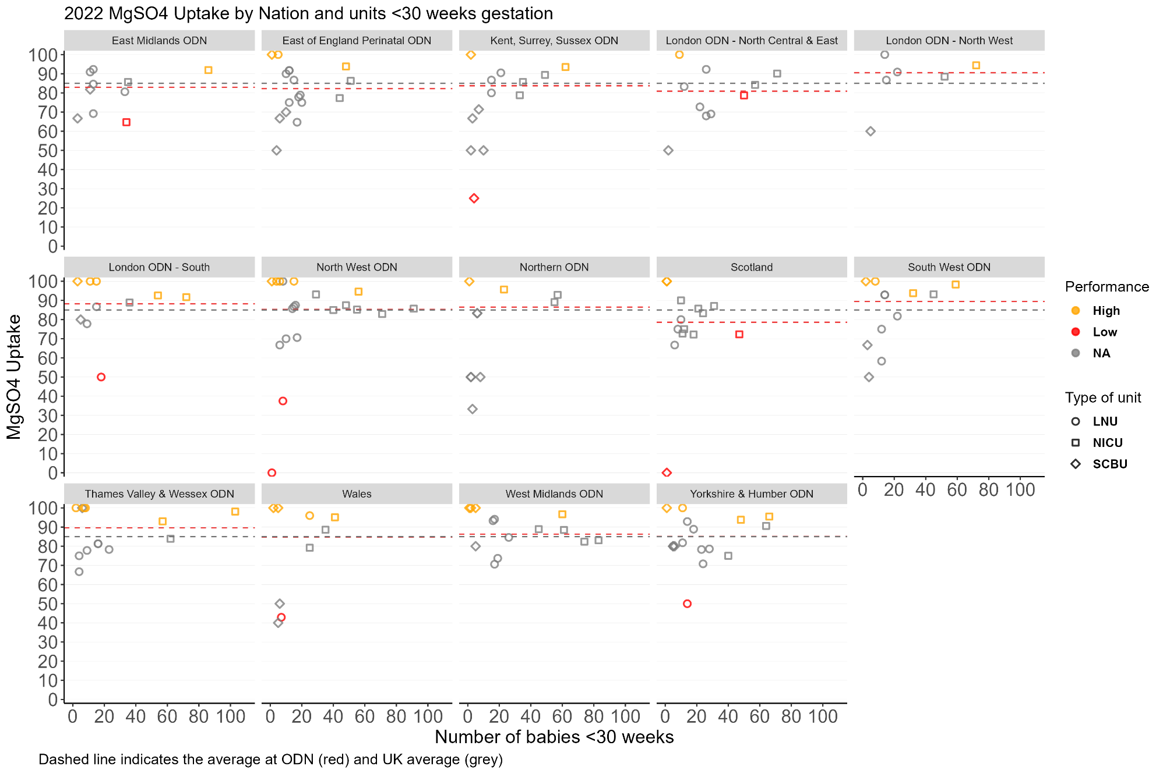
Supplementary Fig. 1. MgSO₄ uptake unit performance in England, Scotland and Wales in 2022 by Operational Delivery Network for babies under 30 weeks’ gestation.
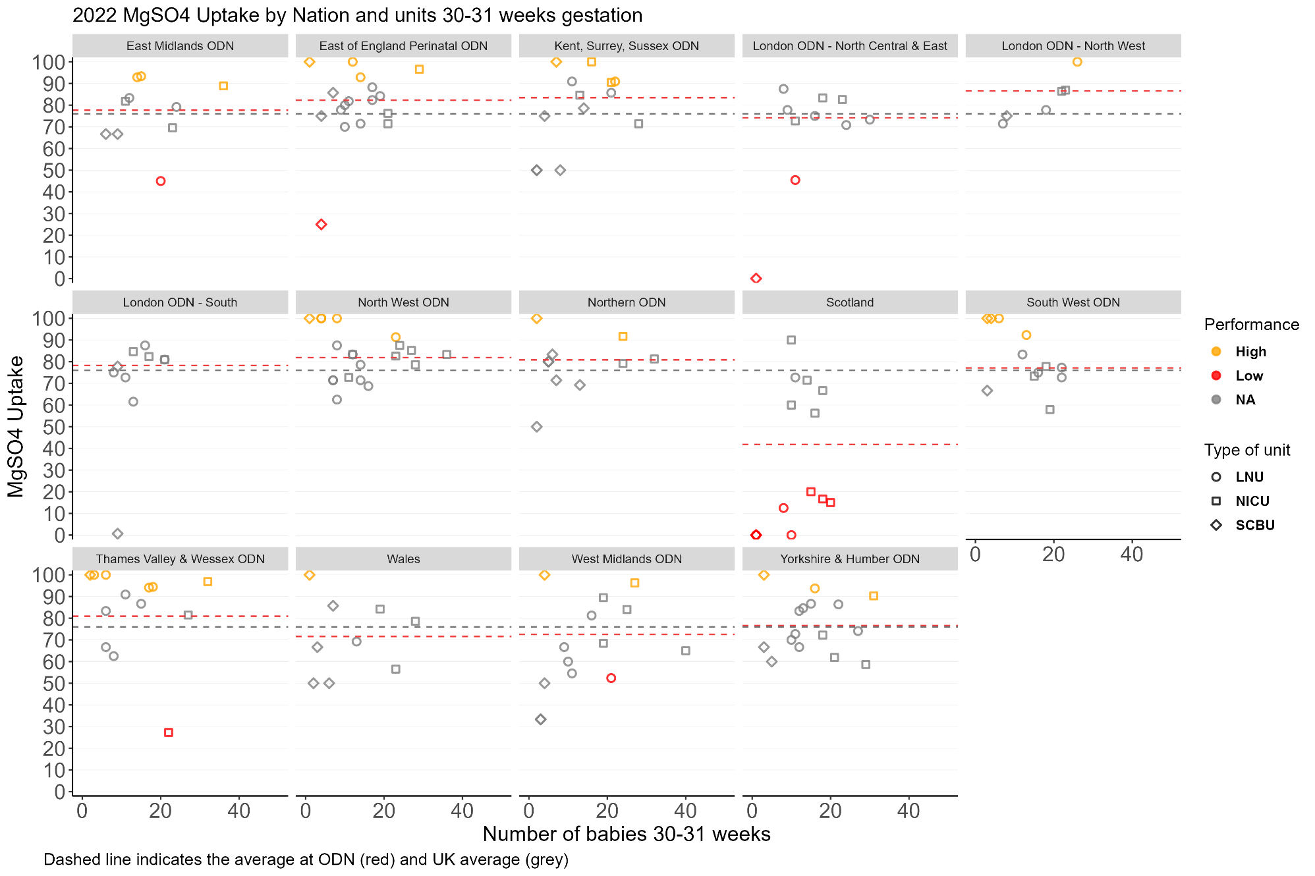
Supplementary Fig. 2. MgSO₄ uptake unit performance in England, Scotland and Wales in 2022 by Operational Delivery Network for babies between 30 weeks and under 32 weeks’ gestation.

Supplementary Table 2. Illustrative hypothetical unit-level funding for a future QI programme: baseline and high cost scenarios
Unit type | Unit-level funding by 2022 performance rating (£)
 | baseline scenario |  |  | high cost scenario
 | standard | high | low | standard | high | low
LNU | 4,000 | 2,000 | 6,000 | 8,000 | 4,000 | 12,000
NICU | 7,500 | 5,500 | 9,500 | 15,000 | 11,000 | 19,000
SCBU | 7,500 | 5,500 | 9,500 | 15,000 | 11,000 | 19,000

Supplementary Table 3. Illustrative hypothetical ODN and national funding for a future QI programme
Nation | English ODNs | Number of maternity units by performance level in 2022 |  |  |  | funding scenario (£)
 |  | standard | high | low | total | baseline | high cost
 | East Midlands | 9 | 0 | 1 | 10 | 59,500 | 119,000
 | East of England Perinatal | 15 | 2 | 0 | 17 | 88,500 | 177,000
 | Kent, Surrey, Sussex | 11 | 1 | 1 | 13 | 87,000 | 174,000
 | London - North Central & East | 7 | 2 | 1 | 10 | 52,000 | 104,000
 | London - North West | 5 | 1 | 0 | 6 | 32,500 | 65,000
 | London - South | 6 | 3 | 1 | 10 | 53,500 | 107,000
 | North West | 13 | 5 | 2 | 20 | 102,000 | 204,000
 | Northern | 9 | 1 | 0 | 10 | 73,000 | 146,000
 | South West | 9 | 3 | 0 | 12 | 63,000 | 126,000
 | Thames Valley & Wessex | 9 | 4 | 0 | 13 | 58,000 | 116,000
 | West Midlands | 9 | 5 | 0 | 14 | 77,500 | 155,000
 | Yorkshire & Humber | 13 | 3 | 1 | 17 | 92,000 | 184,000
England |  | 115 | 30 | 7 | 152 | 838,500 | 1,677,000
Scotland |  | 10 | 2 | 2 | 14 | 94,500 | 189,000
Wales |  | 4 | 4 | 1 | 9 | 54,500 | 109,000
Total |  | 129 | 36 | 10 | 175 | 987,500 | 1,975,000

Supplementary Table 4. High-cost scenario - National Value of Implementation for potential initiatives to Increase MgSO₄ uptake in England, Scotland and Wales with three different implementation effectiveness and implementation costs for a single year (under 32 weeks gestation).

 | England |  | Scotland |  | Wales |  | Total
Number of babies, N | 6,297 |  | 507 |  | 269 |  | 7,073
Low performance: Implementation effect: 1%
Increment of pre-term babies treated with MgSO₄ | 63 |  | 5 |  | 3 |  | 71
Net cost of implementation, £ | 1,677,000 |  | 189,000 |  | 109,000 |  | 1,975,000
Implementation cost-effectiveness, £ per additional patient treated | 26,632 |  | 37,278 |  | 40,520 |  | 27,923
Net Monetary Benefit of the Policy*, £ | -170,829  (-640,364; 362,999) |  | -67,731  (-105,536; -24,750) |  | -44,658  (-64,716; -21,854) |  | -283,219  (-810,616; 316,395)
Mid performance: Implementation effect: 5%
Increment of pre-term babies treated with MgSO₄ | 315 |  | 25 |  | 13 |  | 354
Net cost of implementation, £ | 1,677,000 |  | 189,000 |  | 109,000 |  | 1,975,000
Implementation cost-effectiveness, £ per additional patient treated | 5,326 |  | 7,456 |  | 8,104 |  | 5,585
Net Monetary Benefit of the Policy*, £ | 5,853,853  (3,535,570; 8,446,193) |  | 417,343  (230,688; 626,064) |  | 212,709  (113,674; 323,450) |  | 6,483,905  (3,879,932; 9,395,707)
High performance: Implementation effect: 10%
Increment of pre-term babies treated with MgSO₄ | 630 |  | 51 |  | 27 |  | 707
Net cost of implementation, £ | 1,677,000 |  | 189,000 |  | 109,000 |  | 1,975,000
Implementation cost-effectiveness, £ per additional patient treated | 2,663 |  | 3,728 |  | 4,052 |  | 2,792
Net Monetary Benefit of the Policy*, £ | 13,384,706  (8,748,139; 18,569,385) |  | 1,023,686  (650,375; 1,441,128) |  | 534,417  (336,349; 755,900) |  | 14,942,810  (9,734,864; 20,766,414)

