SUPPLEMENTARY MATERIAL

Contents
1. SUPPLEMENTARY METHODS 3
1.1. KFRE equations 3
Table S1. Original KFRE equations for non-North American population 3
1.2. Coding of predictors 3
Table S2. Coding of variables 3
1.3. 2009 CKD Epidemiology Collaboration (CKD-EPI) formula for eGFR 3
Table S3. Values for components of 2009 CKF-EPI formula for eGFR 3
1.4. Laboratory considerations 4
1.5. Outcome measure 4
1.6. Statistical analysis details 5
1.6.1. Multiple Imputation 5
1.6.2. Prognostic performance 7
2. SUPPLEMENTARY TABLES OF RESULTS 10
Table S4. EsSalud's Healthcare Networks distribution of the study population according to missing data and outcome in 3a-4 CKD Stages 10
Table S5. Baseline characteristics of the study population with CKD Stages 3a-4 according to missing data in KFRE's predicted risk 12
Table S6. Baseline characteristics of the study population with CKD Stages 3a-4 according to the outcome at 5 years 15
Table S7. Cumulative incidence of kidney failure and death without kidney failure in patients with CKD stages 3a-4 18
Table S8. Comparisons of characteristics of original cohort that recalibrated Non-North American version of KFRE and our study population 19
3. SUPPLEMENTARY FIGURES 22
Figure S1. Distribution of the 2-year and 5-year predicted risk estimated by KFRE equation according to kidney failure outcomes. 22
Figure S2. Distribution of the four KFRE equation variables in CKD 3a-4 patients. 23
Figure S3. Distribution of the 2-year and 5-year predicted risk estimated by KFRE equation according to kidney failure outcomes in sensitivity analysis with non-winsorized data of ACR . 24
Figure S4. Distribution of the four KFRE equation variables in CKD 3a-4 patients in sensitivity analysis with non-winsorized data of ACR. 25

SUPPLEMENTARY METHODS

KFRE equations
KFRE’s equations that were used in Latin America correspond to equations recalibrated by Tangri N, et al. (1) for non-North American Population (see Table S1). Equations were firstly reported on page 9 of the supplementary material of the original paper. Equations are implemented also in the following web app: https://kidneyfailurerisk.com/.

Table S1. Original KFRE equations for non-North American population
Time horizon | Original equation calibrated for non-North American population
2 years | $$1-{0.9832}^{e^{(-0.2201×\left(\frac{age}{10}-7.036\right)+0.2467×\left(sex-0.5642\right)-0.5567×\left(\frac{eGFR}{5}-7.222\right)+0.4510×\left(\log\left(ACR\right)-5.137\right))}}$$
5 years | $$1-{0.9365}^{e^{(-0.2201×\left(\frac{age}{10}-7.036\right)+0.2467×\left(sex-0.5642\right)-0.5567×\left(\frac{eGFR}{5}-7.222\right)+0.4510×\left(\log\left(ACR\right)-5.137\right))}}$$
Source: Tangri N, et al. (1)

Coding of predictors

Table S2. Coding of variables
Variable | Coding
age | integer number that indicates the age in completed years
male | 1 = male; 0 = female
eGFR_ckdepi | estimated glomerular filtration rate obtained by CKD-EPI formula in ml/min/1.73m²
acr | albumin-to-creatinine ratio in mg/g

2009 CKD Epidemiology Collaboration (CKD-EPI) formula for eGFR
We used original CKD-EPI formula for eGFR proposed by Levey A, et al. (2) as it is shown below:
$$eGFR = A×{(SCr/B)}^{C}×{0.993}^{age}×(1.159 if black)$$
Where $A, B, and C$ are the detailed in Table S3:

Table S3. Values for components of 2009 CKF-EPI formula for eGFR
Female |  | Male
$$SCr ≤ 0.7$$ | $$A=144$$  $$B=0.7$$  $$C=-0.329$$ | $$SCr ≤ 0.9$$ | $$A=141$$  $$B=0.9$$  $$C=-0.411$$
$$SCr > 0.7$$ | $$A=144$$  $$B=0.7$$  $$C=-1.209$$ | $$SCr > 0.9$$ | $$A=141$$  $$B=0.9$$  $$C=-1.209$$
Source: Levey A, et al. (2)

Laboratory considerations
The predictors used to validate the 4-variable KFRE model (referred to as model 3 in the original publication) were as follows: age (scaled to 10 years), eGFR (ml/min per 1.73 m² according to the CKD-EPI formula, see Table S3), sex, and urinary albumin/creatinine ratio (ACR) in mg/g. eGFR and ACR were evaluated in local laboratories of various healthcare facilities or health networks. Although there is inevitably some degree of variability in the laboratory assessment of these variables between centers, a standardized methodology was used as all centers become part of the Health Social Security of Peru (ESSALUD). These standardized procedures involved obtaining a blood sample to determine serum creatinine levels for calculating the glomerular filtration rate and a random urine sample to determine creatinine and albumin levels for calculating the ACR and assessing kidney damage. Pre-analytical conditions were verified at each facility. Urine samples were collected in a 10-15 ml volume container and transported between 4 to 8 degrees Celsius to the respective laboratory for daily processing. Samples were processed for the quantitative and automated determination of urine albumin and creatinine. The analytical process and quality of the results followed good analytical quality control practices. Laboratory results were entered into an MS Excel spreadsheet and sent to the National Renal Health Center for processing as part of the national renal health surveillance system named VISARE.

Outcome measure
The primary outcome variable was the time to kidney failure, defined using a composite of multiple data sources and criteria. The main proxy for kidney failure was the exact date of the first hemodialysis, obtained from the National Center for Renal Health's digital biological registry, which manages dialysis at a national level within EsSalud. We also cross-referenced this information with electronic health records from the Hospital Management System (SGH) since 2013.
Kidney failure was identified if patients had any of the following ICD-10 codes in their records:
- N18.5 (Chronic kidney disease, stage 5)
- N18.6 (End-stage renal disease)
- Z99.2 (Dependence on renal dialysis)
- Z49.1 (Extracorporeal dialysis)
- Z49.2 (Other specified dialysis)
- Z94.0 (Kidney transplant status)
This computational phenotyping method, based on ICD-10 coding, follows an established scheme previously used in the literature(3).
Given that EsSalud, the Peruvian social health insurance system, provides full coverage for renal replacement therapy (RRT), conservative management of kidney failure is rare, as patients are typically referred for RRT. Therefore, the classification of stage G5 CKD was used as a reliable proxy for the need for RRT in this context.
Death was considered a competing risk in this analysis. Data on mortality were obtained by linking information from two national sources: the National Death System of Peru (SINADEF) and the National Registry of Identification and Civil Status (RENIEC), both accessed through the Office of Insured Services.
This approach provided a comprehensive and accurate method for identifying the time to kidney failure in patients, taking into account the healthcare context and practices within EsSalud.

Statistical analysis details

Multiple Imputation
Imputation modeling strategies
Due to the presence of missing data in key variables of the KFRE equation, we used the aregImpute function from the Hmisc package in R for multiple imputation. This approach applies additive regression, bootstrapping, and predictive mean matching to impute missing values under the assumption that data are missing at random (MAR). We incorporated the four KFRE variables (age, sex, eGFR, and ACR) into the imputation model, along with auxiliary variables such as diabetes mellitus and hypertension, to make the MAR assumption more plausible and improve the imputation's accuracy.

Number of Imputations
We performed 100 imputations, guided by the recommendation to use at least the same percentage as the overall proportion of missing data. In our case, around 70% of the dataset had missing values, particularly for ACR. By using 100 imputations, we aimed to enhance the stability of the estimates and minimize Monte Carlo error due to the high proportion of missing data. This choice of a relatively high number of imputations ensures that the results are reliable, especially when dealing with variables that have substantial amounts of missing data.

Bootstrap Process
The aregImpute function generates imputations using a bootstrap resampling method. Specifically, 1,000 bootstrap samples were drawn to build the imputation model, which improves the robustness of the estimates. This large number of bootstrap iterations helps in stabilizing the regression estimates and reducing the variability caused by the imputation process. By default, aregImpute employs this bootstrapping strategy to repeatedly fit regression models for each variable with missing values, enhancing the precision of the imputation.

Splines
In the imputation model, aregImpute uses restricted cubic splines to model continuous variables. In this study, we specified nk = 3, which indicates the number of knots used for the spline function. Using three knots provides a flexible yet parsimonious fit for non-linear relationships within the data, making it suitable for variables such as age and eGFR. The spline function captures potential non-linear trends without overfitting, a crucial aspect when dealing with clinical data that might exhibit complex patterns. However, splines were not applied to categorical variables (e.g., sex, diabetes, hypertension) since these variables are naturally discrete. The default settings of aregImpute avoid using splines for binary or categorical predictors, aligning with our analysis requirements.

Handling ACR, Albuminuria, and Creatinuria
The ACR variable, calculated as the ratio of albuminuria to creatinuria, was actively imputed alongside its constituent variables. To avoid circularity, we did not use albuminuria, creatinuria, or ACR to impute one another; however, they were used to impute other variables in the dataset. The inclusion of auxiliary variables such as age, sex, diabetes mellitus, and hypertension in the imputation model was critical to enhancing the plausibility of the MAR assumption and improving the quality of the imputed values.

Semi-Compatible Imputation Model
To ensure compatibility with the substantive models used in the main analysis, a semi-compatible imputation model was employed. This model incorporated the outcome indicator and accounted for competing risks by including the cumulative hazards for each event (kidney failure or death without reaching dialysis) and first-order interactions between cumulative hazards and variables with complete data (age, sex, and eGFR). This approach ensures that the imputation model reflects the structure of the substantive model, thus enhancing the validity of the subsequent analyses.

Prognostic performance
Estimation of Observed Risk
To estimate the absolute risk of kidney failure while accounting for the competing risk of death, we used non-parametric cumulative incidence function (CIF) curves, estimated via the Aalen-Johansen method. This method provides robust estimates of CIF for kidney failure and death without kidney failure, including 95% confidence intervals (CIs). Additionally, absolute risks at 1, 2, 3, 4, and 5 years were tabulated using the same method for further detail.

External Validation of KFRE Equations at the National Level
Individual incidence risks of kidney failure were estimated using the original KFRE equations recalibrated for non-North American populations.

Discrimination Metrics
Discrimination reflects the model's ability to differentiate between subjects who will and will not experience kidney failure. We calculated the truncated concordance index (C-index) at 2 and 5 years using the timeROC package in R. The time-dependent area under the ROC curve (C/D AUC-td) was also computed to evaluate cumulative sensitivity and dynamic specificity. To properly handle competing risks, subjects who died from other causes before developing kidney failure were censored with an infinite time, thus avoiding risk overestimation.

Calibration Metrics
Calibration was assessed through a series of key metrics: calibration intercept, calibration slope, and the observed-to-expected (O/E) ratio. Each of these metrics was computed using pseudo-observations from the cumulative incidence function estimated through the Fine-Gray model (cmprsk package in R).

Calibration Intercept
The calibration intercept was calculated using a complementary log-log (cloglog) transformation of the predicted risk, which adjusts for asymmetry in its distribution. Pseudo-observations generated from the CIF were then used in a generalized estimating equation (GEE) model to estimate the intercept, accounting for clustering by patient ID. The intercept's robust standard error was obtained via the sandwich estimator, allowing for the assessment of overall bias in risk predictions.

Calibration Slope
The calibration slope was estimated by fitting a GEE model that included the cloglog-transformed predicted risk as an offset and the predicted risk itself as a linear predictor. This method incorporated pseudo-observations to consider competing risks. The resulting slope's standard error was derived using the sandwich estimator, providing a reliable assessment of how well the model predictions align with the actual risk distribution.

Observed-to-Expected (O/E) Ratio
The O/E ratio was calculated as the natural logarithm of the ratio between the observed cumulative incidence and the predicted risk. Both estimates considered competing risks, with the standard error of the log O/E ratio computed using the delta method to capture uncertainty in the CIF estimates.

O/E Difference
The difference between the observed and predicted risks was computed directly using CIF estimates, with its standard error derived from the Fine-Gray model's observed cumulative incidence.

Calibration Curve
Calibration curves were generated using LOESS smoothing, applied to the cumulative incidence function obtained from the Fine-Gray model (riskRegression package in R). This non-parametric method accommodates the competing risk of death, providing an accurate visualization of model performance across different risk levels at 2- and 5-year horizons.

Pooling Across Imputed Datasets
All metrics (calibration intercept, calibration slope, O/E ratio, O/E difference, C-index, Brier score, and logit-transformed AUC) were calculated within each of the 100 imputed datasets. Pooled estimates and their associated standard errors were derived using Rubin's rules (Hmisc package in R), which combines within- and between-imputation variability to provide a comprehensive overall estimate.

SUPPLEMENTARY TABLES OF RESULTS

Table S4. EsSalud's Healthcare Networks distribution of the study population according to missing data and outcome in 3a-4 CKD Stages
 | Total | Complete data in all variables used for multiple imputation  (% row) |  | Outcome  (% row)
Characteristic | N = 30,031 | Datos completos  N = 9,818 | Datos perdidos  N = 20,213 | Alive w/o Kidney Failure  N = 23,579 | Kidney Failure  N = 1,308 | Death w/o Kidney Failure  N = 5,144
EsSalud Network
Metropolitan Lima | 14,784 (49.2%) | 8,897 (60.2%) | 5,887 (39.8%) | 10,770 (72.8%) | 1,097 (7.42%) | 2,917 (19.7%)
Other Regions | 15,247 (50.8%) | 921 (6.04%) | 14,326 (94.0%) | 12,809 (84.0%) | 211 (1.38%) | 2,227 (14.6%)
EsSalud Network*
Amazonas | 54 (0.18%) | 7 (13.0%) | 47 (87.0%) | 48 (88.9%) | 0 (0%) | 6 (11.1%)
Ancash: Anchas (except Huaraz) | 2,018 (6.72%) | 46 (2.28%) | 1,972 (97.7%) | 1,700 (84.2%) | 32 (1.59%) | 286 (14.2%)
Ancash: Huaraz | 223 (0.74%) | 60 (26.9%) | 163 (73.1%) | 198 (88.8%) | 2 (0.90%) | 23 (10.3%)
Apurímac | 266 (0.89%) | 7 (2.63%) | 259 (97.4%) | 233 (87.6%) | 2 (0.75%) | 31 (11.7%)
Arequipa | 477 (1.59%) | 11 (2.31%) | 466 (97.7%) | 375 (78.6%) | 22 (4.61%) | 80 (16.8%)
Ayacucho | 537 (1.79%) | 8 (1.49%) | 529 (98.5%) | 469 (87.3%) | 6 (1.12%) | 62 (11.5%)
Cajamarca | 117 (0.39%) | 3 (2.56%) | 114 (97.4%) | 100 (85.5%) | 1 (0.85%) | 16 (13.7%)
Cusco | 295 (0.98%) | 5 (1.69%) | 290 (98.3%) | 246 (83.4%) | 3 (1.02%) | 46 (15.6%)
Huancavelica | 48 (0.16%) | 0 (0%) | 48 (100.0%) | 39 (81.3%) | 2 (4.17%) | 7 (14.6%)
Huánuco | 491 (1.63%) | 50 (10.2%) | 441 (89.8%) | 435 (88.6%) | 2 (0.41%) | 54 (11.0%)
Ica | 124 (0.41%) | 5 (4.03%) | 119 (96.0%) | 95 (76.6%) | 7 (5.65%) | 22 (17.7%)
Junín | 197 (0.66%) | 13 (6.60%) | 184 (93.4%) | 164 (83.2%) | 2 (1.02%) | 31 (15.7%)
La Libertad | 1,544 (5.14%) | 336 (21.8%) | 1,208 (78.2%) | 1,209 (78.3%) | 74 (4.79%) | 261 (16.9%)
Lambayeque | 3,477 (11.6%) | 108 (3.11%) | 3,369 (96.9%) | 3,010 (86.6%) | 3 (0.09%) | 464 (13.3%)
Lima y Callao: Sabogal | 84 (0.28%) | 4 (4.76%) | 80 (95.2%) | 63 (75.0%) | 1 (1.19%) | 20 (23.8%)
Lima: Almenara | 3,795 (12.6%) | 295 (7.77%) | 3,500 (92.2%) | 3,037 (80.0%) | 57 (1.50%) | 701 (18.5%)
Lima: Rebagliati | 10,905 (36.3%) | 8,598 (78.8%) | 2,307 (21.2%) | 7,670 (70.3%) | 1,039 (9.53%) | 2,196 (20.1%)
Loreto | 632 (2.10%) | 15 (2.37%) | 617 (97.6%) | 525 (83.1%) | 11 (1.74%) | 96 (15.2%)
Madre de Dios | 71 (0.24%) | 20 (28.2%) | 51 (71.8%) | 55 (77.5%) | 0 (0%) | 16 (22.5%)
Moquegua | 350 (1.17%) | 5 (1.43%) | 345 (98.6%) | 285 (81.4%) | 3 (0.86%) | 62 (17.7%)
Pasco | 566 (1.88%) | 50 (8.83%) | 516 (91.2%) | 506 (89.4%) | 1 (0.18%) | 59 (10.4%)
Piura | 508 (1.69%) | 18 (3.54%) | 490 (96.5%) | 408 (80.3%) | 2 (0.39%) | 98 (19.3%)
Puno: Juliaca | 849 (2.83%) | 21 (2.47%) | 828 (97.5%) | 699 (82.3%) | 0 (0%) | 150 (17.7%)
Puno: Puno (except Juliaca) | 592 (1.97%) | 18 (3.04%) | 574 (97.0%) | 494 (83.4%) | 5 (0.84%) | 93 (15.7%)
San Martín | 55 (0.18%) | 30 (54.5%) | 25 (45.5%) | 47 (85.5%) | 0 (0%) | 8 (14.5%)
San Martín: Moyobamba | 492 (1.64%) | 12 (2.44%) | 480 (97.6%) | 417 (84.8%) | 4 (0.81%) | 71 (14.4%)
Tacna | 978 (3.26%) | 55 (5.62%) | 923 (94.4%) | 816 (83.4%) | 20 (2.04%) | 142 (14.5%)
Tumbes | 83 (0.28%) | 0 (0%) | 83 (100.0%) | 64 (77.1%) | 3 (3.61%) | 16 (19.3%)
Ucayali | 203 (0.68%) | 18 (8.87%) | 185 (91.1%) | 172 (84.7%) | 4 (1.97%) | 27 (13.3%)
* Each network is conformed by two or more healthcare centers

Table S5. Baseline characteristics of the study population with CKD Stages 3a-4 according to missing data in KFRE's predicted risk
Characteristic | Imputed Data  (% col) | Available Data  (% col) | Complete data in all variables used for multiple imputation  (% row)
Characteristic | N = 30,031 | N = 30,031 | All variable with complete data  N = 9,818 | At least 1 variable with missing data  N = 20,213 | p-value
Sex |  |  |  |  | <0.001¹
Femenino | 13,097 (43.6%) | 13,097 (43.6%) | 2,591 (19.8%) | 10,506 (80.2%)
Masculino | 16,934 (56.4%) | 16,934 (56.4%) | 7,227 (42.7%) | 9,707 (57.3%)
Age (years) |  |  |  |  | <0.001²
Mean (SD) | 73.8 (11.1) | 73.8 (11.1) | 75.6 (11.6) | 73.0 (10.8)
Median (Q1 - Q3) | 75.0 (67.0 - 82.0) | 75.0 (67.0 - 82.0) | 76.0 (69.0 - 84.0) | 74.0 (66.0 - 81.0)
Min - Max | 18.0 - 109.0 | 18.0 - 109.0 | 18.0 - 109.0 | 22.0 - 108.0
EsSalud Network |  |  |  |  | <0.001¹
Metropolitan Lima | 14,784 (49.2%) | 14,784 (49.2%) | 8,897 (60.2%) | 5,887 (39.8%)
Other Regions | 15,247 (50.8%) | 15,247 (50.8%) | 921 (6.0%) | 14,326 (94.0%)
Hypertension |  |  |  |  | <0.001¹
No | 7,254 (24.2%) | 6,620 (27.2%) | 325 (4.9%) | 6,295 (95.1%)
Yes | 22,777 (75.8%) | 17,696 (72.8%) | 4,736 (26.8%) | 12,960 (73.2%)
Missing |  | 5,715 | 4,757 | 958
Diabetes Mellitus |  |  |  |  | <0.001¹
No | 17,567 (58.5%) | 13,643 (63.7%) | 746 (5.5%) | 12,897 (94.5%)
Yes | 12,464 (41.5%) | 7,782 (36.3%) | 2,231 (28.7%) | 5,551 (71.3%)
Missing |  | 8,606 | 6,841 | 1,765
Persistent Albuminuria Categories
A1 | 14,662 (48.8%) | 5,183 (52.8%) | 5,183 (100.0%) | 0 (0.0%)
A2 | 10,095 (33.6%) | 2,874 (29.3%) | 2,874 (100.0%) | 0 (0.0%)
A3 | 5,274 (17.6%) | 1,761 (17.9%) | 1,761 (100.0%) | 0 (0.0%)
Missing |  | 20,213 | 0 | 20,213
eGFR Categories |  |  |  |  | <0.001¹
G3a | 18,491 (61.6%) | 18,491 (61.6%) | 5,043 (27.3%) | 13,448 (72.7%)
G3b | 8,201 (27.3%) | 8,201 (27.3%) | 3,423 (41.7%) | 4,778 (58.3%)
G4 | 3,339 (11.1%) | 3,339 (11.1%) | 1,352 (40.5%) | 1,987 (59.5%)
CKD KDIGO Classification
Low risk | 0 (0.0%) | 0 (0.0%) | 0 (NA%) | 0 (NA%)
Moderately increased risk | 9,403 (31.3%) | 3,106 (31.6%) | 3,106 (100.0%) | 0 (0.0%)
High risk | 10,169 (33.9%) | 3,102 (31.6%) | 3,102 (100.0%) | 0 (0.0%)
Very high risk | 10,459 (34.8%) | 3,610 (36.8%) | 3,610 (100.0%) | 0 (0.0%)
Missing |  | 20,213 | 0 | 20,213
Serum Creatinine (mg/dL) |  |  |  |  | <0.001²
Mean (SD) | 1.4 (0.4) | 1.4 (0.4) | 1.5 (0.4) | 1.4 (0.4)
Median (Q1 - Q3) | 1.3 (1.2 - 1.6) | 1.3 (1.2 - 1.6) | 1.4 (1.3 - 1.7) | 1.3 (1.1 - 1.5)
Min - Max | 0.9 - 4.5 | 0.9 - 4.5 | 0.9 - 4.1 | 0.9 - 4.5
eGFR using CKD-EPI (ml/min/1.73m²) |  |  |  |  | <0.001²
Mean (SD) | 45.9 (10.8) | 45.9 (10.8) | 43.2 (10.4) | 47.2 (10.8)
Median (Q1 - Q3) | 48.5 (39.4 - 54.5) | 48.5 (39.4 - 54.5) | 45.4 (36.5 - 51.3) | 50.1 (41.3 - 55.7)
Min - Max | 15.0 - 60.0 | 15.0 - 60.0 | 15.0 - 60.0 | 15.0 - 60.0
Albumin-Creatinine Ratio (mg/g)
Mean (SD) | 802.1 (3,534.1) | 984.5 (4,075.4) | 984.5 (4,075.4) | NA (NA)
Median (Q1 - Q3) | 32.0 (8.1 - 160.3) | 25.5 (5.8 - 155.1) | 25.5 (5.8 - 155.1) | NA (NA - NA)
Min - Max | 0.6 - 27,817.5 | 0.6 - 27,817.5 | 0.6 - 27,817.5 | Inf - -Inf
Missing |  | 20,213 | 0 | 20,213
Urine Albumin (mg/dl) |  |  |  |  | 0.034²
Mean (SD) | 35.8 (161.5) | 56.5 (212.8) | 56.5 (212.9) | 58.3 (210.3)
Median (Q1 - Q3) | 1.6 (0.4 - 8.4) | 1.7 (0.4 - 11.5) | 1.7 (0.4 - 11.5) | 2.9 (0.7 - 16.0)
Min - Max | 0.0 - 1,365.2 | 0.0 - 1,365.2 | 0.0 - 1,365.2 | 0.0 - 1,365.2
Missing |  | 21,249 | 1,186 | 20,063
Urine Creatinine (mg/dL) |  |  |  |  | <0.001²
Mean (SD) | 60.8 (50.5) | 65.9 (45.0) | 76.5 (42.7) | 46.4 (42.6)
Median (Q1 - Q3) | 49.2 (27.0 - 85.0) | 58.3 (36.7 - 85.0) | 69.6 (45.7 - 91.4) | 40.9 (10.6 - 64.9)
Min - Max | 0.1 - 221.3 | 0.1 - 221.3 | 0.1 - 221.3 | 0.1 - 221.3
Missing |  | 16,739 | 1,187 | 15,552
2-Year Mortality |  |  |  |  | <0.001¹
No | 27,640 (92.0%) | 27,640 (92.0%) | 8,801 (31.8%) | 18,839 (68.2%)
Yes | 2,391 (8.0%) | 2,391 (8.0%) | 1,017 (42.5%) | 1,374 (57.5%)
2-Year Outcome |  |  |  |  | <0.001¹
Alive w/o Kidney Failure | 27,227 (90.7%) | 27,227 (90.7%) | 8,661 (31.8%) | 18,566 (68.2%)
Kidney Failure | 793 (2.6%) | 793 (2.6%) | 348 (43.9%) | 445 (56.1%)
Death w/o Kidney Failure | 2,011 (6.7%) | 2,011 (6.7%) | 809 (40.2%) | 1,202 (59.8%)
5-Year Mortality |  |  |  |  | <0.001¹
No | 24,261 (80.8%) | 24,261 (80.8%) | 7,480 (30.8%) | 16,781 (69.2%)
Yes | 5,770 (19.2%) | 5,770 (19.2%) | 2,338 (40.5%) | 3,432 (59.5%)
5-Year Outcome |  |  |  |  | <0.001¹
Alive w/o Kidney Failure | 23,579 (78.5%) | 23,579 (78.5%) | 7,236 (30.7%) | 16,343 (69.3%)
Kidney Failure | 1,308 (4.4%) | 1,308 (4.4%) | 574 (43.9%) | 734 (56.1%)
Death w/o Kidney Failure | 5,144 (17.1%) | 5,144 (17.1%) | 2,008 (39.0%) | 3,136 (61.0%)
SD: standard deviation, Q1: first quartile, Q3: third quartile, ACR: urine albumin to creatinine ratio, eGFR: glomerular filtration rate estimated by CKD-EPI formula
*Death after or before kidney failure

Table S6. Baseline characteristics of the study population with CKD Stages 3a-4 according to the outcome at 5 years
Characteristic | Imputed Data  (% columna) |  |  | Availabe Data  (% fila)
Characteristic | Alive w/o Kidney Failure  N = 23,579 | Kidney Failure  N = 1,308 | Death w/o Kidney Failure  N = 5,144 | Alive w/o Kidney Failure  N = 23,579 | Kidney Failure  N = 1,308 | Death w/o Kidney Failure  N = 5,144
Sex
Femenino | 11,078 (84.6%) | 479 (3.7%) | 1,540 (11.8%) | 11,078 (84.6%) | 479 (3.7%) | 1,540 (11.8%)
Masculino | 12,501 (73.8%) | 829 (4.9%) | 3,604 (21.3%) | 12,501 (73.8%) | 829 (4.9%) | 3,604 (21.3%)
Age (years)
Mean (SD) | 72.8 (10.8) | 70.3 (13.7) | 79.5 (10.0) | 72.8 (10.8) | 70.3 (13.7) | 79.5 (10.0)
Median (Q1 - Q3) | 73.0 (66.0 - 80.0) | 71.0 (62.0 - 80.0) | 80.0 (74.0 - 86.0) | 73.0 (66.0 - 80.0) | 71.0 (62.0 - 80.0) | 80.5 (74.0 - 86.0)
Min - Max | 18.0 - 109.0 | 24.0 - 103.0 | 26.0 - 107.0 | 18.0 - 109.0 | 24.0 - 103.0 | 26.0 - 107.0
EsSalud Network
Metropolitan Lima | 10,770 (72.8%) | 1,097 (7.4%) | 2,917 (19.7%) | 10,770 (72.8%) | 1,097 (7.4%) | 2,917 (19.7%)
Other Regions | 12,809 (84.0%) | 211 (1.4%) | 2,227 (14.6%) | 12,809 (84.0%) | 211 (1.4%) | 2,227 (14.6%)
Hypertension
No | 5,886 (81.1%) | 145 (2.0%) | 1,223 (16.9%) | 5,416 (81.8%) | 93 (1.4%) | 1,111 (16.8%)
Yes | 17,693 (77.7%) | 1,163 (5.1%) | 3,921 (17.2%) | 13,998 (79.1%) | 713 (4.0%) | 2,985 (16.9%)
Missing |  |  |  | 4,165 | 502 | 1,048
Diabetes Mellitus
No | 14,337 (81.6%) | 438 (2.5%) | 2,792 (15.9%) | 11,491 (84.2%) | 118 (0.9%) | 2,034 (14.9%)
Yes | 9,242 (74.1%) | 870 (7.0%) | 2,352 (18.9%) | 5,857 (75.3%) | 476 (6.1%) | 1,449 (18.6%)
Missing |  |  |  | 6,231 | 714 | 1,661
Persistent Albuminuria Categories
A1 | 11,767 (80.3%) | 448 (3.1%) | 2,447 (16.7%) | 4,116 (79.4%) | 109 (2.1%) | 958 (18.5%)
A2 | 7,899 (78.3%) | 427 (4.2%) | 1,768 (17.5%) | 2,049 (71.3%) | 164 (5.7%) | 661 (23.0%)
A3 | 3,912 (74.2%) | 433 (8.2%) | 929 (17.6%) | 1,071 (60.8%) | 301 (17.1%) | 389 (22.1%)
Missing |  |  |  | 16,343 | 734 | 3,136
eGFR Categories
G3a | 15,880 (85.9%) | 138 (0.7%) | 2,473 (13.4%) | 15,880 (85.9%) | 138 (0.7%) | 2,473 (13.4%)
G3b | 5,956 (72.6%) | 388 (4.7%) | 1,857 (22.6%) | 5,956 (72.6%) | 388 (4.7%) | 1,857 (22.6%)
G4 | 1,743 (52.2%) | 782 (23.4%) | 814 (24.4%) | 1,743 (52.2%) | 782 (23.4%) | 814 (24.4%)
CKD KDIGO Classification
Low risk | 0 (NA%) | 0 (NA%) | 0 (NA%) | 0 (NA%) | 0 (NA%) | 0 (NA%)
Moderately increased risk | 8,123 (86.4%) | 53 (0.6%) | 1,226 (13.0%) | 2,650 (85.3%) | 20 (0.6%) | 436 (14.0%)
High risk | 8,228 (80.9%) | 182 (1.8%) | 1,760 (17.3%) | 2,374 (76.5%) | 64 (2.1%) | 664 (21.4%)
Very high risk | 7,227 (69.1%) | 1,073 (10.3%) | 2,158 (20.6%) | 2,212 (61.3%) | 490 (13.6%) | 908 (25.2%)
Missing |  |  |  | 16,343 | 734 | 3,136
Serum Creatinine (mg/dL)
Mean (SD) | 1.4 (0.4) | 2.2 (0.6) | 1.5 (0.4) | 1.4 (0.4) | 2.2 (0.6) | 1.5 (0.4)
Median (Q1 - Q3) | 1.3 (1.1 - 1.5) | 2.1 (1.7 - 2.6) | 1.4 (1.2 - 1.7) | 1.3 (1.1 - 1.5) | 2.1 (1.7 - 2.6) | 1.4 (1.2 - 1.7)
Min - Max | 0.9 - 4.5 | 1.0 - 4.2 | 0.9 - 4.1 | 0.9 - 4.5 | 1.0 - 4.2 | 0.9 - 4.1
eGFR using CKD-EPI (ml/min/1.73m²)
Mean (SD) | 47.5 (9.8) | 29.4 (10.5) | 42.6 (11.1) | 47.5 (9.8) | 29.4 (10.5) | 42.6 (11.1)
Median (Q1 - Q3) | 49.8 (42.1 - 55.1) | 27.0 (21.0 - 35.7) | 44.4 (34.9 - 51.6) | 49.8 (42.1 - 55.1) | 27.0 (21.0 - 35.7) | 44.4 (35.0 - 51.6)
Min - Max | 15.0 - 60.0 | 15.0 - 59.9 | 15.0 - 60.0 | 15.0 - 60.0 | 15.0 - 59.9 | 15.0 - 60.0
Albumin-Creatinine Ratio (mg/g)
Mean (SD) | 713.1 (3,268.3) | 2,497.2 (6,711.4) | 778.9 (3,425.7) | 705.6 (3,309.6) | 4,731.4 (8,953.5) | 918.3 (3,816.7)
Median (Q1 - Q3) | 30.2 (7.6 - 145.6) | 93.4 (16.1 - 617.5) | 34.4 (9.0 - 167.0) | 19.9 (5.2 - 110.2) | 372.6 (65.4 - 2,745.1) | 34.1 (8.7 - 181.8)
Min - Max | 0.6 - 27,817.5 | 0.6 - 27,817.5 | 0.6 - 27,817.5 | 0.6 - 27,817.5 | 0.6 - 27,817.5 | 0.6 - 27,817.5
Missing |  |  |  | 16,343 | 734 | 3,136
Urine Albumin (mg/dl)
Mean (SD) | 31.0 (145.4) | 120.5 (328.2) | 36.4 (161.2) | 41.4 (173.3) | 241.8 (445.7) | 51.1 (197.3)
Median (Q1 - Q3) | 1.5 (0.4 - 7.5) | 4.9 (0.8 - 26.5) | 1.9 (0.5 - 9.4) | 1.3 (0.4 - 8.0) | 18.6 (4.2 - 154.0) | 2.4 (0.6 - 12.4)
Min - Max | 0.0 - 1,365.2 | 0.0 - 1,365.2 | 0.0 - 1,365.2 | 0.0 - 1,365.2 | 0.0 - 1,365.2 | 0.0 - 1,365.2
Missing |  |  |  | 17,225 | 735 | 3,289
Urine Creatinine (mg/dL)
Mean (SD) | 60.7 (51.1) | 58.5 (43.6) | 62.0 (49.2) | 66.3 (46.2) | 59.3 (33.3) | 66.6 (43.3)
Median (Q1 - Q3) | 48.6 (26.0 - 85.0) | 50.0 (31.2 - 78.0) | 51.4 (29.6 - 85.0) | 58.7 (36.0 - 86.0) | 53.9 (37.8 - 76.2) | 59.2 (38.7 - 85.0)
Min - Max | 0.1 - 221.3 | 0.1 - 221.3 | 0.1 - 221.3 | 0.1 - 221.3 | 0.1 - 221.3 | 0.1 - 221.3
Missing |  |  |  | 13,688 | 557 | 2,494
2-Year Mortality
No | 23,579 (85.3%) | 928 (3.4%) | 3,133 (11.3%) | 23,579 (85.3%) | 928 (3.4%) | 3,133 (11.3%)
Yes | 0 (0.0%) | 380 (15.9%) | 2,011 (84.1%) | 0 (0.0%) | 380 (15.9%) | 2,011 (84.1%)
2-Year Outcome
Alive w/o Kidney Failure | 23,579 (86.6%) | 515 (1.9%) | 3,133 (11.5%) | 23,579 (86.6%) | 515 (1.9%) | 3,133 (11.5%)
Kidney Failure | 0 (0.0%) | 793 (100.0%) | 0 (0.0%) | 0 (0.0%) | 793 (100.0%) | 0 (0.0%)
Death w/o Kidney Failure | 0 (0.0%) | 0 (0.0%) | 2,011 (100.0%) | 0 (0.0%) | 0 (0.0%) | 2,011 (100.0%)
5-Year Mortality
No | 23,579 (97.2%) | 682 (2.8%) | 0 (0.0%) | 23,579 (97.2%) | 682 (2.8%) | 0 (0.0%)
Yes | 0 (0.0%) | 626 (10.8%) | 5,144 (89.2%) | 0 (0.0%) | 626 (10.8%) | 5,144 (89.2%)
SD: standard deviation, Q1: first quartile, Q3: third quartile, ACR: urine albumin to creatinine ratio, eGFR: glomerular filtration rate estimated by CKD-EPI formula
*Death after or before kidney failure

Table S7. Cumulative incidence of kidney failure and death without kidney failure in patients with CKD stages 3a-4
Year | Kidney failure |  | Death without kidney failure
Year | Event / Total (Censor) | Cumulative Incidence (95%CI) | Event / Total (Censor) | Cumulative Incidence (95%CI)
1 | 442 / 27617 (1053) | 1.49% (1.36% to 1.63%) | 919 / 27617 (1053) | 3.1% (2.91% to 3.31%)
2 | 351 / 24801 (1373) | 2.73% (2.55% to 2.92%) | 1092 / 24801 (1373) | 6.96% (6.67% to 7.26%)
3 | 254 / 22801 (600) | 3.66% (3.45% to 3.88%) | 1146 / 22801 (600) | 11.16% (10.8% to 11.53%)
4 | 167 / 18369 (3212) | 4.32% (4.09% to 4.56%) | 1062 / 18369 (3212) | 15.36% (14.93% to 15.79%)
5 | 94 / 14008 (3333) | 4.76% (4.51% to 5.02%) | 925 / 14008 (3333) | 19.71% (19.22% to 20.2%)
%: observed risk estimated via cumulative incidence function with the Aalen-Johansen estimator to account for competing risk; CI: confidence interval

Table S8. Comparisons of characteristics of original cohort that recalibrated Non-North American version of KFRE and our study population
Characteristics | Original Study (Non-North American population)¹ | Current study
Characteristics | Original Study (Non-North American population)¹ | Imputed data | Available data
Numbef of participants | 103753 | 30031
F/U Time, years, Median (IQR) | 4 (3, 6) | 4.9 (3.1, 7.4) | 4.9 (3.1, 7.4)
Age, years (SD) | 71 (12) | 73.8 (11.1) | 73.8 (11.1)
Male, n (%) | 46632 (45%) | 16934 (56.4%) | 16934 (56.4%)
Black ethnicity, n (%) | 393 (0.4%) | 0 (0%) | 0 (0%)
eGFR, ml/min/1.73m² (SD) | 47 (12) | 45.9 (10.8) | 45.9 (10.8)
Albuminuria, n (%)³ | 24962 (34%) | 14662 (48.8%) | 4635 (47.2%)
Kidney Failure Incidence (per 1000 py) | 9.2 | 9.5 | 9.5
Diabetes | 33467 (33%)² | 12464 (41.5%) | 7782 (36.3%)
Hypertension | 63453 (74%)² | 22777 (75.8%) | 17696 (72.8%)
F/U: follow-up; eGFR: glomerular filtration rate estimated by CKD-EPI formula.
¹ Unless otherwise indicated, these data were sourced from Table 1 of the article externally validating the KFRE in non-North American populations: Tangri N, Grams ME, Levey AS, et al. Multinational assessment of accuracy of equations for predicting risk of kidney failure: a meta-analysis. JAMA. doi: 10.1001/jama.2015.18202.
² The prevalence of diabetes and hypertension were sourced from eTable1 in the Supplementary Online Content (page 16), specifically the section for non-North American populations, as detailed in the paper: Tangri N, Grams ME, Levey AS, et al. Multinational assessment of accuracy of equations for predicting risk of kidney failure: a meta-analysis. JAMA. doi: 10.1001/jama.2015.18202.
³ACR > 30 mg/g

Table S9. Validation Metrics for Predictive Performance of the Original an Recalibrated versions of 4-Variable KFRE Model

Performance measure | Original KFRE | Method A | Method B | Method C | Method D
2 years
Calibration
Average predicted risk | 1.48% | 2.52% | 2.82% | 2.45% | 2.69%
Overall observerd risk | 2.73% (2.54% to 2.92%) | 2.73% (2.54% to 2.92%) | 2.73% (2.54% to 2.92%) | 2.73% (2.54% to 2.92%) | 2.73% (2.54% to 2.92%)
OE ratio | 1.84 (1.7 to 1.99) | 1.08 (1.01 to 1.16) | 0.97 (0.9 to 1.04) | 1.11 (1.04 to 1.19) | 1.02 (0.95 to 1.09)
OE difference | 1.25% (1.05% to 1.44%) | 0.21% (0.02% to 0.4%) | -0.09% (-0.28% to 0.1%) | 0.28% (0.09% to 0.47%) | 0.04% (-0.15% to 0.23%)
Calibration Intercept | 0.02 (-0.13 to 0.18) | -0.6 (-0.74 to -0.46) | -0.1 (-0.2 to 0) | -0.57 (-0.71 to -0.42) | -0.05 (-0.15 to 0.05)
Calibration Slope | 0.58 (0.53 to 0.63) | 0.58 (0.53 to 0.63) | 0.82 (0.75 to 0.88) | 0.58 (0.53 to 0.63) | 0.82 (0.75 to 0.88)
Discrimination
AUC | 0.88 (0.86 to 0.89) | 0.88 (0.86 to 0.89) | 0.88 (0.86 to 0.89) | 0.88 (0.86 to 0.89) | 0.88 (0.86 to 0.89)
5 years
Calibration
Average predicted risk | 4.48% | 4.48% | 5.19% | 4.14% | 4.59%
Overall observerd risk | 4.76% (4.51% to 5.02%) | 4.76% (4.51% to 5.02%) | 4.76% (4.51% to 5.02%) | 4.76% (4.51% to 5.02%) | 4.76% (4.51% to 5.02%)
OE ratio | 1.06 (1 to 1.13) | 1.06 (1.01 to 1.12) | 0.92 (0.87 to 0.97) | 1.15 (1.09 to 1.22) | 1.04 (0.98 to 1.1)
OE difference | 0.29% (0% to 0.58%) | 0.28% (0.02% to 0.54%) | -0.42% (-0.68% to -0.17%) | 0.62% (0.37% to 0.88%) | 0.18% (-0.08% to 0.43%)
Calibration Intercept | -0.47 (-0.59 to -0.35) | -0.47 (-0.57 to -0.37) | -0.16 (-0.23 to -0.08) | -0.36 (-0.47 to -0.26) | -0.02 (-0.09 to 0.06)
Calibration Slope | 0.58 (0.54 to 0.62) | 0.58 (0.54 to 0.62) | 0.81 (0.76 to 0.86) | 0.58 (0.54 to 0.62) | 0.81 (0.76 to 0.86)
Discrimination
AUC | 0.85 (0.84 to 0.87) | 0.85 (0.84 to 0.87) | 0.85 (0.84 to 0.87) | 0.85 (0.84 to 0.87) | 0.85 (0.84 to 0.87)
%, percentage; C-index, truncated agreement index; CKD, chronic kidney disease; O/E and O-E, observed vs expected ratio and differences, respectively; t, time

SUPPLEMENTARY FIGURES
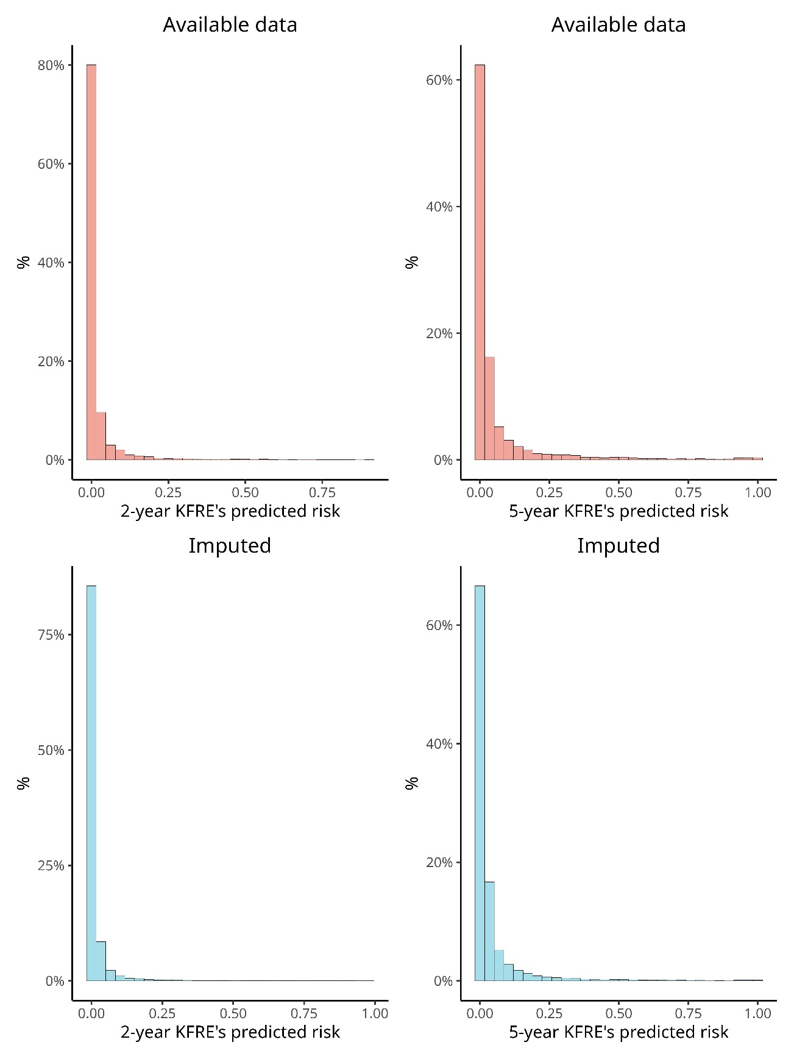

Figure S1. Distribution of the 2-year and 5-year predicted risk estimated by KFRE equation according to kidney failure outcomes.

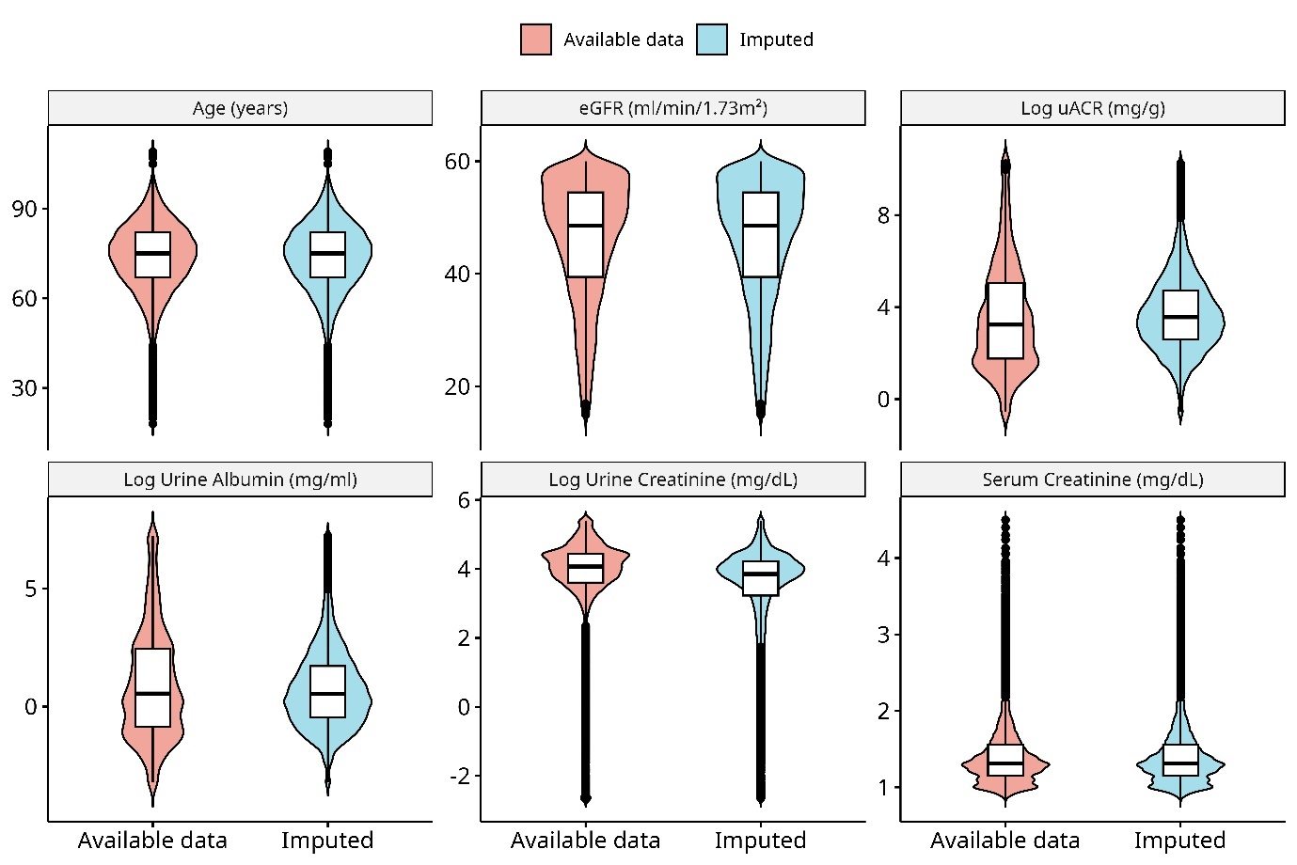

Figure S2. Distribution of the four KFRE equation variables in CKD 3a-4 patients.

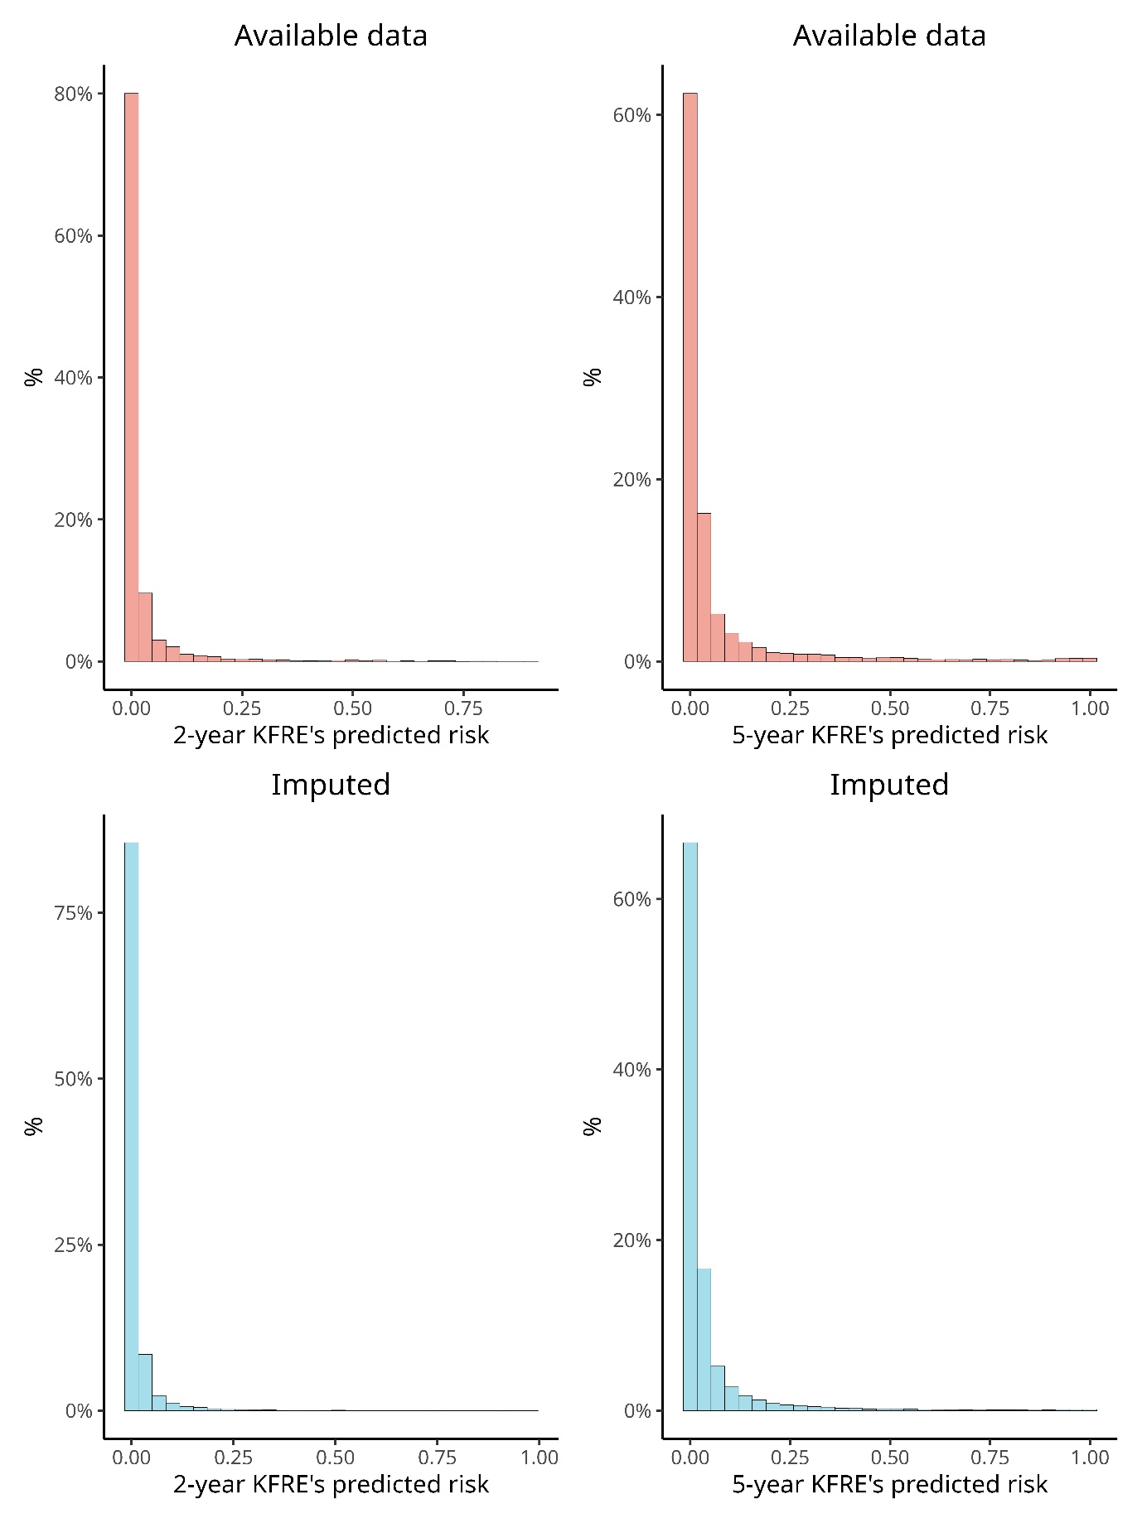

Figure S3. Distribution of the 2-year and 5-year predicted risk estimated by KFRE equation according to kidney failure outcomes in sensitivity analysis with non-winsorized data of ACR .

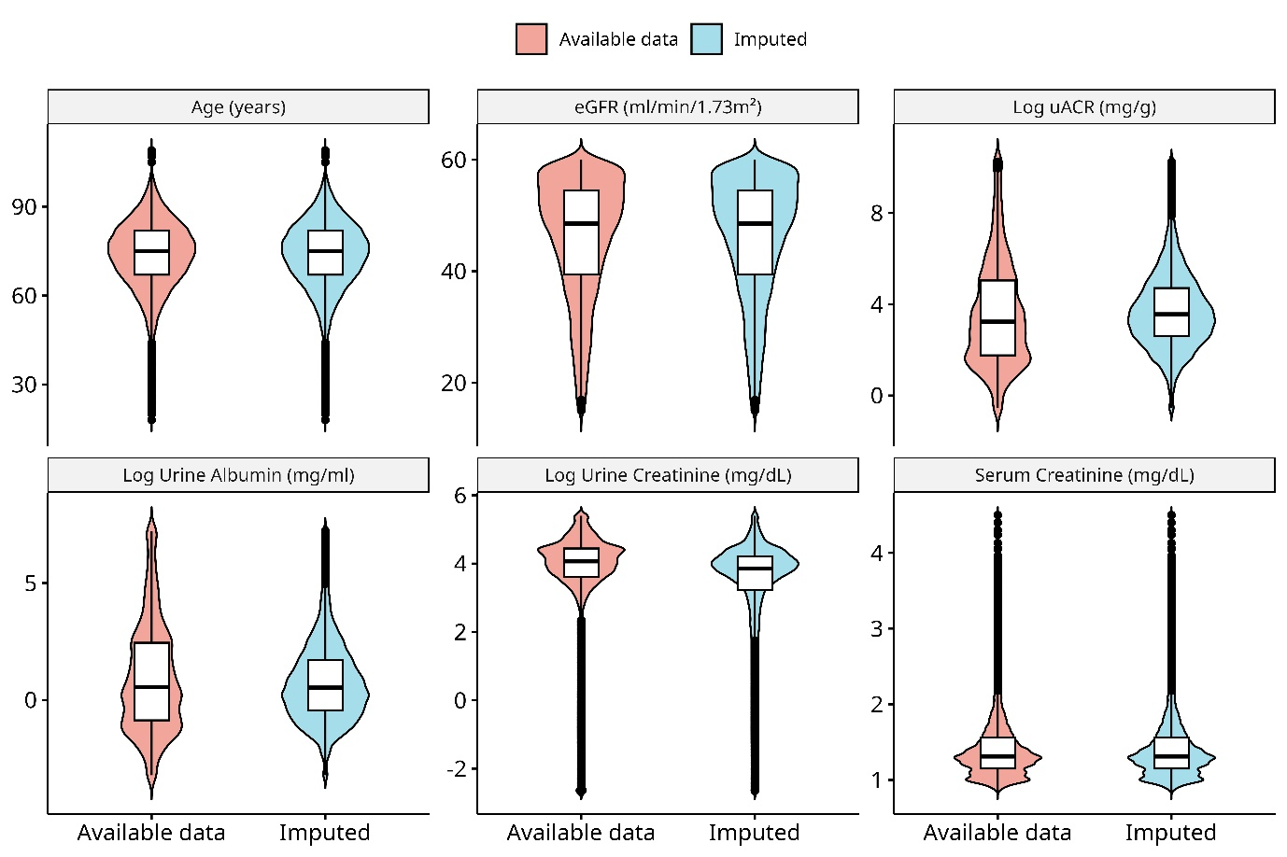

Figure S4. Distribution of the four KFRE equation variables in CKD 3a-4 patients in sensitivity analysis with non-winsorized data of ACR.

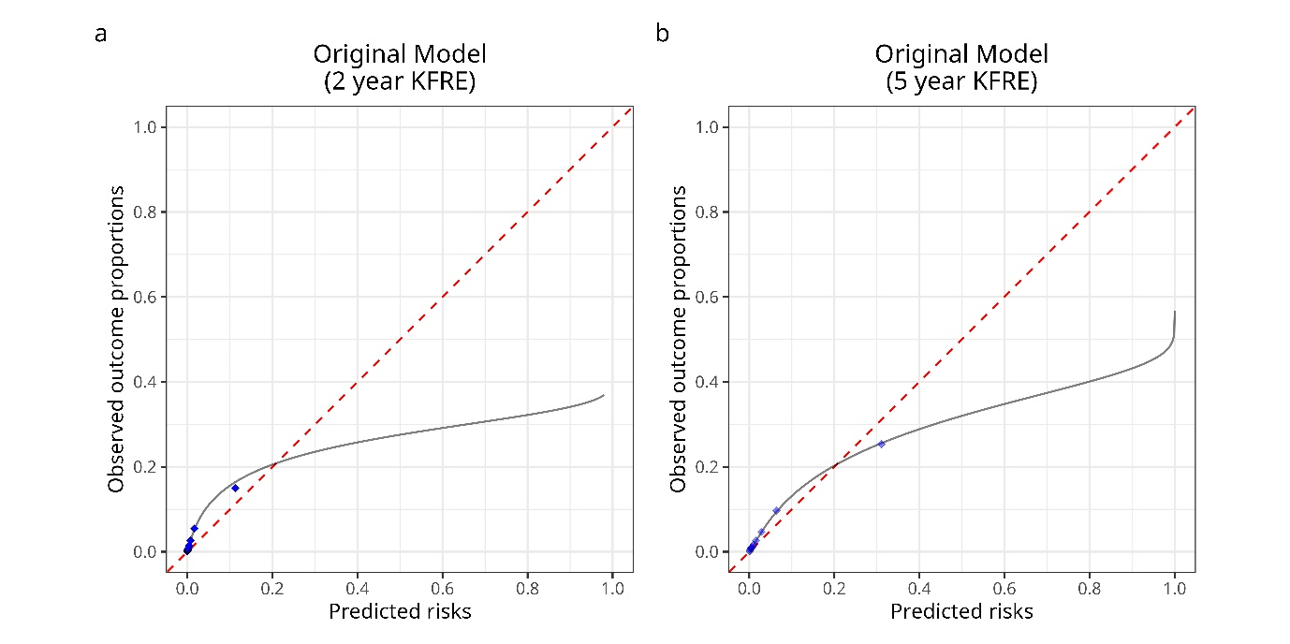Figure S5. Calibration curves of the original KFRE model in sensitivity analysis with non-winsorized data of ACR. The predicted risk by the KFRE model is shown on the x-axis, and the observed risk on the y-axis. The observed risk was estimated using cumulative incidence function curves to account for the competing risk of death without kidney failure. CKD: chronic kidney disease

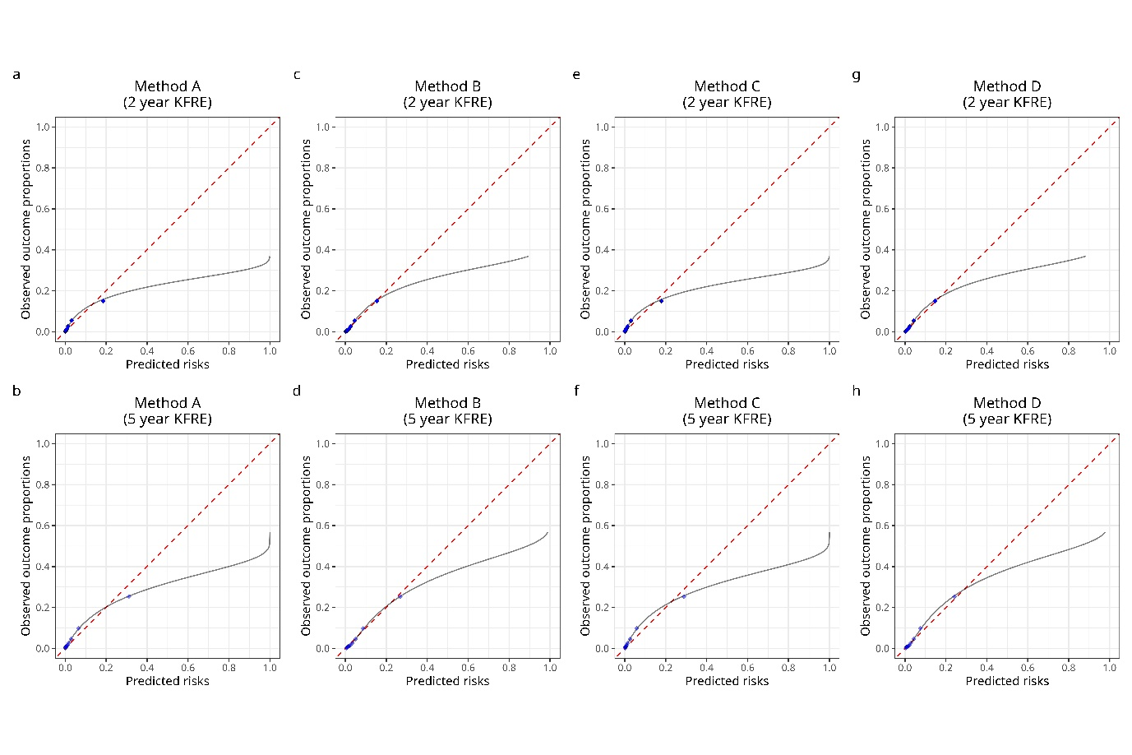

Figure S6. Calibration plots for the recalibrated KFRE models showing observed outcome proportions against predicted risks in sensitivity analysis with non-winsorized data of ACR. Recalibrated models using (A) method A at 2 years, (B) method A at 5 years, (C) method B at 2 years, (D) method B at 5 years, (E) method C at 2 years, (F) method C at 5 years, (G) method D at 2 years, and (H) method D at 5 years. The red dashed line represents the ideal calibration line where predicted risks perfectly match observed proportions. Blue points indicate the deciles of predicted risk, and the grey line represents a smoothed calibration curve.

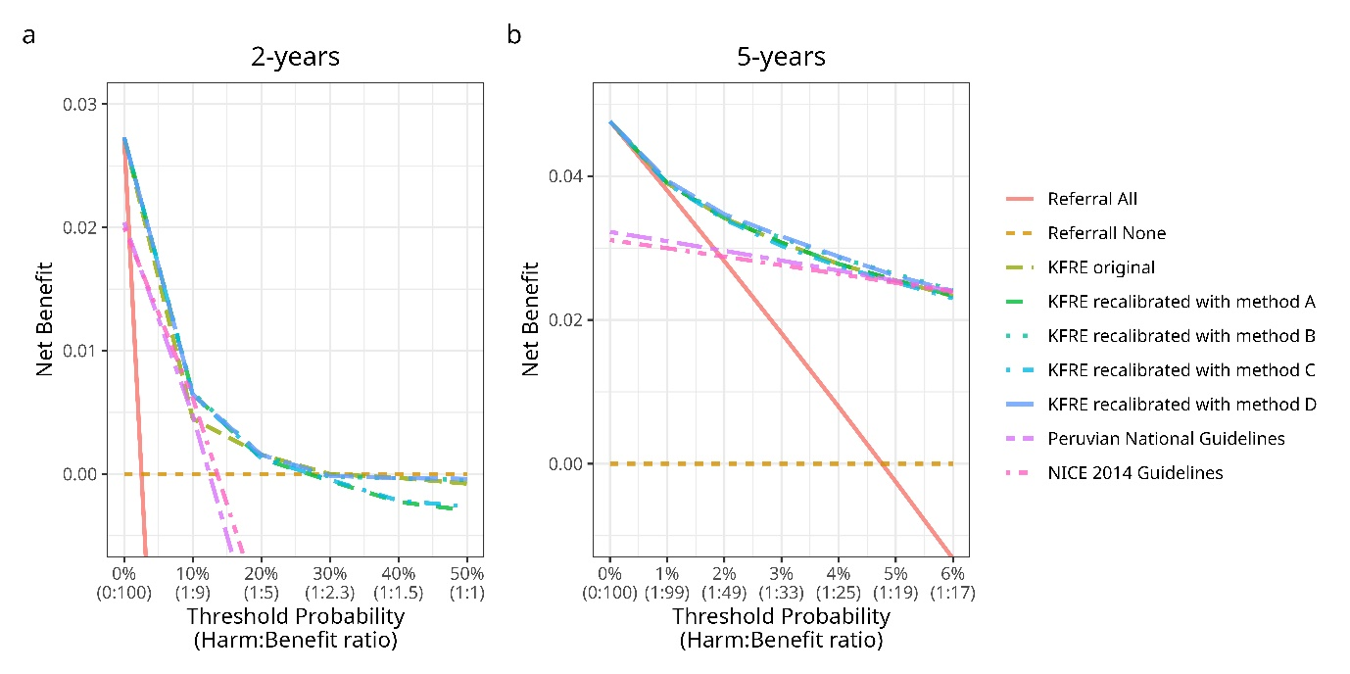

Figure S7. Decision curve analysis (DCA) for the original and recalibrated KFRE models, and alternative nephrology referral guidelines (NICE 2014 and Peruvian National Guidelines) in sensitivity analysis with non-winsorized data of ACR. Net benefit is plotted against the threshold probability for the (A) 2-year and (B) 5-year horizon. The lines indicate the performance, in terms of net benefit, of different strategies: the original KFRE model, recalibrated KFRE models (Methods A, B, C, and D), Peruvian National Guidelines, NICE 2014 Guidelines, and the strategies of referring all or none. The net benefit values show how each strategy performs in balancing the correct identification of high-risk patients against minimising unnecessary referrals.

  - REFERENCES
1. Tangri N, Grams ME, Levey AS, Coresh J, Appel LJ, Astor BC, et al. Multinational Assessment of Accuracy of Equations for Predicting Risk of Kidney Failure: A Meta-analysis. JAMA. 12 de enero de 2016;315(2):164-74. doi: 10.1001/jama.2015.18202.
2. Levey AS, Stevens LA, Schmid CH, Zhang Y (Lucy), Castro AF, Feldman HI, et al. A New Equation to Estimate Glomerular Filtration Rate. Ann Intern Med. 5 de mayo de 2009;150(9):604-12.
3. Friberg L, Gasparini A, Carrero JJ. A scheme based on ICD-10 diagnoses and drug prescriptions to stage chronic kidney disease severity in healthcare administrative records. Clinical Kidney Journal. 1 de abril de 2018;11(2):254-8. doi: 10.1093/ckj/sfx085.

