Table 1: Study Characteristics

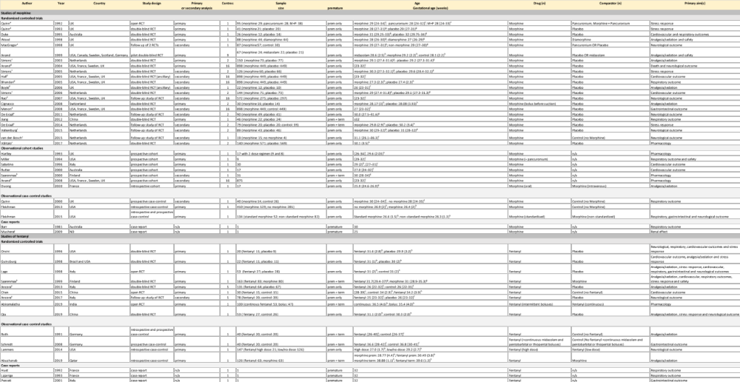

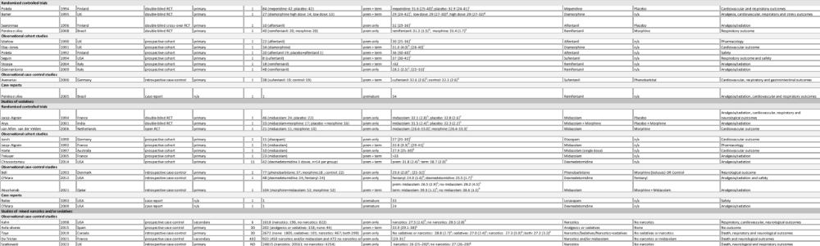

Abbreviations: RCT: randomised control trial
^{a,b,c,d,e} refer to related studies
^{f} median [range]
^{g} median (interquartile range)
^{h} mean (SD)
^{i} [range]
^{j} mean [range]

Table 2: Studies for analgosedation with morphine

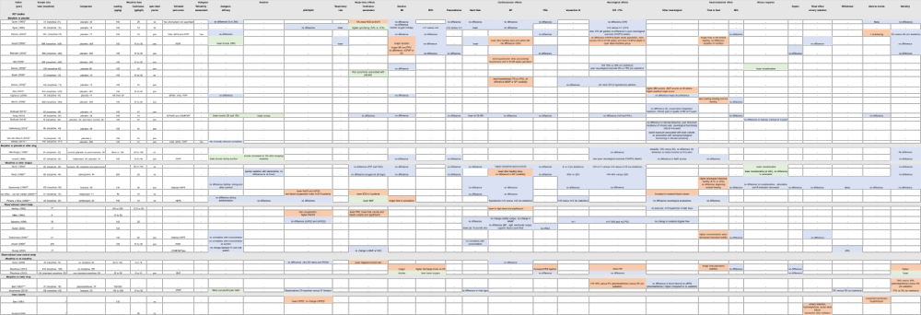

Cell colours indicate outcomes associated with favourable (green), neutral (blue) or unfavourable (red) effect of the studied drug.

* also in fentanyl table
**also in synthetic opioids table
*** also in sedatives table
a,b,c,d,e refer to related studies
Secondary studies marked in italics

Table 3: Studies for analgosedation with fentanyl

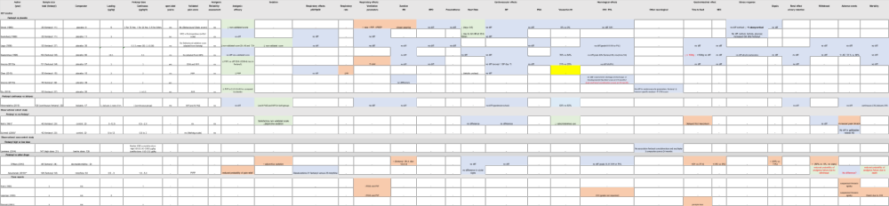

Cell colours indicate outcomes associated with favourable (green), neutral (blue) or unfavourable (red) effect of the studied drug.

* also in sedatives table
**also in morphine table
a refers to related studies
Secondary studies marked in italics

Table 4: Studies for analgosedation with synthetic opioids

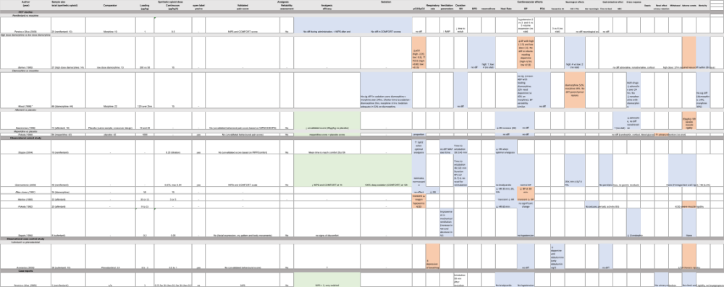

Cell colours indicate outcomes associated with favourable (green), neutral (blue) or unfavourable (red) effect of the studied drug.

*also in morphine table
CHEOPS - Children's Hospital of East Ontario Pain Scale
NIPS - Neonatal Infant Pain Scale

Table 5: Studies for analgosedation with sedatives

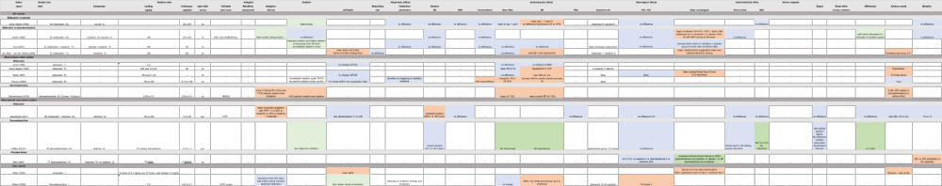

Cell colours indicate outcomes associated with favourable (green), neutral (blue) or unfavourable (red) effect of the studied drug.

* study also in morphine table
** study also in fentanyl table

Table 6: Studies for analgosedation with narcotics sedatives

Cell colours indicate outcomes associated with favourable (green), neutral (blue) or unfavourable (red) effect of the studied drug.

