Differential effects of soil warming on N dynamics in plantation and natural regeneration subtropical forests during initial warming years.
Dongmei Wan ·Shidong Chen
Authors and Affiliations
Dongmei Wan^{1, 2} ·Shidong Chen^{1, 2}
1 School of Geographical Sciences, Fujian Normal University, Fuzhou 350007, China.
2 State Key Laboratory of Subtropical Mountain Ecology (Funded by the Ministry of Science and Technology and Fujian Province), Fujian Normal University, Fuzhou 350007, China.
Corresponding author
Correspondence to Shidong Chen (sdchen@fjnu.edu.cn)
Dongmei Wan is the first author of this paper
Acknowledgements
Funding for this work was provided by the National Science Foundation of China (grant numbers: 32271727 and 31930071).

Abstract
Aims To assess how +5 °C soil warming affects nitrogen (N) dynamics in early-stage subtropical forests, we compared Chinese fir plantations and natural regeneration. The hypothesis was that warming accelerates N mineralization and nitrification, increasing risks of leaching and gaseous losses where sapling N uptake is limited.
Methods A warming experiment was conducted in subtropical China using buried heating cables (+5°C), incorporating treatments of Chinese fir (Cunninghamia lanceolata) plantation and natural regeneration.
Results Warming significantly increased annual net N mineralization and nitrification in plantations (except in August) and in natural regeneration during January. In plantations, warming elevated DON, NO₃⁻-N, and NH₄⁺-N in surface soil (0-10 cm), as well as NO₃⁻-N throughout the 0-60 cm profile, particularly in January. In contrast, NH₄⁺-N decreased in natural regeneration in August. Warming also increased NO₃⁻-N concentrations in leachate and elevated N₂O emissions across both natural regeneration and plantation plots. The abundance of functional genes related to N cycling declined under warming, although natural regeneration maintained higher levels of denitrification genes (narG, nirK, nosZ) and the N-fixation gene (nifH) compared to plantations. Enrichment of δ¹⁵N in N-rich plant organs further reflected enhanced soil N transformation under warming.
Conclusion Warming induced a more open soil N cycle in subtropical forests, with greater N leaching in plantations than in natural regeneration during early warming years. This highlights the importance of forest management and the value of near-natural practices under climate change.
Keywords
Soil warming, Plantation, Natural regeneration, N loss, Chinese fir
Introduction
Global warming has led to a 1.10 ± 0.12 °C of increase in average global surface temperature between 2011 and 2020, compared to the 1850-1900 baseline (IPCC. 2021). Warming may be increased risk of soil nitrogen (N) loss from ecosystems by altering soil N transformation patterns and plant-soil interactions (Dai et al. 2020; Elrys et al. 2024; Lyu et al. 2024). Nitrous oxide (N₂O) is the third most significant long-lived greenhouse gas, atmospheric N₂O levels have increased from 270.1 ppb in 1975 to 333 ppb in 2021 (Mander et al. 2021; Tian et al. 2020). Leaching also contributes to that causes soil N loss, resulting in soil nutrient depletion and potentially causing downstream water eutrophication (Kreyling et al. 2015). Forests are the key components of terrestrial ecosystems, not only impacted by climate change but also crucial in regulating and mitigating its negative effects (Makarieva et al. 2023). Warming-induced changes in soil N loss will significantly impact the structure and function of forest ecosystems, and potentially altering the progression of climate change.
As a fundamental component of plant proteins, N is a vital macronutrient and often a critical limiting factor for forest ecosystems functions (Wang et al. 2014). Temperature regulates microbial activity, influencing soil N storage, fluxes, plant N supply, and N₂O emissions, making it a key factor in N dynamics (Dai et al. 2020; Lie et al. 2021). Warming is widely known to enhance soil N mineralization and nitrification by stimulating microbial activity, thus increasing soil N availability. N dynamics in plant-soil continuum have exhibited heterogeneous responses to warming, due to inherent difference in soil N availability across ecosystems and disparities in N uptake by plants. Most studies in N-limited temperate forests suggest that increased soil N availability due to warming enhances plant productivity and alleviate soil N loss (Butler et al. 2012; Elrys et al. 2024). Compared to temperate forests, tropical and subtropical forests exhibit high soil N transformation rates and are generally considered N-saturated (Elrys et al. 2024). In N-saturated ecosystems, warming may increase the risk of N loss if not accompanied by corresponding increases in plant N uptake and microbial immobilization (Elrys et al. 2023; Lyu et al. 2024; Zhu et al. 2021). This is particularly true during periods of frequent rainfall, when N leaching is more likely. Results in the subtropical forest have shown that increased plant N uptake driven by tree growth can concurrently reduce N losses (Lyu et al. 2024). However, in the early growth stage, young trees have underdeveloped root systems, limiting their ability to uptake soil nutrients and leaving a gap in soil nutrient utilization (Li et al. 2016). Subtropical forests are globally recognized for their high plant diversity, and in China, approximately 65% of forests are located in this region (Piao et al. 2009), with over 32% used for commercial production (Lyu et al. 2024). Given the importance of these forests, it is crucial to investigate soil N dynamics in response to a warming during early forest establishment in subtropical regions.
As global forest cover continues to decline, with a reported 3% loss, forest restoration efforts have gained momentum worldwide (Lof et al. 2019). In ecological restoration and forest management, natural regeneration and plantation are the primary approaches, with the former widely considered a more effective strategy (Chazdon and Guariguata 2016; Lohbeck et al. 2021). Plantation often results in the removal of substantial above-ground biomass, significant disturbances, and changes to the regional microenvironment, such as higher soil temperature and reduced water availability (Brockerhoff et al. 2017; Menge et al. 2023). Forest growth is highly dependent on N, while its composition and structure play a crucial role in the assimilation, sequestration, and reutilization of soil nutrient (Chen et al. 2021). Naturally regenerated forests, characterized by high biodiversity and complex soil organic matter (Wang and Shi 2023), effectively regulate N dynamics and stabilize the soil N cycle (Butler et al. 2012; Chen et al. 2023b). However, the typically single-species composition and frequent human disturbances in plantation may limit the ability of plants to take up the released N (Chen et al. 2023a; Yan et al. 2022). Studies show that practices such as removing understory vegetation and thinning can enhance tree growth by reducing competition for water and nutrients, which may improve trees' uptake and utilization of soil nutrients (Wang et al. 2019; Zavadilová et al. 2023). Plants absorption plays crucial role in regulating the relationship between plants and soil nutrients, and N loss is expected to decrease as plant N use efficiency improves (Lyu et al. 2024; Zhu et al. 2023). Compared to natural regeneration, plantations exhibit stronger productivity responses to climate warming, particularly with significantly lower drought resistance and resilience (Ma et al. 2025). Currently, most findings on the N cycle are derived from culture experiments that do not account for the role of in situ plants (He et al. 2020). However, how warming regulate N dynamics between soil and plants under different silvicultural practices remains poorly understood.
Chinese fir (Cunninghamia lanceolata (Lamb.) Hook), a fast-growing economic tree species, covers 9.9 million hectares, constituting 17.33% of China's and 7.56% of the world's plantation areas (FAO. 2020; Xu et al. 2019). Southeastern China is a primary growing region for Chinese fir, characterized by hilly and sloping topography; concentrated rainfall during the rainy season, rapid temperature increases (Cavaleri et al. 2015). These conditions contribute to the release of large quantities of soil nutrients. This study aims to examine the effects of warming on soil N availability and potential N losses under natural regeneration and artificial planting, to solve the gap of early forest N dynamics under warming. To achieve this, we established a soil warming experiment in Fujian Province, southeastern China, using soil heating cables, which encompassed both plantation and natural regeneration treatments. Both treatments are commonly used in silvicultural practices (Aoyama et al. 2011). We observed how N dynamics in plant organs and soils respond to warming under different silvicultural practices. We aimed to test two hypotheses: (1) soil warming accelerates net N mineralization and nitrification by stimulating microbial activity, and because early-stage saplings have limited N uptake, this process may increase N leaching and gaseous N losses; and (2) these warming effects vary between plantation and natural regeneration, with the latter’s diverse vegetation and microbial communities potentially buffering N losses more effectively than in monoculture plantation.
Materials and methods
Study site and experimental design
The experiment was conducted at the Chenda Observation Study Site (26°19′55′ N, 117°36′53′E) within the Sanming Forest Ecosystem National Observation and Research Station in southeastern China. This region is characterized by a subtropical monsoonal climate with a mean annual temperature of 19.1 °C and mean annual precipitation of 1750 mm. Nearly 75% of the annual precipitation occurs between March and August.
In August 2013, we established 20 experimental plots, each measuring 2 m × 2 m. PVC boards were inserted to a depth of 70 cm to separate the plots. The soil was classified as acidic red soil according to the Chinese soil classification system, which is equivalent to Oxidisol in the USDA soil taxonomy. In November 2013, healthy Chinese fir saplings were randomly planted in the plots, with four plants per plot. The soil profile was warmed using cable to raise the temperature by 5°C above ambient, to a depth of 10 cm at 20 cm horizontal intervals. Five replicates of each treatment were arranged in a randomized block design. Temperature sensors (T109, Campbell Scientific Inc., Logan, USA) were installed at a depth of 10 cm between the pairs of cables. After five months of acclimatization, the warming treatment was electrified in March 2014. Understorey vegetation in the plantation plots was periodically removed, whereas no treatment was applied to the natural regeneration plots. The plantation was recorded as: control (CT), warming (W), natural regeneration was recorded as: control (NW), warming (WNW). The dominant woody species include Trema dielsiana, Mallotus lianus, Rhus chinensis, Rubus corchorifolius, Litsea cubeba, and Aralia chinensis. The dominant herbaceous species are Gahnia tristis, Scleria terrestris, Miscanthus floridulus, Isachne globosa, Paspalum orbiculare, and Ageratum conyzoides. Warming increased vegetation biomass in natural regeneration (Table S1).
Sample collection and indicator measurement
Soil available nitrogen N content
Soil samples were collected in November 2014, and January, April, and August 2015. Samples were collected from three randomly selected sites at depths of 0-10 cm, 10-20 cm, 20-40 cm, 40-60 cm, then combined to form composite soil samples for each plot. Five grams of fresh soil, sieved through a 2 mm sieve, was weighed into a 50 mL centrifuge tube and 20 mL of 2 M KCl solution was added and stoppered. After centrifugation with shaking, the samples were filter through a 45 μm membrane, and stored at 4°C until analysis. The NH₄⁺-N, NO₃⁻-N and DON contents of the samples were measured using a continuous flow analyzer (Skalar san++, Netherlands).
Soil leachate collection
Soil suction samplers (suction lysimeters, SM32) were installed at a depth of 60 cm in each experimental plot. During the experiment, soil leachate was collected monthly using the negative pressure method. We multiplied the content of NO₃⁻-N in the soil leachate samples by the volume of water collected to determine NO₃⁻-N content. The determination of NO₃⁻-N content is referred to the above method
Rate of soil net N mineralization and nitrification
The N mineralization in the field was monitored through continuous sampling using in situ PVC pipe incubation (Raison et al. 1987). In November 2014, and in January, April, and August 2015, soil net N mineralization and nitrification were measured using the PVC buried tube incubation (Raison et al. 1987). Before starting the experiment, PVC pipes 15 cm in length and 4 cm in diameter were prepared. At the beginning of each month, two PVC pipes were driven vertically into the soil to a depth of 10 cm. One pipe was carefully removed and taken back to the laboratory for analysis of the inorganic N concentration, serving as the initial value for soil nitrogen mineralization. The other pipe was capped and left in situ for incubation until the end of the month, after which it was removed and the inorganic N concentration was measured again. For the determination of NH₄⁺-N and NO₃⁻-N, the same method as described above was used. Soil net N mineralization and nitrification rates were calculated as follows:
$$Net N mineralization rate=\left(MineralN_{late}-MineralN_{early}\right)/day$$
$$Net Nitrification rate=\left(NitrifierN_{late}-NitrifierN_{early}\right)/day$$
Where Mineral N _{late} and Mineral N_{early} are inorganic nitrogen (NH₄⁺-N + NO₃⁻-N) concentrations analyzed at the end and beginning of the month, respectively. Nitrifier N _{late} and Nitrifier N_{early} are NO₃⁻-N concentrations analyzed at the end and beginning of the month, respectively.
Soil N₂O emissions
The emission of N₂O from forest soil were measured using a static chamber system in combination with gas chromatography. The static chamber consisted of a base and a top box. The base included a PVC ring with a diameter of 20 cm and a height of 10 cm, which was included into the ground using a sharpened edge at the bottom. The chamber’s a top box had a diameter of 20 cm and a height of 30 cm. It featured a grooved rubber gasket for sealing and a central rubber plug for syringe needle inlet/outlet, gas mixing, and pumping. The procedure involved embedding the bottom of the top box firmly into the base before gas samples collection. The chamber was sealed for 1 hour to allow gas accumulation, after which a 30 ml gas sample was collected using a 50 ml syringe and deposited into a gas bag (Delin, China). N₂O concentrations were analyzed using a gas chromatograph (GC-2014, Shimadzu, Japan). The gas flux was subsequently calculated according to the following formula:
$$F=\frac{M}{Vm} ·\frac{∆c}{∆t}·\frac{273}{273+T}·\frac{V}{S}$$
where F represents the N₂O emission flux, with positive values indicating net emission, and negative value indicating net absorption; M is the molar mass of the gas (44.01 g/mol); Vm is the standard molar volume of the gas (22.4 L/mol); Δc/Δt is the linear slope of gas concentration change over time during the observation period. T is the soil temperature (℃); V is the volume of the chamber plus the exposed volume of the base (L); and S is the base area (m²).
Plant organ δ¹⁵N isotope
Mature leaves, branches, and trunks were collected after cutting. Leaves, branches, trunks and fine roots (< 2 mm) were heated at 105 ℃ to halt chlorophyll activity then dried at 60 ℃ until a constant weight was achieved. The samples were ground into fine powder and sieved through a 100-mesh sieve. δ¹⁵N isotope analysis was conducted using a isotope-ratio mass spectrometer (MAT-253, Thermo Fisher Scientific Inc, Waltham, MA, USA).
$δ^{15}N\left(‰\right)=\left(R_{sample}-R_{standand}\right)/R_{standand}×$1000
where R _{sample} is the value of sample, and R _{standard} is the value of standard material.
Soil microbial community structures
Weigh 0.5 g of freeze-dried soil and extracted the total DNA using the PowerSoil Pro kit (Qiagen, Germany) following the manufacturer's protocol. The purity and concentration of the extracted soil DNA ware measured using a Nanodrop 1000 spectrophotometer (ND-1000, USA). The DNA was stored at -80°C for future experiments. The abundances of the ammonia-oxidising bacteria (AOA-amoA), archaea ammonia-oxidising bacteria (AOB-amoA), and denitrification function gene (narG, nirK and nosZ) and N fixing gene (nifH) were quantified using were quantified using real-time quantitative PCR (qPCR) on a CFX96 apparatus (Bio-Rad, CA, USA). The reaction system for the qPCR assays was 20 μL. For the AOA-amoA, AOB-amoA, narG, nirK, nosZ, and nifH genes, the reaction mixture of 10 μL of Premix Ex Taq™ polymerase (Takara, Japan), 0.5 μL of the forward primer, 0.5 μL of the reverse primer, 8 μL of sterile water, and 1 μL of DNA. Gene copy numbers were calculated based on the standard curve.
Statistical Analysis
Data were tested for normality and homogeneity before analysis. A factorial analysis of variance (ANOVA) was use to compared the differences between all indicators in the control and warming treatments and to determine whether warming had a significant impact. Statistical analyses were performed using SPSS 20.0 software (Statistical Graphics Crop, Princeton, USA). Diagrams were drawn using Origin 2021 software.
Results
Micrometeorology
The mean air temperature during the experiment was 18.1 °C, and precipitation was 1826.5 mm (Fig. 1a). The topsoil temperature at 10 cm depth in the warming plots were consistently 5.2 ± 0.12 °C higher than in the control plots, achieving the expected warming effect (Fig. 1b). Soil volumetric moisture decreased by 5.2 % under warming (Fig. 1c).
Soil net N mineralization and nitrification rates
The soil net N mineralization rate significantly increased during the experimental period under the W treatment (P＜0.01; Fig. 2a-d). Net nitrification rates also showed a significant increase (P < 0.01; Fig. 2e-g), except in August (P < 0.01; Fig. 2h). The rates of net nitrification and net N mineralization exhibited a significant increase under the NW treatment in January (P < 0.05; Fig. 2b and f). During the growing season, WNW treatments resulted in slightly, but not significantly lower rates of net nitrification and net N mineralization compared with other treatments (Fig. 2c-d and g-h).
The soil available N content
The W treatment significantly affected soil available N content, whereas the WNW treatment had no significant effect. In January, the W treatment significantly increased NO₃⁻-N, NH₄⁺-N, and DON contents in the 0-10 cm soil layer (P＜0.01; Fig.3 a2-b2-c2). In August, WNW treatment led to significantly decreased NH₄⁺-N (P＜0.01; Fig.3 b4).
Influences of warming on soil N loss
Soil NO₃⁻-N content increased at various depths under the W treatment, but the increase was significant only in January (Fig.4c), with a tendency to first decrease and then increase with depth. During the growing season, the WNW treatment had little effect on soil NO₃⁻-N content at different depths, with significant changes observed only in January (Fig.4d).
Further observation of NO₃⁻-N content in soil leachate showed that W and WNW treatments significantly increased NO₃⁻-N content (P＜0.01), by 240.19% and 488.13%, respectively, compared to control (Fig.5).
Warming increased soil N₂O emissions under the W and WNW treatments by 125.23% and 169.35%, respectively (Fig.6), although these increases were not statistically significant. Regardless of warming or control conditions, the naturally regenerated saplings had slightly higher N₂O emission compared to the assisted regeneration saplings.
Influences of warming on the abundance of functional genes of soil microorganisms
The abundance of A-amoA and B-amoA decreased with WNW and W treatments, respectively (Fig.7a and b). The abundance of narG, nirK, nosZ, and nifH was lower in plantation than in natural regeneration (Fig.7 c - f). W treatment led to a decrease in the abundance of nosZ and nifH compared to WNW treatment (P＜0.01, Fig.7 e and f), while the WNW treatment led to a reduction in the abundance of narG in natural saplings (Fig.7 c).
Influences of warming on δ¹⁵N in different organs of plants
Warming significantly increased δ¹⁵N levels in plant organs with high nitrogen content, such as leaves and fine roots (Fig.8 a and b). The δ¹⁵N of leaves and fine roots of plantation saplings was higher than that of natural saplings in both warming and control treatments (Fig.8 a and b).
Discussion
The response of soil N dynamics to warming is intricately linked to a complex interaction between soil and plant (Lyu et al. 2024; Zhang et al. 2022; Zhu et al. 2023). The observed net rates of N mineralization and nitrification are often lower than actual field rates due to the influence of plant growth (Risch et al. 2020). In our experiment, the competitive uptake of soil N by plants reduced net N mineralization rate in the warming treatments compared to the control during the rapid growth phase of the natural regeneration sapling (Fig. 2; Fig. S1A). During the non-growing season, warming increased net N mineralization and nitrification rates both in plantation and natural regeneration (Fig. 2 b and f). During this period, reduced or ceased plant metabolic activity lowers N demand (Guo et al. 2021), thereby increasing soil available N content, especially in plantation (Fig. 3). In the initial stage of tree growth (the first year), plantation saplings absorbed fewer minerals due to limited vegetation diversity (Lyu et al. 2024; Mediavilla et al. 2014). Simultaneously, natural regeneration plots exhibit greater root system diversity and higher root biomass than plantation, collectively enhancing the uptake of available N (Hu et al. 2021). Consequently, the warming exhibited significantly higher net N mineralization and nitrification rates than the control for most of the year in plantation (Fig. 2; Fig. S1a). In acidic soils, the nitrification process is primarily governed by AOA amoA (He et al. 2012; Zhu et al. 2014), in our result, AOA amoA abundance exceeded that of AOB amoA across all treatments (Fig. 7), this theory has gained further support. Previous studies suggest that warming increases in the abundance of both AOA amoA and AOB amoA, potentially enhancing nitrification (Lyu et al. 2024; Zhang et al. 2019; Zhong et al. 2022). Meta-analyses and another experimental studies have shown that warming either had no significant effect on or decreased the abundance of AOA and AOB (Dai et al. 2020; Long et al. 2012). However, our results showed that warming significantly decreased AOA amoA abundance in natural regeneration and AOB amoA in plantation (Fig. 7). This may be related to substrate availability, in a warming plus N addition experiment, exogenous N input alleviated substrate limitation, resulting in increased AOB abundance (Waghmode et al. 2019). In contrast, warming alone accelerated N mineralization and depleted NH₄⁺-N, thereby intensifying substrate competition between AOA and AOB (Waghmode et al. 2019). The ¹⁵N tracing technique has identified, heterotrophic nitrification as a key process NO₃⁻-N production in subtropical forest soil (Zhang et al. 2020; Zhu et al. 2014). Warming significantly decreased the soil pH in plantations (Fig. S1), potentially promoting fungi-mediated heterotrophic nitrification (Zhang et al. 2020; Zhu et al. 2014). Therefore, the increase in nitrification in the plantation was primarily attributed to warming-enhanced heterotrophic nitrification.
As an important intermediate in the N cycle, DON links organic matter decomposition to plant nutrient acquisition. Derived mainly from plant litter, root exudates, and microbial residues, DON constitutes a major fraction of the soil N pool and supplies inorganic N to plants and microorganisms through mineralization (Jones et al. 2004; Ren et al. 2025). Warming accelerates the decomposition of organic matter, increasing the DON content in the soil and providing sufficient nitrogen for mineralization (Ren et al. 2025). Warming enhanced mineralization and nitrification rates, increasing inorganic N concentrations in both soil and leachate, particularly in plantation plots (Fig. 2; Fig. 5). However, the seasonal pattern of soil inorganic N dynamics under warming remains poorly understood. For example, in January, warming significantly increased soil inorganic N concentrations, which contrasts with the conventional expectation that low winter temperatures suppress N transformation processes (Schütt et al. 2014). This anomaly suggests that warming may stimulate microbial activity even under low-temperature conditions (Schütt et al. 2014). With warming, plant growth may accelerate and root uptake of NH₄⁺-N may increase, especially during the peak growing season (e.g., August), which could partially explain the reduced mineralization rates and decreased NH₄⁺-N concentrations observed in our results (Fig. 2; Fig. 3). However, differences in plant N uptake preferences and the varying migration rates of N forms in the soil contribute to discrepancies in soil N loss (Darrah 1993; Li et al. 2016). Chinese fir, especially young trees, assimilate NH₄⁺-N more efficiently than NO₃⁻-N in acidic soils, as plants expend more energy to absorb NO₃⁻-N (Li et al. 2016). Our study found that the proportion of NH₄⁺-N in inorganic N exceeded that of NO₃⁻-N, except in the W treatment (Table S2). These findings align with previous research showing that NH₄⁺-N is the dominant form of N in this soil type (Li et al. 2016; Lyu et al. 2024). NH₄⁺-N and NO₃⁻-N exhibit different mobility and transformation rates in soil (Darrah 1993). While NO₃⁻-N can easily diffuse within the soil , NH₄⁺-N typically gets fixed by the soil, reducing its mobility (Hachiya and Sakakibara 2016). With the increased rate of soil N mineralization and nitrification due to warming, NH₄⁺-N may only be a temporary link in the N cycle, fungi in the field can directly convert organic N into NO₃⁻-N, bypassing NH₄⁺-N formation (Costa et al. 2006; Zhu et al. 2014), which is prone to soil N loss due to the ease of diffusion of NO₃⁻-N in the soil solution. Our results indicated that, warming increased soil NO₃⁻-N content by 284.89% in the plantation compared to the control, but by 12.79% in natural regeneration (Fig. S1). The N loss of forest soil will change with the regulation of plant growth. Regional studies have shown that, over time, effective N losses from soil tend to decline, accompanied by an increase in tree biomass (Lyu et al. 2024).
If plant uptake is low and the remaining NO₃⁻-N is easily leached into the subsoil, the increase in soil NO₃⁻-N due to warming leads to greater N loss (Li et al. 2022). In January, the soil profile of plantation and natural regeneration exhibited a significant increase in NO₃⁻-N due to warming (Fig. 4 c and d). Nevertheless, as the non-growing season of subtropical trees, winter requires less N, suggesting that winter may be a vulnerable period for soil NO₃⁻-N leaching in this region. Plants with deeper roots may uptake and use NO₃⁻-N from the deep soil. Chinese fir a shallow-rooted species, especially saplings have a weaker ability to recycle deep soil NO₃⁻-N (Germon et al. 2020). Warming significantly increased NO₃⁻-N content in deep soil solution, with a greater increase in plantation than that of in natural regeneration (Fig. 5). Sufficient soil NO₃⁻-N availability reduces the reliance of N-fixing microorganisms on biological N fixation due to its higher energy demand, ultimately resulting in decreased nifH gene abundance (Zheng et al. 2023). This was linked to the higher abundance of nifH in natural regeneration soils, which was significantly reduced in plantation soils following warming (P < 0.01). Similarly, the abundance of narG, involved in the reduction of NO₃⁻ to NO₂⁻, exhibited a similar trend, potentially contributing to the accumulation of NO₃⁻-N in the plantation soil (Shan et al. 2021). The increased NO₃⁻-N content of the subsoil may result from surface leaching or from enhanced nitrification (Krüger et al. 2021). Reduced soil moisture due to warming elevates soil redox potential, creating conditions for higher nitrification rates, despite the anaerobic environment of subsoil being typically unsupportive of this process (Chen et al. 2018).
N₂O emission is another crucial pathway for soil N loss. Natural soil emissions in tropical and subtropical regions are a main source of global N₂O emissions (Tian et al. 2020). In our study, warming increased soil N₂O emission by 161.69% in plantation and 168.96% in natural regeneration (Fig.6). Analogical, the abundance of denitrification function genes was higher in natural regeneration soil than in plantation (Fig.8). This suggests that denitrification rate was higher in natural regeneration soil, potentially due to higher vegetation cover and soil water content, which are beneficial to nitrification (Kooch et al. 2016). Higher soil water content not only enhances substrate availability, but also creates more anaerobic microzones, leading to increased denitrification rate (Huang and Hall 2017), as soil denitrification is a partially anaerobic (Kuypers et al. 2018). N₂O emissions are also influenced by substrate availability (Xu et al. 2023). Warming increased NO₃⁻-N leaching in plantation, thereby constraining the substrate supply for N₂O production. In natural regeneration soil, narG and nirK (encoding NO₂⁻ reductase) have higher abundances, indicating increased N₂O production (Fig.6; Fig.8). However, N₂O consumption (i.e., its reduction to N₂), relative to production, also plays a critical role in regulating emissions from soil to the atmosphere (Shan et al. 2021). The nosZ gene, encoding N₂O reductase, is key to reducing N₂O to N₂ (Shan et al. 2021). In our study, nosZ gene abundance was higher in natural regeneration plots than in plantation, and warming significantly reduced its abundance in plantation (Fig.8 e), consistent with the observed trend of increased N₂O emissions (Fig.6). These results suggest a diminished capacity of the microbial community to reduce N₂O to N₂, thereby increasing the potential for N₂O accumulation in plantation, which is likely further exacerbated by warming.
The natural N stable isotope (δ¹⁵N) provides comprehensive insights into ecosystem N cycling (Sheng et al. 2014). Soil N transformations process has an isotopic fractionation effect on δ¹⁵N, especially nitrification and denitrification (Dhondt et al. 2003; Sheng et al. 2014). Plant and soil δ¹⁵N values are positively correlated with soil N mineralization and nitrification rates (Chen et al. 2022). Higher δ¹⁵N typically indicates a more open soil N cycle, in which N can be lost from the ecosystem via leaching and gaseous N emissions (Chen et al. 2022; Liao et al. 2021). Plants derive their N from the soil, δ¹⁵N is accumulates in them, which could intensify its effect in the soil (Chen et al. 2022; Wang et al. 2022). The increase in the abundance of plant organs δ¹⁵N under warming suggests increased soil N loss (Schaeffer et al. 2013). In the plantation treatment, δ¹⁵N abundance in plant organs (leaves and fine roots) was higher than in natural regeneration, under both control and warming treatments, implying more rapid N transformation and higher nitrogen loss in the soil, which was which was exacerbated by warming. This finding aligns with the observed patterns of soil net N mineralization and nitrification, thereby reinforcing our conclusions (Fig. 2). In contrast, a previous study in a tropical forest reported that warming reduced both foliar δ¹⁵N values and inorganic N leaching losses (Lie et al. 2021). This discrepancy may be attributed to differences in forest developmental stages. Finally, given the higher risk of N loss in plantation ecosystems, forest restoration should prioritize near-natural management to improve N cycling resilience under climate warming.
Conclusion
Forest management practices influence plant growth and govern soil N uptake and retention. Whether through natural regeneration or plantation, warming accelerates N loss, opening the N cycle. Natural regeneration has a higher potential to retain soil N than plantation. Thus, under future warming, subtropical forest ecosystems may face more serious N risks, emphasizing the importance of species-rich natural regeneration forests for soil N retention. Future research should prioritize investigating the role of in-situ vegetation in the soil N cycle, particularly in addressing challenges posed by climate change. A more profound understanding and optimization of N uptake and retention mechanisms in in-situ plants can lead to targeted forest management strategies, mitigating N loss and safeguarding ecosystem functions and services. Several limitations of this study should be acknowledged. Future research could benefit from incorporating soil δ¹⁵N measurements to strengthen our conclusions and examining variation across tree age classes to further validate the findings.
References
Aoyama K, Yoshida T, Harada A, Noguchi M, Miya H, Shibata H (2011) Changes in carbon stock following soil scarification of non-wooded stands in Hokkaido, northern Japan. Journal of Forest Research 16: 35-45. doi: https://doi.org/10.1007/s10310-010-0204-y.
Brockerhoff EG, Barbaro L, Castagneyrol B, Forrester DI, Gardiner B, González-Olabarria JR, Lyver POB, Meurisse N, Oxbrough A, Taki H, Thompson ID, van der Plas F, Jactel H (2017) Forest biodiversity, ecosystem functioning and the provision of ecosystem services. Biodiversity and Conservation 26: 3005-3035. doi: https://doi.org/10.1007/s10531-017-1453-2.
Butler SM, Melillo JM, Johnson JE, Mohan J, Steudler PA, Lux H, Burrows E, Smith RM, Vario CL, Scott L, Hill TD, Aponte N, Bowles F (2012) Soil warming alters nitrogen cycling in a New England forest: implications for ecosystem function and structure. Oecologia 168: 819-828. doi: https://doi.org/10.1007/s00442-011-2133-7.
Cavaleri MA, Reed SC, Smith WK, Wood TE (2015) Urgent need for warming experiments in tropical forests. Global Change Biology 21: 2111-2121. doi: https://doi.org/10.1111/gcb.12860.
Chazdon RL, Guariguata MR (2016) Natural regeneration as a tool for large‐scale forest restoration in the tropics: prospects and challenges. Biotropica 48: 716-730. doi: https://doi.org/10.1111/btp.12381.
Chen H, Zou J, Cui J, Nie M, Fang C (2018) Wetland drying increases the temperature sensitivity of soil respiration. Soil Biology and Biochemistry 120: 24-27. doi: https://doi.org/10.1016/j.soilbio.2018.01.035.
Chen Q, Chen J, Andersen MN, Cheng XJGcb (2022) Elevational shifts in foliar‐soil δ15N in the Hengduan Mountains and different potential mechanisms. 28: 5480-5491.
Chen S, Hua J, Liu W, Yang S, Wang X, Ji W (2023a) Effects of Artificial Restoration and Natural Recovery on Plant Communities and Soil Properties across Different Temporal Gradients after Landslides. Forests 14. doi: https://doi.org/10.3390/f14101974.
Chen X, Taylor AR, Reich PB, Hisano M, Chen HYH, Chang SX (2023b) Tree diversity increases decadal forest soil carbon and nitrogen accrual. Nature 618: 94-101. doi: https://doi.org/10.1038/s41586-023-05941-9.
Chen XL, Chen HYH, Searle EB, Chen C, Reich PB (2021) Negative to positive shifts in diversity effects on soil nitrogen over time. Nature Sustainability 4: 225-U234. doi: https://doi.org/10.1038/s41893-020-00641-y.
Costa E, Pérez J, Kreft J-U (2006) Why is metabolic labour divided in nitrification? Trends in Microbiology 14: 213-219. doi: https://doi.org/10.1016/j.tim.2006.03.006.
Dai ZM, Yu MJ, Chen HH, Zhao HC, Huang YL, Su WQ, Xia F, Chang SX, Brookes PC, Dahlgren RA, Xu JM (2020) Elevated temperature shifts soil N cycling from microbial immobilization to enhanced mineralization, nitrification and denitrification across global terrestrial ecosystems. Global Change Biology 26: 5267-5276. doi: https://doi.org/10.1111/gcb.15211.
Darrah PR (1993) The rhizosphere and plant nutrition: a quantitative approach. In: NJ Barrow (ed) Plant Nutrition — from Genetic Engineering to Field Practice: Proceedings of the Twelfth International Plant Nutrition Colloquium, 21–26 September 1993, Perth, Western Australia. Springer Netherlands, Dordrecht.
Dhondt K, Boeckx P, Van Cleemput O, Hofman G (2003) Quantifying nitrate retention processes in a riparian buffer zone using the natural abundance of ¹⁵N in NO₃−. Rapid Communications in Mass Spectrometry 17: 2597-2604. doi: https://doi.org/10.1002/rcm.1226.
Elrys AS, Desoky E-SM, Zhu Q, Liu L, Yun-xing W, Wang C, Shuirong T, Yanzheng W, Meng L, Zhang J, Müller C (2024) Climate controls on nitrate dynamics and gross nitrogen cycling response to nitrogen deposition in global forest soils. Science of The Total Environment 920. doi: https://doi.org/10.1016/j.scitotenv.2024.171006.
Elrys AS, Zhu Q, Jiang C, Liu J, Sobhy HHH, Shen Q, Uwiragiye Y, Wu Y, El-Tarabily KA, Meng L, Mueller C, Zhang J (2023) Global soil nitrogen cycle pattern and nitrogen enrichment effects: Tropical versus subtropical forests. Global Change Biology 29: 1905-1921. doi: https://doi.org/10.1111/gcb.16603.
FAO. (2020) Global forest resources assessment, 2020: Main report. Food and Agriculture Organization of the United Nations.
Germon A, Laclau J-P, Robin A, Jourdan C (2020) Tamm Review: Deep fine roots in forest ecosystems: Why dig deeper? Forest Ecology and Management 466. doi: https://doi.org/10.1016/j.foreco.2020.118135.
Guo WJ, Zhang ZL, Liu Q, Xiao J, Yin HJ (2021) Seasonal variations in plant nitrogen acquisition in an ectomycorrhizal alpine forest on the eastern Tibetan Plateau, China. Plant and Soil 459: 79-91. doi: https://doi.org/10.1007/s11104-020-04644-8.
Hachiya T, Sakakibara H (2016) Interactions between nitrate and ammonium in their uptake, allocation, assimilation, and signaling in plants. Journal of Experimental Botany. doi: https://doi.org/10.1093/jxb/erw449.
He J, Hu HW, Zhang L (2012) Current insights into the autotrophic thaumarchaeal ammonia oxidation in acidic soils. Soil Biology and Biochemistry 55: 146-154. doi: https://doi.org/10.1016/j.soilbio.2012.06.006.
He X, Chi Q, Cai Z, Cheng Y, Zhang J, Müller C (2020) ¹⁵N tracing studies including plant N uptake processes provide new insights on gross N transformations in soil-plant systems. Soil Biology and Biochemistry 141. doi: https://doi.org/10.1016/j.soilbio.2019.107666.
Hu M, Zou B, Huang Z, Wang S, Su X, Ding X, Zheng G, Chen HYJFE, Management (2021) Fine root biomass and necromass dynamics of Chinese fir plantations and natural secondary forests in subtropical China. 496: 119413.
Huang W, Hall SJ (2017) Elevated moisture stimulates carbon loss from mineral soils by releasing protected organic matter. Nature Communications 8. doi: https://doi.org/10.1038/s41467-017-01998-z.
IPCC. (2021) Climate Change 2021 The Physical Science Basis. Working Group I Contribution to the Sixth Assessment Report of the Intergovernmental Panel on Climate Change.(Cambridge University Press,2021）.
Jones DL, Shannon D, V. Murphy D, Farrar J (2004) Role of dissolved organic nitrogen (DON) in soil N cycling in grassland soils. Soil Biology and Biochemistry 36: 749-756. doi: https://doi.org/10.1016/j.soilbio.2004.01.003.
Kooch Y, Rostayee F, Hosseini SM (2016) Effects of tree species on topsoil properties and nitrogen cycling in natural forest and tree plantations of northern Iran. Catena 144: 65-73. doi: https://doi.org/10.1016/j.catena.2016.05.002.
Kreyling J, Schuerings J, Malyshev AV, Vogt L, Werner C, Jentsch A (2015) Nitrogen leaching is enhanced after a winter warm spell but mainly controlled by vegetation composition in temperate zone mesocosms. Plant and Soil 396: 85-96. doi: https://doi.org/10.1007/s11104-015-2587-1.
Krüger M, Potthast K, Michalzik B, Tischer A, Küsel K, Deckner FFK, Herrmann M (2021) Drought and rewetting events enhance nitrate leaching and seepage-mediated translocation of microbes from beech forest soils. Soil Biology and Biochemistry 154. doi: https://doi.org/10.1016/j.soilbio.2021.108153.
Kuypers MMM, Marchant HK, Kartal B (2018) The microbial nitrogen-cycling network. Nature Reviews Microbiology 16: 263-276. doi: https://doi.org/10.1038/nrmicro.2018.9.
Li C, Li Q, Xu X, Ouyang H (2016) Nitrogen acquisition strategies of Cunninghamia lanceolata at different ages. The Acta Ecologica Sinica 36: 2620-2625. doi: https://doi.org/10.5846/stxb201411162271.
Li S-L, Xin L, Yue F-J, Yan Z, Wang T, Li S, Liu C-Q (2022) Nitrogen dynamics in the Critical Zones of China. Progress in Physical Geography: Earth and Environment 46: 869-888. doi: https://doi.org/10.1177/03091333221114732.
Liao K, Lai X, Zhu Q (2021) Soil δ15N is a better indicator of ecosystem nitrogen cycling than plant δ15N: A global meta-analysis. SOIL 7: 733-742. doi: https://doi.org/10.5194/soil-7-733-2021.
Lie Z, Huang W, Liu X, Zhou G, Yan J, Li Y, Huang C, Wu T, Fang X, Zhao M, Liu S, Chu G, Kadowaki K, Pan X, Liu J (2021) Warming leads to more closed nitrogen cycling in nitrogen-rich tropical forests. Global Change Biology 27: 664-674. doi: https://doi.org/10.1111/gcb.15432.
Lof M, Madsen P, Metslaid M, Witzell J, Jacobs DF (2019) Restoring forests: regeneration and ecosystem function for the future. New Forests 50: 139-151. doi: https://doi.org/10.1007/s11056-019-09713-0.
Lohbeck M, Rother DC, Jakovac CC (2021) Editorial: Enhancing Natural Regeneration to Restore Landscapes. Frontiers in Forests and Global Change 4. doi: https://doi.org/10.3389/ffgc.2021.735457.
Long X, Chen C, Xu Z, Linder S, He J (2012) Abundance and community structure of ammonia oxidizing bacteria and archaea in a Sweden boreal forest soil under 19-year fertilization and 12-year warming. Journal of Soils and Sediments 12: 1124-1133. doi: https://doi.org/10.1007/s11368-012-0532-y.
Lyu M, Chen S, Zhang Q, Yang Z, Xie J, Wang C, Wang X, Liu X, Xiong D, Xu C, Lin W, Chen G, Chen Y, Yang Y (2024) Rapid positive response of young trees growth to warming reverses nitrogen loss from subtropical soil. Functional Ecology 38: 1222-1235. doi: https://doi.org/10.1111/1365-2435.14526.
Makarieva AM, Nefiodov AV, Rammig A, Nobre AD (2023) Re-appraisal of the global climatic role of natural forests for improved climate projections and policies. Frontiers in Forests and Global Change 6. doi: https://doi.org/10.3389/ffgc.2023.1150191.
Mander Ü, Krasnova A, Escuer-Gatius J, Espenberg M, Schindler T, Machacova K, Pärn J, Maddison M, Megonigal JP, Pihlatie M, Kasak K, Niinemets Ü, Junninen H, Soosaar K (2021) Forest canopy mitigates soil N₂O emission during hot moments. npj Climate and Atmospheric Science 4. doi: https://doi.org/10.1038/s41612-021-00194-7.
Mediavilla S, García-Iglesias J, González-Zurdo P, Escudero A (2014) Nitrogen resorption efficiency in mature trees and seedlings of four tree species co-occurring in a Mediterranean environment. Plant and Soil 385: 205-215. doi: https://doi.org/10.1007/s11104-014-2230-6.
Menge JH, Magdon P, Wöllauer S, Ehbrecht M (2023) Impacts of forest management on stand and landscape-level microclimate heterogeneity of European beech forests. Landscape Ecology 38: 903-917. doi: https://doi.org/10.1007/s10980-023-01596-z.
Piao S, Fang J, Ciais P, Peylin P, Huang Y, Sitch S, Wang T (2009) The carbon balance of terrestrial ecosystems in China. Nature 458: 1009-U1082. doi: https://doi.org/10.1038/nature07944.
Raison RJ, Connell MJ, Khanna PK (1987) Methodology for studying fluxes of soil mineral-N in situ. Soil Biology and Biochemistry 19: 521-530. doi: https://doi.org/10.1016/0038-0717(87)90094-0.
Ren T, Smreczak B, Ukalska-Jaruga A, Hassan W, Cai A (2025) Asymmetric responses of soil dissolved organic carbon and dissolved organic nitrogen to warming: A meta-analysis. CATENA 252: 108871. doi: https://doi.org/10.1016/j.catena.2025.108871.
Risch AC, Zimmermann S, Moser B, Schütz M, Hagedorn F, Firn J, Fay PA, Adler PB, Biederman LA, Blair JM, Borer ET, Broadbent AAD, Brown CS, Cadotte MW, Caldeira MC, Davies KF, di Virgilio A, Eisenhauer N, Eskelinen A, Knops JMH, MacDougall AS, McCulley RL, Melbourne BA, Moore JL, Power SA, Prober SM, Seabloom EW, Siebert J, Silveira ML, Speziale KL, Stevens CJ, Tognetti PM, Virtanen R, Yahdjian L, Ochoa‐Hueso R (2020) Global impacts of fertilization and herbivore removal on soil net nitrogen mineralization are modulated by local climate and soil properties. Global Change Biology 26: 7173-7185. doi: https://doi.org/10.1111/gcb.15308.
Schaeffer SM, Sharp E, Schimel JP, Welker JM (2013) Soil–plant N processes in a High Arctic ecosystem, NW Greenland are altered by long‐term experimental warming and higher rainfall. Global Change Biology 19: 3529-3539. doi: https://doi.org/10.1111/gcb.12318.
Schütt M, Borken W, Spott O, Stange CF, Matzner E (2014) Corrigendum “Temperature sensitivity of C and N mineralization in temperate forest soils at low temperatures”. Soil Biology and Biochemistry 77. doi: 10.1016/j.soilbio.2014.06.001.
Shan J, Sanford RA, Chee‐Sanford J, Ooi SK, Löffler FE, Konstantinidis KT, Yang WHJGcb (2021) Beyond denitrification: the role of microbial diversity in controlling nitrous oxide reduction and soil nitrous oxide emissions. 27: 2669-2683. doi: https://doi.org/10.1111/gcb.15545.
Sheng W, Yu G, Fang H, Liu Y, Wang Q, Chen Z, Zhang L (2014) Regional patterns of 15N natural abundance in forest ecosystems along a large transect in eastern China. Scientific Reports 4. doi: https://doi.org/10.1038/srep04249.
Tian H, Xu R, Canadell JG, Thompson RL, Winiwarter W, Suntharalingam P, Davidson EA, Ciais P, Jackson RB, Janssens-Maenhout G, Prather MJ, Regnier P, Pan N, Pan S, Peters GP, Shi H, Tubiello FN, Zaehle S, Zhou F, Arneth A, Battaglia G, Berthet S, Bopp L, Bouwman AF, Buitenhuis ET, Chang J, Chipperfield MP, Dangal SRS, Dlugokencky E, Elkins JW, Eyre BD, Fu B, Hall B, Ito A, Joos F, Krummel PB, Landolfi A, Laruelle GG, Lauerwald R, Li W, Lienert S, Maavara T, MacLeod M, Millet DB, Olin S, Patra PK, Prinn RG, Raymond PA, Ruiz DJ, van der Werf GR, Vuichard N, Wang J, Weiss RF, Wells KC, Wilson C, Yang J, Yao Y (2020) A comprehensive quantification of global nitrous oxide sources and sinks. Nature 586: 248-256. doi: https://doi.org/10.1038/s41586-020-2780-0.
Waghmode TR, ZHANG X, DONG W, ZHANG C, HU CJCJoE-A (2019) Impact of soil warming on the activity and abundance of nitrifiers under nitrogen fertilization conditions. 27: 1649-1655.
Wang D, Olatunji OA, Xiao J (2019) Thinning increased fine root production, biomass, turnover rate and understory vegetation yield in a Chinese fir plantation. Forest Ecology and Management 440: 92-100. doi: https://doi.org/10.1016/j.foreco.2019.03.012.
Wang J, Shi X (2023) Soil biodiversity in natural forests potentially exhibits higher resistance than planted forests under global warming. Frontiers in Plant Science 14. doi: https://doi.org/10.3389/fpls.2023.1135549.
Wang M, Shen Q, Xu G, Guo S (2014) New Insight into the Strategy for Nitrogen Metabolism in Plant Cells.
Wang Y, Niu G, Wang R, Rousk K, Li A, Hasi M, Wang C, Xue J, Yang G, Lü X, Jiang Y, Han X, Huang J (2022) Enhanced foliar 15N enrichment with increasing nitrogen addition rates: Role of plant species and nitrogen compounds. Global Change Biology 29: 1591-1605. doi: https://doi.org/10.1111/gcb.16555.
Xu C, Zhu H, Wang J, Ji C, Liu Y, Chen D, Zhang H, Wang J, Zhang YJSB, Biochemistry (2023) Fertilizer N triggers native soil N-derived N2O emissions by priming gross N mineralization. 178: 108961.
Xu J, Xie S, Han A, Rao R, Huang G, Chen X, Hu J, Liu Q, Yang X, Zhang L (2019) Forest Resources in China—the 9th national forest inventory. National Forestry and Grassland Administration Beijing, China.
Yan B, Duan M, Wang R, Li J, Wei F, Chen J, Wang J, Wu Y, Wang G (2022) Planted forests intensified soil microbial metabolic nitrogen and phosphorus limitation on the Loess Plateau, China. Catena 211. doi: https://doi.org/10.1016/j.catena.2021.105982.
Zavadilová I, Szatniewska J, Stojanović M, Fleischer P, Vágner L, Pavelka M, Petrík P (2023) The effect of thinning intensity on sap flow and growth of Norway spruce. Journal of Forest Science 69: 205-216. doi: https://doi.org/10.17221/17/2023-jfs.
Zhang B, Chen L, Jin S, Guo Q, Hou J (2022) The Influence of Plants on the Migration and Transformation of Nitrogen in Plant-Soil Systems: a Review. Journal of Soil Science and Plant Nutrition 22: 4084-4102. doi: https://doi.org/10.1007/s42729-022-01009-1.
Zhang Q, Li Y, He Y, Brookes PC, Xu JM (2019) Elevated temperature increased nitrification activity by stimulating AOB growth and activity in an acidic paddy soil. Plant and Soil 445: 71-83. doi: https://doi.org/10.1007/s11104-019-04052-7.
Zhang Y, Dai S, Huang X, Zhao Y, Zhao J, Cheng Y, Cai Z, Zhang J (2020) pH-induced changes in fungal abundance and composition affects soil heterotrophic nitrification after 30 days of artificial pH manipulation. Geoderma 366: 114255. doi: https://doi.org/10.1016/j.geoderma.2020.114255.
Zheng M, Xu M, Li D, Deng Q, Mo J (2023) Negative responses of terrestrial nitrogen fixation to nitrogen addition weaken across increased soil organic carbon levels. Science of The Total Environment 877: 162965. doi: https://doi.org/10.1016/j.scitotenv.2023.162965.
Zhong Y, Yan W, Canisares LP, Wang S, Brodie EL (2022) Alterations in soil pH emerge as a key driver of the impact of global change on soil microbial nitrogen cycling: Evidence from a global meta‐analysis. Global Ecology and Biogeography 32: 145-165. doi: https://doi.org/10.1111/geb.13616.
Zhu J, Jansen Willems A, Müller C, Dörsch P (2021) Topographic differences in nitrogen cycling mediate nitrogen retention in a subtropical, N-saturated forest catchment. Soil Biology and Biochemistry 159. doi: https://doi.org/10.1016/j.soilbio.2021.108303.
Zhu T, Meng T, Zhang J, Zhong W, Müller C, Cai Z (2014) Fungi-dominant heterotrophic nitrification in a subtropical forest soil of China. Journal of Soils and Sediments 15: 705-709. doi: https://doi.org/10.1007/s11368-014-1048-4.
Zhu ZH, Du H, Gao K, Fang YT, Wang KL, Zhu TB, Zhu J, Cheng Y, Li DJ (2023) Plant species diversity enhances soil gross nitrogen transformations in a subtropical forest, southwest China. Journal of Applied Ecology 60: 1364-1375. doi: https://doi.org/10.1111/1365-2664.14407.
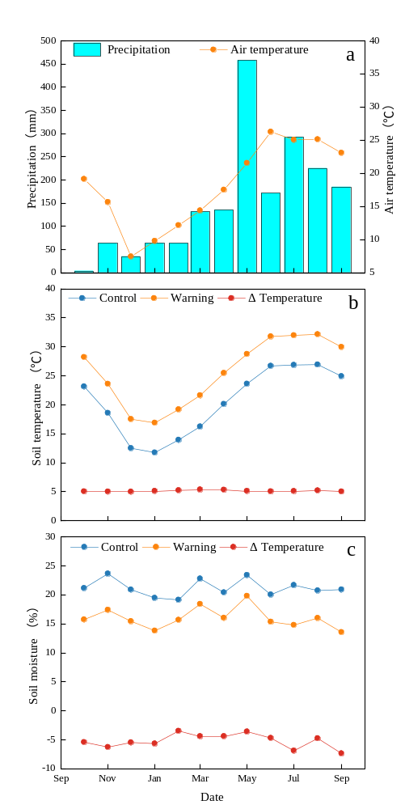
Fig.1 Month precipitation and air temperature, along with soil temperature and moisture variations at a depth of 10 cm in control and warming plots during experimental warming (from October 2014 to September 2015). Note: Δ represents the differences in soil temperature or moisture between control and warming treatment.
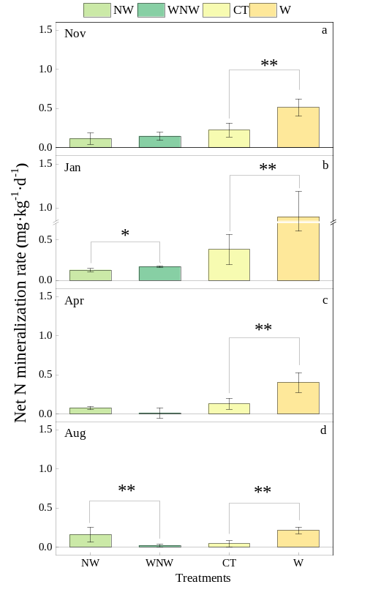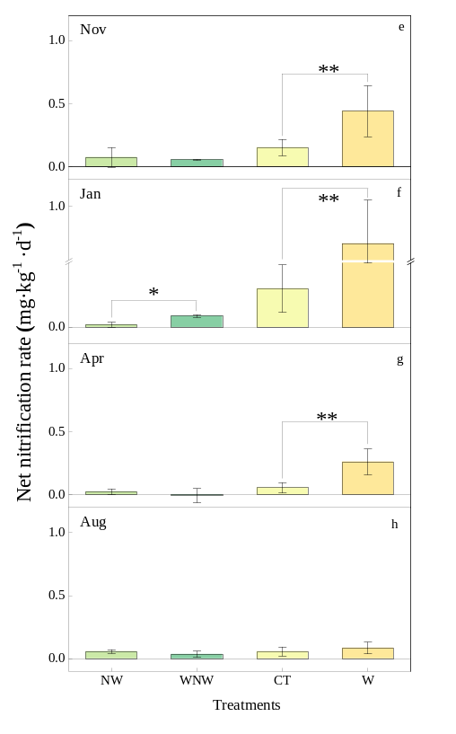
Fig.2 Soil net N mineralization and nitrification rates across different months (a-d: net N mineralization rate; e-h: net nitrification rate). Data are presented as means ± standard errors (n=5). An asterisk denotes a significant effect at P < 0.05, while two asterisks denote significance at P < 0.01.

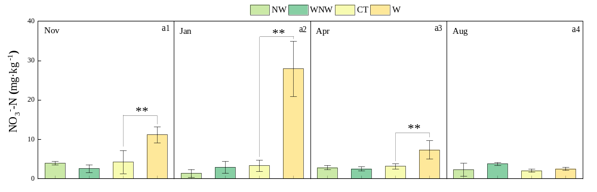
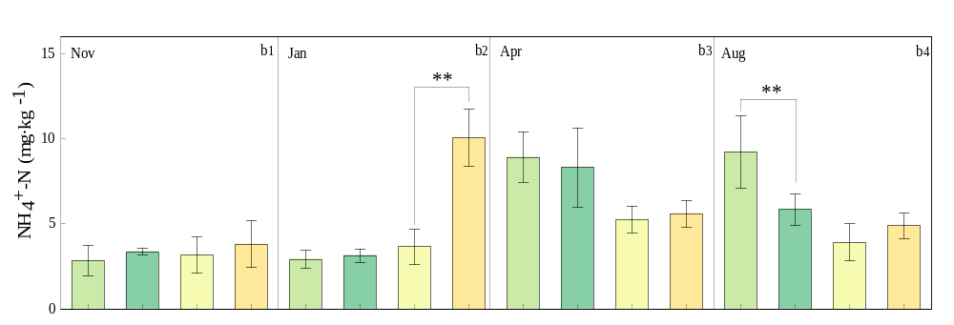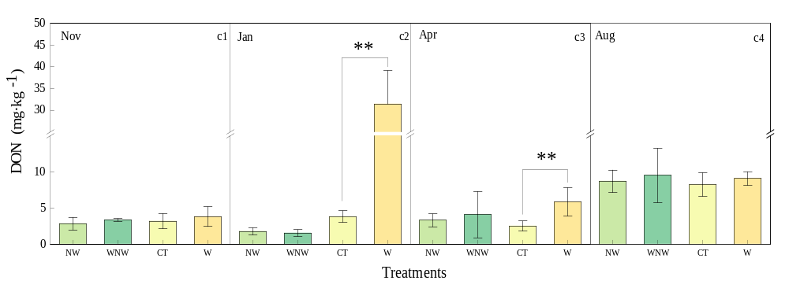
Fig. 3 Available soil N and dissolved organic N content across different months (a1-4: NO₃⁻-N; b2-d: NH₄⁺-N; c1-4: DON). Data shown as are means ± standard errors (n=5). An asterisk denotes a significant effect at P < 0.05, while two asterisks denote significance at P < 0.01.
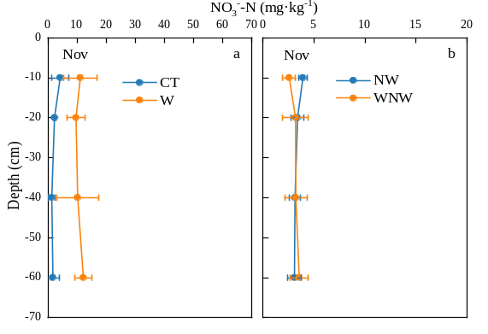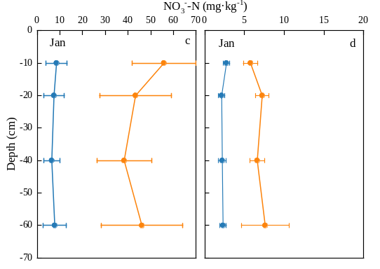
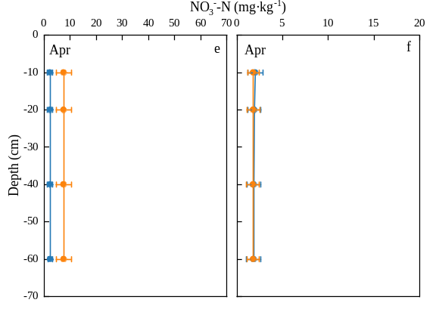
Fig. 4 Soil NO₃⁻-N content at various soil depth (plantation: a-c-e; natural regeneration: b-d-f). Data are presented as means ± standard errors (n=5).
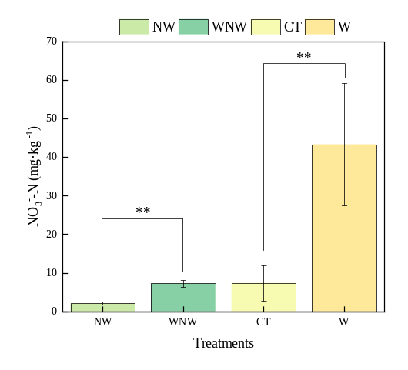
Fig. 5 Soil NO₃⁻-N content in soil leachate. Data are presented as means ± standard errors (n=5). An asterisk denotes a significant effect at P < 0.05, while two asterisks denote significance at P < 0.01.
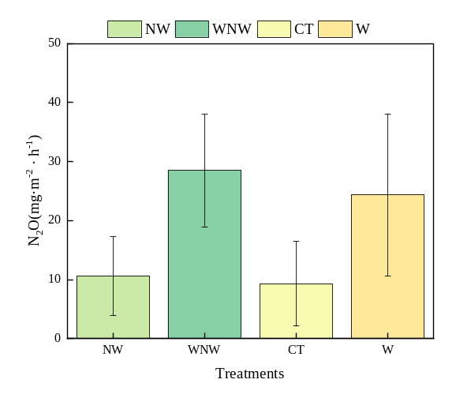
Fig.6 Soil N₂O emission flux. Data are presented as means ± standard errors (n=5). An asterisk denotes a significant effect at P < 0.05, while two asterisks denote significance at P < 0.01.
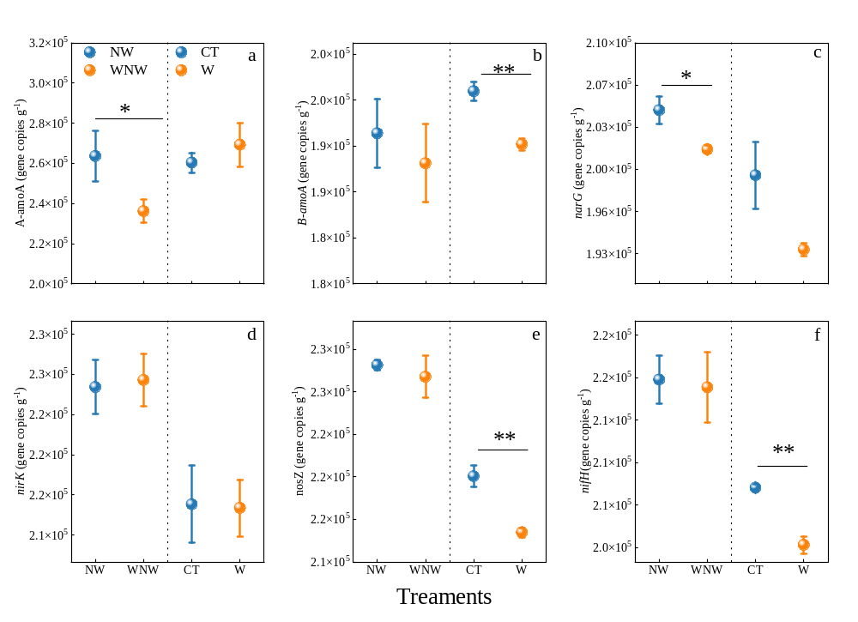Fig. 7 Abundance of functional genes involved in the N cycle (a: A-amoA; b: B-amoA; c: narG; d: nirK; e: nosZ; f: nifH). Data represent means ± standard errors (n=5). An asterisk denotes a significant effect at P < 0.05, while two asterisks denote significance at P < 0.01.
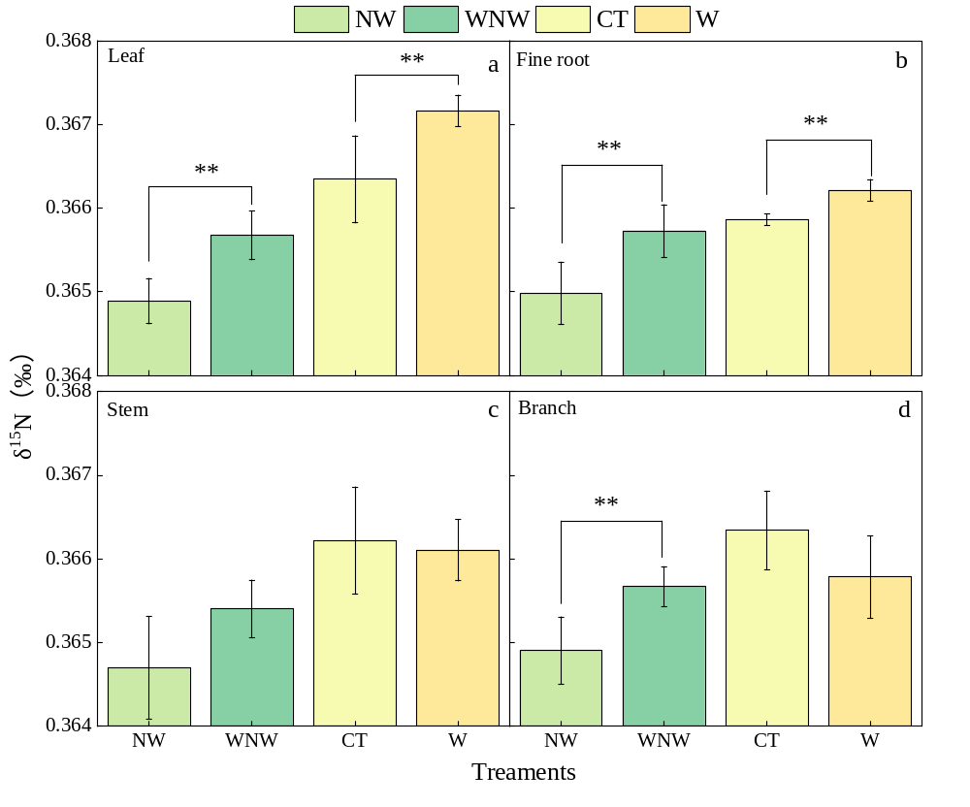Fig. 8 δ¹⁵N content in different organs of plants (a: leaves; b: fine roots; c: stem; d: branches). Data are presented a means ± standard errors (n=5). An asterisk denotes a significant effect at P < 0.05, while two asterisks denote significance at P < 0.01.

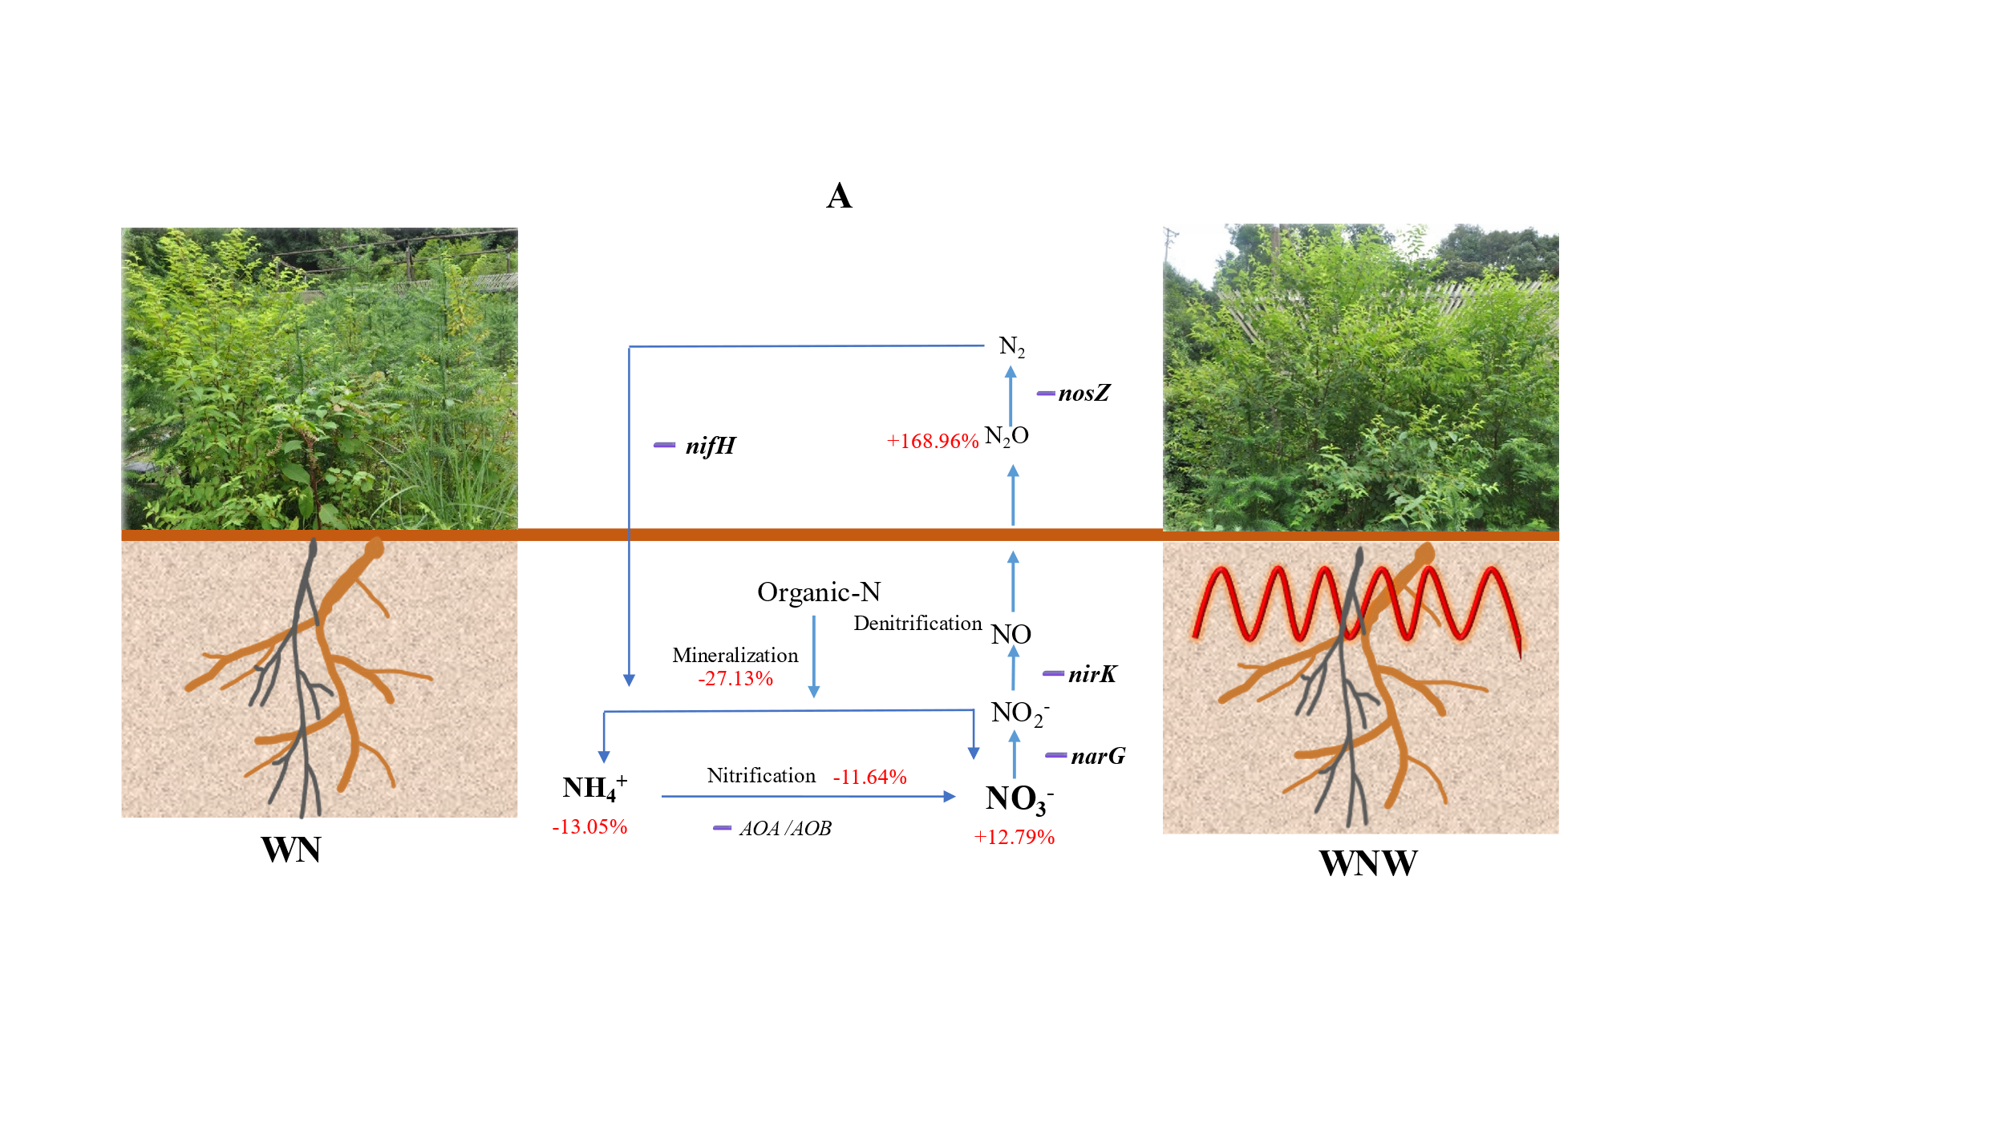
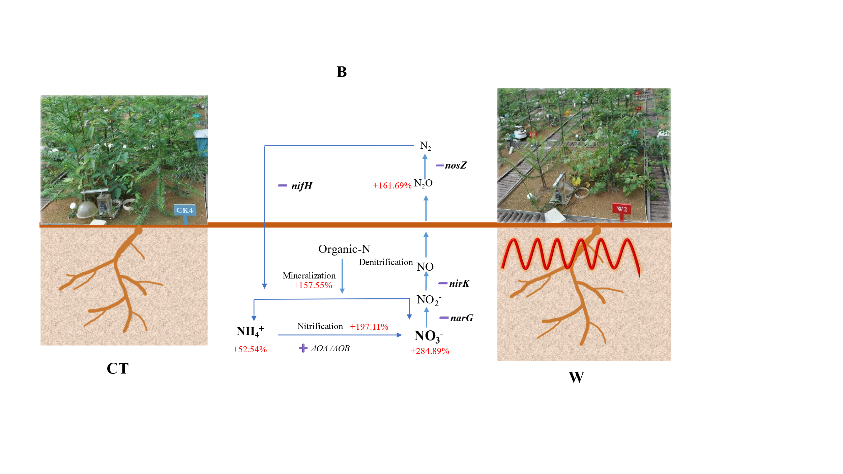
Fig. S1 Schematic diagram illustrating Nitrogen N cycle processes model diagram under soil warming in natural regeneration (A) and plantation (B). Note: The blue lines show the process of soil N cycling, the red characters show the changes of soil N conversion after soil warming, ➕or ➖ indicate the effects of soil warming on soil N conversion microorganisms.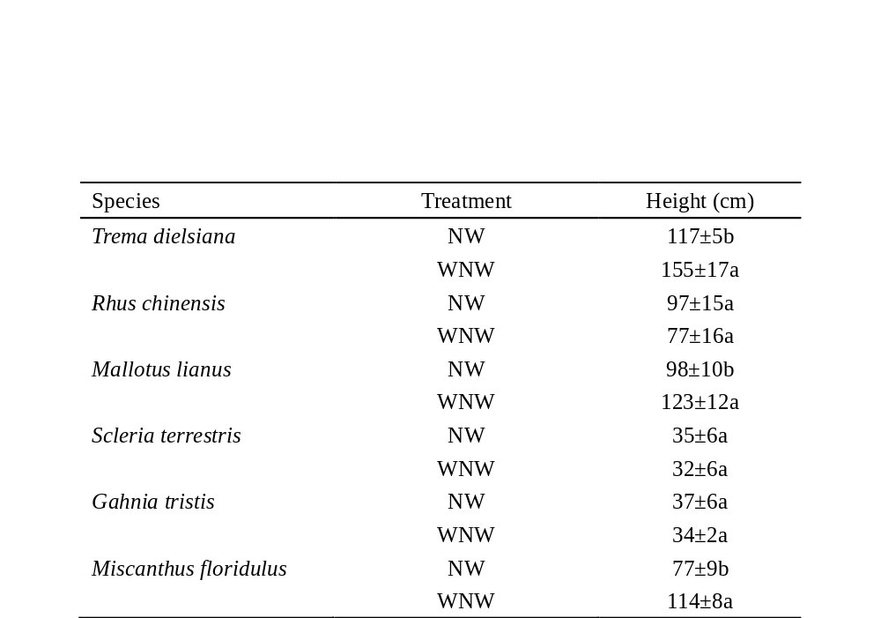
Table S1 Plant species and their respective heights in natural regeneration plots. Data are presented as means ± standard errors, n=5. Different lowercase letters indicated significant difference at the 0.05 level.
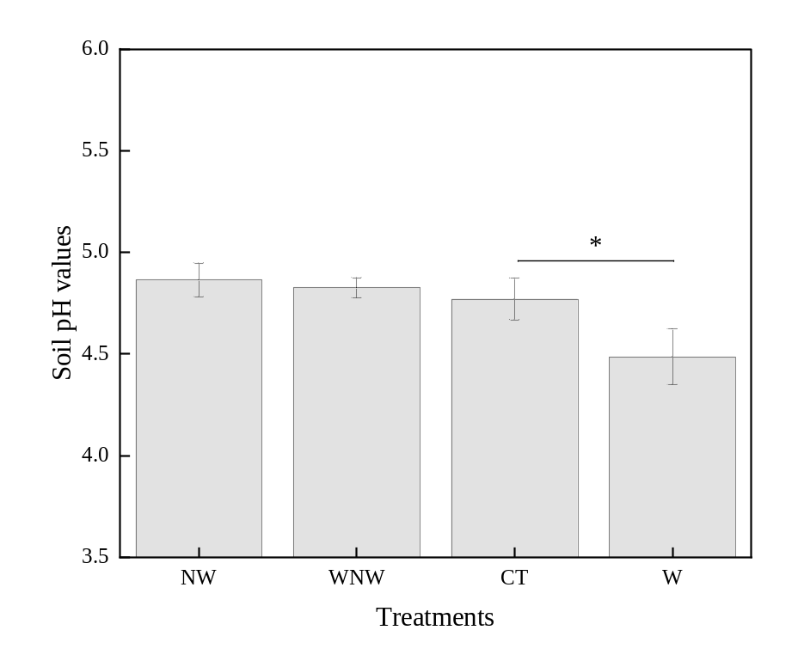
Fig. S2 Soil pH. Data are presented a means ± standard errors (n=5). An asterisk denotes a significant effect at P < 0.05.
Table S2 Ratio of NH₄⁺-N and NO₃⁻-N to inorganic nitrogen (IN)
