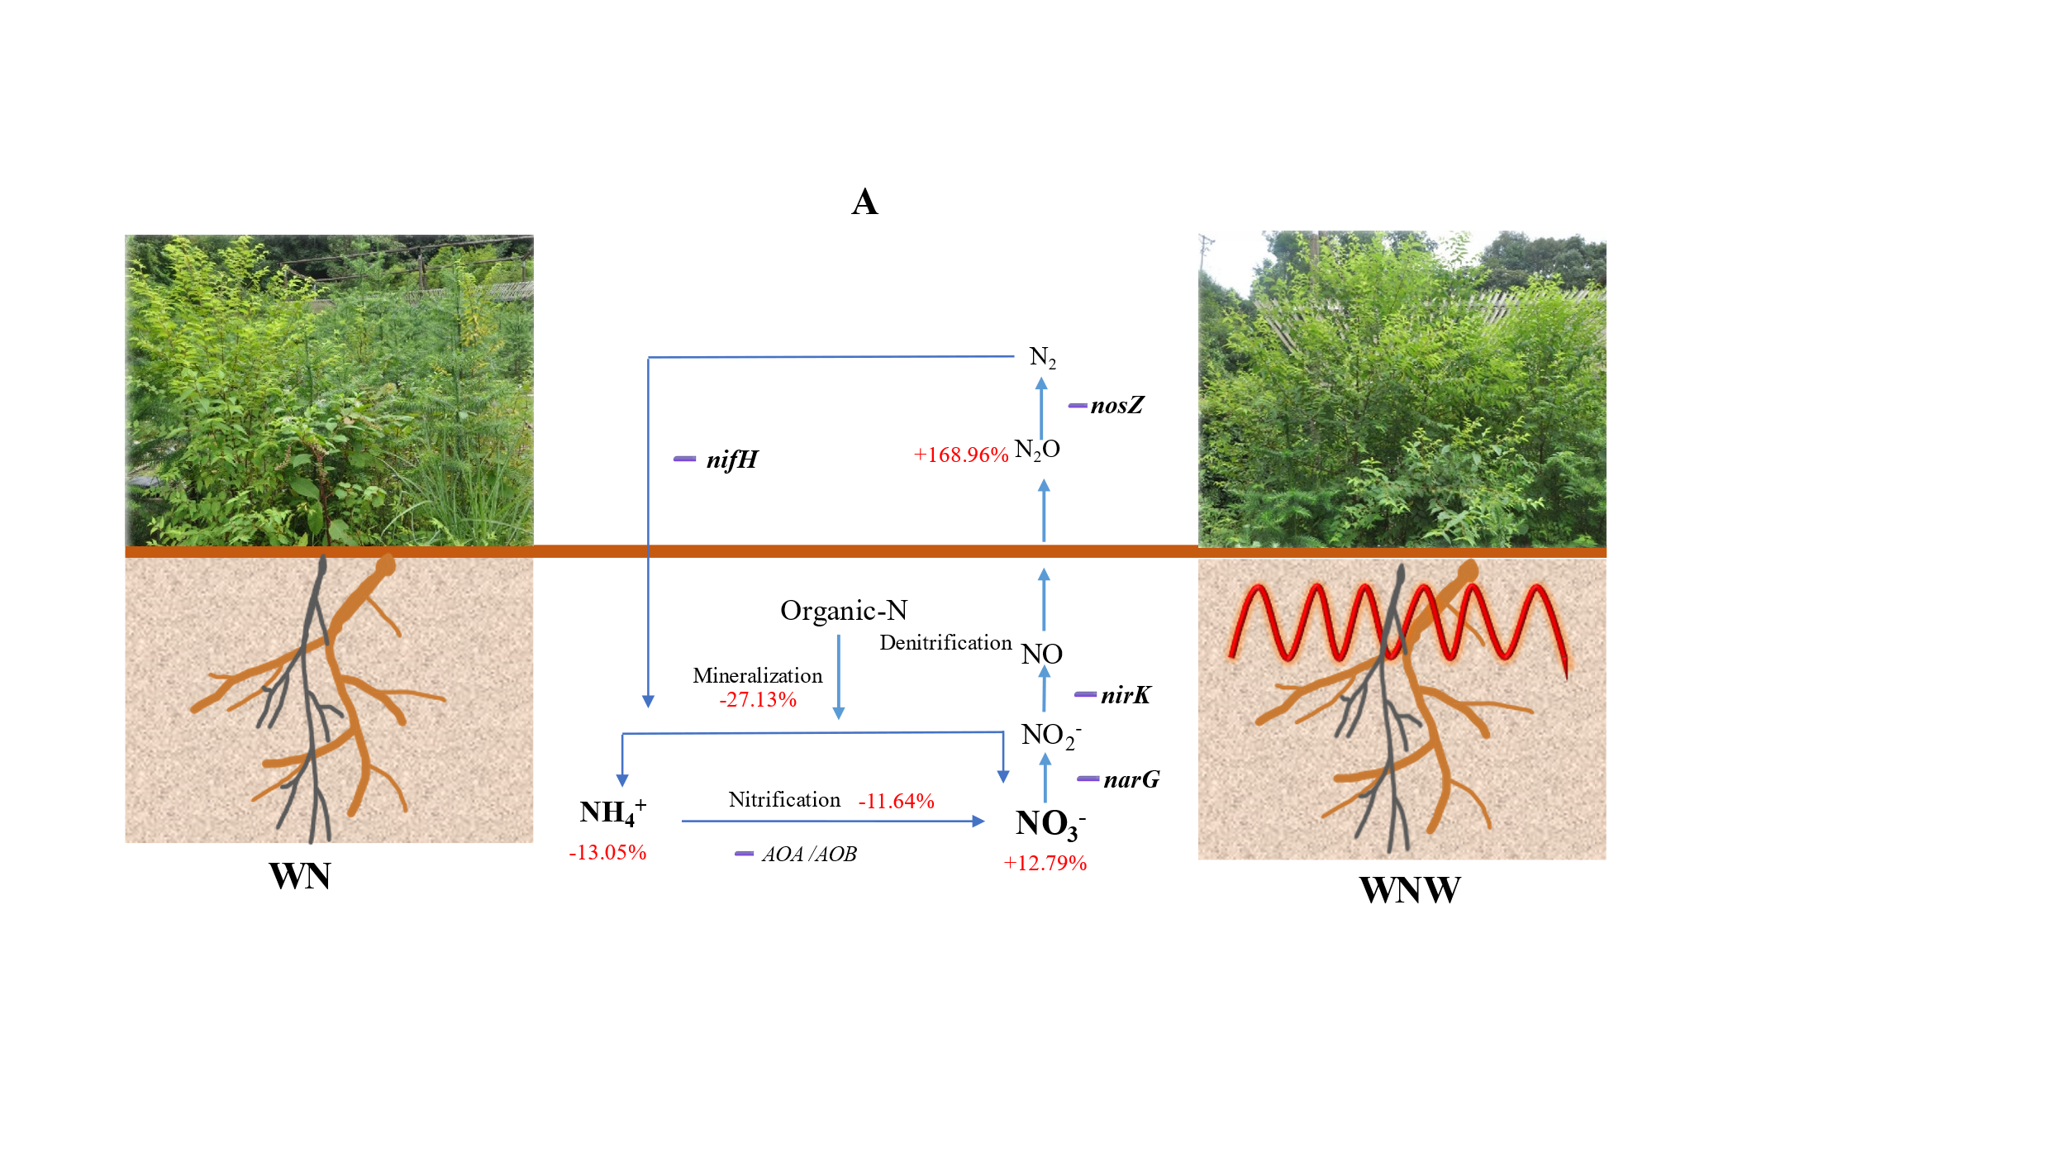
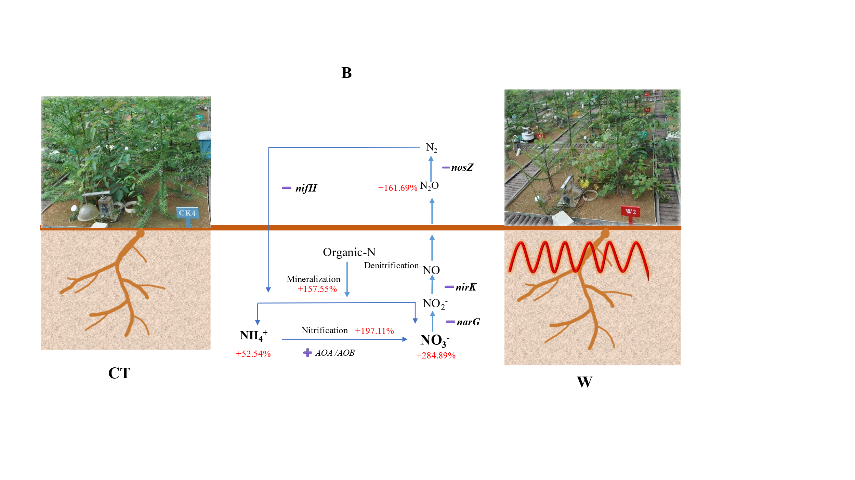
Fig. S1 Schematic diagram illustrating Nitrogen N cycle processes model diagram under soil warming in natural regeneration (A) and plantation (B). Note: The blue lines show the process of soil N cycling, the red characters show the changes of soil N conversion after soil warming, ➕or ➖ indicate the effects of soil warming on soil N conversion microorganisms.

