Supplementary information for the manuscript submission “Novel Antisense-Peptide Nucleic Acids to Prevent Bacterial Biofilm Among Gram-Negative Bacteria Implicated in Catheter-Associated Urinary Tract Infections”

Hannah Q. Karp et al.

Supplementary methods
Screening for biofilm-formation among clinical isolates
A Gram-negative repository of over 700 clinical isolates from blood, urine, and respiratory specimen collected from Carilion Clinic patients (Roanoke, VA) was created by Jayasimha Rao, Ph.D. and Anthony W. Baffoe-Bonnie, MD from 2009 to the present (IRB No. 1263). 25-30 % (vol/vol) glycerol stocks of clinical isolates of K. pneumoniae, E. cloacae, E. coli, and P. mirabilis (stored at -80 °C) were streaked onto Tryptic Soy Agar plates and incubated overnight at 37 °C. Single colonies were subcultured in 4 mL of Luria Bertani (LB) Miller’s media overnight at 37 °C in shaking conditions (200 rpm). Bacterial subcultures were normalized to optical density (OD) 600 = 0.01 in LB media. 60 µL of a standard diluted 10⁻³ tube was plated in duplicate or triplicate in a 96-well clear flat bottom polystyrene tissue culture-treated microplate, incubated statically at 30 ˚C for 24 or 48 h in a humid chamber, and biofilm biomass was quantified as described in the main methods section under “Biofilm biomass quantification”. Biofilm-forming laboratory strain of P. aeruginosa, PAO1, was used as a positive control.
Supplementary figures and tables
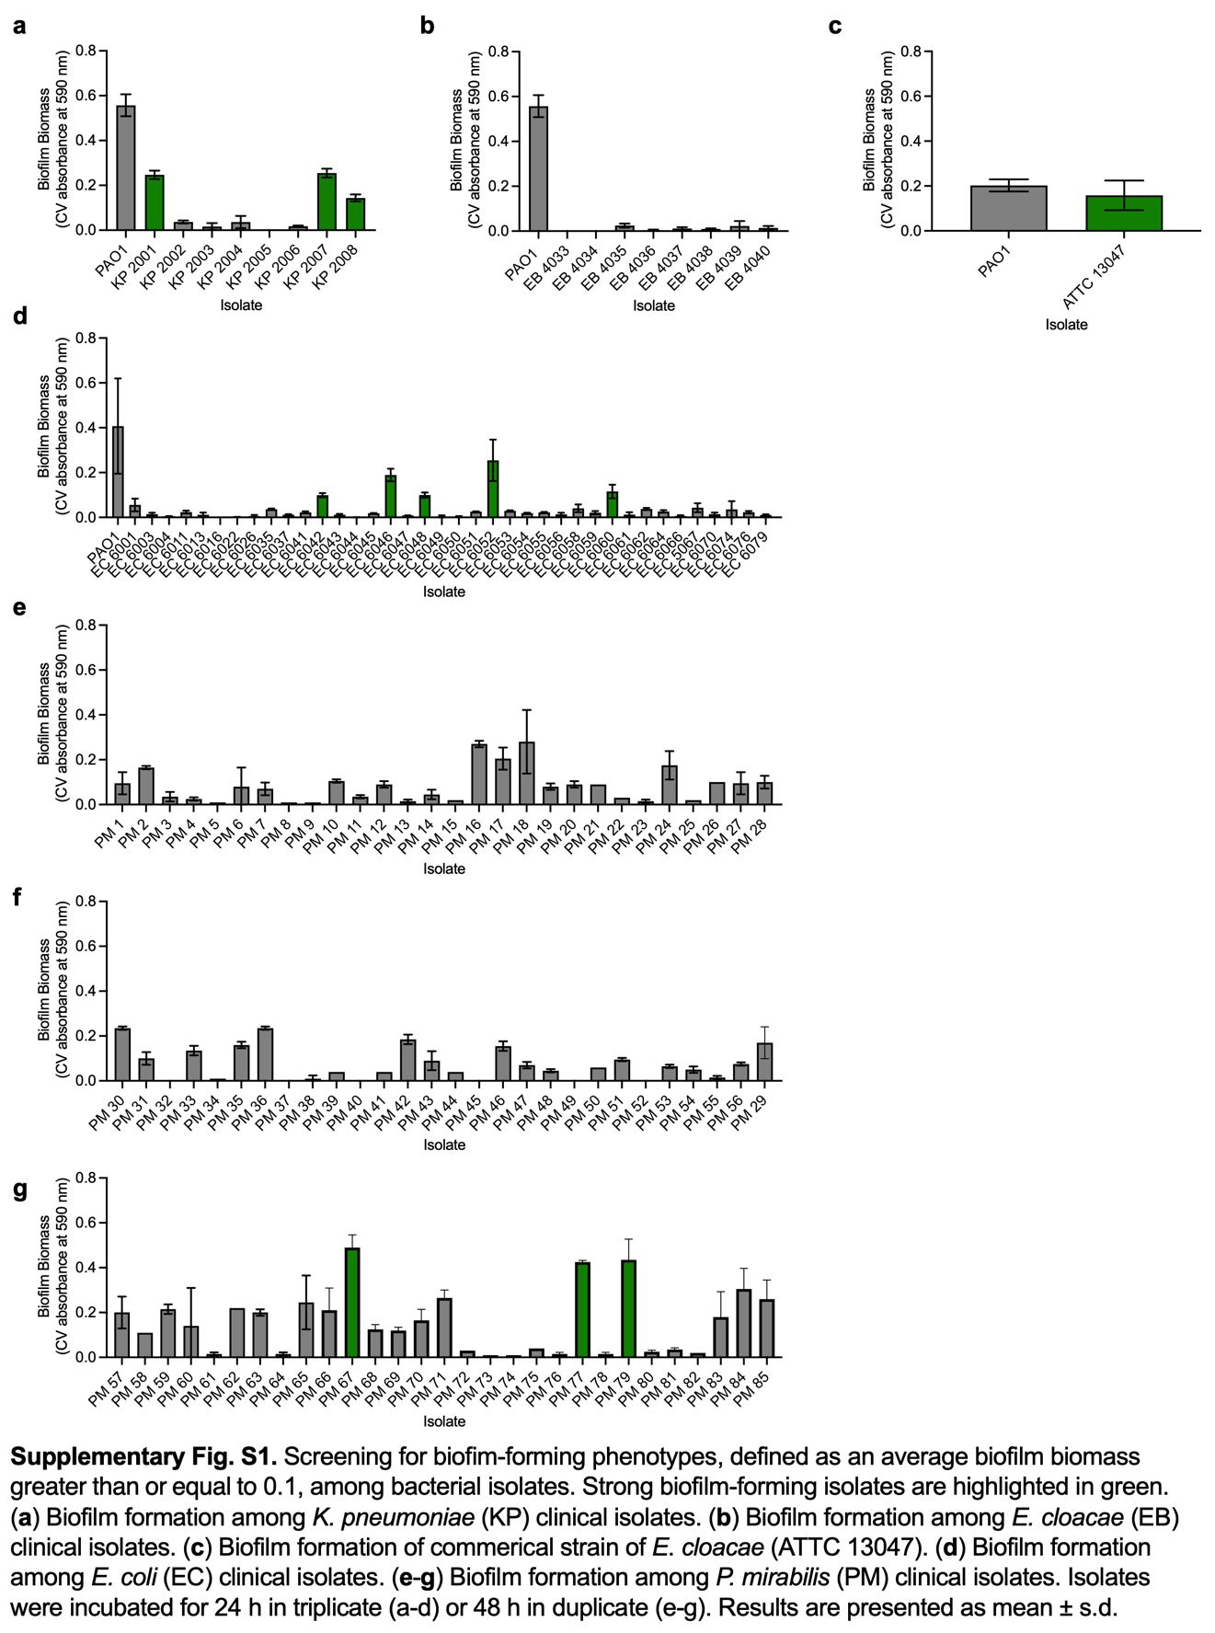
Supplementary Table S1. Bacteria-specific supplemented medias. PAO1 and K. pneumoniae utilized the standard minimal M9+ media described in the methods section under “Antisense-PNA treatment”.
Bacterial species | Major deviation(s) from the standard media
E. cloacae | Chrome azurol S(CAS) agar¹
E. coli | Chrome azurol S(CAS) agar¹
P. mirabilis | Sodium citrate, ammonium sulfate²

Supplementary references
- Louden, B. C., Haarmann, D. & Lynne, A. M. Use of Blue Agar CAS Assay for Siderophore Detection. J Microbiol Biol Educ 12, 51–53 (2011).
- Armbruster, C. E., Hodges, S. A. & Mobley, H. L. T. Initiation of swarming motility by Proteus mirabilis occurs in response to specific cues present in urine and requires excess L-glutamine. J Bacteriol 195, 1305–1319 (2013).

