Silhouette Rating Scale (SRS, Lombardo, Cerolini, Esposito & Lucidi)

ITA: 1) Osserva le figure che seguono e indica con una crocetta quale figura rappresenta COME SEI

ENG: 1) Please, observe the nine figures and select the one that you perceive as most accurately depicting your current body size

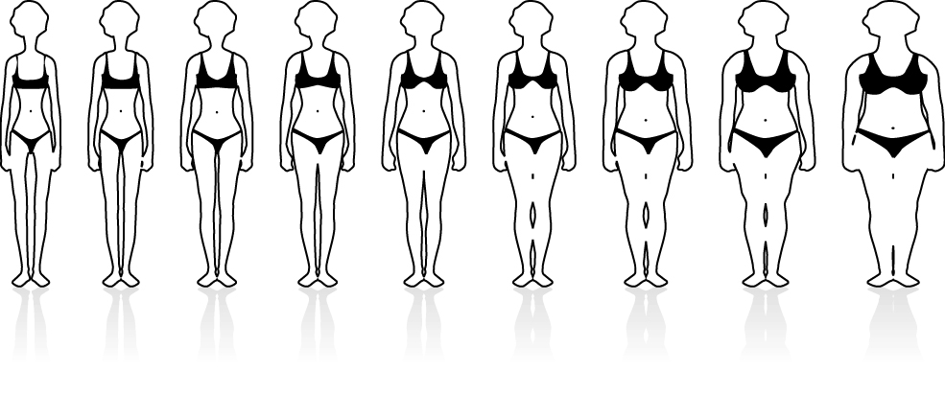
1  2  3  4  5  6  7  8  9 

ITA: 2) Osserva le figure che seguono e indica con una crocetta quale figura rappresenta COME VORRESTI ESSERE

ENG: 2) Please, observe the nine figures and select the one that that you perceive as most accurately depicting how you would like to be

1  2  3  4  5  6  7  8  9 

ITA: 1) Osserva le figure che seguono e indica con una crocetta quale figura rappresenta COME SEI
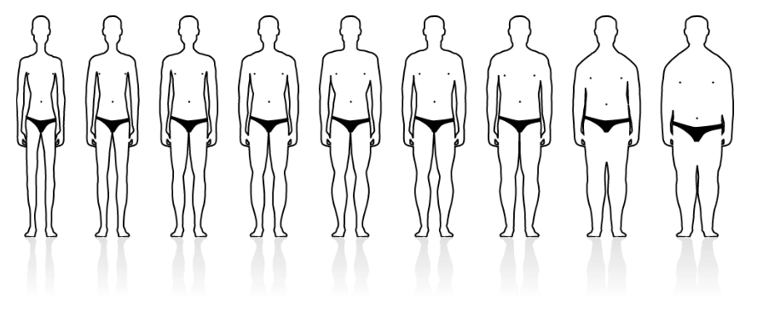
ENG: 1) Please, observe the nine figures and select the one that you perceive as most accurately depicting your current body size
1  2  3  4  5  6  7  8  9 

ITA: 2) Osserva le figure che seguono e indica con una crocetta quale figura rappresenta COME VORRESTI ESSERE

ENG: 2) Please, observe the nine figures and select the one that that you perceive as most accurately depicting how you would like to be

1  2  3  4  5  6  7  8  9 

