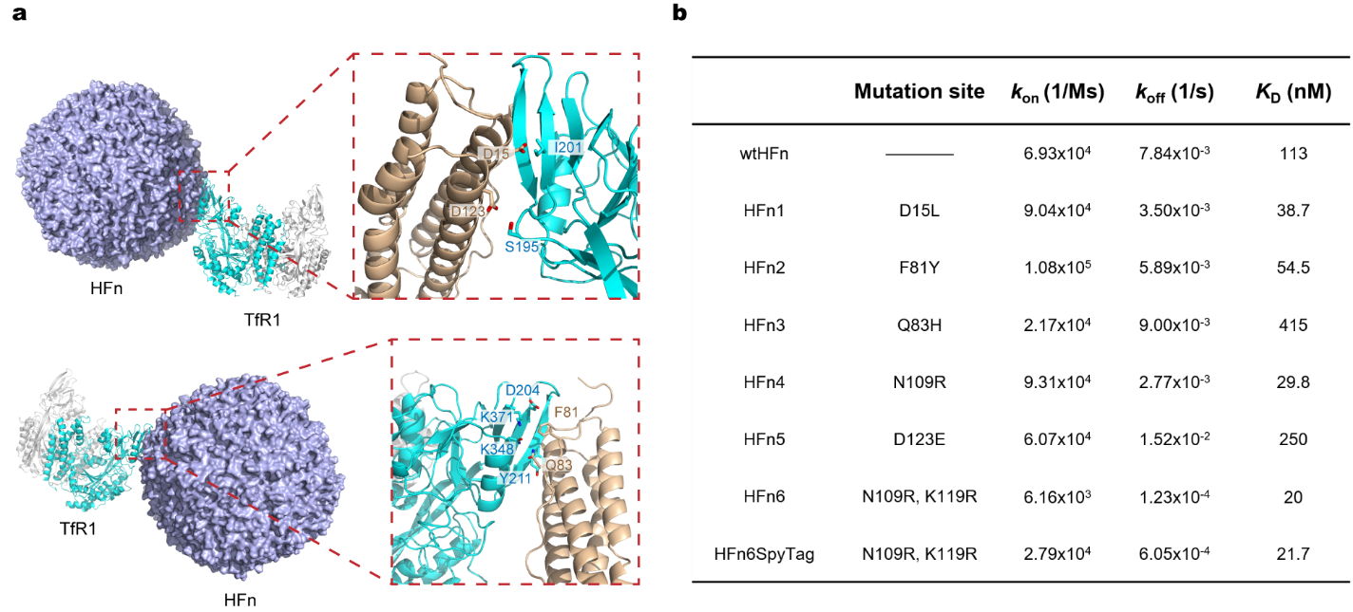
Extended Data Figure 1. Design of HFn mutations to increase the affinity between HFn and TfR1. a, Interface of the HFn and TfR1 interaction; HFn residues related to mutant-1 and mutant-5 (D15 and D123) and adjacent residues in TfR1 are shown in stick representation. b, Determination of the affinity between HFn mutants and TfR1 by SPR.
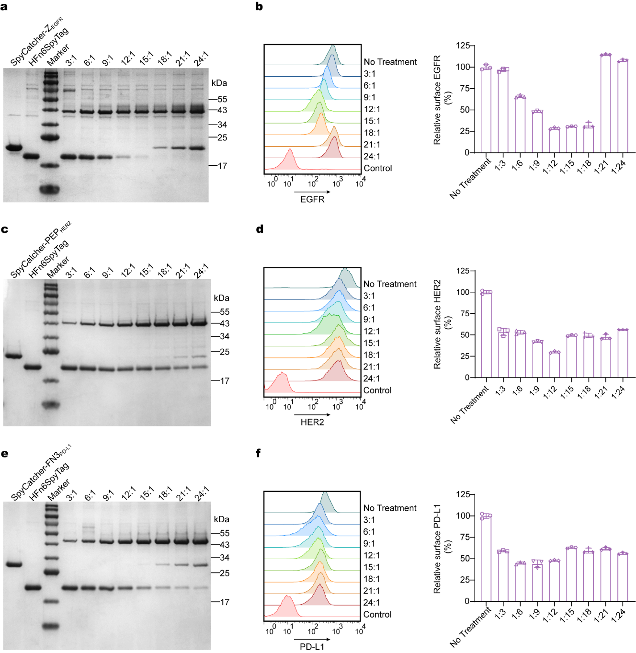
Extended Data Figure 2. Optimization of the coupling ratio between HFn6SpyTag and affibody. a, c, e, SDS‒PAGE gel images of HFn6SpyTag incubated with SpyCatcher-Z_{EGFR} (a), SpyCatcher-PEP_{HER2} (c) or SpyCatcher-FN3_{PD-L1} (e) at various molar ratios for 1 h at room temperature. b, Determination of EGFR degradation in U87 MG cells via flow cytometry following a 24-hour treatment with a mixture of HFn6SpyTag and SpyCatcher-Z_{EGFR} at various molar ratios. d, Determination of HER2 degradation in SKBR3 cells by flow cytometry following a 24-hour treatment with a mixture of HFn6SpyTag and SpyCatcher-PEP_{HER2} at various molar ratios. f, Determination of PD-L1 degradation in HT1080 cells via flow cytometry following a 24-hour treatment with mixtures of HFn6SpyTag and SpyCatcher-FN3_{PD-L1} at various molar ratios. For b, d and f, the data are presented as the mean values ± s.d. of n = 3 independent experiments.
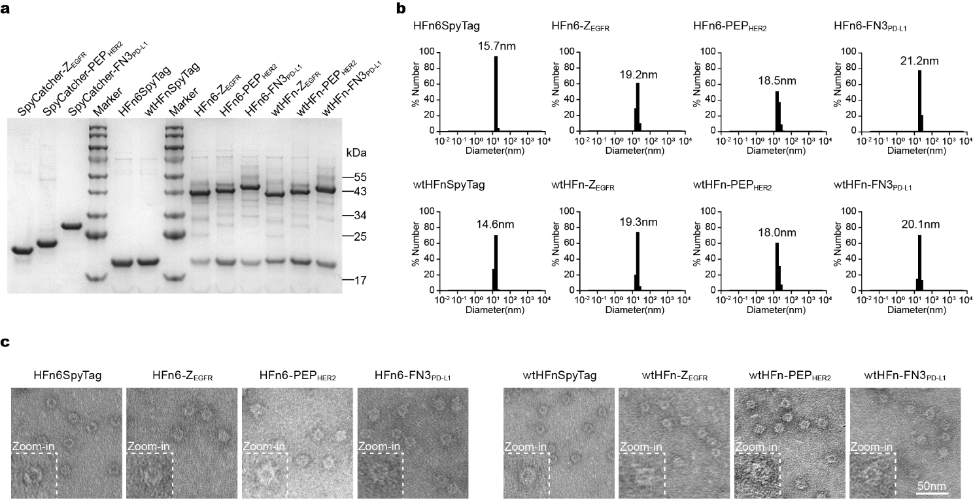
Extended Data Figure 3. Characterization of the HFn-LYTACs. a, SDS‒PAGE gel images of HFn-LYTACs utilized in both in vitro and in vivo studies. b, Size distribution of HFn-LYTACs measured by DLS. c, Characterization of HFn and HFn-LYTACs through TEM.

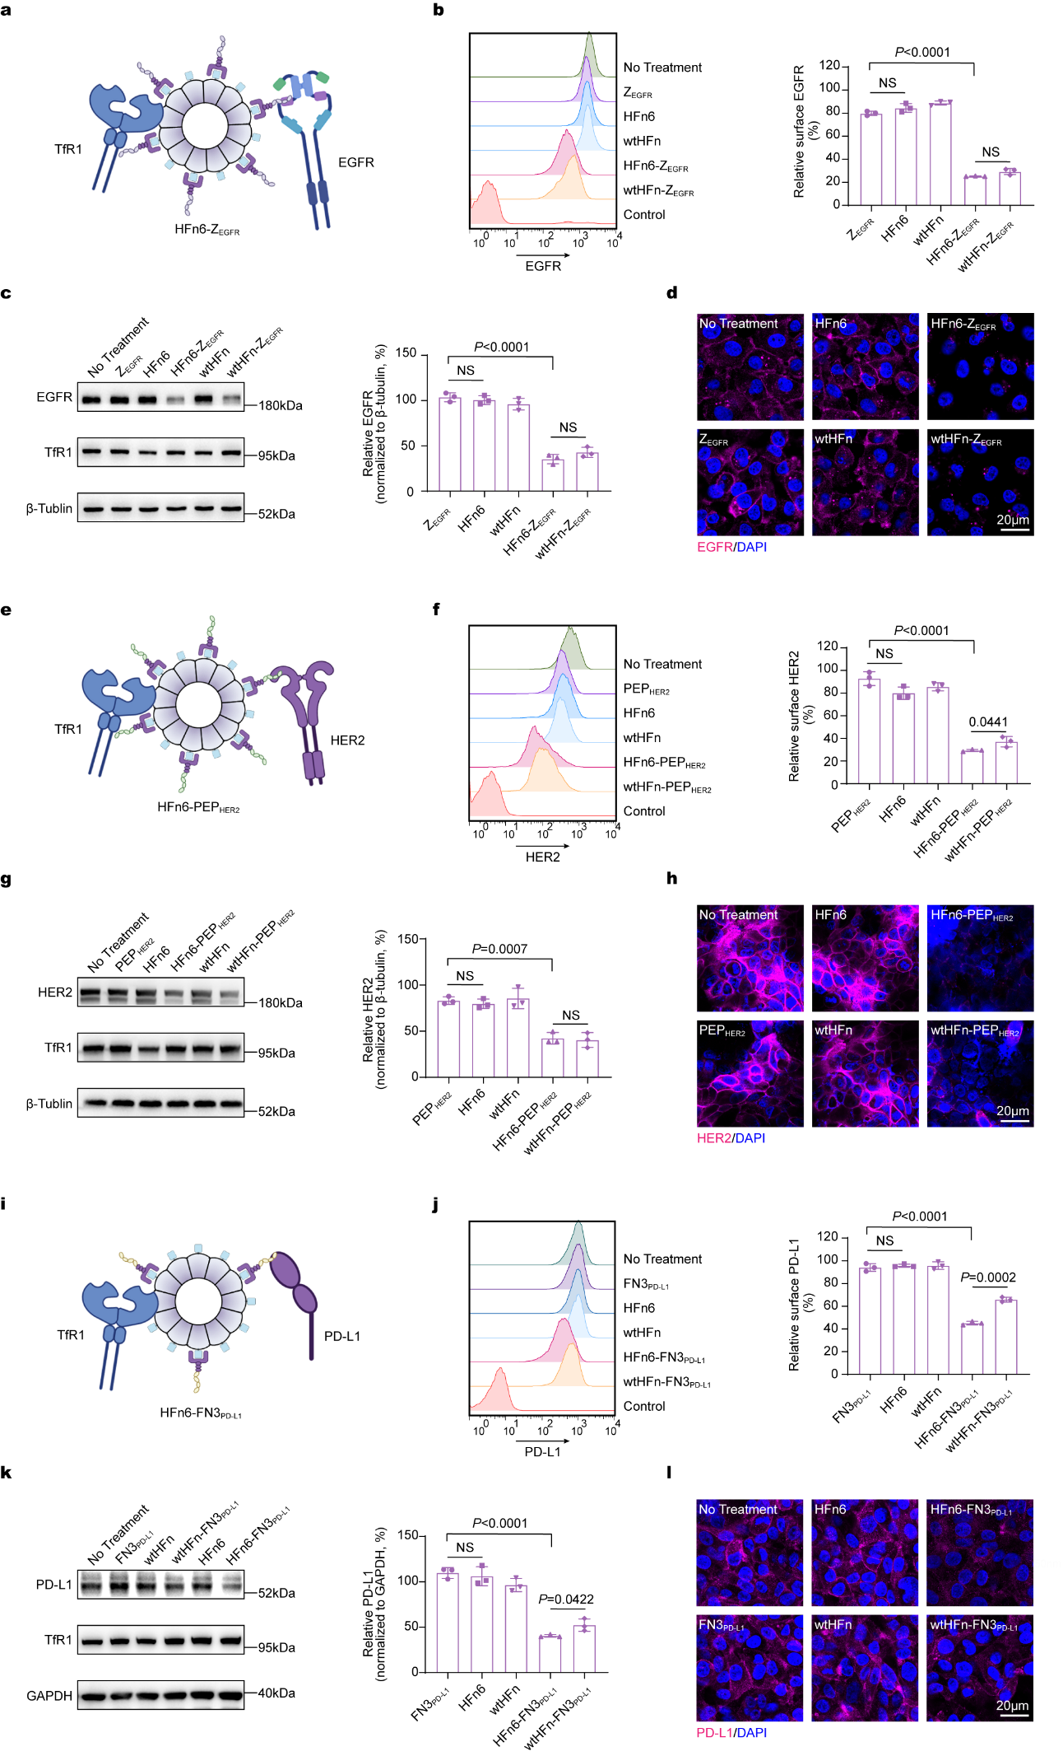
Extended Data Figure 4. The HFn-LYTAC platform promotes the degradation of various targets. a, Illustration of EGFR degradation mediated by HFn6-Z_{EGFR}. b-d, Determination of EGFR degradation in MDA-MB-231 cells via flow cytometry (b), western blotting (c) and confocal microscopy (d) following a 48-hour treatment with 300 nM HFn-LYTAC or an equivalent dose of HFn or Z_{EGFR.} e, Illustration of HER2 degradation mediated by HFn6-PEP_{HER2}. f-h, Determination of HER2 degradation in NCI-N87 cells via flow cytometry (f), western blotting (g) and confocal microscopy (h) following a 48-hour treatment with 300 nM HFn-LYTAC or an equivalent dose of HFn or PEP_{HER2}. i, Illustration of PD-L1 degradation mediated by HFn6-FN3_{PD-L1}. j‒l, Determination of PD-L1 degradation in MDA-MB-231 cells via flow cytometry (j), western blotting (k) and confocal microscopy (l) following 48 hours of treatment with 300 nM HFn-LYTAC or an equivalent dose of HFn or FN3_{PD-L1}. For all flow cytometry and western blot experiments, the data are presented as the mean values ± s.d. of n = 3 independent experiments. P values were determined by one-way ANOVA with Fisher’s LSD multiple comparisons test. NS, not significant. The icons in a, e and i were created with BioRender.com.
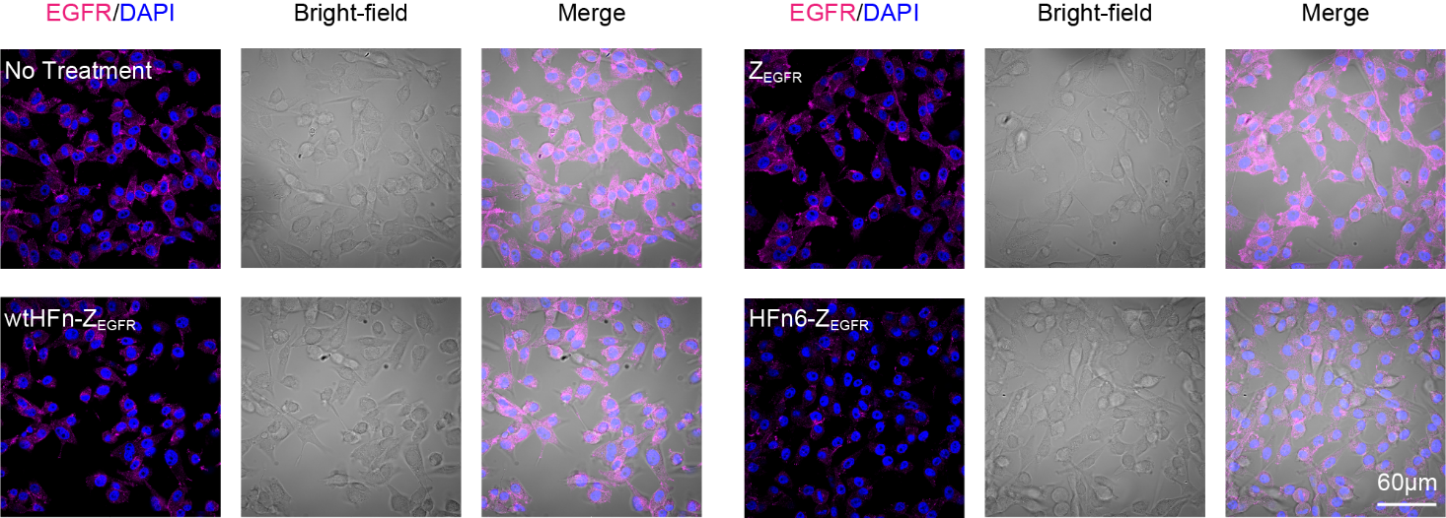
Extended Data Figure 5. Visualization of EGFR degradation in U87 MG cells by confocal microscopy after treatment with 300 nM HFn6-Z_{EGFR} or wtHFn6-Z_{EGFR} for 24 h.
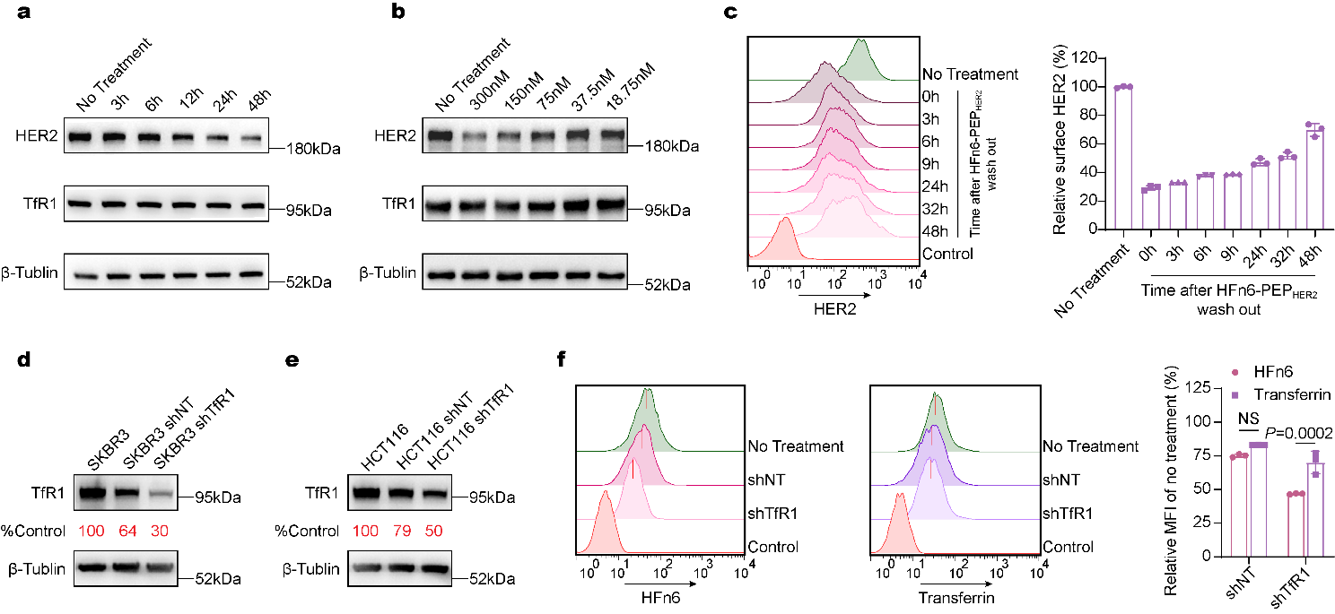
Extended Data Figure 6. Principles of HFn-LYTAC-mediated target degradation. a, Western blot analysis of HER2 degradation in SKBR3 cells incubated with 300 nM HFn6-PEP_{HER2} for 3–48 h. b, Western blot analysis of HER2 degradation in SKBR3 cells incubated with 18.75–300 nM HFn6-PEP_{HER2} for 24 h. c, HER2 levels recovered over time after removing HFn6-PEP_{HER2} from SKBR3 cells. d, shRNA-mediated knockdown of TfR1 in SKBR3 cells after 48 h of transfection. e, shRNA-mediated knockdown of TfR1 in HCT116 cells after 48 h of transfection. f, Uptake of HFn6 and transferrin in both HCT116 cells and TfR1-knockdown HCT116 cells was analyzed by flow cytometry. Compared with transferrin alone, 50% knockdown of TfR1 in HCT116 cells resulted in significantly lower uptake of HFn6. For c and f, the data are presented as the mean values ± s.d. of n = 3 independent experiments. P values were determined by two-way ANOVA with Fisher’s LSD multiple comparisons test. NS, not significant.
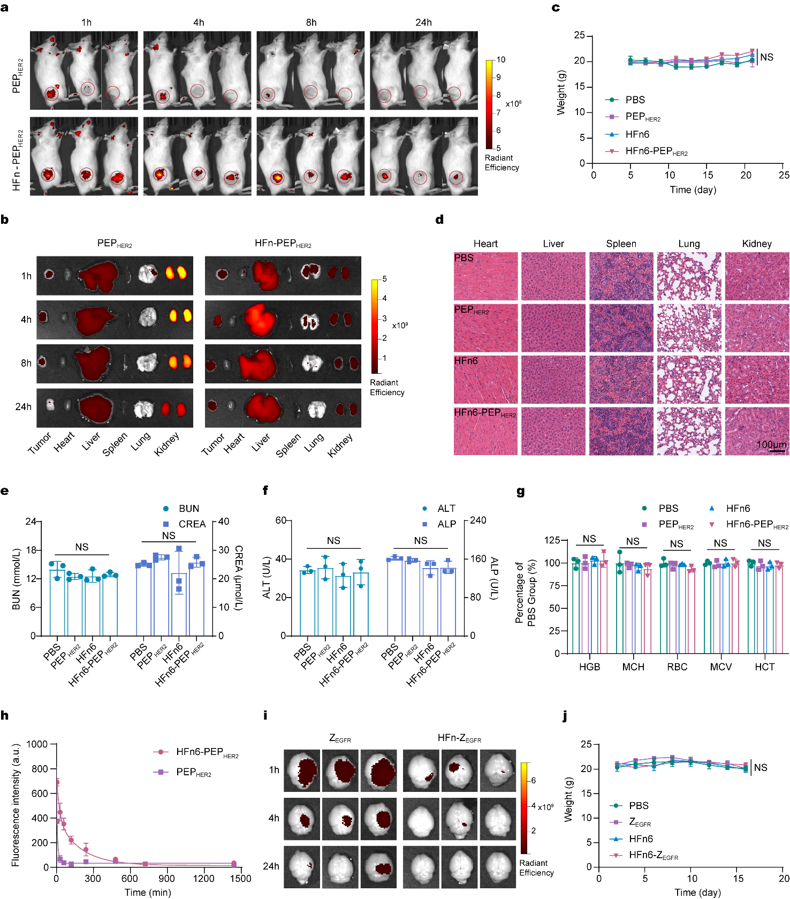
Extended Data Figure 7. Evaluation of the targeting efficacy and biocompatibility of HFn-LYTAC. a, In vivo fluorescence images of NCI-N87 xenograft tumor model mice at 1 h, 4 h, 8 h and 24 h after i.v. injection of PEP_{HER2} or HFn6-PEP_{HER2}. b, Ex vivo fluorescence images of the tumors and major organs of NCI-N87 xenograft tumor mice at 1 h, 4 h, 8 h and 24 h after i.v. injection of PEP_{HER2} and HFn6-PEP_{HER2}. c, Body weight curves of NCI-N87 xenograft tumor model mice in different treatment groups. d, Representative H&E staining images of major organs in different treatment groups. e, Serum biochemistry detection of kidney function indices (BUN and CREA) after 7 i.v. injections of different formulations. f, Serum biochemistry detection of liver function indices (ALT and ALP) after 7 i.v. injections of different formulations. g, CBC analyses of NCI-N87 xenograft tumor mice after 7 i.v. injections of different formulations. h, Evaluation of the plasma half-life of PEP_{HER2} and HFn6-PEP_{HER2}. i, Ex vivo fluorescence images of brains from U87 MG orthotopic xenograft mice at 1 h, 4 h and 24 h after i.v. injection of Z_{EGFR} or HFn6-Z_{EGFR}. j, Body weight curves of U87 MG orthotopic xenograft mice in different treatment groups. For e, f, g and h, the data are presented as the mean values ± s.d. of n = 3 independent experiments. P values were determined by one-way ANOVA with Fisher’s LSD multiple comparisons test. For c and j, the data are presented as the mean values ± s.d. of n = 6 and n = 5 independent experiments, respectively. P values were determined by two-way ANOVA with Dunnett’s multiple comparisons test. NS, not significant.

Extended Data Table 1. Determination of the affinity between HFn-LYTAC and TOI or TfR1 by SPR.
