Table S1. Measured methods and meanings of URM parameters¹
Parameters (Unit) | Schema or formula | Definition or measurement | Significance or role in this study
Active area (cm²) | 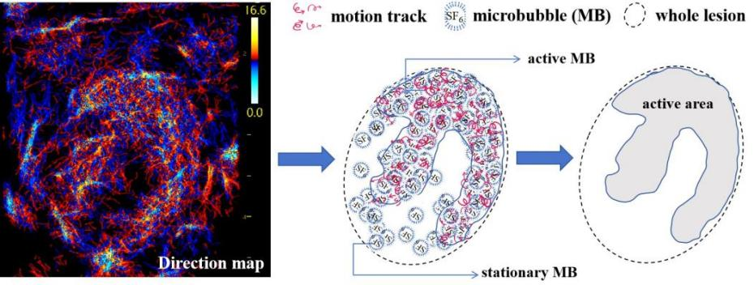 | In the direction map, compared with no MB area or the area where MBs are stationary, the CEUS MBs have visible motion track in the active area. | This is a hemodynamic area, rather than a vascular closure or a liquefied necrosis area, where the MBs move more frequently with disordered orientation.
Area ratio (also called as “vessel ratio”) (none) | 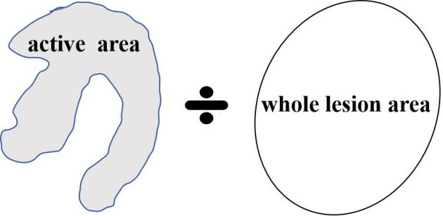 | Active area divided by the area of the entire lesion. | The ratio excludes the influence of different lesion size, and reflects the contribution of the vascularly active region to the entire lesion in terms of microvascular metastatic potential.
Blood vessel complexity (none) | 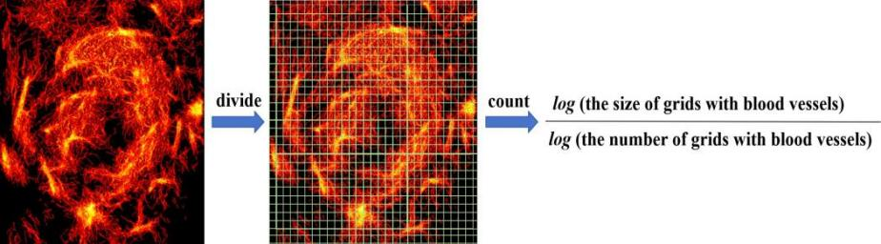 | Images are multiple times divided into many small grids with different scales (sizes). Count the number of grids with blood vessels and the size of grids. Use a formula to get a slope value based on their log ratio. The greater the difference, the higher the complexity of the microvessels. | Quantify whether the shape of blood vessels is curved or disordered.
Complexity ratio (none) | 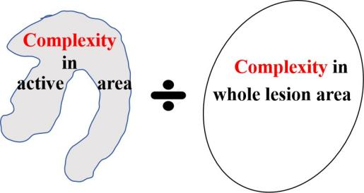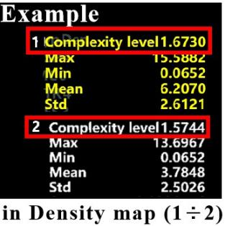 | The ratio of “vessel complexity in region 1” to “vessel complexity in region 2”². | Reflect the difference in blood vessel complexity between the two regions.
Blood vessel density (none) | 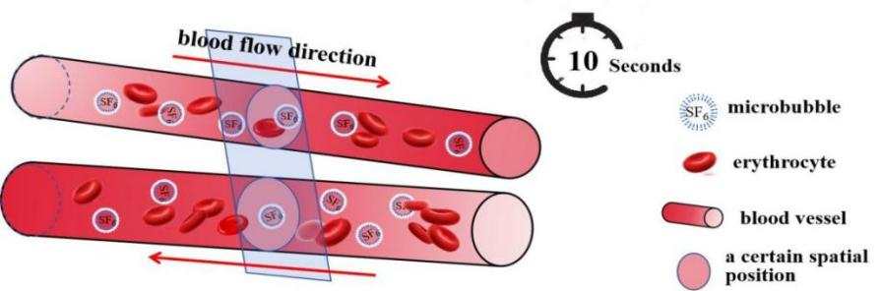  For example, a certain spatial position (area) has 2 vessels. In 10 s, 3 MBs in these areas showed movement. | The number of MB that moved through a certain spatial position in the blood vessel during the acquisition time (usually 10 s). The greater the number of MB that have moved through this spatial position, the greater the density value corresponding to this point. | An actual MB density reflect the blood vessel density in the measured area.
Density ratio (none) | 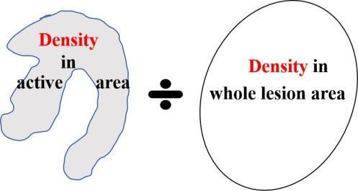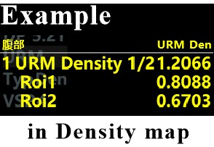 | The ratio of “vessel density in the region of interest (Roi) 1” to “vessel density in the Roi 2”.² | Reflect the difference in blood vessel density between the two regions.
Blood flow velocity (mm/s) | 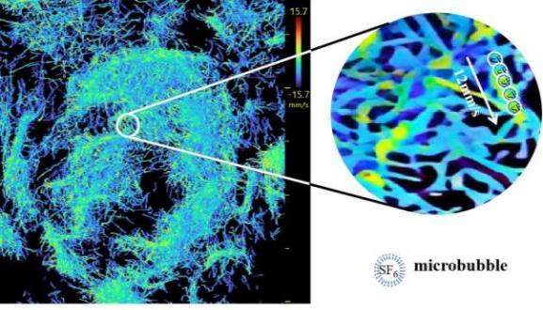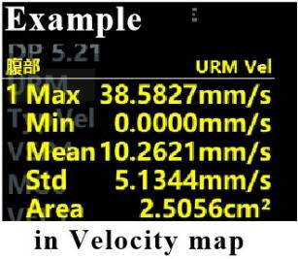 | MB displacement/movement in unit time at the region of interest. The distribution character of velocity was determined in the form of “maximum, minimum, and average”. | The actual speed of MB movement reflects the velocity of the blood in the measured area.
Blood vessel diameter (µm) | 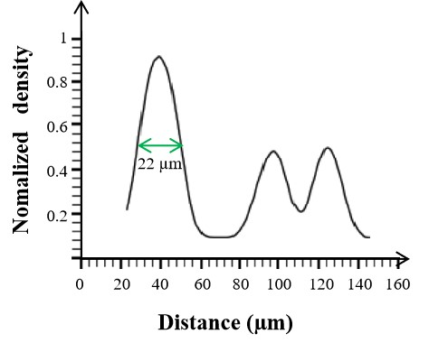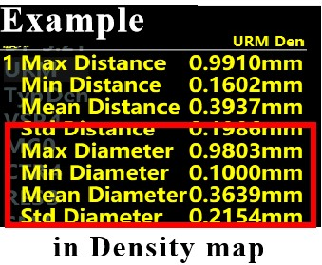  The distance marked by green double arrow is the vessel diameter. | MB concentrations are highest at the centre of the vessel and lowest at the edge of the vessel; therefore, MB concentrations from one side of the vessel to the opposite side exhibit a plot of “low-high-low” smooth peak-like distribution. At the selected measurement location, half of the peak base that tangent of the smooth peak (that is, the distance between MB at the lowest MB concentration) is the vascular diameter.³ The distribution of vessel diameter was determined in the form of “maximum, minimum, and average”. | In theory, the larger the diameter, the greater the blood flow.
Perfusion index (none) | Perfusion index = “mean blood flow velocity” × “area ratio”⁴  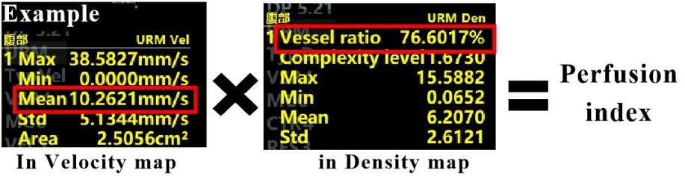 | Perfusion index cannot be directly obtained from URM images. It was calculated by multiplying two measured parameters. | Area with high perfusion index have more blood vessels and faster blood flow.
¹ MB, microbubbles; URM, ultrasound resolution microscopy; CEUS, contrast-enhanced ultrasound.
² In this study, the active area is referred by “region 1” and “Roi 1” and the total area of the lesion are referred by “Region 2” and “Roi 2”.
³ The measurement method regarding “half of the peak base tangent of the smooth peak (that is, the distance between MB at the lowest MB concentration) is the vascular distance” is referred from the article [42].
⁴ “Area ratio” was shown as “vessel ratio” in the ULTIMUS 9E US system screen, which are actually the same parameters.

