Acylcarnitine profiling in meningiomas with different NF2 mutation status
Joanna Bogusiewicz ¹, Jacek Furtak ^{2,3}, Marcin Birski ³, Krystyna Soszyńska ⁴, Anna Majdańska ⁴, Agata Ryfa ⁴, Marek Harat ^{2,3}* and Barbara Bojko ¹*
¹ Department of Pharmacodynamics and Molecular Pharmacology, Faculty of Pharmacy, Collegium Medicum in Bydgoszcz, Nicolaus Copernicus University in Torun, Bydgoszcz, Poland
² Medical Faculty, Bydgoszcz University of Science and Technology, Bydgoszcz, Poland
³ Department of Neurosurgery, 10th Military Research Hospital and Polyclinic, Bydgoszcz, Poland
⁴ Laboratory of Clinical Genetics and Molecular Pathology, Department of Medical Analytics, 10th Military Research Hospital and Polyclinic, Bydgoszcz, Poland
* Correspondence: harat@10wsk.mil.pl (M.H.), bbojko@cm.umk.pl (B.B.).

SUPPLEMENTARY MATERIALS

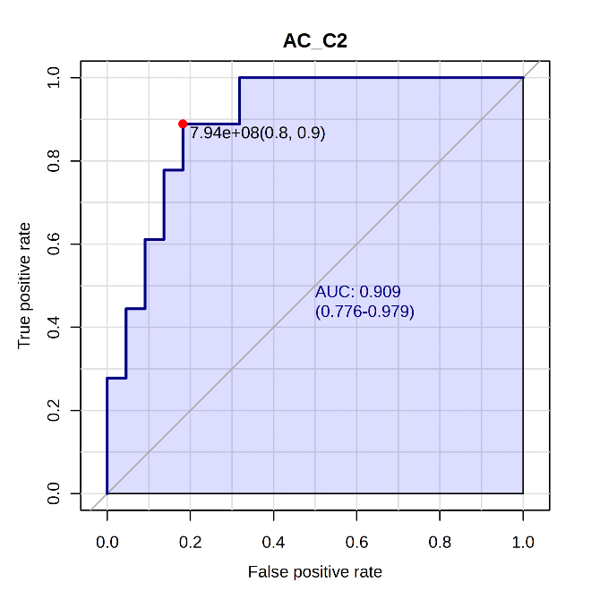 | 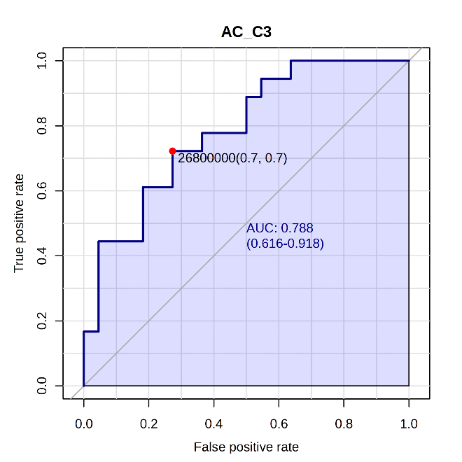
AC C2:0 | AC C3:0
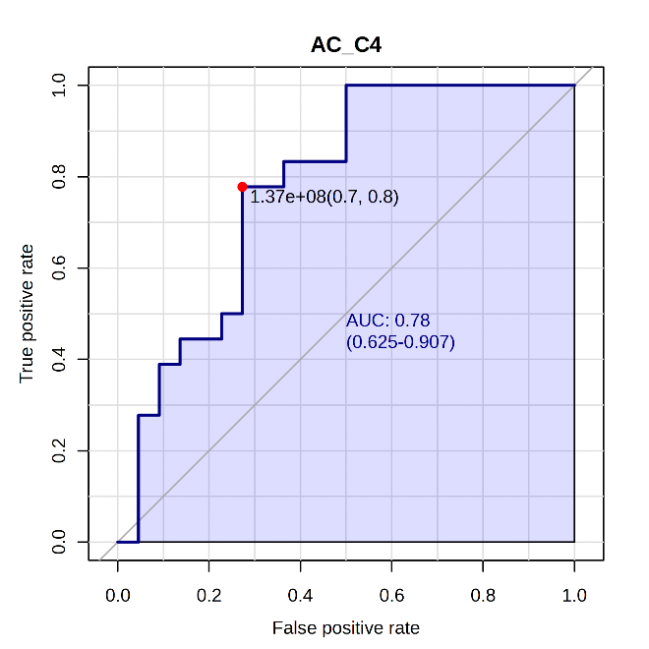 | 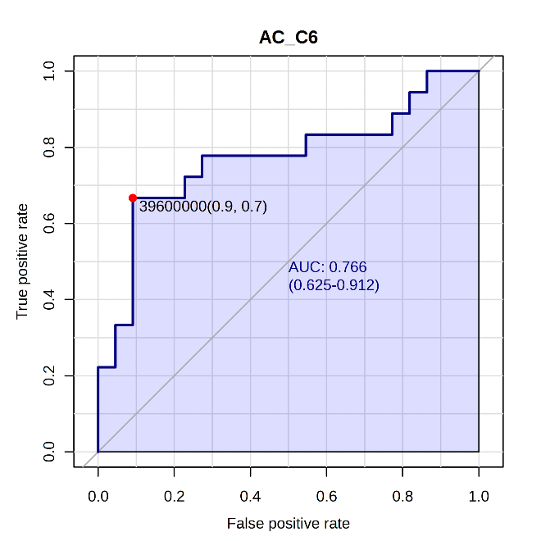
AC C4:0 | AC C6:0
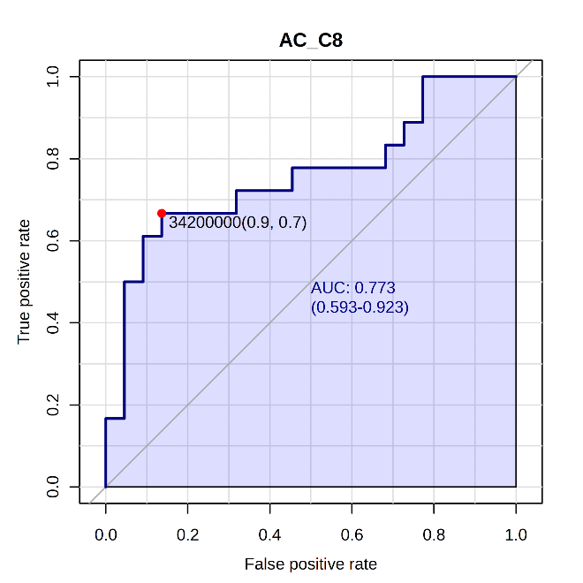 | 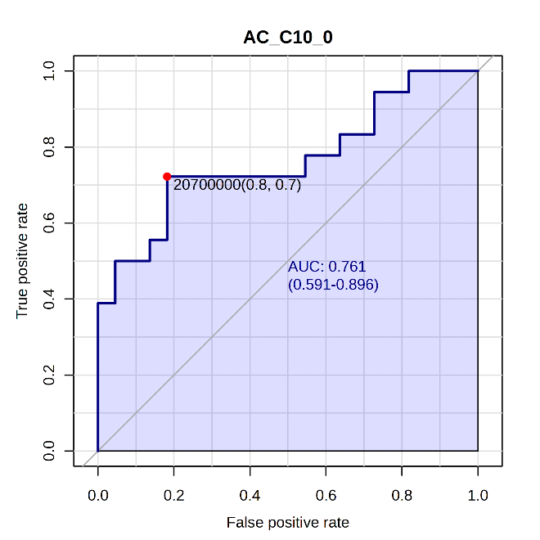
AC C8:0 | AC C10:0
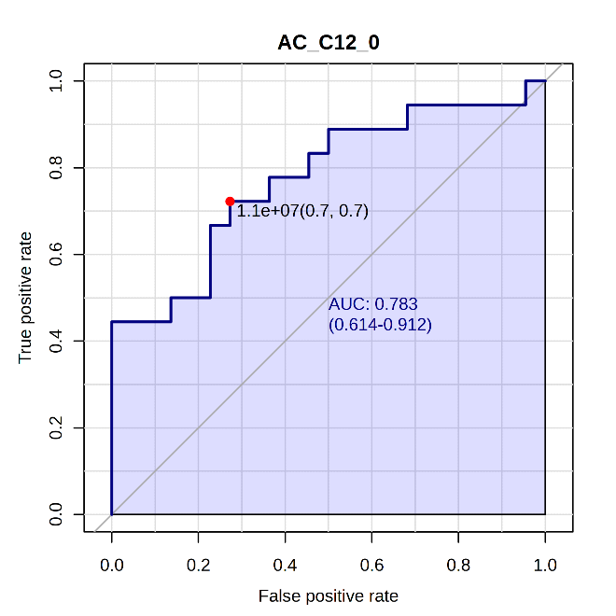 | 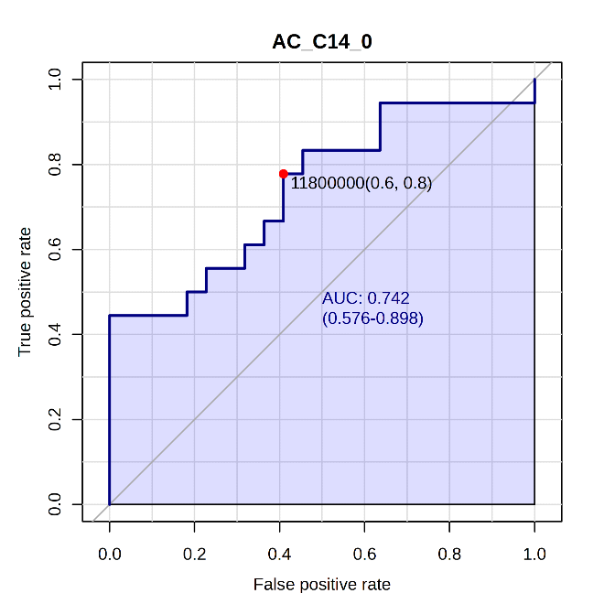
AC C12:0 | AC C14:0
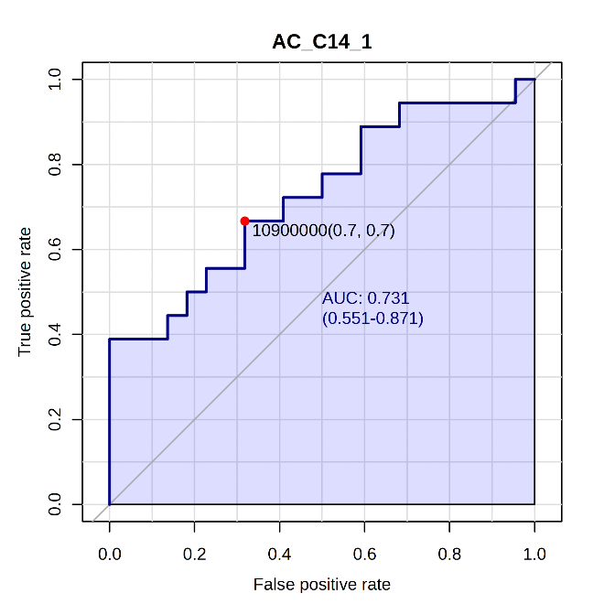 | 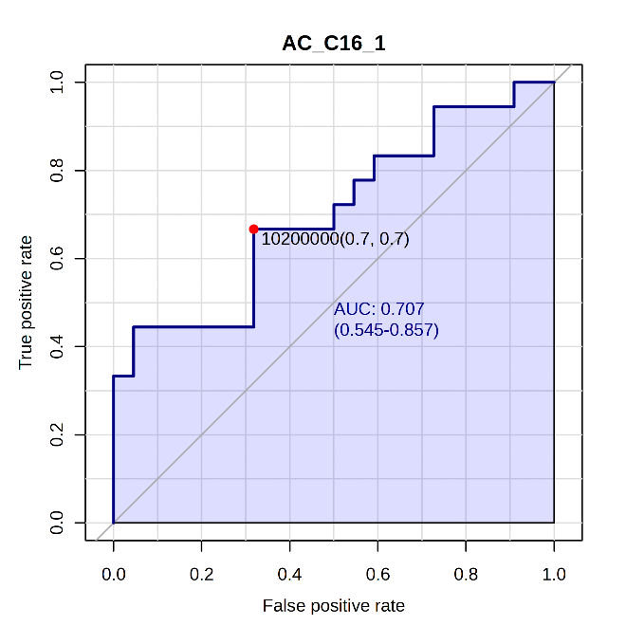
AC C14:1 | AC C16:1

Fig. S1. Receiver operating characteristic(ROC) curves for significantly altered acylcarnitines in NF2 mutated and NF2 wildtype meningiomas.
‘

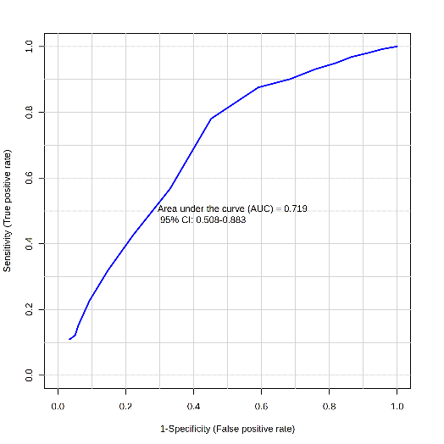
Fig. S2. Receiver operating characteristic(ROC) curve for all studied acylcarnitines in NF2 mutated and NF2 wildtype meningiomas.

