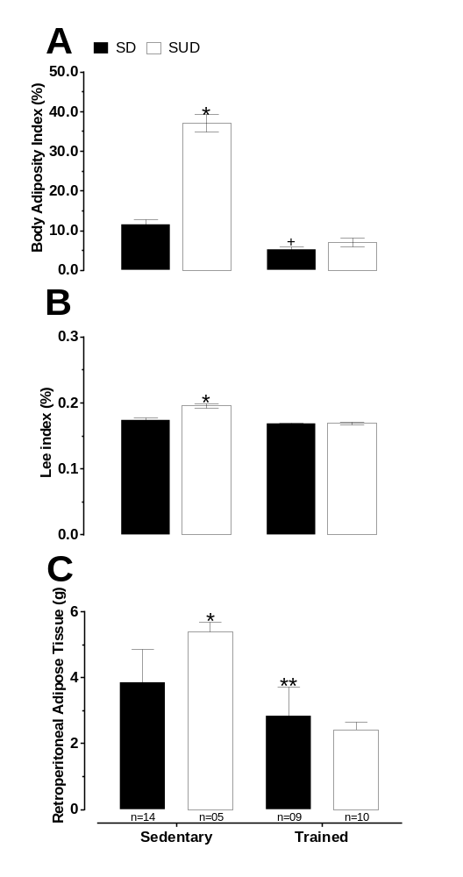
Figure S1: Body adiposity index values (panel A), *different from S-SD, T-SD and T-SUD groups, ⁺different from S-SD group. Lee index values (panel B), *different from S-SD, T-SD, T-SUD groups. Retroperitoneal adipose tissue weight values (panel C), *different from S-SD, T-SD and T-SUD groups, **different from S-SD group. It was used the parametric test, two-way ANOVA followed by Tukey’s post-test; p<0.05; all the measurements above were realized after the 8th week of T. The bars represent group mean data. Differences among the pairs of means are indicated by different signs.

