ARRIVE CHECKLIST
1. Study design
Describe in Supplementary Material in scheme of experimental design (figure S2) and quoted in the page 5.

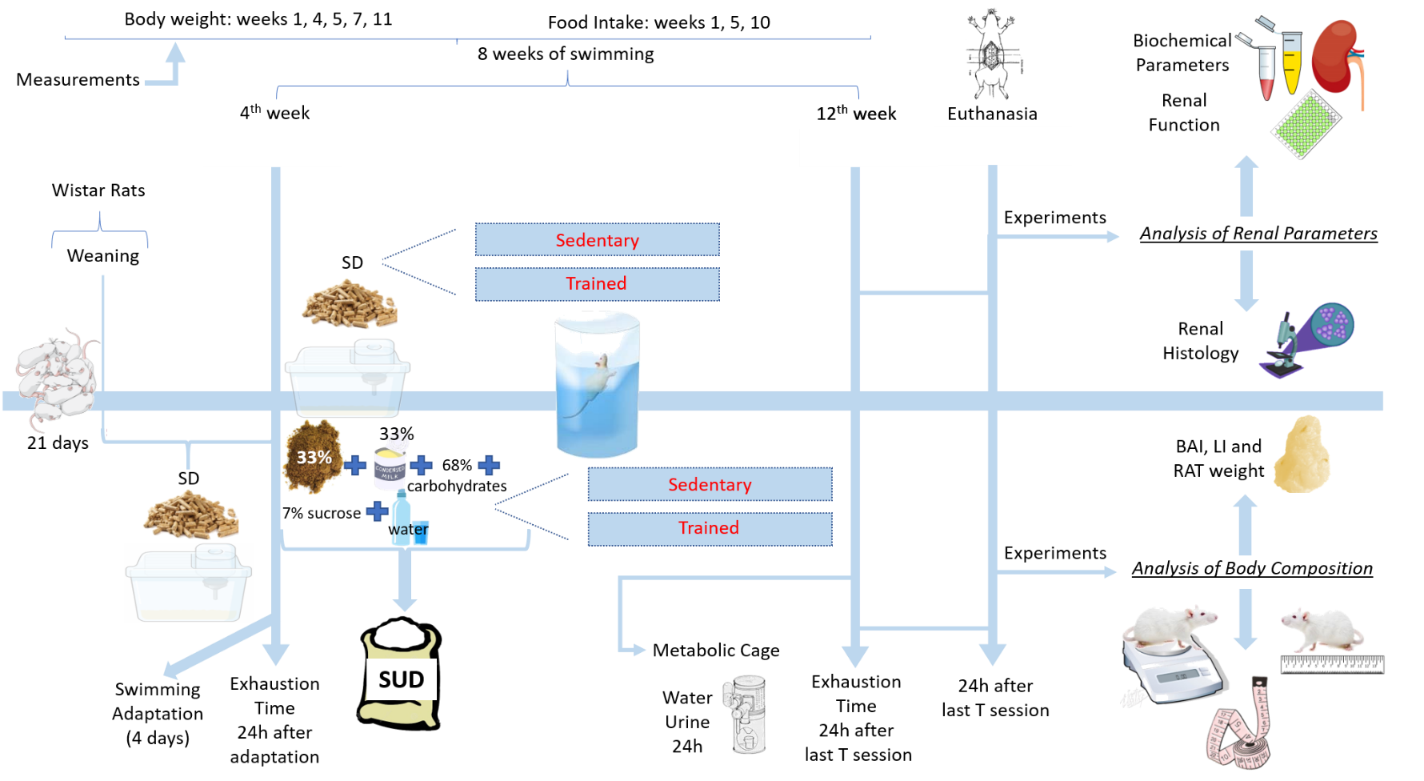
FIGURE S2: Scheme of experimental design showing the different stages for the development of the model, allocation of animals in different groups and main experimental tests carried out in this study. Weaned rats from CCA-UFOP were fed initially with commercial pellet feed until the 4th week. After period these animals were fed with diets containing 68% carbohydrates, 33% standard commercial feed, 33% condensed milk, 7% sucrose and the remaining water or standard pellet diet for more 8 weeks. In the 4th week, the rats were adapted (4 days) to the aquatic environment and the animals related to the trained groups underwent swimming training for 8 weeks. The exhaustion time protocol was performed at weeks 4 and 12 to assess the animals' physical performance. The measurements of water intake and urinary volume of 24h performed in a metabolic cage were performed on the 12th week, in addition to the renal (for analysis of renal function and histology) and body composition (BAI, LI and RAT weight) experiments, which were performed 24 hours after last T session at the end of the 12th week, at which time the rats were euthanized and samples of blood and kidney tissue were collected for analysis. Body weight measurements were taken at weeks 1, 4, 5, 7 and 11 and food intake measurements were taken at weeks 1, 5 and 10. CCA-UFOP (Center of Animal Science of UFOP); SD (standart diet); SUD (sucrose diet); T (swimming training).
2. Sample size
Described on pages 4 “Methods, paragraph 1”, in the topic Animals and Supplementary Material (Table S3).
Groups | n | Diet | Treatment
S-SD | 14 | SD | Sedentary
T-SD | 09 | SD | Swimming – 8 weeks
S-SUD | 05 | SUD | Sedentary
T-SUD | 10 | SUD | Swimming - 8 weeks

SD (standart diet); SUD (sucrose diet).

The animals were taken to the study after weaning for 21 days, stayed for 4 weeks eating SD, after these 4 weeks, these animals were divided into 4 groups, 2 sedentary groups (S-SD and S-SUD) and two groups trained (T-SD and T-SUD), being that the SD groups were fed during the 12 weeks with SD and the SUD groups with a diet rich in sucrose. All animals were adapted to the aquatic environment for 4 days (15min on the first day, increasing 15min each day until reaching the fourth day with 60min). The exhaustion protocol was performed 24 hours after the last day of adaptation. From the 4th to the 12th week the animals assigned to the trained groups, trained swimming without overload initially, with the load being introduced from the 5th week of training. At the 12th week, the animals were placed in metabolic cages to measure ingested water and urinary volume of 24h and 24h after the last training session, the animals were euthanized and experiments related to the analysis of body composition and renal function parameters were performed.

3. Inclusion and exclusion criteria
Described in Supplementary Material (Table S3).
Criteria for the inclusion of animals (defined before the beginning of the experiment and data collection): Normal growth conditions and healthy aspect, being those who didn’t meet this criterion would be excluded. Handling of the animals: carried out with great care to minimize stress. Monitoring: throughout the experimental protocol at different times of the day.
4. Randomisation
Described on pages 4, “Methods, paragraph 1”, in the topic Animals and in Supplementary Material (Table S3).
Randomisation for Minimisation: carried out using the minimization process taking into account the uncomfortable variables pertinent to this strategy such as: time and day of the experiment, manipulation of the animal by the same researchers, characteristics of the animals and their location and adaptation to the experiment sites.

5. Blinding
Described on page 7, “Methods, paragraph 13”, in the topic Data and Statistical Analysis.

6. Outcome measures
Described in the pages 6 and 7, topics: Plasma and Urine Creatinine Concentration and Urine Protein and Renal Histology.
In this study, renal function was evaluated using plasma and urine creatinine concentration and urine protein measurements, in order to analyze the GRF of these animals and if there is proteinuria in their urine. Renal morphology was also evaluated, using histological techniques to assess the structure of the renal glomeruli, the main structures involved in the blood filtration process.
7. Statistical methods
Described on pages 7, “Methods, paragraph 13”, in the topic Data and Statistical Analysis.

8. Experimental animals
Described on pages 4 and 5, “Methods, paragraph 1”, in the topic Animals.

9. Experimental procedures
Described on pages 4 to 7, “Methods, paragraph 3, 4, 5, 7, 8, 10, 11, 12, 13”, in the topics: Exercise training and evaluation of endurance capacity; Water Intake, Urinary Volume and Water Balance Measurements in 24h; Euthanasia; Determination of the LI; Determination of the BAI; Plasma and Urine Creatinine Concentration and Urine Protein; Renal Histology.

10. Results
Described on pages 8 and 9, “Results, paragraph 1 to 5” in the topics: Confirmation of the effectiveness of the T employed; Effects of T on body composition; Effects of the T on 24-hours parameters hydric; Effects of the T on the renal biochemical parameters; Effects of the T on renal structure.

