Supplementary Information for “Universal quantum phase transition from superconducting to insulating-like states in pressurized Bi₂Sr₂CaCu₂O_{8+δ} superconductors”

Yazhou Zhou¹*, Jing Guo^{1,6}*, Shu Cai¹*, Jinyu Zhao^{1,4}, Genda Gu², Chengtian Lin³, Hongtao Yan^{1,4}, Cheng Huang^{1,4}, Chongli Yang¹, Sijin Long^{1,4}, Yu Gong⁴, Yanchun Li⁵, Xiaodong Li⁵,
Qi Wu¹, Jiangping Hu^{1,4}, Xingjiang Zhou^{1,4,6}, Tao Xiang^{1,4} and Liling Sun^{1,4,6}†

¹Institute of Physics, National Laboratory for Condensed Matter Physics, Chinese Academy of Sciences, Beijing, 100190, China
² Condensed Matter Physics & Materials Science Department, Brookhaven National Laboratory, NY, 11973-5000 USA
³Max-Planck-Institut fu¨r Festko¨rperforschung, D-70569 Stuttgart, Germany
⁴University of Chinese Academy of Sciences, Department of Physics, Beijing 100190, China
⁵Institute of High Energy Physics, Chinese Academy of Science, Beijing 100049, China
⁶Songshan Lake Materials Laboratory, Dongguan, Guangdong 523808, China

- Sample information and experimental details
  - Single crystal growth
The as-grown optimally-doped (OP) single crystals rods of Bi₂Sr₂CaCu₂O_{8+δ} were grown by a floating zone method, as described in Ref. 1. To get the under-doped (UD) and over-doped (OD) crystals of Bi₂Sr₂CaCu₂O_{8+δ}, the as-grown crystals of Bi₂Sr₂CaCu₂O_{8+δ} were annealed in a vacuum quartz with Ti pieces at 500 °C for 7 days and under a pure oxygen flow at 450 °C for 10 days, respectively.
The Bi₂Sr_{1.63}La_{0.37}CuO_{6+δ} (La-doped Bi2201) single crystals were grown by oxygen annealing and quenching method, as described in Ref. 2. The feed rods for the experiments were prepared by the conventional solid-state reaction method. The mixture of Bi₂O₃, SrCO₃, CaCO₃, La₂O₃ and CuO with the required ratio was heated at 860 ºC for 5 h, and then at 780 ºC for 24 h. The produced rods were sintered at 870 ºC for 48 h in order to reach a complete reaction of the reagents. The pre-melting and crystal-growth experiments were performed using an infrared-radiation furnace.
The Bi₂Sr₂Ca₂Cu₃O_{10+δ} (Bi2223) single crystals were grown by traveling-solvent-floating-zone method, as described in Ref. 3. The feed rods for the experiments were also prepared by the solid-state reaction method. The mixture of Bi₂O₃, SrCO₃, CaCO₃ and CuO with the ratio of Bi:Sr:Ca:Cu = 2.1:1.9:2.0:3.0 was heated at 750 ºC for 24 h, and then at 820 ºC for 36 h. The produced rods were sintered at 850 ºC for 48 h in order to realize a complete reaction among the reagents. During the growth, both feed and seed rods were counter rotating. The growth runs were carried out in a flowing Ar/O₂ mixture with various oxygen contents.
  - High-pressure experimental measurements
High pressure was generated by a diamond anvil cell made of BeCu alloy. Diamond anvils with 300 μm and 250 μm culet (flat areas of the diamond anvils) were used for different independent measurements, respectively. The four-probe method was applied for our resistance and magnetoresistance measurements. A mixture of c-BN powder and epoxy was adopted as the insulating layer (Fig.S1a). In the high-pressure Hall coefficient (R_{H}) measurements, the magnetic field is applied perpendicular to the ab-plane of the single crystal sample, a constant current goes through the electrode and the Hall voltage is measured (Fig.S1b). The obtained values of R_{H} plotted in Fig.4d are obtained from a linear fit to the plot of Hall resistance versus field ranging from 0 T to 2 T (Fig.S2). In the high-pressure transport and diamagnetic measurements, NaCl powder was employed as the pressure transmitting medium. Pressure was determined by the ruby fluorescence method ⁴.
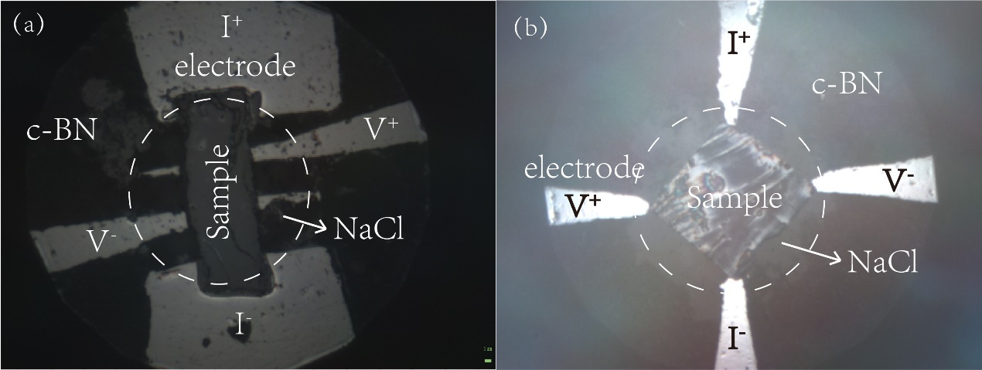
Figure S1 The Layouts of the high-pressure resistance (a) and Hall coefficient (b) measurements for the Bi-based cuprate superconductors.
Figure S2 Magnetic field (B) dependence of Hall resistance (R_{xy}) for the over doped Bi2212, which displays a linear behavior in the pressure range investigated. The data is measured at 100 K. The sample thickness is about 5 μm.
High pressure magnetic susceptibility measurements were carried out in a diamond anvil cell fabricated from Cu-Be alloy, which is equipped with the gas membrane system. To minimize the temperature-dependent background, the nonmagnetic gasket made from the Ni-Cr alloy was adopted in these experiments. The sample is surrounded by a secondary coil (pickup coil) and a field-generating primary coil which is wound on the top of the secondary coil. The alternating flux through the pickup coil produces an ac voltage which is the measured signal. When the sample is cooled below T_{C}, the field is expelled from the sample due to the superconducting shielding effect, forcing some of the flux lines out of the pickup coil and leading to a reduction in the induced voltage in the pickup coil ⁵⁻⁷. For the primary coil, the alternating magnetic field was stimulated at 13.83 KHz, and the signal was collected at the same frequency. The superconducting transition can be captured by a step-like diamagnetic signal in this ac susceptibility measurement. The modulated magnetic field is provided by the secondary coil that is stimulated at 13.3 Hz, and its amplitude is around 9.9 mT. Here, the modulated susceptibility can be expressed by Δχ′= χ′ (9.9mT) - χ′(0mT). Consequently, the result of χ′(B) produces a peak-like function in the secondary locked-in amplifier, instead of a step-like function which is collected by a single phase-locked amplifier. Such a measurement with the magnetic field modulation has been used by Geophysics lab in Carnegie Institute for the studies of pressure effect on superconductivity and pressure-induced superconductivity in materials ⁷⁻⁹.
High-pressure powder X-ray diffraction (XRD) measurements at low temperature were carried out on beamline 4W2 at the Beijing Synchrotron Radiation Facility. Low birefringent diamonds with culets of 300 μm were used for the experiments. A monochromatic X-ray beam with a wavelength of 0.6199 Å was employed for the measurements. To keep the samples in the same pressure environment as that in the resistance and ac susceptibility measurements, NaCl powder was employed as the pressure transmitting medium. Low-temperature pressure was determined by the ruby fluorescence method ⁴.
- Extend high-pressure results
  - Reproducible high pressure resistance measurements on the UD, OP and OD Bi2212 superconductors
We performed the same high-pressure measurements on the UD, OP and OD Bi2212 single crystals that were cut from different batches. As shown in Fig.S3, the in-plane resistance as a function of temperature of the three kinds of samples exhibits a reproducible behavior - the superconductivity is destroyed at a pressure of P_{i} and then an insulating-like state appears, although the values of P_{i} are slightly different from different runs (Fig.1).
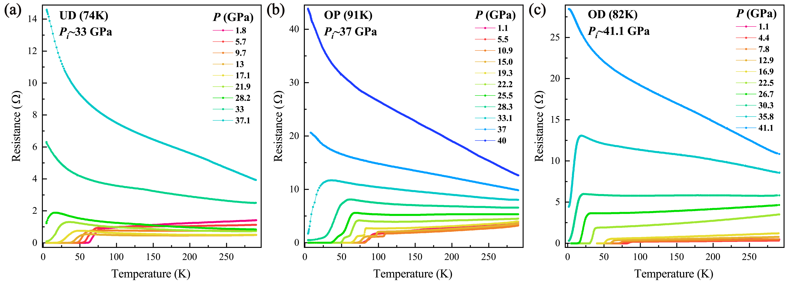
Figure S3 Temperature dependence of in-plane resistance for the UD, OP and OD Bi₂Sr₂CaCu₂O_{8+δ} (Bi2212) superconductors at different pressures. P_{i} represents the pressure where an insulating-like phase appears. In figure b, we observed two-step transitions (a crossover from two-dimensional to three-dimensional superconducting phases) below 25.9 GPa, in good agreements with the previous studies ¹⁰.
We noted that the high-pressure susceptibility measurements have been previously conducted on the Bi2212 and Bi2223 superconductors by employing ac susceptibility measurements with liquid or gas as pressure transmitting medium ^{9,11}, in which a more complicated change of T_{c} with pressure was observed in the similar pressure range to this study. Because it is difficult to make the contacts between the electrodes and the cuprate sample for the high-pressure resistance measurements with liquid or gas pressure transmitting medium, we employed the NaCl powder as the pressure transmitting medium in the present study. The different phenomena observed in the high-pressure measurements with different pressure transmitting mediums suggest that the superconductivity of these superconductors is sensitive to the pressure transmitting medium.
  - High pressure resistance measurements on the Bi₂Sr_{1.63}La_{0.37}CuO_{6+δ} (Bi2201) and the Bi_{2.1}Sr_{1.9}Ca₂Cu₃O_{10+δ} (Bi2223) superconductors
We performed the high-pressure resistance measurements on the Bi₂Sr_{1.63}La_{0.37}CuO_{6+δ} (Bi2201) superconductor with one CuO₂ plane in a unit cell and the Bi₂Sr₂Ca₂Cu₃O_{10+δ} (Bi2223) superconductor with three CuO₂ planes per unit cell. We found the same high pressure behavior as that observed in the Bi2212 superconductors. The quantum phase transition from superconducting state to an insulating-like state appears at Pi=23.2 GPa for the Bi2201 superconductor (Fig.S4a) and at 42 GPa for the Bi2223 superconductor (Fig.S4b), demonstrating that the quantum phase transition from superconducting to insulating-like states is a universal behavior in the bismuth-bearing cuprate superconductors.
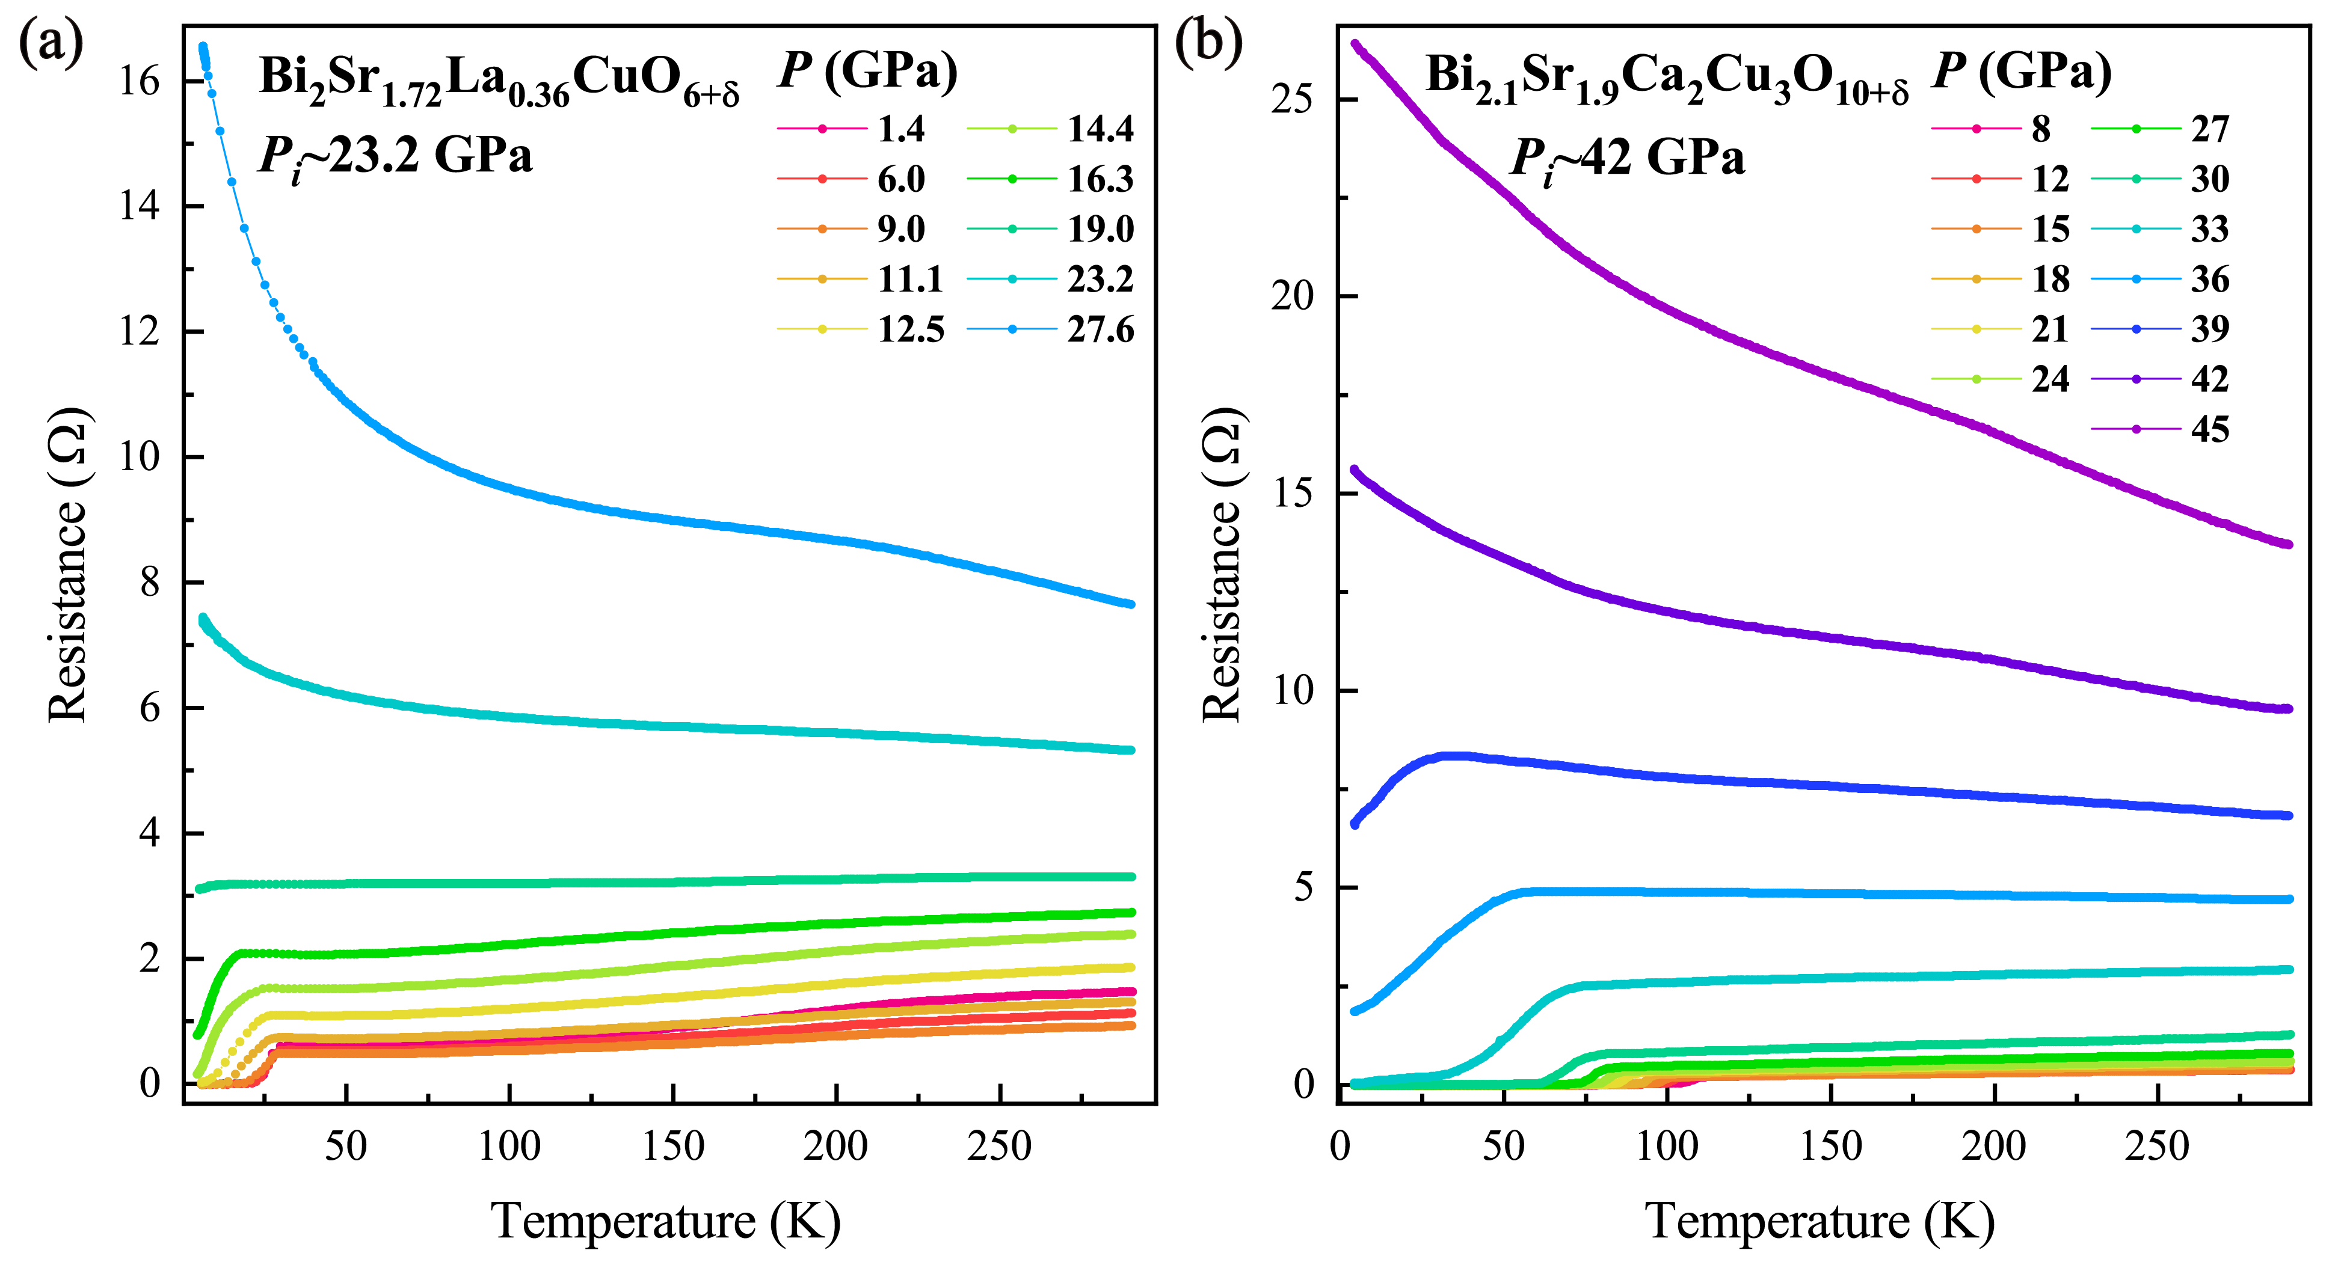
Figure S4 Temperature dependence of in-plane resistance for the La-doped Bi2201 and Bi2223 superconductors at different pressures, displaying the same behavior of the quantum phase transition from a superconducting to an insulating-like states as that found in Bi2212 superconductors.
  - Temperature dependence of in-plane resistance in the process of releasing pressure for the OD sample
To study whether the observed insulating-like behavior is caused by the pressure-induced cracks in the material, we conducted the pressure measurements on the over-doped Bi2212 sample. As shown in Fig.S5, releasing pressure from 50.5 GPa where the sample shows an insulating-like state (see red line) down to 14.3 GPa where the sample is superconducting in the process of the increasing pressure (see blue line). Since T_{c} observed at the releasing pressure of 14.3 GPa is almost the same as that of uploading data at 14 GPa (see the green line), it indicates a reversible transition between the superconducting state to the insulating-like state. These results rule out the possibility that the observed quantum phase transition is resulted from the pressure-induced cracks. Noted that the absence of the zero resistance in the pressure-released sample is reasonably attributed to the pressure-induced cracks, the reversible superconductivity indicates that the crack effect should be not crucial on the quantum phase transition from a superconducting state to an insulating-like state.
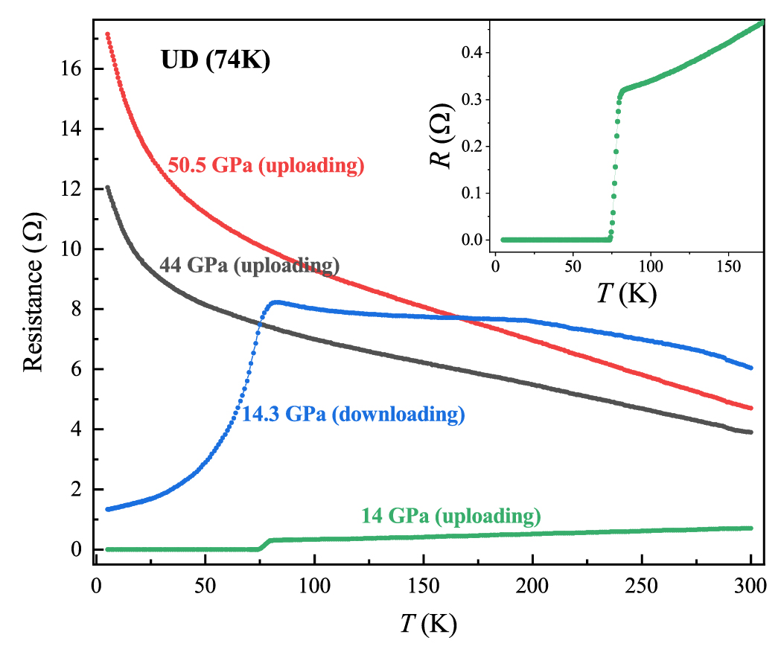
Figure S5 Temperature dependence of ab-plane resistance in the procedure of releasing pressure from 50.5 GPa (see red line）to 14.3 GPa (see blue line), where its T_{c} is almost the same as that of uploading data at 14 GPa (see the green line), indicating a reversible transition between a superconducting to an insulating-like states. The inset displays an enlarged view of low temperature resistance of the sample subjected to 14 GPa upon increasing pressure.
  - High pressure Hall resistance measurements on Bi₂Sr_{1.63}La_{0.37}CuO_{6+δ} (Bi2201) superconductor
We performed high pressure Hall measurements for the Bi2201 superconductor. Figure S6 shows the pressure versus T_{c} and Hall coefficient R_{H} as a function of pressure. We found the same results as that observed in Bi2212, i.e. R_{H}(P) decreases with increasing pressure below ~ 16 GPa and then it stays almost constant at P>16 GPa, the critical pressure crossed the transition from a superconducting state to an insulting-like state (Fig.S6). These results indicate that the phenomenon of the saturation in R_{H} exists universally in the Bi-based cuprates.
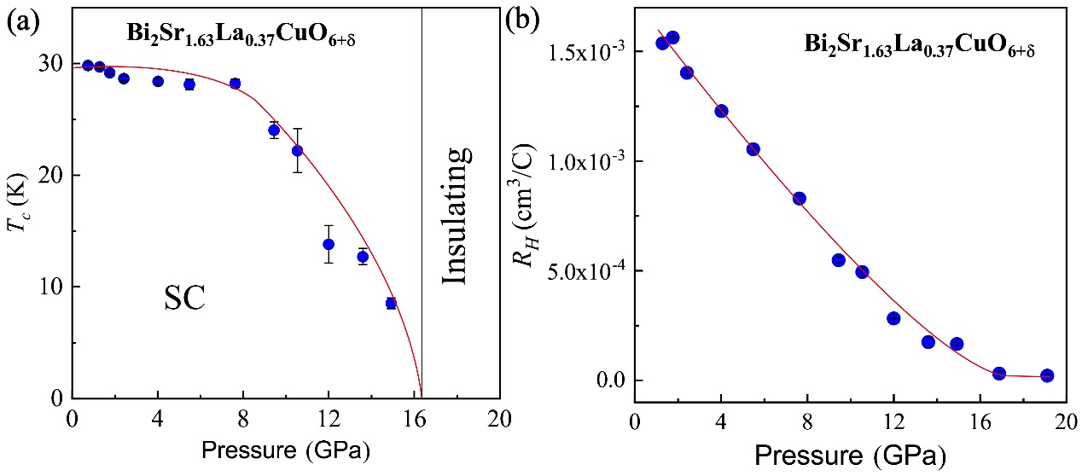
Figure S6 Pressure dependence of T_{c} (a) and Hall coefficient (b) for the Bi₂Sr_{1.63}La_{0.37}CuO_{6+δ} superconductor with one CuO₂ plane in a unit cell.
  - High-pressure and low-temperature X-ray diffraction measurements
To clarify whether the observed quantum phase transition from a superconducting to an insulating-like states found in the Bi2212 superconductors is related to a pressure-induced crystal structure phase transition, we conducted the high-pressure synchrotron X-ray diffraction measurements at 50 K for the OD sample, in which the same pressure medium (NaCl powder) as that used in our resistance and diamagnetism measurements was employed. The XRD patterns are displayed in Fig. S7a, all peaks can be indexed well by the orthorhombic structure with space group Amaa, and no new peak was observed up to 43.1 GPa. These results indicate that the pressurized sample does not undergo a structural phase transition in the pressure range studied. By fitting the XRD patterns, we obtained the lattice parameters and the volume as a function of pressure (Fig. S7b and S7c).
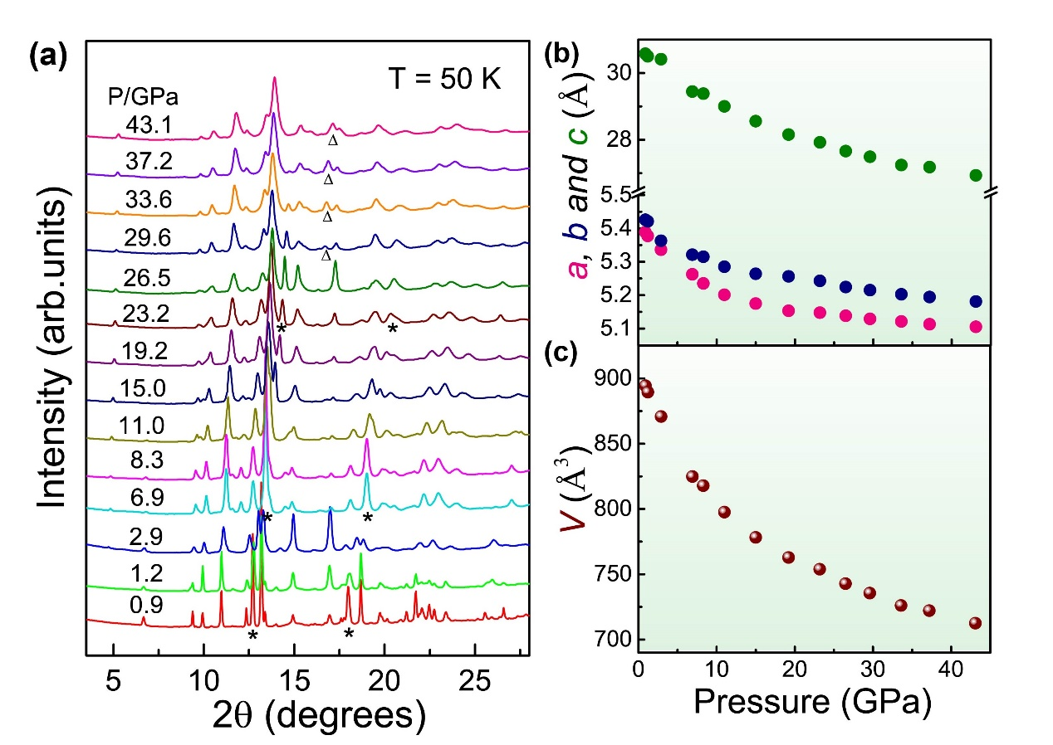
Figure S7 Structure information of the OD Bi₂Sr₂CaCu₂O_{8+δ} superconductor under pressure. (a) X-ray diffraction patterns of the sample collected at 50 K and different pressures. The stars (*) and triangle (Δ) in the patterns indicate the diffraction peaks of the NaCl powder crystallized in the B1 phase and the B2 phase, respectively. (b) and (c) Pressure dependences of lattice parameters (a, b and c) and volume (V).
  - Determinations of the superconducting transition temperature (T_{c}), characteristic temperature of insulating-like state transition (T_{ins}) and the corresponding error bars in the normalizing phase diagram
The onset T_{c} value is determined by the intersection of the two-line method. Figure S8 shows the details about how to determine the error bar of T_{c} obtained at different pressures.
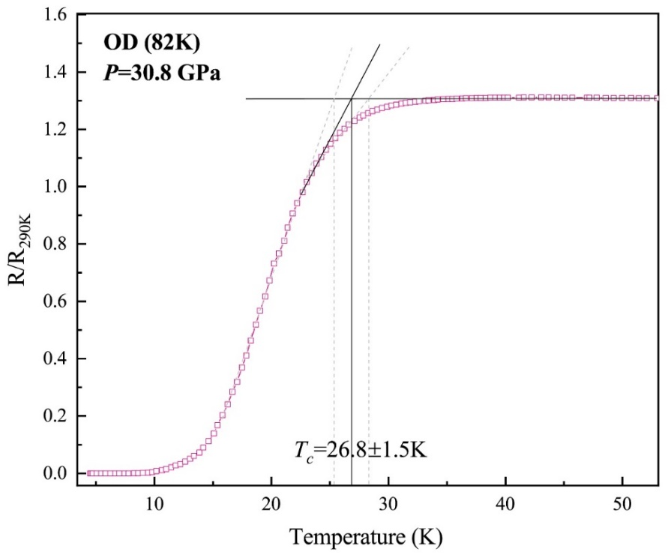
Figure S8 In-plane resistance as a function of temperature for the compressed Bi2212 sample, showing how to estimate the T_{c} value and its error bar in the normalizing P-T phase diagram (left panel of Fig.3).
The characteristic temperature (T_{ins}) is introduced in order to describe the comparative extent of the insulating-like behavior. The method of determining T_{ins} includes the following three aspects: (1) based on our resistance measurements, we know the critical pressure (P_{c}) of the quantum phase transition from the superconducting state to an insulating-like state; (2) from our mapping results of R/R_{290K} versus temperature, we also know that the quantum phase transition occurs when R/R_{290K} = 3 (for example for the over-doped Bi2212, see bottom right penal of Fig.3), which is a critical ratio of a superconducting/metallic state to an insulating-like state transition, and we define this ratio as the critical ratio of the quantum phase transition upon increasing pressure; (3) then, the T_{ins} values for different pressures can be determined through the intersection point between R/R_{290K} =3 and R/R_{290K}(T) at a fixed pressure, as indicated in Fig.S9. Noted that the R/R_{290K} ratio of the quantum phase transition is different for the differently doped superconductors.
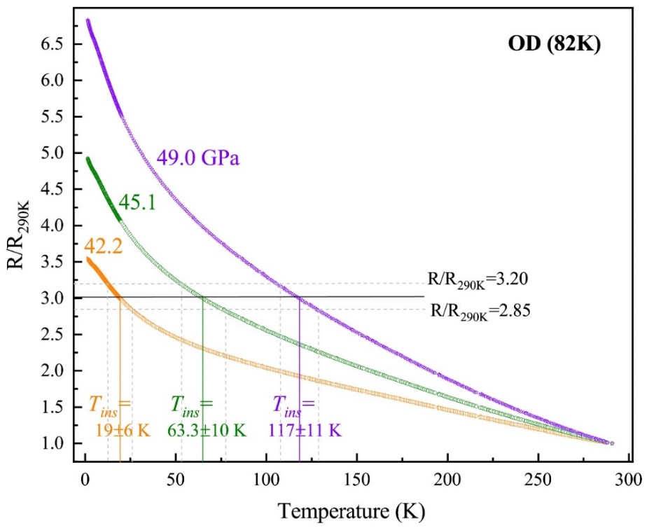
Figure S9 Temperature dependence of resistance for the OD Bi2212 superconductors which are subjected to 42.2 GPa, 45.1 GPa and 49 GPa, respectively, displaying how to estimate the T_{ins} value and its error bar in the normalizing P-T phase diagram (left panel of Fig.3). The solid line intersected to the temperature axis is T_{ins}, the range of the dash lines is error bar.
  - Fitting insulating-like behavior for the OD sample
To understand the nature of the insulating behavior found in this study, we fit the low temperature resistance with exponential dependance and power law for the over doped Bi2212 sample, as shown in Fig. S10. It is seen that the fits with exponential-dependence and power-law indicate that the observed insulating-like state deviates from the typical insulating and semiconducting states, implying its peculiarity among the strongly correlated systems. Since its mechanism is unclear now, we hope that our results will call for some instant investigations from the theoretical and experimental sides.
We have fitted our data to R~Ln(T) for the under- and over-doped Bi2212 samples and compare the results with that reported by Ando et al ¹² and Shi eta al ¹³. We find that the in-plan resistance of our samples in their insulating state is linearly proportional to ln(T) in the temperature range of 1.5K-5K for the under-doped sample and 4-6.5 K for the over-doped sample (Fig. S11a and 11c). This linear behavior of our compressed samples below 6 K is similar to the behavior observed in the under-doped LSCO sample below 10K ¹² and the Eu-doped LSCO sample subjected to the different magnetic fields below 3K ¹³. The characteristic resistance (R₀) extracted from the linear fit of R~Ln(T) to T=0K, a parameter to describe the extent of insulating state, as a function of pressure is extracted for our Bi-based cuprate samples (Fig. S11b and 11d). We find that R₀(P) is enhanced upon increasing pressure, implying that the insulating behavior of the Bi-based cuprates becomes more obvious under pressure. The obtained result is opposite to that observed in the LSCO samples tuned by the chemical doping or application of external magnetic field, and demonstrates that pressure-tuning method leads to an alternative transport property. The distinct behavior in R₀(P) found in the compressed Bi-based superconductors indicates that the effect of pressure on the cuprate superconductors is unique.

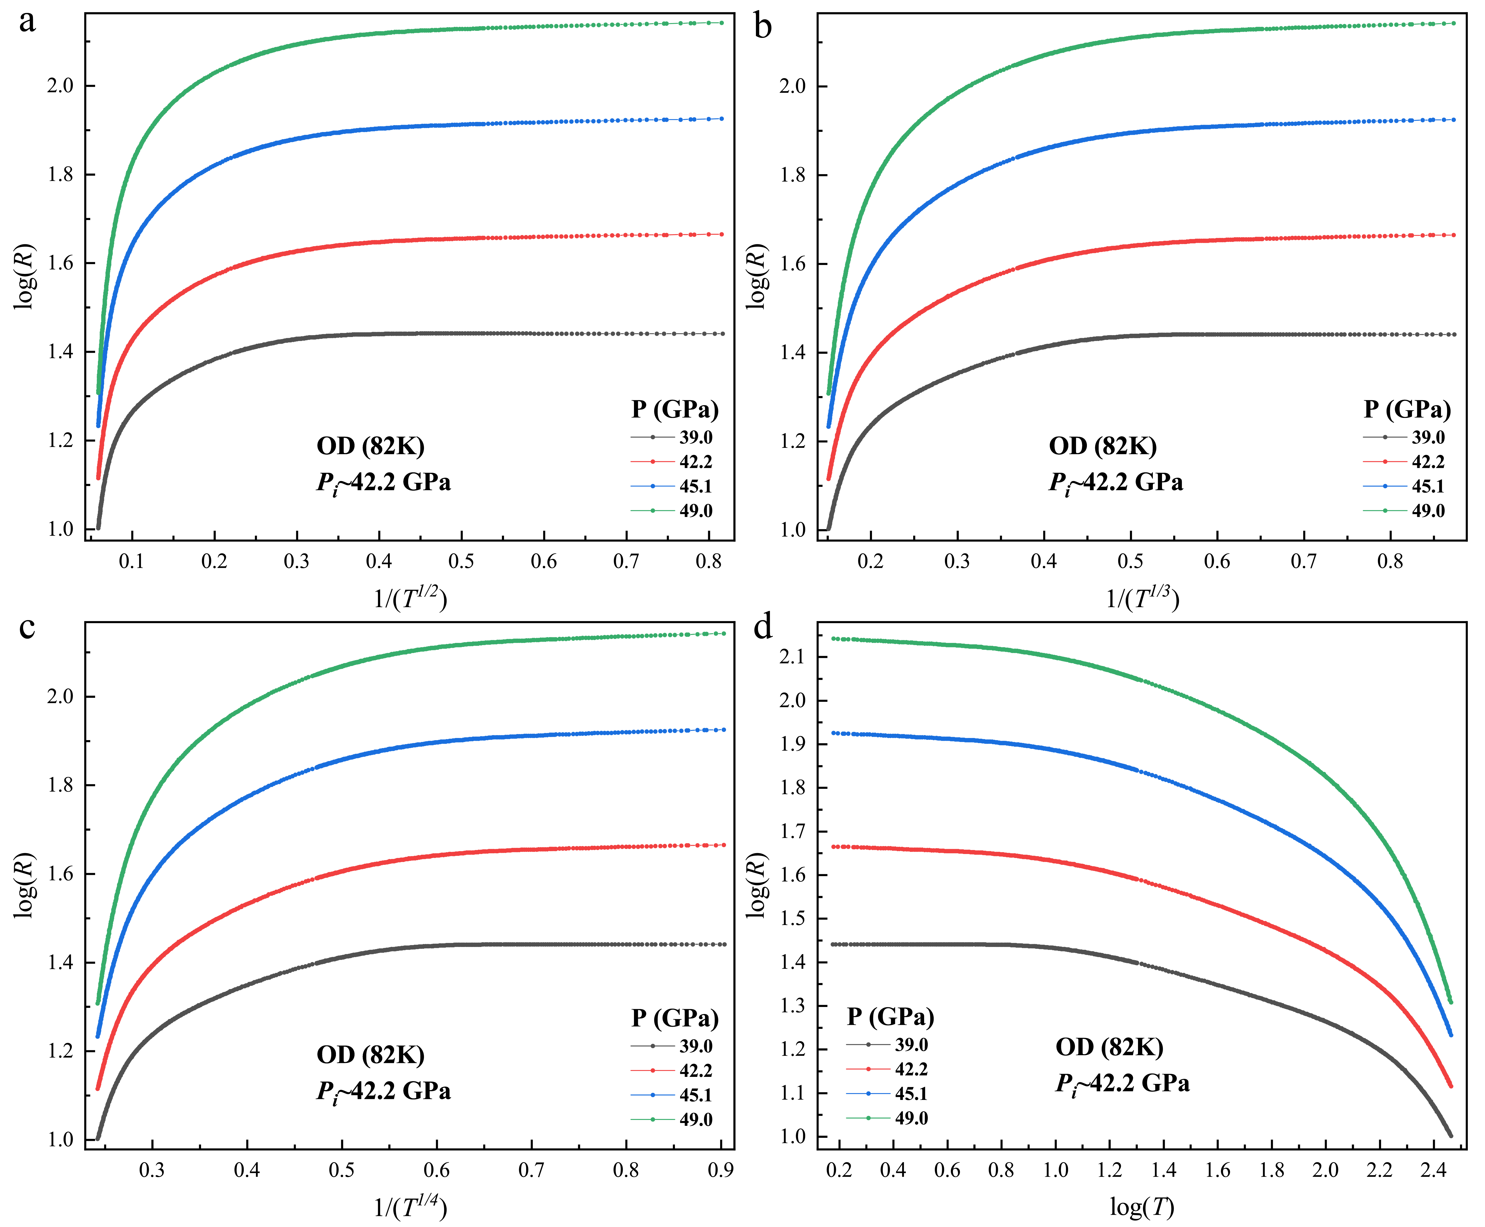
Fig. S10 Temperature dependence of resistance for the over doped (OD) Bi2212 at pressures where the insulating-like state presents.
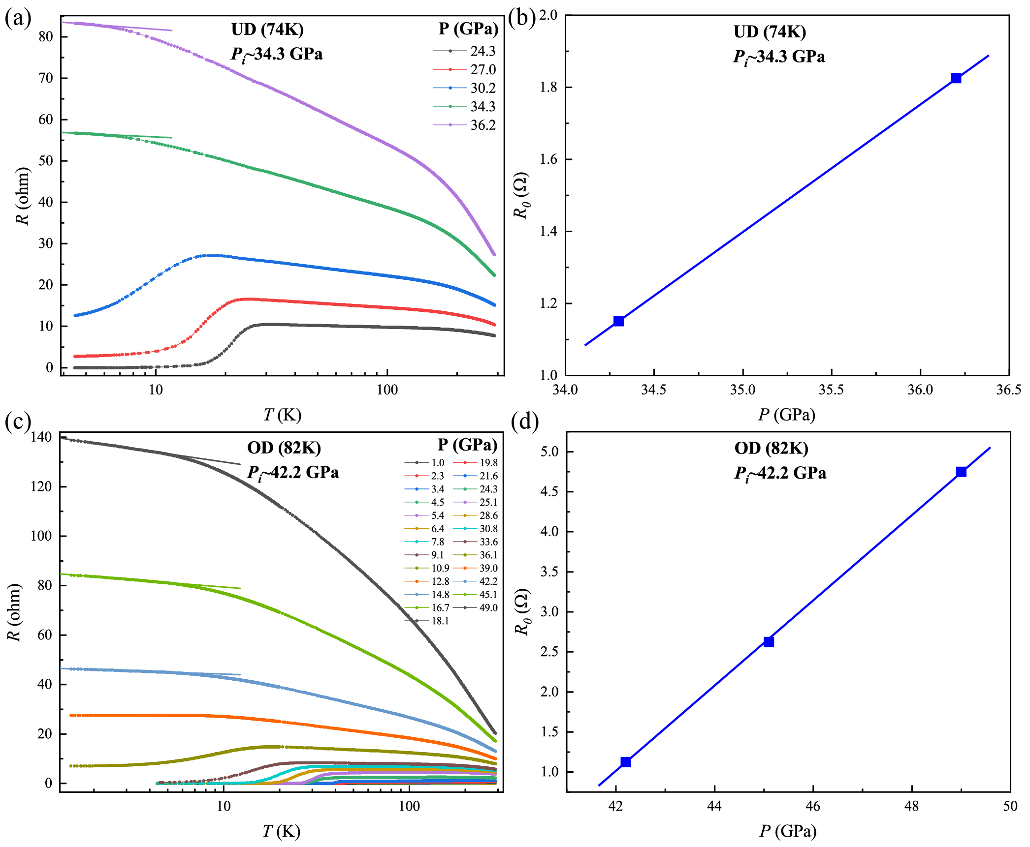
Figure S11 (a) and (c) Temperature dependence of the ab-plan resistance for the under- and over-doped Bi2212 samples at different pressures. The solid line is the linear fit to the R~Ln(T) in the low temperature regime. (b) and (d), Pressure dependence of characteristic resistance (R₀) that is extracted from the linear fit of R~Ln(T) to T=0K for the under- and over-doped samples.

Correspondence and requests for materials should be addressed to L.S. (llsun@iphy.ac.cn).
* These authors contributed equally to this work.

References
1 Gu, G. D., Takamuku, K., Koshizuka, N. & Tanaka, S. Large single crystal Bi-2212 along the c-axis prepared by floating zone method. Journal of Crystal Growth 130, 325-329 (1993).
2 Zhang, Y.-X., Zhao, L., Gu, G.-D. & Zhou, X.-J. A Reproducible Approach of Preparing High-Quality Overdoped Bi₂Sr₂CaCu₂O_{8+δ} Single Crystals by Oxygen Annealing and Quenching Method. Chinese Phys. Lett. 33, 067403 (2016).
3 Lin, C. T. & Liang, B. in New Trends in Superconductivity (eds James F. Annett & Sergei Kruchinin) 19-28 (Springer Netherlands, 2002).
4 Mao, H. K., Xu, J. & Bell, P. M. Calibration of the ruby pressure gauge to 800 kbar under quasi-hydrostatic conditions. Journal of Geophysical Research: Solid Earth 91, 4673-4676 (1986).
5 Hamlin, J. J., Tissen, V. G. & Schilling, J. S. Superconductivity at 17K in yttrium metal under nearly hydrostatic pressures up to 89 GPa. Phys. Rev. B 73, 094522 (2006).
6 Sun, L. et al. Re-emerging superconductivity at 48 kelvin in iron chalcogenides. Nature 483, 67 (2012).
7 Timofeev, Y. A., Struzhkin, V. V., Hemley, R. J., Mao, H.-k. & Gregoryanz, E. A. Improved techniques for measurement of superconductivity in diamond anvil cells by magnetic susceptibility. Review of Scientific Instruments 73, 371-377 (2002).
8 Struzhkin, V. V., Hemley, R. J., Mao, H.-k. & Timofeev, Y. A. Superconductivity at 10–17 K in compressed sulphur. Nature 390, 382-384 (1997).
9 Chen, X.-J. et al. Enhancement of superconductivity by pressure-driven competition in electronic order. Nature 466, 950-953 (2010).
10 Guo, J. et al. Crossover from two-dimensional to three-dimensional superconducting states in bismuth-based cuprate superconductor. Nat. Phys. 16, 295-300 (2020).
11 Deng, L. et al. Higher superconducting transition temperature by breaking the universal pressure relation. Proc. Natl. Acad. Sci. U.S.A. 116, 2004-2008 (2019).
12 Ando, Y., Boebinger, G. S., Passner, A., Kimura, T. & Kishio, K. Logarithmic Divergence of both In-Plane and Out-of-Plane Normal-State Resistivities of Superconducting La_{2-x}Sr_{x}CuO₄ in the Zero-Temperature Limit. Phys. Rev. Lett. 75, 4662-4665 (1995).
13 Shi, Z., Baity, P. G., Sasagawa, T. & Popović, D. Vortex phase diagram and the normal state of cuprates with charge and spin orders. Science Advances 6, eaay8946 (2020).

