Supplementary materials
Table 1: Baseline characteristics of responder and non-responder LARC patients
Characteristics | Non-pCR (n=30) | pCR (n=20) | P-value
Gender |  |  | 0.797
Male | 22 (73.3%) | 14 (70.0%)
Female | 8 (26.7%) | 6 (30.0%)
Age |  |  | 0.643
≥60 | 13 (43.4%) | 10 (50.0%)
＜60 | 17 (56.7%) | 10 (50.0%)
cT stage |  |  | 0.409
T3 | 29 (96.7%) | 20 (100%)
T4 | 1 (3.3%) | 0 (0%)
cN stage |  |  | 0.774
N0 | 6 (20.0%) | 5 (25.0%)
N1 | 21 (70.0%) | 14 (70.0%)
N2 | 3 (10.0%) | 1 (5.0%)
RAS/RAF status |  |  | 0.419
Mutant | 13 (43.3%) | 11 (55.0%)
Wide type | 17 (56.7%) | 9 (45.0%)

Figure S1: A, recruitment and samples collection of MSS rectal cancer patients in this study. Three time-point for plasma samples collection was separately baseline, post-radiotherapy and post-PDL1 based immunotherapy. B, workflow of this study was shown, in this study, the plasma proteomics and metabolomics were performed and analyzed for possible biomarker selections. Aberration: MSS, microsatellite stable; PDL1, Programmed cell death 1 ligand 1.

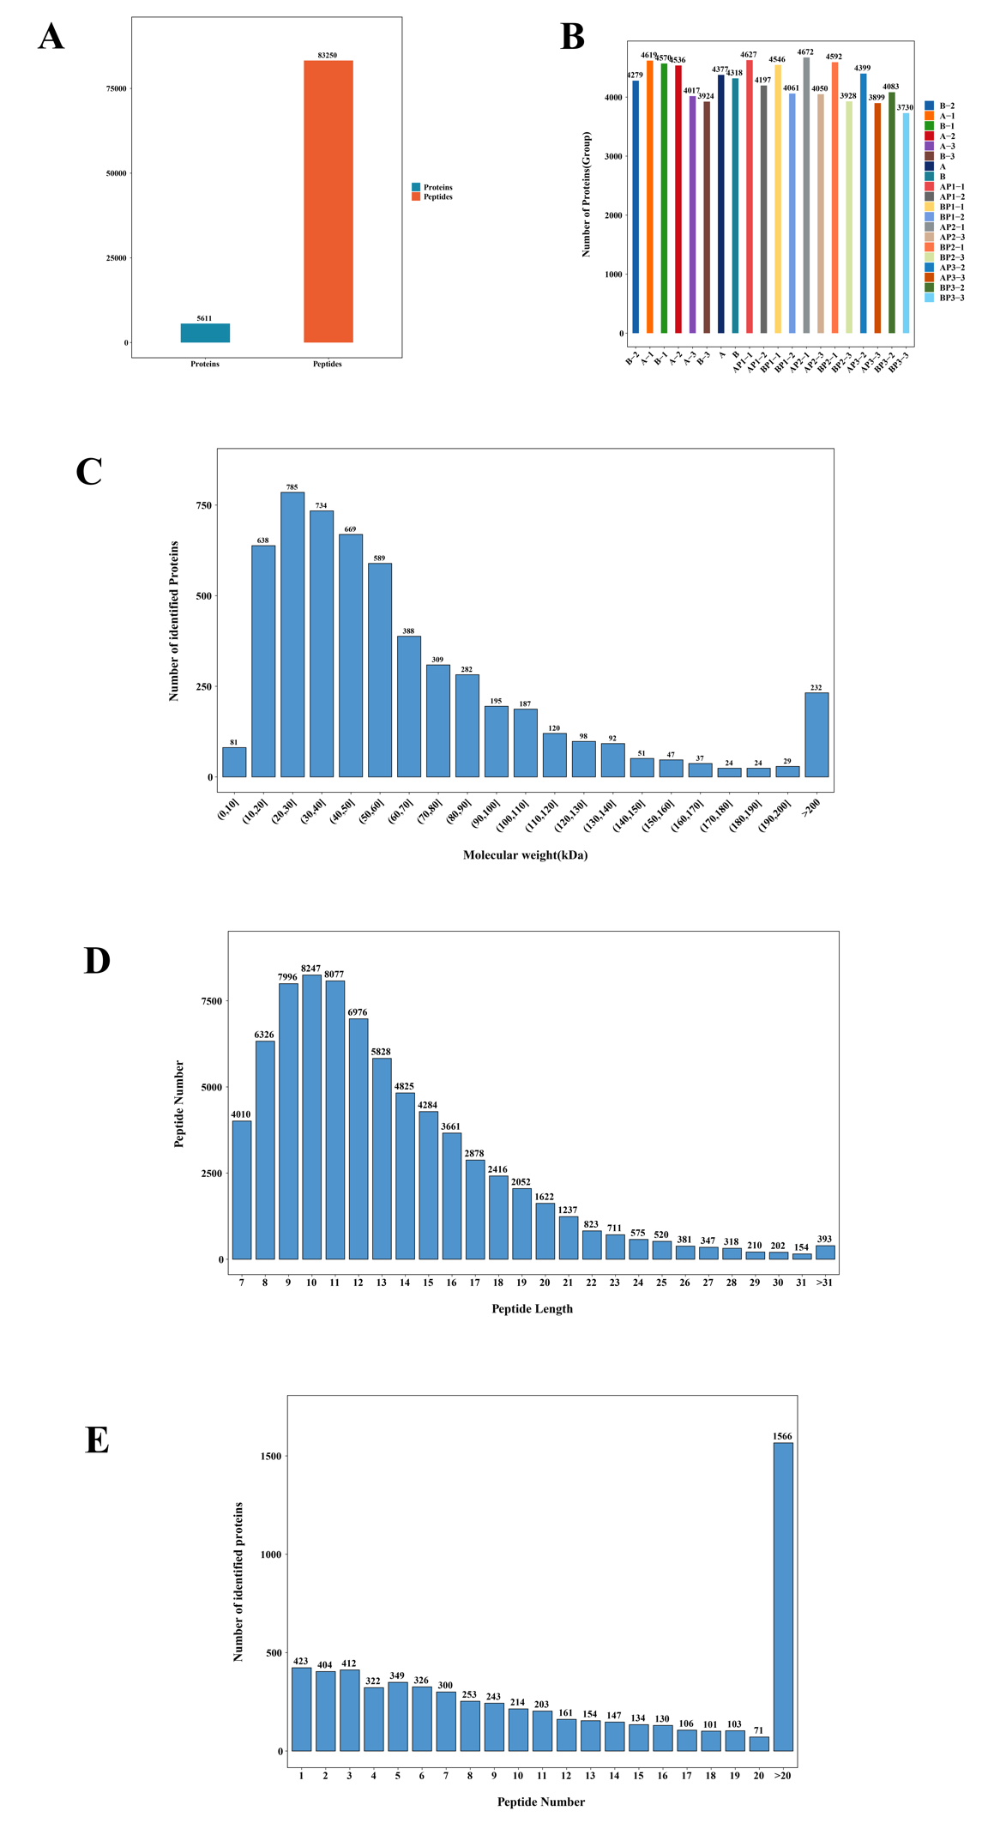
Figure S2: A, for plasma proteomics analysis, A total of 5611 gene products (GPs) were identified in all the plasma samples of the recruited cohort, of which 83250 peptide GPs were identified. B, separate number of proteins and peptides were shown in each group. Data related to Supplementary data 1 and data 2). C to E, the molecular weights, peptide lengths and numbers are also shown in Figure S2C to S2E.

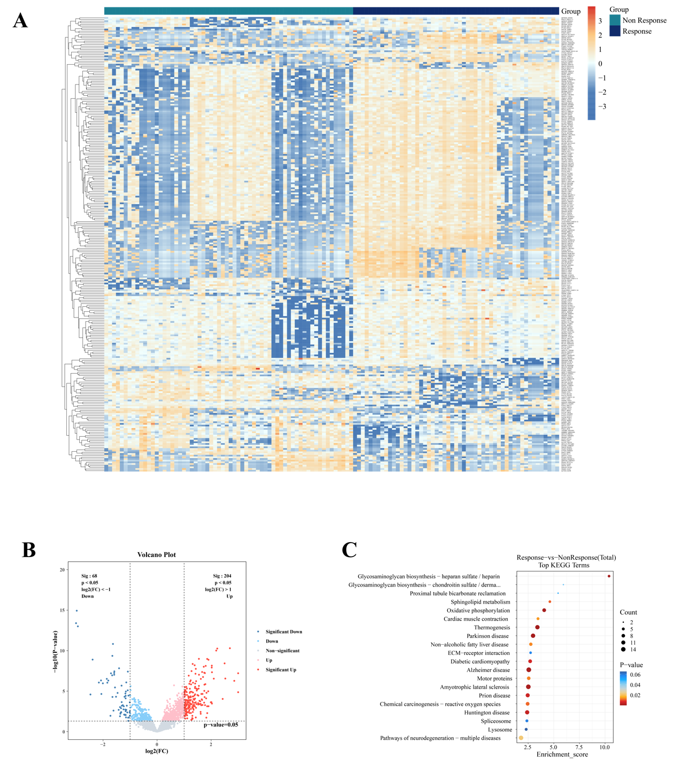
Figure S3: A, Heatmap analysis revealed the significant proteins between response and non-response samples. B, 204 proteins were significantly upregulated and that 68 were significantly downregulated and data related to Supplementary data 3 according to the protein classes in the Human Protein Atlas (HPA) database. C, the KEGG analysis revealed genes related to neutrophil degranulation and the innate immune system, among other activities (adjusted P value < 0.05).

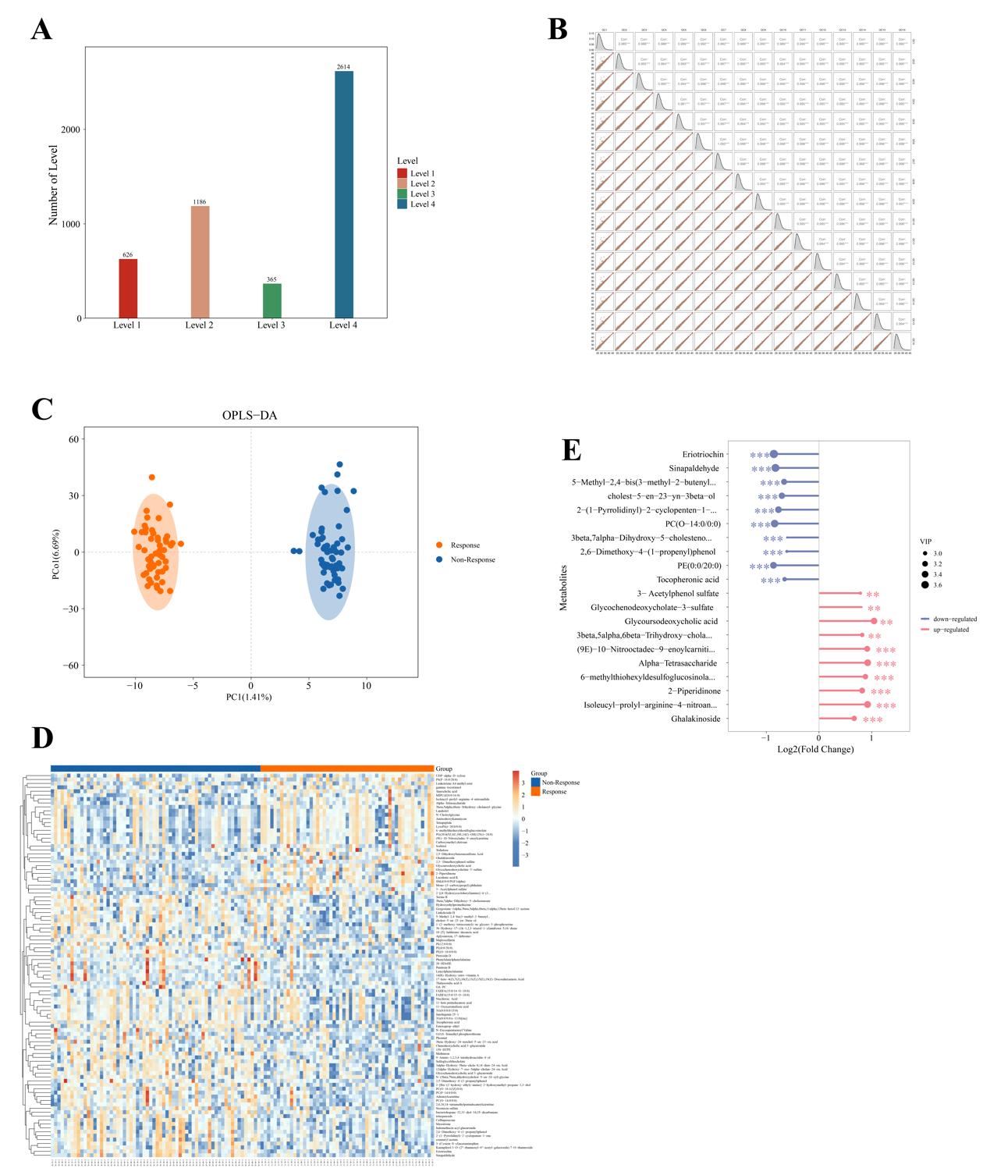
Figure S4: A, for plasma metabolomics analysis, four levels and a total of 4,791 endogenous metabolites were identified. B, the results of the quality control analysis are shown. C, OPLS-DA analyses revealed that the plasma metabolome was significantly different between the response and nonresponse cohorts. D, this study conducted a heatmap comparison to identify metabolites with significantly differential peaks between different response groups and data related to Supplementary data 4. E, Differential plasma metabolites with consistent shifts across the response and nonresponse cohorts were revealed.

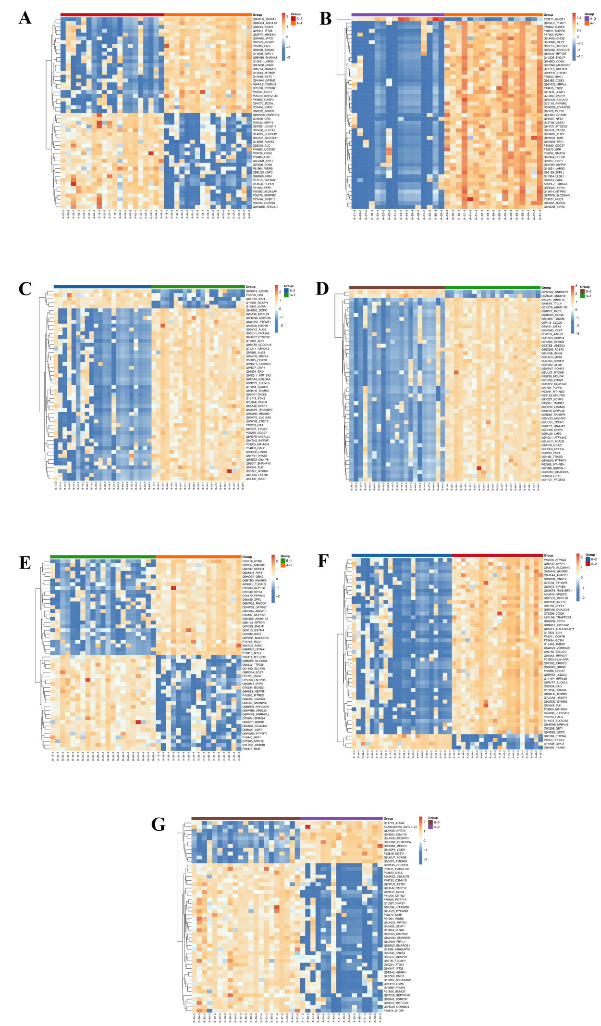
Figure S5: plasma proteomics analysis for different proteins between response and nonresponse samples at baseline, post-radiotherapy and post-immunotherapy stages.

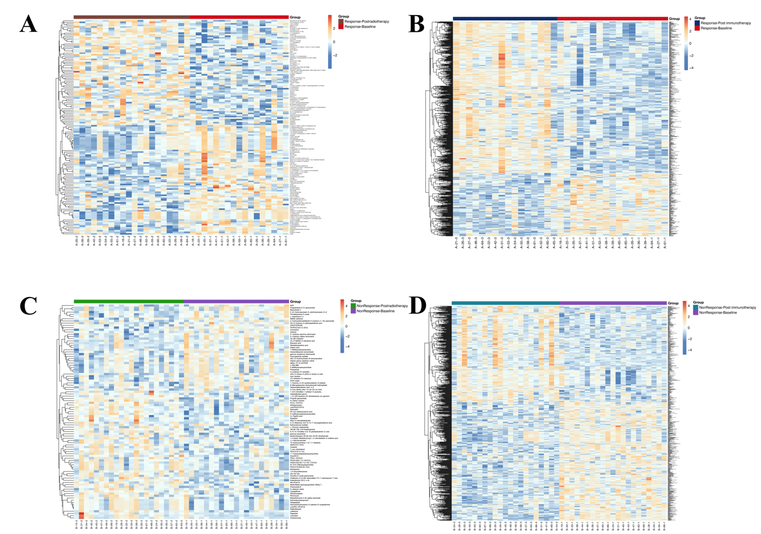
Figure S6: plasma metabolomics analysis for different metabolites between response and nonresponse samples at baseline, post-radiotherapy and post-immunotherapy stages.

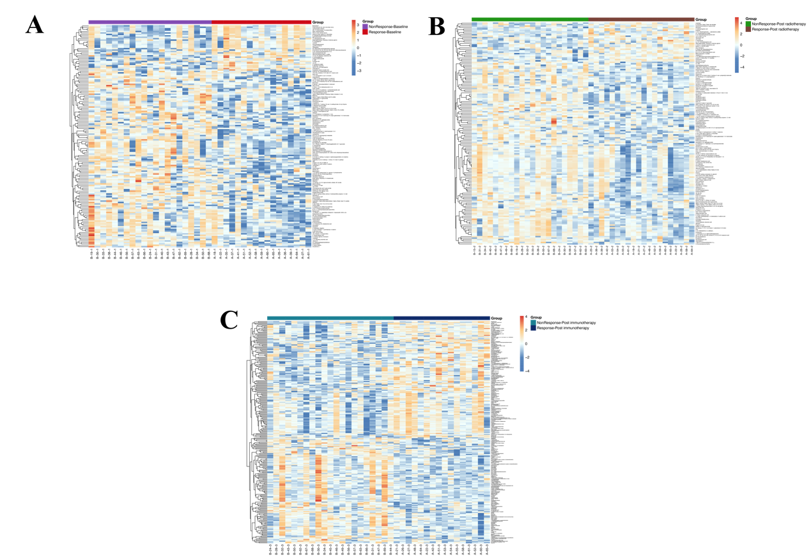
Figure S7: integrated analysis of metabolomics and proteomics in this study.

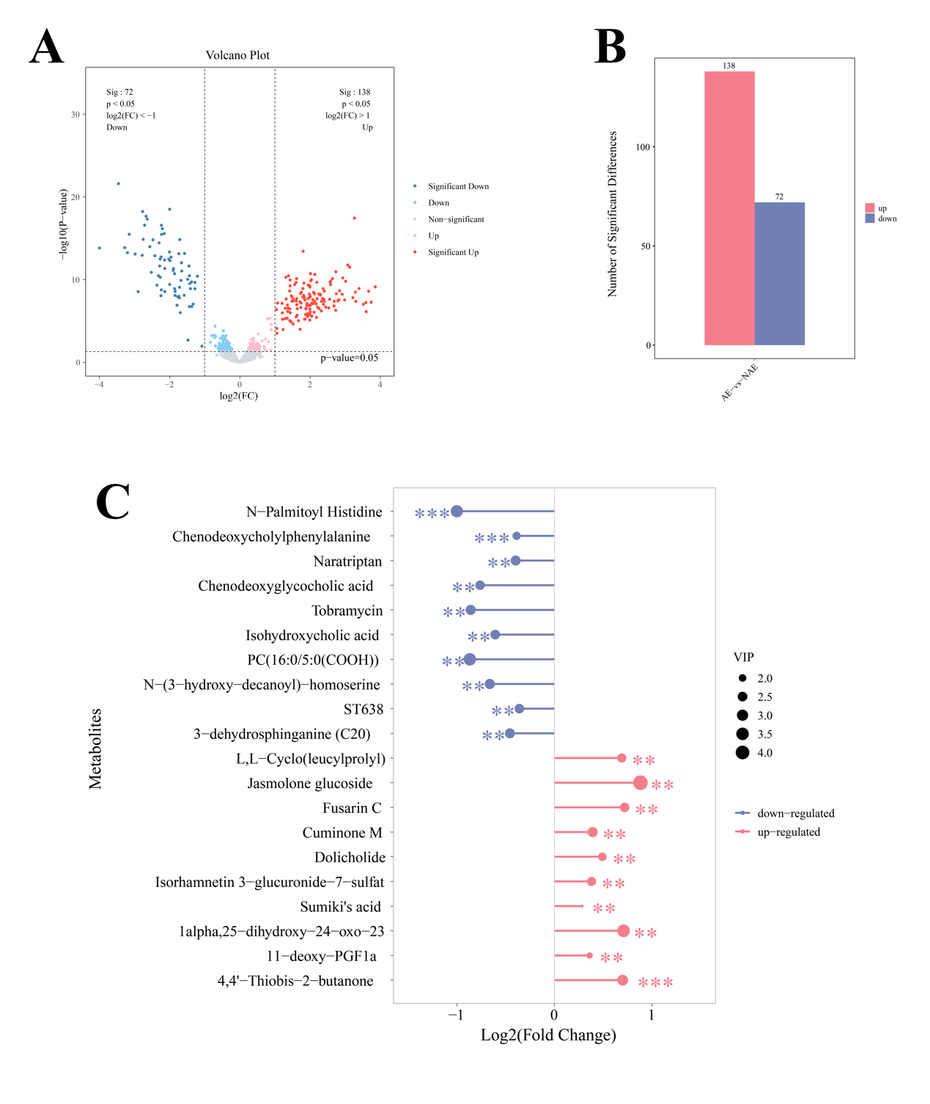
Figure S8: A and B, for analysis of AE and NAE samples, volcano map for significantly expressed proteins was shown in Figure S8A-S8B and data related to Supplementary data 9. C, metabolite alterations between the AE and NAE cohorts, including alterations in N-Palmitoyl Histidine, Chenodeoxycholylphenylalanine, 4,4'-Thiobis-2-butanone, Naratriptan, Chenodeoxyglycocholic acid and 11-deoxy-PGF1a were shown and data related to Supplementary data 10.

