Supplementary Appendix
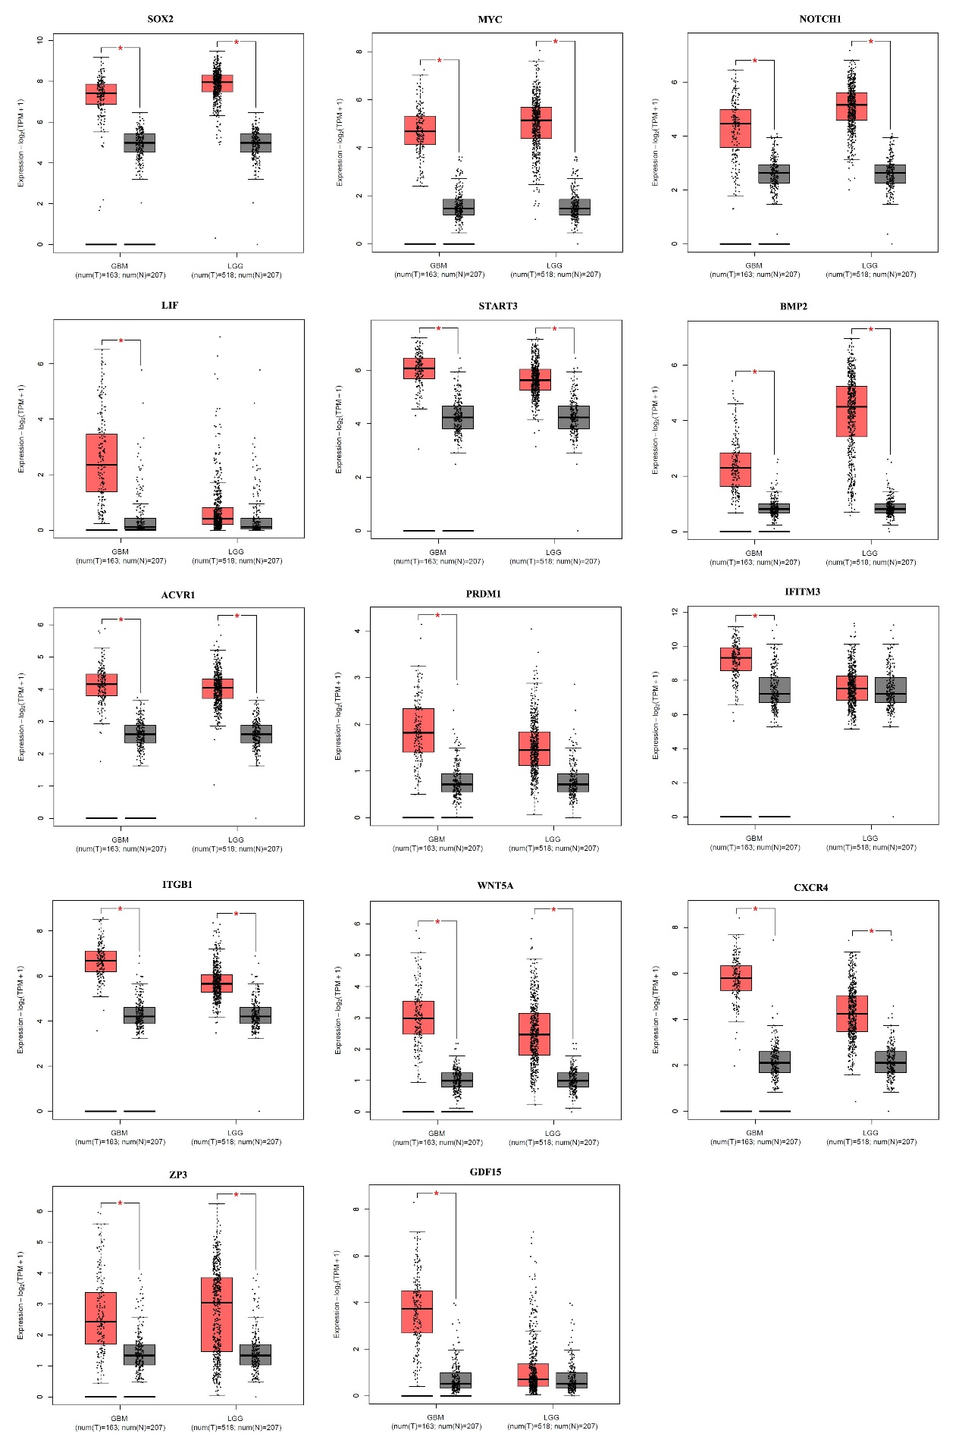
Supplementary Figure S1. Increase expression of genes related to embryonic/germ cell development in gliomas versus normal brain tissues. *P<0.01
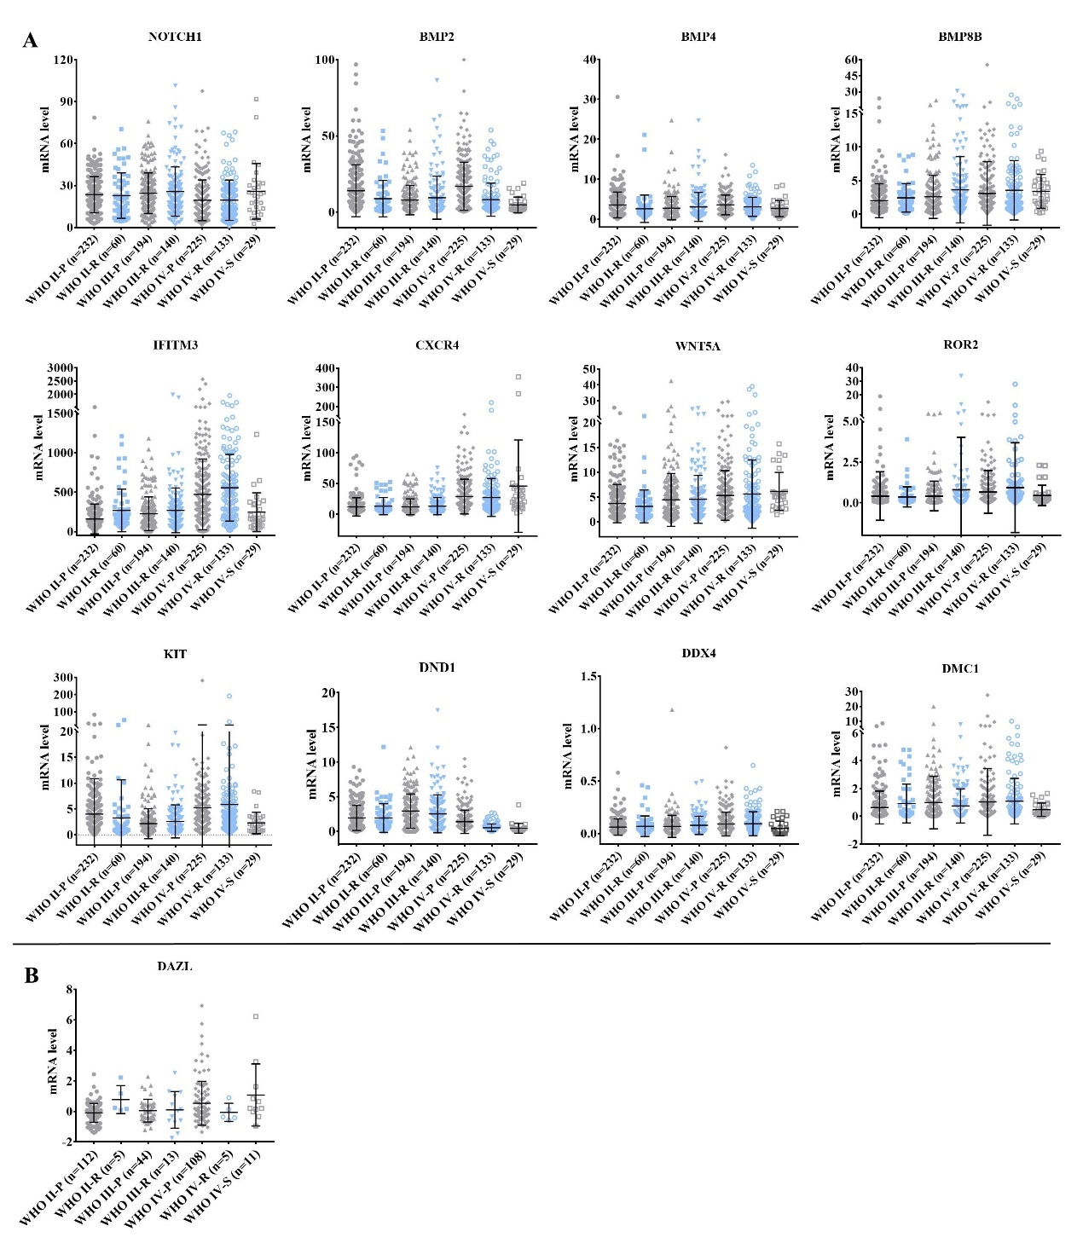
Supplementary Figure S2. Association between the expression of genes related to embryonic/germ cell development and the pathologic grades/outcomes of gliomas. a RNA sequencing showing the mRNA expression profiles of the indicated genes in subtypes of gliomas that had different pathologic grades. b RNA array showing the mRNA expression profile of DAZL in subtypes of gliomas that had different pathologic grades.

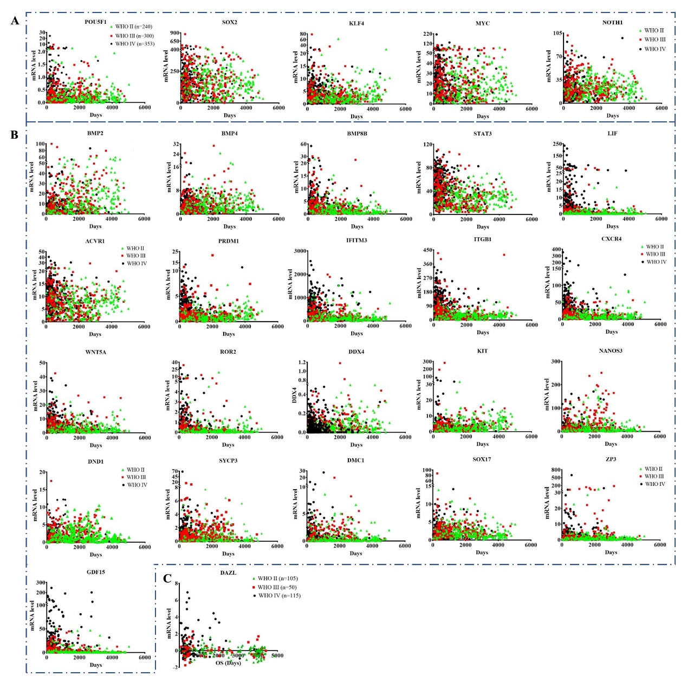
Supplementary Figure S3. Association between the expression of genes related to embryonic/germ cell development and the pathologic grades/outcomes of gliomas. a RNA sequencing and clinical data showing the mRNA expression profiles of the genes related to IPS reprogramming in gliomas that had different pathologic grades and outcomes. b RNA sequencing and clinical data showing the mRNA expression profiles of the genes related to IPS reprogramming in gliomas that had different pathologic grades and outcomes. c RNA array showing the mRNA expression profile of DAZL in gliomas that had different pathologic grades.

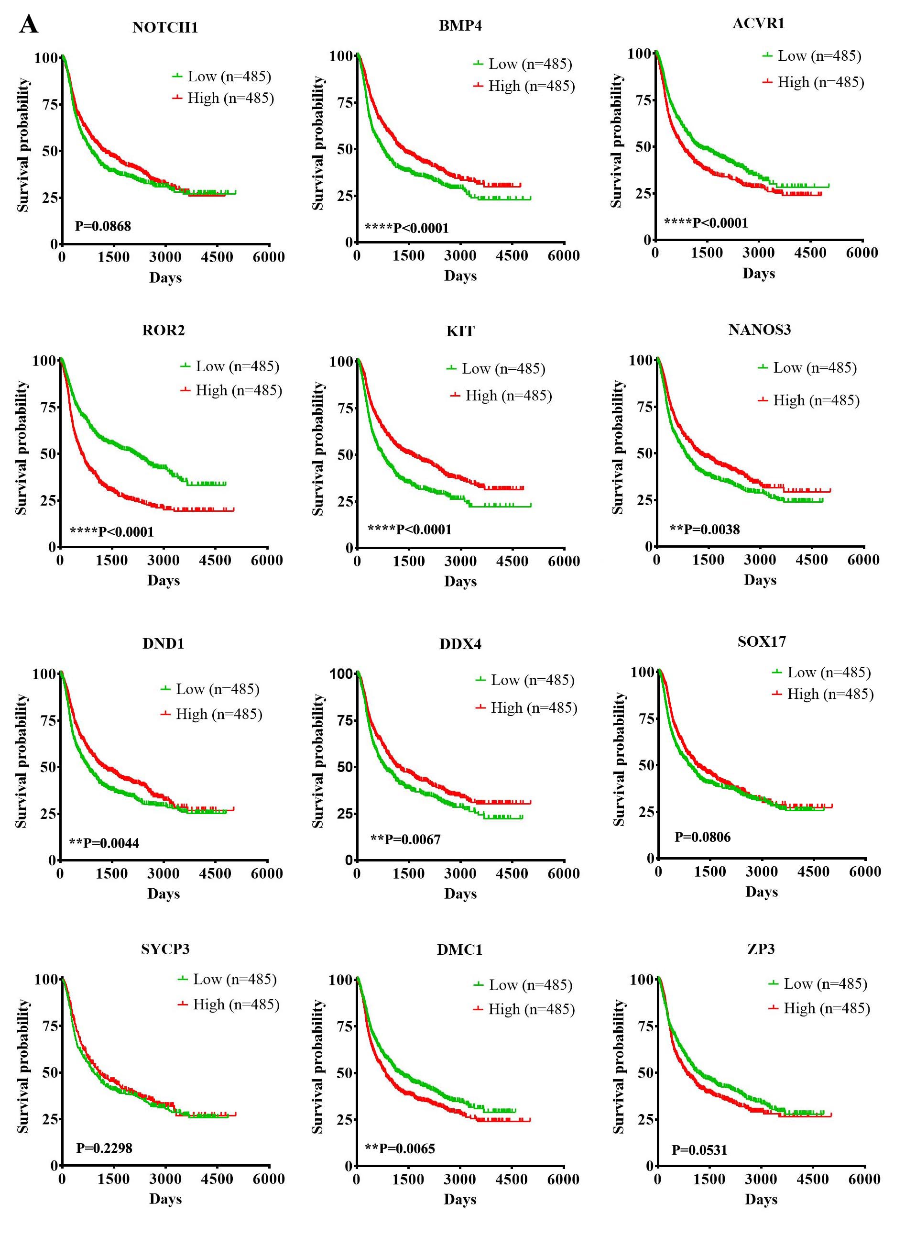
Supplementary Figure S4. Association between the expression of genes related to pluripotency and the pathologic grades/outcomes of gliomas. a RNA sequencing and clinical data showing the mRNA expression profiles of the indicated genes in gliomas that had different pathologic grades and outcomes.

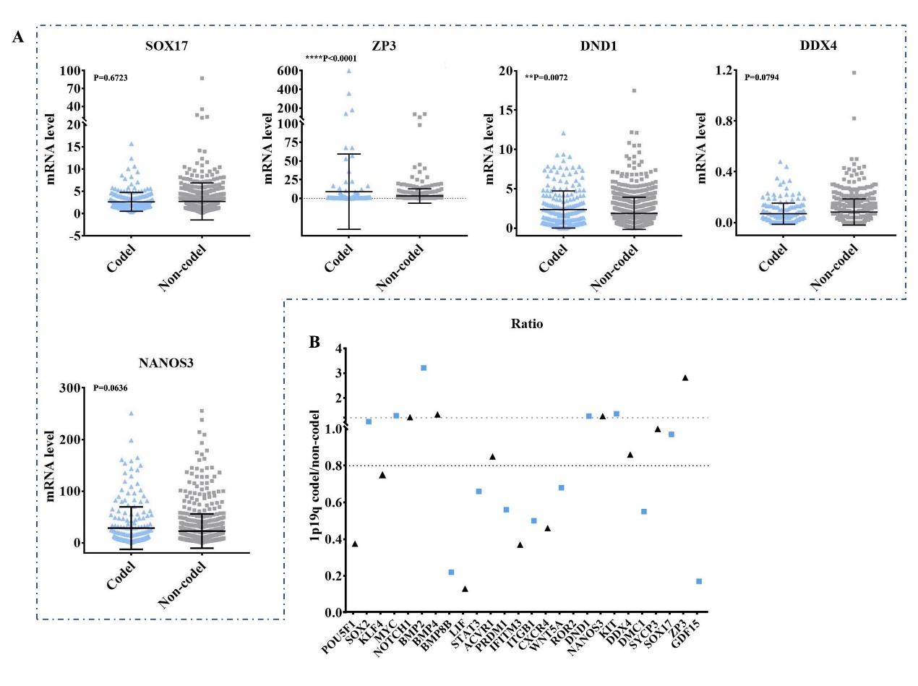
Supplementary Figure S5. Association between the mRNA levels of various genes and 1p/19q codeletion status in gliomas. a RNA sequencing and clinical data showing the relationship between the mRNA level of the indicated genes and 1p/19q codeletion status. b The ratio of gliomas with 1p/19q codeletion to gliomas without 1p/19q codeletion and the mean mRNA values of various genes.

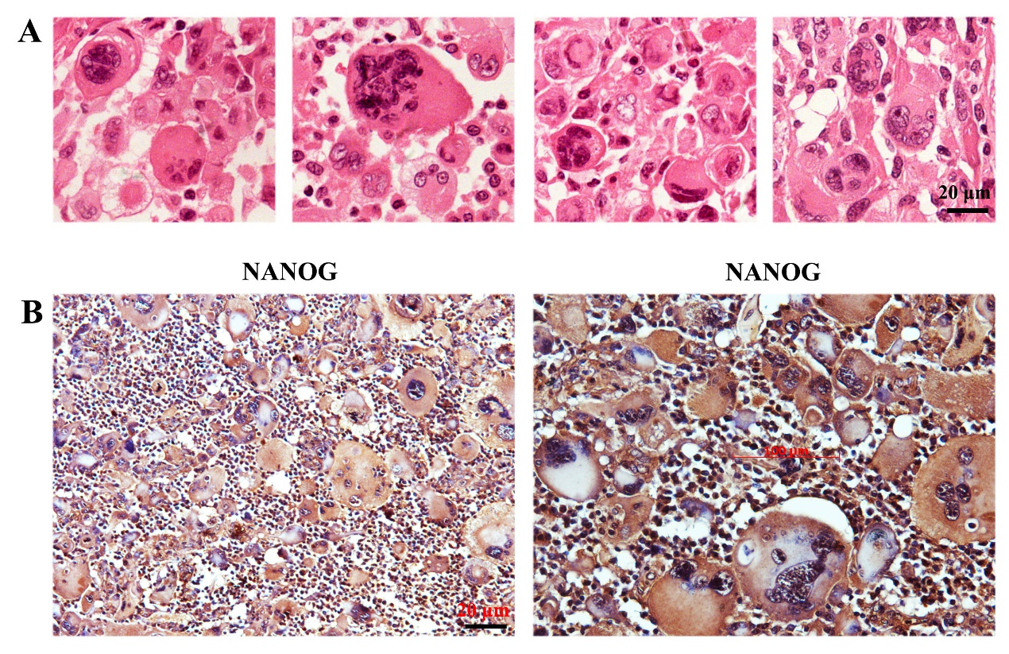
Supplementary Figure S6. Clinical significance of WHO classification, molecular group patient and embryonic/germ cell-like cell appearance. a Gliomas classified according to the WHO grade. b Patients with the same 1p19q status classified by the molecular group showed different overall survival. c Morphology and marker expression of embryonic/germ cell-like cells in human glioma tissues. d HE staining and Immunohistochemistry assays showing the germ cell-like cell and embryo-like structures at different developmental stages. Scale bar=50 μm (c).

Supplementary Table S1. Sequencing data of CRIPSR-Cas9 knockout glioma cells.
Mutation | sgRNA target/ mutant target | indels
A172-Dazl^{+/-} | …ACCATATCTAGCAAAGAAGCTTCTAATCTCA…… | -5 bp
A172-Dazl^{+/-} | …ACCATAT----------AAAGAAACTTCTCACCCTCT… | -5 bp
U251-Dazl^{+/-} | …ACCATATCTAGCAAAGAAGCTTCTAATCTCA…… | -4 bp
U251-Dazl^{+/-} | …ACCATATCAA----AAAAAA----TTCTTATCTCC…… | -4 bp
LN229-Dazl^{+/-} | …ACCATATCTAGCAAAGAAGCTTCTAATCTCA…… | -2bp
LN229-Dazl^{+/-} | …ACCATA----TAATAAACAACCATTCAATCTA… | -2bp

Supplementary Table S2. Detailed information from the CGGA database regarding mRNA sequencing.
 | Sample Number
 | Total | WHO II | WHO III | WHO IV
mRNAseq_325  for figure 3-5. | 313  (4 without WHO information) | 98 | 75 | 136 | Data without survival information was deleted. Data with incomplete survival less than three years was deleted.
Combined with mRNAseq_325 and mRNAseq_693  for figure 6.  Some data without 1p19q status | 898 | 242 | 301 | 352 | Data without survival information was deleted. Data without WHO classification was deleted.

Supplementary Table S3. Comparison of gene expression in subtype of gliomas with distinct WHO classification (Unpaired t test with Welch's correction).
 | Mean ± SEM
Genes | WHO II-P  (n=232) | WHO II-R  (n=59)  (Vs II-P) | WHO III-P  (n=194)  (Vs II-P) | WHO III-R  (n=140)  (Vs III-P) | WHO IV-P  (n=225)  (Vs III-P) | WHOIV-R  (n=133)  (Vs IV-P) | WHO IV-S  (n=30)  (Vs IV-P)
POU5F1 | 0.31±0.03 | 0.34 ± 0.06  ns | 0.38 ± 0.06  ns | 0.34 ± 0.05  ns | 0.63 ± 0.12  * | 0.62 ± 0.12  ns | 0.33 ± 0.05  *
ROR2 | 0.42± 0.10 | 0.37± 0.08  ns | 0.42 ± 0.07  ns | 0.80± 0.27  ns | 0.67 ± 0.09  * | 0.93 ± 0.24  ns | 0.45 ± 0.11  ns
WNT5A | 3.7 ± 0.26 | 3.10± 0.43  ns | 4.42 ± 0.38  ns | 4.541± 0.41  ns | 5.32 ± 0.33  ns | 5.602± 0.60  ns | 6.13 ± 0.70  ns
GDF15 | 2.80± 0.58 | 6.52± 1.32  * | 3.29 ± 0.42  ns | 6.68 ± 0.76  **** | 17.74± 1.97  **** | 25.67± 5.39  ns | 6.20 ± 1.35  ****
ITGB1 | 30.89±1.46 | 44.13±4.73  ** | 45.39±4.44  ** | 57.48 ± 4.66  ns | 78.87± 4.40  **** | 81.79± 5.79  ns | 114.7±11.59  **
CXCR4 | 12.19±0.97 | 13.4± 1.81  ns | 12.37±0.92  ns | 13.39 ± 1.18  ns | 28.87± 1.89  **** | 27.4 ± 2.67  ns | 45.91±13.69  ****
ZP3 | 3.79± 1.60 | 6.12± 3.16  ns | 5.29 ± 1.34  ns | 1.93± 0.53  * | 3.12 ± 0.52  ns | 7.12 ± 4.48  ns | 0.68 ± 0.22  ****
KLF4 | 4.27± 0.35 | 4.12± 0.48  ns | 3.13 ± 0.35  ns | 4.21 ± 0.64  ns | 4.27 ± 0.27  ns | 4.77± 0.38  ns | 3.13 ± 0.35  *
MYC | 19.44±1.00 | 26.94± 3.38  * | 21.11 ± 1.6  ns | 24.92 ± 1.65  ns | 19.71± 1.39  ns | 19.37± 1.49  ns | 42.27±6.12  **
STAT3 | 28.61±1.02 | 32.02± 2.45  ns | 30.45±1.52  ns | 35.54 ± 1.93  * | 41.25± 1.55  **** | 44.25± 2.12  ns | 52.63±3.44  **
BMP8B | 1.99± 0.17 | 2.42± 0.28  ns | 2.57 ± 0.23  * | 3.63±0.42  * | 3.07 ± 0.32  ns | 3.55 ± 0.38  ns | 3.40 ± 0.46  ns
ACVR1 | 7.27± 0.27 | 8.19 ± 0.56  ns | 7.17 ± 0.37  ns | 8.40±0.42  * | 8.54 ± 0.40  * | 8.50± 0.44  ns | 11.89±0.64  ****
PRDM1 | 1.25± 0.07 | 1.19± 0.15  ns | 1.39 ± 0.15  ns | 1.41± 0.12  ns | 2.25 ± 0.14  **** | 2.05± 0.18  ns | 2.53 ± 0.27  ns
IFITM3 | 160.1±12.39 | 269 ± 35.16  ** | 226.5±15.32  *** | 268.9±24.04  ns | 472.2±30.0  **** | 556.1±36.7  ns | 245.7±45.03  ****
SOX17 | 2.17± 0.13 | 4.22 ± 0.54  **** | 2.30±0.13  ns | 3.63±0.64  * | 2.25 ± 0.16  ns | 2.59 ± 0.29  ns | 1.01 ± 0.10  ****
DMC1 | 0.62± 0.08 | 0.84± 0.17  ns | 1.02± 0.14  ** | 0.73 ± 0.10  ns | 1.07 ± 0.17  ns | 1.09 ± 0.14  ns | 0.47± 0.08  **
SYCP3 | 0.88± 0.08 | 0.80± 0.11  ns | 1.10± 0.11  ns | 0.99± 0.11  ns | 1.26 ± 0.31  ns | 0.82±0.085  ns | 0.26± 0.065  **
DND1 | 1.97± 0.13 | 2.12± 0.29  ns | 2.30± 0.16  ns | 2.10± 0.19  ns | 1.56 ± 0.15  *** | 1.46 ± 0.15  ns | 0.64± 0.08  ****
KIT | 4.53± 0.28 | 3.37± 0.42  * | 5.42± 1.74  ns | 3.122 ± 0.24  ns | 2.8 ± 0.32  ns | 3.12 ± 0.69  ns | 4.672 ± 1.34  ns
NANOS3 | 21.5± 2.27 | 29.74±6.19  ns | 33.5 ± 3.33  ** | 22.33 ± 2.31  ** | 16.33± 1.78  **** | 17.3 ± 2.04  ns | 5.79±0.71  ****
BMP4 | 3.65± 0.20 | 3.92± 0.40  ns | 3.50± 0.25  ns | 3.48 ± 0.26  ns | 2.52± 0.15  ** | 2.56± 0.22  ns | 2.59± 0.27  ns
BMP2 | 17.13±0.99 | 15.49± 2.49  ** | 12.29 ± 0.96  *** | 14.6 ± 1.43  ns | 5.44 ± 0.61  **** | 5.84± 0.89  ns | 12.48± 2.34  **
DDX4 | 0.06± 0.01 | 0.07± 0.01  ns | 0.07 ± 0.01  ns | 0.08 ± 0.01  ns | 0.09 ± 0.01  * | 0.05 ± 0.01  ** | 0.05 ± 0.01  **
SOX2 | 154.5± 6.23 | 180.8±14.2  ns | 170.1 ± 8.50  ns | 198.2±11.52  ns | 149 ± 6.87  ns | 167.6 ±9.80  ns | 181.2±15.05  ns
NOTCH1 | 23.42 ±0.85 | 22.82± 2.11  ns | 24.47 ± 1.04  ns | 25.69 ± 1.49  ns | 19.43±0.97  *** | 19.49 ±1.25  ns | 25.86± 3.62  ns

Supplementary Table S4. Comparison of gene expression in gliomas with distinct WHO classifications (Unpaired t test with Welch's correction and Mann Whitney test).
 | Mean ± SEM
Genes | LGG (n=625) | GBM(n=88) | sGBM(n=0) | LGG&GBM | LGG&sGBM
POU5F1 | 0.3402 ± 0.02 | 0.60± 0.08 | 0.33± 0.05 | 0.0014** | 0.7699 ns
SOX2 | 171.6 ± 4.59 | 157.9 ± 5.36 | 181.2± 15.05 | 0.0516 ns | 0.5442 ns
KLF4 | 4.092 ± 0.213 | 4.35± 0.21 | 3.126 ± 0.35 | 0.3837 ns | 0.0224*
MYC | 21.89 ± 0.79 | 21.34 ± 1.11 | 42.27 ± 6.12 | 0.6842 ns | 0.0025**
STAT3 | 31.05 ± 0.78 | 43.16 ± 1.19 | 52.63 ± 3.44 | <0.0001**** | <0.0001****
LIF | 1.633 ± 0.20 | 8.631 ± 1.20 | 9.81± 6.95 | <0.0001**** | <0.0001**** (MW test)
NOTCH1 | 24.2 ± 0.60 | 19.95 ± 0.76 | 25.86± 3.624 | <0.0001**** | 0.6539 ns
ITGB1 | 42.59 ± 1.91 | 82.65 ± 3.38 | 114.7± 11.59 | <0.0001**** | <0.0001****
CXCR4 | 12.63 ± 0.56 | 29.68 ± 1.78 | 45.91± 13.69 | <0.0001**** | <0.0001**** (MW test)
ROR2 | 0.50± 0.07 | 0.74± 0.10 | 0.45± 0.11 | 0.0469 * | 0.7243 ns
WNT5A | 4.05 ± 0.18 | 5.48± 0.28 | 6.131± 0.70 | <0.0001**** | 0.0070**
BMP8B | 2.58 ± 0.14 | 3.258 ± 0.23 | 3.40 ± 0.46 | 0.0112* | 0.0042**** (MW test)
ACVR1 | 7.58± 0.19 | 8.79± 0.29 | 11.89 ± 0.64 | 0.0004*** | <0.0001****
PRDM1 | 1.32±0.06 | 2.20 ± 0.10 | 2.53 ± 0.27 | <0.0001**** | 0.0001***
IFITM3 | 215.3 ± 9.31 | 483.5±22.08 | 245.7± 45.03 | <0.0001**** | 0.5136 ns
GDF15 | 4.17± 0.33 | 19.57 ± 2.19 | 6.201 ± 1.35 | <0.0001**** | 0.1542 ns
ZP3 | 4.06± 0.79 | 4.30 ± 1.57 | 0.68± 0.22 | 0.8882 ns | <0.0001****
DND1 | 2.12 ± 0.09 | 1.46 ± 0.10 | 0.64± 0.08 | <0.0001**** | <0.0001****
NANOS3 | 26.14 ± 1.554 | 15.85 ± 1.26 | 5.79 ± 0.71 | <0.0001**** | <0.0001****
KIT | 4.39 ± 0.56 | 3.06 ± 0.2 | 4.67 ± 1.34 | 0.0383* | 0.8443 ns
BMP4 | 3.59 ± 0.13 | 2.54± 0.12 | 2.60 ± 0.27 | <0.0001**** | 0.0020**
BMP2 | 14.89 ± 0.62 | 6.12 ± 0.51 | 12.48 ± 2.34 | <0.0001**** | 0.3262 ns
SYCP3 | 0.96± 0.05 | 1.03 ± 0.18 | 0.26± 0.06 | 0.7364 ns | <0.0001****
DMC1 | 0.79 ± 0.06 | 1.03 ± 0.11 | 0.47 ± 0.09 | 0.0551 ns | 0.0029**
DDX4 | 0.08 ± 0.004 | 0.06 ± 0.004 | 0.05± 0.01 | 0.0001*** | 0.0140*
SOX17 | 2.73± 0.17 | 2.27 ± 0.14 | 1.01 ± 0.10 | 0.0351* | <0.0001****

Supplementary Table S5. Comparison of the median survival of gliomas with distinct gene expression.
 | Median overall survival
Genes | Low (n=485) | High (n=485) | P | P Summary
POU5F1 | 1321 | 824 | 0.0004 | ***
SOX2 | 1054 | 970 | 0.2773 | ns
KLF4 | 1079 | 952 | 0.238 | ns
MYC | 1023 | 1008 | 0.1466 | ns
NOTCH1 | 842 | 1197 | 0.0868 | ns
BMP2 | 506 | 2304 | <0.0001 | ****
BMP4 | 745 | 1321 | <0.0001 | ****
BMP8B | 2219 | 660 | <0.0001 | ****
LIF | 2499 | 484 | <0.0001 | ****
STAT3 | 2199 | 609 | <0.0001 | ****
ACVR1 | 1252 | 782 | <0.0001 | ****
PRDM1 | 1933 | 681 | <0.0001 | ****
IFITM3 | 2367 | 540 | <0.0001 | ****
ITGB1 | 2527 | 523 | <0.0001 | ****
CXCR4 | 2199 | 576 | <0.0001 | ****
WNT5A | 1977 | 681 | <0.0001 | ****
ROR2 | 2156 | 623 | <0.0001 | ****
SOX17 | 863 | 1122 | 0.0806 | ns
KIT | 723 | 1588 | <0.0001 | ****
NANOS3 | 825 | 1244 | 0.0038 | **
DND1 | 809 | 1252 | 0.0044 | **
DDX4 | 788 | 1188 | 0.0067 | **
SYCP3 | 921 | 1068 | 0.2298 | ns
DMC1 | 1252 | 834 | 0.0065 | **
ZP3 | 1134 | 827 | 0.0531 | ns
GDF15 | 2630 | 473 | <0.0001 | ****

Supplementary Table S6. Comparison of gene expression in gliomas with distinct 1p19q codeletion statue (Unpaired t test with Welch's correction).
 | Mean ± SEM |  |  |  | Mean ratio
Genes | Codel  n=212 | Non-codel  n=728 | P | P Summary | Codel/Noncode
POU5F1 | 0.21 ± 0.01 | 0.55 ± 0.05 | <0.0001 | **** | 0.375
SOX2 | 180.90 ± 7.57 | 173.80 ± 4.07 | 0.4119 | ns | 1.04
KLF4 | 3.52 ± 0.22 | 4.723± 0.20 | <0.0001 | **** | 0.75
MYC | 27.11 ± 1.67 | 21.25 ± 0.72 | 0.0014 | ** | 1.28
NOTCH1 | 27.14 ± 0.99 | 22.21 ± 0.55 | <0.0001 | **** | 1.22
BMP2 | 26.15 ± 1.32 | 8.14 ± 0.36 | <0.0001 | **** | 3.21
BMP4 | 4.11 ± 0.21 | 3.084 ± 0.11 | <0.0001 | **** | 1.33
BMP8B | 0.78 ± 0.06 | 3.62 ± 0.16 | <0.0001 | **** | 0.22
LIF | 0.71 ± 0.17 | 5.554 ± 0.67 | <0.0001 | **** | 0.13
STAT3 | 26.92 ± 1.00 | 40.61 ± 0.83 | <0.0001 | **** | 0.66
ACVR1 | 7.55 ± 0.31 | 8.83 ± 0.19 | 0.0004 | *** | 0.85
PRDM1 | 1.10 ± 0.06 | 1.95 ± 0.07 | <0.0001 | **** | 0.56
IFITM3 | 146.10 ± 7.69 | 397.20 ± 14.03 | <0.0001 | **** | 0.37
ITGB1 | 34.53 ± 1.86 | 69.59 ± 2.35 | <0.0001 | **** | 0.5
CXCR4 | 10.73 ± 0.65 | 23.38 ± 1.06 | <0.0001 | **** | 0.46
WNT5A | 3.53 ± 0.35 | 5.20 ± 0.19 | <0.0001 | **** | 0.68
ROR2 | 0.13 ± 0.02 | 0.76 ± 0.08 | <0.0001 | **** | 0.17
DND1 | 2.35 ± 0.16 | 1.87 ± 0.08 | 0.0072 | ** | 1.26
NANOS3 | 28.27 ± 2.83 | 22.52 ± 1.23 | 0.0636 | ns | 1.26
KIT | 5.19 ± 0.30 | 3.83 ± 0.49 | 0.019 | * | 1.36
DDX4 | 0.07 ± 0.01 | 0.08 ± 0.004 | 0.0794 | ns | 0.86
DMC1 | 0.56 ± 0.07 | 1.02 ± 0.07 | <0.0001 | **** | 0.55
SYCP3 | 1.06 ± 0.09 | 1.06 ± 0.10 | 0.9977 | ns | 1
SOX17 | 2.63 ± 0.15 | 2.72 ± 0.15 | 0.6723 | ns | 0.97
ZP3 | 8.91 ± 3.47 | 3.15 ± 0.36 | <0.0001 | **** | 2.82
GDF15 | 2.30 ± 0.28 | 13.11 ± 1.22 | <0.0001 | **** | 0.17

Supplementary Table S7. RNA sequencing cut-off values of the genes in the molecular group.
Genes | Cut off
LIF | 3.8
ITGB1 | 60
CXCR4 | 30
ROR2 | 2.3
WNT5A | 7.5
STAT3 | 59
IFITM3 | 390
GDF15 | 16.9
ACVR1 | 16.4
BMP8B | 5
PRDM1 | 5
POU5F1 | 2

Supplementary Table S8. Comparison of the median survival of gliomas with distinct classifications.
Classification | Median survival |  | P value
Classification | High | Low | P value
Total (MG only) | 447 (n=520) | 3411 (n=378) | ****P<0.0001
WHO IV+MG | 344 (n=307) | 710 (n=47) | ****P<0.0001
WHO III+MG | 554 (n=143） | 2633 (n=158） | ****P<0.0001
WHO II+MG | 2219 (n=70) | >5000 (n=172) | ****P<0.0001
1p19q-codel+MG | 1265 (n=41) | >5000 (n=138) | ****P<0.0001
1p19q-noncodel+MG | 415(n=463) | 2382 (n=186) | ****P<0.0001
Note：Molecular group （MG）

Supplementary Table S9. Positive ratio of molecular groups in distinct glioma types.
LIF, STAT3, PRDM1, IFITM3, ACVR1, CXCR4, WNT5A, ROR2, ITGB1, POU5F1, GDF15 or BMP8B
types | Positive ratio | Compare
WHO II-Total (n=242) | 29.33% | &WHO III-T: ****P<0.0001  & WHO IV-T: ****P<0.0001
WHO II-Primary (n=202) | 24.71% | &WHO II-R: **P=0.0011  &WHO III-P: **P=0.0015  & WHO IV-P: ****P<0.0001  & WHO IV-S: ****P<0.0001
WHO II-Recurrent (n=40) | 52.50%
WHO III-Total (n=301) | 41.19% | & WHO IV-T: ****P<0.0001  & WHO IV-T: ****P<0.0001
WHO III-Primary (n=181) | 40.88% | & WHO III-R: **P=0.0033  & WHO IV-P: ****P<0.0001  & WHO IV-S: ****P<0.0001
WHO III-Recurrent (n=120) | 58.3%
WHO IV-Total (n=354) | 87.28%
WHO IV-Primary (n=206) | 83.98% | & WHO IV-R: P=0.1818 ns  & WHO IV-S: ****P<0.0001
WHO IV-Recurrent (n=119) | 89.91%
WHO IV-Secondary (n=29) | 100%

Supplementary Table S10. Comparison of the median survival of gliomas with the WHO classification.
 | WHO classification
 | WHO II | WHO III | WHO IV | P value
Median survival | >5000 (n=242) | 1109 (n=301) | 349 (n=352) | ****P<0.0001

Supplementary Table S11. Expression ratio of proteins related to embryonic/germ cells in glioma tissues.
 | POU5F1/SOX2/NANOG/NANOS3/DDX4/DAZL
 | Sigle positive | All positive
WHO IV (n=20) | 80% | 50%
WHO III (n=8) | 62.5% | 37.5%
WHO II (n=10) | 40% | 20%

