A Meta-Analysis of Bipolar Disorder and Creativity:
Exploring the Influence of Multiple Variables

Supplementary Information

Table S1. Coding scheme.
Level | Variable | Explanation
Study | Authors
Study | Age of study | Years as of 2024
Study | Country | Country of conduction
Study | Study type | Mean difference or correlation
Sample | Gender | % Female
Sample | Mean age | Mean age in years
Sample | Population type | Teenagers(12-18)/Adults(>18)/Senior citizens(>55)/Mixed
Sample | Artistic profile | Yes or No
BD | Diagnosis | Clinical or subclinical
BD | BD assessment tool | Name of instrument
BD | BD assessment category | Based on DSM, HPS, or other
BD | BD presentation | Bipolar I, bipolar mixed, or subclinical
BD | BD status | Euthymic, manic, or depression
BD | Number of episodesª | Mean number of affective episodes
BD | Onset age | Mean age of first affective episode
BD | Duration | Mean duration of illness (in years)
BD | Hospitalizationª | Yes or No
BD | Medication | Yes or No
BD | Comorbidity | Yes or No
Creativity | Scoring | Fluency, flexibility, originality, elaboration, other, or whole
Creativity | Creativity assessment | Name of instrument
Creativity | Creativity Category | DT, CT, art creativity, or other
Creativity | Creativity Test | Cognitive test or self-report
Creativity | Creativity domain | Verbal, visual, numeric, or mixed
Creativity | Time | Time restriction: Yes or No
IQ | IQ test | Test name
IQ | IQ score | Mean score of IQ
Family study | Relative’s degree | First-degree, second-degree, or others
Family study | BD diagnosis | Yes or No
Family study | Creativity score | Higher, lower, or no significant differences
IQ = Intelligence Quotient. DSM = Diagnostic and Statistical Manual of Mental Disorders. HPS = Hypomanic Personality Scale. DT = Divergent Thinking. CT = Convergent Thinking. ª Not enough information was reported in the studies to further analyze the variable.

Table S2. Overview of BD and creativity assessment tools used in the included studies.

Study | Study Type | BD Assessment | Creativity Assessment
Santosa, Strong ⁴¹ | Mean difference | Structured Clinical Interview for DSM-IV Diagnosis (SCID) | Barron–Welsh Art Scale (BWAS); Adjective Check List Creative Personality Scale (ACL-CPS); TTCT
B. P ⁷⁰ | Mean difference | International Classification of Diseases-10 (ICD) | Divergent Production Abilities Test (DPAT)
Fodor ⁷¹ | Mean difference | The Millon Clinical Multiaxial Inventory III (MCMI-III) | The Remote Associates Test of creativity (RAT)
Ghadirian, Gregoire ⁷² | Mean difference | The Symptom Checklist–90–Revised (SCL–90–R) | A battery of tests measuring creativity and creative thinking in nonverbal, visual–motor, perceptual, and verbal subtests
Goldfinch ⁷³ | Mean difference | GENERAL BEHAVIOR INVENTORY (GBI); Depressed Adjective Checklist (DACL) | Holland and Nicholls Inventory of Creative Activities (HN)
Greenwood, Chow ⁷⁴ | Mean difference | DSM-5 | ACL-CPS; TTCT; CAQ
Hoşgören Alici, Devrimci Özgüven ⁷⁵ | Mean difference | DSM-4 | RAT; AUT
Jamison, Gerner ⁷⁶ | Mean difference | Resesrch Diagnostic Criteria (RDC) | Not mentioned
Thalbourne and Delin ⁷⁷ | Mean difference | DSM-III-R | A specially constructed scale to measure creative personality, consisting of nine true-false items, five of which came from the Torrance Creative Motivation Inventory
Johnson, Tharp ⁷⁸ | Mean difference | Structured Clinical Interview for DSM–IV–TR Axis I Disorders (SCID) | Unusual Uses Task (UUT); CAQ
Richards, Kinney ⁷⁹ | Mean difference | DSM-2; DSM-3 | Lifetime Creativity Scales
Rybakowski and Klonowska ⁸⁰ | Mean difference | ICD-10; DSM-IV | The Revised Art Scale (RAS)-a modified version of the Barron-Welsh Art Scale; the Berlin Intelligence Structure Test (BIS)
Shapiro ⁸¹ | Mean difference | GBI; Positive and Negative Affect Schedule (PANAS); The Lifetime Schedule for Affective Disorders and Schizophrenia (SADS-L) | the Kent-Rosonoff Word Association Test (KRWAT); ACL-CPS
Shapiro and Weisberg ⁸² | Mean difference | GBI | ACL-CPS
Simeonova, Chang ⁸³ | Mean difference | SCID; the Family History-Research Diagnostic Criteria (FH-RDC); the Affective Disorders Module of the Washington Schedule for Affective Disorders and Schizophrenia for School-Age Children (WASH-U-KSADS); Schedule for Affective Disorders and Schizophrenia for School-Age Children-Present and Lifetime (K-SADS-PL); DSM-4 | BWAS
Soeiro-de-Souza, Post ⁸⁴ | Mean difference | DSM-4 | BWAS
Srivastava, Childers ⁸⁵ | Mean difference | SCID | BWAS;ACL-CPS;TTCT
Strong ⁸⁶ | Mean difference | SCID | BWAS
Tremblay, Grosskopf ⁸⁷ | Mean difference | DSM-3 | Occupational creativity index
Tu, Kuan ⁸⁸ | Mean difference | DSM-4 | ATTA; Chinese Word Remote Associates Test (CWRAT)
Thalbourne and Delin ⁷⁷ | Correlation | Not mentioned | A specially constructed scale to measure creative personality, consisting of nine true-false items, five of which came from the Torrance Creative Motivation Inventory
Srivastava, Childers ⁸⁵ | Correlation | SCID | BWAS; ACL-CPS; TTCT
Vellante, Zucca ⁸⁹ | Correlation | The brief Temperament Evaluation of the Memphis, Pisa, Paris and San Diego-Autoquestionnaire (TEMPS-A) | CAQ
Selig ⁹⁰ | Correlation | TEMPS-A | CAQ
Erdman ⁹¹ | Correlation | ASRM | CAQ; Khatena-Torrance Creative Perception Inventory (KTCPI)
Wohl ⁹² | Correlation | the Hypomanic Personality Scale (HPS) | TTCT
Schuldberg ⁹³ | Correlation | Scales of Hypothetical Psychosis-Proneness | AUT; BWAS; How Do You Think; ACL-CPS; RAT
Carter, Hass ⁹⁴ | Correlation | Hypomania Checklist-32 (HCL-32) | CAQ; Wallach-Kogan Creativity Tests (WKCT)
Frantom and Sherman ⁹⁵ | Correlation | General Behavior Inventory (GBI) | What Kind of Person Are You? (WKOPAY); Something About Myself (SAM)
Furnham, Batey ⁹⁶ | Correlation | HPS | Divergent Thinking Tests; The Biographical Inventory of Creative Behaviours (BICB); A Self-rating of creativity
Gostoli, Cerini ⁹⁷ | Correlation | TEMPS-A | test of divergent feelings (TDF)
Jaracz and Borkowska ⁹⁸ | Correlation | TEMPS-A | BWAS
Rodrigue and Perkins ⁹⁹ | Correlation | MCMI-III | ATTA
Siegel and Bugg ¹⁰⁰ | Correlation | HPS | ATTA;CAQ
von Stumm, Chung ¹⁰¹ | Correlation | HPS | Runco Ideational Behaviour Scale; AUT
Zabelina, Condon ¹⁰² | Correlation | HPS | ATTA; CAQ
Nadasi ¹⁰³ | Correlation | HPS; The Minnesota Multiphasic Inventory - 2nd edition (MMPI-2) | AUT; BWAS

Table S3. Descriptive information
Level | Variable | m | k | N | M | SD | Q | df | p
Study | Age of study | 35 | 114 | 48979 | 16.86 | 10.23 | 0.19 | 1 | 0.67
Study | Country |  |  |  |  |  | 27.91 | 9 | 0.001**
Study | Australia | 1 | 5 | 365
Study | Brazil | 1 | 2 | 144
Study | China | 1 | 6 | 115
Study | India | 1 | 2 | 90
Study | Italy | 2 | 4 | 633
Study | Poland | 2 | 17 | 178
Study | Turkey | 1 | 2 | 58
Study | UK | 4 | 11 | 882
Study | USA | 22 | 65 | 17175
Study | Study type |  |  |  |  |  | 44.19 | 2 | < .0001***
Study | Mean difference | 20 | 67 | 16401
Study | Correlational | 17 | 47 | 3721
Sample | Gender(% F) | 34 | 105 | 5587 | 60.5 | 0.10 | 1.88 | 1 | 0.17
Sample | Age | 28 | 104 | 5234 | 29.58 | 7.84 | 3.31 | 1 | 0.07
Sample | Population type |  |  |  |  |  | 19.65 | 3 | 0.0002**
Sample | Teenagers | 2 | 4 | 244
Sample | Adults | 16 | 47 | 2151
Sample | Mixed | 16 | 60 | 3282
Sample | Artistic profile |  |  |  |  |  | 10.29 | 2 | 0.0058**
Sample | Artistic | 6 | 15 | 15111
Sample | Non-artistic | 28 | 91 | 4376
BD | Diagnosis |  |  |  |  |  | 33.01 | 2 | < .0001***
BD | Clinical | 17 | 63 | 16171
BD | Subclinical | 19 | 51 | 3834
BD | BD assessment |  |  |  |  |  | 24.54 | 3 | < .0001***
BD | DSM | 14 | 59 | 15976
BD | HPS | 6 | 16 | 1300
BD | Other | 17 | 39 | 2939
BD | BD presentation |  |  |  |  |  | 25.14 | 3 | < .0001***
BD | BD I | 3 | 86 | 314
BD | Mixed | 6 | 33 | 933
BD | Subclinical | 18 | 49 | 3469
BD | BD status |  |  |  |  |  | 20.36 | 3 | 0.0001***
BD | Depression | 1 | 5 | 88
BD | Euthymic | 9 | 32 | 1145
BD | Mania | 1 | 5 | 88
BD | Medication |  |  |  |  |  | 0.20 | 2 | 0.91
BD | Yes | 7 | 28 | 1014
BD | No | 3 | 21 | 344
BD | Comorbidity |  |  |  |  |  | 1.48 | 2 | 0.48
BD | Yes | 3 | 10 | 383
BD | No | 3 | 14 | 360
BD | Duration | 3 | 23 | 293 | 10.43 | 1.99 | 6.93 | 1 | 0.0085*
BD | Onset age | 3 | 12 | 317 | 22.48 | 1.33 | 7.94 | 1 | 0.0048*
Creativity | Scoring |  |  |  |  |  | 77.18 | 6 | < .0001***
Creativity | Whole | 33 | 98 | 18894
Creativity | Ori | 5 | 7 | 1289
Creativity | Flu | 4 | 4 | 1199
Creativity | Flex | 1 | 1 | 115
Creativity | Elab | 2 | 2 | 205
Creativity | Other | 3 | 2 | 656
Creativity | Category |  |  |  |  |  | 224.25 | 4 | < .0001***
Creativity | CT | 4 | 4 | 886
Creativity | DT | 19 | 41 | 3465
Creativity | Art creativity | 9 | 16 | 1695
Creativity | Other | 23 | 52 | 18347
Creativity | Task category |  |  |  |  |  | 165.52 | 2 | < .0001***
Creativity | Cognitive test | 22 | 59 | 3685
Creativity | Self-report | 25 | 52 | 4861
Creativity | Domain |  |  |  |  |  | 21.70 | 4 | 0.0002**
Creativity | Verbal | 27 | 68 | 4962
Creativity | Visual | 12 | 27 | 1547
Creativity | Numeric | 1 | 3 | 88
Creativity | Mixed | 5 | 13 | 676
IQ | Scores | 5 | 9 | 588 |  |  | 0.98 | 1 | 0.32
Family history | Creativity scores |  |  |  |  |  | 1.39 | 3 | 0.71
Family history | Higher | 2 | 2 | 193
Family history | Lower | 1 | 1 | 116
Family history | NS | 1 | 2 | 90
m = number of studies. k = number of effect sizes. N = sample size. Q = Cochran’s Q test for heterogeneity. df = degrees of freedom. * p < 0.05 and *** p < 0.0001

Table S4. Results of subgroup analysis
Level | Variable | k | g | 99%CI |  | Z |  | p
 |  |  |  | LL | UL
Study | Study type
Study | Mean difference | 67 | 0.04 | -0.17 | 0.25 |  | 0.37 |  | 0.49
Study | Correlational | 47 | 0.32 | 0.22 | 0.42 |  | 6.47 |  | <.0001***
Sample | Population type
Sample | Teenagers | 4 | 0.57 | 0.23 | 0.92 |  | 3.23 |  | 0.0012**
Sample | Adults | 47 | 0.18 | 0.07 | 0.28 |  | 3.26 |  | 0.0011**
Sample | Mixed | 60 | 0.19 | 0.02 | 0.36 |  | 2.15 |  | 0.03*
Sample | Artistic profile
Sample | Artistic | 15 | 0.31 | -0.02 | 0.64 |  | 1.87 |  | 0.06
Sample | Non-artistic | 91 | 0.18 | 0.04 | 0.31 |  | 2.54 |  | 0.0112*
BD | Diagnosis
BD | Clinical | 63 | 0.06 | -0.17 | 0.29 |  | 0.51 |  | 0.61
BD | Subclinical | 51 | 0.32 | 0.22 | 0.41 |  | 6.67 |  | <.0001***
BD | BD assessment
BD | DSM | 59 | 0.15 | -0.07 | 0.38 |  | 1.33 |  | 0.18
BD | HPS | 16 | 0.40 | 0.25 | 0.54 |  | 5.34 |  | <.0001***
BD | Other | 39 | 0.17 | 0.01 | 0.33 |  | 2.13 |  | 0.0335 *
BD | BD presentation
BD | BD I | 8 | -0.23 | -0.90 | 0.42 |  | -0.70 |  | 0.48
BD | Mixed | 33 | 0.16 | -0.10 | 0.42 |  | 1.22 |  | 0.22
BD | Subclinical | 51 | 0.32 | 0.22 | 0.41 |  | 6.67 |  | <.0001***
BD | BD status
BD | Depression | 5 | -0.31 | -0.56 | -0.07 |  | -2.55 |  | 0.0109*
BD | Mania | 5 | 0.30 | 0.07 | 0.53 |  | 2.55 |  | 0.0108*
BD | Euthymic | 32 | -0.14 | -0.45 | 0.17 |  | -0.89 |  | 0.37
BD | Medication
BD | Yes | 28 | 0.04 | -0.33 | 0.42 |  | 0.23 |  | 0.82
BD | No | 21 | 0.11 | -0.18 | 0.40 |  | 0.75 |  | 0.45
BD | Comorbidity
BD | Yes | 10 | 0.26 | -0.22 | 0.74 |  | 1.08 |  | 0.28
BD | No | 14 | 0.04 | -0.13 | 0.20 |  | 0.45 |  | 0.65
Creativity | Scoring
Creativity | Whole | 98 | 0.20 | 0.08 | 0.34 |  | 2.92 |  | 0.0035**
Creativity | Ori | 7 | 0.24 | 0.15 | 0.33 |  | 5.26 |  | <.0001***
Creativity | Flu | 4 | 0.08 | -0.01 | 0.17 |  | 1.73 |  | 0.08
Creativity | Flex | 1
Creativity | Elab | 2 | -0.17 | -0.68 | 0.34 |  | -0.64 |  | 0.52
Creativity | Other | 2 | 0.54 | 0.47 | 0.60 |  | 16.42 |  | <.0001***
Creativity | Category
Creativity | CT | 4 | -0.08 | -0.70 | 0.54 |  | -0.25 |  | 0.80
Creativity | DT | 41 | 0.08 | -0.05 | 0.21 |  | 1.19 |  | 0.23
Creativity | Art creativity | 16 | 0.34 | 0.14 | 0.55 |  | 3.26 |  | 0.0011**
Creativity | Other | 52 | 0.31 | 0.16 | 0.45 |  | 4.13 |  | <.0001***
Creativity | Task category
Creativity | Cognitive test | 59 | 0.10 | -0.03 | 0.23 |  | 1.46 |  | 0.14
Creativity | Self-report | 52 | 0.29 | 0.18 | 0.41 |  | 5.00 |  | <.0001***
Creativity | Domain
Creativity | Verbal | 68 | 0.18 | 0.05 | 0.31 |  | 2.72 |  | 0.0065**
Creativity | Visual | 27 | 0.18 | 0.05 | 0.31 |  | 2.64 |  | 0.0082**
Creativity | Numeric | 3 | 0.02 | -0.26 | 0.29 |  | 0.11 |  | 0.92
Creativity | Mixed | 13 | 0.03 | -0.07 | 0.12 |  | 0.59 |  | 0.55
Small (g = 0.20), medium (g = 0.50), and large (g = 0.80) effect sizes regarding conventions for Hedge’s g⁴⁸ are written in bold numbers. * p < 0.05, ** p < 0.01, and *** p < 0.0001.

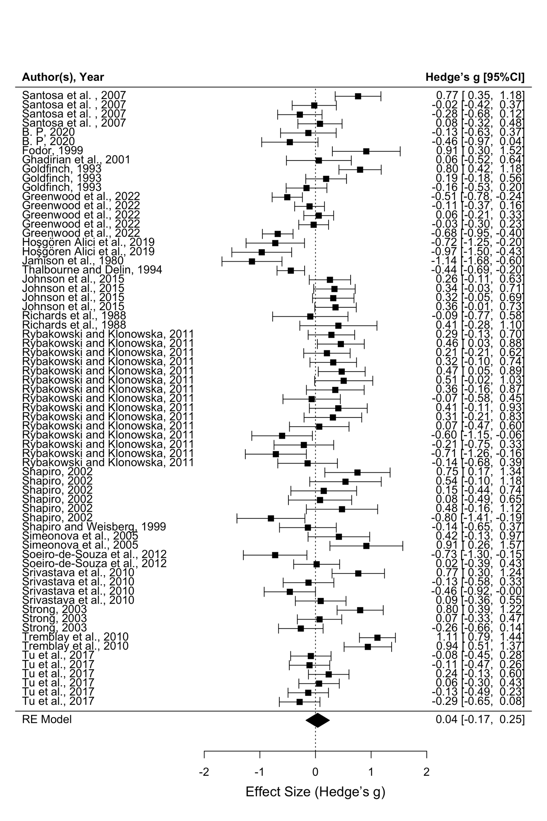
Figure S1. Forest plot for subset of studies using mean differences.

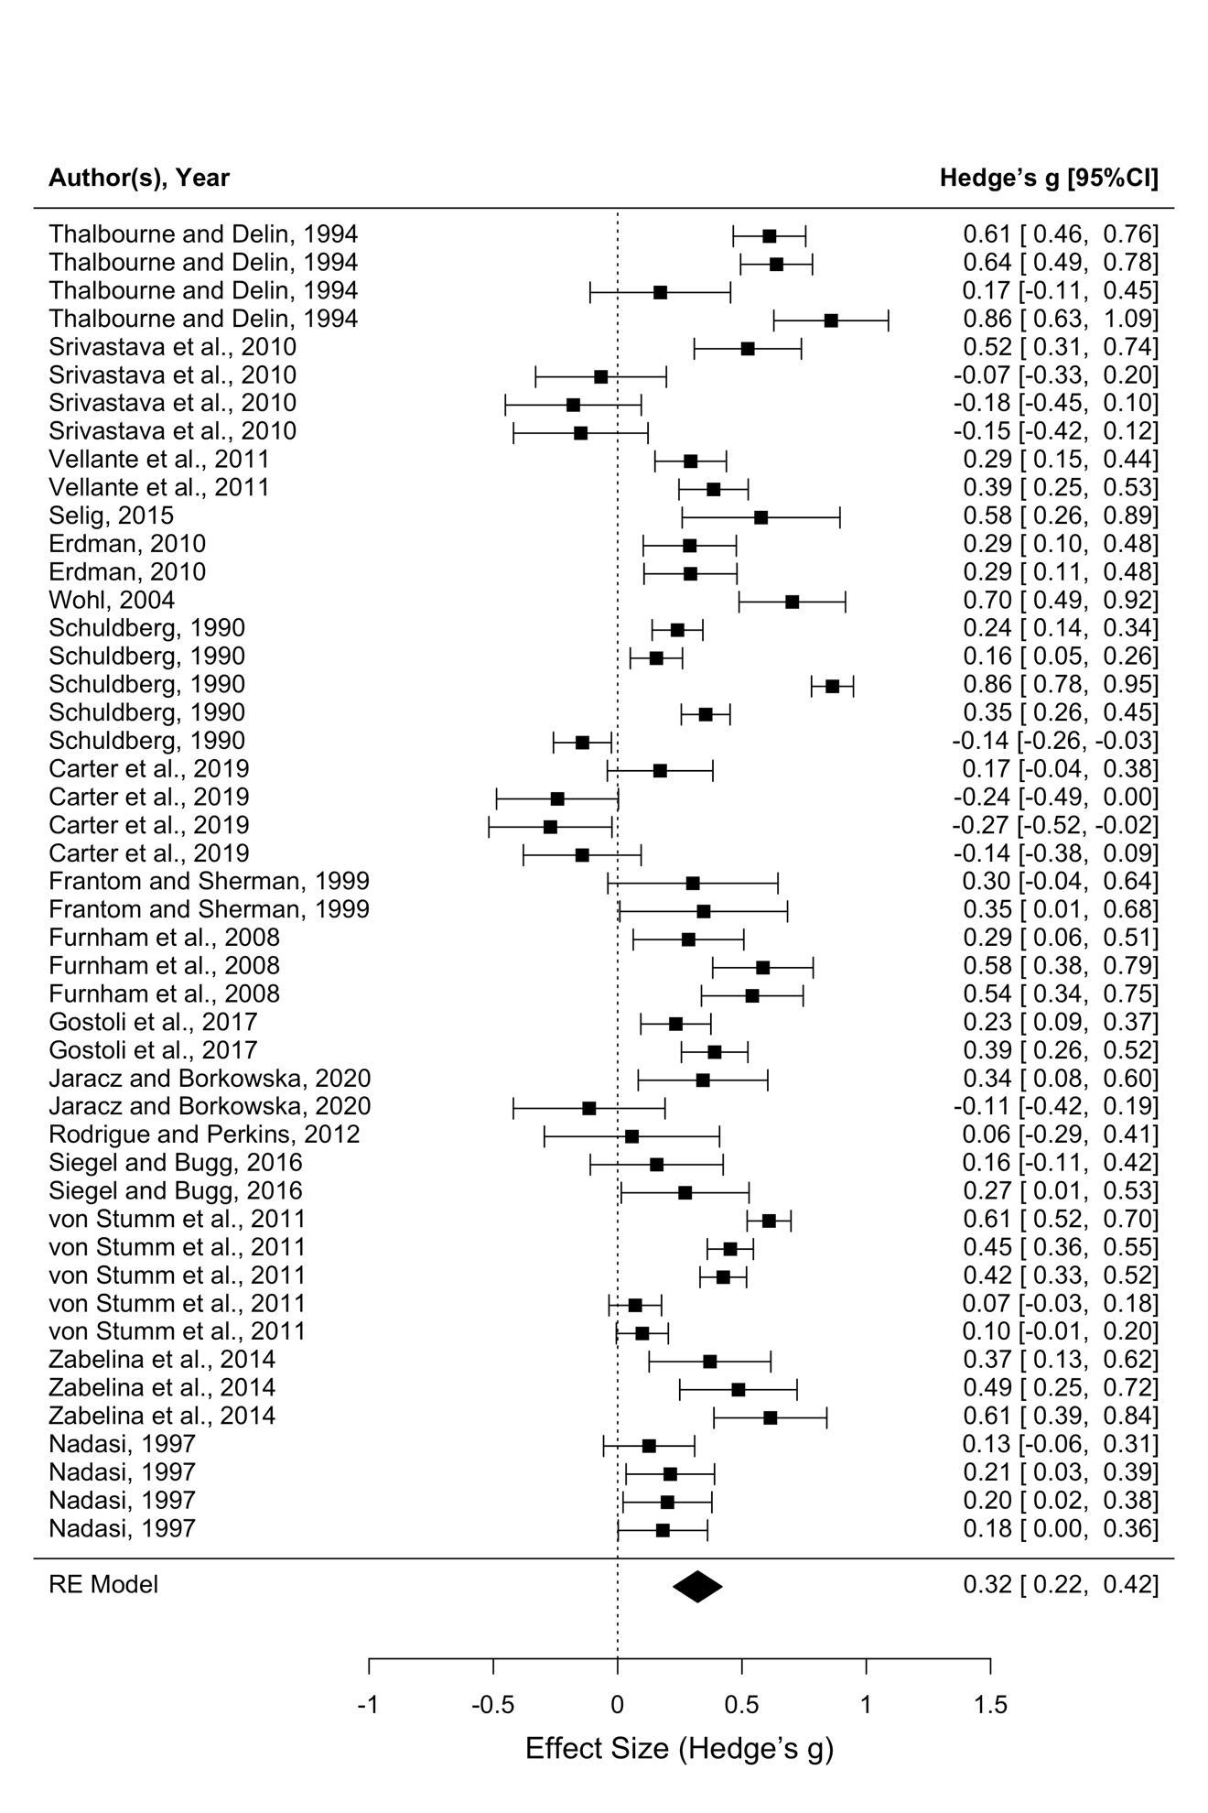
Figure S2. Forest plot for subset of studies using a correlational design.

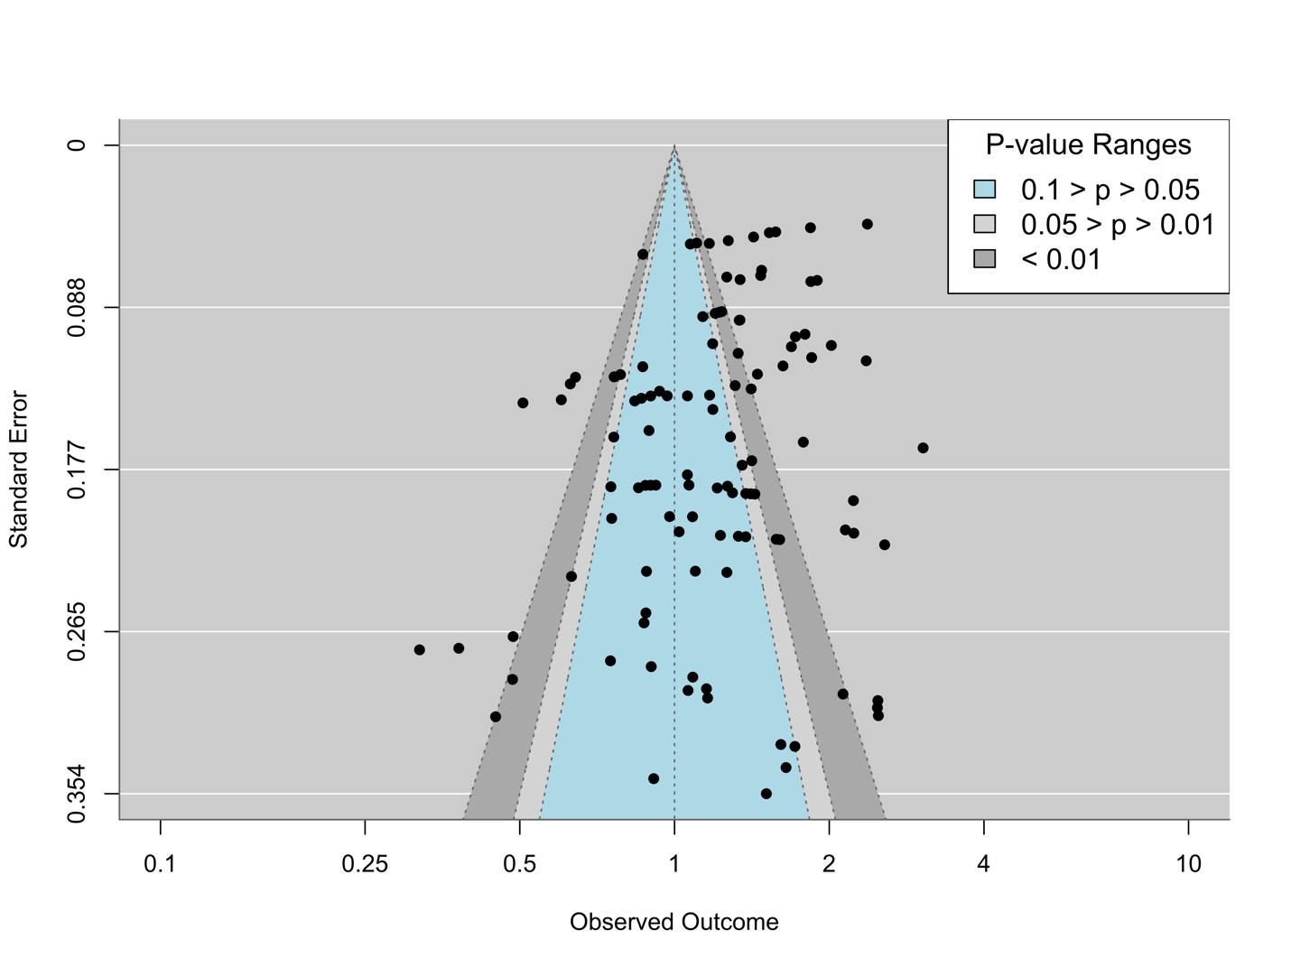
Figure S3. Funnel plot for analyzing publication bias
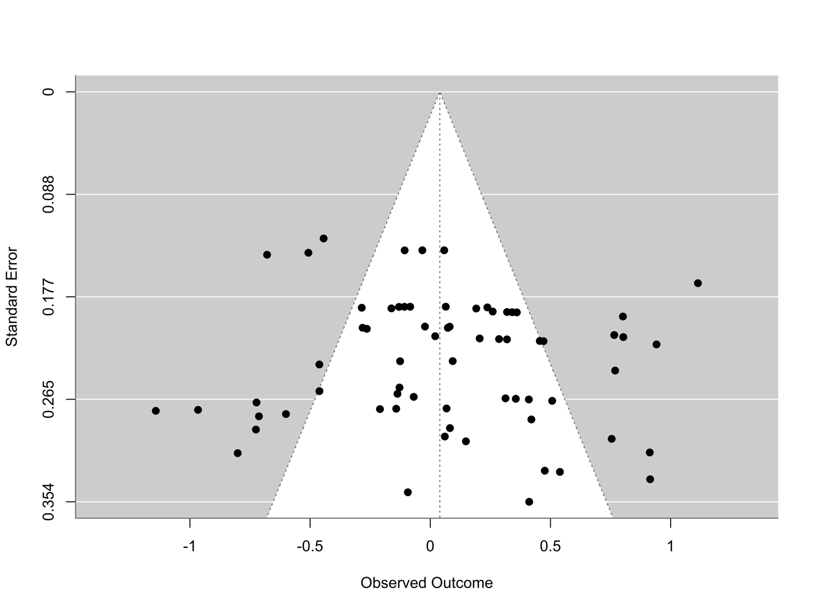
Figure S4. Funnel plot for analyzing publication bias for the subset using mean differences.

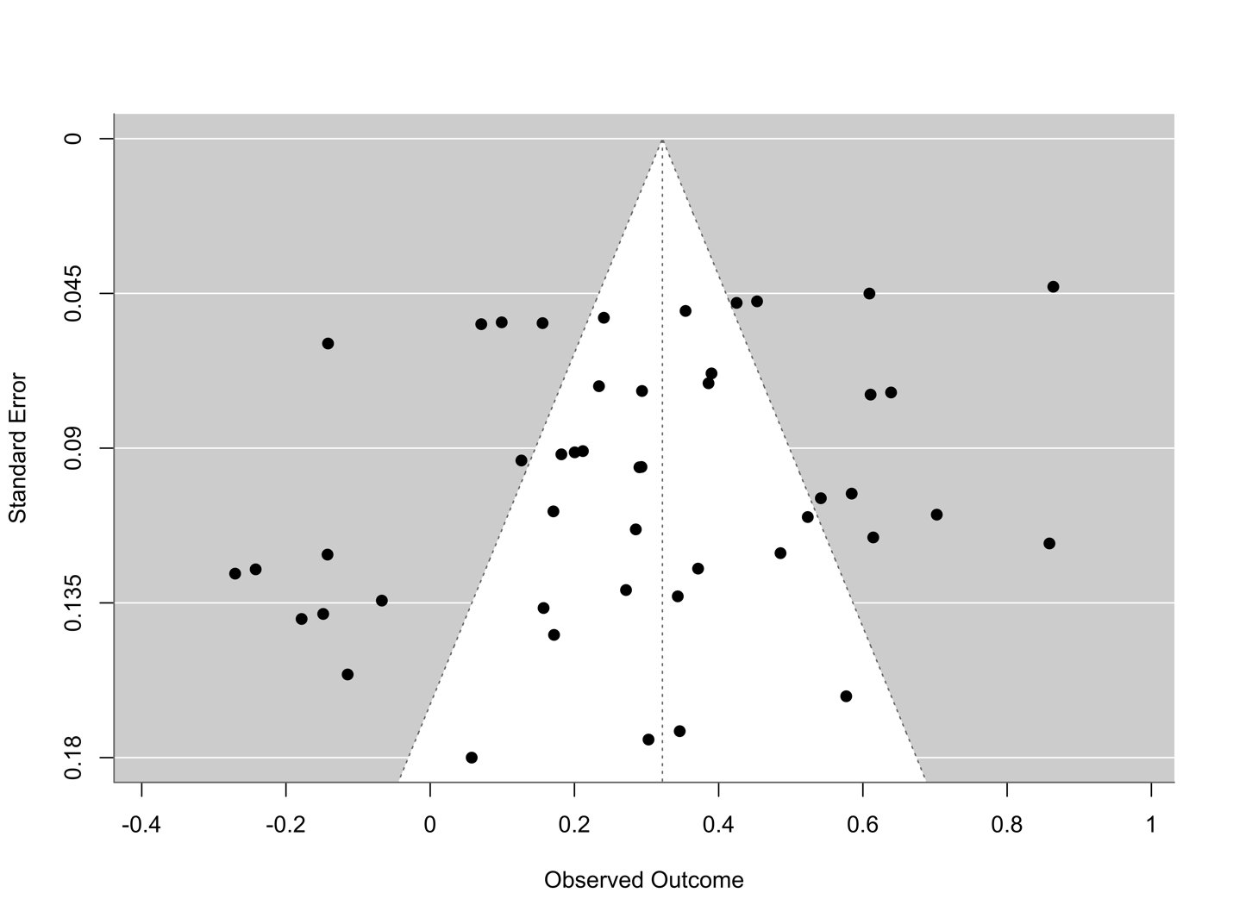
Figure S5. Funnel plot for analyzing publication bias for the subset using correlational design.

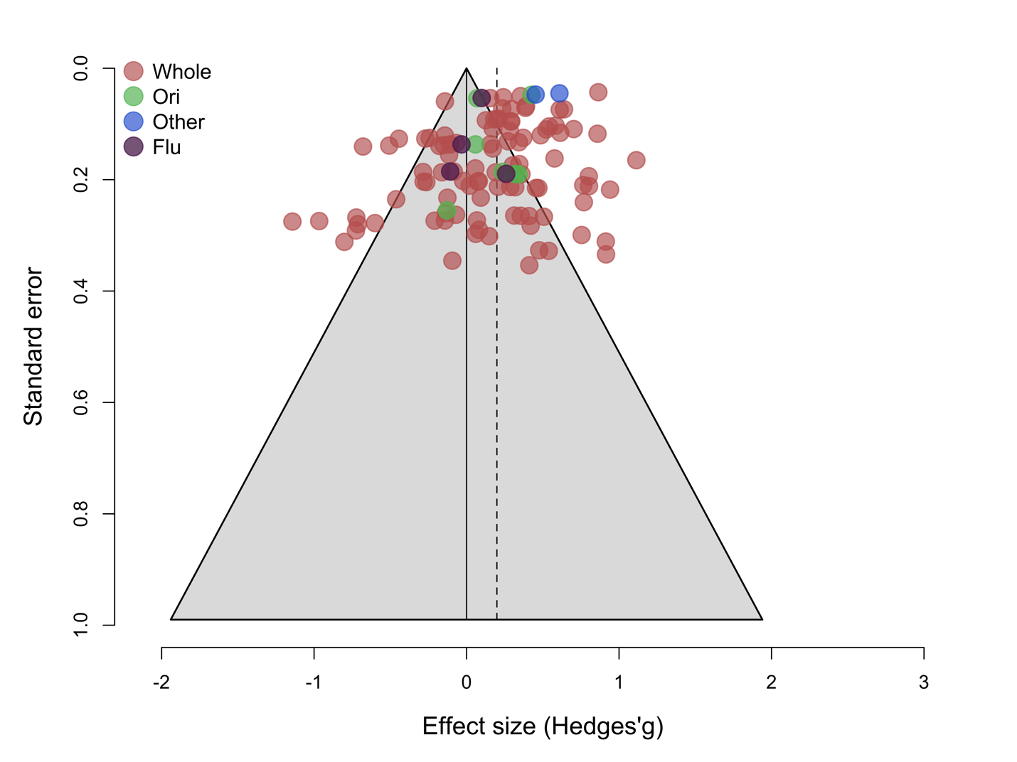
Figure S6. Funnel plot for analyzing publication bias for different creativity scoring.

