Can Electric Fields Drive Chemistry for an Aqueous Microdroplet?

Hongxia Hao¹⁻³, Itai Leven¹⁻³, Teresa Head-Gordon¹⁻⁵
¹Chemical Sciences Division, Lawrence Berkeley National Laboratory
²Pitzer Center for Theoretical Chemistry and Departments of Chemistry³, Bioengineering⁴ and Chemical and Biomolecular Engineering⁵,
University of California, Berkeley, California 94720

Corresponding author: thg@berkeley.edu

Table S1. Table of averaged electric field with/out excess charges at surface and the bulk region defined by instantaneous surface method. Unit in MV/cm. Table of averaged electric field with/out excess charges at surface and the bulk region defined by Gibbs surface method. Units are in MV/cm.

System | Instantaneous Surface Method |  | Gibbs Surface Method
System | Surface | Inner bulk | Surface | Inner bulk
R40 pure | -25.45±0.95 | -8.54±0.24 | -16.24±1.31 | -8.53±0.37
R60 pure | -29.06±0.37 | -7.20±0.03 | -17.43±0.38 | -7.58±0.02
R80 pure | -32.78±0.23 | -6.39±0.08 | -17.06±0.21 | -6.81±0.10
R40 + 24 H₃O⁺ | -34.62±0.83 | -4.66±0.58 | -23.38±0.11 | -4.69±0.37
R40 + 24 OH– | -15.09±1.01 | -4.99±0.16 | -10.67±0.38 | -4.98±0.11
R40 + 24 Na⁺ | -30.88±0.81 | -8.39±0.31 | -20.93±0.30 | -8.37±0.28
R40 + 24 Cl– | -14.37±1.15 | -6.98±1.03 | -10.80±0.46 | -6.93±0.82
R40 + 16Na⁺ 8Cl– | -26.39±2.02 | -7.84±0.78 | -17.27±0.37 | -7.74±0.74
R40 + 8Na⁺16Cl– | -21.93±0.73 | -6.84±0.36 | -14.39±0.48 | -6.88±0.35
R40 + 12Na⁺12Cl– | -24.84±0.89 | -5.84±0.49 | -16.26±0.17 | -5.88±0.40

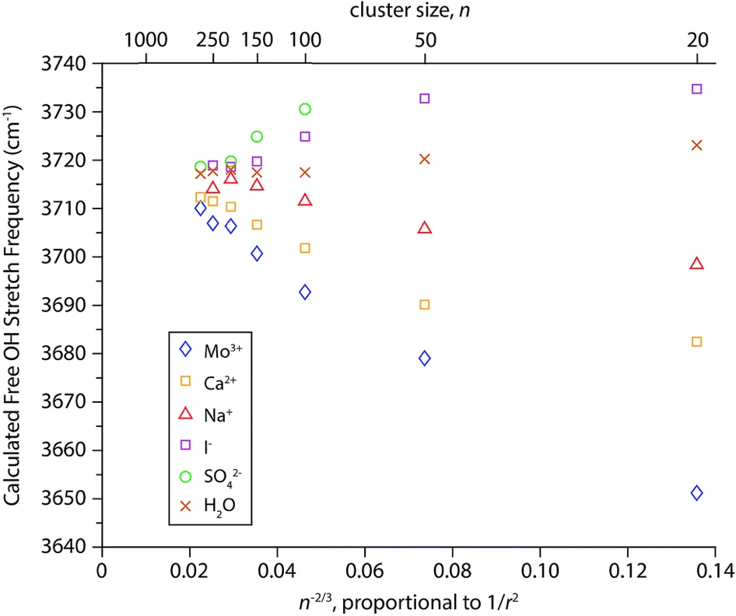
Figure S1. Centroid frequencies of the AAD free OH bands from simulated spectra using an electrostatic point charge model. Frequencies of the AAD free OH bands from spectra of (H₂O)_{n} and M(H₂O)_{n}. Here M = Mo³⁺, Ca²⁺, Na⁺, I– and SO₄^{–2} as a function of n^{2/3}, which is proportional to 1/r² where r is the droplet radius. Simulation with the OPLS-2005 force field; adapted with permission from the Royal Society of Chemistry.⁴²

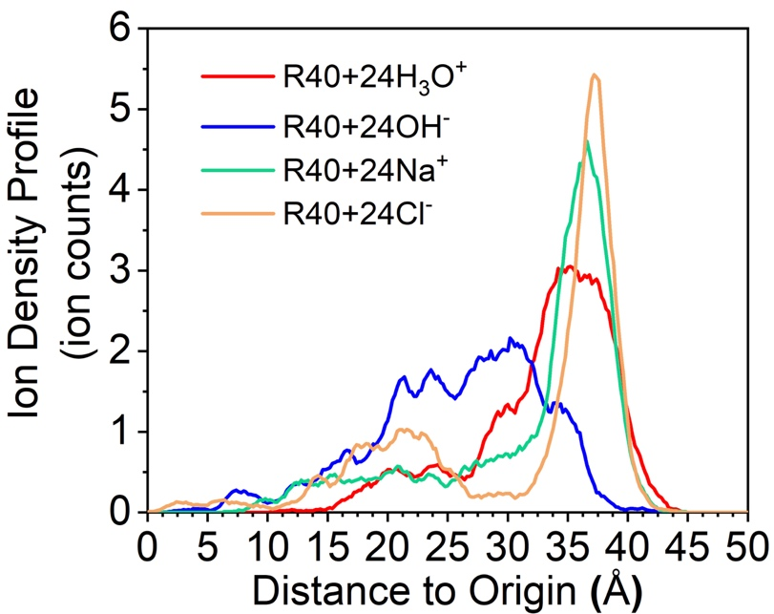
Figure S2. Ion density profiles. The ion density profile of a R40 droplet with an excess of Na⁺ ions, Cl– ions, H₃O⁺ ions and OH– ions.

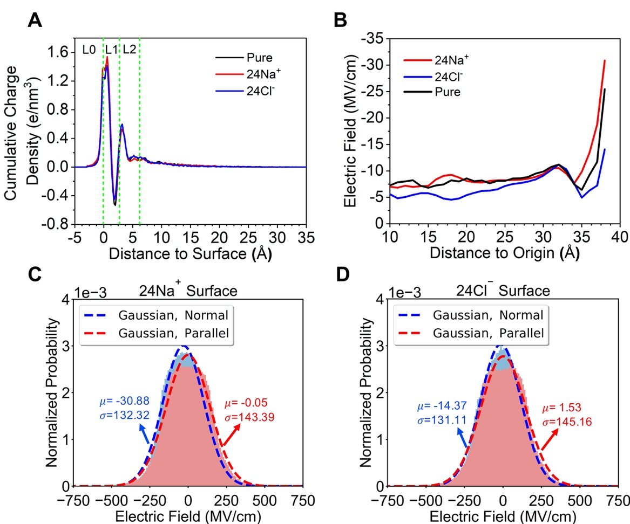
Figure S3. Normal to surface interfacial electric fields of droplets in the presence of excess Na⁺ and Cl– ions. Interfacial electric fields of droplets in the presence of excess Na⁺ and Cl– ions in a R40 water droplet. (A) Cumulative charge density using the core and shell centers obtained from the ReaxFF/C-GeM model. (B) The integrated electric fields (normal to the surface) trends. And the Gaussian signatures of the surface electric fields normal to the surface with excess (C) Na⁺ and (D) Cl– ions.
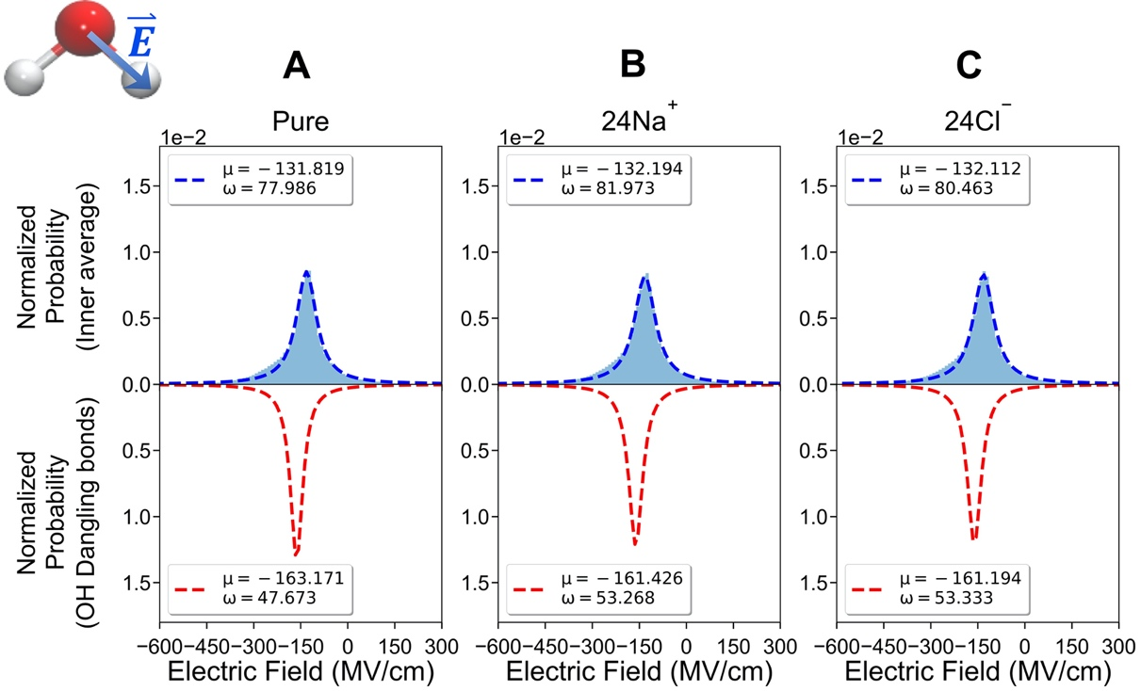
Figure S4. Electric field distributions arising from electric field projections on the O-H bonds of the hydrogen-bonded water molecules. Electric field distributions arising from electric field projections on the O-H bonds of the hydrogen-bonded water molecules in the inner droplet region and the surface free O-H water bonds respectively for the R40 droplet with (A) pure water, (B) water with 24 Na⁺ ions, and (C) water with 24 Cl– ions.

