Supplemental material
Spatio-temporal variation in stable isotope and elemental composition of key-species reflect environmental changes in the Baltic Sea
Camilla LIENART^{1,2}, Andrius GARBARAS³, Susanne QVARFORDT⁴, Jakob WALVE⁴, Agnes ML KARLSON^{1,4}
¹ Baltic Sea Center, Stockholm University, Sweden
² Tvärminne Zoological Station, University of Helsinki, Hanko, Finland
³ Mass Spectrometry Laboratory, Center for Physical Science and Technology, Vilnius, Lithuania
⁴ Department of Ecology, Environment and Plant sciences, Stockholm University, Sweden

Table of contents
- Supplemental methods
Table S1: description of the sites, data sets and data pre-treatment (p 2)
Details on compound specific amino-acid-δ¹⁵N analysis and isotope standards (p 3-5)
Table S2: Initial set of predictors included in the DistLM and PLSR models (p 6)
- Supplemental results
Local elemental and isotope composition of Cladophora
Table S3: Testing for difference between stations (p 7)
Fig. S1: Elemental and isotope variables for Cladophora of each station over time (p 8)
Table S4: Testing for trends in time-series for each station (p 9)
Regional elemental and isotope composition of Cladophora and Mytilus
Table S5: Testing for differences between regions (p 10)
Table S6: Testing for correlations within region and taxa (p 11)
Table S7: Testing for trends in time-series within region and taxa (p 12)
Table S8: Testing for correlations between Cladophora and Mytilus for each region (p 13)
Table S9: Testing for correlations between regions, within taxa (p 13)
Fig. S2: PCA of Cladophora and Mytilus elemental and isotope composition (p 14)
Fig. S3: δ¹⁵N-Phe for Mytilus and Cladophora of the 3 regions over time (p 14)
Fig. S4: Abundance and Bm:Ab ratio of Mytilus over time (p 15)
Environmental data
Fig. S5: Temporal trends of environmental variables for the three regions (p 16)
Table S10: Testing for trends in time-series of environmental variables within region (p 17)
Table S11: Testing for correlations in environmental variables within region (p 18)

Explaining elemental, isotope baselines and population changes
Fig. S6: N:P in Cladophora and Mytilus in relationship with DIN:DIP in the water (p 19)
Fig. S7: Local N:P in Cladophora and DIN:DIP in the water at A (p 20)
Table S12: DistLM models results (p 21)
References (p 22)

- Supplemental methods

Table S1: Details of regions characteristics, elemental and isotope analyses, environmental datasets and data pre-treatment. See material and methods in the main text.
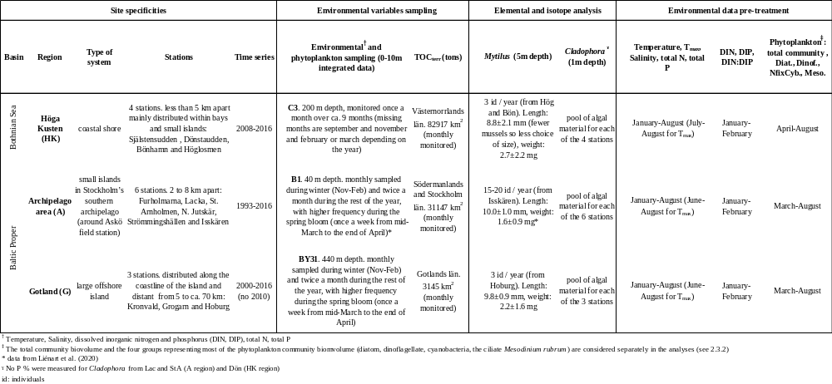

Supplemental methods: analysis of amino-acid-δ¹⁵N

Mytilus samples
The amino-acid-δ¹⁵N measurements of Mytilus were performed at the Center for Physical Science and Technology, Vilnius, Lithuania. The amino-acid extraction and derivatization were performed by C. Liénart following the method of Ledesma et al. (2020) and described hereafter. The samples analyses (GC-C-IRMS) were performed by A. Garbaras.
Prior to the derivatization, amino acids were hydrolysed in glass vials using a 6 M hydrochloric acid (HCl) for 70 min, 150 °C under N₂ gas headspace. Thereafter, samples were evaporated until dryness under a gentle stream of N₂ gas at ca. 80 °C and resuspended in 0.01 M HCl and loaded in cation-exchange columns for the purification step (cation-exchange chromatography, Dowex 50WX8 resin, Bio-Rad Laboratories). The amino acids fraction was eluted from the columns with a 10% NH₃ solution and the mobile phase was evaporated until dryness and stored at -20°C. The derivatization of amino acids was performed according to a modified version of the method described by Yarnes and Herszage (2017). First, 100 µl 0.4M HCl was added to dissolve the sample, followed by addition of 35 µl methanol and 30 µl pyridine. Then, 15 µl of methyl chloroformate was added to initiate reaction. Thereafter, 100 µl of chloroform was added, and the sample was centrifugated. Finally, the organic phase was transferred to gas chromatography vial with a 250-µl insert.
Amino acid derivatives were injected at 250 °C (splitless, 1 min), and separated on a chromatographic column SGE BPX 70 (30m; 0.32 mm I.D.; 0.25µm film) at a constant flow rate of 1.4 mL/min under the following temperature program: 80 °C (hold 2 min); 180 °C (4 °C/min) and 250 °C (5 °C/min, hold 9 min). GC injector temperature was 250 °C.
GC-C-IRMS was performed on a Thermo Trace GC gas chromatograph (Ultra, Thermo) coupled to a ThermoFinnigan Delta Advantage isotope ratio mass spectrometer cia GCC III combustion interface. The combustion reactor was a quartz tube containing CuO and NiO wires maintained at 940 °C. The reduction reactor was a quartz tube containing Cu wires maintained at 650 °C. Water from the flow was removed by Nafion tube. During the δ¹⁵N analysis, CO₂ was removed from the gas stream through the use of liquid nitrogen trap to prevent isobaric interferences within the ion source.
An example of chromatogram is presented hereafter. Data analysis was performed with Isodat NT 3.0 software. 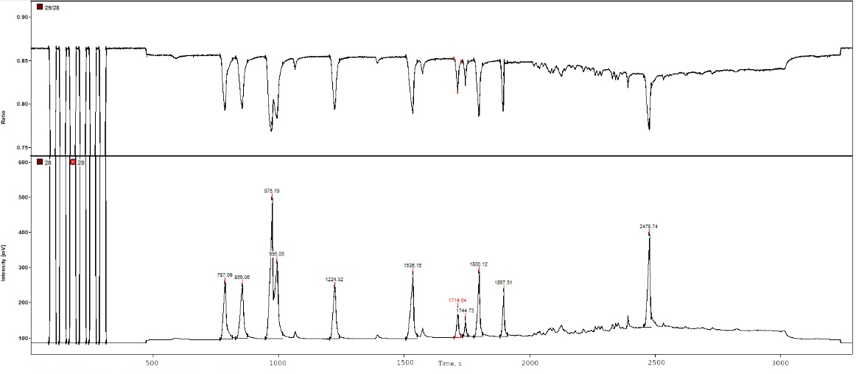
Chromatogram of amino acids derivatives. First 6 peaks are reference N₂ gas peaks. Peak sequence: 787 s – Alanine, 856 s –Valine, 1714 s – Phenylalanine, 1744 s – Benzoic acid.

Cladophora samples
The amino-acid-δ¹⁵N measurements of Cladophora were performed at the University of California Davis Stable Isotope Facility (Department of Plant Sciences, UC Davis) following the method available on the webpage: https://stableisotopefacility.ucdavis.edu/gcamino.html, and described hereafter.
“Amino acids are made suitable for gas chromatography by derivatization as N-acetyl methyl esters (NACME, Corr, Berstan and Evershed 2007). Prior to derivatization, amino acids are liberated from sample material proteins by acid hydrolysis (6 M HCl, 70 min, 150 ºC under N₂ headspace). Additional purification steps, such as strong cation-exchange chromatography (SCX; Dowex 50WX8 resin), may be required for sample materials with significant fractions of carbohydrates, lipids, salts, or other potential matrix interferences.
NACME amino acid derivatives are injected at 260 ºC (splitless, 1 min) and separated on an Agilent DB 35 column (60 m X 0.32 mm ID, 1.5 µm film thickness) at constant flow rate of 2 mL/min under the following temperature program: 70 °C (hold 2 min); 140 °C (15 °C/min, hold 4 min); 240 °C (12 °C/min, hold 5 min); and 255 °C (8 °C/min, hold 35 min).
GC-C-IRMS is performed on a Thermo Trace GC 1310 gas chromatograph coupled to a Thermo Scientific Delta V Advantage isotope-ratio mass spectrometer via a GC IsoLink II combustion interface. The combustion reactor is a NiO tube containing CuO and NiO wires maintained at 1000 °C. Water is subsequently removed through a Nafion dryer before the analyte gases are transferred to the IRMS. During ¹⁵N analysis, CO₂ is removed from the post-combustion carrier stream through the use of a liquid nitrogen trap to prevent isobaric interferences within the ion source.
All samples are analyzed in duplicate; further replicates may be analyzed if initial measurements fall outside expected measurement error. Replicates of the quality control and assessment materials are measured every 5 samples.”

Supplemental methods: external and internal standards for bulk and amino-acid compound specific stable isotope analysis
Caffeine (IAEA-600) was used as secondary reference material for the reference gas calibration. Two internal standards, wheat flour and fish muscle tissue (Esox lucius), were analysed at the beginning and end of each batch of samples and during the batch, after every 12th sample. Caffeine (IAEA-600) was used a as a secondary reference material for GC-C-IRMS system.

Table S2: The initial set of predictors included as potential explanatory variables in the DistLM and PLSR models. A set of predictors identical to the first model is indicated with “as above”, only removed (-) or added (+) variables are written out. Please refer to Liénart et al. (2020, their Table S1) for the detailed rationale and references in including predictors in the models. Briefly, physical (temperature, salinity) and chemical (nutrients as proxy for eutrophication) variables were included in every model for both taxa. The Baltic Sea Index (BSI) was included as a climate proxy.
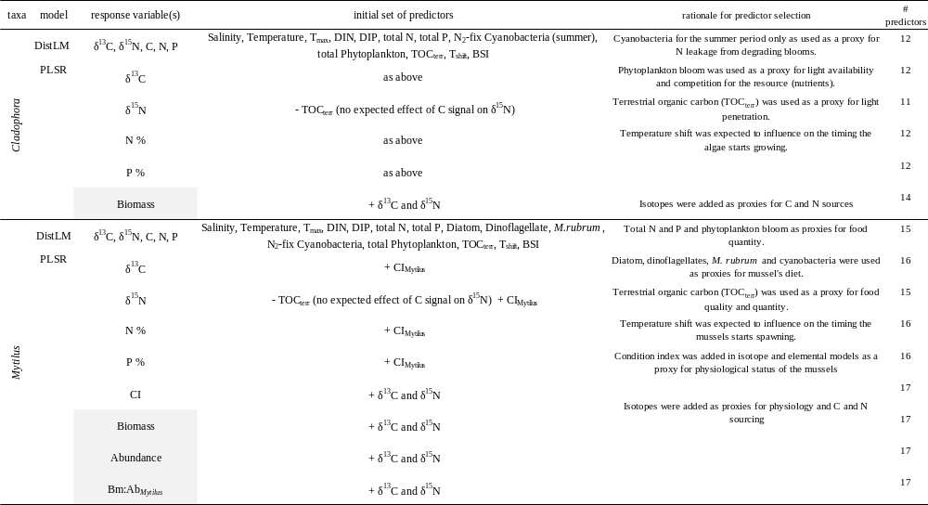
- Supplemental results
Local elemental and isotope composition of Cladophora
Table S3: Testing for differences in Cladophora biological variables between stations within each region. Kruskal-Wallis test p-values are highlighted in grey and in red and bold if values were significant, followed by Bonferroni-corrected Mann-Whitney pairwise comparison test p-values in the inner boxes, significant are in red.
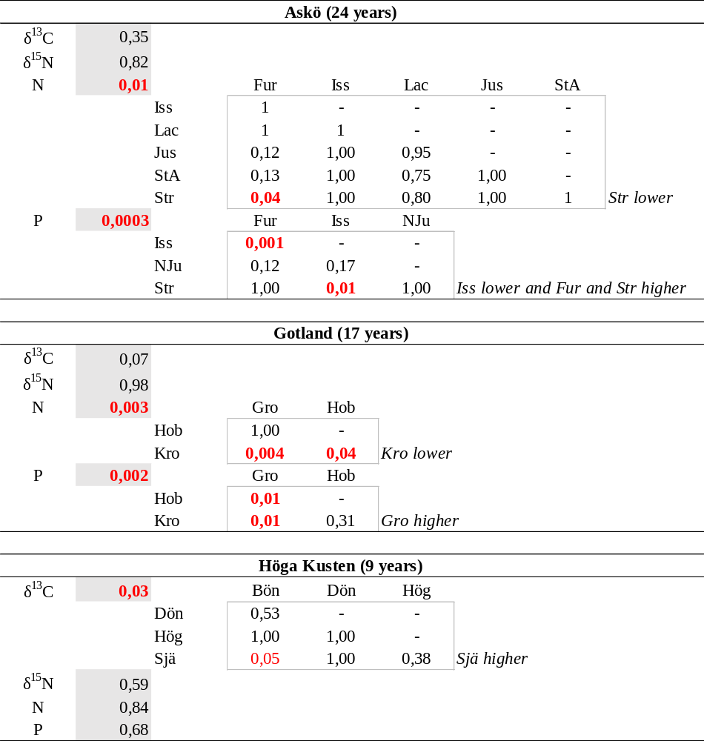

Figure S1: Temporal trends in biological variables for Cladophora sampled at different stations in the three regions.
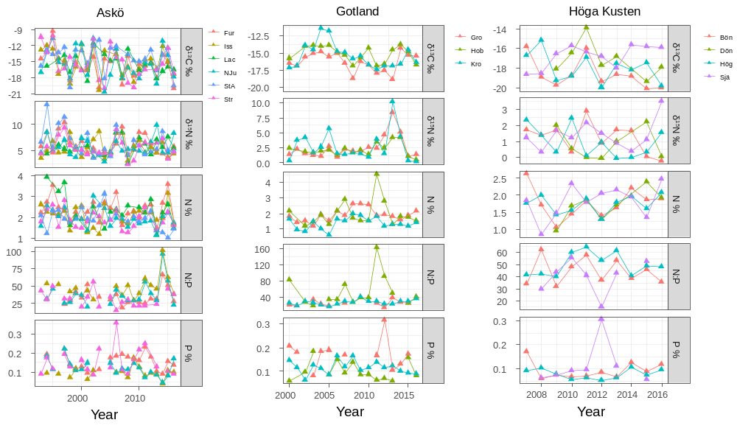

Table S4: Testing time series for unidirectional trends in Cladophora biological parameters for each station and region. Mann-Kendall tests corrected for autocorrelation. Significant trends are in bold red, close to significant are in red, p = 0.05.
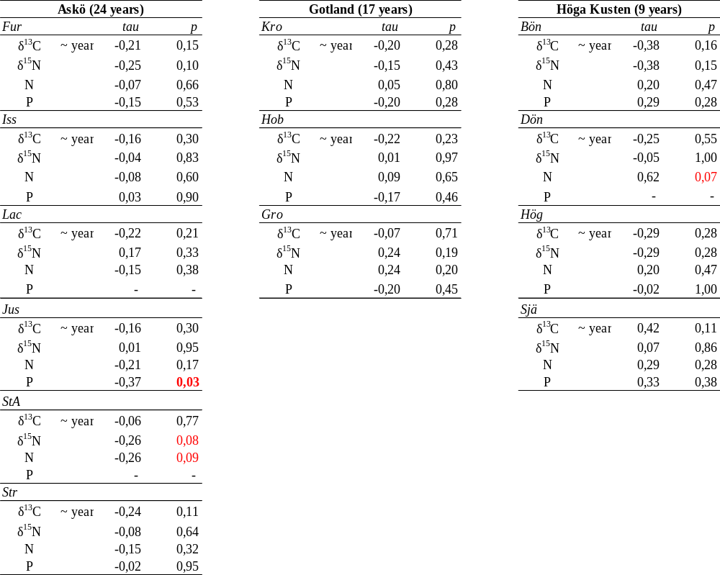

Regional elemental and isotope composition of Cladophora and Mytilus
Table S5: Testing for differences in biological variables between regions (8 last years of the time series) for each taxon. Kruskal-Wallis test p-values (highlighted in grey), if significant (in red bold), followed by Bonferroni-corrected Mann-Whitney pairwise comparison test (p-values in the inner boxes, red bold if significant, close to significant are in red). A: Archipelago, G: Gotland, HK: Höga Kusten.
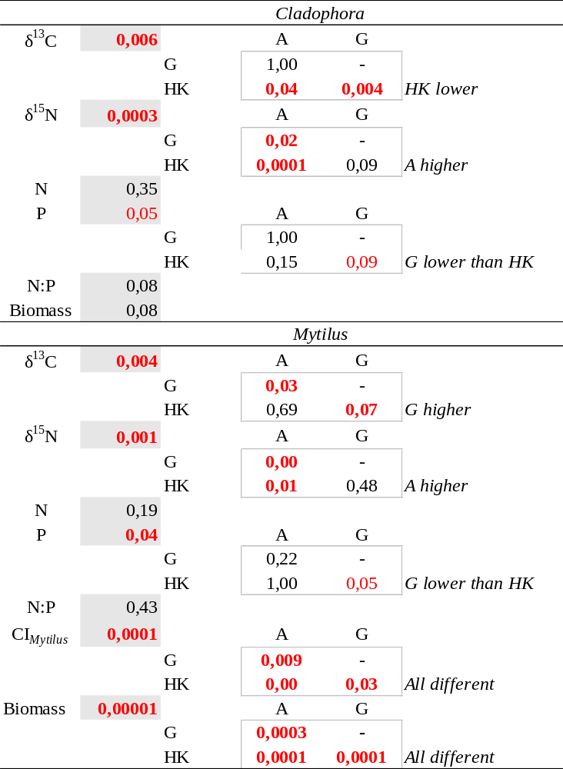

Table S6: Testing for correlations in biological variables for Cladophora and Mytilus of each region (A: Archipelago, G: Gotland, HK: Höga Kusten). Spearman or Pearson (highlighted in grey) correlation tests. Significant correlations are in red bold, close to significant are in red, p = 0.05. ca. 13 % of the combinations were significantly correlated (out of autocorrelation).
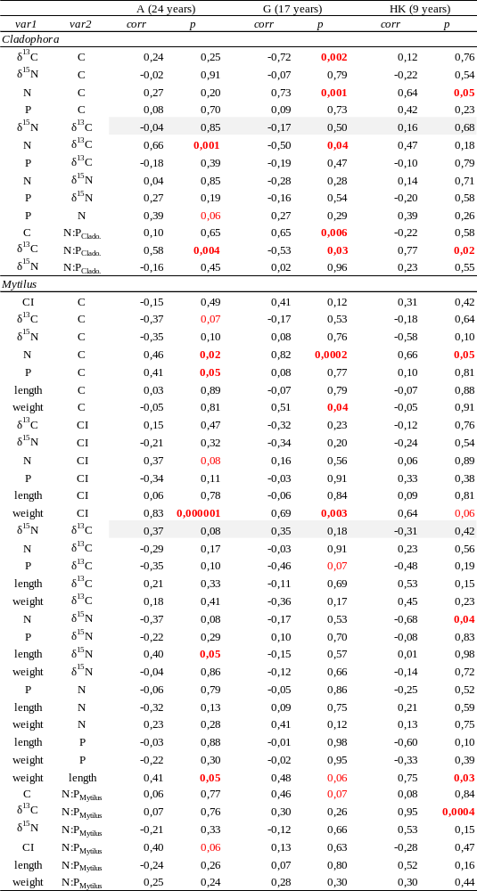
Table S7: Testing time series for unidirectional trends in biological parameters for each taxon and region (A: Archipelago, G: Gotland, HK: Höga Kusten). Mann-Kendall tests corrected for autocorrelation. Significant trends are in bold red, close to significant are in red, p = 0.05. The variables in grey were calculated on the entire population (see Material and Methods).

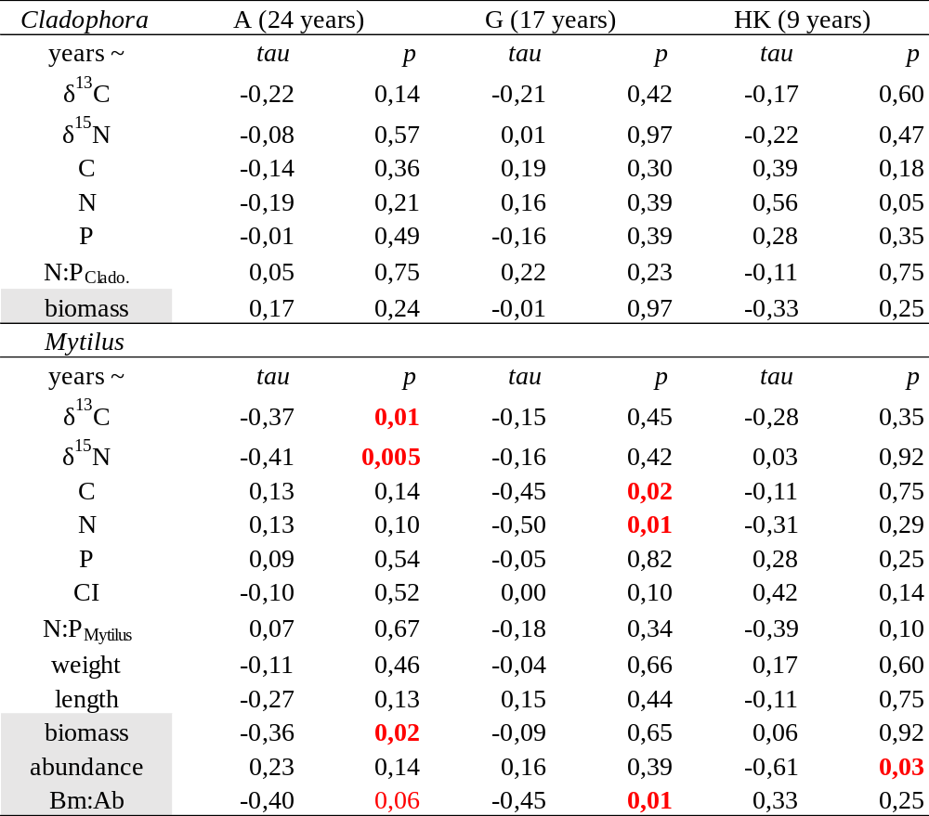

Table S8: Testing for correlations in biological variables between Cladophora and Mytilus for paired regions (A: Archipelago, G: Gotland, HK: Höga Kusten) over similar time period. Spearman or Pearson (highlighted in grey) correlation tests. Significant correlations are in red bold, close to significant are in red, p = 0.05.
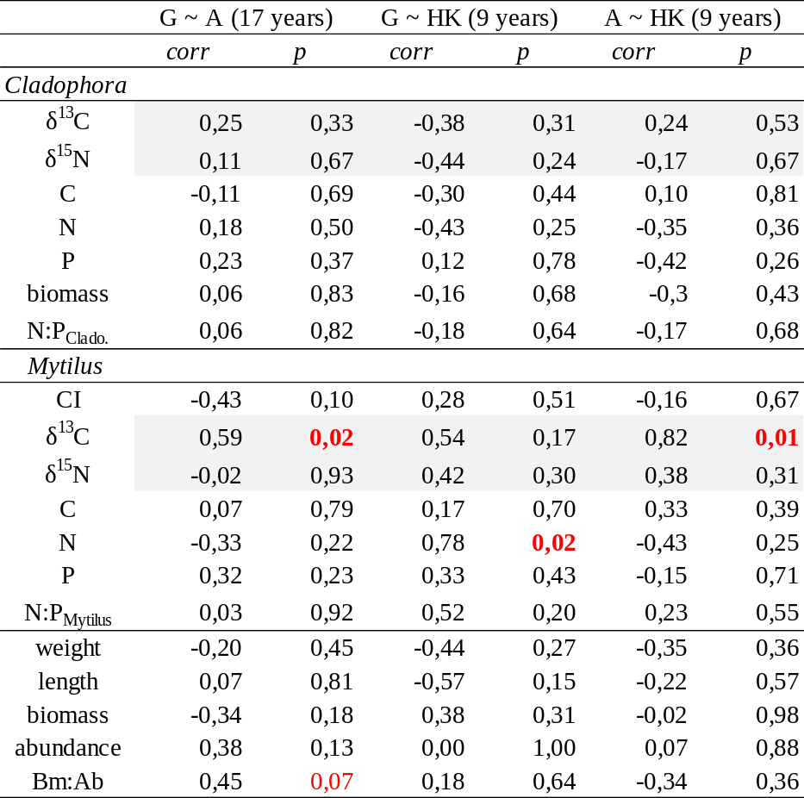

Table S9: Spearman or Pearson (highlighted in grey) correlation tests between Cladophora and Mytilus for each region (A: Archipelago, G: Gotland, HK: Höga Kusten). Significant correlations are in red bold, p = 0.05
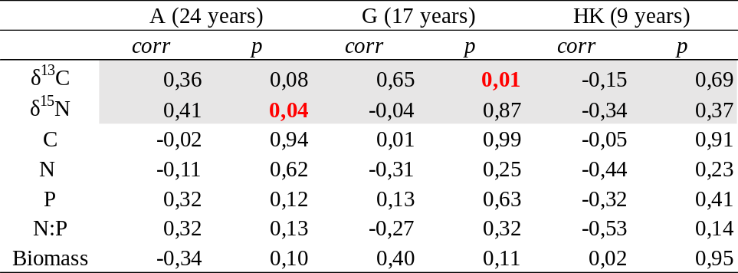

Figure S2: Principal component analysis (PCA) of a) Cladophora and b) Mytilus elemental and isotope composition: δ¹³C, δ¹⁵N, % C, N, P and CI (for Mytilus only) for the three regions (Archipelago: black, Gotland: orange, Höga Kusten: blue). Scaled data. Ellipses represent 50% of the data. See temporal trends (raw data) on Fig. 2 in the main text.
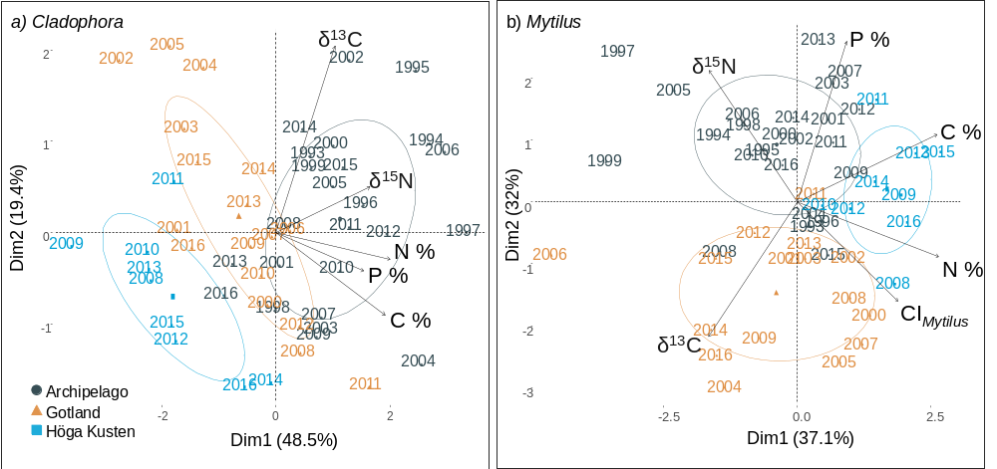

Figure S3: Nitrogen isotope ratio of the source amino-acid phenylalanine (δ¹⁵N-Phe) for Cladophora (triangles) and Mytilus (circles) of the 3 regions (Archipelago: black, Gotland: orange, Höga Kusten: blue) over time. Decreasing pattern is observed for Cladophora at A and G, but there was generally too few measured time points to statistically test for unidirectional trend (Fig. 3).
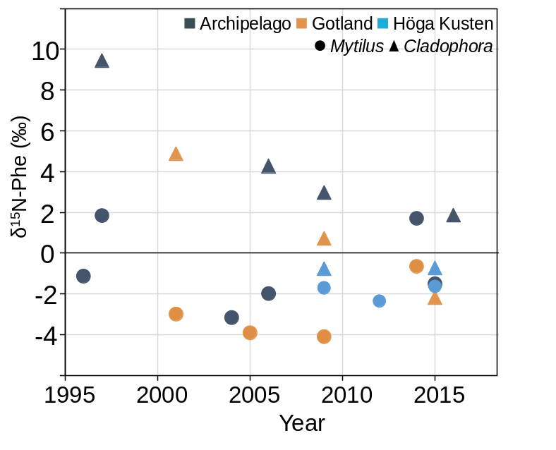

Figure S4: Abundance of Mytilus (individuals per m², the left axis is for Askö archipelago (black) and Gotland (orange) and the right axis is for Höga Kusten (blue)) and Bm:Ab_{Mytilus} (mg dry weight per individual, a proxy for average mussel size in the population, the left axis is for Askö archipelago and Höga Kusten and the right axis is for Gotland).

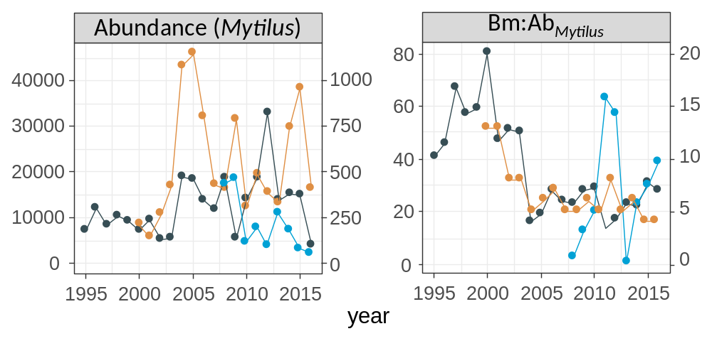
Environmental data
Figure S5: Temporal trends of environmental variables for the three regions B1 (black), BY31 (orange) and C3 (blue). Table S11 gives the statistical tests for temporal trends. A summary of the environmental variables over time demonstrating region specific pattern is in the main text Fig. 5. T_{max}: water maximum temperature in summer, T_{shift}: water temperature shift, TOC_{terr}: total organic carbon from land (the left axis is for B1 (black) and BY31 (orange), the right axis is for C3 (blue)), DIN or DIP: dissolved inorganic nitrogen / phosphorus. Total phytoplankton is expressed in mm³ L⁻¹ while the different groups (Diatom, Dinoflagellates, M. Rubrum, N₂-fixing cyanobacteria) are expressed as an integrated sum (area under the curve linear interpolation, see material and methods). Trends in N₂-fixing cyanobacteria over the productive season are very similar to the trends over the summer period only (not shown). The Baltic Sea Index has the same values for all regions.
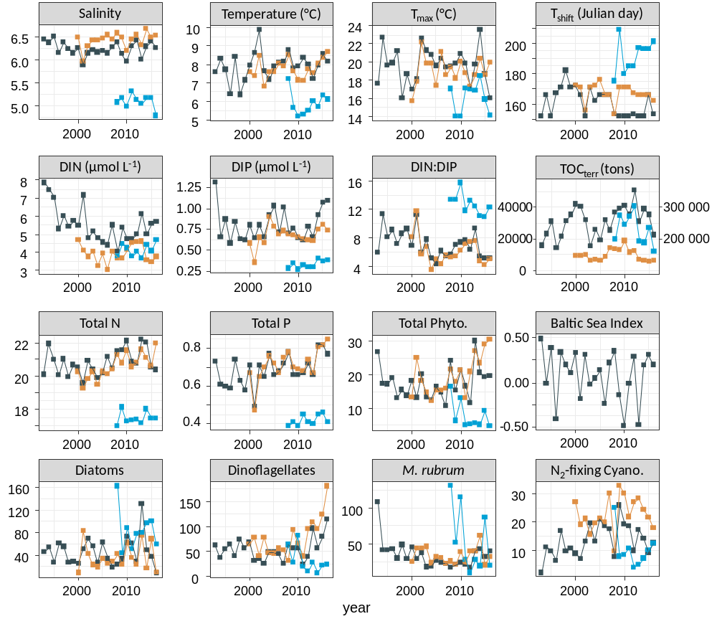

Table S10: Testing time series for unidirectional trends in environmental parameters for each region. Mann-Kendall tests corrected for autocorrelation. Significant trends are in bold / red. p = 0.05. See Fig. S6 for raw data.

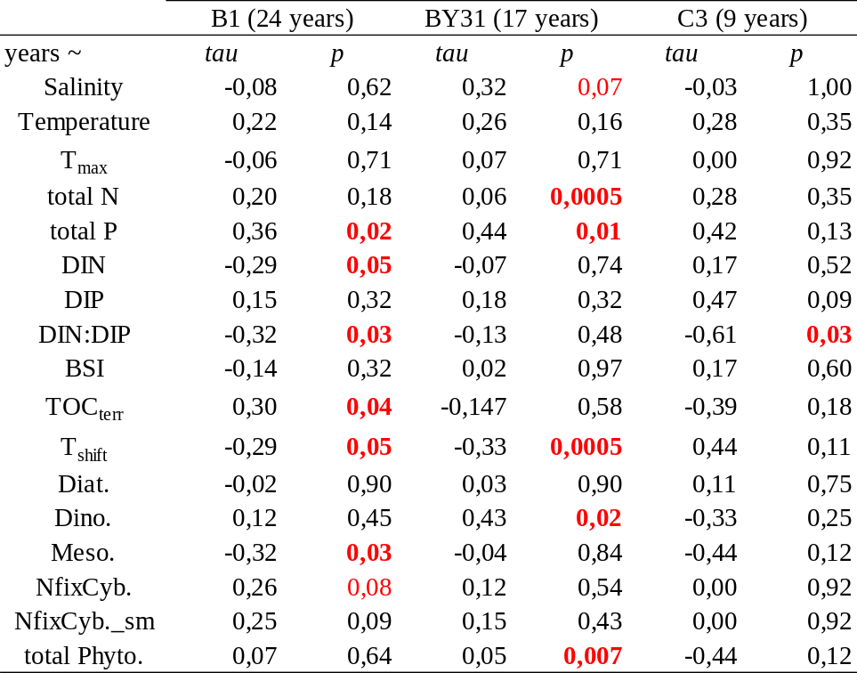
T_{max}: water maximum temperature in summer, DIN or DIP: Dissolved Inorganic Nitrogen / Phosphorus, BSI: Baltic Sea Index, TOC_{terr}: total organic carbon from land, T_{shift}: water temperature shift, Diat.: diatom, Dino.: dinoflagellates, Meso.: Mesodinium rubrum, NfixCyb.: N₂-fixing cyanobacteria (sm: summer).

Table S11: Testing for correlations in environmental variables for each region, B1, BY31 and C3. Spearman correlation tests. Significant correlations are in red bold, close to significant are in red, p = 0.05. Between 10 and 20 % of the combinations were significantly correlated for each site (out of autocorrelation, in grey).
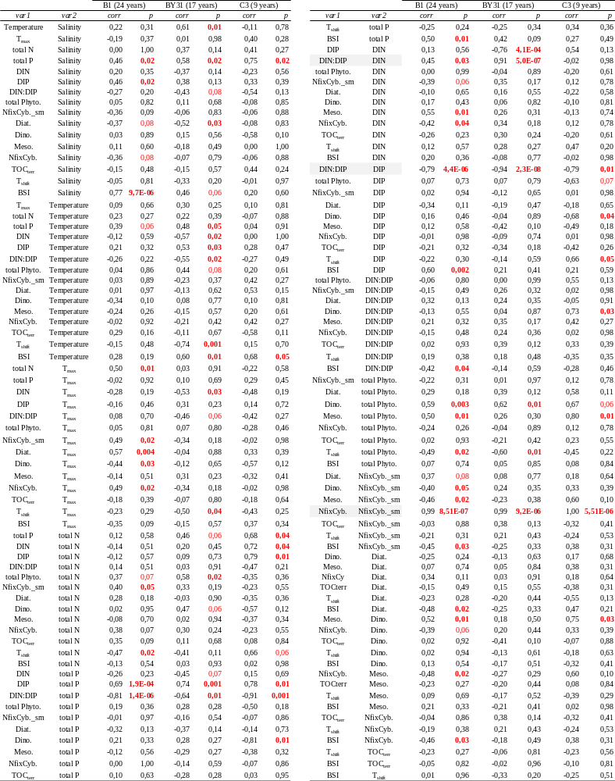
T_{max}: water maximum temperature in summer, DIN or DIP: Dissolved Inorganic Nitrogen / Phosphorus, BSI: Baltic Sea Index, TOC_{terr}: total organic carbon from land, T_{shift}: water temperature shift, Diat.: diatom, Dino.: dinoflagellates, Meso.: Mesodinium rubrum, NfixCyb.: N₂-fixing cyanobacteria (sm: summer).
Explaining elemental, isotope baselines and population changes
Figure S6: Temporal trends in N:P and relationship with DIN:DIP in the water (mol:mol, winter values) of a) Cladophora (triangles) and b) Mytilus (circles) in the 3 regions (Archipelago: black, Gotland: orange, Höga Kusten: blue). Linear models showed no effect of region or DIN:DIP on N:P of Mytilus (p-value = 0.09), while N:P of Cladophora (outliers previously identified with z-score tests were not considered in model calculations) differed between regions: Cladophora from G differed from A and HK (slope and intercept, general p-value = 0.0004).
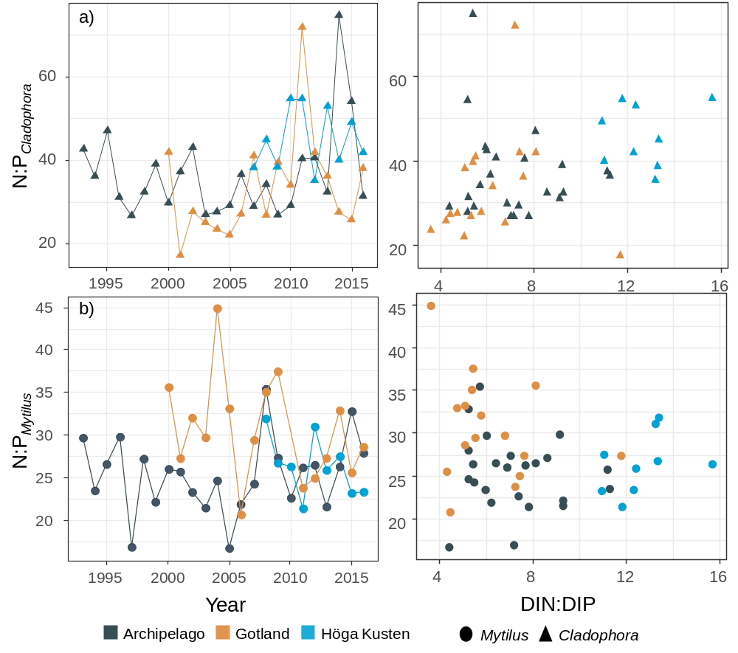

Figure S7: a) N:P_{Cladophora} and b) DIN:DIP in the water (mol:mol, summer values available only) for two coastal stations of the Askö archipelago region (Sö 25 and Sö 28, see Fig. 1) with distance from land. Kruskal-Wallis test for Cladophora N:P between the 4 stations: p = 0.0014; Wilcoxon post-hoc test: Iss significantly higher than Fur (p = 0.005), Jus (p = 0.04) and Str (p = 0.003). No significant difference in DIN:DIP between the two stations (p = 0.3).

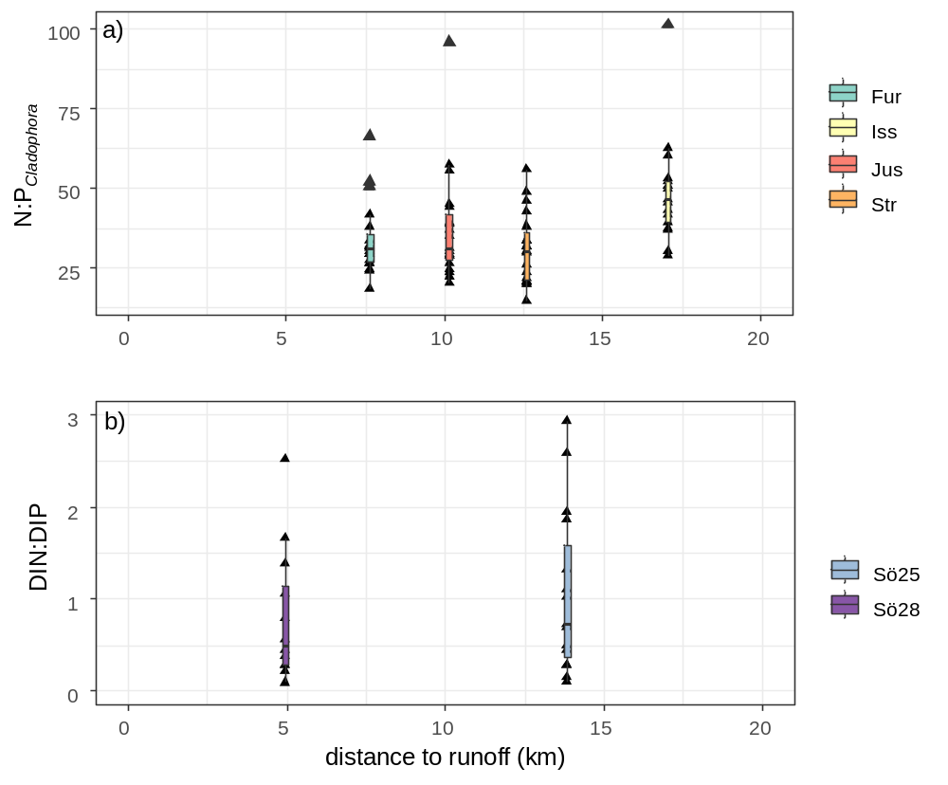
Table S12: DistLM model selection for explanatory variables based on Akaike information criterion (AIC). Response variables for both organisms are δ¹³C, δ¹⁵N, C, N and P. Euclidean distances of normalized data, forward selection of explanatory variables.
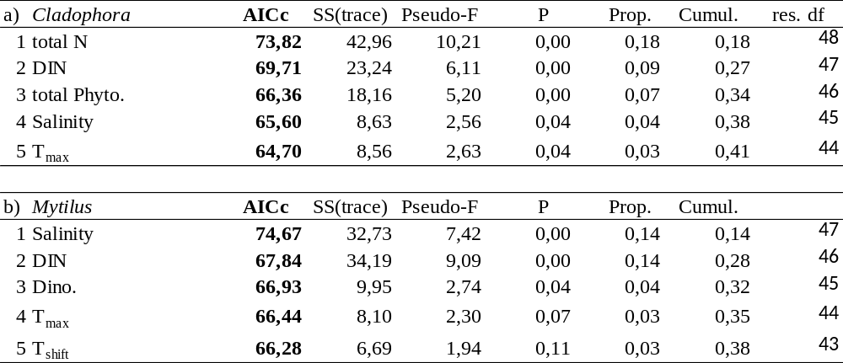
DIN: dissolved inorganic nitrogen, T_{max}: water maximum temperature in summer, T_{shift}: water temperature shift, total Phyto.: total phytoplankton bloom, Dino.: dinoflagellates.

References
Corr L T, Berstan R, Evershed P O (2007) Optimisation of derivatisation procedures for the determination of δ¹³C values of amino acids by gas chromatography/combustion/isotope ratio mass spectrometry. Rapid Commun Mass Sp 21:3759. [doi: 10.1002/rcm.3252]
Ledesma M, Gorokhova E, Holmstrand H, et al (2020) Nitrogen isotope composition of amino acids reveals trophic partitioning in two sympatric amphipods. Ecol Evol 10:10773–10784. https://doi.org/10.1002/ece3.6734
Liénart C, Garbaras A, Qvarfordt S, et al (2020) Long‐term changes in trophic ecology of blue mussels in a rapidly changing ecosystem. Limnol Oceanogr lno.11633. https://doi.org/10.1002/lno.11633
Yarnes, C T, & Herszage, J (2017) The relative influence of derivatization and normalization procedures on the compound-specific stable isotope analysis of nitrogen in amino acids. Rapid Commun Mass Sp 31(8):693–704. https://doi.org/10.1002/rcm.7832

