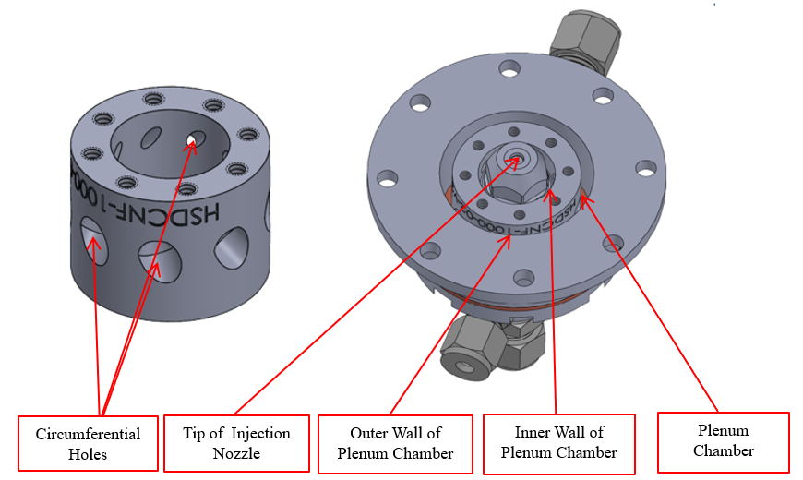
a
b
Extended Data Fig. 1: (a) Custom made housing for the injection nozzle showing the 8 radial circumferential holes drilled in the inner wall of the plenum chamber to create vortex 2 via addition of heated compressed air and (b) The injection nozzle fitted into the custom-made housing with the outer wall of the plenum chamber and its mounting flange installed.

Extended Data Table 1: Sample process conditions and product yield.
Parameters | Values
Feed rate | 10 ml/min
Feed composition | 2.8 wt. %
Feed temperature | 95 ºC
Heater set temperature for Air to vortex 1 | 375 ºC
Heater set temperature for Air to vortex 2 | 375 ºC
Compressed Air pressure to vortex 1 | 148 psi
Compressed Air pressure to vortex 1 | 132 psi
Compressed air flowrate to vortex 1 | 12 scf/m
Compressed air flowrate to vortex 1 | 28 scf/m
Total mass of CNF delivered during run | 2.81 g
Total mass of CNF recovered from filter paper 1 | 1.75 g
Total mass of CNF recovered in all filter media | 2.25 g
Filter Paper 1 yield (most nanofibrous material) | 62.39 %
Total product yield | 80.22 %

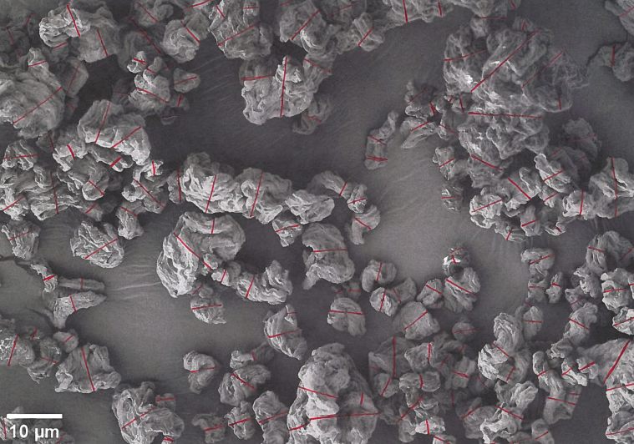
a
b
c

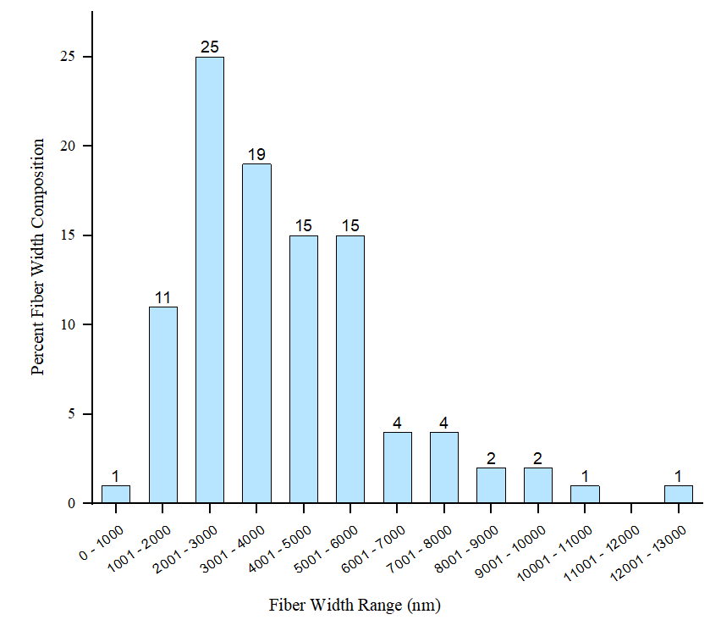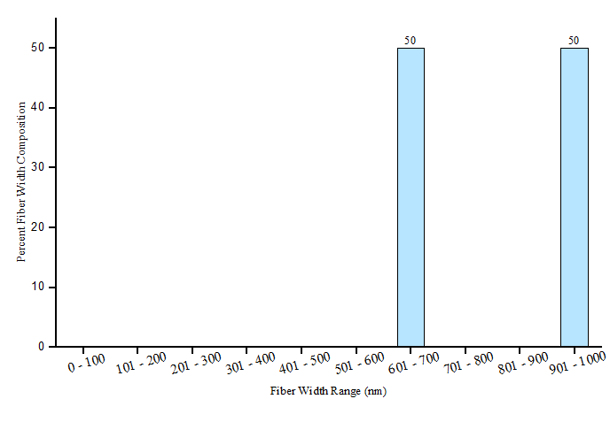
Extended Data Fig. 2: (a) Scanning electron micrograph of spray dried CNF. Red lines indicate the location of fiber width measurements as performed by the software package ImageJ, (b) Histogram of the percentage of fibers analyzed with widths in the defined size range over the full sample range of 0 –13000 nm. (c) Histogram of the percentage of fibers analyzed with widths in the defined size range of 0 – 1000 nm. The total number of fibers analyzed was 142.
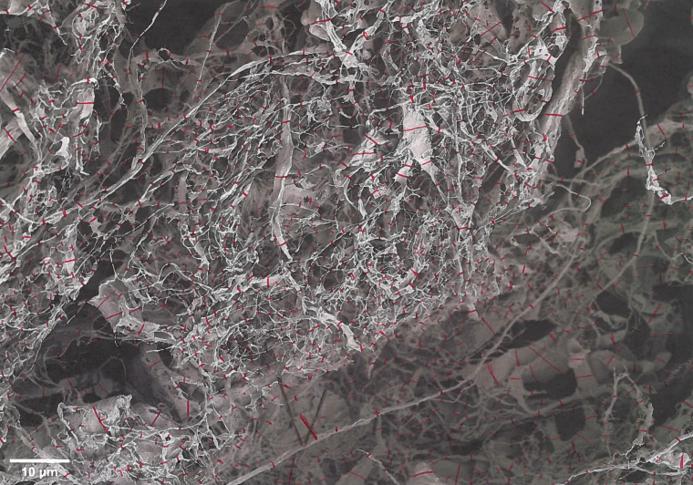
a
b
c
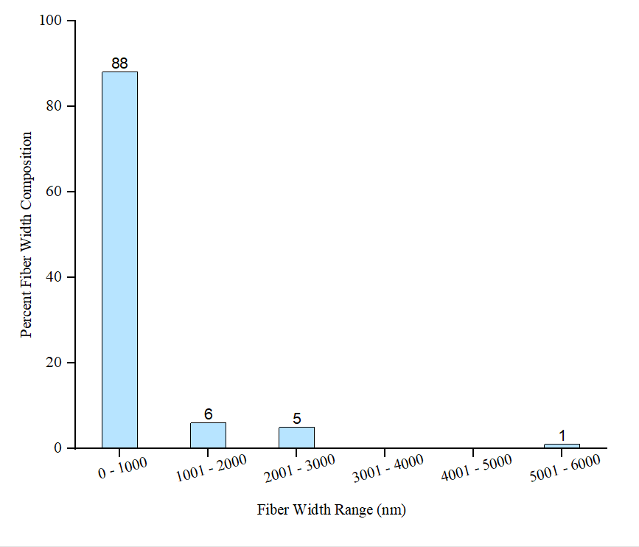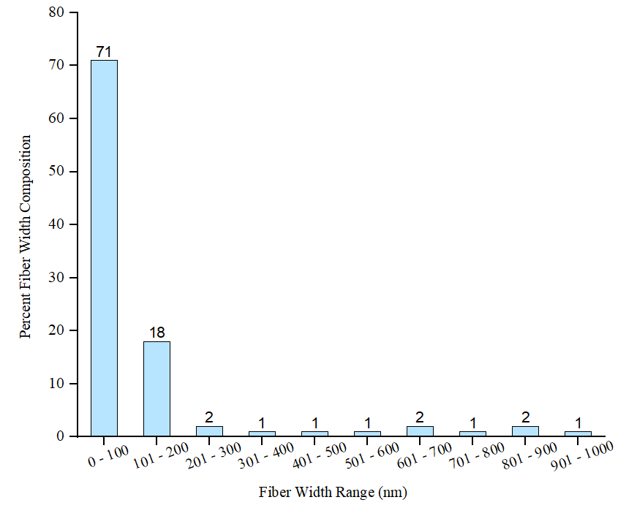

Extended Data Fig. 3: (a) Scanning electron micrograph of freeze dried CNF. Red lines indicate the location of fiber width measurements as performed by the software package ImageJ, (b) Histogram of the percentage of fibers analyzed with widths in the defined size range over the full sample range of 0 – 7000 nm, (c) Histogram of the percentage of fibers analyzed with widths in the defined size range of 0 – 1000 nm. The total number of fibers analyzed was 519.

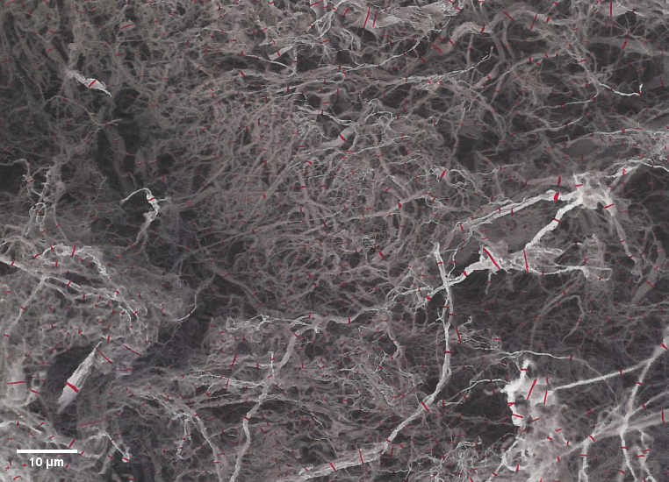
a
c
b
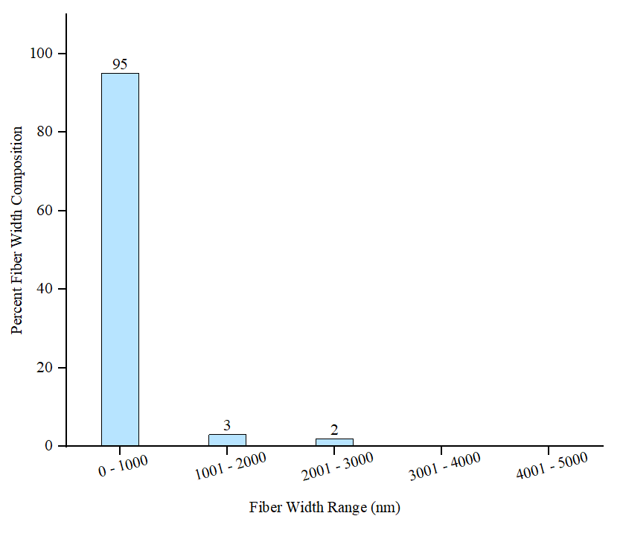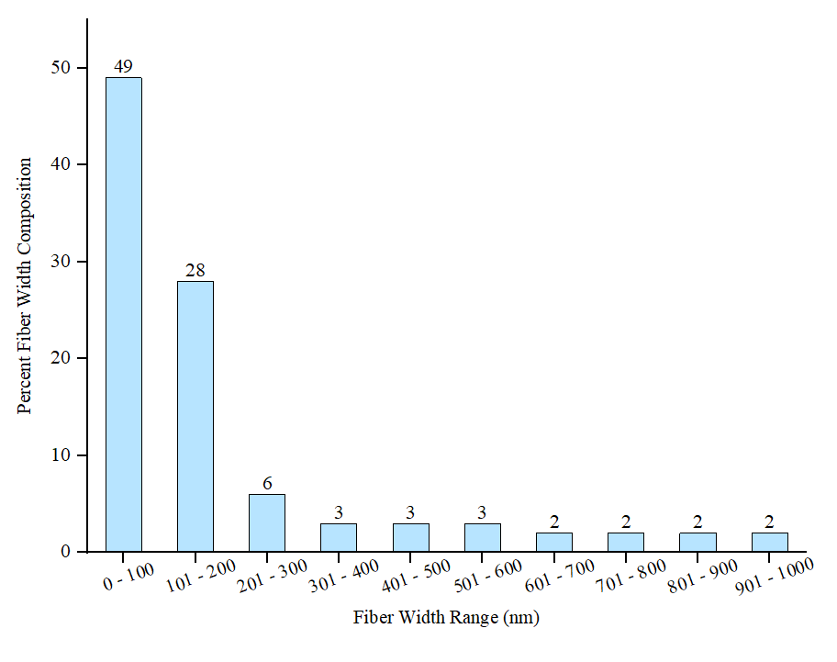
Extended Data Fig. 4: (a) Scanning electron micrograph of Supercritical CO₂ dried CNF. Red lines indicate the location of fiber width measurements as performed by the software package ImageJ, (b) Histogram of the percentage of fibers analyzed with widths in the defined size over the full sample range of 0 – 5000 nm, (c) Histogram of the percentage of fibers analyzed with widths in the defined size range of 0 – 1000 nm. The total number of fibers analyzed was 410.

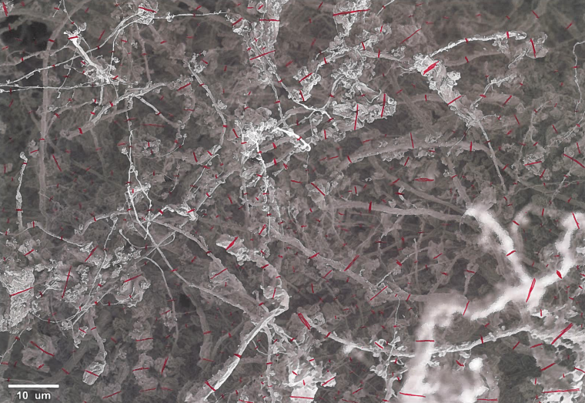
b
c
a
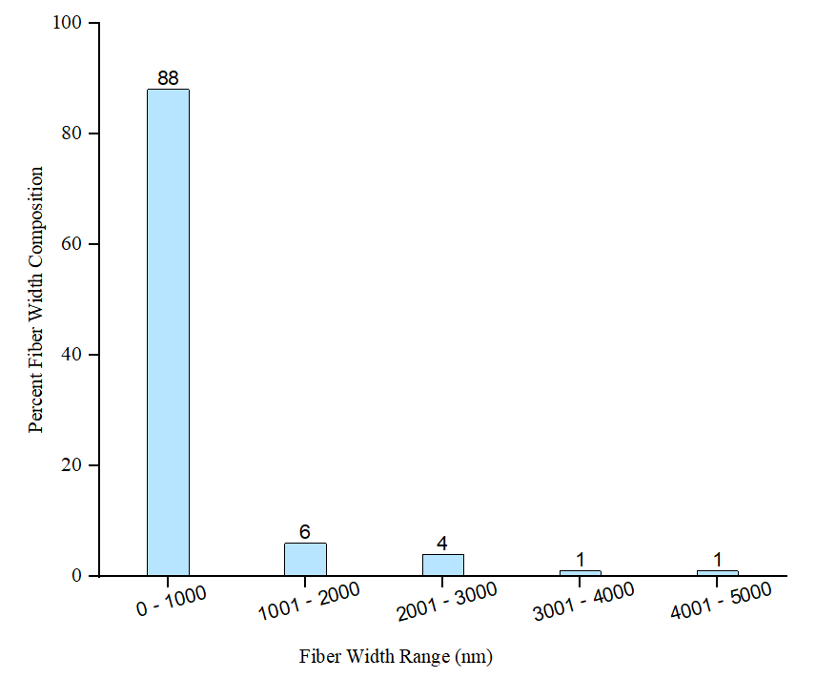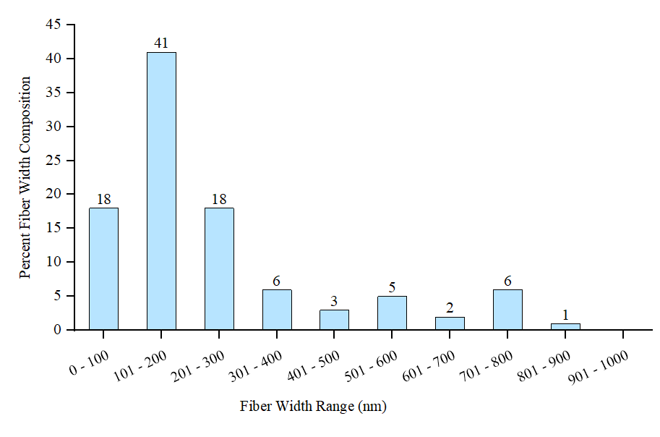
Extended Data Fig. 5: (a) Scanning electron micrograph of high shear dried CNF. Red lines indicate the location of fiber width measurements as performed by the software package ImageJ.
(b) Histogram of the percentage of fibers analyzed with widths in the defined size over the full sample range of 0 – 5000 nm, (c) Histogram of the percentage of fibers analyzed with widths in the defined size range of 0 – 1000 nm. The total number of fibers analyzed was 244.

