Precise Atomic Control of Adjacent Nitrogen Microenvironment in Covalent Organic Frameworks for Boosting Hydrogen Peroxide Photosynthesis

Materials and reagents
All the reagents and solvents used for the synthesis were commercially available and used without further purification.

Methods
Synthesis of COF-T33
For the synthesis of COF-T33, a Pyrex glass tube (15 mL) was charged with 1,3,5-triformylphloroglucinol (63 mg, 0.3 mmol), melamine (38 mg, 0.3 mmol), 4 mL DMAc, 2 mL DMSO and 0.6 mL 6 M acetic acid aqueous solution. The tube was first sonicated until forming fluffy solid and then flash frozen at 77 K (liquid N₂ bath) and degassed by three times freeze-pump-thaw cycles. The tube was sealed and heated at 120 °C for 72 h. After cooling down to room temperature, the precipitate was collected, which was washed by DMAc, pure water and acetone. Finally, the powder was dried at 120 °C under vacuum oven overnight. Yield = 88.9%.
Synthesis of COF-TB33
For the synthesis of COF-TB33, a Pyrex glass tube (15 mL) was charged with 1,3,5-triformylphloroglucinol (42 mg, 0.2 mmol), 4,4',4''- (1,3,5-Triazine-2,4,6-triyl) trianiline (71 mg, 0.2 mmol), 4 mL DMAc, 2 mL DMSO and 0.6 mL 6 M acetic acid aqueous solution. The tube was first sonicated until forming fluffy solid and then flash frozen at 77 K (liquid N₂ bath) and degassed by three times freeze-pump-thaw cycles. The tube was sealed and heated at 120 °C for 72 h. After cooling down to room temperature, the precipitate was collected, which was washed by DMAc, pure water and acetone. Finally, the powder was dried at 120 °C under vacuum oven overnight. Yield = 91.7 %.
Synthesis of COF-T32
For the synthesis of COF-T32, a Pyrex glass tube (15 mL) was charged with 1,3,5-triformylphloroglucinol (42 mg, 0.2 mmol), 2,4,6-Triaminopyrimidine (25 mg, 0.2 mmol), 2.6 mL DMAc, 1.3 mL DMSO and 0.4 mL 6 M acetic acid aqueous solution. The tube was first sonicated until forming fluffy solid and then flash frozen at 77 K (liquid N₂ bath) and degassed by three times freeze-pump-thaw cycles. The tube was sealed and heated at 120 °C for 72 h. After cooling down to room temperature, the precipitate was collected, which was washed by DMAc, pure water and acetone. Finally, the powder was dried at 120 °C under vacuum oven overnight. Yield = 94.6 %.
Synthesis of COF-T30
For the synthesis of COF-T30, a Pyrex glass tube (15 mL) was charged with 1,3,5-triformylphloroglucinol (63 mg, 0.3 mmol), 1,3,5-Benzenetriamine (37 mg, 0.3 mmol), 4 mL DMAc, 2 mL DMSO and 0.6 mL 6 M acetic acid aqueous solution. The tube was first sonicated until forming fluffy solid and then flash frozen at 77 K (liquid N₂ bath) and degassed by three times freeze-pump-thaw cycles. The tube was sealed and heated at 120 °C for 72 h. After cooling down to room temperature, the precipitate was collected, which was washed by DMAc, pure water and acetone. Finally, the powder was dried at 120 °C under vacuum oven overnight. Yield = 98.3%.
Synthesis of COF-T22-m
For the synthesis of COF-T22-m, a Pyrex glass tube (15 mL) was charged with 1,3,5-triformylphloroglucinol (42 mg, 0.2 mmol), 2,5-Diaminepyrimidine (33 mg, 0.3 mmol), 2.6 mL DMAc, 1.3 mL DMSO and 0.4 mL 6 M acetic acid aqueous solution. The tube was first sonicated until forming fluffy solid and then flash frozen at 77 K (liquid N₂ bath) and degassed by three times freeze-pump-thaw cycles. The tube was sealed and heated at 120 °C for 72 h. After cooling down to room temperature, the precipitate was collected, which was washed by DMAc, pure water and acetone. Finally, the powder was dried at 120 °C under vacuum oven overnight. Yield = 60.2 %.
Synthesis of COF-T22-p
For the synthesis of COF-T22-p, a Pyrex glass tube (15 mL) was charged with 1,3,5-triformylphloroglucinol (42 mg, 0.2 mmol), Pyrazine-2,5-diamine (33 mg, 0.2 mmol), 2.6 mL DMAc, 1.3 mL DMSO and 0.4 mL 6 M acetic acid aqueous solution. The tube was first sonicated until forming fluffy solid and then flash frozen at 77 K (liquid N₂ bath) and degassed by three times freeze-pump-thaw cycles. The tube was sealed and heated at 120 °C for 72 h. After cooling down to room temperature, the precipitate was collected, which was washed by DMAc, pure water and acetone. Finally, the powder was dried at 120 °C under vacuum oven overnight. Yield = 53.2 %.
Synthesis of COF-T21
For the synthesis of COF-T21, a Pyrex glass tube (15 mL) was charged with 1,3,5-triformylphloroglucinol (42 mg, 0.2 mmol), Pyridine-2,5-diamine (32.7 mg, 0.3 mmol), 2.6 mL DMAc, 1.3 mL DMSO and 0.4 mL 6 M acetic acid aqueous solution. The tube was first sonicated until forming fluffy solid and then flash frozen at 77 K (liquid N₂ bath) and degassed by three times freeze-pump-thaw cycles. The tube was sealed and heated at 120 °C for 72 h. After cooling down to room temperature, the precipitate was collected, which was washed by DMAc, pure water and acetone. Finally, the powder was dried at 120 °C under vacuum oven overnight. Yield = 99.6 %.
Synthesis of COF-T20
For the synthesis of COF-T20, a Pyrex glass tube (15 mL) was charged with 1,3,5-triformylphloroglucinol (42 mg, 0.2 mmol), p-Phenylenediamine (32.4 mg, 0.3 mmol), 2.6 mL DMAc, 1.3 mL DMSO and 0.4 mL 6 M acetic acid aqueous solution. The tube was first sonicated until forming fluffy solid and then flash frozen at 77 K (liquid N₂ bath) and degassed by three times freeze-pump-thaw cycles. The tube was sealed and heated at 120 °C for 72 h. After cooling down to room temperature, the precipitate was collected, which was washed by DMAc, pure water and acetone. Finally, the powder was dried at 120 °C under vacuum oven overnight. Yield = 98.9%.
Low-dose integrated differential phase contrast-scanning transmission electron microscopy (iDPC-STEM)
The high-resolution iDPC-STEM images were captured under a Cs-corrected STEM (Thermo Scientific™ Spectra 300 S/TEM) operated at 300 kV. All the datasets were acquired using a probe at 300 keV beam energy and 29.9 mrad probe-forming semi-angle. The electron-beam current was reduced < 1 pA by unfiltered monochromator. The dwell time was 2 μs and the electron dose was < 210 e⁻/Å².

Photocatalytic H₂O₂ production
A reaction flask (PCX-50C Multi-Channel Photochemical Reaction System, Beijing Perfectlight, China) was charged with the photocatalyst 5 mg, 10 mL H₂O and 10 mL BA. The resulting suspension was ultrasonicated until the photocatalyst was dispersed before degassing thoroughly by O₂ bubbling for 20 min. The reaction mixture was illuminated by a LED (PCX-50C Multi-Channel Photochemical Reaction System, Beijing Perfectlight, China). The reaction system was kept at 25 °C as controlled by cooling water.
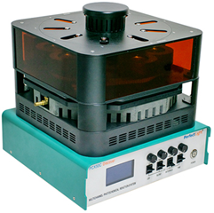

H₂O₂ detection methods
N, N-diethyl-1,4-phenylene-diamine sulfate (DPD) colorimetry was used to detect the concentration of H₂O₂: Sodium phosphate buffer was prepared by adding sodium dihydrogen phosphate (0.5 M) dropwise to the sodium dihydrogen phosphate solution (0.5 M) and testing the mixture until the pH equals 6. The 0.1 g of DPD was dissolved in 10 mL of 0.05 M H₂SO₄ solution. 5 mg of peroxidase (POD) was dissolved in 5 mL of DI water. During the experiment, a 10 mL colorimetric tube was added 3 mL Sodium phosphate buffer, 0.2 mL sample aliquot was filtered by a 0.22 μM PES filter, 0.05 mL of DPD solution, 0.05 mL of POD solution, and 6.7 mL water. After the mixture was stirred for 50 s, the absorbance was measured at 552 nm by a UV/Visible spectrophotometer (UV-9000S, Metash).

Photocatalytic H₂ production
The photocatalytic activity of the samples was evaluated by water splitting for hydrogen evolution under visible light irradiation. Typically, 25 mg photocatalyst and 10 mL triethanolamine (TEOA) serving as the sacrificial electron donor were added to 90 mL ultrapure water under stirring. Then, H₂PtCl₆ 6H₂O aqueous solution was added as the precursor for the co-catalyst Pt, which was in-situ photo-reduced during the photocatalytic reaction (~3 wt% Pt). Next, the solution was degassed and irradiated by a 300 W Xenon lamp. The photocatalytic H₂ evolution rate was determined by using a GC-7900 instrument with a thermal conductivity detector (TCD) and high-purity Ar₂ as the carrier gas.

In-situ DRIFT testing experiments
COF powder was placed in an in-situ sample cell, and nitrogen gas flowed through the sample for 20 minutes to replace impurities before background scanning. And then, continue to flow O₂, BA and water vapor for 30 minutes, and record the data every 20 minutes.

Quantum chemical computational details
All calculations in this work were performed using Gaussian 09 program package¹. Full geometry optimizations and energy calculations were performed to locate all the stationary points, using the M062x² with 6-311+G(d,p)³⁻⁴ basis. Dispersion corrections were computed with Grimme's D3(BJ) method in optimization⁵. Frequency analysis was carried out to verify the optimized geometry to be a minimum or transition structure and to obtain the thermal corrections for the Gibbs free energy. Harmonic vibrational frequency was performed at the same level to guarantee that there is no imaginary frequency in the molecules, i.e. they locate on the minima of potential energy surface. Convergence parameters of the default threshold were retained (maximum force within 4.5×10⁻⁴ Hartrees/Bohr and root mean square (RMS) force within 3.0×10⁻⁴ Hartrees/Radian) to obtain the optimized structure. The optimal structure was identified given that all calculations for structural optimization were successfully converged within the convergence threshold of no imaginary frequency, during the process of vibration analysis.

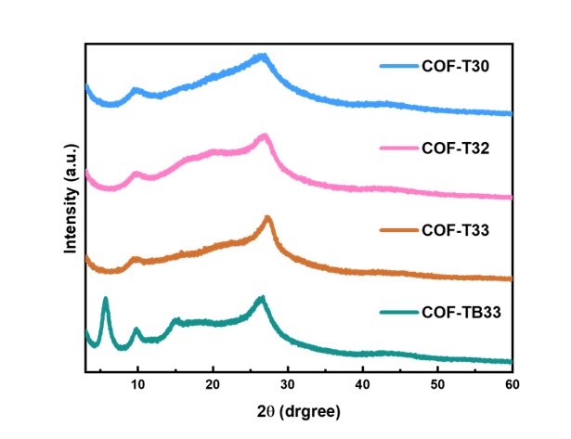
Figure S1 PXRD patterns of four COFs.

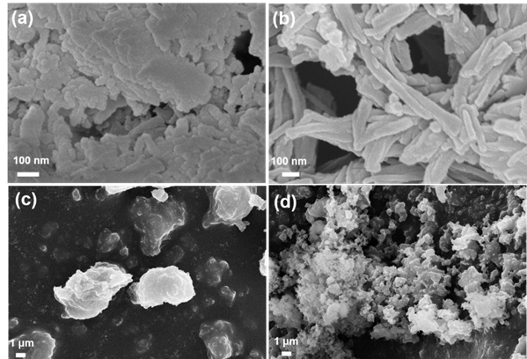
Figure S2 SEM images of COF-TB33 (a), COF-T33 (b), COF-T32 (c) and COF-T30 (d).
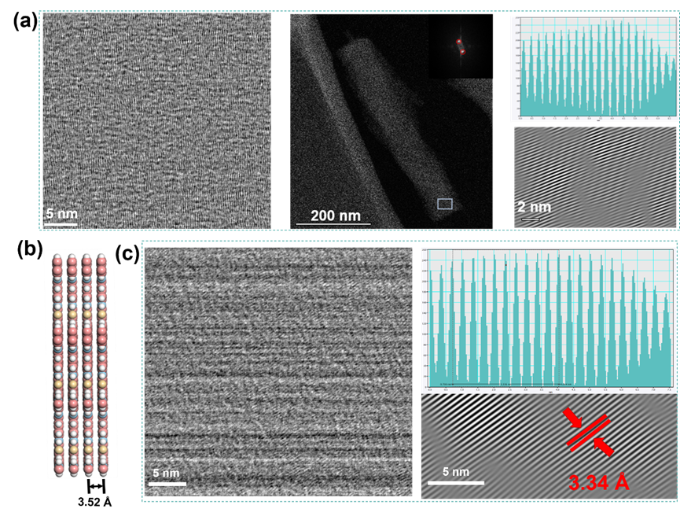
Figure S3 (a) iDPC-STEM image, HAADF-STEM and IFT analysis of COF-T33. (b) Space-ﬁlling AA eclipsed stacking models of COF-TB33. (c) iDPC-STEM image and IFT analysis of COF-TB33.
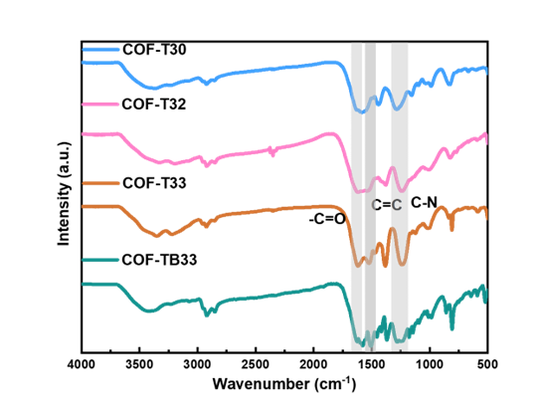
Figure S4 FTIR spectra of four COFs.
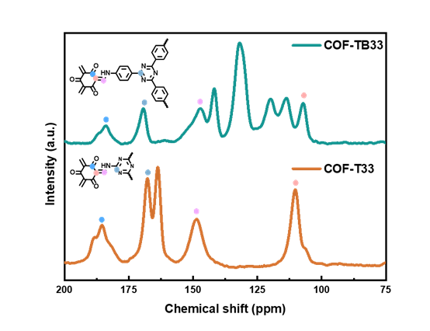
Figure S5 Solid-state ¹³C NMR spectra of COF-TB33 and COF-T33.

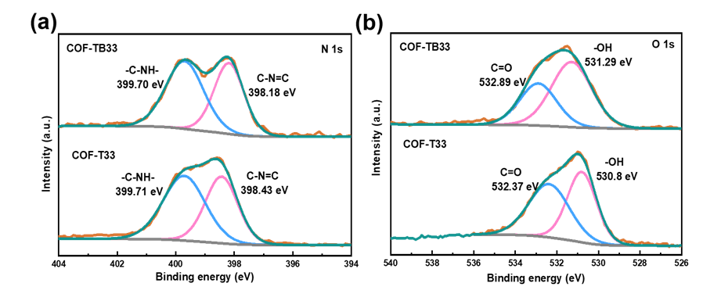
Figure S6 (a) N 1s XPS and (b) O 1s XPS spectra of COF-TB33 and COF-T33.

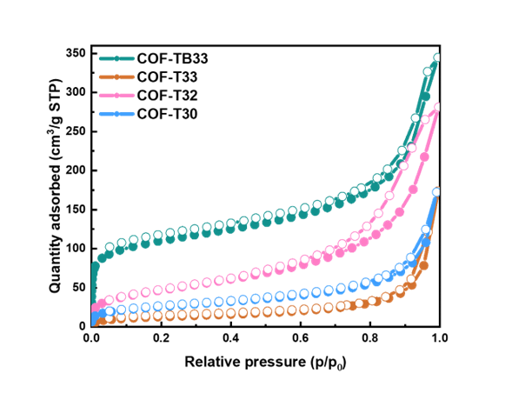
Figure S7 N₂ adsorption/desorption isotherms of four COFs.
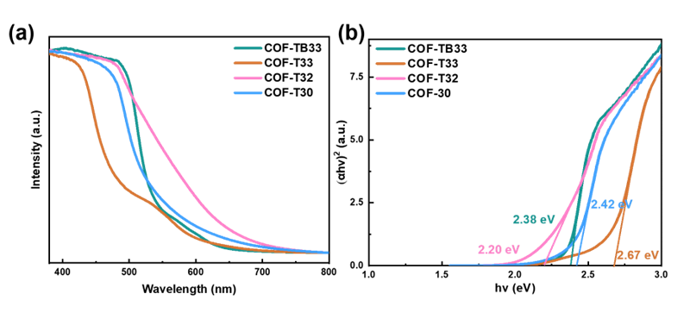
Figure S8 (a) UV-Vis DRS and (b) Tauc plot analyses for band gap calculations of four COFs.

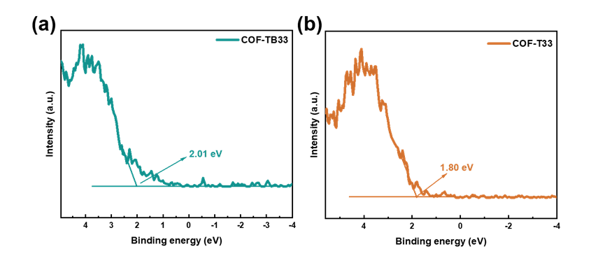
Figure S9 VB XPS spectra of COF-TB33 (a) and COF-T33 (b).

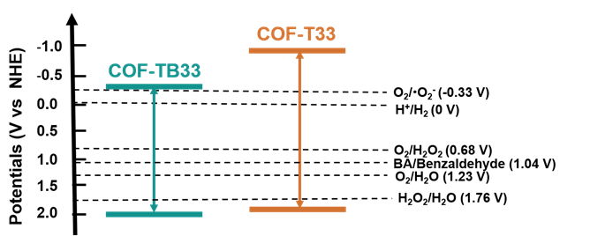
Figure S10 Schematic illustrations of the band structures for COF-TB33 and COF-T33.

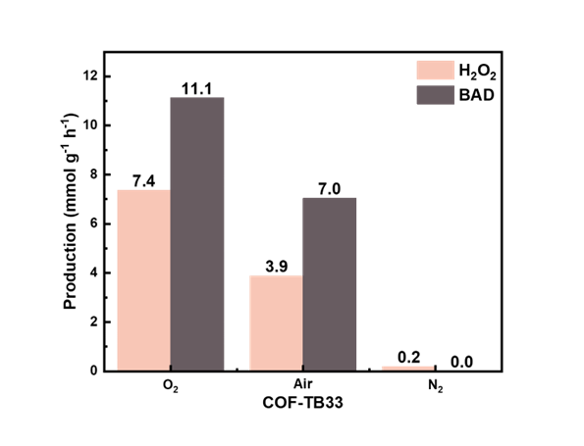
Figure S11 H₂O₂ production of COF-TB33 under different conditions (O₂, Air and N₂).

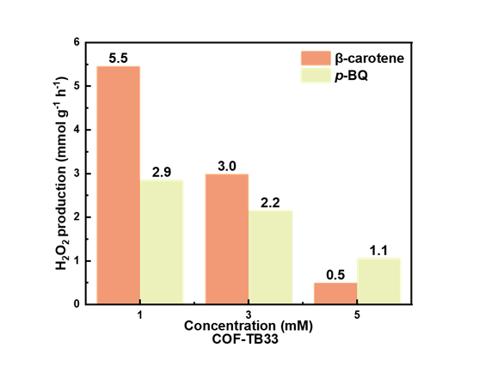
Figure S12 H₂O₂ production for COF-T33 under the different concentrations of β-carotene and p-BQ.

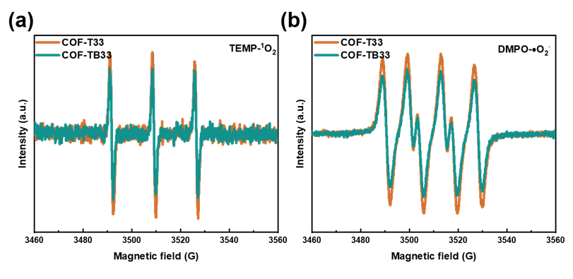
Figure S13 (a) Comparison of EPR signals of ¹O₂ over COF-T33 and COF-TB33 in the presence of TEMP. (b) Comparison of EPR signals of O₂⁻ over COF-T33 and COF-TB33 in the presence of DMPO.

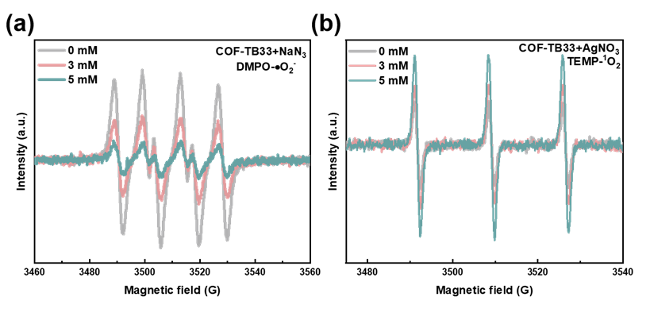
Figure S14 (a) EPR signals of DMPO-•O₂⁻ over COF-TB33 in the presence of different concentrations of NaN₃ (¹O₂ scavengers). (b) EPR signals of TEMP-¹O₂ over COF-TB33 in the presence of different concentrations of AgNO₃ (e⁻ scavengers).

Electrochemical Rotating disk electrode (RDE) measurement. The RDE performance was tested on a CHI760e electrochemical workstation by a three-electrode configuration electrochemical cell. A Standard three-electrode setup was used with a Rotating disk electrode (glassy carbon electrode with an area of 0.19625 cm²), Ag/AgCl, and graphite rod electrode as working electrode, reference electrode, and a counter electrode, respectively. The preparation of the working electrode catalyst solution: catalyst ink was prepared by ultrasonic dispersion of 4 mg COFs in 1050 μL mixture solution (1000 μL DMF and 50 μL 5% Nafion), and then 10 μL catalyst ink was drop-added to the electrode surface to form a catalyst film after 4h of natural air drying. The linear sweep voltammograms (LSV) were measured in an O₂-saturated 0.1 M phosphate buffer solution (pH = 7) with different rotation speeds. The corresponding average transfer number was calculated by the Koutecky-Levich equation following:
$$\frac{1}{J} =\frac{1}{J_{L}}+\frac{1}{J_{K}}=\frac{1}{{Bω}^{1/2}}+\frac{1}{J_{K}}$$
$$B=0.2nFC_{o}D_{o}^{2/3}V^{-1/6}$$
Where J is the measured current density, J_{K} refers to the kinetic current density, J_{L} is the limiting diffusion current density, n is the transfer electron number, F represents the Faraday constant (96485 C mol⁻¹), C_{o} is saturated oxygen concentration in electrolyte (1.26 × 10⁻³ mol L⁻¹). D_{o} is the diffusion coefficient of O₂ (2.7 ×10⁻⁵ cm² s⁻¹), V is the kinetic viscosity of the electrolyte (0.01 cm² s⁻¹), ω is the rotation rate (rad·s⁻¹) of the electrode, respectively.
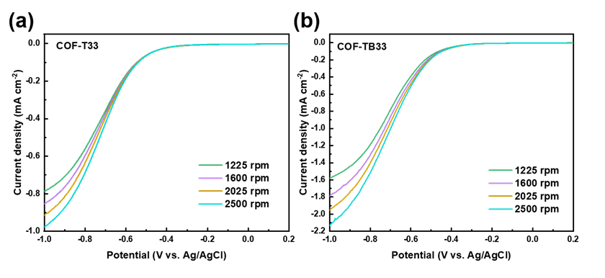
Figure S15 The LSV curves measured by RDE with different rotating of COF-T33 (a) and COF-TB33 (b).

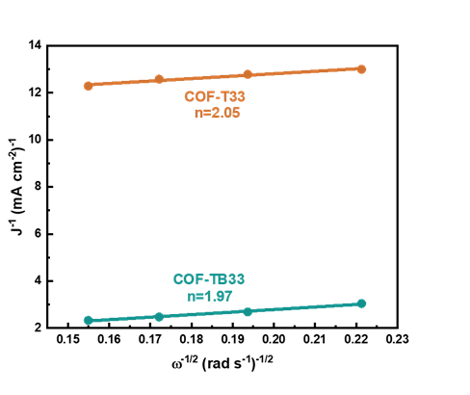
Figure S16 The Koutecky–Levich plots obtained via RDE measurements in phosphate buffer (pH=7) solution with continuous O₂ purging.

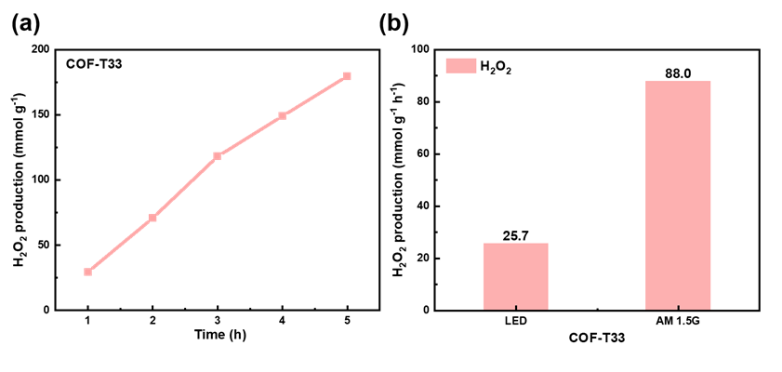
Figure S17 (a) Long-term photocatalytic cycling experiments of COF-T33. (b) Performance of COF-T33 photocatalytic production of H₂O₂ under different light sources.

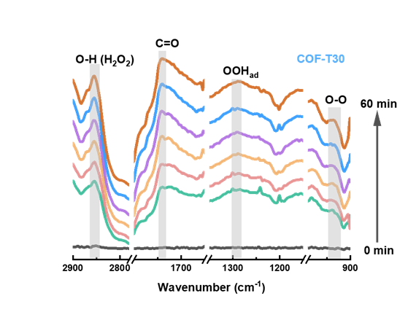
Figure S18 In-situ DRIFT spectra of COF-T30.

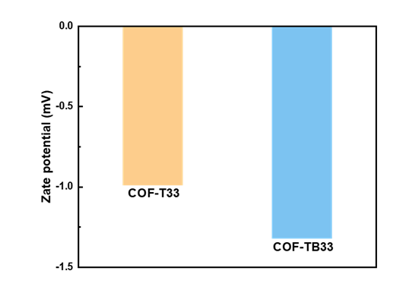
Figure S19 Zeta potentials of COF-T33 and CCOF-TB33.

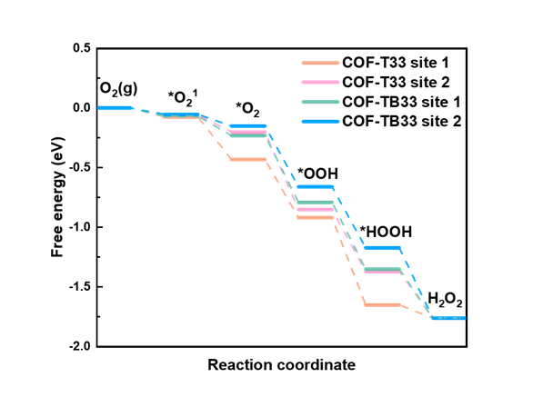
Figure S20 Gibbs free energy changes of the three different active sites on the COF-T33 and COF-TB33 for ORR.

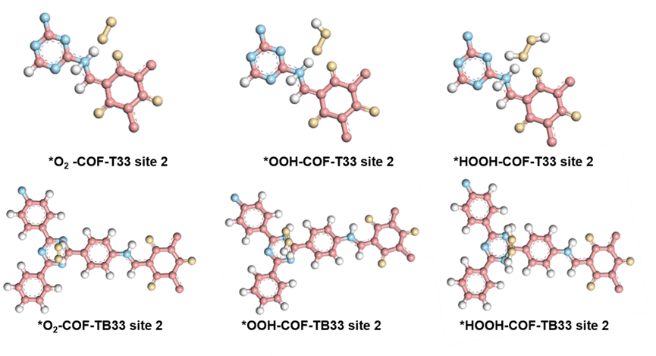
Figure S21 Different reaction intermediates of *O₂, *OOH and *HOOH on COF-T33 and COF-TB33 respectively.

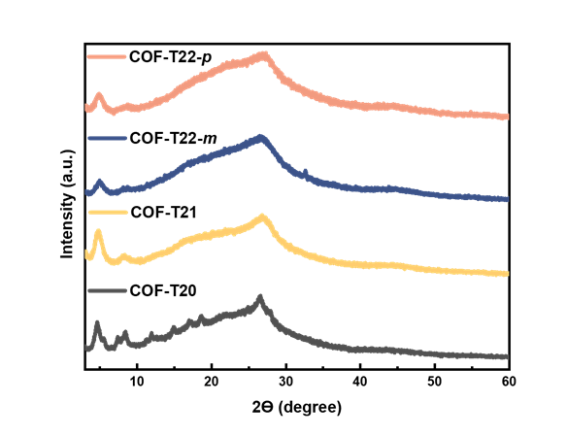
Figure S22 PXRD patterns of four COFs.

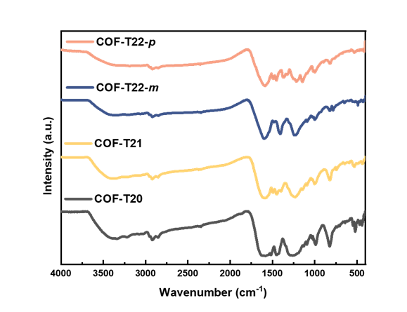
Figure S23 FTIR patterns of four COFs.

Table S1 Oxygen adsorption energy of COFT33 and COF-TB33.
Sites | Adsorption energy
COF-T33 site 1 | -8.7 kcal mol⁻¹
COF-T33 site 2 | -6.9 kcal mol⁻¹
COF-TB33 site 1 | -6.3 kcal mol⁻¹
COF-TB33 site 2 | -5.2 kcal mol⁻¹

Table S2 Photocatalytic H₂O₂ generation performance comparison of COF-T33 with some other reported COF photocatalysts.
Photocatalyst | H₂O₂ yield rate /mmol/g/h | Irradiated conditions | Solvent | Ref
COF-T33 | 25.7 | LED | H₂O:BA (1:1) | This work
COF-T33 | 88 | 300W Xe AM 1.5G | H₂O:BA (1:1) | This work
TpDz | 7.327 | 300W Xe (λ>420 nm) | H₂O | 6
COF-TpHt | 11.986 | 300W Xe (λ>420 nm) | H₂O:BA (9:1) | 7
H₂Se-COF | 6.145 | 300W Xe (λ>420 nm) | H₂O:BA (9:1) | 8
TF₅₀-COF | 1.739 | 300W Xe (λ>400 nm) | H₂O:EtOH (9:1) | 9
TZ-COF | 4.951 | 300W Xe (λ>420 nm) | H₂O:BA (1:1) | 10
Py-Da-COF | 1.242 | 300W Xe (λ>420 nm) | H₂O:BA (9:1) | 11
COF-TAPB-BPDA | 1.24 | 300W Xe (λ>420 nm) | H₂O:BA (4:1) | 12
PyIm-COF | 5.85 | 300W Xe (λ>420 nm) | H₂O | 13
PMCR-1 | 5.5 | 300W Xe (λ>420 nm) | H₂O:BA (10:1) | 14
DVA-COF | 8.45 | LED (λ=420 nm) | H₂O:BA (9:1) | 15
TAH-COF | 6.003 | AM 1.5G | H₂O | 16
COF-O | 1.5 | 30 W LED lamp (420 nm) | H₂O | 17
iCOF-DBTP | 10.01 | (420≤λ≤780 nm) | H₂O | 18
TD-COF | 4.06 | LED (λ=420-700 nm) | H₂O | 19
PD²⁺-COF_{16.7} | 11.965 | 300W Xe (λ>400 nm) | H₂O:EtOH (9:1) | 20
EO-COF | 2.675 | 300W Xe (λ>400 nm) | H₂O:EtOH (9:1) | 21
o-COF-TpPzda | 4.396 | 300W Xe (λ>420 nm) | H₂O | 22
Hz-TP-BT-COF | 5.7 | 300W Xe (λ=420-600 nm) | H₂O | 23
TaptBtt | 1.407 | 300W Xe AM 1.5G | H₂O | 24

References
1 Xie, H. et al. Molecular mechanism comparison of decarbonylation with deoxygenation and hydrogenation of 5-hydroxymethylfurfural catalyzed by palladium acetate. Phys. Chem. Chem. Phys. 21, 3795-3804, doi:10.1039/c8cp07723a (2019).
2 Krishnan, R., Binkley, J. S., Seeger, R. & Pople, J. A. Self-consistent molecular orbital methods. XX. A basis set for correlated wave functions. J. Chem. Phys. 72, 650-654, doi:10.1063/1.438955 (1980).
3 Weigend, F. & Ahlrichs, R. Balanced basis sets of split valence, triple zeta valence and quadruple zeta valence quality for H to Rn: Design and assessment of accuracy. Phys Chem Chem Phys 7, 3297-3305, doi:10.1039/b508541a (2005).
4 Xu, S., He, T., Li, J., Huang, Z. & Hu, C. Enantioselective synthesis of D-lactic acid via chemocatalysis using MgO: Experimental and molecular-based rationalization of the triose's reactivity and preliminary insights with raw biomass. Applied Catalysis B: Environmental 292, doi:10.1016/j.apcatb.2021.120145 (2021).
5 Grimme, S.; Antony, J.; Ehrlich, S.; Krieg, H., A consistent and accurate ab initio parametrization of density functional dispersion correction (DFT-D) for the 94 elements H-Pu. J. Chem. Phys. 132, 15, 154104. doi: 10.1063/1.3382344 (2010)
6 Liao, Q. et al. Regulating Relative Nitrogen Locations of Diazine Functionalized Covalent Organic Frameworks for Overall H₂O₂ Photosynthesis. Angewandte Chemie International Edition 62, e202310556, doi:10.100 2/anie.202310556 (2023).
7 Shao, C. et al. A covalent organic framework inspired by C₃N₄ for photosynthesis of hydrogen peroxide with high quantum efficiency. Chinese Journal of Catalysis 46, 28-35, doi:10.1016/s1872-2067(22)64205-0 (2023).
8 Dong, P. et al. Stepwise Protonation of Three-Dimensional Covalent Organic Frameworks for Enhancing Hydrogen Peroxide Photosynthesis. Angewandte Chemie International Edition, e202405313, doi:10.1002/anie.202405313 (2024).
9 Wang, H., Yang, C., Chen, F., Zheng, G. & Han, Q. A Crystalline Partially Fluorinated Triazine Covalent Organic Framework for Efficient Photosynthesis of Hydrogen Peroxide. Angewandte Chemie International Edition 61, e202202328, doi:10.1002/anie.202202328 (2022).
10 Mou, Y. et al. Linkage Microenvironment of Azoles-Related Covalent Organic Frameworks Precisely Regulates Photocatalytic Generation of Hydrogen Peroxide. Angewandte Chemie International Edition 62, e202309480, doi:10.1002/anie.202309480 (2023).
11 Sun, J. et al. Pyrene Based Covalent Organic Frameworks for Photocatalytic Hydrogen Peroxide Production. Angewandte Chemie International Edition 62, e202216719, doi:10.1002/anie.202216719 (2023).
12 Yang, T., Chen, Y., Wang, Y., Peng, X. & Kong, A. Weakly Hydrophilic Imine-Linked Covalent Benzene-Acetylene Frameworks for Photocatalytic H₂O₂ Production in the Two-Phase System. ACS Appl Mater Interfaces 15, 8066-8075, doi:10.1021/acsami.2c20506 (2023).
13 Wu, W. et al. Pyridine-based Covalent Organic Frameworks with Pyridyl-Imine Structures for Boosting Photocatalytic H₂O₂ Production via One-Step 2e⁻ Oxygen Reduction. Angewandte Chemie International Edition, e202404563, doi:10.1002/anie.202404563 (2024).
14 Das, P., Roeser, J. & Thomas, A. Solar Light Driven H₂O₂ Production and Selective Oxidations Using a Covalent Organic Framework Photocatalyst Prepared by a Multicomponent Reaction. Angewandte Chemie International Edition, e202304349, doi:10.1002/anie.202304349 (2023).
15 Yu, H. et al. Vinyl-Groups-Anchored Covalent Organic Framework for Promoted Photocatalytic Hydrogen Peroxide Generation. Angewandte Chemie International Edition, e202402297, doi:10.1002/anie.202402297 (2024).
16 Xu, T. et al. Constructing Photocatalytic Covalent Organic Frameworks with Aliphatic Linkers. Journal of the American Chemical Society 146, 20107-20115, doi:10.1021/jacs.4c04244 (2024).
17 Xie, Z. et al. Variation of Chemical Microenvironment of Pores in Hydrazone-Linked Covalent Organic Frameworks for Photosynthesis of H₂O₂. Angewandte Chemie International Edition 63, e202410179, doi:10.1002/anie.202410179 (2024).
18 Li, G. et al. Boosting exciton dissociation by regulating dielectric constant in covalent organic framework for photocatalysis. Chem Catalysis 2, 1734-1747, doi:10.1016/j.checat.2022.05.002 (2022).
19 Yue, J. Y. et al. Thiophene-Containing Covalent Organic Frameworks for Overall Photocatalytic H₂O₂ Synthesis in Water and Seawater. Angewandte Chemie International Edition 62, doi:10.1002/anie.202309624 (2023).
20 Hao, F. et al. Photo-Driven Quasi-Topological Transformation Exposing Highly Active Nitrogen Cation Sites for Enhanced Photocatalytic H₂O₂ Production. Angewandte Chemie International Edition 62, e202315456, doi:10.1002/anie.202315456 (2023).
21 Li, P. et al. 1D Covalent Organic Frameworks Triggering Highly Efficient Photosynthesis of H₂O₂ via Controllable Modular Design. Angewandte Chemie International Edition 63, e202319885, doi:10.1002/anie.202319885 (2024).
22 Yang, T. et al. Robust Covalent Organic Framework Photocatalysts for H₂O₂ Production: Linkage Position Matters. Angewandte Chemie International Edition, e202404077, doi:10.1002/anie.202404077 (2024).
23 Liu, R. et al. Linkage-engineered donor-acceptor covalent organic frameworks for optimal photosynthesis of hydrogen peroxide from water and air. Nature Catalysis 7, 195-206, doi:10.1038/s41929-023-01102-3 (2024).
24 Qin, C. et al. Dual donor-acceptor covalent organic frameworks for hydrogen peroxide photosynthesis. Nature Communications 14, 5238, doi:10.1038/s41467-023-40991-7 (2023).

