Supplementary Information
Potential of topical microemulsion serum formulations to enhance in vitro and clinical anti-skin wrinkle benefits of Cordyceps militaris extracts

Pachabadee Marsup ^{1,2}, Sasithorn Sirilun ², Adchara Prommaban ², Suwannee Sriyab ², Waranya Neimkhum ³, Jakkapan Sirithunyalug ^{2,4}, Songyot Anuchapreeda ^{4,5}, Chaiwat To-anun ⁶ and Wantida Chaiyana ^{2,4,} *

¹ Master’s Degree Program in Cosmetic Science, Faculty of Pharmacy, Chiang Mai University, Chiang Mai 50200, Thailand
² Department of Pharmaceutical Sciences, Faculty of Pharmacy, Chiang Mai University, Chiang Mai 50200, Thailand
³ Department of Pharmaceutical Technology, Faculty of Pharmaceutical Sciences, Huachiew Chalermprakiet University, Samutprakarn 10250, Thailand
⁴ Research Center of Pharmaceutical Nanotechnology, Chiang Mai University, Chiang Mai, 50200, Thailand
⁵ Division of Clinical Microscopy, Department of Medical Technology, Faculty of Associated Medical Sciences, Chiang Mai University, Chiang Mai, 50200, Thailand
⁶ Department of Entomology and Plant Pathology, Faculty of Agriculture, Chiang Mai University, Chiang Mai, 50200, Thailand
* Correspondence: Wantida Chaiyana, Department of Pharmaceutical Sciences, Faculty of Pharmacy, Chiang Mai University, Chiang Mai 50200, Thailand; wantida.chaiyana@gmail.com; Tel.: +66-5394-4343
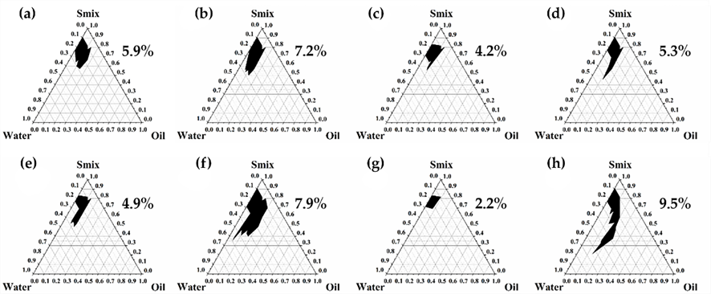
Fig. S1. Pseudoternary phase diagrams constructed using the mixture of Tween® 85 and butylene glycol (1:1) with various oil types, including apricot kernel oil (a), argan oil (b), avocado oil (c), canola oil (d), corn oil (e), jojoba oil (f), perilla oil (g), and sugar squalane (h). The dark area represents the microemulsion region.

Fig. S2. Pseudoternary phase diagrams constructed using sugar squalane with the mixture of Tween® 85 and various types of co-surfactant, including glycerin (a), propylene glycol (b), and butylene glycol (c). The ratio of Tween® 85 to co-surfactant was 1:1. The dark area represents the microemulsion region.
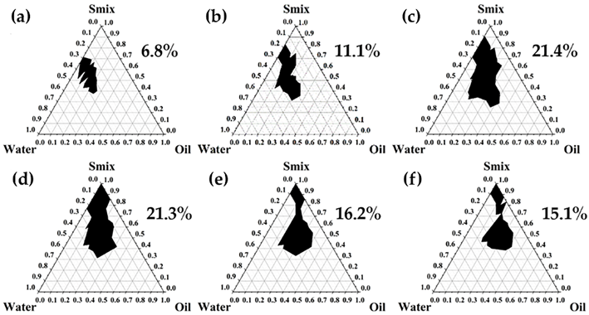

Fig. S3. Pseudoternary phase diagrams of microemulsion using sugar squalane with the mixture of Tween® 85 and propylene glycol in the weight ratio of 1:2 (a), 1:1 (b), 2:1 (c), 3:1 (d), 4:1 (e) and 5:1 (f). The dark area represents the area of microemulsion.

