Supplementary Information for

Direct measure of soil carbon persistence over annual to centennial timescales

Joshua D. Landisª*, Caitlin Hicks Pries^{b}, Carl E. Renshawª, Sophie von Fromm^{b}, Diogo Spinola^{c}, Raquel Portes^{c}, William H. McDowell^{d,e}, Christopher J. Nytch^{f}, Jun Zhou^{g}, Daniel Obrist^{h}, Marisa Palucisª, Karis McFarlane^{i}

ªDept. of Earth Sciences, Dartmouth College, Hanover, NH, 03755 USA
^{b}Dept. of Biological Sciences, Dartmouth College, Hanover, NH, 03755 USA
^{c}Faculty of Environment, University of Northern British Columbia, Prince George, V2N 4Z9, CA
^{d}Dept. of Natural Resources and the Environment, University of New Hampshire, Durham, NH, 03824 USA
^{e}Institute of environment, Florida International University, Miami, FL, 33199 USA
^{f}Dept. of Environmental Sciences, University of Puerto Rico-Río Piedras, San Juan, PR 00925 USA
^{g}State Key Laboratory of Soil and Sustainable Agriculture, Institute of Soil Science, Chinese Academy of Sciences, Nanjing, China 210008
^{h}Division of Agriculture and Natural Resources, University of California, Davis, CA 95616 USA
^{i}Center for Accelerator Mass Spectrometry, Lawrence Livermore National Laboratory, Livermore, CA 94550 USA
*joshua.d.landis@dartmouth.edu

This supplementary information consists of 12 pages and includes Discussions S1-S4 and Figures S1-S5.

Discussion S1. Organo-metal associations in soil, and concordant radionuclide models of SOM age
Carbon-metal associations begin in atmospheric deposition where fallout radionuclides (FRNs) and other particle-reactive metals bind to carbonaceous particulate matter (PM), to dissolved organic matter (DOM) in throughfall (rainfall passing through vegetation canopy), to foliar and forest floor soil organic matter (SOM), or, for geogenic ²²⁸Ra and ²²⁸Th, by direct fixation in foliar organic matter via root-shoot pathways ^{1,2} ³. We refer to these associations as organometallic complexes since they are formed by sorption of metals to organic moities. Once transferred to soils with their associated natural organic matter (NOM), the conjoining of metal and carbon cycles persists during decomposition and the formation of authigenic oxyhydroxides of Fe, Al, and Mn in leaf litter and organic soil horizons ^{4–9}. The conservation of heavy metals, fallout radionuclides, and carbon in organic and mineral soils is progressively driven by oxyhydroxide minerals, which are a primary factor in developing MAOM linked to soil carbon persistence ^{10–15}. The thermodynamic affinity of Pb for SOM is comparable to that of the soil forming elements Fe and Al; these form the strongest metal-humate complexes ^{16,17}. These organometal complexes thus formed evolve to organomineral complexes and MAOM by polymerization and aggregation during pedogenesis^{17,18}. They promote the co-transport of metals and carbon both within soils and across landscapes ^{19–21}. With their strong affinity for carbon, we propose that FRN age models are quintessential chronometers of soil carbon sequestration.

Discussion S2. Comparing LRC, ¹⁴C age, and ¹⁴C turnover models
S.2.1 the LRC model. The LRC model is an empirical, numerical age model based on the fallout radionuclides (FRNs) ⁷Be (half-life 54 days) and ²¹⁰Pb (half-life 22.3 years). The FRNs are produced naturally in the atmosphere and deposited to vegetation and soil by wet and dry deposition in typical proportions of 80% and 20% of annual flux, respectively ^{22,23}. FRNs are critical tracers of modern atmosphere-biosphere interaction because their production in the atmosphere is ubiquitous, their availability is thus universal, and due to their short half-lives their occurrence is readily related to their atmospheric source without overprinting due to mixing with legacy reservoirs.

The LRC model is similar to well-established peat and sediment dating using the well-known Constant Rate of Supply (CRS) model based on ²¹⁰Pb but adds ⁷Be in an open-system framework to allow non-steady-state dating and to explicitly correct for the penetration of FRNs below the soil surface that occurs during rainfall and throughfall. Typically, ca. 40% of FRN deposition to the soil surface occurs with litterfall and the balance enters via wet deposition reaching soil depths of 10 to 15 cm with characteristic exponential decline ^{2,24,25}. The model reference horizon is the canopy of vegetation, and the model traces net downward transport of ²¹⁰Pb from the canopy through soil due to both advective and dispersive processes. Age dates should thus be seen as averages since mixing due to dispersion is not explicitly incorporated into the model. However, these ages accurately and precisely represent the migration time of e.g. an atmospheric pulse of metals such as Hg, Pb, and ²⁴¹Am through the soil column in association with SOM ^{2,23,25}. Impact of roots on LRC dating are discussed below in Discussion S3.

S2.2. calibrated ¹⁴C age. We explored two different approaches to estimating soil carbon age using ¹⁴C (Fig. S1). First, the dating approach compares soil ¹⁴C/¹²C isotopic composition ( in Δ¹⁴C notation) directly to the known atmospheric bomb curve using, e.g., the online CALIbomb tool ²⁶. The Δ ¹⁴C age model assumes a system in which soil is treated as a composite of discrete layers that perfectly record atmospheric ¹⁴C from the time of carbon fixation. The approach does not accommodate soil dispersion that occurs due to bioturbation, cryoturbation, etc. ²⁷. These processes dampen the bomb-peak concentration of ¹⁴C in soils by mixing layers of peak ¹⁴C deposition in the 1960s with those above and below containing lower ¹⁴C concentrations. The ¹⁴C dating model is thus unable to reconstruct the full timescale of ¹⁴C fixation and instead returns values that are discontinuous, either much younger or much older that the true age through decades of the 1960s to 1970s. We call this effect the bomb gap.

Finally, because atmospheric concentrations of ¹⁴C are non-unique through time, the ¹⁴C dating approach yields multiple candidate ages with no a priori expectation for choosing the likely correct one (Fig. S3). Here we define the age closest to LRC as the harmonized age.

S2.3. ¹⁴C turnover models. A second approach for extracting age information from ¹⁴C, the turnover model assumes a homogeneous pool of carbon per layer or horizon and models turnover time or TT of atmospheric ¹⁴C inputs to match measured soil Δ¹⁴C value, assuming steady-state between carbon losses and inputs, i.e. it is a black box mixing model ^{28,29}. TT is the inverse of a first-order loss constant, k. The turnover box model requires a perfectly mixed static horizon in which ongoing inputs are homogenized within the box, with no age stratification. Output of ¹⁴C must exactly reflect composition of the whole pool. If, however, the pool is stratified, then outputs reflect only the oldest carbon, the pool remains younger than prediction, and the model will overestimate turnover time.

Like the calibrated ¹⁴C age model approach, the turnover model produces multiple candidate turnover times due to the symmetry of the atmospheric bomb curve (Fig. S4). These yield an hourglass shape when plotted against LRC soil age. By convention and absent other constraints, the older single-pool turnover time is typically selected (in keeping with presumptions of the model system as static and well-mixed). Here, LRC ages provide independent a priori evidence that the shorter TT is likely to be correct and we select the ¹⁴C candidate closest to LRC age as the harmonized estimate. The TT model numerically smooths data across the bomb gap, but its impact is still evidenced where, for example, the model is unable to converge to a solution for F¹⁴C values >1.13 for soils collected after 2022.

The ¹⁴C calibrated age and turnover approaches represent end-member scenarios of soil transport from pure advection to pure dispersion. LRC succeeds because it empirically measures net transport from both advection and dispersion. While resulting ages thus represent averages and the underlying distribution of ages remains unknown, nonetheless the mean age is both accurate and precise and, for example, accurately dates atmospheric inputs of metals and carbon ^{2,25}.

Discussion S3. impacts of root carbon and below-ground allocation on LRC dating of SOM
The impact of below-ground carbon allocation (roots and exudates) on both age of SOM and the shape of the soil carbon depth profile remain challenging to quantify ^{30,31}. Like ¹⁴C approaches, LRC does not distinguish root and shoot carbon based on age determination alone. This is important because of the different soil depths that root and shoot impact the carbon profile. When assessing the impact of below-ground carbon allocation on LRC dating, it is important to recognize that FRN deposition occurs to both above-ground and below-ground organic matter. Typically, ca. 40% of new FRN deposition is retained above ground by canopy of vegetation, and the remainder penetrates the soil surface where it directly labels or tags SOM in situ^{3,24}. Below-ground FRN deposition declines exponential with depth with ca. 50% of deposition above 5 cm, and ca. 10% of deposition reaching 10 cm or more in forest soils ^{2,25}.

The surface area of live root carbon is limited relative to bulk soil, so root biomass plays a limited role in binding FRNs. There is limited direct uptake of FRNs through plant metabolism, so we do not expect translocation of FRNs to growing roots. For example, in salt marsh with deep-rooted grasses, the contribution of roots to the ²¹⁰Pb budget is about 10% for the entire profile (unpublished data). We instead expect that FRNs label or tag root and exudate carbon continuously, only as it turns over to the SOM pool. The age of SOM computed by LRC will then be a weighted average of above-ground SOM advecting through a given soil layer, and below-ground SOM produced in situ. We explicitly acknowledge that SOM is a mixture of younger and older components, and that LRC yields an average while the distribution of ages remains unknown.

At soil depths below FRN deposition the production of significant root or exudate SOM will not impact LRC dating but will inject additional carbon into the soil profile. The turnover rates of this deep root carbon are generally unknown, and the impact on true age of SOM is therefore difficult to assess. It is significant that we do not see a crossover to younger ages in the LRC v. ¹⁴C age plot (Fig. S5), which suggests that the cumulative turnover of root carbon to SOM is slow relative to advection that governs the LRC model system. It may also be fortuitous that deep root carbon might have similar turnover times to surrounding SOM. From the perspective of carbon flux and k calculated with LRC ages, the injection of deep root carbon into the soil profile will offset SOM losses due to mineralization and may even yield increasing carbon flux with depth. In this manner LRC dating provides a means for identifying and possibly quantifying below-ground allocation if flux or k can be determined otherwise. It may be useful therefore to interpret LRC ages as migration times, which are complementary to carbon turnover and transit times derived from ¹⁴C approaches ^{30,32}.

Discussion S4. Estimating Luquillo NPP from above-ground productivity
Above ground NPP for Luquillo sites is estimated to be 336 g m⁻² y⁻¹ for Elfin forest, 689 g m⁻² y⁻¹ for palo colorado, 1769 g m⁻² y⁻¹ for tabonuco, and as much as 1771 for sierra palm ³³. We assume that below-ground allocation is typically about 30% of total, so if extrapolated to total NPP corresponding rates of carbon accumulation would be 480, 986, and 1362, and 2529 g m⁻² y⁻¹, respectively.

Discussion S5. local calibration of atmospheric ¹⁴C using leaf timeseries
We used a long-term time series of leaf collections to test how well local foliage reflects the published NHZ1 atmospheric curve used for ∆¹⁴C dating. We collected leaves of red oak (Quercus rubra) saplings approximately monthly from 2011 through 2021 for FRN analysis and here used archived samples to measure ¹⁴C ^{34,35}. Age of leaves is known from the recorded date of leaf out. We found a mean difference =1.7 ±0.4 years (±SE, n=7) over the time span of 2013 to 2019 with NHZ1 slightly underestimating age of the leaves [two-tailed t, p=0.009].

References
1. Landis, J. D., Feng, X., Kaste, J. M. & Renshaw, C. E. Aerosol populations, processes and ages contributing to bulk atmospheric deposition: insights from a 9-year study of 7Be, 210Pb, sulfate and major/trace elements. Journal of Geophysical Research: Atmospheres (2021).
2. Landis, J. D. et al. Quantifying soil accumulation of atmospheric mercury using fallout radionuclide chronometry. Nat Commun 15, 5430 (2024).
3. Landis, J. D. Age-Dating of Foliage and Soil Organic Matter: Aligning 228Th:228Ra and 7Be:210Pb Radionuclide Chronometers over Annual to Decadal Time Scales. Environ Sci Technol 57, 15047–15054 (2023).
4. Witzgall, K. et al. Particulate organic matter as a functional soil component for persistent soil organic carbon. Nat Commun 12, (2021).
5. Miller, E. K. & Friedland, A. J. Lead migration in forest soils: response to changing atmospheric inputs. Environ Sci Technol 28, 662–9 (1994).
6. Wang, E. X. & Benoit, G. Fate and transport of contaminant lead in spodosols: A simple box model analysis. Water Air Soil Pollut 95, 381–397 (1997).
7. Kaste, J. M., Friedland, A. J. & Miller, E. K. Potentially mobile lead fractions in montane organic-rich soil horizons. Water Air Soil Pollut 167, 139–154 (2005).
8. Villalobos, M., Bargar, J. & Sposito, G. Mechanisms of Pb(II) sorption on a biogenic manganese oxide. Environ Sci Technol 39, 569–576 (2005).
9. Schroth, A. W., Bostick, B. C., Kaste, J. M. & Friedland, A. J. Lead sequestration and species redistribution during soil organic matter decomposition. Environ Sci Technol 42, 3627–3633 (2008).
10. Kaiser, K. & Guggenberger, G. The role of DOM sorption to mineral surfaces in the preservation of organic matter in soils. Org Geochem 31, 711–725 (2000).
11. Schmidt, M. W. I. et al. Persistence of soil organic matter as an ecosystem property. Nature 478, 49–56 (2011).
12. Sowers, T. D., Adhikari, D., Wang, J., Yang, Y. & Sparks, D. L. Spatial Associations and Chemical Composition of Organic Carbon Sequestered in Fe, Ca, and Organic Carbon Ternary Systems. Environ Sci Technol 52, 6936–6944 (2018).
13. Kramer, M. G. & Chadwick, O. A. Climate-driven thresholds in reactive mineral retention of soil carbon at the global scale. Nat Clim Chang 8, 1104–1108 (2018).
14. Kögel-Knabner, I. & Amelung, W. Soil organic matter in major pedogenic soil groups. Geoderma 384, (2021).
15. Lalonde, K., Mucci, A., Ouellet, A. & Gélinas, Y. Preservation of organic matter in sediments promoted by iron. Nature 483, 198–200 (2012).
16. Kerndorff, H. & Schnitzer, M. Sorption of metals on humic acid. Geochimica Cosmochimica Acta 44, 1701–1708 (1980).
17. Pokrovsky, O. S., Dupré, B. & Schott, J. Fe-Al-organic colloids control of trace elements in peat soil solutions: Results of ultrafiltration and dialysis. Aquatic Geochemistry vol. 11 241–278 Preprint at https://doi.org/10.1007/s10498-004-4765-2 (2005).
18. Bazilevskaya, E., Archibald, D. D. & Martínez, C. E. Mineral colloids mediate organic carbon accumulation in a temperate forest Spodosol: depth-wise changes in pore water chemistry. Biogeochemistry 141, 75–94 (2018).
19. Raudina, T. V. et al. Colloidal organic carbon and trace elements in peat porewaters across a permafrost gradient in Western Siberia. Geoderma 390, (2021).
20. Škerlep, M. et al. Spruce forest afforestation leading to increased Fe mobilization from soils. Biogeochemistry 157, 273–290 (2022).
21. Willenbring, J. K. & von Blanckenburg, F. Meteoric cosmogenic Beryllium-10 adsorbed to river sediment and soil: Applications for Earth-surface dynamics. Earth Sci Rev 98, 105–122 (2010).
22. Landis, J. D. Whole-tree mass balance of fallout radionuclides and atmospheric metals, Chapter 6 in Terrestrial Exchange of Atmospheric Metals: Insights from Fallout Radionuclides. (Dartmouth College, Hanover, 2024).
23. Landis, J. D., Renshaw, C. E. & Kaste, J. M. Beryllium-7 and lead-210 chronometry of modern soil processes: The Linked Radionuclide aCcumulation model, LRC. Geochim Cosmochim Acta 180, 109–125 (2016).
24. Landis, J. D. New Throughfall Mass Balance with Fallout Radionuclides, Chapter 5 in Terrestrial Exchange of Atmospheric Metals: Insights from Fallout Radionuclides. (Dartmouth College, Hanover, NH, 2024).
25. Landis, J. D., Taylor, V. F., Hintelmann, H. & Hrenchuk, L. E. Predicting behavior and fate of atmospheric mercury in soils: age-dating METAALICUS Hg isotope spikes with fallout radionuclide chronometry. EnvironmentalScienceandTechnology inprint, (2024).
26. Reimer, R. W. & Reimer, P. J. CALIBomb http://calib.org accessed 2024-2-7. WWW Program (2024).
27. Kaste, J. M., Heimsath, A. M. & Bostick, B. C. Short-term soil mixing quantified with fallout radionuclides. Geology 35, 243 (2007).
28. Torn, M. S., Swanston, C. W., Castanha, C. & Trumbore, S. E. Storage and turnover of organic matter in soil. in Biophysico-Chemical Processes Involving Natural Nonliving Organic Matter in Environmental Systems (eds. Senesi, N., Xing, B. & Huang, P. M.) 54 (John Wiley & Sons, Inc., 2009).
29. Van Der Voort, T. S. et al. Dynamics of deep soil carbon - Insights from 14C time series across a climatic gradient. Biogeosciences 16, 3233–3246 (2019).
30. Sierra, C. A. et al. Carbon sequestration in the subsoil and the time required to stabilize carbon for climate change mitigation. Global Change Biology vol. 30 Preprint at https://doi.org/10.1111/gcb.17153 (2024).
31. Amundson, R. et al. The radiocarbon age of soil carbon is a function of vertical transport rates. (2024) doi:10.21203/rs.3.rs-4992057/v1.
32. Sierra, C. A., Estupinan-Suarez, L. M. & Chanca, I. The fate and transit time of carbon in a tropical forest. Journal of Ecology 109, 2845–2855 (2021).
33. Weaver, P. L. & Murphy, P. G. Forest Structure and Productivity in Puerto Rico’s Luquillo Mountains. vol. 22 https://about.jstor.org/terms (1990).
34. Landis, J. D. Accumulation of atmospheric metals in natural vegetation, Chapter 4 in Terrestrial Exchange of Atmospheric Metals: Insights from Fallout Radionuclides. (Dartmouth College, Hanover, NH, 2024).
35. Landis, J. D., Renshaw, C. E. & Kaste, J. M. Quantitative retention of atmospherically deposited elements by native vegetation is traced by the fallout radionuclides 7Be and 210Pb. Environ Sci Technol 48, 12022–12030 (2014).
36. Appleby, P. G., Richardson, N. & Nolan, P. J. 241Am dating of lake sediments. Hydrobiologia 214, 35–42 (1991).
37. Hua, Q. et al. ATMOSPHERIC RADIOCARBON for the PERIOD 1950-2019. Radiocarbon 00, (2021).
38. Seiders, V. M. Geologic Map of the El Yunque Quadrangle, Puerto Rico. Miscellaneous Geological Investigations Map I-658. (1991).
39. Burton, W. C., Walsh, G. J. & Armstrong, T. R. Bedrock Geological Map of the Hubbard Brook Experimental Forest, Grafton County, New Hampshire. Open-File Report 00-45-A, v. 1.0. http://pubs.usgs.gov/openfile/of00-45/ (1998).

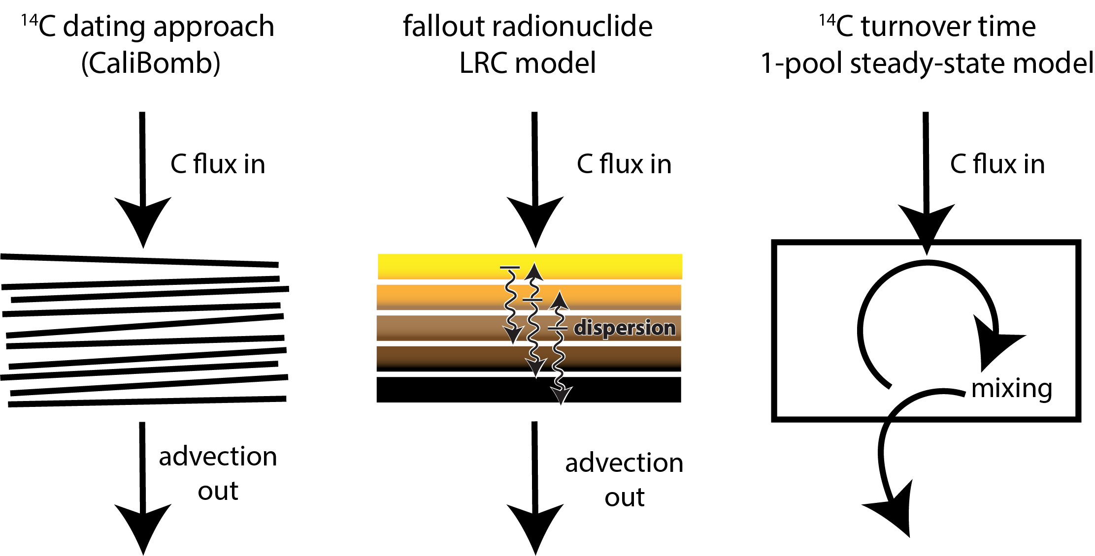

Figure S1. Conceptual models for soil carbon age-depth relationship. (a) calibrated ¹⁴C dating assumes no mixing and that carbon accumulates in discrete layers, e.g. CaliBromb ²⁶, (b) fallout radionuclide Linked Radionuclide aCcumulation (LRC) model is an empirical numerical approach that measures net carbon transport and accommodates partial mixing, with age estimates representing an average of unknown distribution of ages, (c) ¹⁴C turnover model assumes steady-state single pool that is perfectly mixed with loss by first-order process proportional to pool size.

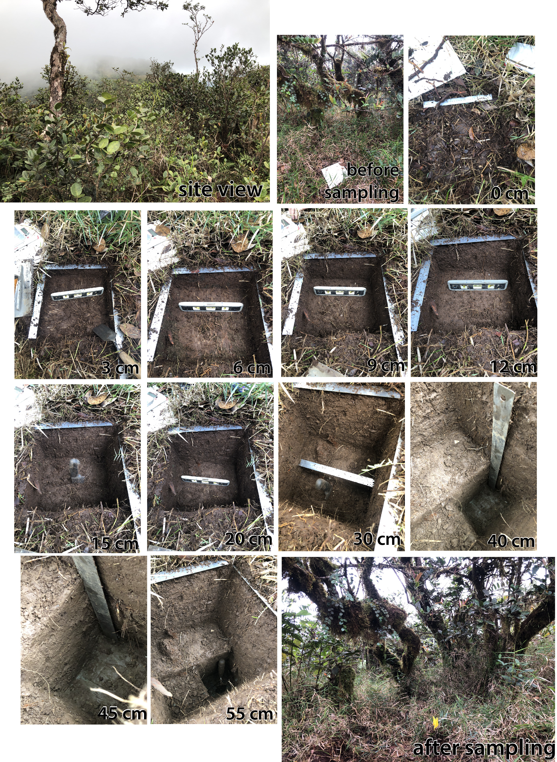
Figure S2. sampling montage of pit LeF03 (hydric Inceptisol underlain by marine-bedded volcaniclastics), 990 m.a.s.l. near Pico del Este, Luquillo LTER, Puerto Rico.
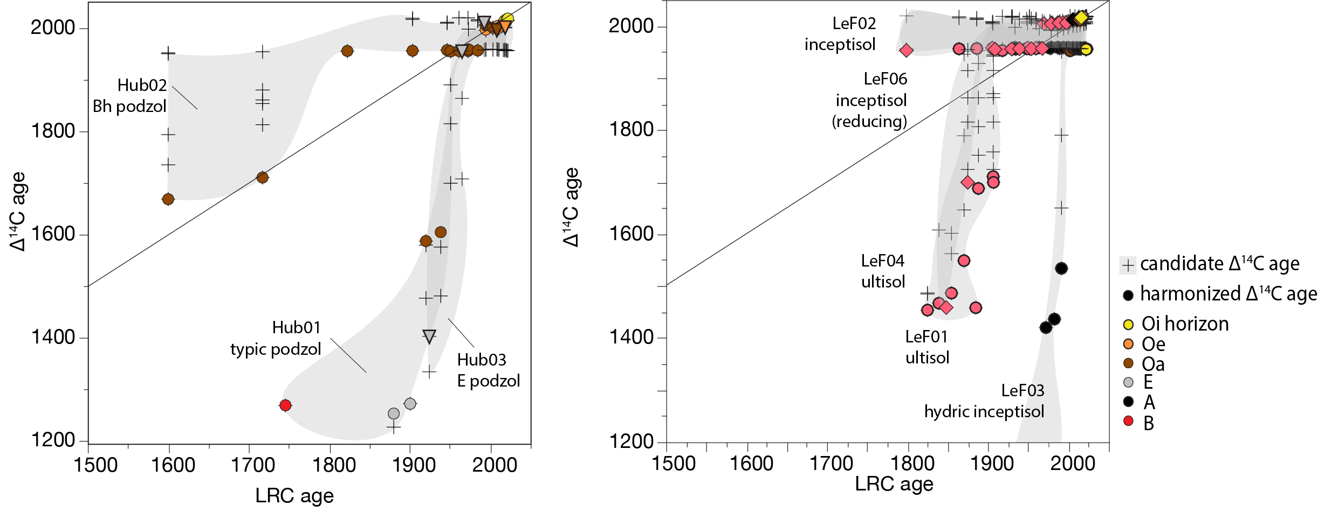
Figure S3. Candidate ages for Δ¹⁴C dating compared to LRC ages. The Δ¹⁴C approach produces multiple candidate ages due to symmetry and variation of the atmospheric ¹⁴C bomb peak. The age closest to RLC is chosen as the harmonized ¹⁴C age.

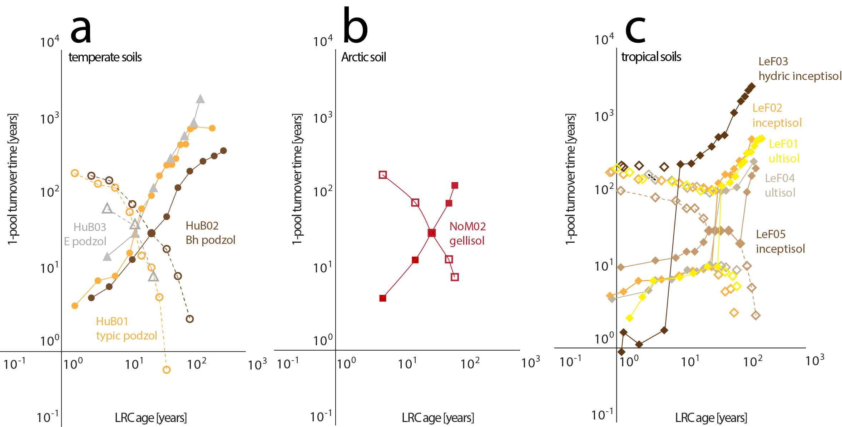

Figure S4. Candidate 1-pool ¹⁴C turnover times (TT) plotted against LRC age for (a) temperate (b) Arctic and (c) tropical soils. Individual soil profiles are distinguished by color, with closed symbols/solid line for harmonized TT (compatible with LRC age) and open symbols/dashed line for alternate TT. ¹⁴C turnover models yield two possible TTs due to symmetry of the global bomb curve. Note hourglass distribution of these ages. LRC provides a priori evidence to pick one. This requires "switchover" from younger to older turnover estimate which is most prominently shown for LeF03 in panel c. Note that age and turnover time are not directly comparable, and turnover is expected to be greater than age ²⁸.

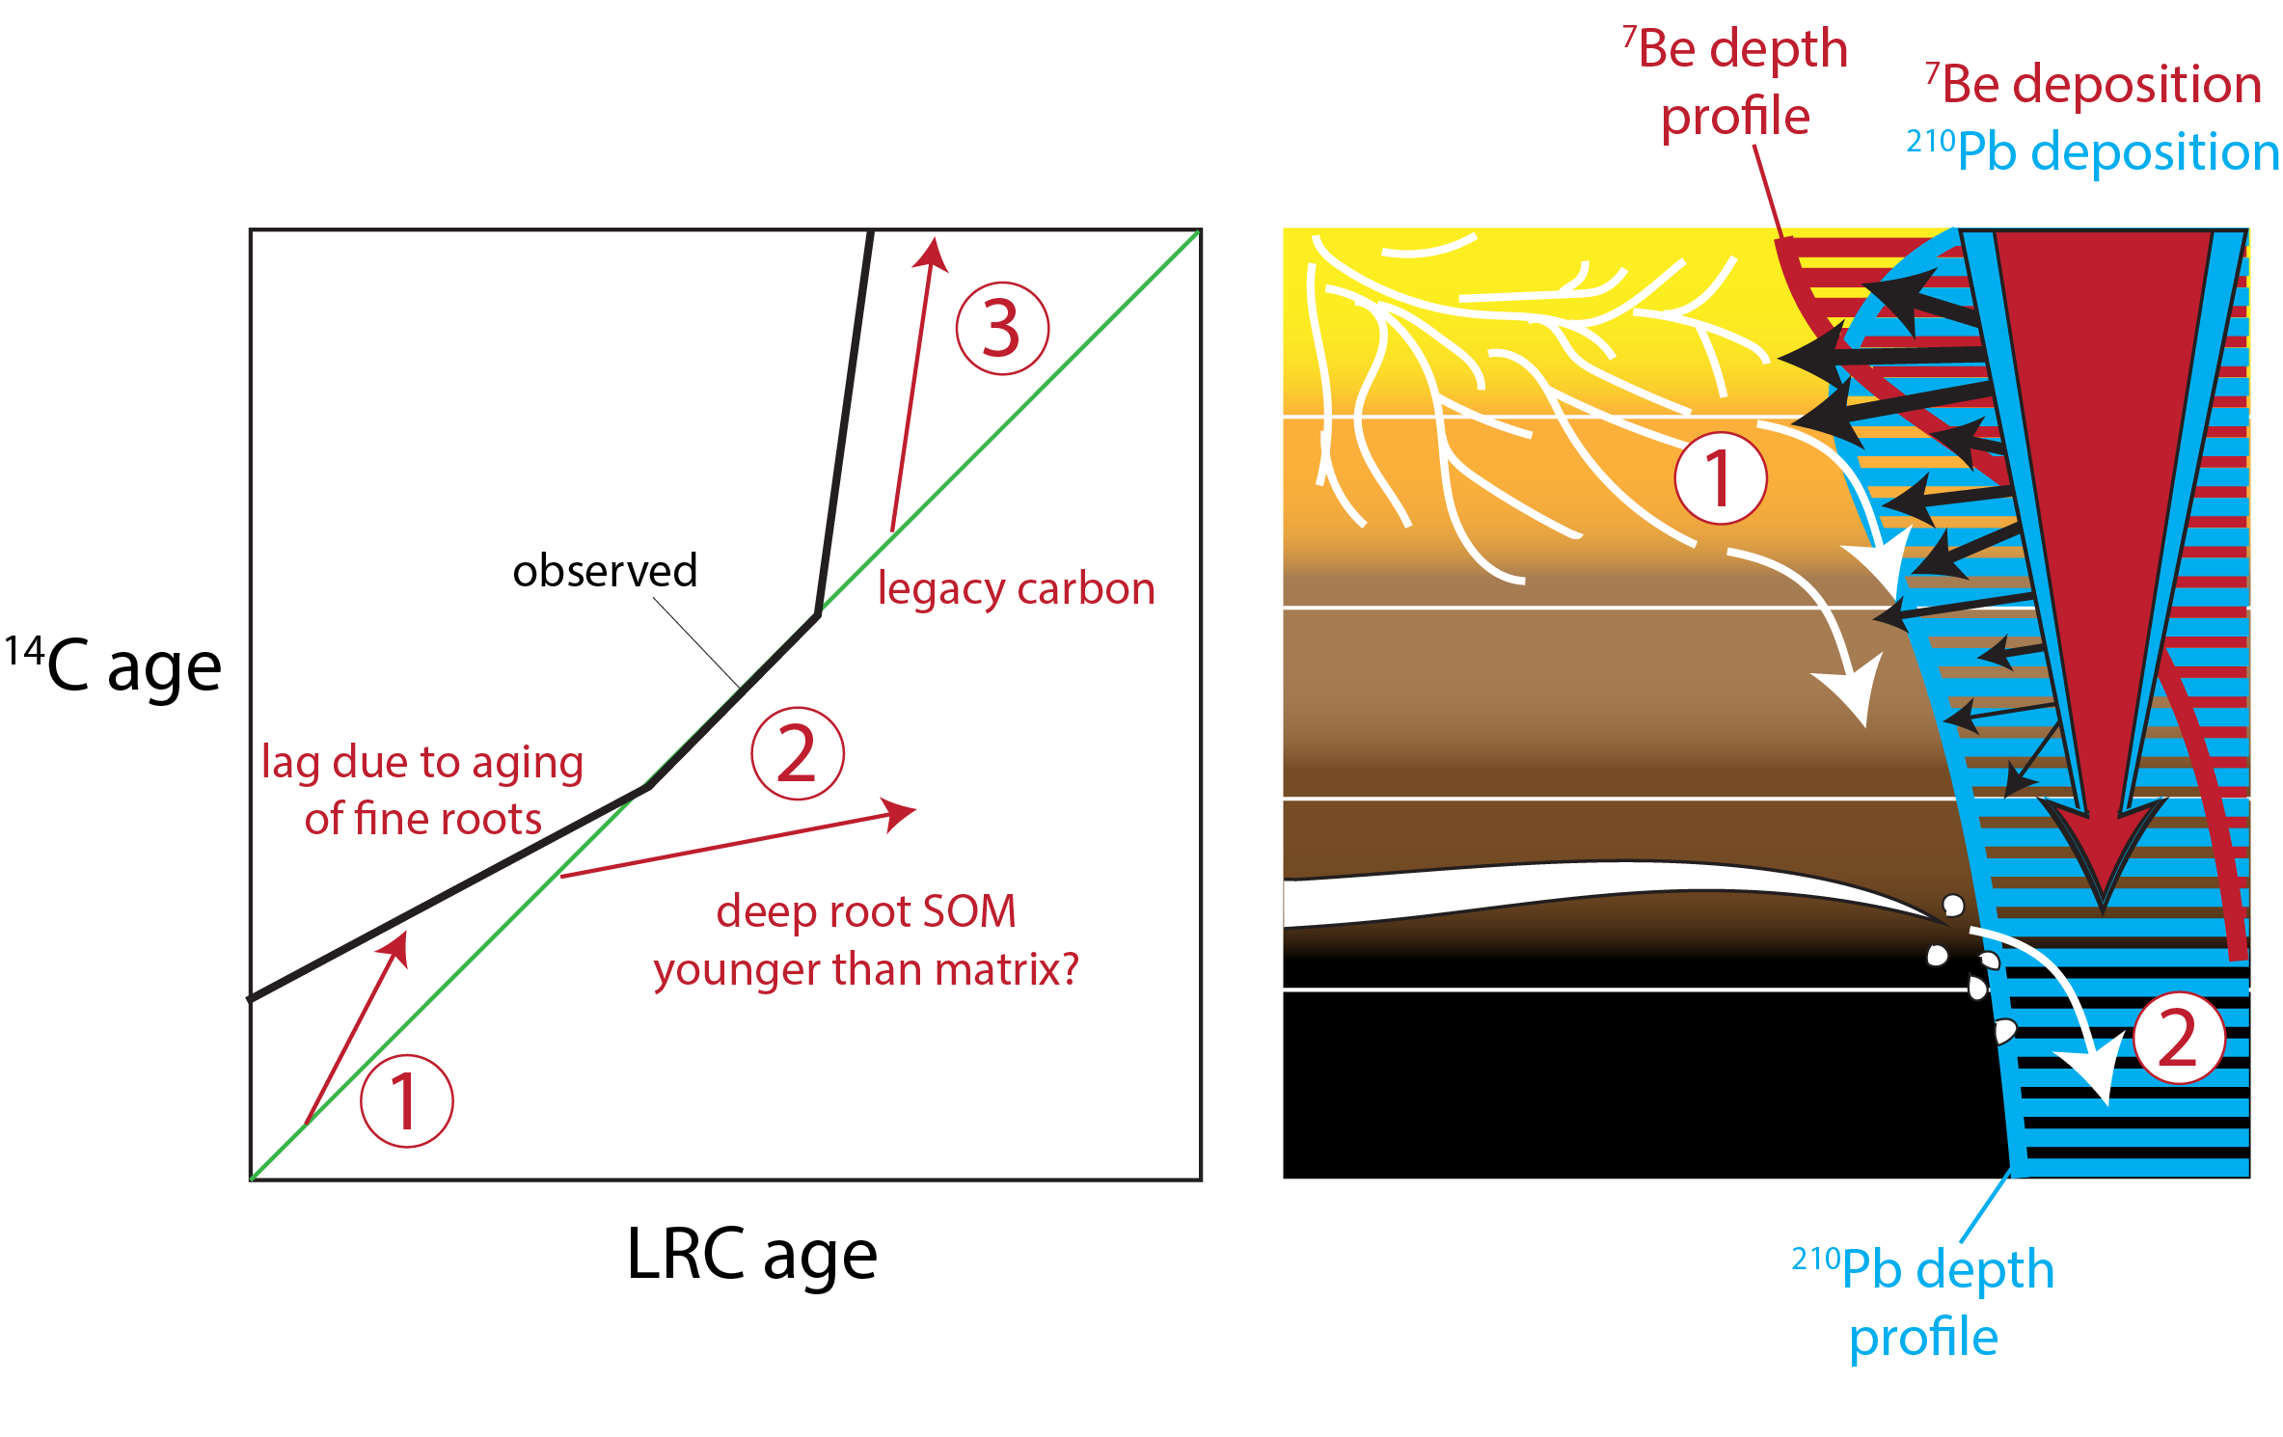
Figure S5. role of root carbon in LRC dating of SOM. (a) conceptual correlation plot of LRC v. ¹⁴C SOM ages shows the familiar lag time of carbon in upper most centimeters (1) corresponding to several decades, as well as contributions from legacy carbon in deeper mineral soils corresponding to ages of centuries to millenia (3). Observed data do not show significant contribution of deep root carbon that is differentially aged from surrounding matrix SOM (2) where ¹⁴C might be younger than LRC ages. This suggests that advection of SOM at all depth is fast relative to root inputs, (b) cartoon depicting FRN labelling of fine root carbon in upper organic soil horizons during atmospheric deposition, and injection of deep root carbon at depths below FRN deposition (>10 cm).

