Extended Data for

Direct measure of soil carbon persistence over annual to centennial timescales

Joshua D. Landisª*, Caitlin Hicks Pries^{b}, Carl E. Renshawª, Sophie von Fromm^{b}, Diogo Spinola^{c}, Raquel Portes^{c}, William H. McDowell^{d,e}, Christopher J. Nytch^{f}, Jun Zhou^{g}, Daniel Obrist^{h}, Marisa Palucisª, Karis McFarlane^{i}

ªDept. of Earth Sciences, Dartmouth College, Hanover, NH, 03755 USA
^{b}Dept. of Biological Sciences, Dartmouth College, Hanover, NH, 03755 USA
^{c}Faculty of Environment, University of Northern British Columbia, Prince George, V2N 4Z9, CA
^{d}Dept. of Natural Resources and the Environment, University of New Hampshire, Durham, NH, 03824 USA
^{e}Institute of environment, Florida International University, Miami, FL, 33199 USA
^{f}Dept. of Environmental Sciences, University of Puerto Rico-Río Piedras, San Juan, PR 00925 USA
^{g}State Key Laboratory of Soil and Sustainable Agriculture, Institute of Soil Science, Chinese Academy of Sciences, Nanjing, China 210008
^{h}Division of Agriculture and Natural Resources, University of California, Davis, CA 95616 USA
^{i}Center for Accelerator Mass Spectrometry, Lawrence Livermore National Laboratory, Livermore, CA 94550 USA
*joshua.d.landis@dartmouth.edu

This Extended Data consists of 9 pages with Extended Data Figures 1-9.

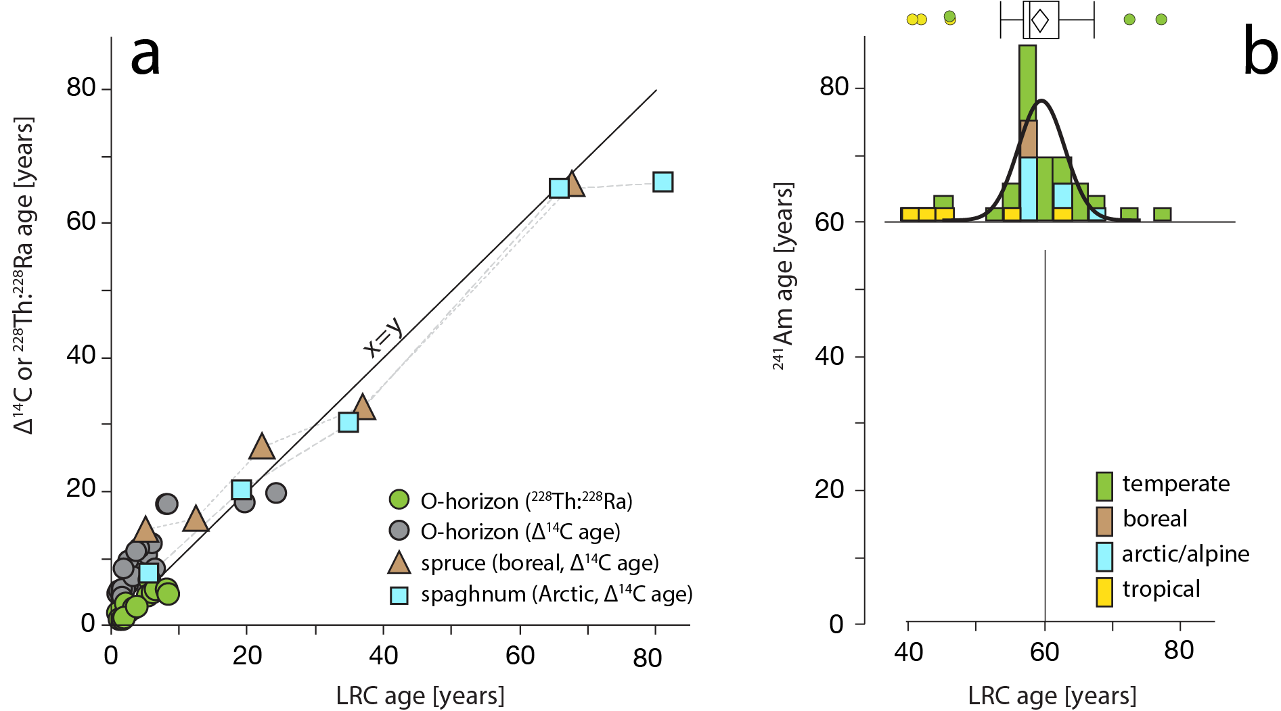

Extended Data 1. Concordance of radionuclide age models and comparison with ∆¹⁴C. (a) comparison of LRC with ∆¹⁴C in gray symbols shows the well-known lag in carbon systems as a bias to older ages, whereas LRC and ²²⁸Th:²²⁸Ra (green) are concordant at ages <10 years. Th:Ra data were reported by Landis ¹ (b) both LRC and ¹⁴C models are concordant with the ²⁴¹Am bomb pulse corresponding to 1964² (aged 60 years from reference year of 2024, shown as a histogram of 39 dated soil profiles).

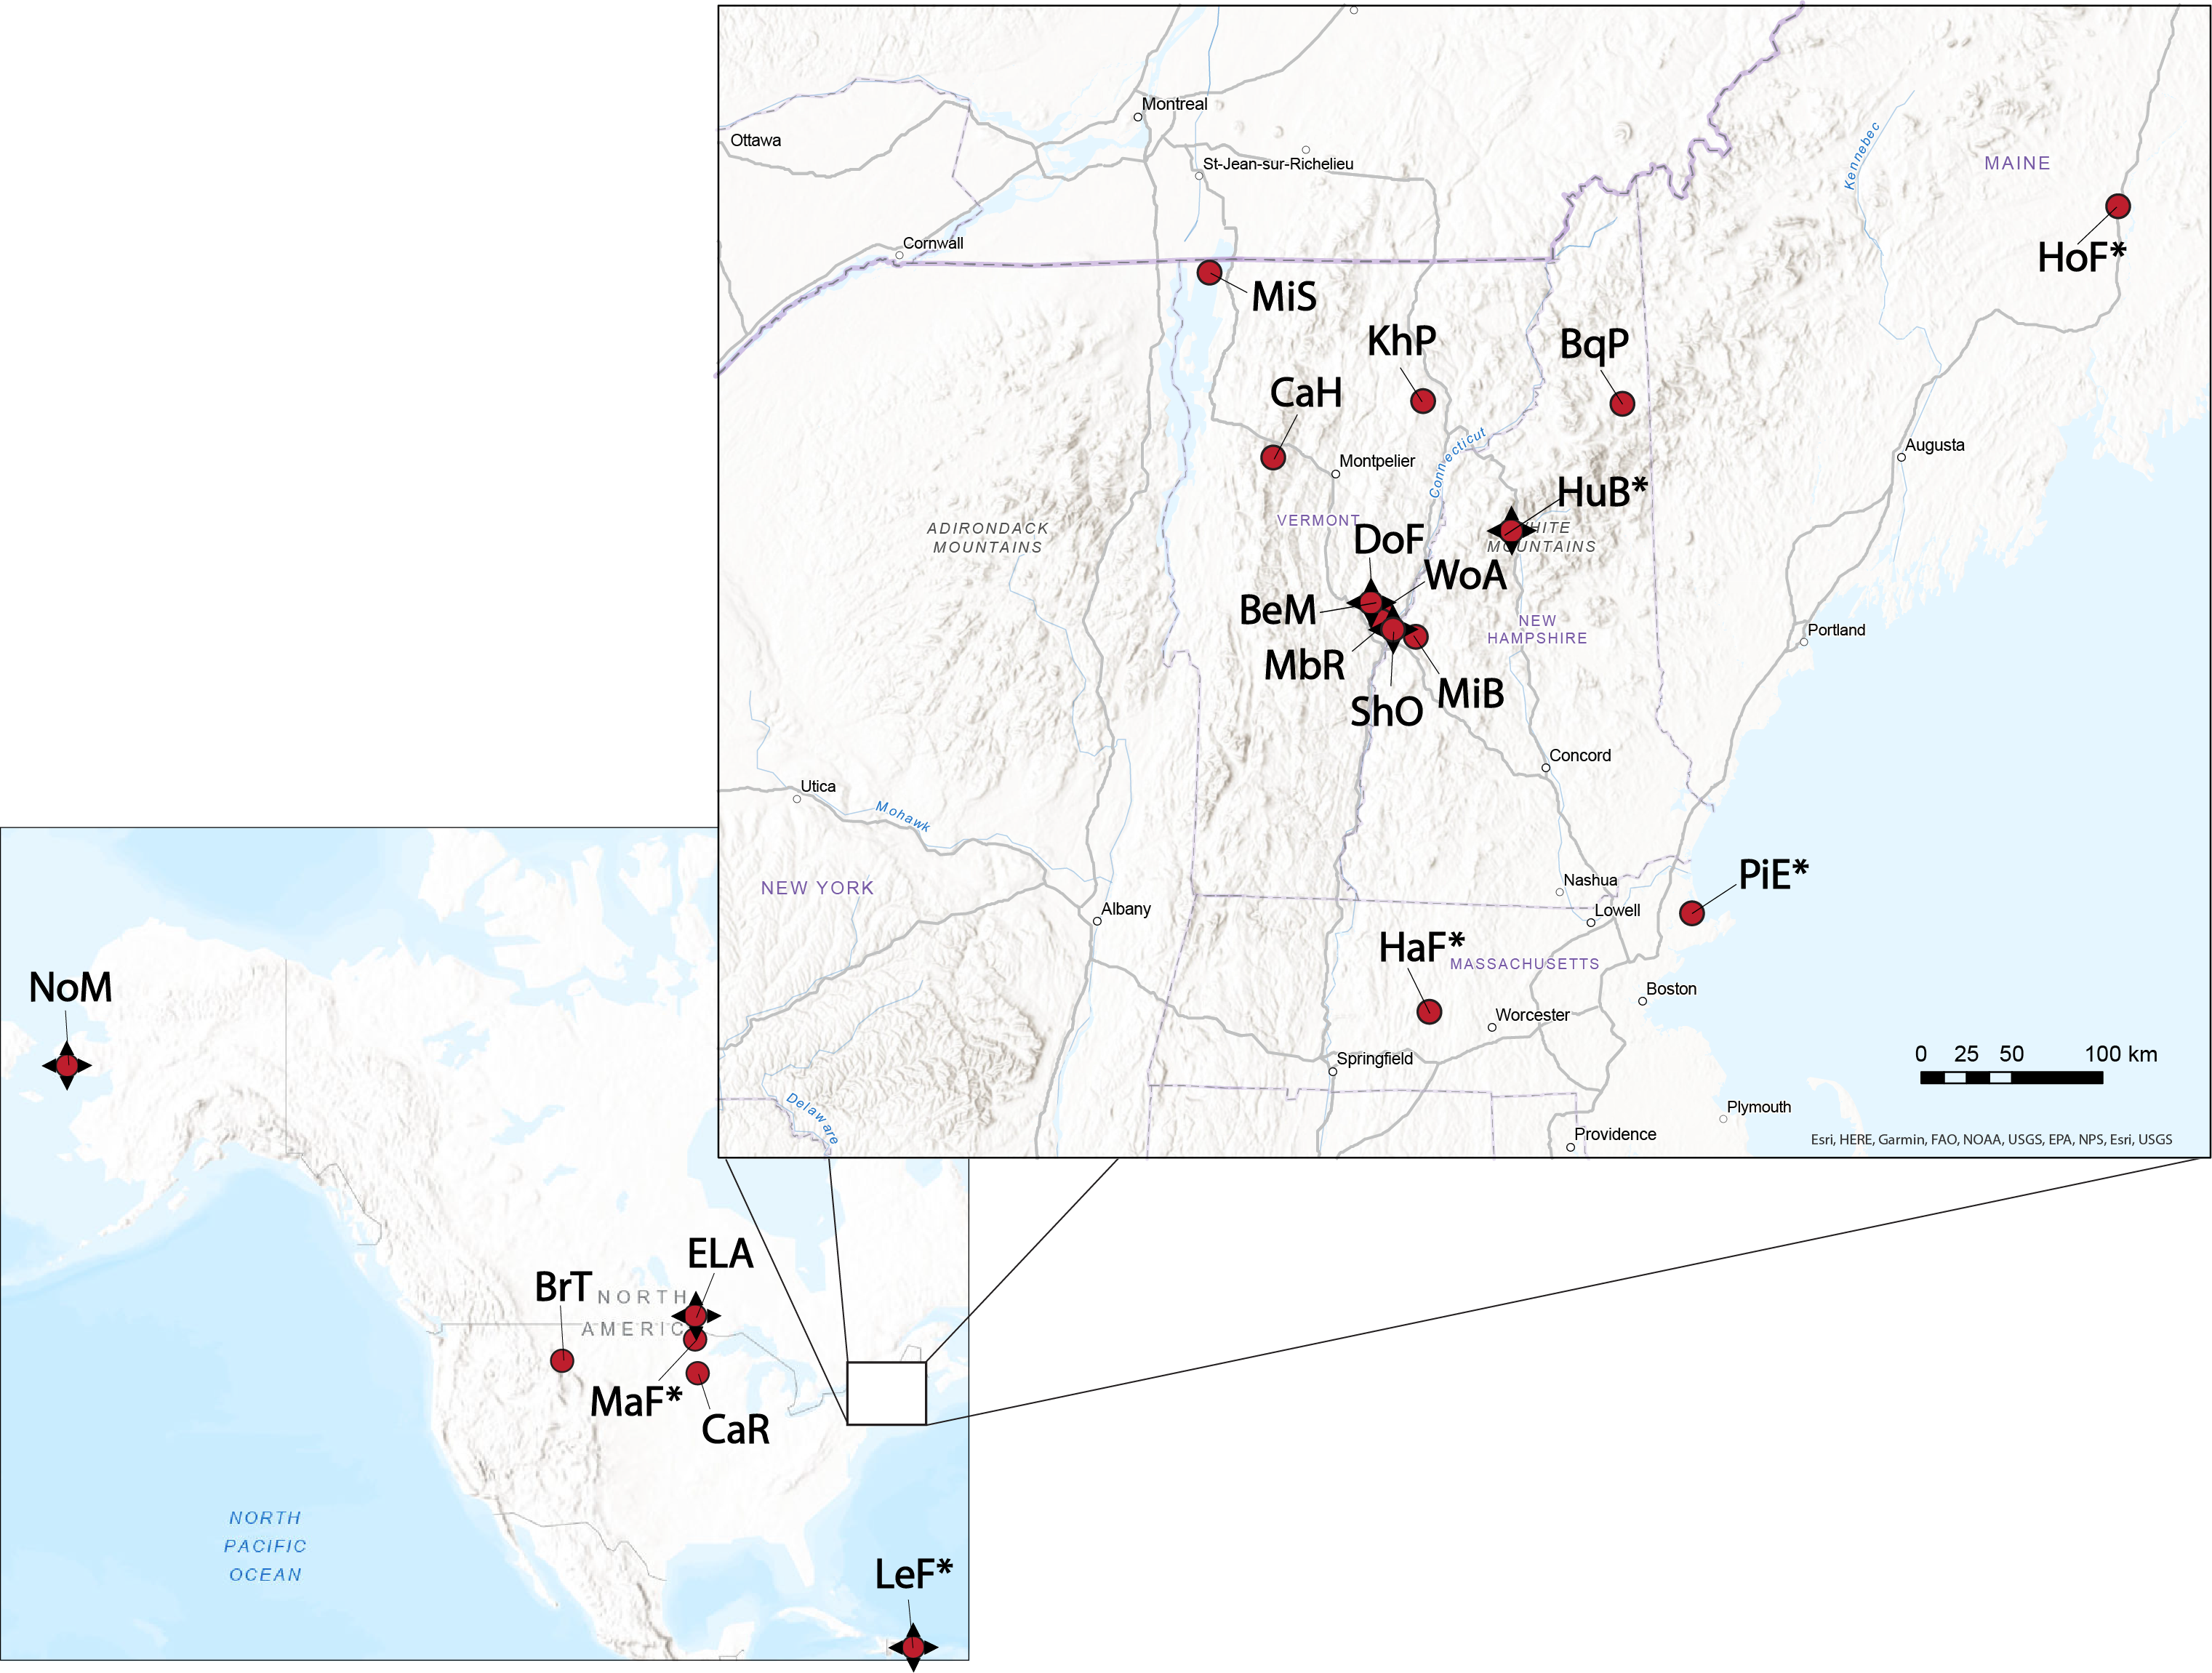

Extended Data 2: site map for age-dating of soil organic matter. Round symbols indicate sites that have been dated by LRC and ²⁴¹Am methods. Stars indicate sites that have also been dated by ¹⁴C methods. Site names with asterisks indicate Long Term Ecological Research (LTER) sites. See text for site names. Not shown: Sisimuit, Greenland (GrL). Adapted from Landis (2023).

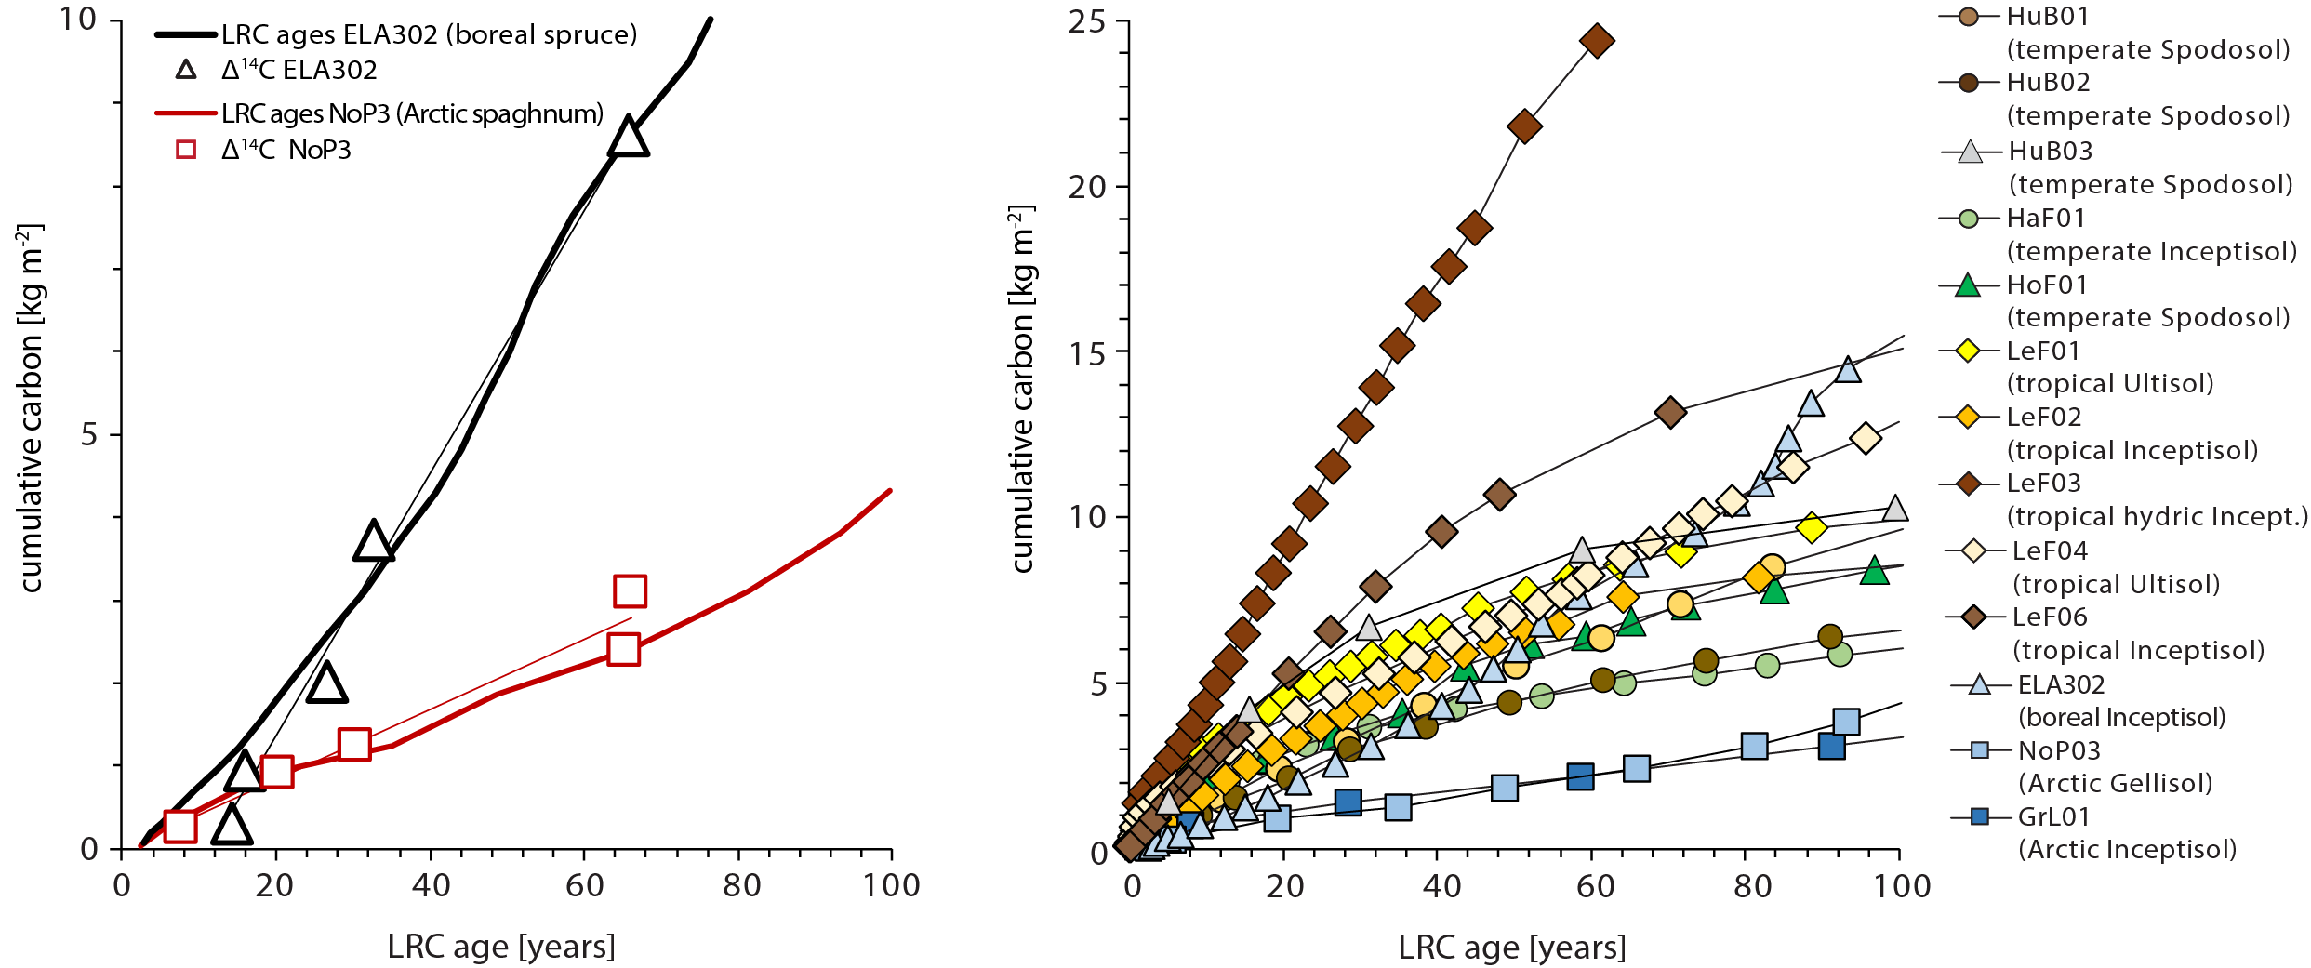
Extended Data 3. cumulative carbon curves, (a) comparing LRC and D¹⁴C age models for boreal spruce and Arctic Sphagnum soils, (b) all soils from temperate, tropical, and Arctic locations.

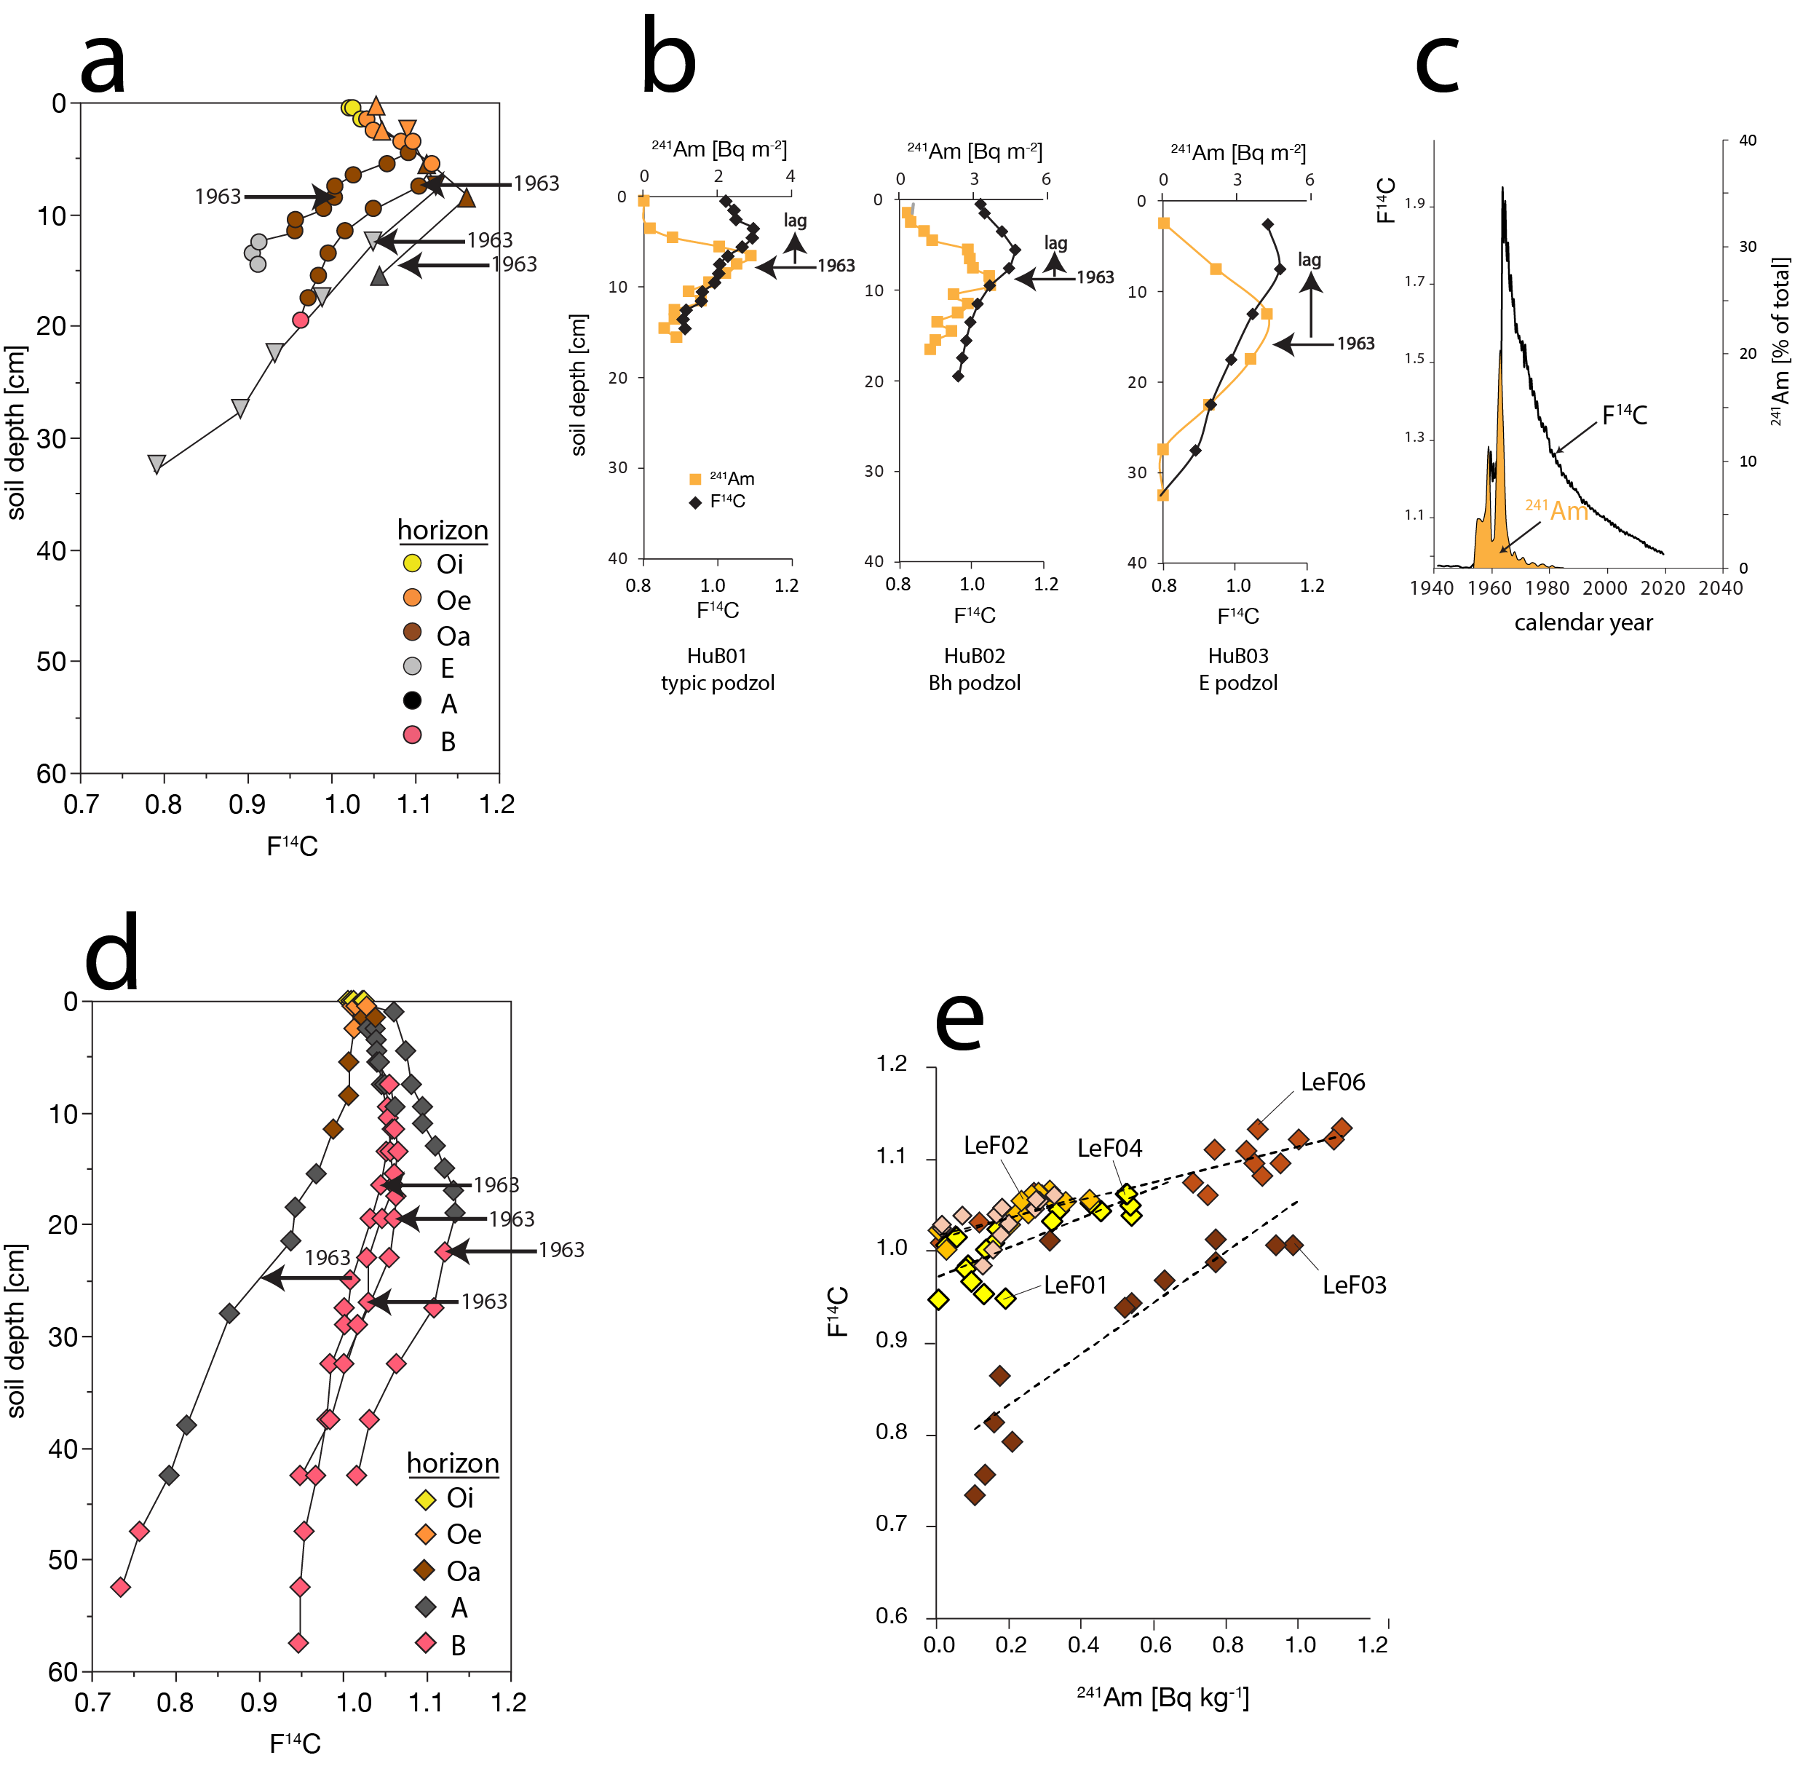

Extended Data 4. comparison of ²⁴¹Am and ¹⁴C soil depth profiles. Note that Am is presented as mass density (Bq m⁻² cm⁻¹) whereas ¹⁴C is presented as concentration (%) or F¹⁴C since bomb carbon is a small fraction of total soil ¹⁴C, i.e. soil is a mixture of bomb and background ¹⁴C. Arrows mark soil depths expected for the 1963 bomb pulse based on LRC dating, and accurately predicts peak distribution of ²⁴¹Am. (a) F¹⁴C for temperate Hubbard Brook Spodosols and boreal Regosol ². (b) F¹⁴C and ²⁴¹Am for Hubbard Brook soils HuB01-03. Both ¹⁴C and ²⁴¹Am display peaks attributable to the bomb pulse, but F¹⁴C is systematically shifted higher due to biological lag in carbon cycle. (c) historical atmospheric records of ²⁴¹Am ³ and F¹⁴C ⁴. (d) F¹⁴C for Luquillo tropical soils. Peaks in ¹⁴C are broad due to rapid advection and preferential flow, as well as possible bioturbation from earthworms, but remain recognizable and centered near prediction by LRC dates. (e) correlation of F¹⁴C and ²⁴¹Am for Luquillo soils.

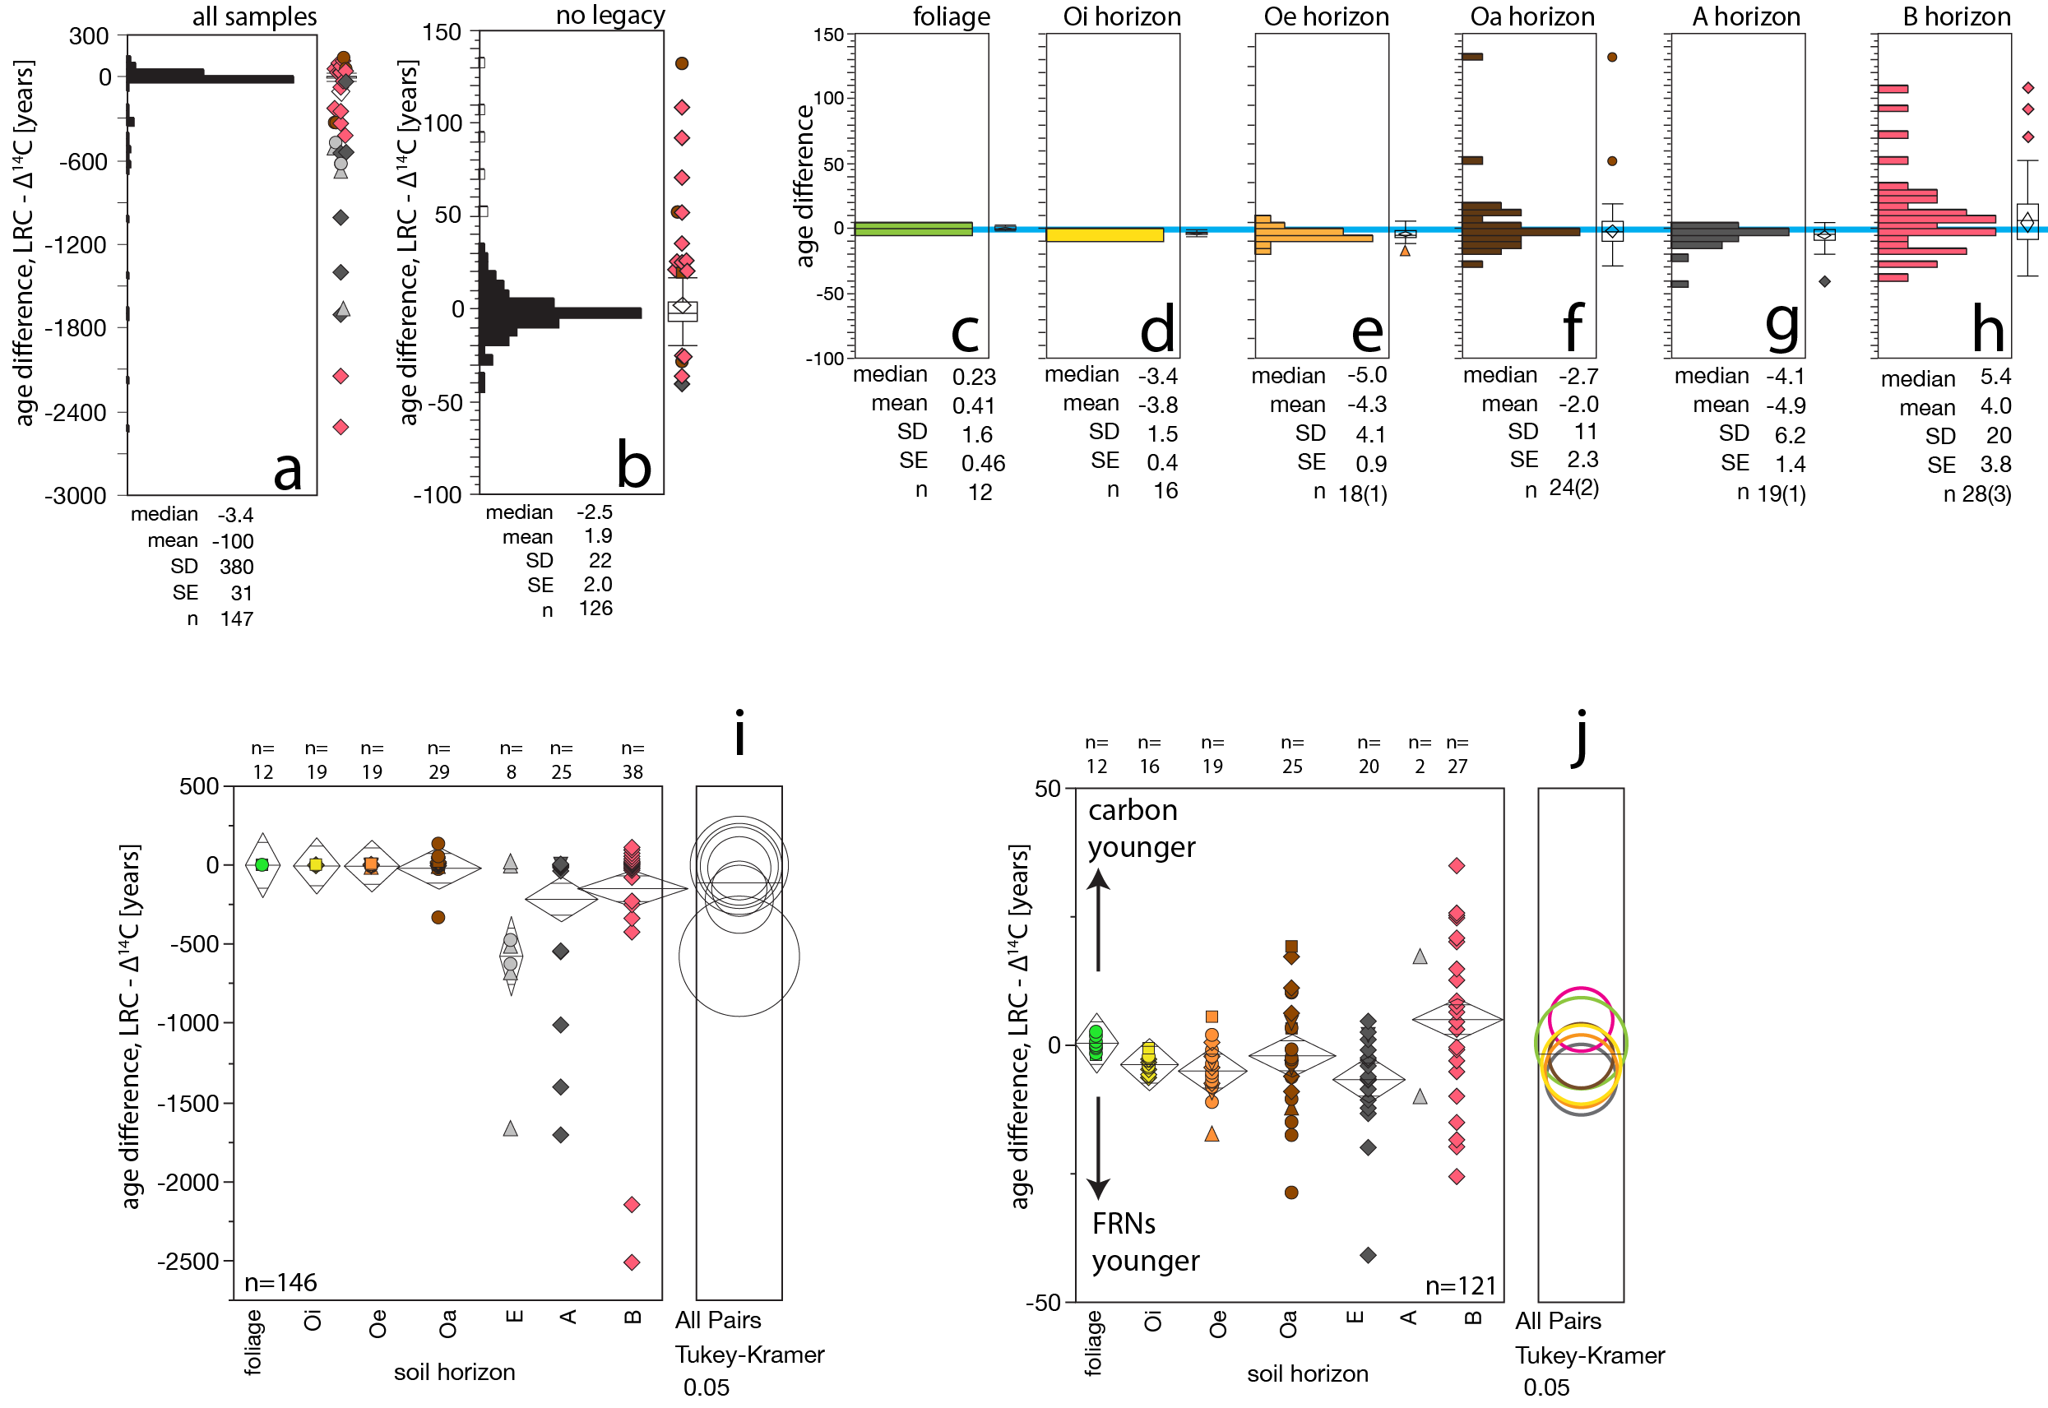

Extended Data 5. Distributions of age differences, LRC minus ∆¹⁴C. (a) full data set (n=147), (b) with samples removed that appear impacted by legacy carbon. (c) through (h) by indicated horizon. Whisker plots show mean, median and quartile range. Symbols represent outliers. (i) ANOVA by horizon for all samples, (j) excluding legacy samples.

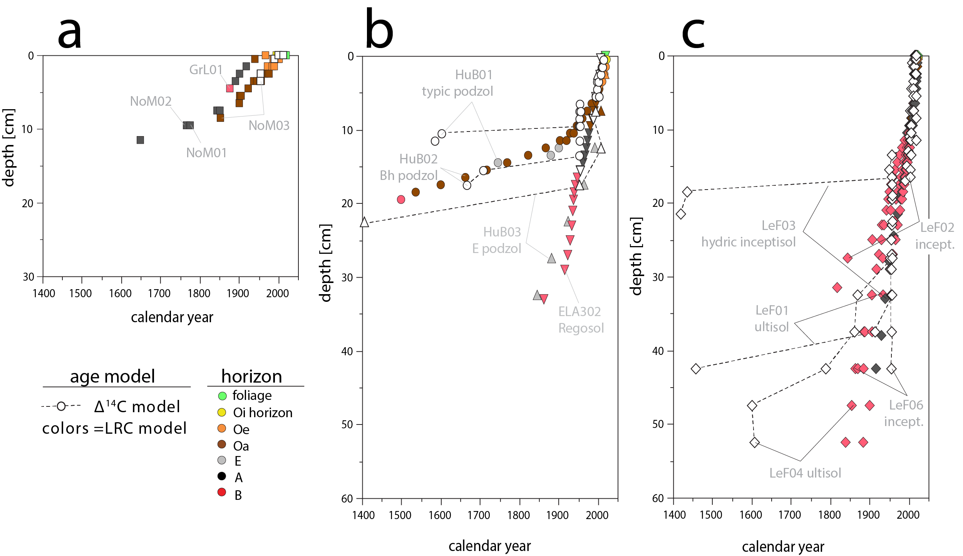
Extended Data 6. Age depth relationships using both LRC and ∆¹⁴C dating approaches. (a) Artic soils including Inceptisol from Sisimuit, Greenland (GrL) and Gelisol from Seward Peninsula, Alaska (NoM), (b) temperate and boreal soils from Hubbard Brook (HuB) and Ontario (ELA), (c) tropical soils from Luquillo Experimental Forest, Puerto Rico.

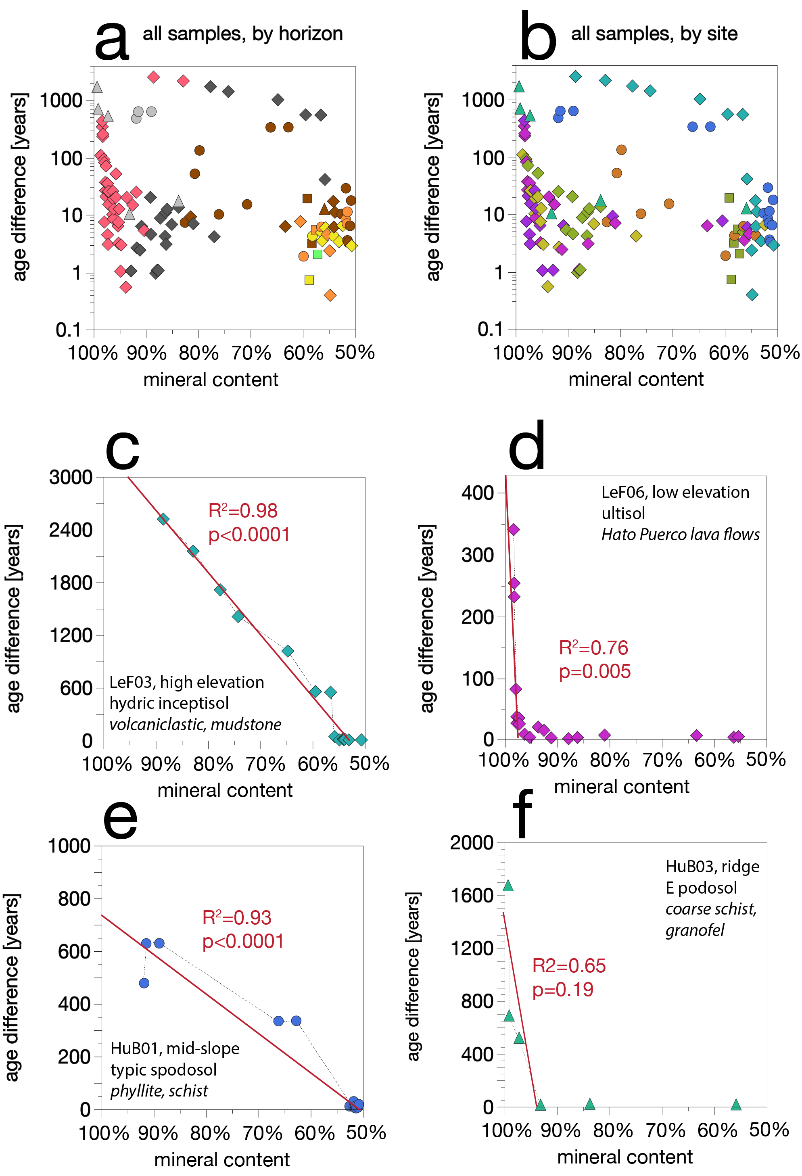

Extended Data 7. soil carbon age difference (∆¹⁴C minus LRC) versus soil carbon content. (a) full data set colored by horizon, (b) full data set colored by each soil profile, (c) through (f) individual soil profiles as indicated. Linear regression is shown in red lines. (c) and (d) contrast parent materials in Luquillo. The influence of legacy carbon is especially great in LeF03 for which parent material is volcaniclastic ⁵. (e) and (f) contrast parent materials in Hubbard Brook, where HuB01 (midslope) parent material includes phyllite and schist whereas HuB03 (ridgetop) is underlain by coarse-grained granofel ⁶.

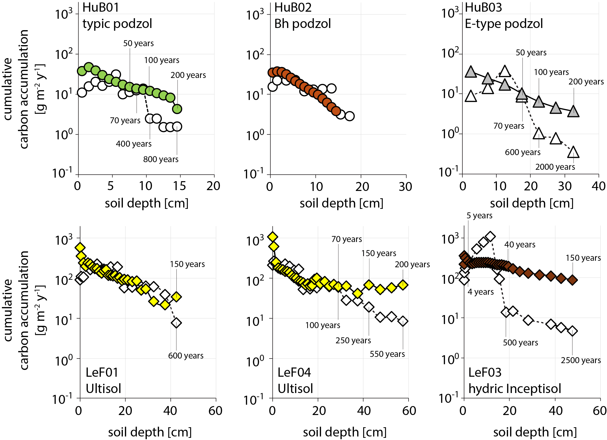

Extended Data 8. Cumulative carbon accumulation versus soil depth. LRC rates are shown in colored symbols, ¹⁴C rates in white symbols with dashed lines. Note log axis. While old ¹⁴C ages may imply persistence, from a mass balance perspective they require very low rates of carbon sequestration that are not reconciled by independent measures of net ecosystem productivity (NEP) where these data are available. For temperate forests we expect ca. 20-50 g m⁻² y⁻¹ over centennial timescales for, e.g., Hubbard Brook (shown), as well as Harvard, and Howland experimental forests (see main text, Fig. 3). Strong departures between LRC and ¹⁴C carbon accumulation rates for Hub01, HuB03, LeF04, LeF06 may reflect slow ingrowth of a passive carbon pool, or admixtures with legacy petrogenic or pedogenic carbon. The old ages of these pools skew ¹⁴C age estimates and accumulate rates derived from them.

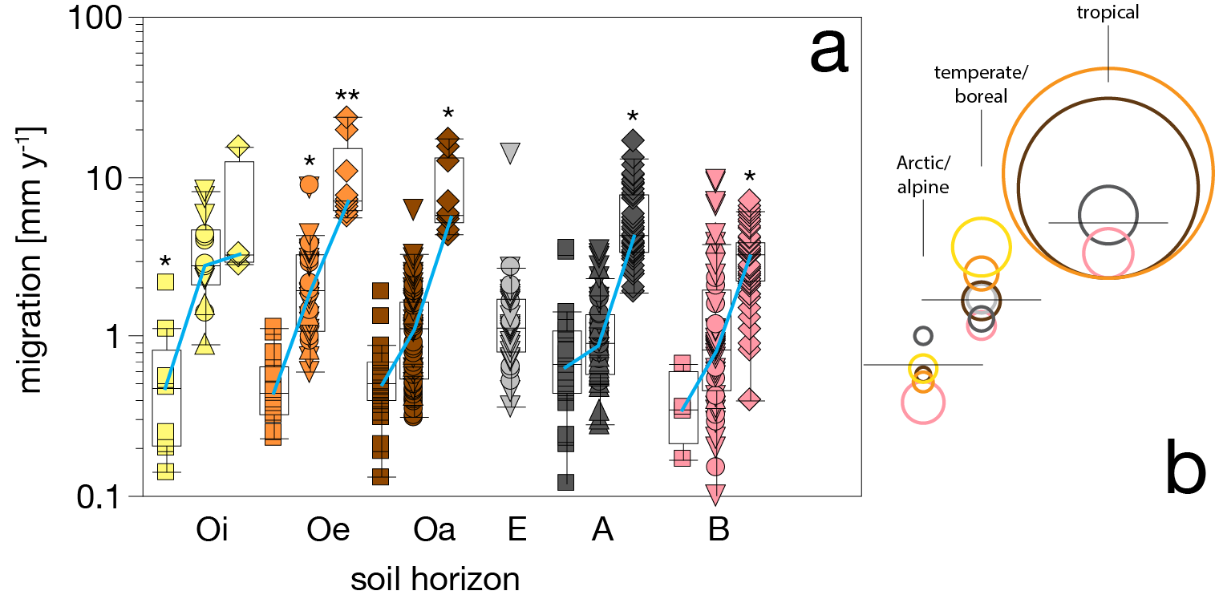
Extended Data 9. soil carbon migration rates measured using LRC model. Tropical soils in diamonds, temperate deciduous in circles, temperate/boreal coniferous in triangles, Arctic/alpine in squares. Within each horizon means are connected with blue lines across biomes, significant differences by Tukey HSD are indicated by asterisk (p<0.05 ) (b) Tukey HSD all-pairs comparisons by biome (p<0.05). Non-overlapping circles show significant different means.

References
1. Landis, J. D. Age-Dating of Foliage and Soil Organic Matter: Aligning 228Th:228Ra and 7Be:210Pb Radionuclide Chronometers over Annual to Decadal Time Scales. Environ Sci Technol 57, 15047–15054 (2023).
2. Landis, J. D., Taylor, V. F., Hintelmann, H. & Hrenchuk, L. E. Predicting behavior and fate of atmospheric mercury in soils: age-dating METAALICUS Hg isotope spikes with fallout radionuclide chronometry. Environmental Science andTechnology inprint, (2024).
3. Appleby, P. G., Richardson, N. & Nolan, P. J. 241Am dating of lake sediments. Hydrobiologia 214, 35–42 (1991).
4. Hua, Q. et al. ATMOSPHERIC RADIOCARBON for the PERIOD 1950-2019. Radiocarbon 00, (2021).
5. Seiders, V. M. Geologic Map of the El Yunque Quadrangle, Puerto Rico. Miscellaneous Geological Investigations Map I-658. (1991).
6. Burton, W. C., Walsh, G. J. & Armstrong, T. R. Bedrock Geological Map of the Hubbard Brook Experimental Forest, Grafton County, New Hampshire. Open-File Report 00-45-A, v. 1.0. http://pubs.usgs.gov/openfile/of00-45/ (1998).

