Supplementary Information for
Evolution of infrastructure burden for US cities by 2100

Data Collection and details

Built Volume from Global Human Settlement Layer (GHSL)
GHS-BUILT-S R2023A dataset is a spatial-temporal raster data published in 2023. This dataset contains built-up area distribution for the world. The data was derived from Landsat (MSS, TM, ETM sensor) and Sentinel-2 (S2) image composite (GHS-composite-S2 R2020A) to generate built-up (BU) surfaces. To get the built area heights ALOS Global Digital Surface Model "ALOS World 3D - 30m (AW3D30), the NASA Shuttle Radar Topographic Mission data - 30m (SRTM30), and the Sentinel-2 global pixel-based image composite from L1C data for the period 2017-2018 have been used. “Any roofed structure erected above ground for any use” is defined as “building” in this dataset as per GHSL documentation¹. Built area volume is calculated by multiplying the building height with built-up surface. The dataset has two attributes: a) the total BU volume and b) the nonresidential (NRES) BU volume². The residential (RES) attribute is assigned to grids based on land use data if they are prevalently for residential use. The data is at 100 m resolution.

Age distribution of residential built-up volume (RBUV)
The US census provides estimates of the total number of occupied and vacant housing units in all cities. At the same time, ACS 5-year estimates provide the percentage of built units during different time periods. Utilizing 2020 census data for the number of housing units and ACS 5-year estimates for 2021 for the age of the built units, we assigned a weighted average age to each city.
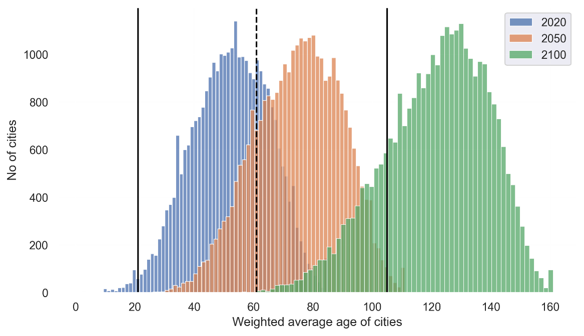
Supplementary Figure 1 Weighted average age of cities in the U.S. derived from the age of housing units weighted by the number of units in each age group. The vertical black lines represents the mean (dotted) and standard deviations (solid lines) of U.S. residential builds lifetime taken from³. As cities age, we can see that the weighted average age of the residential built volume will shift towards the right. By 2050, 80.5% of the cities will have an average residential built volume over 61, that is the average lifetime of U.S. residential buildings, with 0.9% above the age 105.
Here, the weighted average age of cities is calculated from the American Community Survey (ACS) 5-year estimates (2017-2021) dataset of year of structure built for the percent of occupied housing units. This dataset provides percentages of the occupied housing units and their built period. Using the average value of the time span for percent of housing units built, we estimate the weighted average age for built volume for each city. For any city, $i$ , current weighted average age,
$$Age_{w_{i}}=[\left(2024-1939\right)*\%HU_{≤1939} + \left(2024-1950\right)*\%HU_{1940\sim 1959}+ (2024-1970)*\%HU_{1960\sim 1979}+ \left(2024-1990\right)*\%HU_{1980\sim 1999}+ \left(2024-2004\right)*\%HU_{2000\sim 2009}+ (2024-2014)*\%HU_{2010\sim 2019} + \left(2024-2022\right)*\%HU_{≥2020}]/100$$
To find the weighted average age over different time intervals,
$$Age_{w_{i_{t_{n}}}}= \frac{{(Y_{i_{t_{n}}}-Y_{i_{t_{n-1}}})*∆t}/2+ Y_{i_{t_{n-1}}}*(Age_{w_{{i_{t}}_{n-1}}}+ ∆t)}{Y_{i_{t_{n}}}} ; where ∆t= t_{n}-t_{n-1 }$$
where $Y_{i_{t_{n}}}$ is the total RBUV in a city at time$t_{n}$.

Number of Demolished Units
With $d\%$ of total building stock getting demolished each decade, after $n$ decades we estimate the remaining building stock in terms of volume as follows:
Remaining Volume =$V_{0} × {\left(1 –\frac{d}{100}\right)}^{n}$ where $V_{0}$ is the initial built-up volume.

Roadways from Open Street Map (OSM)
Geofabrik's free download server (https://download.geofabrik.de/north-america/us.html) contains state-level roadway data in Protocolbuffer Binary Format (PBF) format⁴. However, for Texas, Florida, and California, the flies are too large. Therefore, for these three states, we downloaded roadway data at the county level from OpenStreetMap (OSM) (https://www.openstreetmap.org) using relation code via Python’s osm2gmns.downloadOSMData() function in openstreetmap file format^{5,6}. The data were exported as links and nodes in comma-separated values (csv) format using osm2GMN.getNetFromFile() function, which contains the geometry information in Well-Known Text (WKT) format. To get place-level roadway lengths, the state-level link files are converted to a geodataframe in Python and clipped to places using geopndas.clip() function. To clip the data using the projected coordinate system, the place boundary was converted to the appropriate UTM (Universal Transverse Mercator) coordinate using the centroid of the place. The link geodataframe was then projected to the corresponding UTM coordinate system. A buffer of 3.6 m (one lane width equivalent) was adopted for place boundary to include roads along the periphery of the place boundaries. Once all places are extracted from state-level data and projected to the corresponding UTM coordinate system, we calculated the geometric length of the links using length function from the Python’s geopandas package to get place-specific lengths (in meter) of roadways by roadway type. Later, we aggregate the lengths by roadway type. To get the lane-meters, we used the available number of lanes column from OSM. For missing lanes, we imputed the lane numbers for each city from the median lane numbers by roadway type.
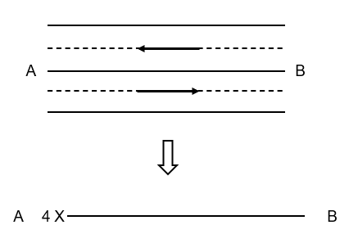
Supplementary Figure 2 Extracting lane-meters from OSM data
Total lane-meters of local roads have been used for scale fitting and projecting. By lane-meters, we mean that if there is a two-lane two-way roadway between two locations A and B, we extracted the lane-meters between A and B as $2*2*length_{AB}=4*length_{AB}$ as shown in Supplementary Figure 2.
For estimating RL at city level, we clipped the roadway network by city boundaries as explained in the Methods section. These cities are not always adjacent, leading to connecting roads (interstates or county roads) that are outside the jurisdiction of the cities. These connecting roads are maintained by federal funding from county-level authorities. Therefore, these roads are excluded from the measurement of per capita RL of cities. For similar reasons, motorway, trunks, primary, secondary, and tertiary roadway classes were excluded when estimating the total lane-meters of roadways for a city⁷.

Scaling laws of cities
Urban scaling laws state that, in cities, various socio-economic quantities exhibit a power law relationship with population size. Urban features—such as infrastructure, energy consumption, and economic output—follow scaling laws. Scaling laws have been studied since the 1940s, with earlier roots in classical mechanics and sociophysics theories⁸. These laws imply that a quantity (e.g., $Y$) depends on population, $P$ in a power-law fashion. Mathematically, this relationship can be expressed as:
$Y ∝ P^{β}$ (1)
The exponent $β$ characterizes the scaling behavior. When $β>1$, it is superlinear scaling, indicating that as a city grows, $Y$ increases faster than linearly with population. Conversely, when $β<1$, it is sublinear scaling, meaning $Y$ grows slowly as population increases⁹. $β=1$ indicates a linear relation. Understanding scaling laws can help city planners anticipate infrastructure needs. If a city doubles in population, the demand for roads, schools, and healthcare will simply not double—it will increase disproportionately. Scaling laws can guide efficient resource allocation. By knowing how $Y$ scales with population, cities can allocate budgets, energy, and services effectively. For instance, roadways, energy consumption scale sublinearly, suggesting that larger cities have more compact roadways and are per capita more energy-efficient⁹. Superlinear scaling in economic output (GDP) means that larger cities are disproportionately productive. Therefore, encouraging urban growth can boost overall economic performance¹⁰. However, these laws have limitations due to their simplified assumptions therefore making it difficult to define the relationships for small cities as well as in the presence of inequalities^{11,12}. Scaling laws assume continuous growth, but cities eventually saturate due to physical constraints (e.g., limited land area). Beyond a certain size, superlinear scaling will break down. Cities are diverse, and local factors, historical legacies, and cultural differences can lead to deviations in scaling laws. Scaling exponents can change over time due to technological shifts, policy interventions, or economic fluctuations¹⁰. At the same time, the scaling laws do not incorporate spatial relations and consider cities as independent entities. Also, they vary with city boundaries¹³. Yet, as discussed by Molinero and Thurner¹⁰ understanding the urban scaling relationship can help city planners with resource management as cities continue to grow since a sublinear relation of population with resources indicates efficient management.
To get the future projection of newly added infrastructure, we applied a scaling relationship between city population and total infrastructure,
$Y=Y_{0}P^{β}$ (2)
where $Y$ is the total infrastructure of a category (buildings or roads) in a city, $P$ is the population and $Y_{0}$ and $β$ are model parameters named as the prefactor and exponent, respectively.
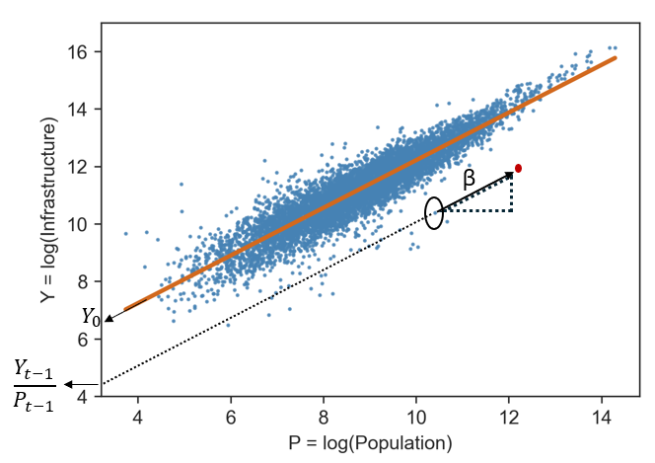
Supplementary Figure 3 Scaling laws of infrastructure vs population

Tables
Supplementary Table 1 Model parameters for different city types from 2020 data
City type (#) | $${log⁡(Y}_{0_{upper}})$$ | $$log⁡(Y_{0_{lower}})$$ | $$Y_{0_{upper}}$$ | $$⁡Y_{0_{lower}}$$ | $$β_{upper}$$ | $$β_{lower}$$ | $$R_{squared}$$
$$Urban_{RBUV}$$ | 6.905 | 6.206 | 997.25 | 495.71 | 1.018 | 0.954 | 0.93
$$Suburban_{RBUV}$$ | 6.931 | 6.783 | 1023.52 | 882.71 | 0.997 | 0.981 | 0.90
$$Periurban_{RBUV}$$ | 7.072 | 6.879 | 1178.50 | 971.65 | 0.969 | 0.947 | 0.85
$$Rural_{RBUV}$$ | 7.596 | 7.510 | 1990.22 | 1826.21 | 0.862 | 0.849 | 0.79
$$Urban_{RL}$$ | 2.297 | 1.936 | 9.94 | 6.93 | 0.963 | 0.868 | 0.88
$$Suburban_{RL}$$ | 4.835 | 4.670 | 125.84 | 106.70 | 0.788 | 0.770 | 0.83
$$Periurban_{RL}$$ | 5.764 | 5.555 | 318.62 | 258.53 | 0.697 | 0.673 | 0.71
$$Rural_{RL}$$ | 7.078 | 6.976 | 1185.59 | 1070.63 | 0.506 | 0.490 | 0.46
Here, RBUV = Residential Built-up Volume, RL = Roadway length
We can see that the exponent values are sublinear for all city types although they do not match the theoretical $\frac{5}{6}$ law for roadway length predicted by Bettencourt⁹. However, Bettencourt’s definition of city boundary is based on travel distance while in our study, the classification of city types is based on population size, housing unit density, urbanized area and commute time¹⁴.
Supplementary Table 2 Cities redefined as urban by 2100
NAME | Population 2020 | City type in 2020 | City type in 2050 | City type in 2100
Spring Valley (NV) | 215597 | suburban | urban | urban
Huntington Beach (CA) | 198711 | suburban | urban | urban
El Cajon (CA) | 106215 | suburban | urban | urban
Quincy (MA) | 101636 | periurban | urban | urban
San Leandro (CA) | 91008 | suburban | urban | urban
Tamarac (FL) | 71897 | periurban | urban | urban
North Miami (FL) | 60191 | periurban | urban | urban
Margate (FL) | 58712 | suburban | urban | urban
National (CA) | 56173 | periurban | urban | urban
Harrisburg (PA) | 50099 | suburban | urban | urban
Salem (MA) | 44480 | suburban | urban | urban
San Bruno (CA) | 43908 | suburban | urban | urban
Foster (CA) | 33805 | suburban | urban | urban
Englewood (CO) | 33659 | suburban | urban | urban
San Pablo (CA) | 32127 | periurban | urban | urban
Burlingame (CA) | 31386 | suburban | urban | urban
Carney (MD) | 29363 | suburban | urban | urban
South Bradenton (FL) | 26858 | suburban | urban | urban
Oak Ridge (FL) | 25062 | suburban | urban | urban
Bayshore Gardens (FL) | 19904 | suburban | urban | urban
Naples (FL) | 19115 | suburban | urban | urban
Laguna Woods (CA) | 17644 | suburban | urban | urban
Fort Myers Beach (FL) | 5582 | suburban | urban | urban
Las Vegas (NV) | 641903 | suburban | suburban | urban
Fargo (ND) | 125990 | suburban | suburban | urban
Boynton Beach (FL) | 80380 | suburban | suburban | urban
La Mesa (CA) | 61121 | suburban | suburban | urban
The Hammocks (FL) | 59480 | periurban | periurban | urban
Coconut Creek (FL) | 57833 | suburban | suburban | urban
Aloha (OR) | 53828 | suburban | suburban | urban
Wheaton (MD) | 52150 | suburban | suburban | urban
Aspen Hill (MD) | 51063 | suburban | suburban | urban
Wilkes-Barre (PA) | 44328 | suburban | suburban | urban
Campbell (CA) | 43959 | suburban | suburban | urban
Waipahu (HI) | 43485 | periurban | periurban | urban
Egypt Lake-Leto (FL) | 36644 | suburban | suburban | urban
Midvale (UT) | 36028 | suburban | suburban | urban
Foothill Farms (CA) | 35834 | periurban | periurban | urban
Parkville (MD) | 31812 | suburban | suburban | urban
Hazleton (PA) | 29963 | suburban | suburban | urban
Easton (PA) | 28127 | suburban | suburban | urban
Wahiawa (HI) | 18658 | periurban | periurban | urban
Pacific Grove (CA) | 15090 | suburban | suburban | urban
Cypress Lake (FL) | 13727 | suburban | suburban | urban
East Bakersfield (CA) | 9749 | suburban | suburban | urban
Sausalito (CA) | 7269 | suburban | suburban | urban
Daytona Beach Shores (FL) | 5179 | suburban | suburban | urban
Surfside Beach (SC) | 4155 | suburban | suburban | urban

Supplementary Table 3 Cities with a per capita residential built volume over 10000 m³/person in 2020
NAMELSAD | Population 2020 | City type | Residential Volume (m³/person) in 2020 | Developed Land (%)
Riverdale city (IA) | 379 | suburban | 11414.7 | 53.4
Weeki Wachee city (FL) | 16 | periurban | 12245.3 | 28.4
Cuyahoga Heights village (OH) | 573 | suburban | 12403.2 | 71.5
Roosevelt CDP (AZ) | 26 | rural | 13513.6 | 8.0
Holiday City village (OH) | 48 | rural | 14541.3 | 41.3
Thompsons town (TX) | 156 | rural | 14609.4 | 10.7
Medley town (FL) | 1056 | suburban | 14679.3 | 77.1
North Washington CDP (CO) | 733 | periurban | 14994.3 | 96.6
Biggs Junction CDP (OR) | 5 | rural | 16033.4 | 22.0
Alamo Lake CDP (AZ) | 4 | rural | 16124.9 | 0.7
Sauget village (IL) | 141 | suburban | 16530.1 | 65.5
Halls Crossing CDP (UT) | 4 | rural | 16981.0 | 1.5
McCook village (IL) | 249 | rural | 17372.0 | 71.9
Lakeside town (CO) | 16 | rural | 19913.1 | 74.5
Rock Island Arsenal CDP (IL) | 182 | periurban | 20438.6 | 54.4
Bedford Park village (IL) | 602 | periurban | 21119.2 | 90.4
Tyndall AFB CDP (FL) | 139 | suburban | 28832.6 | 42.7
Playas CDP (NM) | 25 | rural | 30425.3 | 13.0
Mountain View CDP (WY) | 67 | periurban | 30589.3 | 34.0
Fort Indiantown Gap CDP (PA) | 68 | rural | 37964.3 | 18.0
Teterboro borough (NJ) | 61 | rural | 51192.6 | 95.8
River Bend village (MO) | 3 | rural | 52962.9 | 18.2
Vernon city (CL) | 222 | rural | 75660.2 | 99.9
Industry city (CA) | 264 | rural | 96508.1 | 90.4
Bay Lake city (FL) | 29 | rural | 341691.1 | 35.4
25 cities have a per capita residential built volume of over 10,000 m³/person. Among these cities, there are state parks, industrial towns, recreation centers, and special facilities. For example, Medley town (FL) is an industrial town. Vernon city (CA) gives an estimation of 75660.2 m³/person- residential built volume in 2020; however, an inspection of the city clarifies that this place is termed as “exclusively industrial". Industry city (CA) is almost entirely industrial. Similar cases can be found for Bay Lake city (FL) that houses the theme parks. Both McCook village and Bedford Park (IL) are industrial suburbs of Chicago. Teterboro borough houses the Teterboro Airport. Tyndall Air Force Base (FL) is an air force base. Fort Indiantown Gap (PA) is a National Guard Training Center. Lakeside town (CO) houses an amusement park.
Supplementary Table 4 Median per capita infrastructure by state. The colors range from green (lower burden) to red (higher burden).
 | Median per capita infrastructure
Year | 2020 | 2050 | 2100 | added 2020-2050 | added 2050-2100 | 2020 | 2050 | 2100 | added 2020-2050 | added 2050-2100
State | RBUV in m3 |  |  |  |  | RL in m
AL | 816.1 | 863.5 | 1044.9 | 29.7 | 158.5 | 50.4 | 53.3 | 65.0 | 1.6 | 10.6
AZ | 802.9 | 823.6 | 971.1 | -6.4 | 53.1 | 44.7 | 43.7 | 52.6 | -1.1 | 2.6
AR | 831.1 | 911.2 | 1117.8 | 56.5 | 176.7 | 55.3 | 58.4 | 72.7 | 3.8 | 11.4
CA | 788.8 | 773.9 | 783.0 | -19.8 | -3.1 | 18.9 | 16.5 | 15.5 | -1.4 | -0.4
CO | 825.1 | 810.8 | 846.4 | -25.8 | -9.5 | 35.7 | 33.6 | 31.9 | -2.5 | -1.1
CT | 561.6 | 564.0 | 608.7 | -3.4 | 4.4 | 17.1 | 16.3 | 16.5 | -0.5 | -0.1
DE | 667.5 | 604.3 | 575.7 | -26.2 | -12.1 | 15.3 | 12.3 | 11.0 | -2.6 | -1.4
DC | 583.0 | 575.1 | 564.5 | -8.0 | -10.6 | 3.0 | 2.3 | 1.8 | -0.7 | -0.5
FL | 984.1 | 944.6 | 956.8 | -38.2 | -23.9 | 18.9 | 14.8 | 12.5 | -3.2 | -1.6
GA | 700.4 | 723.4 | 851.9 | -1.2 | 69.2 | 33.3 | 33.3 | 38.6 | -0.5 | 3.9
HI | 475.5 | 423.0 | 372.8 | -32.0 | -40.3 | 8.4 | 6.7 | 5.0 | -1.6 | -1.7
ID | 838.9 | 867.5 | 928.4 | -2.9 | 58.6 | 36.1 | 37.4 | 39.8 | -0.7 | 2.3
IL | 797.1 | 872.2 | 1104.0 | 57.6 | 226.1 | 31.8 | 35.3 | 45.3 | 2.5 | 9.9
IN | 793.6 | 815.2 | 956.8 | 22.3 | 128.0 | 28.1 | 28.2 | 34.3 | 0.7 | 5.3
IA | 874.8 | 925.5 | 1037.0 | 35.7 | 97.7 | 35.1 | 36.5 | 41.8 | 1.4 | 4.1
KS | 1029.3 | 1101.3 | 1243.9 | 61.6 | 118.8 | 61.8 | 66.7 | 76.2 | 4.0 | 7.0
KY | 836.4 | 865.4 | 1017.7 | 1.1 | 90.2 | 25.3 | 25.2 | 29.2 | -0.3 | 3.1
LA | 799.9 | 830.3 | 941.5 | 1.9 | 81.9 | 31.3 | 31.8 | 37.9 | -0.2 | 3.3
ME | 625.0 | 669.7 | 804.5 | 30.7 | 121.5 | 27.1 | 30.1 | 35.9 | 1.3 | 5.8
MD | 586.9 | 583.0 | 593.5 | -14.3 | -7.7 | 15.0 | 13.4 | 13.3 | -1.3 | -0.7
MA | 647.2 | 646.5 | 645.7 | -11.5 | -2.2 | 14.8 | 13.6 | 13.0 | -1.3 | -0.4
MI | 776.9 | 843.3 | 1034.5 | 48.0 | 206.5 | 25.0 | 26.7 | 34.5 | 1.6 | 6.9
MN | 789.8 | 811.2 | 903.0 | 20.4 | 91.7 | 31.9 | 33.3 | 37.2 | 0.8 | 4.5
MS | 749.5 | 812.6 | 1031.7 | 53.1 | 208.3 | 43.0 | 46.6 | 60.0 | 3.1 | 13.8
MO | 836.7 | 906.3 | 1116.6 | 25.7 | 171.7 | 43.2 | 46.1 | 57.1 | 1.4 | 11.0
MT | 987.0 | 960.1 | 929.0 | -21.5 | -11.0 | 79.7 | 70.8 | 68.2 | -2.8 | -1.9
NE | 957.2 | 999.8 | 1053.8 | 14.6 | 36.9 | 48.2 | 50.6 | 52.1 | 0.4 | 1.7
NV | 868.9 | 849.3 | 841.0 | -8.9 | 17.7 | 42.1 | 43.9 | 41.6 | -1.7 | 0.7
NH | 460.5 | 474.6 | 590.7 | 16.3 | 100.1 | 22.5 | 23.3 | 29.1 | 0.6 | 4.9
NJ | 683.6 | 690.8 | 738.1 | -5.6 | 8.7 | 13.4 | 13.0 | 13.1 | -0.7 | -0.1
NM | 946.7 | 1004.8 | 1165.8 | 29.5 | 101.5 | 62.2 | 64.7 | 75.7 | 1.8 | 7.4
NY | 609.9 | 646.5 | 749.1 | 14.0 | 76.2 | 15.7 | 16.2 | 18.6 | 0.2 | 1.7
NC | 775.1 | 790.4 | 896.0 | -7.5 | 32.9 | 33.6 | 34.7 | 37.0 | -1.5 | 1.3
ND | 1038.3 | 910.9 | 731.6 | -82.6 | -168.9 | 59.0 | 47.8 | 34.8 | -9.6 | -12.5
OH | 680.5 | 717.9 | 872.6 | 16.1 | 120.0 | 19.3 | 19.7 | 23.2 | 0.4 | 3.0
OK | 905.1 | 901.7 | 925.1 | -8.0 | 2.6 | 75.4 | 72.9 | 72.4 | -1.6 | -0.6
OR | 887.4 | 864.7 | 898.0 | -17.9 | 17.8 | 22.9 | 21.7 | 21.6 | -1.4 | 0.1
PA | 595.9 | 634.4 | 727.8 | 2.8 | 57.2 | 18.4 | 19.0 | 21.6 | -0.1 | 1.6
RI | 677.9 | 671.4 | 701.8 | -3.3 | 13.2 | 15.4 | 15.2 | 16.5 | -0.4 | 0.5
SC | 774.1 | 788.5 | 873.3 | -10.9 | 12.8 | 36.4 | 34.7 | 36.5 | -2.9 | -0.2
SD | 924.8 | 873.3 | 750.8 | -18.3 | -117.4 | 56.2 | 53.5 | 41.2 | -2.8 | -10.8
TN | 710.3 | 712.6 | 792.2 | -5.2 | 57.4 | 36.9 | 36.0 | 38.4 | -0.9 | 3.0
TX | 776.6 | 734.8 | 725.6 | -31.2 | -15.3 | 32.9 | 28.1 | 26.1 | -3.4 | -1.6
UT | 819.5 | 755.9 | 728.6 | -46.8 | -27.0 | 32.2 | 28.7 | 24.0 | -3.8 | -2.0
VT | 559.3 | 610.7 | 811.0 | 53.9 | 180.7 | 29.3 | 30.4 | 40.7 | 2.6 | 8.2
VA | 682.9 | 720.8 | 792.8 | -7.4 | 32.0 | 24.9 | 24.7 | 28.0 | -0.8 | 1.2
WA | 815.6 | 784.9 | 766.5 | -28.4 | -17.7 | 23.1 | 19.4 | 16.6 | -2.4 | -1.4
WV | 615.0 | 697.1 | 911.1 | 72.3 | 197.7 | 29.2 | 32.6 | 43.3 | 3.6 | 10.0
WI | 748.1 | 790.0 | 937.4 | 23.8 | 125.4 | 28.5 | 29.7 | 35.9 | 0.8 | 5.2
WY | 939.0 | 932.8 | 915.9 | -42.1 | -32.8 | 61.9 | 58.8 | 57.9 | -4.2 | -3.0

References
1. Pesaresi, M. & Politis, P. GHS-BUILT-V R2023A - GHS built-up volume grids derived from joint assessment of Sentinel2, Landsat, and global DEM data, multitemporal (1975-2030). (2023) doi:10.2905/AB2F107A-03CD-47A3-85E5-139D8EC63283.
2. GHSL: Global building volume 1975-2030 (P2023A) | Earth Engine Data Catalog. Google for Developers https://developers.google.com/earth-engine/datasets/catalog/JRC_GHSL_P2023A_GHS_BUILT_V.
3. Aktas, C. B. & Bilec, M. M. Impact of lifetime on US residential building LCA results. Int. J. Life Cycle Assess. 17, 337–349 (2012).
4. Geofabrik Download Server. https://download.geofabrik.de/.
5. OpenStreetMap. OpenStreetMap https://www.openstreetmap.org/ (2023).
6. Lu, J. & Zhou, X. S. Virtual track networks: A hierarchical modeling framework and open-source tools for simplified and efficient connected and automated mobility (CAM) system design based on general modeling network specification (GMNS). Transp. Res. Part C Emerg. Technol. 153, 104223 (2023).
7. United States/Road classification - OpenStreetMap Wiki. https://wiki.openstreetmap.org/wiki/United_States/Road_classification.
8. Eduardo, A. G. Spatial interactions in urban scaling laws. PLoS ONE 15, (2020).
9. Bettencourt, L. M. A. The Origins of Scaling in Cities. Science 340, 1438–1441 (2013).
10. Molinero, C. & Thurner, S. How the geometry of cities determines urban scaling laws. J. R. Soc. Interface (2021) doi:https://doi.org/10.1098/rsif.2020.0705.
11. Ribeiro, H. V., Oehlers, M., Moreno-Monroy, A. I., Kropp, J. P. & Rybski, D. Association between population distribution and urban GDP scaling. PLOS ONE 16, e0245771 (2021).
12. He, Q., Huang, L. & Li, J. Rediscovering the Scaling Law of Urban Land from a Multi-Scale Perspective—A Case Study of Wuhan. Land 11, 914 (2022).
13. Arcaute, E. et al. Constructing cities, deconstructing scaling laws. J. R. Soc. Interface 12, 20140745 (2015).
14. Sutradhar, U., Spearing, L. & Derrible, S. Depopulation and associated challenges for US cities by 2100. Nat. Cities 1, 51–61 (2024).

