Supporting Information
Core unit engineering of Simple-Structured and Low-Cost Acceptors for Non-Fullerene Organic Solar Cells
Fubiao Weng^{1,2}, Songping Shen, Peijin Zheng, Gengbiao Xu, Lintao Chen, Zhiwei Qiu, Yongtao Chen, Shengming Peng¹∗, Junxu Liao²∗∗and Hongbin Zhao³∗∗∗
1. College of Chemistry, Xiangtan University, Xiangtan 411105, People’s Republic of China.
2. College of Chemical Engineering and Energy Technology, Dongguan University of Technology, 523808, China.
(*) E-mail addresses: pengshengming@21cn.com (S. Peng)
(**) E-mail addresses: liaojx83@163.com (J. Liao)
(***) E-mail addresses: zhaohbhanlf@163.com (H. Zhao)

1. Characterization
2. Fabrication and characterization of organic solar cells
3. Materials
4. Synthesis
5. TGA
6. Photovoltaic data
7. ¹H NMR and ¹³C NMR

1. Characterization
¹H and ¹³C NMR spectra were recorded on a Bruker AV-400 (400 MHz and 101 MHz), using the residual solvent resonance of CDCl₃. Matrix-assisted laser desorption/ionization fourier transform ion cyclotron resonance-mass spectrometry (MALDI-FTICR-MS) was determined on IonSpec 4.7 Tesla Fourier transform mass spectrometer. Gas chromatograph mass spectrometer (GC-MS) was determined on GCMS-QP2010 (Shimadzu) gas chromatograph mass spectrometer. UV-vis absorption spectra were measured using a UV-vis spectrophotometer (Shimadzu UV-5500). Cyclic voltammetry (CV) measurements were performed on a CHI660E electrochemical workstation in a three-electrode cell in anhydrous acetonitrile solvents solution of Bu₄NPF₆ (0.1 M) with a scan rate of 50 mV/s at room temperature under argon. An Ag/Ag⁺ wire, two platinum wires were used as the reference electrode, counter electrode, and working electrode, respectively. The potential of Ag/Ag⁺ reference electrode was internally calibrated by using ferrocene/ ferrocenium (Fc/Fc⁺) as the redox couple. Atomic force microscopy (AFM) images were investigated on a Dimension Icon AFM (Bruker) in a tapping mode. Space-charge-limited current (SCLC): The current density–voltage (J–V) characteristics of the hole or electron only devices are fitted by the Mott–Gurney law: J = (9/8)ε_{r}ε₀μ(V²/L³) where J is the current density, ε_{r} is the dielectric permittivity of the active layer, ε₀ is the vacuum permittivity, L is the thickness of the active layer, μ is the mobility. V=V_{app}-V_{bi}, where V_{app} is the applied voltage, V_{bi} is the offset voltage (V_{bi} is 0 V here). The mobility can be calculated from the slope of the J^{0.5}~V curves.
2. Fabrication and characterization of organic solar cells
Organic solar cells with inverted device architecture of ITO/ZnO/PTB7-Th: acceptors/MoO₃/Al were fabricated. The ITO-coated glass substrates were firstly cleaned by ultrasonic treatment in detergent, deionized water, acetone, and isopropyl alcohol for 20 minutes, respectively. After drying at 110 °C for one night, ZnO precursor solution was spin coated at 4000 rpm and the ZnO layer was generated at 200 °C for 15 min in ambient atmosphere. The optimal active layers with a certain thickness were spin-coated from a solution of PTB7-Th: acceptors with a weight ratio 1:1.2 in chlorobenzene. Solution with a volume ratio DIO of 0.3% was stirred overnight prior to cast. The active layers were allowed to heat at 100 °C for 10 min in a N₂-filled glovebox. The MoO₃ were deposited by sequential thermal evaporation of 3 nm followed by 90 nm of Al. The active area of devices is 4.00 mm². Current density-voltage (J-V) characteristics were measured using a Keithley 2400 Source Measure Unit. The currents were measured under 100 mW cm⁻² simulated 1.5 Global (AM 1.5 G) solar simulator (Enli Technology Co., Ltd, SS-F5-3A). The light intensity was calibrated by a standard Si solar cell (SRC-2020, Enli Technology Co., Ltd). EQE spectra were carried out by using a QEX10 Solar Cell IPCE measurement system (PV Measurements, Inc.).
3. Materials
2,2'-(9,9-dioctyl-9H-fluorene-2,7-diyl)bis(4,4,5,5-tetramethyl-1,3,2-dioxaborolane) (1), 9-(heptadecan-9-yl)-2,7-bis(4,4,5,5-tetramethyl-1,3,2-dioxaborolan-2-yl)-9H-carbazole (5) were synthesized according to the reported literatures. Other reagents and solvents were purchased from commercial sources and were used without further purification unless stated otherwise. Tetrahydrofuran (THF) and ether were distilled over sodium and benzophenone.
4. Synthesis
4,4'-(9-(heptadecan-9-yl)-9H-fluorene-2,7-diyl)dibenzaldehyde (3)
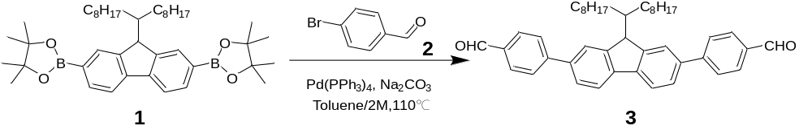
To the suspension of 2,2'-(9,9-dioctyl-9H-fluorene-2,7-diyl)bis(4,4,5,5-tetramethyl-1,3,2-dioxa borolane) (1) (2.44g, 3.80mmol) and 4-bromobenzaldehyde (2) (1.54 g, 8.4mmol) in toluene (50 mL) Na₂CO₃ solution (30 mL, 2M) was added Pd(PPh₃)₄ (115 mg, 0.1 mmol). The mixture was stirred at 110 ºC under Ar atmosphere for 12h. After completion of the reaction, the mixture was poured into water and extracted with ethyl acetate. The organic layers were separated, dried over anhydrous MgSO₄, and filtered. Solvents were removed under reduced pressure and the crude residue was further purified by column chromatography (petroleum ether: dichloromethane: ethyl acetate = 10:2:1 as eluents) to afford the compound 3 as a yellow solid (1.86 g, yield: 82%). ¹H NMR (400 MHz, CDCl₃) δ: 10.09 (s, 1H), 8.00 (d, J = 8.1 Hz, 1H), 7.85 (d, J = 6.5 Hz, 2H), 7.83 (d, J = 2.4 Hz, 2H), 7.66 (d, J = 7.9 Hz, 1H), 7.62 (s, 1H), 2.10 - 2.04 (m, 2H), 1.17 – 1.03 (m, 10H), 0.78 (t, J = 7.0 Hz, 3H), 0.71 (s, 2H). ¹³C NMR (101 MHz, CDCl₃) δ: 191.96, 152.09, 147.55, 140.96, 138.91, 135.13, 130.37, 127.75, 126.59, 121.75,120.58, 77.43, 77.11, 76.80, 55.55, 40.36, 31.79, 29.96, 29.20, 23.83, 22.62, 14.11.
4,4'-(9-(heptadecan-9-yl)-9H-carbazole-2,7-diyl)dibenzaldehyde (6)
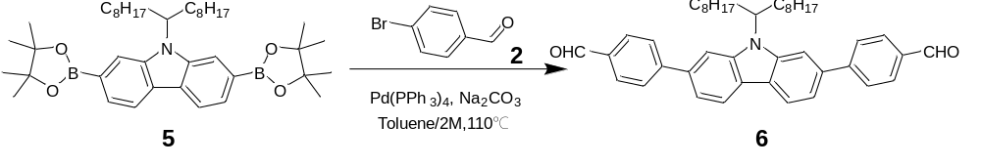
The compound 6 was synthesized according to the same procedure as for preparing compound 3 using 9-(heptadecan-9-yl)-2,7-bis(4,4,5,5-tetramethyl-1,3,2-dioxaborolan -2-yl)-9H-carbazole 5 (2.49g, 3.80mmol) and compound 2(1.54g, 8.4mmol) as reactants. The crude product was purified on silica column using petroleum ether: ethyl acetate = 10: 1 as eluents to give the dicarbaldehyde 6 as a yellow solid in 95% yield. ¹H NMR (400 MHz, CDCl₃) δ: 9.92 (s, 1H), 8.10 (d, J = 3.8 Hz, 1H), 7.79 (d, J = 3.9 Hz, 1H), 7.70 (s, 1H), 7.57 (d, J = 6.4 Hz, 1H), 7.51 (s, 1H), 4.66–4.60 (m, 1H), 2.32 (dd, J = 9.0, 4.4 Hz, 2H), 2.19–1.81 (m, 2H), 1.11 (s, 10H), 0.77 (d, J = 7.1 Hz, 3H). ¹³C NMR (101 MHz, CDCl₃) δ: 182.82, 155.58, 143.10, 142.24, 139.75, 137.64, 131.24, 130.71, 124.31, 124.14, 123.06, 121.27, 117.99, 109.59, 106.96, 77.42, 77.10, 76.79, 56.85, 33.78, 31.75, 29.90, 29.58, 26.80, 22.61, 14.08.

FPTC
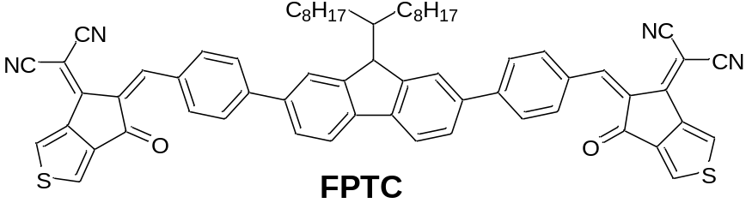

To a solution of dialdehyde 3 (149 mg, 0.25 mmol) and 2-(6-oxo-5,6-dihydro-4H-cyclopenta[c]thiophen-4-ylidene)malononitrile (4) (200 mg, 1. 0 mmol) in CHCl₃ (50 mL) was added pyridine (1 mL) under argon, and then the mixture was stirred at room temperature for 12 h. After TLC monitoring the reaction was completed, the mixture was poured into methanol and filtered. The residue was purified by column chromatography using petroleum ether: dichloromethane: ethyl acetate = 10:2:1 as eluents, yielding FPTC as a dark blue solid (120 mg, 50%). ¹H NMR (400 MHz, CDCl₃) δ: 8.84 (s, 1H), 8.42 (s, 1H), 7.99 (s, 1H), 7.88 (d, J = 4.20Hz, 1H), 7.87 (dd, J = 13.8, 6.0Hz, 2H), 7.84–7.77 (m, 2H), 7.77 (s, 1H), 7.62 (d, J = 4.1 Hz, 1H), 2.10 (d, J = 7.8 Hz, 2H), 1.11 (d, J = 29.8Hz, 11H), 0.77 (t, J = 6.7 Hz, 4H), 0.65 (s, 2H). ¹³C NMR (101 MHz, CDCl3) δ: 181.51, 173.41, 161.40, 156.23, 152.61, 146.46, 142.73 – 142.11, 139.29, 136.40, 132.66, 128.67, 127.94, 126.24, 125.73, 125.16, 121.10, 120.88, 114.91, 114.03, 77.36, 77.04, 76.73, 68.33, 55.89, 51.63, 40.27, 33.06, 31.75, 29.89, 29.21, 23.85, 22.59, 20.11, 14.06.MALDI-TOF-MS, m/z : calcd for C63H54N4O2S2 [M]+ : 962.369; found 963.428.

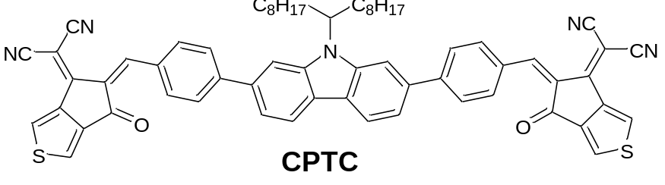CPTC
V

CPTC was synthesized according to the same procedure as for preparing FPTC using compound 6 and compound 4 as reactants. The crude product was purified by column chromatography using petroleum ether: dichloromethane: ethyl acetate = 10:2:1 as eluents, yielding CPTC as a dark blue solid in 89% yield. 11H NMR (400 MHz, CDCl3) δ : 8.93 (s, 2H), 8.70 (s, 2H), 8.57 (s, 2H), 8.21 (dd, J = 11.5, 8.4 Hz, 2H), 8.02 (d, J = 8.1 Hz, 4H), 7.88 (d, J = 11.8 Hz, 4H), 7.65 (d, J = 12.6 Hz, 2H), 7.54 (d, J = 7.0 Hz, 2H), 5.11 – 4.32 (m, 1H), 2.39 (dd, J = 9.5, 4.2 Hz, 2H), 2.11 – 2.00 (m, 2H), 1.13 (s, 21H), 0.79 (s, 7H).13C NMR (101 MHz, CDCl3) δ: 162.88, 156.63, 152.58, 150.87, 143.58 – 142.08, 131.92, 130.16, 129.16, 127.93, 127.67, 125.48, 121.18, 119.88, 115.12, 114.15, 112.51, 107.98, 77.21, 76.86, 76.73, 70.02, 67.87, 55.86, 40.21, 32.89, 31.76, 29.51, 23.84, 22.58, 14.07. MALDI-TOF-MS, m/z : calcd for C63H55N5O2S2 [M]+ : 977.380; found 978.028
5. TGA
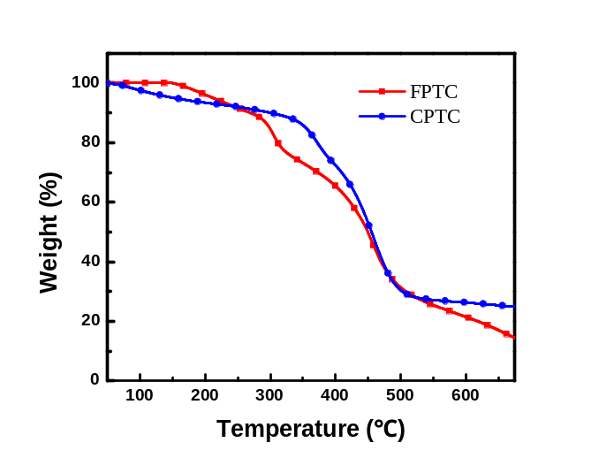
Fig. S1. The TG curves of FPTC and CPTC.
6. Photovoltaic data
Table S1. The OPV performance of PTB7-Th: FPTC blends based devices prepared under different conditions
D:A ratio  (w/w) | DIO  (v%) | Annealing temperature  (ºC) | V_{oc}  (V) | J_{sc}  (mA cm⁻²) | FF | PCE  (%)
1:1.5 | 0 | RT | 0.66 | 3.42 | 32.74 | 0.81
1:1.2 | 0 | RT | 0.72 | 3.75 | 33.89 | 0.90
1:1 | 0 | RT | 0.72 | 3.59 | 33.38 | 0.85
1.2:1 | 0 | RT | 0.72 | 3.36 | 31.19 | 0.74
1:1.2 | 0.1 | RT | 0.71 | 3.83 | 35.16 | 0.94
1:1.2 | 0.3 | RT | 0.71 | 3.98 | 36.19 | 1.01
1:1.2 | 0.5 | RT | 0.71 | 3.86 | 34.69 | 0.93
1:1.2 | 0.3 | 90 | 0.71 | 4.01 | 36.76 | 1.03
1:1.2 | 0.3 | 100 | 0.71 | 4.18 | 37.05 | 1.09
1:1.2 | 0.3 | 110 | 0.70 | 4.08 | 36.24 | 1.02
1:1.2 | 0.3 | 100 | 0.71 | 4.16±0.05 | 36.76±0.05 | 1.03±0.06 ª
ª The average PCE values from 10 devices.
Table S2. The OPV performance of PTB7-Th:FPTC and PTB7-Th: CPTC blends based devices prepared under their optimized conditions.
 | D:A ratio  (w/w) | DIO  (v%) | AT  (ºC) | V_{oc}  (V) | J_{sc}  (mA cm⁻²) | FF | PCE  (%)
PTB7-Th:  CPTC | 1:1.2 | 0.3 | 100 | 0.49 | 0.42 | 23.98 | 0.12 (0.05ª)
ª The average PCE values in brackets from 10 devices.
7. ¹H NMR and ¹³C NMR
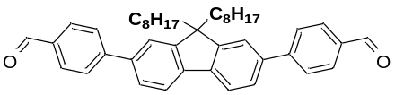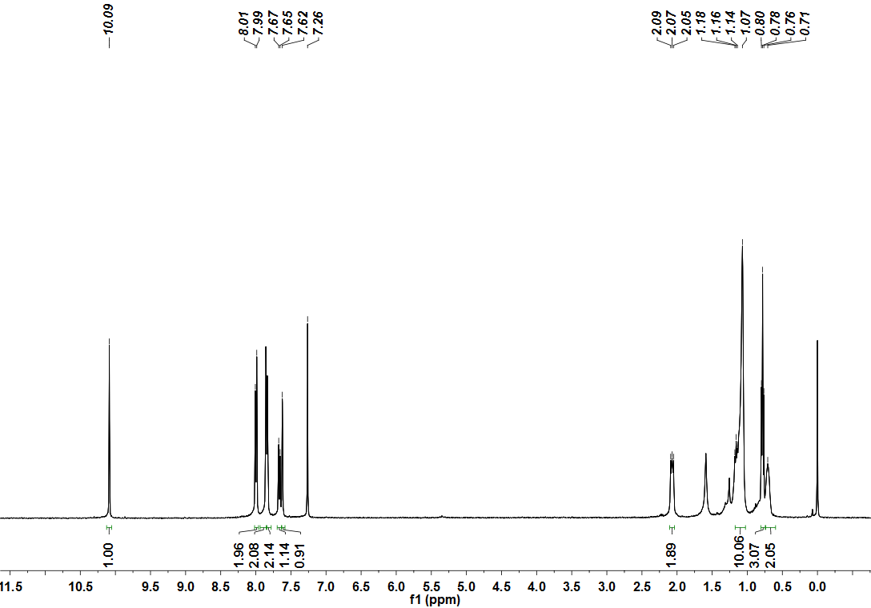
Fig. S2. ¹H NMR of compound 3

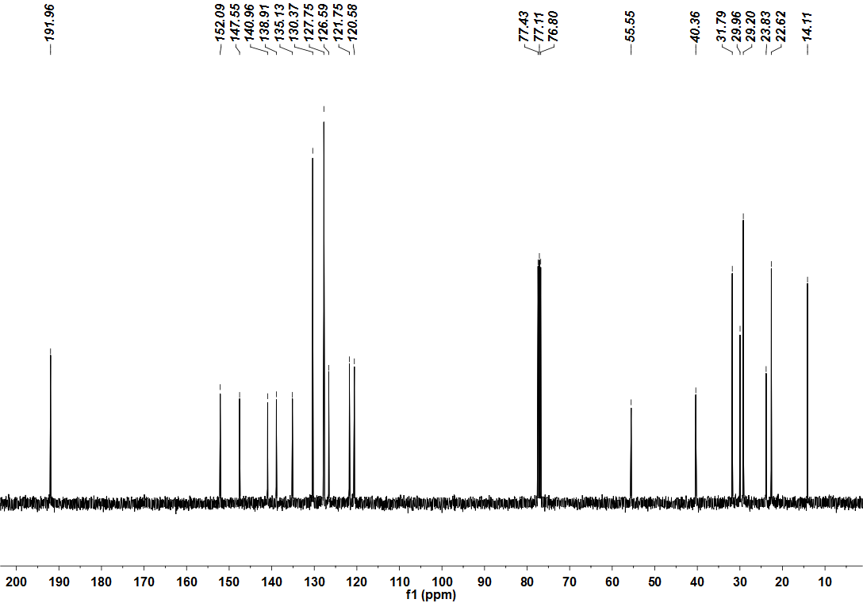
Fig. S3. ¹³C NMR of compound 3

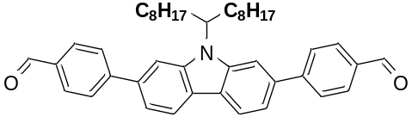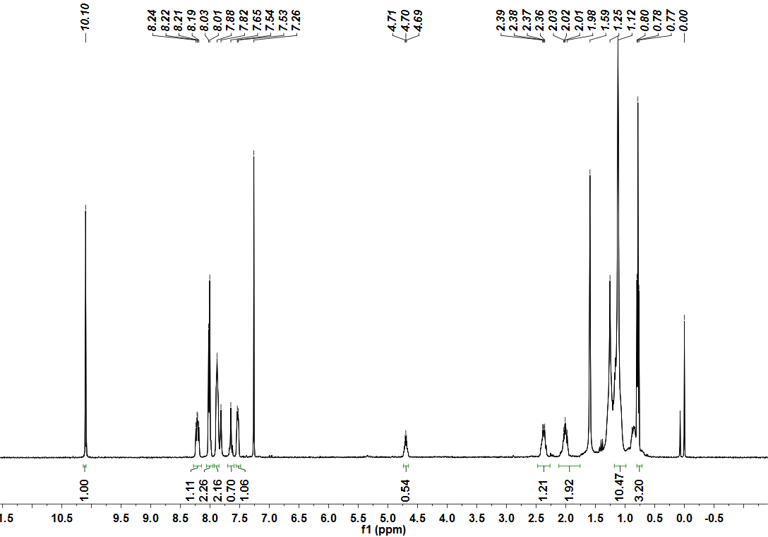
Fig. S4. ¹H NMR of compound 6

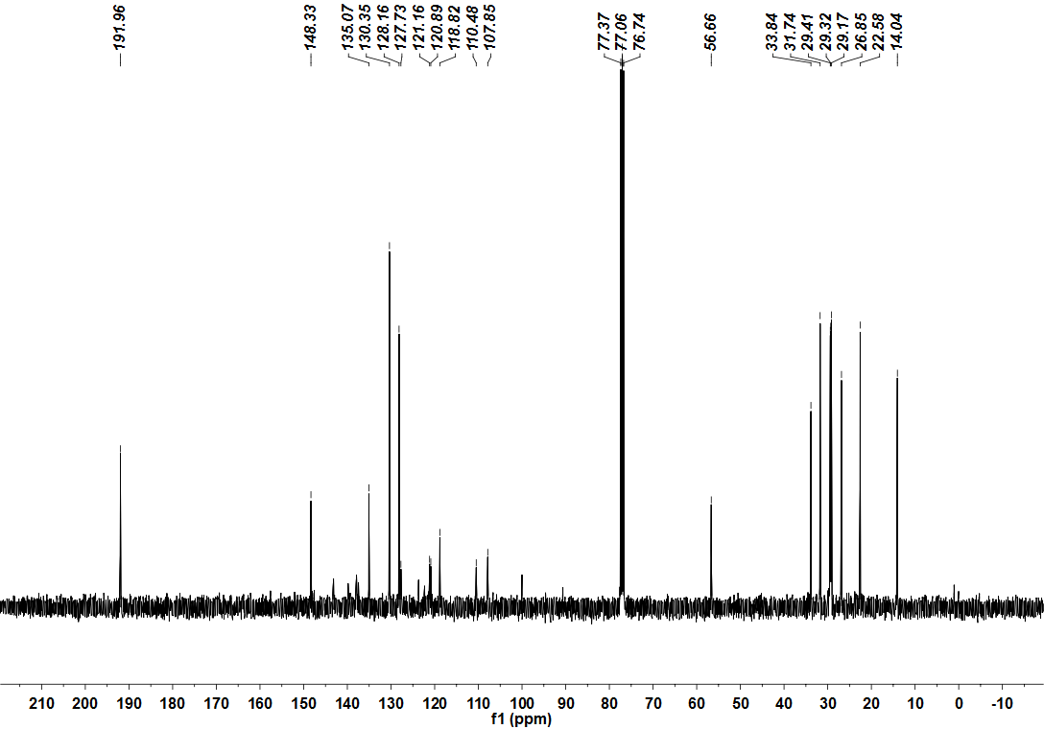
Fig. S5. ¹³C NMR of compound 6

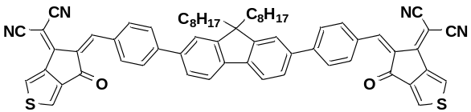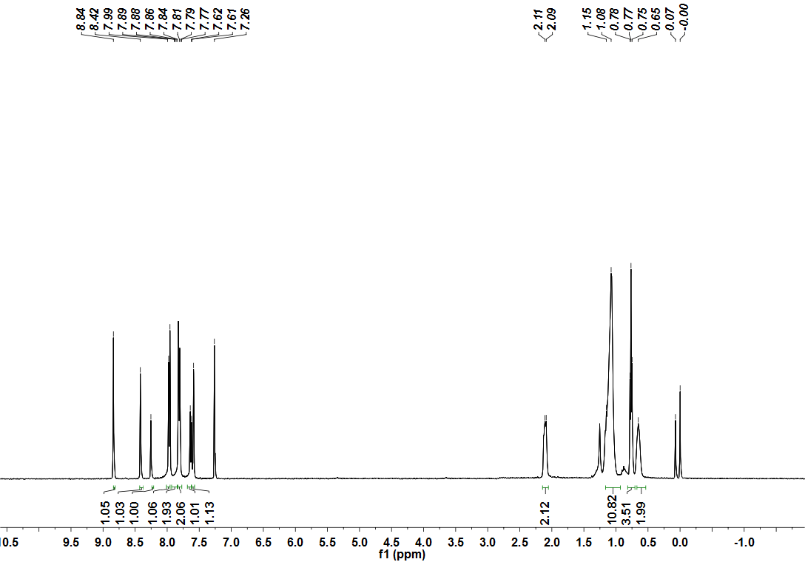
Fig. S6. ¹H NMR of compound FPTC

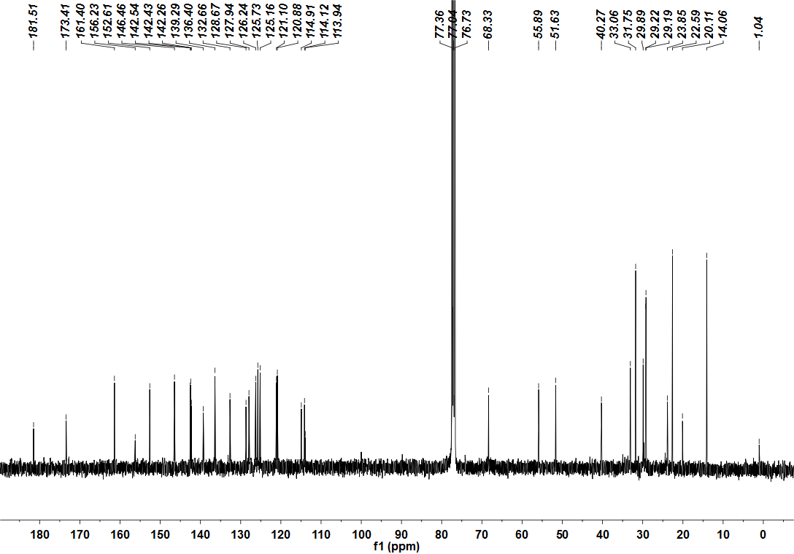
Fig. S7. ¹³C NMR of compound FPTC
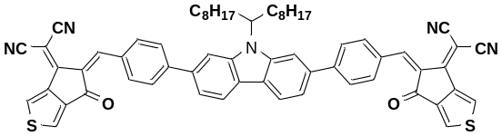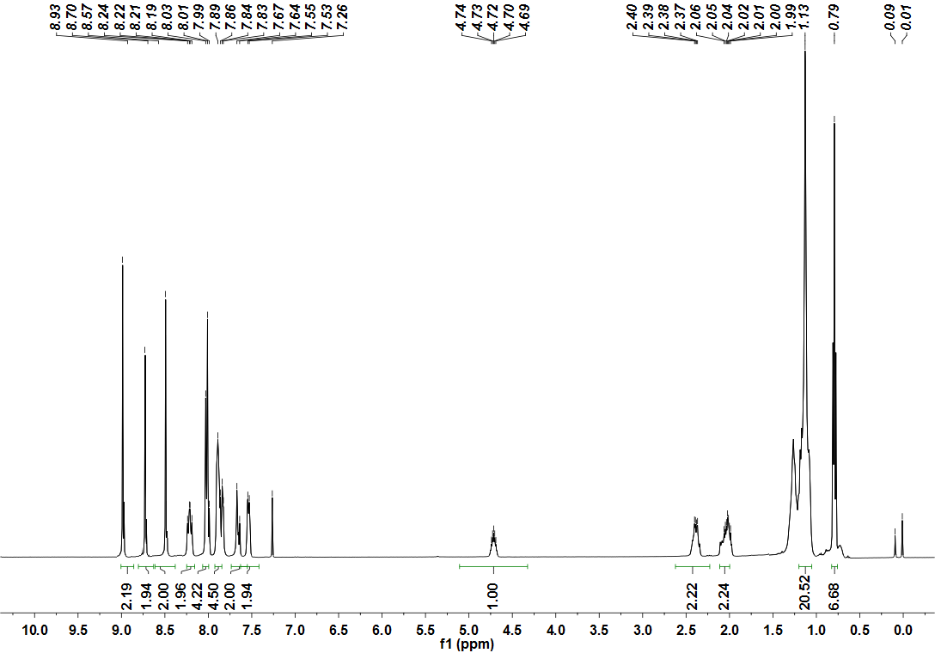
Fig. S8. ¹H NMR of compound CPTC

Fig. S9. ¹³C NMR of compound CPTC

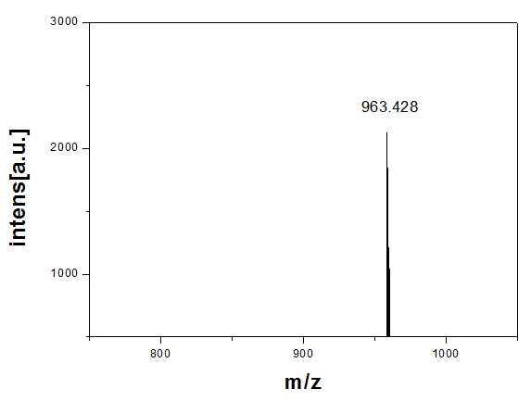
Fig. S10. MALDI-TOF-MS of compound FPTC
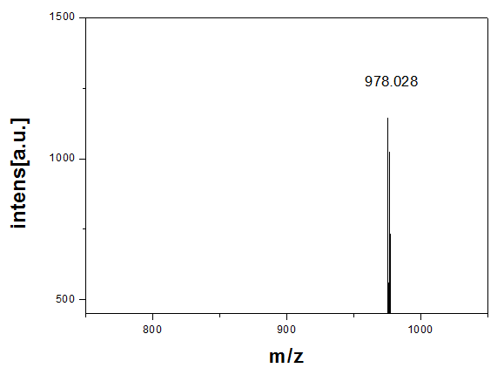
Fig. S11. MALDI-TOF-MS of compound CPTC

∗∗ Corresponding Author: liaojx83@163.com (J. Liao)
∗∗ Corresponding Author: liaojx83@163.com (J. Liao)

