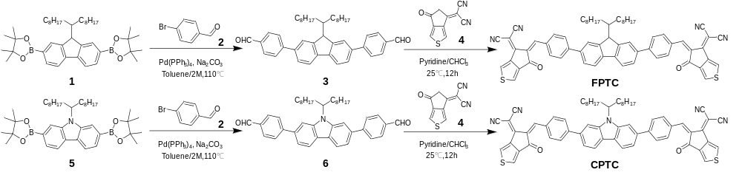
Scheme 1. Synthetic route of FPTC and CPTC

