Supplementary material
Trajectory Analysis
Repeated trajectory analyses were performed to identify the latent classes by changing the number of groups from 2 to 4, with the same starting values calculated from the 1-group model. According to Muthén & Muthén (2000) , there are general criteria for selecting optimal numbers of latent classes. These criteria include comparing relative fit across models, examining the "quality" of classification across models, and interpreting usefulness of latent class trajectories.
A large number of fit indices can be used when choosing among models. Examples include the Akaike information criterion (AIC; Akaike, 1987), consistent AIC (CAIC; Bozdogan, 1987), Bayesian information criterion (BIC, Schwartz, 1978), the Lo-Mendell-Rubin likelihood ratio test (LMR; Lo, Mendell, & Rubin, 2001), the bootstrap parametric likelihood ratio test (BLRT; Muthén, 2006), and the approximation of integrated classification likelihood using BIC (ICLBIC; Biernacki, Celeux, & Govaert, 2000). Although all of these fit indices are common (Bauer & Curran, 2003a; Bozdogan, 1987; Jung & Wickrama, 2008; Nagin, 1999), there are strengths and limitations of each. For example, AIC tends to overestimate the true number of classes, whereas BIC and CAIC tend to underestimate (Bauer & Curran, 2003a; McLachlan & Peel, 2000). Furthermore, BIC is largely insensitive to sample size (D'Unger, Land, McCall, & Nagin, 1998), a possible strength of the method. The bootstrapped parametric likelihood ratio test, a newer method, often outperforms alternatives including BIC (Nylund, et al., 2007).
Quality of classification across models is measured using entropy (Connell & Frye, 2006). Entropy ranges from 0.0 to 1.0, with values closer to 1.0 representing better classification. It provides a summary measure of the probability of membership for each individual for the class the individual most likely belongs to (Connell & Frye, 2006).
In this study, the shapes and optimal number of groups were determined by the following criteria: 1) AIC, BIC and aBIC decreased at least 20; 2) Entropy>0.7; 3)% Participants per class >7.426. Random starts were used to avoid convergence towards local maxima. Finally, the best fitting model based on above criteria was quadratic trajectories of two groups, and the final model was described as
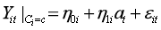
where is the outcome for individual at time in latent class of the latent class variable ; are age-related time scores; the random intercepts, random slopes and random quadratic are expressed as
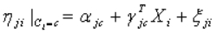
where 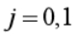; is a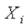 -dimensional vector of time-invariant covariates.

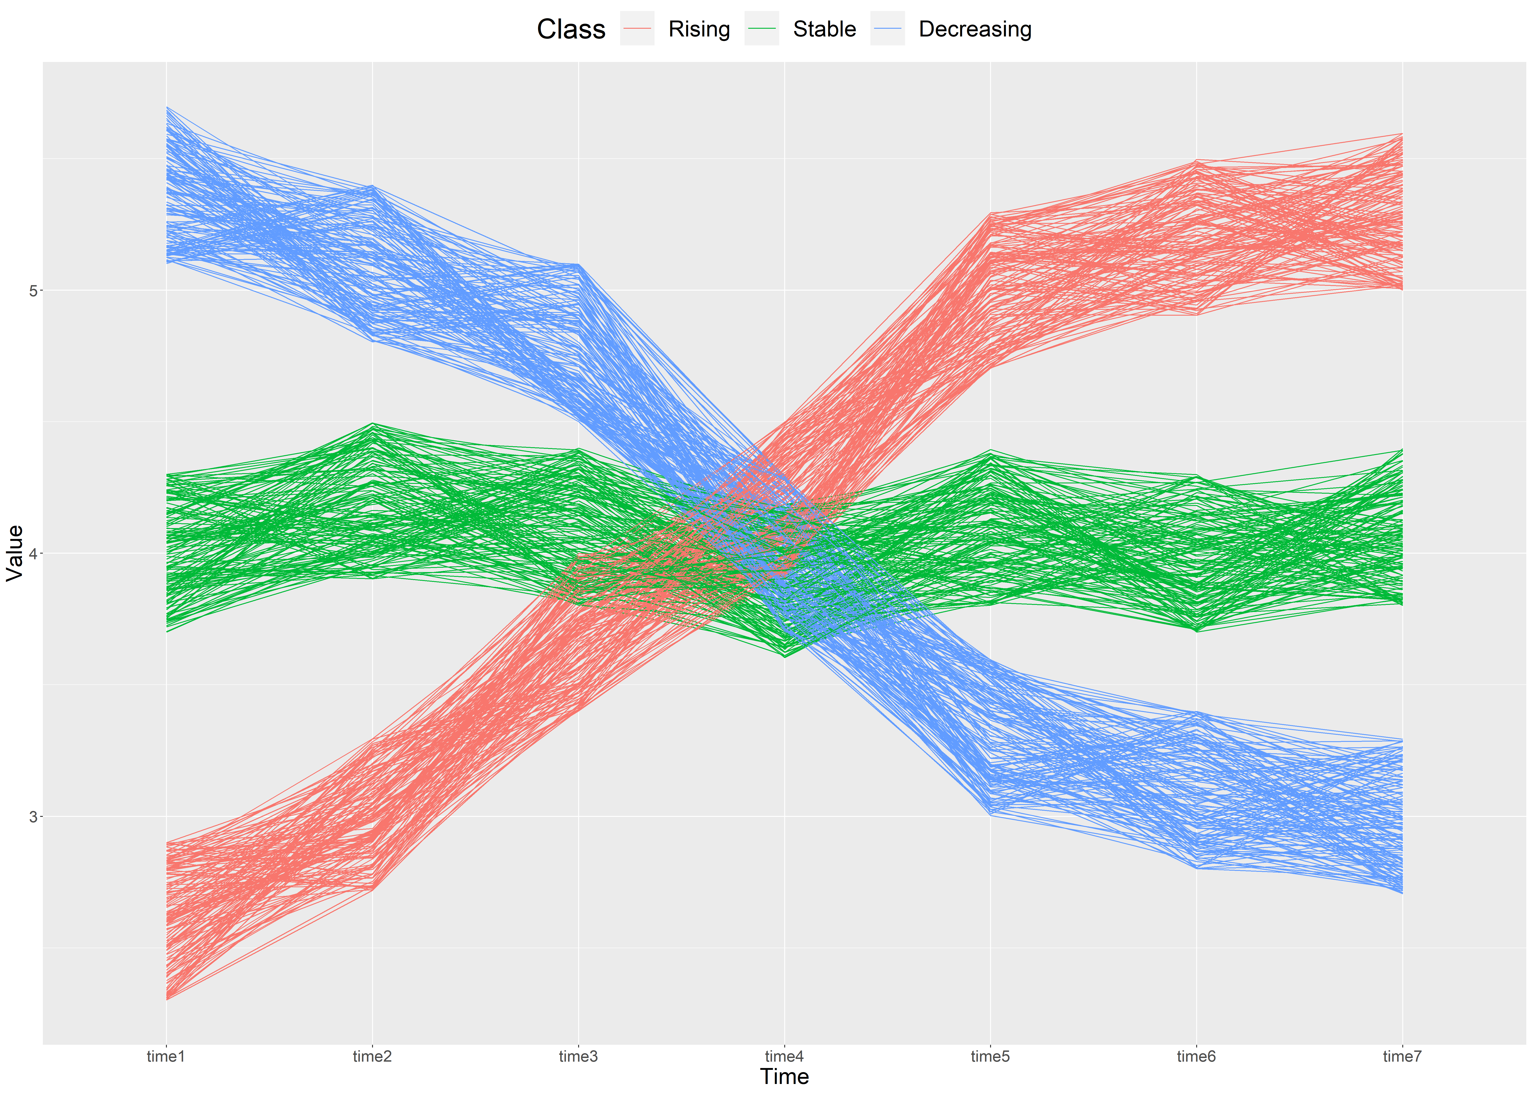Figure S1. Schematic diagram of longitudinal data with group heterogeneity
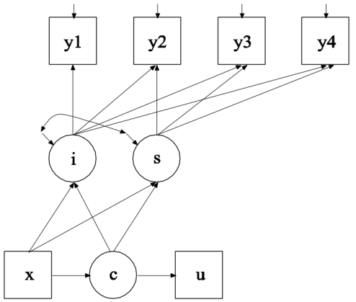
Figure S2. Schematic diagram of GMM with a categorical distal outcome
Exhibit 1 Results of GMM fit statistics with EQ5D5L as dependent variable (unconditional)
Models | AIC | BIC | aBIC | Entropy | LMR | BLRT | % Participants per class
Linear
Class-1 | -1008.208 | -956.190 | -997.440 | - | - |  | -
Class-2 | -1185.076 | -1121.053 | -1171.823 | 0.994 | 0.002 | <0.000 | 1.733/98.267
Class-3 | -1240.381 | -1164.355 | -1224.644 | 0.926 | 0.380 | <0.000 | 93.317/4.950/1.733
Class-4 | -1274.582 | -1186.551 | -1256.359 | 0.861 | 0.085 | <0.000 | 80.446/1.238/9.653/8.663
Linear-Free Estimation
Class-2 | -1373.809 | -1285.778 | -1355.586 | 0.807 | <0.000 | <0.000 | 11.634/88.366
Class-3 | -1483.700 | -1359.656 | -1458.022 | 0.702 | 0.002 | <0.000 | 9.653/47.030/43.317
Class-4 | -1570.512 | -1410.456 | -1537.380 | 0.734 | 0.194 | <0.000 | 4.455/42.079/43.317/10.149
AIC: Akaike information criterion; BIC: the Bayesian information Criterion; aBIC: Sample-Size Adjusted BIC; Entropy: Indicator for evaluating classification quality; % Participants per class: proportion of participants per class; The best fitting model is highlighted in bold characters.

Exhibit 2 Results of GMM fit statistics with KOOS-PS as dependent variable (unconditional)
Models | AIC | BIC | aBIC | Entropy | LMR | BLRT | % Participants per class
Linear
Class-1 | 14672.858 | 14724.877 | 14683.626 | - | - |  | -
Class-2 | 14615.152 | 14679.175 | 14628.405 | 0.987 | 0.006 | <0.000 | 1.980/98.020
Class-3 | 14612.567 | 14688.594 | 14628.305 | 0.724 | 0.750 | 0.429 | 1.980/82.673/15.347
Class-4 | 14605.875 | 14693.906 | 14624.097 | 0.792 | 0.078 | 0.050 | 2.475/0.248/18.564/78.713
Linear-Free Estimation
Class-2 | 14577.944 | 14665.976 | 14596.167 | 0.994 | 0.022 | <0.000 | 1.485/98.515
Class-3 | 14526.081 | 14650.125 | 14551.758 | 0.744 | 0.001 | <0.000 | 1.980/23.762/74.257
Class-4 | 14503.067 | 14663.123 | 14536.199 | 0.597 | 0.214 | 0.333 | 15.842/2.228/25.495/56.436
AIC: Akaike information criterion; BIC: the Bayesian information Criterion; aBIC: Sample-Size Adjusted BIC; Entropy: Indicator for evaluating classification quality; % Participants per class: proportion of participants per class; The best fitting model is highlighted in bold characters.

Exhibit 3 Results of GMM fit statistics with Pain-VAS as dependent variable (unconditional)
Models | AIC | BIC | aBIC | Entropy | LMR | BLRT | % Participants per class
Linear
Class-1 | 8049.318 | 8101.336 | 8060.085 | - | - |  | -
Class-2 | 7969.182 | 8033.205 | 7982.435 | 0.886 | 0.102 | <0.000 | 7.178/92.822
Class-3 | 7921.143 | 7997.170 | 7936.881 | 0.802 | 0.001 | <0.000 | 77.228/4.208/18.564
Class-4 | 7863.320 | 7951.351 | 7881.543 | 0.846 | 0.020 | <0.000 | 70.050/1.238/22.277/6.436
Linear-Free Estimation
Class-2 | 7786.911 | 7874.943 | 7805.134 | 0.702 | <0.000 | <0.000 | 22.030/77.970
Class-3 | 7733.279 | 7857.323 | 7758.957 | 0.652 | 0.064 | <0.000 | 27.970/55.446/16.584
Class-4 | 7679.609 | 7839.665 | 7712.741 | 0.796 | 0.296 | 0.326 | 10.644/14.851/14.604/59.901
AIC: Akaike information criterion; BIC: the Bayesian information Criterion; aBIC: Sample-Size Adjusted BIC; Entropy: Indicator for evaluating classification quality; % Participants per class: proportion of participants per class; The best fitting model is highlighted in bold characters.

Exhibit 4 Results of GMM fit statistics with EQ5D5L as dependent variable (with KOOS-PS_I and KOOS-PS_S as covariates)
Models | AIC | BIC | aBIC | Entropy | LMR | BLRT | % Participants per class
Linear-Free Estimation
GMM-2 | -1719.877 | -1591.832 | -1693.372 | 0.841 | <0.000 | <0.000 | 11.139/88.861
GMM-3 | -1823.518 | -1635.451 | -1784.587 | 0.868 | 0.059 | <0.000 | 83.811/5.446/10.644
GMM-4 | -1920.748 | -1672.661 | -1869.394 | 0.766 | 0.240 | <0.000 | 11.881/44.802/2.723/40.594
AIC: Akaike information criterion; BIC: the Bayesian information Criterion; aBIC: Sample-Size Adjusted BIC; Entropy: Indicator for evaluating classification quality; % Participants per class: proportion of participants per class; KOOS-PS_I and KOOS-PS_S act on the categorical latent variables and continuous latent variables of EQ5D5L ;The best fitting model is highlighted in bold characters.

Exhibit 5 Parameter estimation results for the two class model of EQ-5D-5L
 |  | Estimated value | Standard error | t Value | P Value
Category 1（n=45）
Intercept term | KOOS-PSI | 0.021 | 0.004 | 5.779 | <0.000
 | KOOS-PSS | -0.022 | 0.017 | -1.304 | 0.192
 | Mean residuals | -0.446 | 0.221 | -2.015 | 0.044
 | Residual variance | 0.023 | 0.009 | 2.461 | 0.014
Slope term | KOOS-PSI | 0.002 | 0.003 | 0.647 | 0.518
 | KOOS-PSS | -0.007 | 0.009 | -0.831 | 0.406
 | Mean residuals | -0.103 | 0.182 | -0.569 | 0.569
 | Residual variance | 0.003 | 0.008 | 0.330 | 0.742
Residual covariance | Intercept with slope | 0.000 | 0.004 | -0.035 | 0.972
Category 2（n=359）
Intercept term | KOOS-PSI | 0.030 | 0.003 | 11.617 | <0.000
 | KOOS-PSS | -0.020 | 0.005 | -4.389 | <0.000
 | Mean residuals | -1.012 | 0.149 | -6.776 | <0.000
Slope term | KOOS-PSI | -0.015 | 0.002 | -7.531 | <0.000
 | KOOS-PSS | 0.020 | 0.004 | 5.197 | <0.000
 | Mean residuals | 0.955 | 0.121 | 7.920 | <0.000
Residual covariance | Intercept with slope | 0.002 | 0.002 | 1.194 | 0.232
Logistic regression | KOOS-PSI | 0.869 | 0.057 | -2.278 | 0.023
 | KOOS-PSS | 0.590 | 0.084 | -4.906 | <0.000
Note: The correlation coefficient matrix for the latent variables in the Category 2 (rising group) is not positive definite, resulting in negative residual variance estimates, so the residual variance of the intercept and slope terms in the Category 2 are not shown in this paper. Logistic regression: The category latent variables for EQ-5D-5L are the dependent variables (stable group is the reference group) and KOOS-PSI and KOOS-PSS are the independent variables.

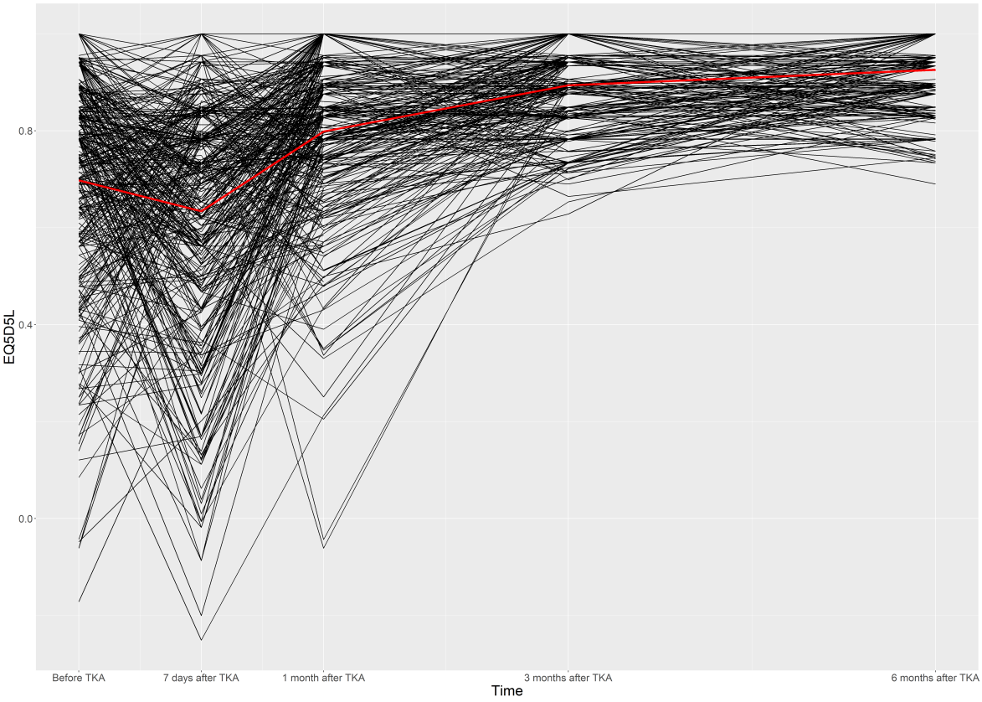
Figure S3 Growth trajectory of the "rising group" of EQ5D5L
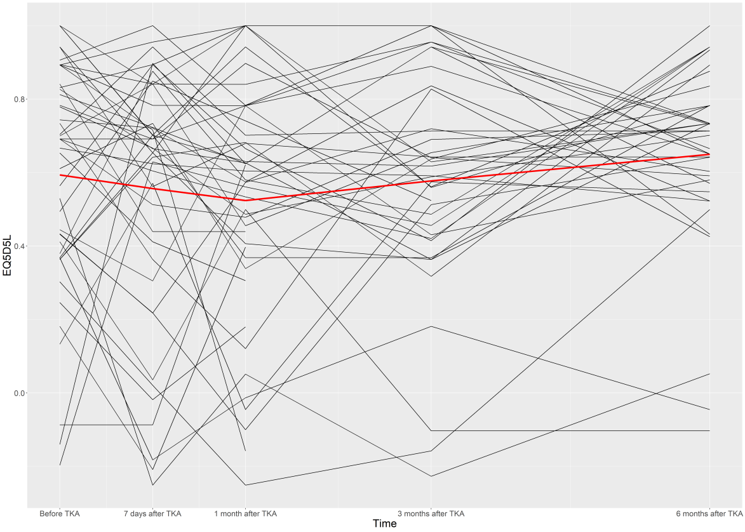
Figure S4 Growth trajectory of the "smooth group" of EQ5D5L

