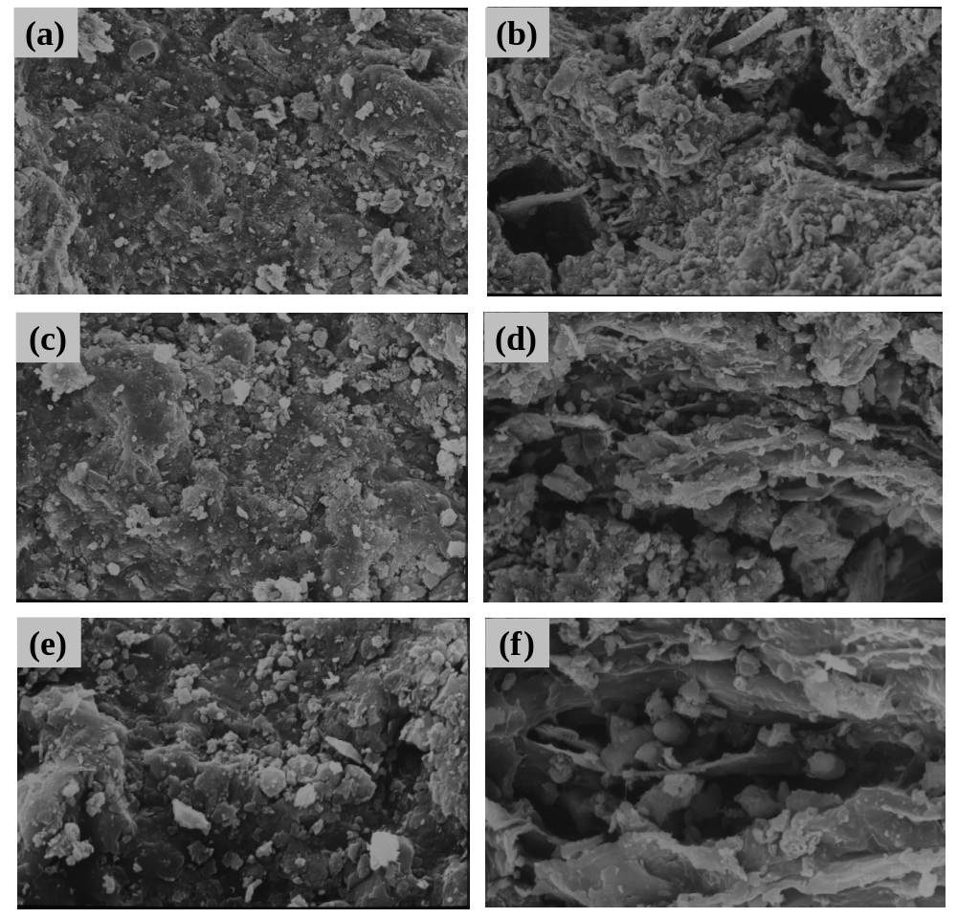
Fig. A.1. Scanning election microscopy (SEM) of the SS (a) and B (b) at 500× magnification; SS (c) and B (d) at 1000× magnification; SS (e) and B (f) at 3000× magnification.

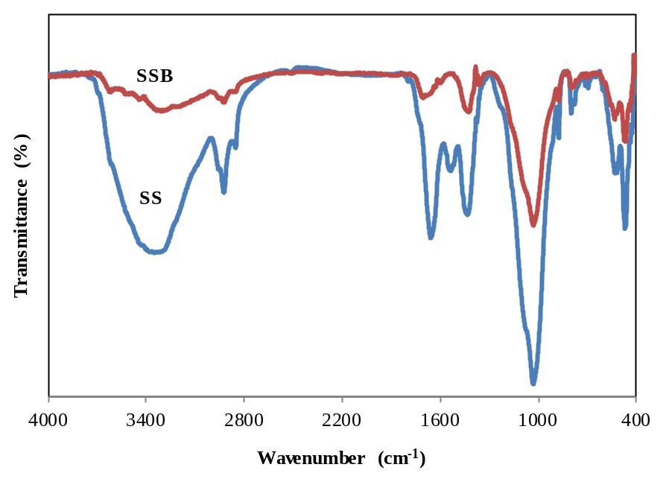
Fig. A.2. FTIR spectra of SS and B

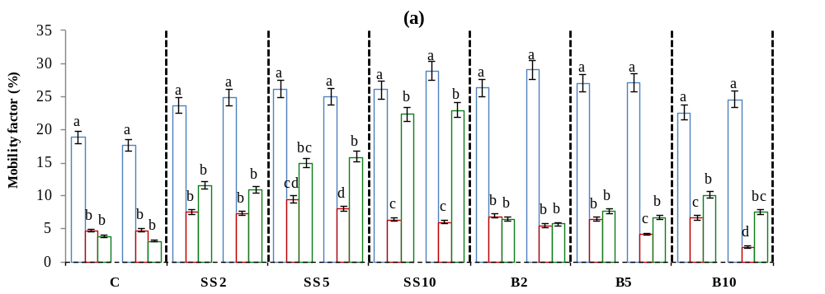
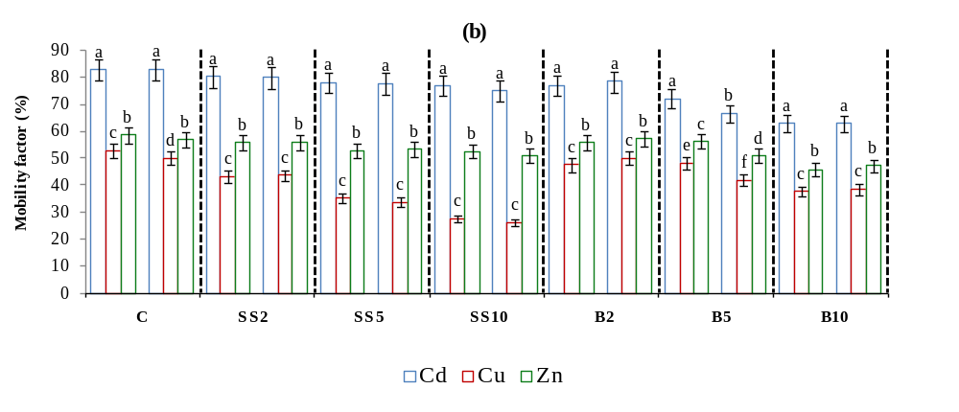
Fig. A.3. Mobility factor based on data from the sequential extraction of PTEs in rhizosphere soils (left columns) and bulk soils (right columns) of non-spiked (a) and spiked treatments (b) collected from the pots. C: control soil; SS: sewage sludge; B: sewage sludge biochar. Columns marked with the same letter between two dash lines are not significantly different (Duncan's multiple range test) at the p < 0.05 level.

Table A.1. Correlation coefficient between different forms of PTEs in rhizosphere soils and PTEs contents in aboveground parts of cherry tomato (n = 7)
Different forms of PTEs in soil | PTEs content in aerial part of plant
Different forms of PTEs in soil | Non-spiked treatments |  |  |  | Spiked treatments
 | Cd | Cu | Zn |  | Cd | Cu | Zn
EXCH | - | 0.672 | 0.765* |  | 0.659 | 0.833* | 0.211
CARB | 0.144 | 0.713 | 0.823* |  | -0.644 | -0.884** | 0.654
Fe-Mn OX | - | 0.616 | 0.439 |  | -0.335 | 0.087 | -0.209
OM | 0.112 | -0.264 | 0.124 |  | -0.011 | 0.259 | 0.041
RES | -0.491 | -0.128 | 0.063 |  | 0.301 | 0.440 | 0.359
MF | 0.259 | 0.607 | 0.755* |  | 0.352 | -0.889** | 0.245
DTPA | 0.909** | 0.895** | 0.763* |  | 0.748* | 0.577 | 0.214
EXCH: solution and exchangeable; CARB: bound to carbonate phase; Fe-Mn OX: bound to iron and manganese oxides; OM: bound to organic matter and sulfides; RES: residual; MF: mobility factor
**Correlation is significant at the 0.01 level
*Correlation is significant at the 0.05 level
- Not detectable

