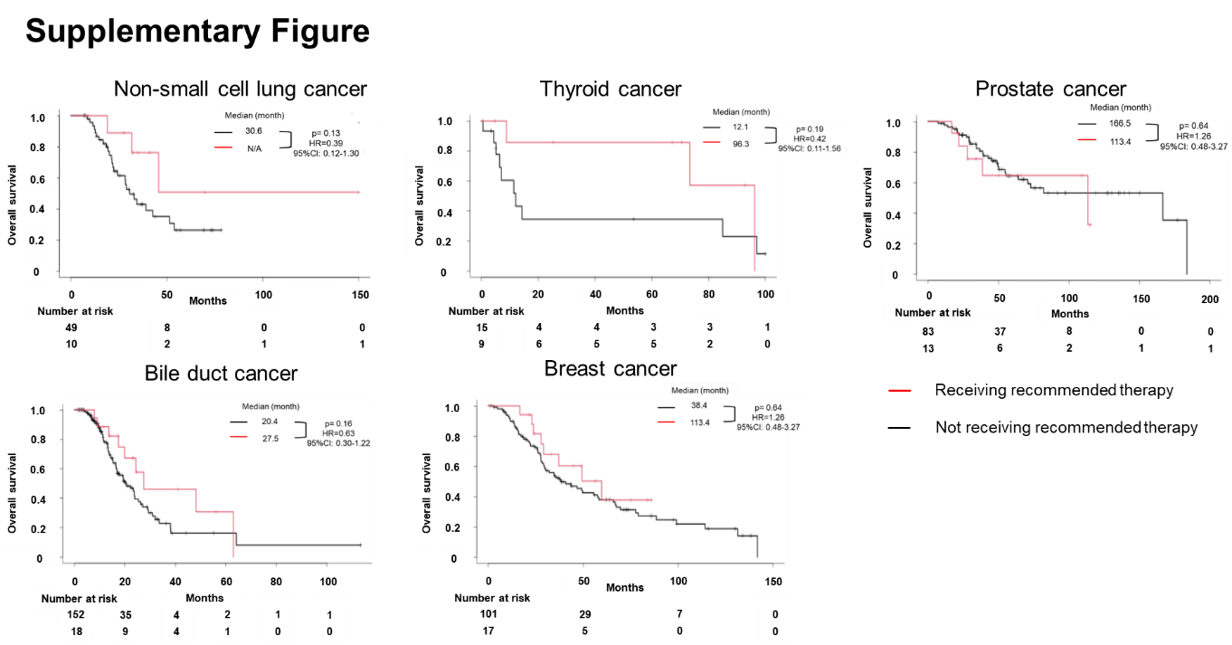
Supplementary Figure. Kaplan–Meier plots for overall survival from 1st line chemotherapy based on MTB-recommended treatment for each cancer type. No significant differences were observed in the overall survival of the groups.

