Supplementary Information
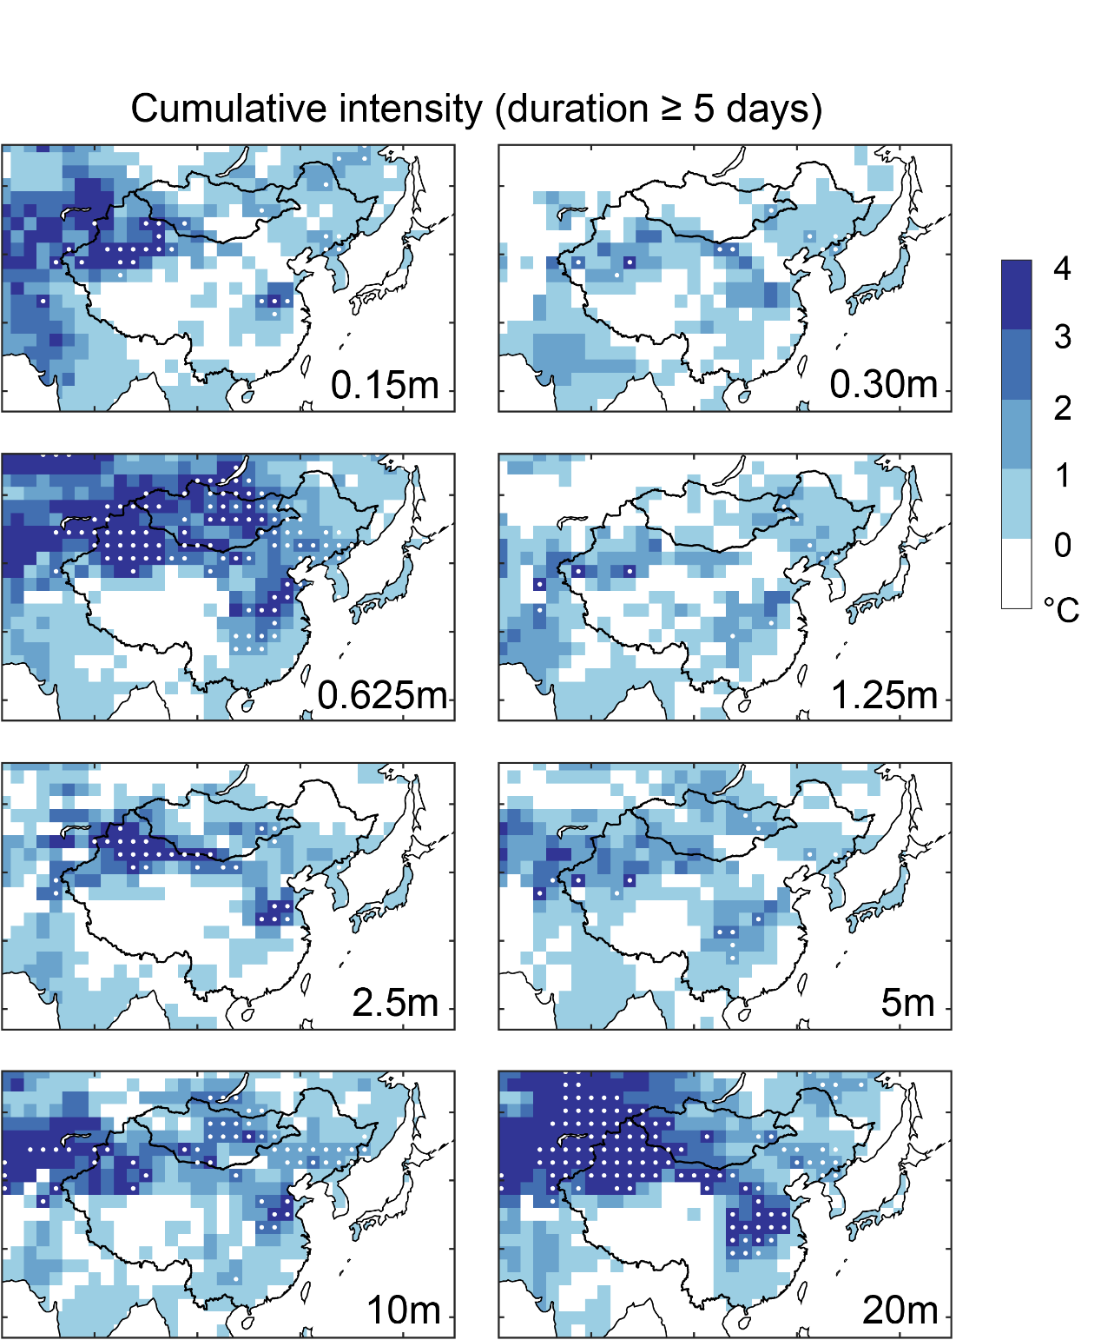
Fig. S1 Similar to Extended Data Fig. 1, but for the extremecold events lasting at least 5 days.

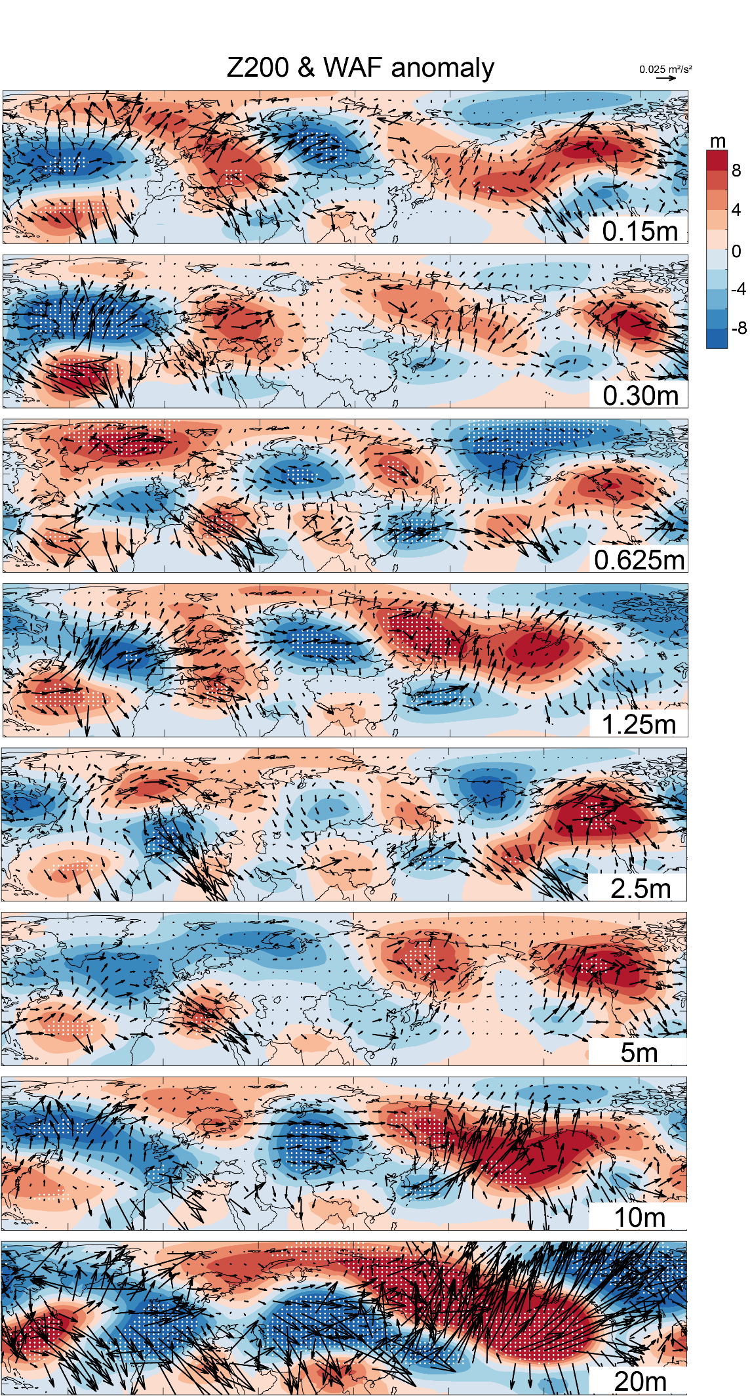
Fig. S2 The results of each experiments in Fig. 4a. To demonstrate the gradient difference better, we remove the zonal-mean component.
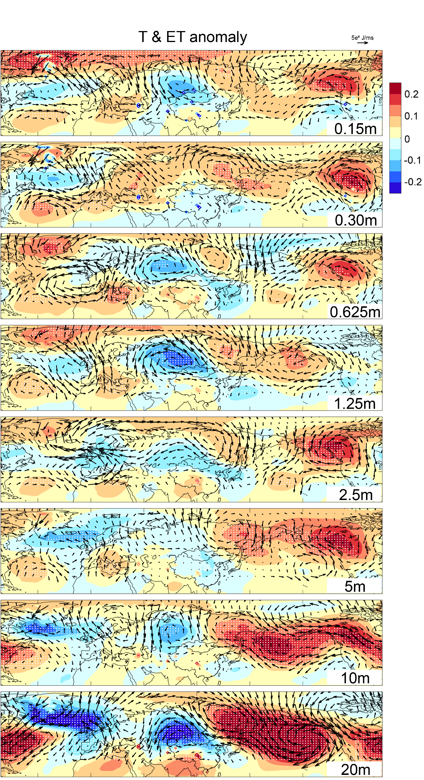
Fig. S3 The results of each experiments in Fig. 4b.
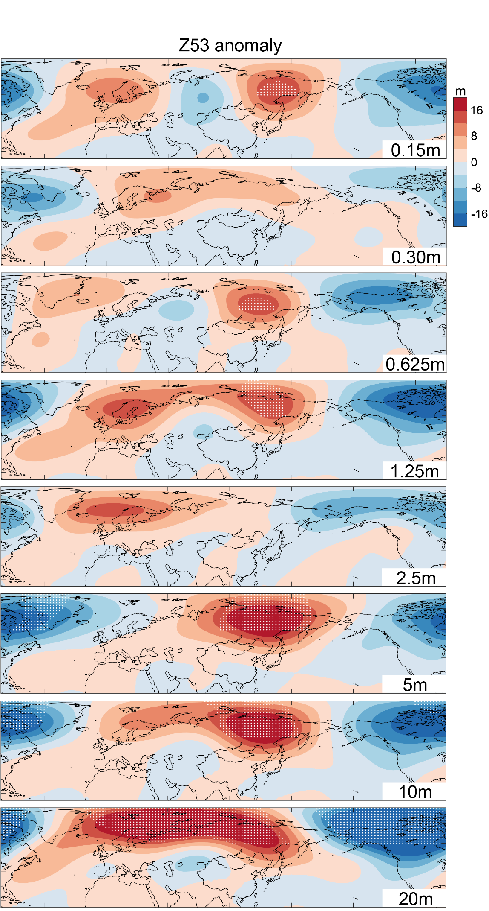
Fig. S4 The results of each experiments in Fig. 4c. To demonstrate the gradient difference better, we remove the zonal-mean component.
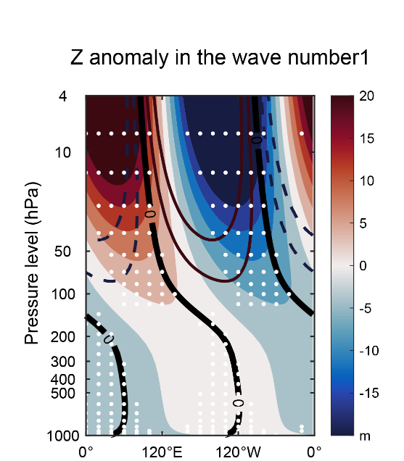
Fig. S5 The changes in wavenumber-1 component of geopotential height between 45 and 75°N, composited in the sea-level experiments in winters, relative to SL0m. The contour indicates the climatology wave number 1 in SL0m. The stipplings indicate that all sea-level experiments agree with the sign of the ensemble mean anomalies. Although the weakened upward propagation of waves would strengthen the vortex in the stratosphere, this effect was primarily observed on the North American side, with the vortex weakening on the Eurasian side. This shift in the polar vortex may potentially enhance the intensity of cold events in East Asia.
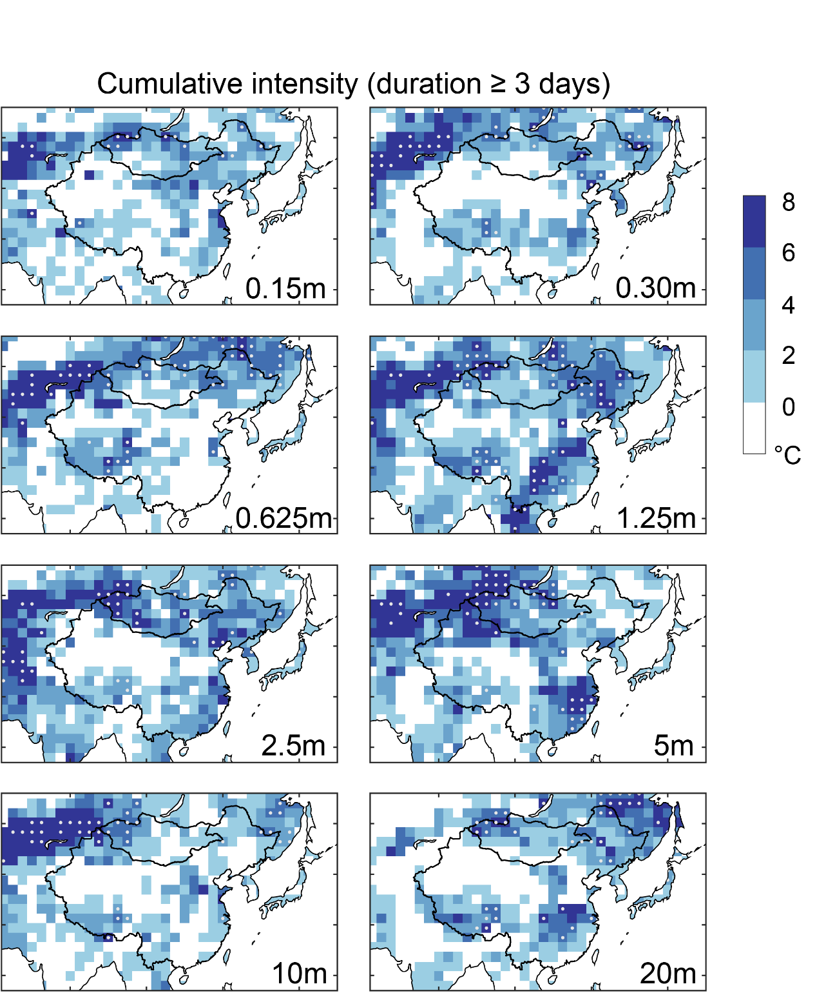
Fig. S6 Similar to Extended Data Fig. 1, but for the result of atmosphere-only experiments. Please note that the colorbar range of Fig. S5 and Extended Data Fig.1 is different.
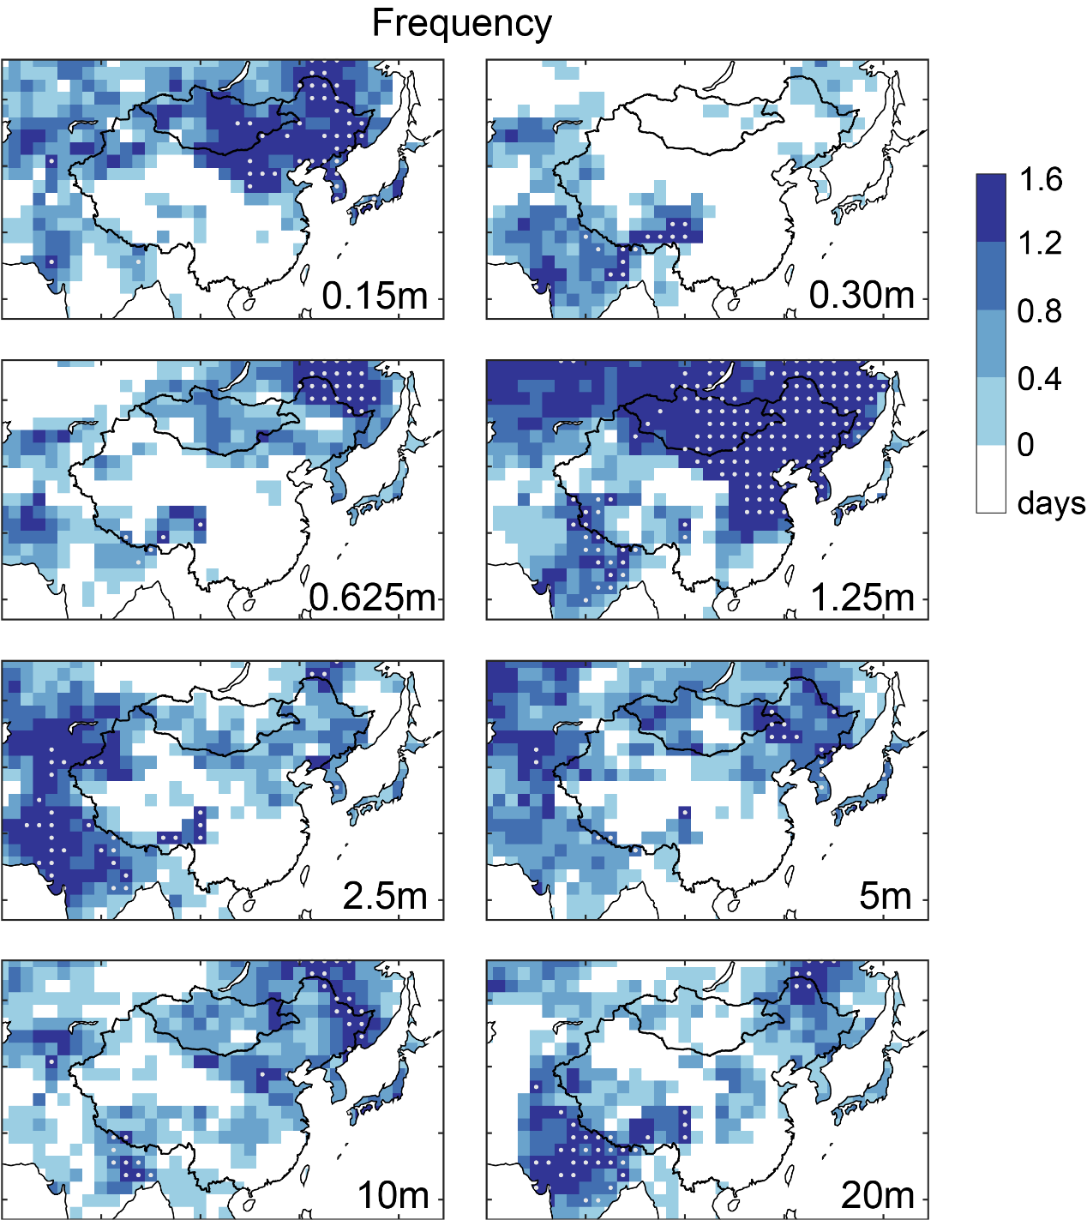
Fig. S7 Similar to Extended Data Fig. 2, but for the result of atmosphere-only experiments. Please note that the colorbar range of Fig. S6 and Extended Data Fig. 2 is different.
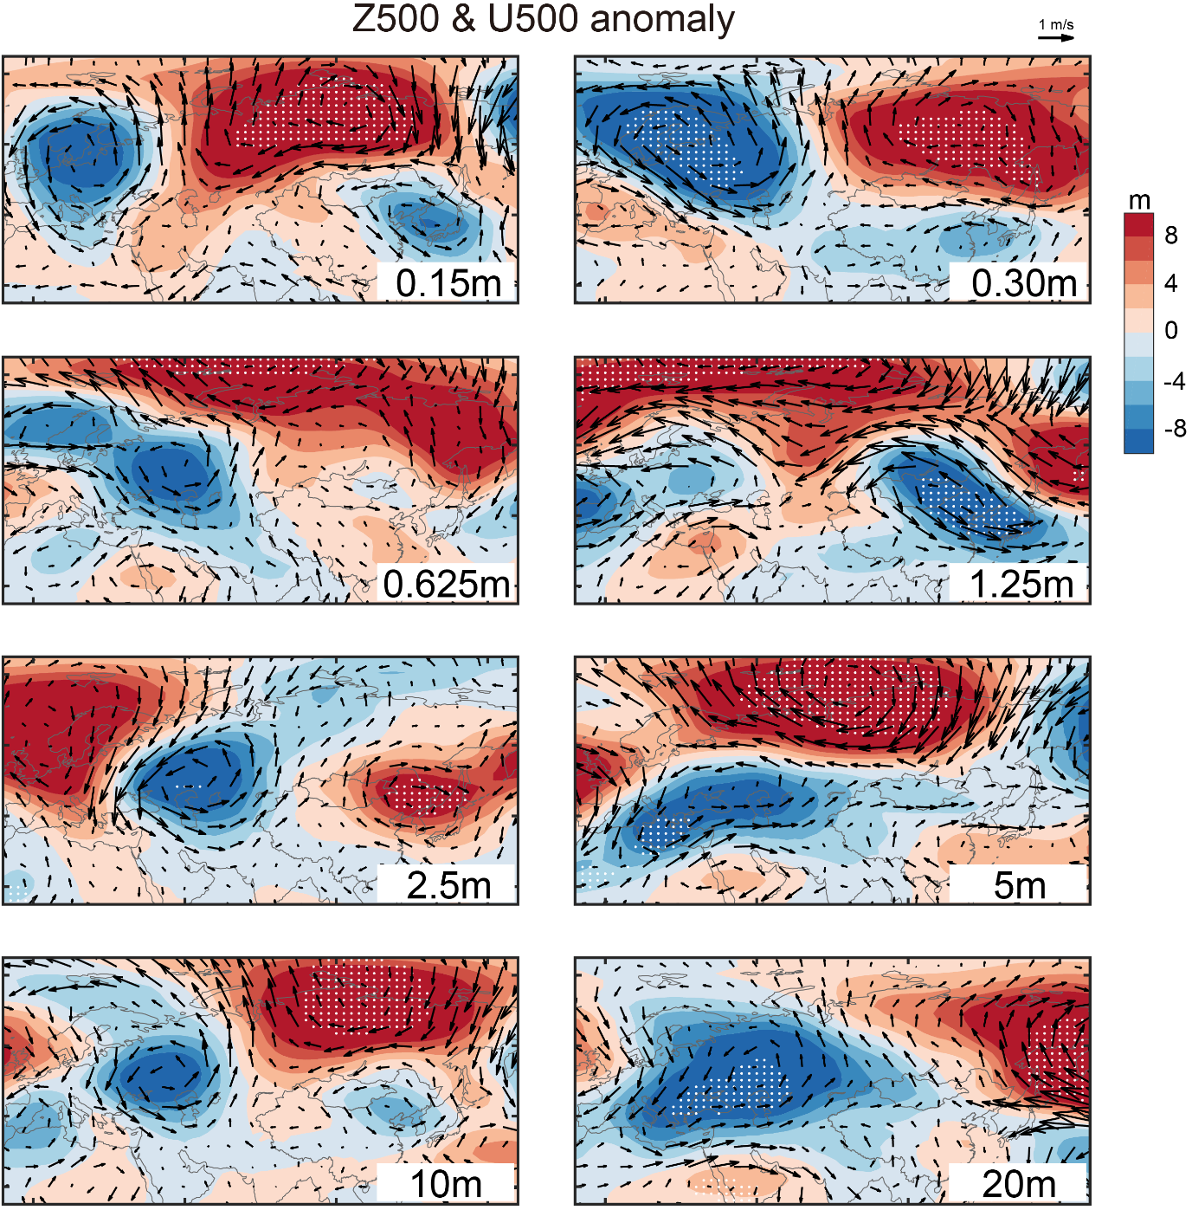
Fig. S8 The results of each experiments in Fig. 6a.

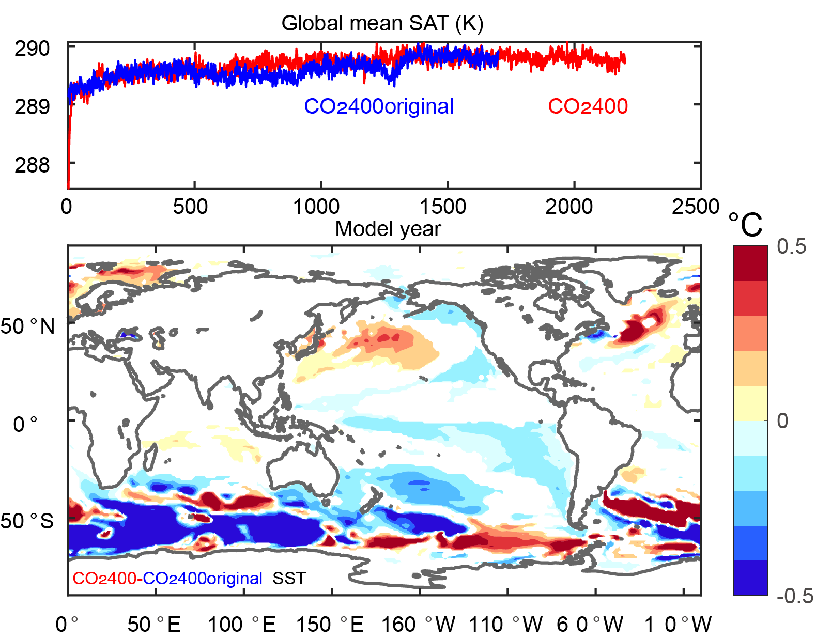
Fig. S9 The CO₂400original experiment. Top figure displays the global mean surface atmospheric temperature (SAT) in the model run. Bottom figure displays the differences in SST between the two CO₂400 experiments (90% confidence level, t-test). No matter which experiment is used as the baseline, the increase in North Pacific SST and East Asian cold events is robust.

References
1. Zhang, Z. et al. Atmospheric and oceanic circulation altered by global mean sea-level rise. Nature Geoscience, 1-7 (2023).

