Supplemental Material
Phycotoxins along two New Jersey Estuaries – Limitations of Passive Samplers in a Complex System
C. Taylor Armstrong^{a,*}, Gregg Sakowicz^{b,c}, Juliette Smith^{d}, Marta P. Sanderson^{d}, Kimberly S. Reece^{d}, Allen Placeª
Table S1 Average ± standard deviation of Salinity (ppt), pH, measured monthly along 11 sites in two New Jersey estuaries from September 2020-November 2020, April 2021-November 2021, and April 2022– November 2022 and PO₄³⁺ (µM), NH₄⁺ (µM), NO₃⁻ (µM) measure from April 2022– November 2022. (n=19)
Basin | Location | Salinity (ppt) | pH | PO₄³⁺ (µM) | NH₄⁺ (µM) | NO₃⁻ (µM)
Mullica River-Great Bay | A | 28.1±2.44 | 7.92±0.11 | 0.18±0.1 | 1.56±1.33 | 0.16±0.25
Mullica River-Great Bay | B | 25.77±3.31 | 7.9±0.11 | 0.18±0.12 | 1.78±1.74 | 0.21±0.32
Mullica River-Great Bay | C | 13.27±4.55 | 7.3±0.22 | 0.09±0.07 | 1.57±1.09 | 0.47±0.26
Mullica River-Great Bay | D | 1.61±2.48 | 6.54±0.63 | 0.0±0.01 | 0.21±0.27 | 1.21±0.86
Mullica River-Great Bay | E | 0.03±0.02 | 5.64±0.43 | 0.0±0 | 0.08±0.12 | 1.71±0.59
Toms River-Barnegat Bay | F | 29.43±1.29 | 8±0.15 | 0.18±0.08 | 2.25±1.68 | 0.25±0.34
Toms River-Barnegat Bay | G | 26.18±2.63 | 7.81±0.24 | 0.14±0.1 | 2.73±1.31 | 1.18±1.68
Toms River-Barnegat Bay | H | 20±3.31 | 8.02±0.13 | 0.01±0.01 | 0.55±0.45 | 0.04±0.09
Toms River-Barnegat Bay | I | 16.62±3.31 | 7.86±0.2 | 0.01±0.02 | 0.67±0.44 | 0.73±0.65
Toms River-Barnegat Bay | J | 6.55±6.35 | 6.76±0.64 | 0.03±0.05 | 1.72±1.07 | 7.16±1.85
Toms River-Barnegat Bay | K | 0.06±0.01 | 5.98±0.58 | 0.02±0.02 | 2.17±0.81 | 10.19±4.42

Table S2 Measured differences in toxin levels (ng/g resin ± standard deviation) between replicate SPATT bags deployed each month in two New Jersey estuaries in 2022 (n=2)
Sample | Phycotoxin
Sample | AZA-1 | AZA-2 | DTX-1 | GDA | OA | PTX-2 | YTX
Site B  June-July 22 | BDª | BDª | 333.17±41.44 | BDª | 698.59±86.54 | 396.49±60.32 | BDª
Site I  July-Aug 22 | BDª | 0.59±0.16 | 47.18±4.61 | 11.35±0.32 | 224.68±13.38 | 5.7±1.32 | BDª
Site B  Aug-Sept 22 | BDª | BDª | 70.67±0.71 | 14.94±0.72 | 256.34±20.2 | 68.85±9.96 | 5.29±0.44
Site H  Aug-Sept 22 | BDª | 0.78±0.1 | 18.99±3.49 | 434.12±28.08 | 113.49±1.93 | 2.07±0.08 | BDª
Site A  Oct-Nov 22 | 0.18±0.03 | 0.42±0.05 | 48.91±15.93 | BDª | 223.36±31.92 | 105.92±25.95 | 15.91±0.92
ª Below Detected
Table S3 Gene copies quantified from ~200 mg (wet weight) SPATT resin samples using PhytoxigeneTM CyanoDTec kits. (n=1)
Site (Lat/Long) | Month | 16S rRNA cyanobacteria copies | Cyra copies | Sxta copies
A (39.5079/-74.3385) | April-May | 2,743
 | May-June | 45,847
 | June-July | 15,939
 | July-August | 11,946
 | August-September | 9,789
 | September-October | 29,016
 | October-November | 14,383
B (39.4979/-74.3811) | April-May | 4,121
 | May-June | 54,779
 | June-July | 98,270
 | July-August | 90,564 |  | 53
 | August-September | 71,339 |  | 39
 | September-October | 58,949
 | October-November | 121,067
C (39.5479/-74.4608) | April-May | 9,039
 | May-June | 28,850
 | June-July | 642
 | July-August | 18,635
 | August-September | 1,646
 | September-October | 2,636
 | October-November | 8,378
D (39.5937/-74.5515) | April-May | 743
 | May-June | 6503
 | June-July | 1892
 | July-August | 18,635
 | August-September | 46,347
 | September-October | 1,340
 | October-November | 1,230
E (39.6224/-74.6254) | April-May | 73,323
 | May-June | 6,156
 | June-July | 6,604
 | July-August | 21,430
 | August-September | 920
 | September-October | 748
 | October-November | 270
F (39.7618/-74.1104) | April-May | 13,037
 | May-June | 27,944
 | June-July | 84,641
 | July-August | 12,428
 | August-September | 7,365 |  | 78
 | September-October | 5,880
 | October-November | 94,278
G (39.7876/-74.1834) | April-May | 1,091
 | May-June | 146,045
 | June-July | 24,801
 | July-August | 87,776 | 1,663
 | August-September | 14,623
 | September-October | 35,999
 | October-November | 28,776
H (39.9218/-74.0828) | April-May | 5,038
 | May-June | 32,464
 | June-July | 395,375 | 927
 | July-August | 36,508
 | August-September | 96,284 | 437
 | September-October | 73,416 | 270
 | October-November | 347,568
I (39.9295/-74.1178) | April-May | 10,848
 | May-June | 94,338
 | June-July | 93,618
 | July-August | 64,498 | 313
 | August-September | 26,895 | 495
 | September-October | 18,062 | 232
 | October-November | 15,979
J (39.9500/-74.1962) | April-May | 18,612
 | May-June | 94,338 |  | 25
 | June-July | 49,811 |  | 1873
 | July-August | 13,554 |  | 62
 | August-September | 45,584 |  | 42
 | September-October | 19,661 |  | 45
 | October-November | 16,624
K (39.9763/-74.2182) | April-May | 5,285
 | May-June | NA
 | June-July | NA
 | July-August | 71,111
 | August-September | 59,062
 | September-October | 1,216
 | October-November | 2,162

Table S4 Toxin quantities measured in 1 g HP-20 resin controls, where resin was put in ultrapure water with 25 ng okadaic acid, microcystin-RR, microcystin-LR, and microcystin-YR for one hour at 20℃ in the dark, and stored at 4℃ for either 0 days, 21 days or 49 days. Resin was activated in 100% MeOH on August 1, 2022 (n=3)
Sample Name | Total Days stored at 4℃ | Date exposed to phycotoxins/stored at 4℃ | Date stored at 20℃ | Phycotoxin (ng/g resin)
 |  |  |  | MC-RR | MC-LR | MC-YR | OA
Control Pre-Toxin 1 day | 21 days | 08/3/2022 | 08/24/2022 | 8.97±0.35 | 10.76±0.18 | 9.28±0.31 | 10.15±2.34
Control Pre-Toxin 1 month | 49 days | 08/3/2022 | 09/21/2022 | 6.95±2.81 | 13.56±4.13 | 22.62±6.03 | 5.98±1.01
Control Post-Toxin 1 day | 0 days | 08/25/2022 | 08/25/2022 | 12.31±2.03 | 13.36±1.63 | 12.58±1.44 | 8.36±1.39
Control Post-Toxin 1 month | 0 days | 09/22/2022 | 09/22/2022 | 9.64±0.54 | 10.28±1.15 | 8.95±1.83 | 8.37±0.78

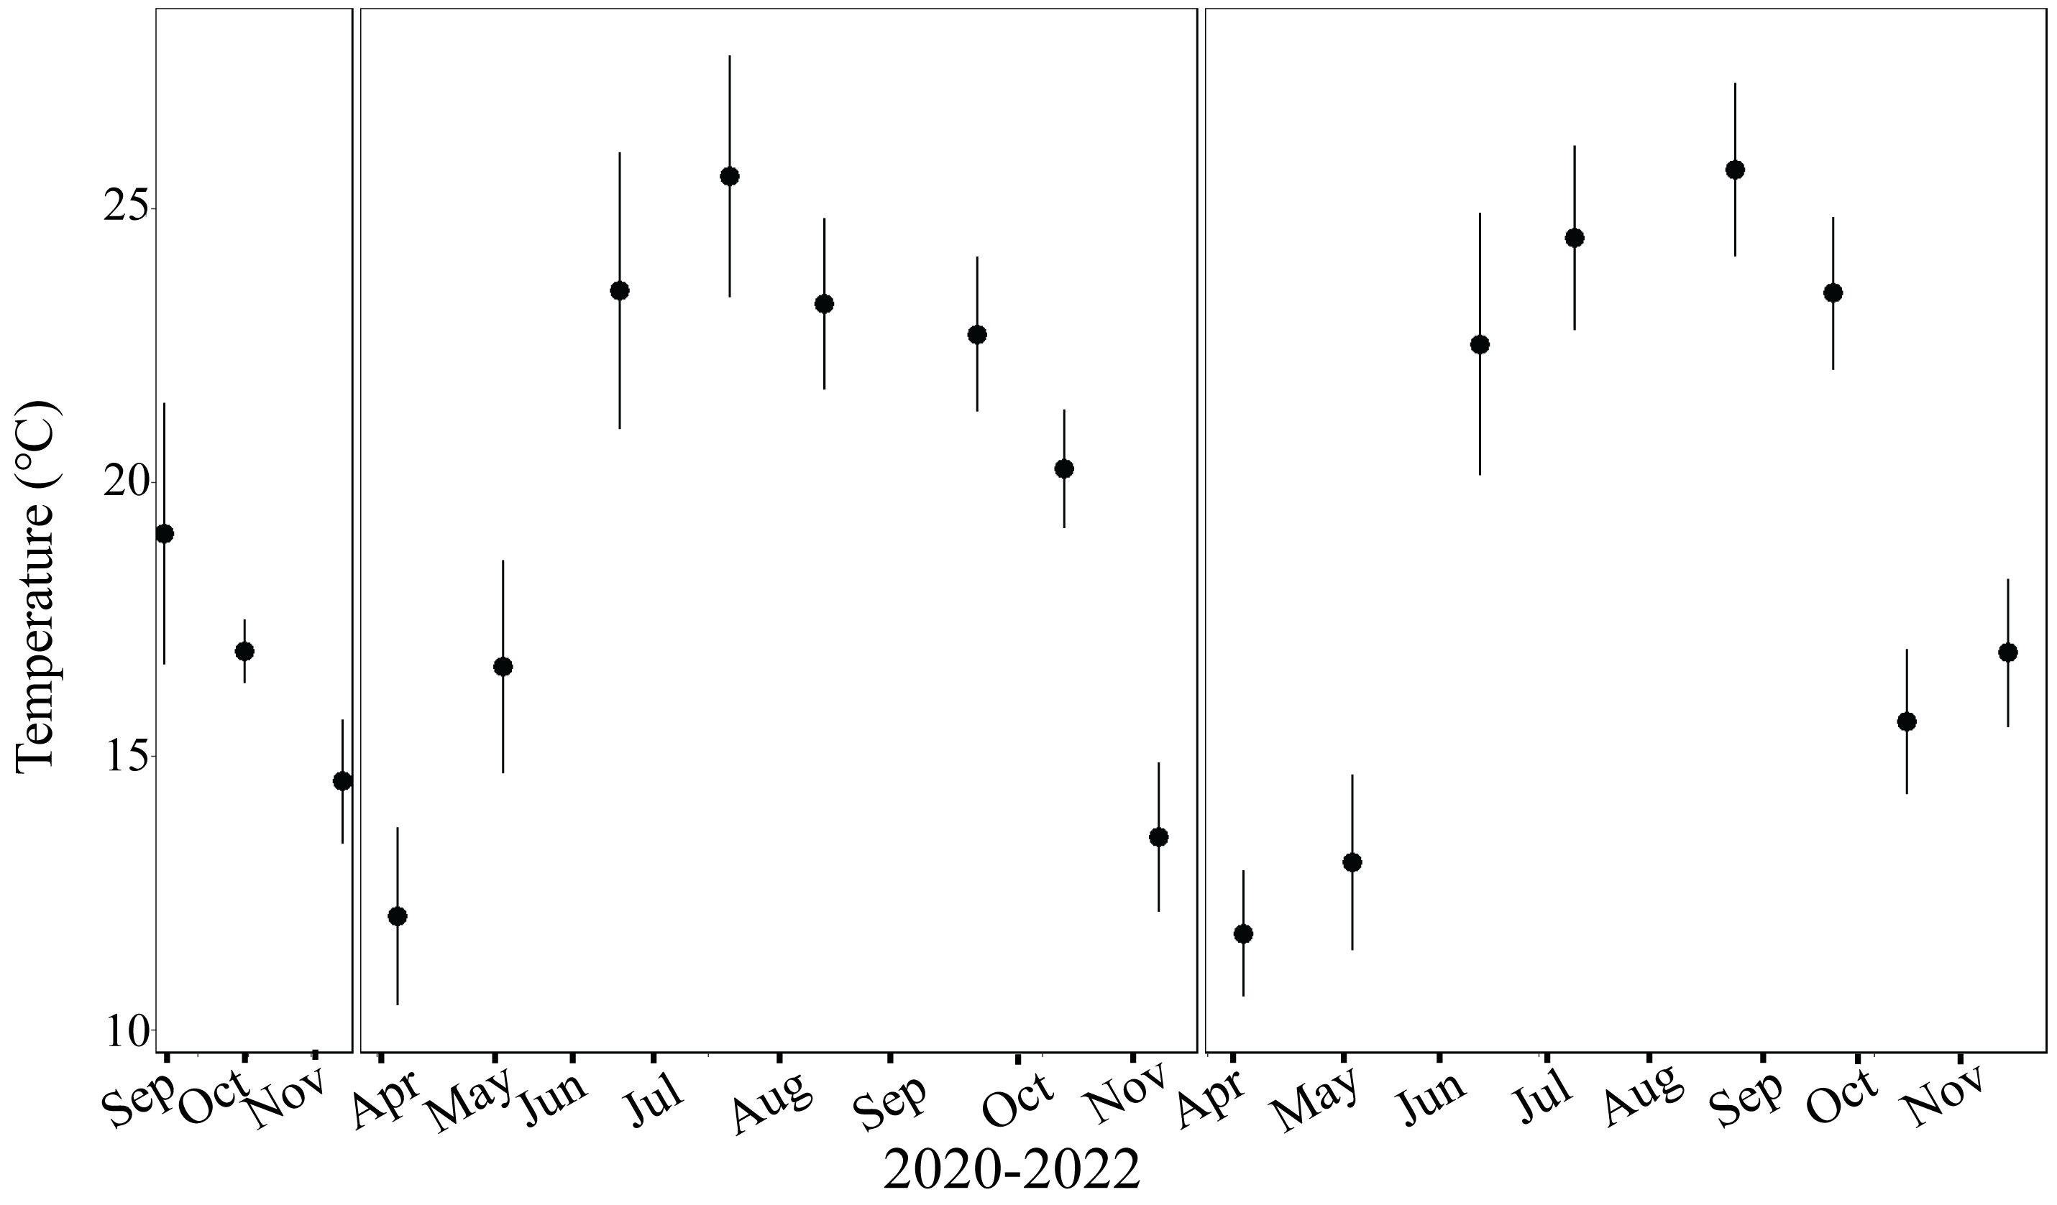Fig. S1 Average ± standard deviation Sea Surface Temperature (℃) measured with YSI at 11 sites in New Jersey from 2020-2022. (n=11)

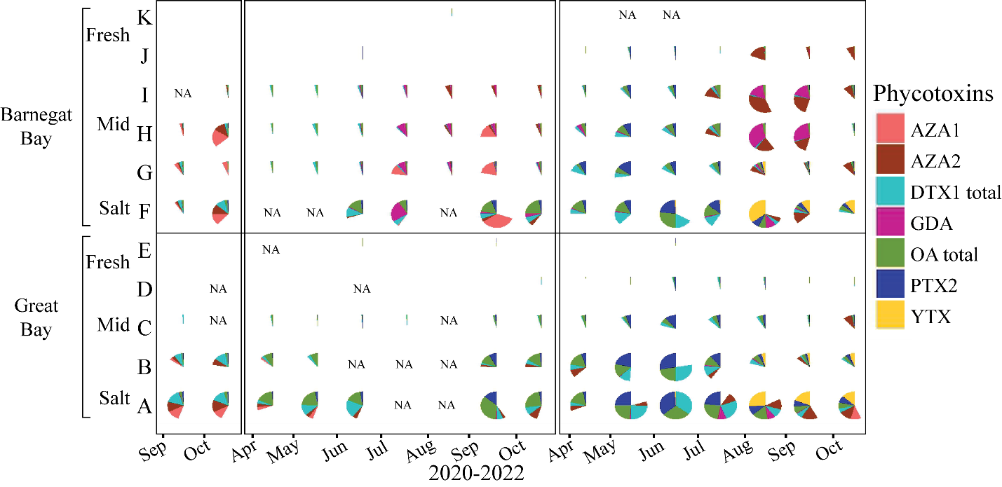
Fig. S2 Comparison of phycotoxins observed using solid phase adsorption toxin tracking devices (SPATTs) with each phycotoxin min-max normalized ($x^{'}=\frac{x-min⁡(x)}{\max\left(x\right)-min(x)})$ along 11 sites in two New Jersey estuaries from September 2020 – November 2022. NA = sample was lost

