Immediate and legacy effects of snow exclusion on soil fungal diversity and community composition

Li Zhang^{1 #}, Yuzhi Ren^{1 #}, Kaijun Yang², Zhijie Li³, Bo Tan¹, Yang Liu¹, Han Li¹, Chengming You¹, Sining Liu¹, Lixia Wang¹, Rui Yin⁴, Jian Zhang¹ and Zhenfeng Xu^{1, *}

¹Forestry Ecological Engineering in the Upper Reaches of the Yangtze River Key Laboratory of Sichuan Province & National Forestry and Grassland Administration Key Laboratory of Forest Resources Conservation and Ecological Safety on the Upper Reaches of the Yangtze River & Rainy Area of West China Plantation Ecosystem Permanent Scientific Research Base, Institute of Ecology & Forestry, Sichuan Agricultural University, Chengdu 611130, People’s Republic of China
²Global Ecology Unit CREAF-CSIC-UAB, CSIC, 08193 Barcelona, Catalonia, Spain
³Forschungszentrum Jülich GmbH, Agrosphere (IBG-3), Jülich, Germany
⁴Helmholtz-Centre for Environmental Research-UFZ, Department of Community Ecology, Theodor-Lieser-Strasse 4, 06110 Halle (Saale), Germany

# Joint first author
*Correspondence: xuzf@sicau.edu.cn

Table S1 Sequencing results and number of observed and estimated OTUs at the species level (70% 18S identity)
 | Number of joined fungal sequences by FLASH | Fungal sequence numbers in the OTU table by UPARSE | OTUs
ETP_C1 | 41008 | 11947 | 123
ETP_C2 | 31250 | 11947 | 99
ETP_C3 | 34419 | 11947 | 116
ETP_SE1 | 30383 | 11947 | 120
ETP_SE2 | 38255 | 11947 | 98
ETP_SE3 | 32512 | 11947 | 118
DSP_C1 | 39670 | 11947 | 137
DSP_C2 | 33164 | 11947 | 127
DSP_C3 | 20675 | 11947 | 134
DSP_SE1 | 25794 | 11947 | 135
DSP_SE2 | 30377 | 11947 | 128
DSP_SE3 | 41046 | 11947 | 128
MGS_C1 | 31801 | 11947 | 74
MGS_C2 | 39840 | 11947 | 92
MGS_C3 | 36408 | 11947 | 108
MGS_SE1 | 30002 | 11947 | 106
MGS_SE2 | 36565 | 11947 | 70
MGS_SE3 | 31204 | 11947 | 106
In total | 604373 | 215046
DSP: deep snow period; ETP: early thawing period; MGS: middle in the growing season. C: Control; SE: snow exclusion.
Table S2 Total and relative number of sequences and operational taxonomic units (OTUs) distributed to different fungal orders.
 | Ascomycota | No. of seqs | % of all seqs | No. of OTUs | % of OTUs
1 | Hypocreales | 32850 | 15.28 | 3 | 1.80
2 | Archaeorhizomycetales | 18397 | 8.55 | 2 | 1.20
3 | Eurotiales | 10156 | 4.72 | 3 | 1.80
4 | Sordariales | 8581 | 3.99 | 5 | 2.99
5 | Pezizales | 4796 | 2.23 | 7 | 4.19
6 | Pleosporales | 4026 | 1.87 | 4 | 2.40
7 | Helotiales | 4016 | 1.87 | 1 | 0.60
8 | Saccharomycetales | 1997 | 0.93 | 7 | 4.19
9 | Capnodiales | 1779 | 0.83 | 1 | 0.60
10 | Orbiliales | 1268 | 0.59 | 1 | 0.60
11 | Dothideales | 978 | 0.45 | 1 | 0.60
12 | Chaetothyriales | 958 | 0.45 | 1 | 0.60
13 | Botryosphaeriales | 955 | 0.44 | 1 | 0.60
14 | Microascales | 670 | 0.31 | 1 | 0.60
15 | Magnaporthales | 186 | 0.09 | 1 | 0.60
16 | Diaporthales | 80 | 0.04 | 1 | 0.60
17 | Jahnulales | 74 | 0.03 | 1 | 0.60
18 | Arachnomycetales | 49 | 0.02 | 1 | 0.60
 | Unclassified and norank Ascomycota | 12125 | 5.64 | 18 | 10.78
 | Ascomycota Total | 103941 | 48.33 | 60 | 35.93
 | Basidiomycota | No. of seqs | % of all seqs | No. of OTUs | % of OTUs
1 | Agaricales | 8823 | 4.10 | 4 | 2.40
2 | Tremellales | 2923 | 1.36 | 6 | 3.59
3 | Russulales | 547 | 0.25 | 1 | 0.60
4 | Trechisporales | 337 | 0.15 | 1 | 0.60
5 | Malasseziales | 163 | 0.08 | 1 | 0.60
6 | Sporidiobolales | 65 | 0.03 | 1 | 0.60
7 | Pucciniales | 34 | 0.02 | 1 | 0.60
 | Unclassified and norank Basidiomycota | 44297 | 20.60 | 18 | 10.78
 | Basidiomycota Total | 57189 | 26.59 | 33 | 19.76
 | Chytridiomycota | No. of seqs | % of all seqs | No. of OTUs | % of OTUs
 | Norank Chytridiomycota | 18230 | 8.48 | 27 | 16.17
 | Chytridiomycota Total | 18230 | 8.48 | 27 | 16.17
 | Glomeromycota | No. of seqs | % of all seqs | No. of OTUs | % of OTUs
 | Norank Glomeromycota | 1553 | 0.72 | 6 | 3.59
 | Chytridiomycota Total | 1553 | 0.72 | 6 | 3.59
 | LKM15 | No. of seqs | % of all seqs | No. of OTUs | % of OTUs
 | Norank LKM15 | 6943 | 0.32 | 10 | 6.00
 | LKM15 Total | 6943 | 0.32 | 10 | 6.00
 | Cryptomycota | No. of seqs | % of all seqs | No. of OTUs | % of OTUs
 | Norank Cryptomycota | 193 | 0.09 | 5 | 2.99
 | Cryptomycota Total | 193 | 0.09 | 5 | 2.99
 | Unclassified and norank fungi Total | 33246 | 15.46 | 26 | 15.57
Fig. S1 Seasonal dynamics of air temperature (2 m above the ground surface) and soil temperature (5 cm depth) from November 2015 to November 2016 and soil moisture (b) in control and snow exclusion plots. The dot indicates snow depth during the winter. The asterisk indicates the sampling period. The small chart shows air and soil temperatures in winter.

Fig. S2 One-way ANOVA test bar plot for fungal phyla in (a) control (C) plots and (b) snow exclusion (SE) plots. DSP: deep snow period; ETP: early thawing period; MGS: middle in the growing season. * indicated a significant difference among sampling dates for a same snow treatment.

Fig. S3 Wilcoxon rank-sum test bar plot for fungal phyla in the deep snow period (DSP), the early thawing period (ETP), and the middle in the growing season (MGS). C: Control; SE: snow exclusion. * indicated a significant difference between snow regimes on a specific sampling date.

Fig. S4 One-way ANOVA test bar plot for fungal genus in (a) control (C) plots and (b) snow exclusion (SE) plots. DSP: deep snow period; ETP: early thawing period; MGS: middle in the growing season. * indicated a significant difference among sampling dates for a same snow treatment.

Fig. S5 Wilcoxon rank-sum test bar plot for fungal genus in the deep snow period (DSP), the early thawing period (ETP), and the middle in the growing season (MGS). C: Control; SE: snow exclusion. * indicated a significant difference between snow regimes on a specific sampling date.
Fig. S1
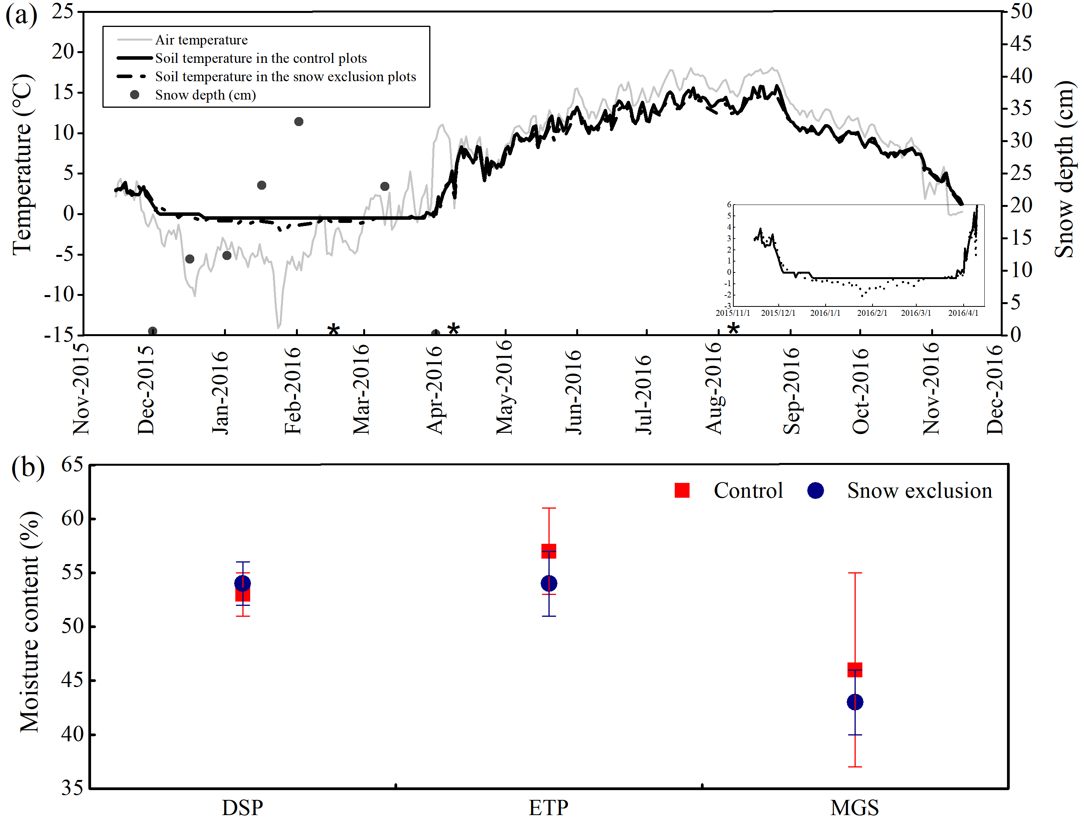
Fig. S2
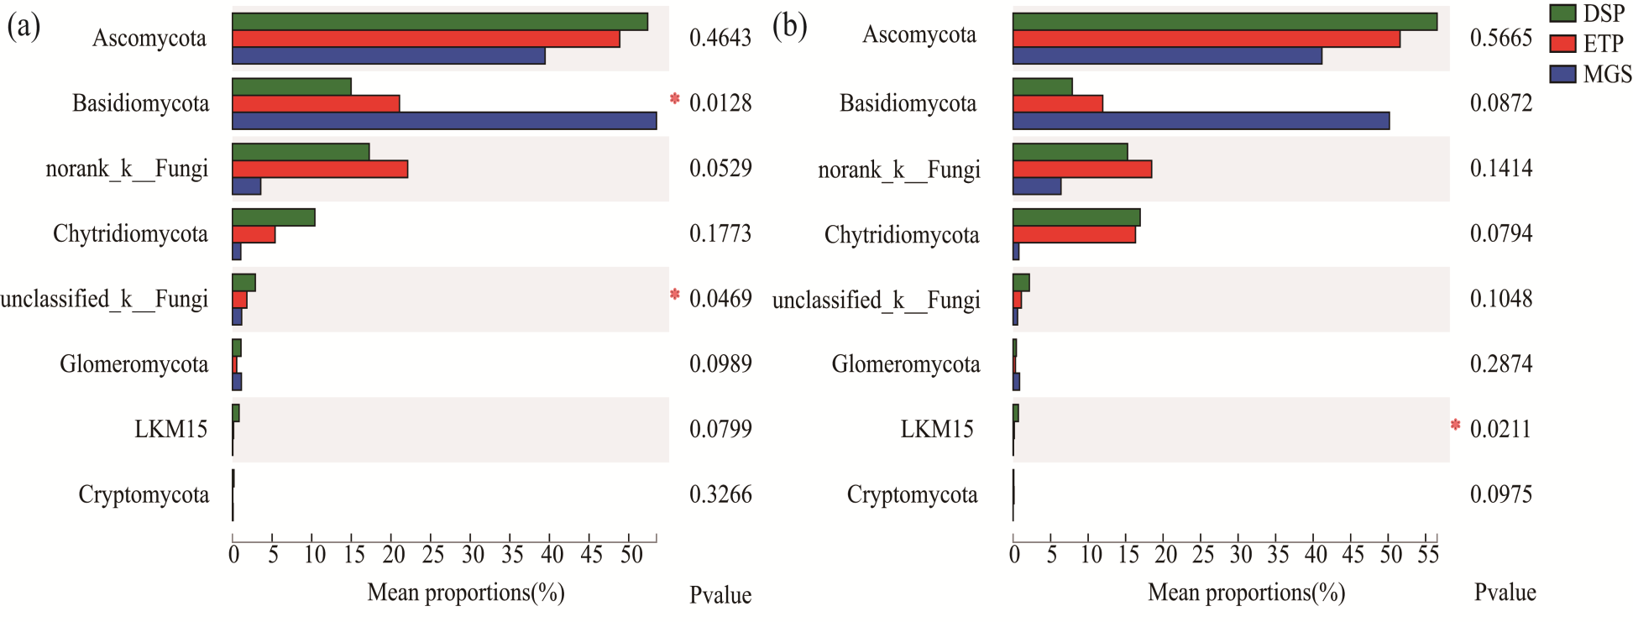
Fig. S3
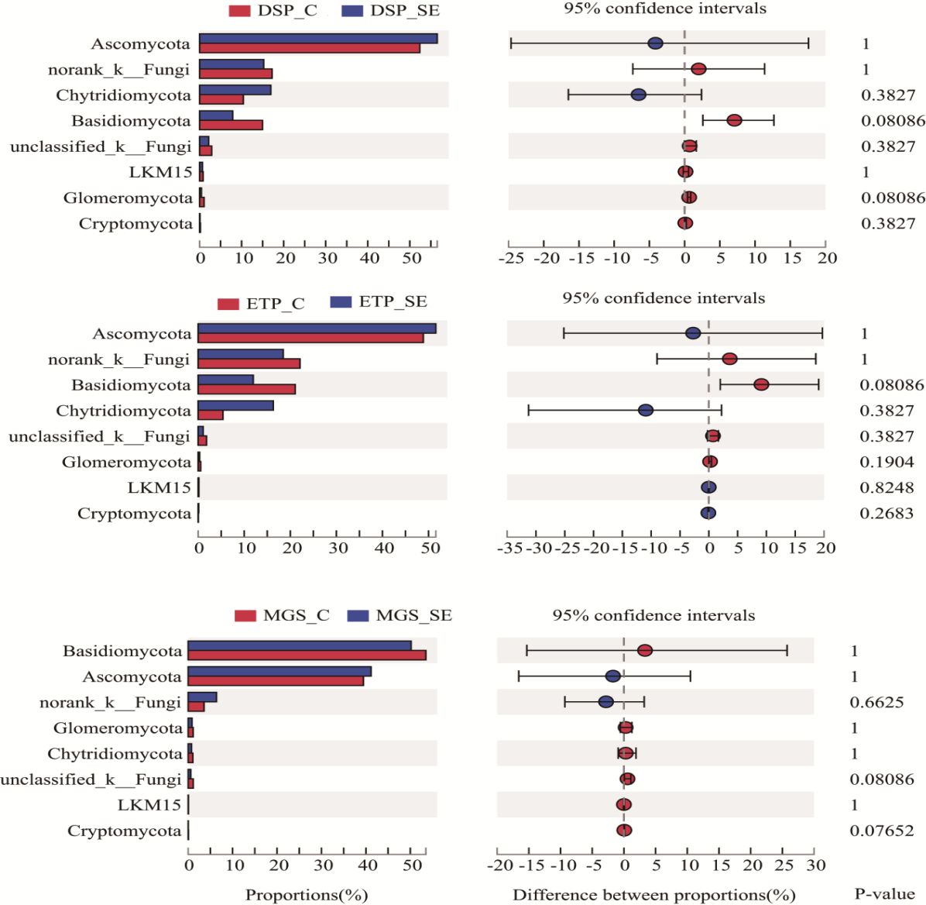
Fig. S4
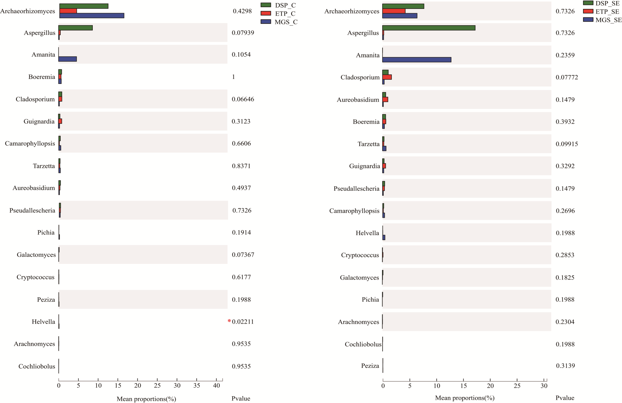
Fig. S5
