Supplementary file

Asynchronicity of deglacial permafrost thawing controlled by millennial-scale climate variability
Xinwei Yan, Xu Zhang*, Bo Liu, Huw T. Mithan, John Hellstrom, Sophie Nuber, Russell Drysdale, Junjie Wu, Fangyuan Lin, Ning Zhao, Yuao Zhang, Wengang Kang, Jianbao Liu*

*Corresponding authors: xuang@bas.ac.uk (X. Zhang); liujb@pku.edu.cn (J.B. Liu)

This file includes:

Supplementary Table 1

Supplementary Figures 1 to 13

Supplementary References
Supplementary Table 1: Ground surface temperature information for the Tibetan Plateau from model runs presented in this study.
Ground Surface Temperature | Annual  [°C] | Min  [°C] | Max  [°C]
piCTRL | -0.69 | -13.03 | 7.90
CTRL | -5.63 | -18.08 | 4.80
Hosing | -4.85 | -17.24 | 6.31

Supplementary Figures 1-13
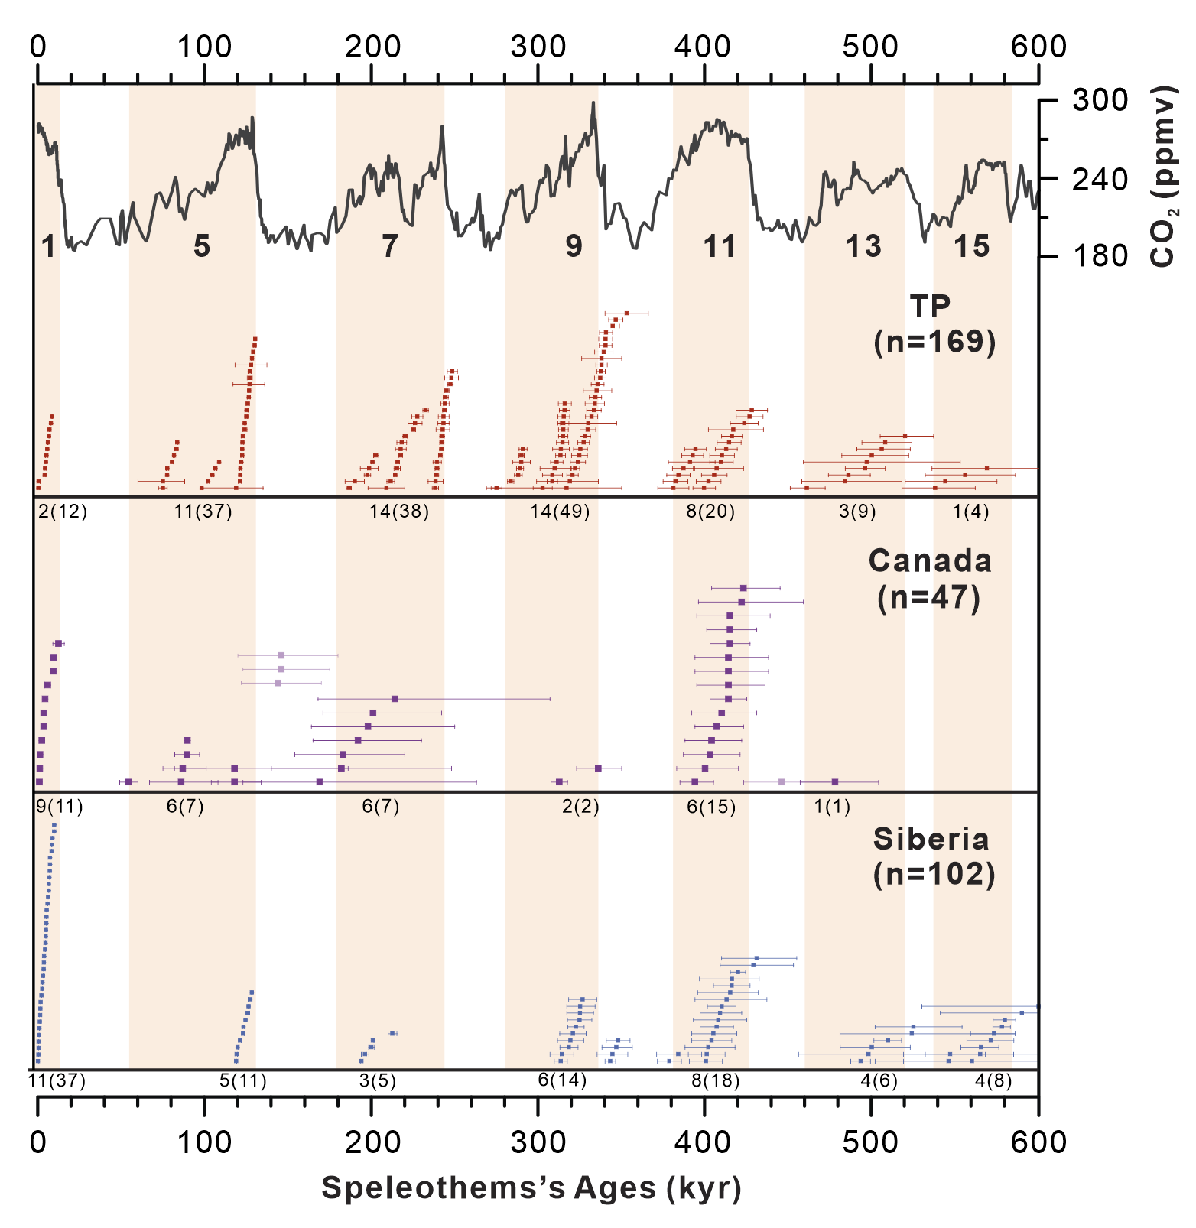
Supplementary Fig. 1 | Compiled speleothem ages. Individual U-Th/U-Pb ages with 95% uncertainties from published studies from Canadian, Siberian and Tibetan Plateau permafrost regions, the number below indicate the number of speleothems that grew and, in parentheses, the number of age determinations in each interglacial period(orange vertical bars). Also shown is the CO₂ record of EPICA Dome C¹, with interglacial Marine isotope stages (MIS) numbers below.
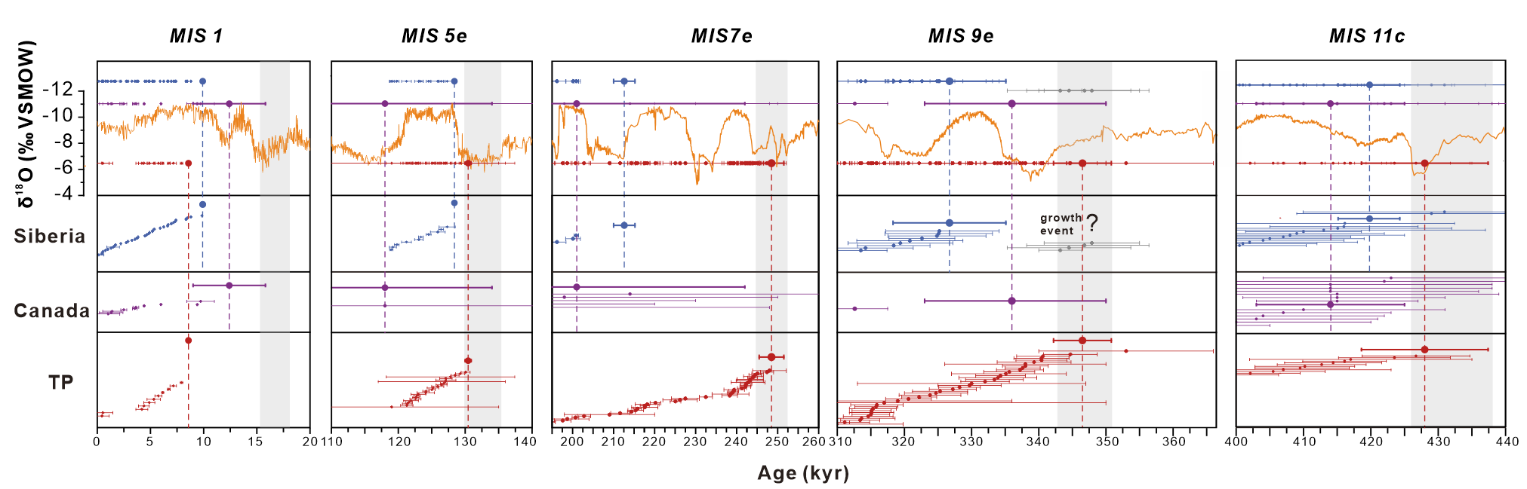
Supplementary Fig. 2 | Selection of the dates representing onset of continuous thawing during interglacial MIS 1 to MIS 11c. The panels show the distribution of Siberian (blue), Canadian (purple) and Tibetan Plateau (red) speleothem ages (±2σ) in time. The relatively large bold circle with error bars indicates the onset of continuous permafrost thawing in circumarctic (i.e. Canada and Siberia) and TP (Methods). The upper panel background is the East Asian Summer Monsoon composite records² (orange). The grey error bars of T-IV represent a temporary growth event. Vertical bars indicate the Terminal stadials.

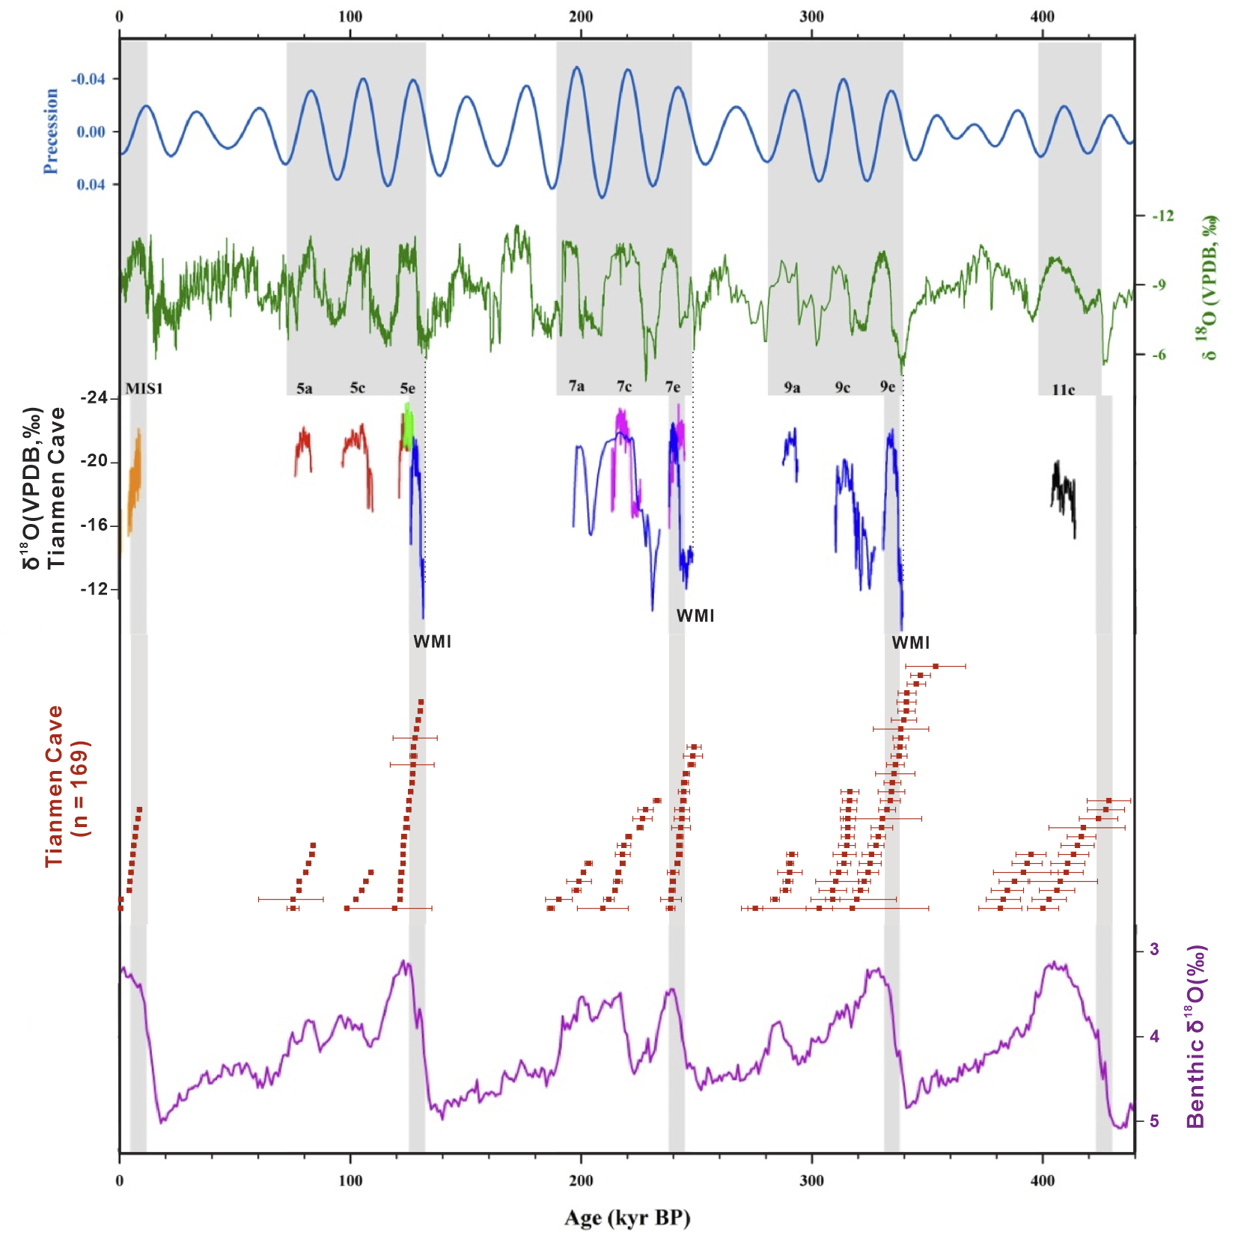
Supplementary Fig. 3 | Comparison of Tianmen cave records with East Asian Summer Monsoon composite records. From top to down, insolation precession³; East Asian Summer Monsoon composite δ¹⁸O records²; Tianmen cave δ¹⁸O record⁴, composed by six stalagmites in different colors, WMI indicates weak monsoon interval; ages with errors of Tianmen cave stalagmites; LR04 benthic δ¹⁸O stack⁵.
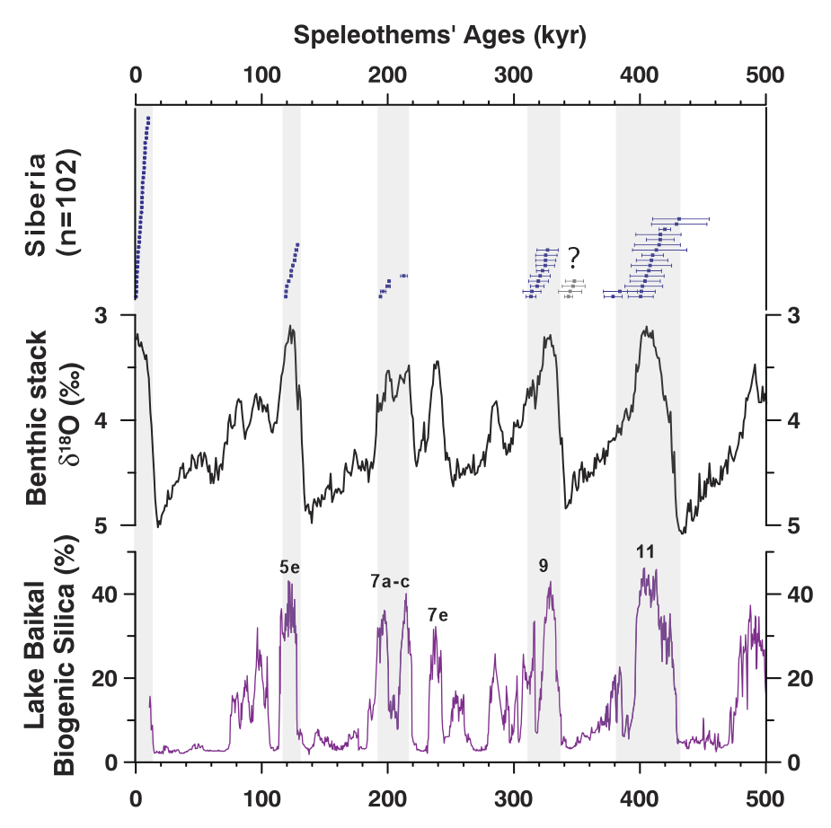
Supplementary Fig. 4 | Comparison of speleothems’ growth periods in Siberia with benthic stack δ¹⁸O record⁵ and Lake Baikal biogenic silica contents²⁷. The grey error bars of T-IV represent a temporary growth event.
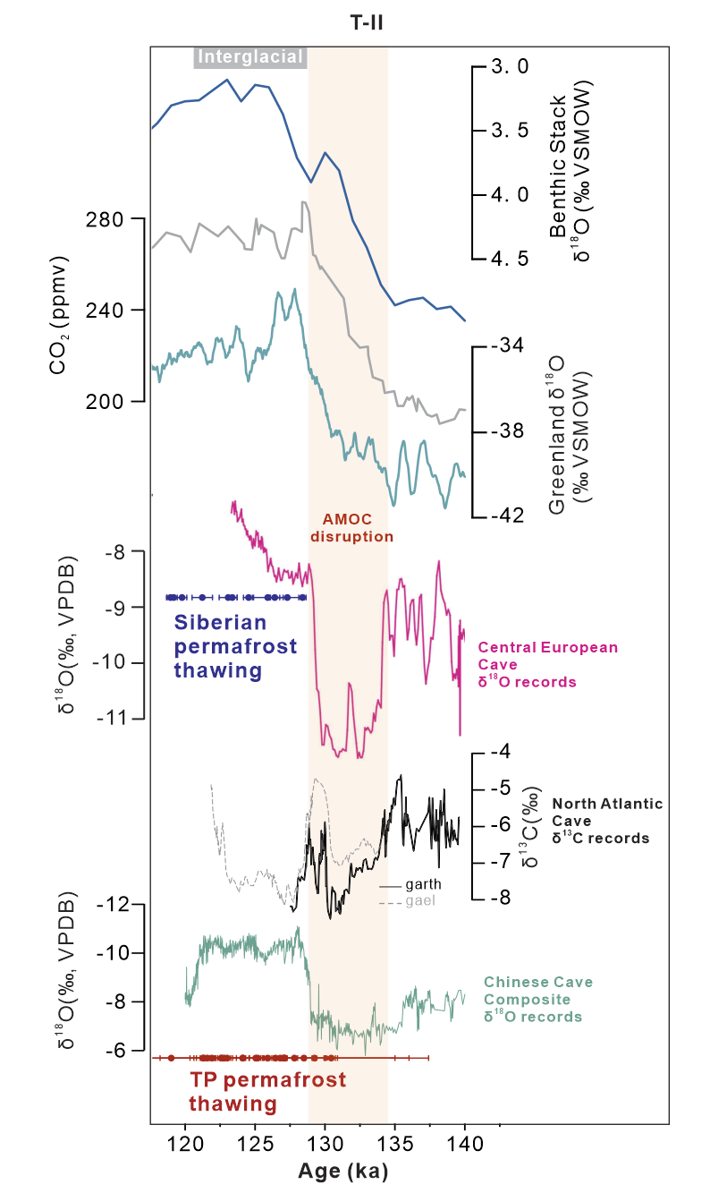
Supplementary Fig. 5 | Comparison of speleothem growth phase with speleothem records during T-II, also shown is the global climatic background. From top to bottom: Global benthic δ¹⁸O stack⁵; Atmospheric CO₂ concentration¹; Synthetic Greenland δ¹⁸O record⁶; Speleothem δ¹⁸O records of Central European⁷; Speleothem δ¹³C records of North Atlantic⁸; Chinese speleothem composite records². Orange vertical bars indicate the deglacial Atlantic meridional overturning circulation (AMOC) disruptions.
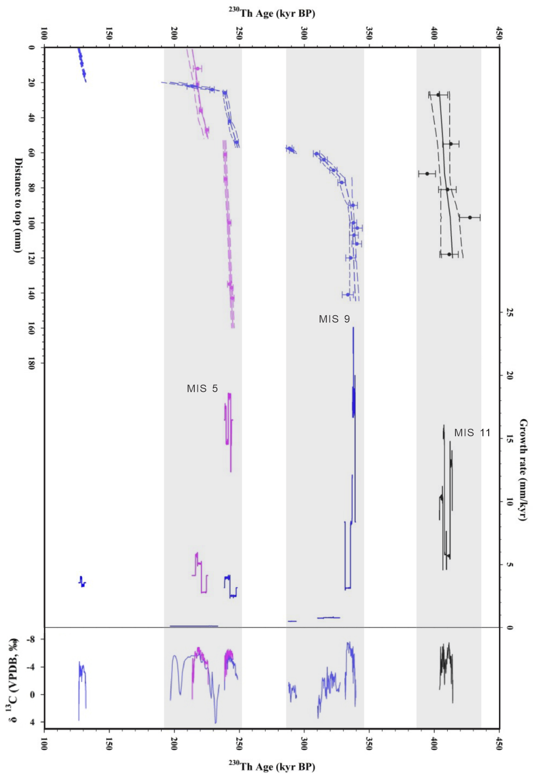
Supplementary Fig. 6 | Plots of age versus depth for stalagmites 19TM-2 (black), 19TM-3 (blue)and 19TM-5 (pink) from Tianmen cave and grow rate time series. The Tianmen speleothem δ¹³C record was shown in the bottom panel. Replotted from ref. (⁴).
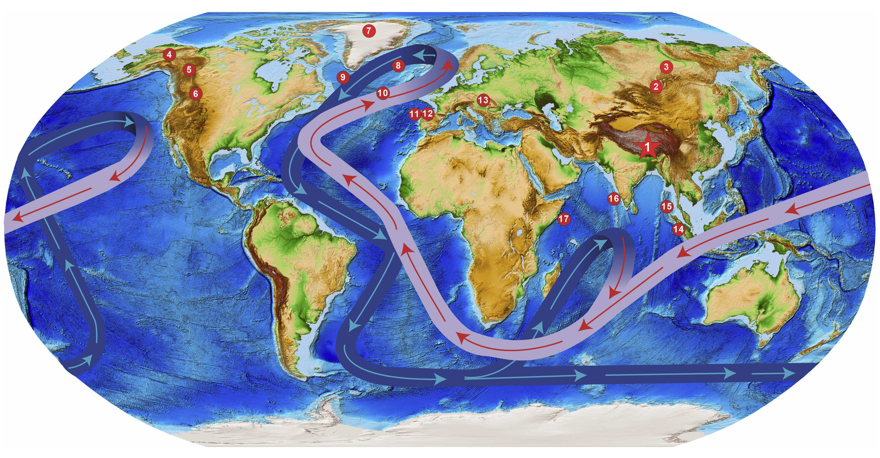
Supplementary Fig. 7 | Tibetan Plateau cave study area compared to other sites discussed in text and sites of importance. 1: Tianmen Cave site; 2-3: Okhotnichya, Botovskaya and Lenskaya Ledyanaya caves (Siberian permafrost region)⁹; 4-6:Caves of Northern Yukong, Nahanni and Southern Canadian Rockies (Canadian permafrost region); 7: North Greenland Ice Core Project (NGRIP)¹⁰; 8: ODP Site 983 (ref.¹¹); 9: MD03-2665&-2664 and Site U1305; 10: Site U1304; 11: SU81-18 and MD01-2444 of Iberian Margin; 12: Northwest Iberia cave⁸; 13: Central European cave⁷. 14: SO189-39KL (off Sumatra)¹²; 15: ADM-159 (Andaman Sea)¹³; 16: SK237-GC04 (Arabian Sea)¹⁴; 17: MD85674 (off East Africa)¹⁵. Global bathymetry data are available from the GEBCO website at https://doi.org/10.5285/1c44ce99-0a0d-5f4f-e063-7086abc0ea0f (GEBCO Compilation Group, 2024).
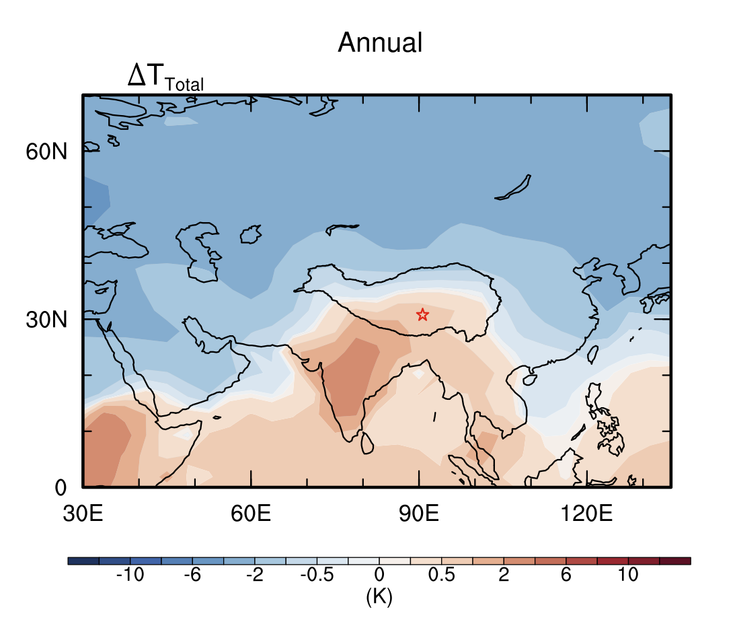
Supplementary Fig. 8 | Tibetan Plateau annual mean temperature anomaly in response to AMOC collapse.
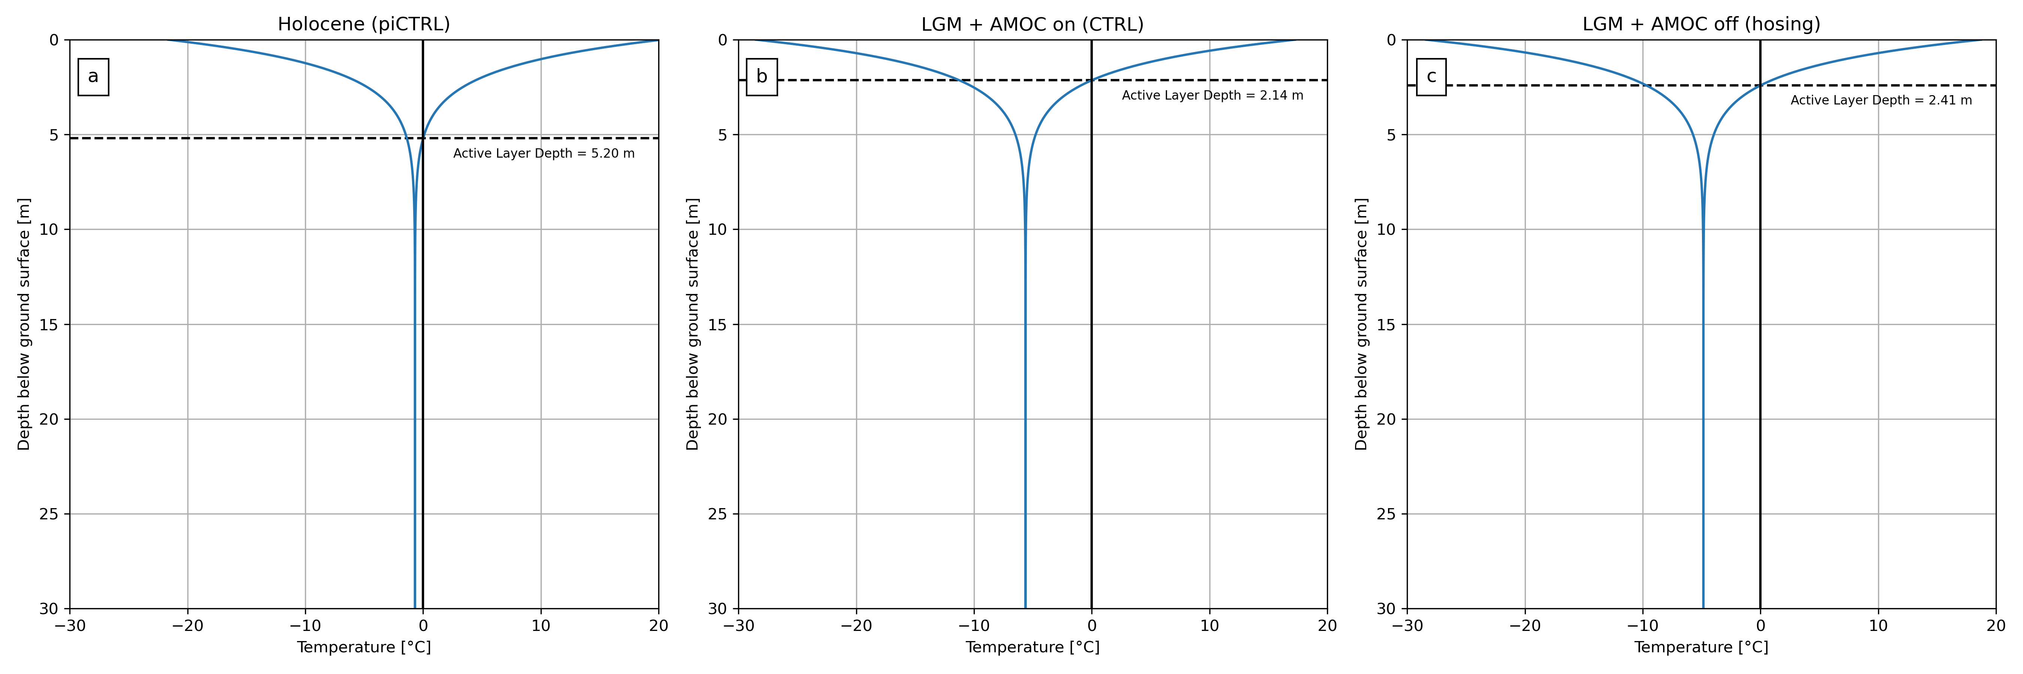
Supplementary Fig. 9 | Permafrost temperature plots for three global climate scenarios. (a) the Holocene, (b) the Last Glacial Maximum (LGM) with a glacial AMOC, and (c) during a “Heinrich Event” in the glacial setting where AMOC is collapsed.
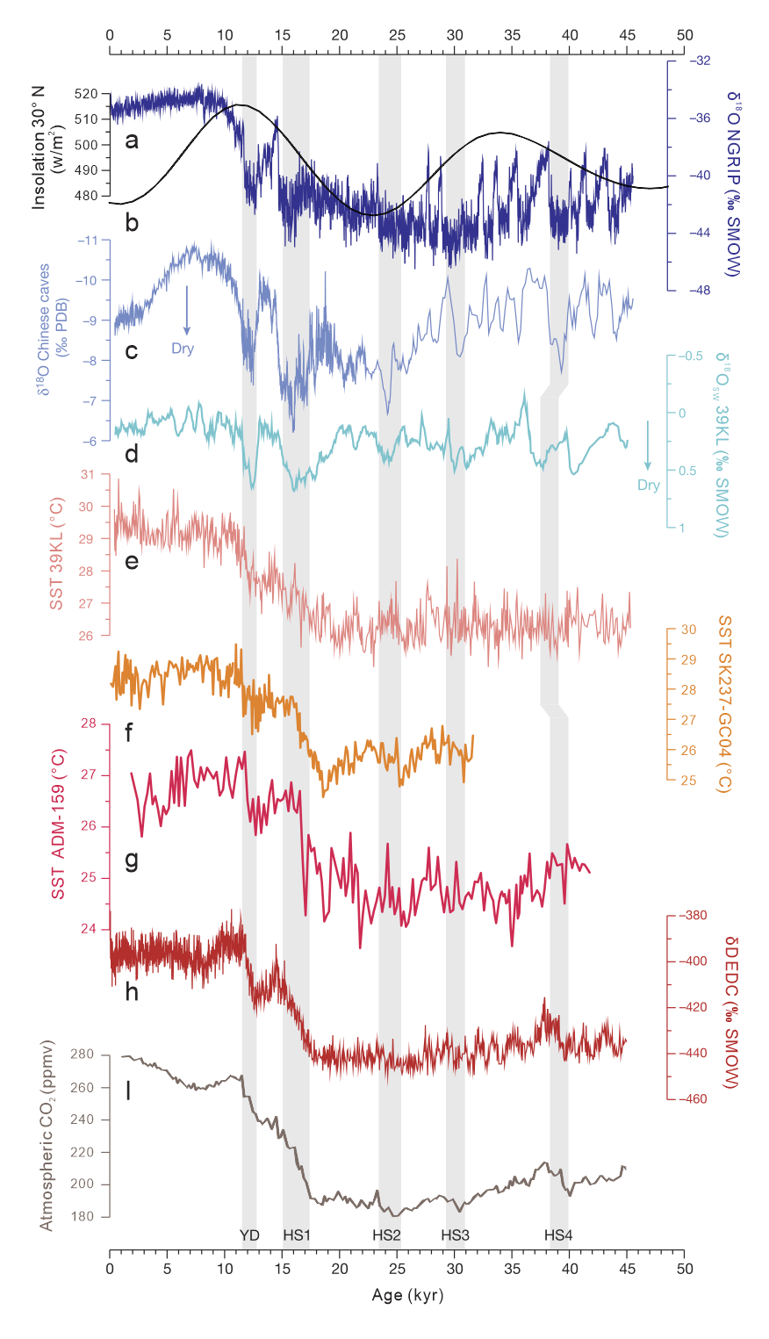
Supplementary Fig. 10 | Comparison of South Asian hydroclimate and Indian Ocean sea surface temperature (SST) data with other records of paleoclimate. a: δ¹⁸O data of Greenland ice core NGRIP¹⁶; b: The 30°N summer insolation¹⁷; c: Asian summer monsoon strength as given by a composite Chinese cave speleothem δ¹⁸O record²; d: sea-level-corrected δ¹⁸O_{SW} of core SO189-39KL off western Sumatra¹²; e: Sea surface temperature reconstruction at site SO189-39KL off western Sumatra¹², f: SST reconstruction at site SK237-GC04 of Arabian Sea¹⁴, g: SST reconstruction at site ADM-159 of Andaman Sea¹³. h: δD data from the EPICA Dome C ice core¹⁸. i: Atmospheric CO₂ record from the EPICA Dome C ice core¹⁹. Grey bars indicate the Younger Dryas (YD), and Heinrich stadials (HSs) 1 to 4 as recorded in North Atlantic deep-sea cores²⁰.
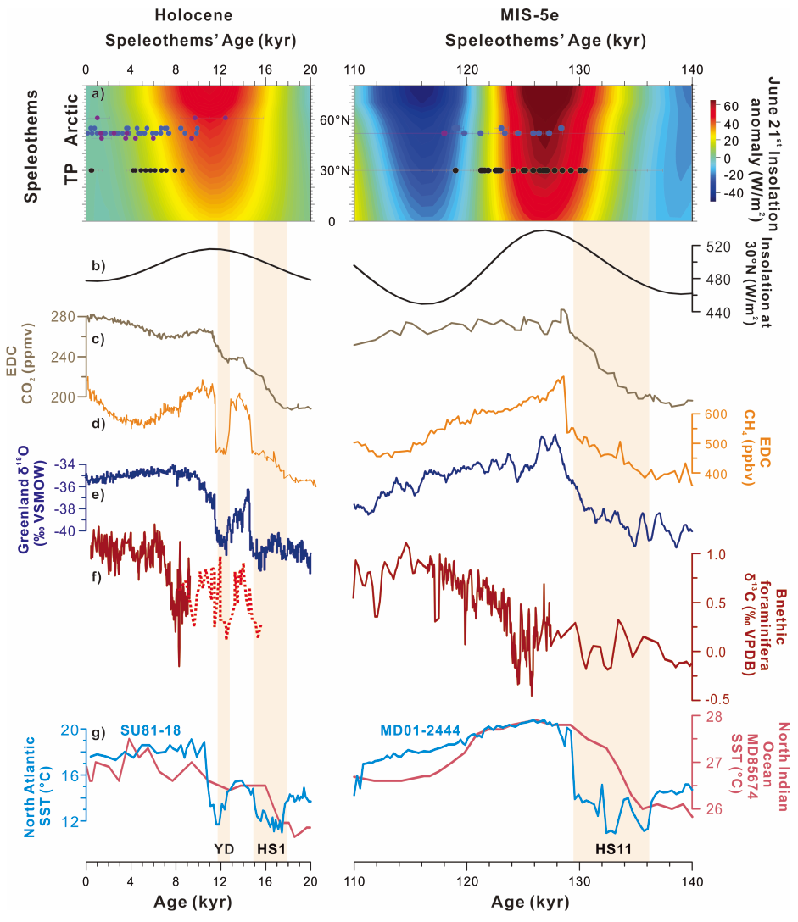
Supplementary Fig. 11 | Forcing, climatic records and permafrost thawing across the Holocene (left) and the Last Interglacial (LIG, right). (a) Distribution of speleothem U–Th ages (±2σ) in Canadian (purple), Siberian (blue) and Tibetan Plateau (black) caves in time (ka) and space (latitude ° N). The background is 21st June insolation as anomalies relative to their average value of the last 1000 years across latitudes. (b) Summer insolation at 30 °N (orange)¹⁷ and EASM composite records (green)². (c, d) CH₄ and CO₂ records, respectively, of EPICA Dome C^{1,21}. (e) NGRIP Greenland δ¹⁸O record¹⁰ (Holocene). Synthetic Greenland δ¹⁸O record⁶ (MIS 5e). (f) C. wuellerstorfi δ¹³C from the Eirik Drift (MD03-2665&-2664)^{22,23} (solid line) and IODP Site U1304 in North Atlantic²⁴ (dashed line). (g) Sea surface temperature reconstructions from North Indian Ocean¹⁵ (based on UK’37, red) and North Atlantic (Iberian margins; based on UK’37, blue)^{25,26}. Orange boxes indicates deglacial Herich Events.
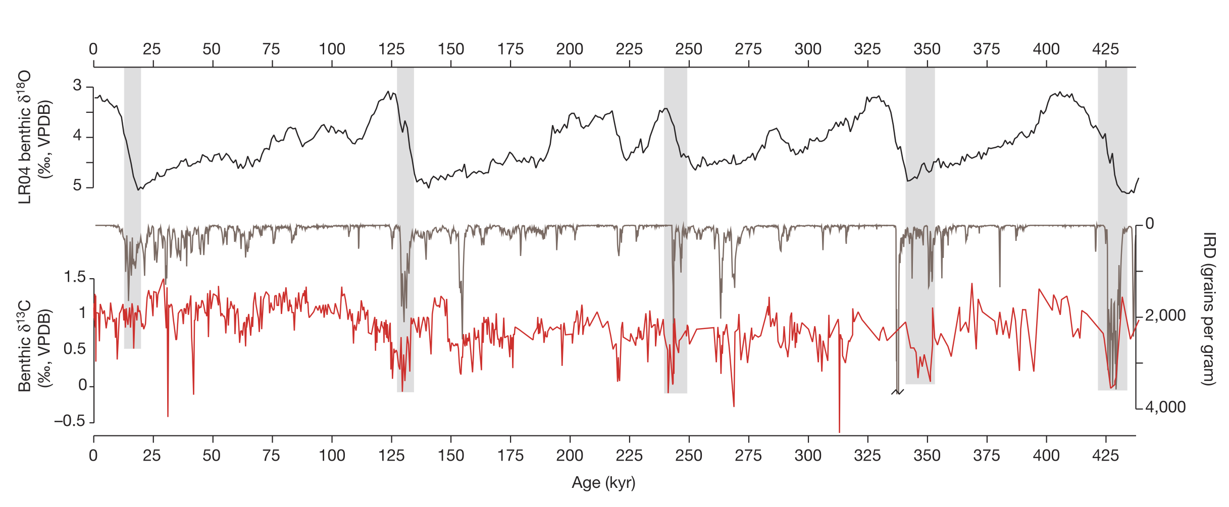
Supplementary Fig. 12 | The ice rafted debris (IRD) abundance and carbon isotope of benthic foraminifera in the ODP Site 983. Vertical bars indicate the terminations. Replotted from ref. (¹¹).
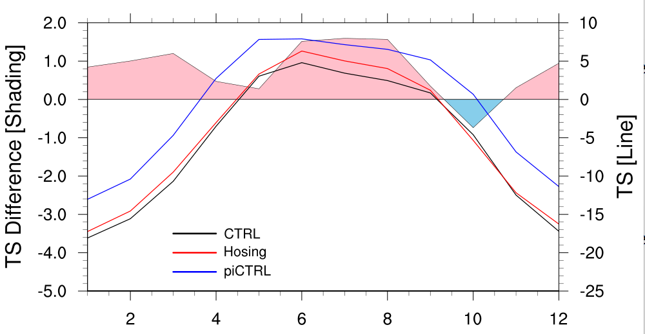
Supplementary Fig. 13 | Simulated temperatures on Tianmen Cave in Pre-industrial (piCTRL), the Last Glacial Maximum (CTRL) and the LGM hosing (Hosing) experiments. Summer warming anomaly in Hosing is evident in comparison to CTRL.
Supplementary References
1. Lüthi, D. et al. High-resolution carbon dioxide concentration record 650,000–800,000 years before present. Nature 453, 379–382 (2008).
2. Cheng, H. et al. The Asian monsoon over the past 640,000 years and ice age terminations. Nature 534, 640–646 (2016).
3. Berger, A. L. Long-Term Variations of Caloric Insolation Resulting from the Earth’s Orbital Elements. Quat. Res. 9, 139–167 (1978).
4. Wang, H. et al. Orbital-scale hydroclimate variations in the southern Tibetan Plateau over the past 414,000 years. Quat. Sci. Rev. 291, 107658 (2022).
5. Lisiecki, L. E. & Raymo, M. E. A Pliocene-Pleistocene stack of 57 globally distributed benthic δ18O records. Paleoceanography 20, (2005).
6. Barker, S. et al. 800,000 Years of Abrupt Climate Variability. Science 334, 347–351 (2011).
7. Koltai, G. et al. A penultimate glacial climate record from southern Hungary. J. Quat. Sci. 32, 946–956 (2017).
8. Stoll, H. M. et al. Rapid northern hemisphere ice sheet melting during the penultimate deglaciation. Nat. Commun. 13, 3819 (2022).
9. Cheung, M.-C., Zong, Y., Zheng, Z., Liu, Z. & Aitchison, J. C. Holocene temperature and precipitation variability on the central Tibetan Plateau revealed by multiple palaeo-climatic proxy records from an alpine wetland sequence. The Holocene 27, 1669–1681 (2017).
10. Wolff, E. W., Chappellaz, J., Blunier, T., Rasmussen, S. O. & Svensson, A. Millennial-scale variability during the last glacial: The ice core record. Quat. Sci. Rev. 29, 2828–2838 (2010).
11. Barker, S. et al. Icebergs not the trigger for North Atlantic cold events. Nature 520, 333–336 (2015).
12. Mohtadi, M. et al. North Atlantic forcing of tropical Indian Ocean climate. Nature 509, 76–80 (2014).
13. Liu, S. et al. Paleoclimatic responses in the tropical Indian Ocean to regional monsoon and global climate change over the last 42 kyr. Mar. Geol. 438, 106542 (2021).
14. Saraswat, R., Lea, D. W., Nigam, R., Mackensen, A. & Naik, D. K. Deglaciation in the tropical Indian Ocean driven by interplay between the regional monsoon and global teleconnections. Earth Planet. Sci. Lett. 375, 166–175 (2013).
15. Bard, E., Rostek, F. & Sonzogni, C. Interhemispheric synchrony of the last deglaciation inferred from alkenone palaeothermometry. Nature 385, 707–710 (1997).
16. Svensson, A. et al. A 60 000 year Greenland stratigraphic ice core chronology. Clim. Past 4, 47–57 (2008).
17. Laskar, J. et al. A long-term numerical solution for the insolation quantities of the Earth. Astron. Astrophys. 428, 261–285 (2004).
18. Parrenin, F. et al. Synchronous Change of Atmospheric CO2 and Antarctic Temperature During the Last Deglacial Warming. Science 339, 1060–1063 (2013).
19. Bereiter, B. et al. Revision of the EPICA Dome C CO2 record from 800 to 600 kyr before present. Geophys. Res. Lett. 42, 542–549 (2015).
20. Hemming, S. R. Heinrich events: Massive late Pleistocene detritus layers of the North Atlantic and their global climate imprint. Rev. Geophys. 42, (2004).
21. Loulergue, L. et al. Orbital and millennial-scale features of atmospheric CH4 over the past 800,000 years. Nature 453, 383–386 (2008).
22. Kleiven, H. (Kikki) F. et al. Reduced North Atlantic Deep Water Coeval with the Glacial Lake Agassiz Freshwater Outburst. Science 319, 60–64 (2008).
23. Galaasen, E. et al. Rapid Reductions in North Atlantic Deep Water During the Peak of the Last Interglacial Period. Science 343, (2014).
24. Galaasen, E. V. et al. Interglacial instability of North Atlantic Deep Water ventilation. Science 367, 1485–1489 (2020).
25. Tzedakis, P. C. et al. Enhanced climate instability in the North Atlantic and southern Europe during the Last Interglacial. Nat. Commun. 9, 4235 (2018).
26. Bard, E., Rostek, F., Turon, J.-L. & Gendreau, S. Hydrological Impact of Heinrich Events in the Subtropical Northeast Atlantic. Science 289, 1321–1324 (2000).
27. Prokopenko, A. A. et al. Biogenic Silica Record of the Lake Baikal Response to Climatic Forcing during the Brunhes. Quat. Res. 55, 123–132 (2001).

