Supplemental material 1 for: Sexual dimorphism and morphological integration in the orchid bee brain
Supplemental Figure 1 Summary of the length (black line) and width (grey line) of the head capsule measured for Euglossa dilemma males and females

Supplemental Table 1- Summary statistics for each standardized major axis regression
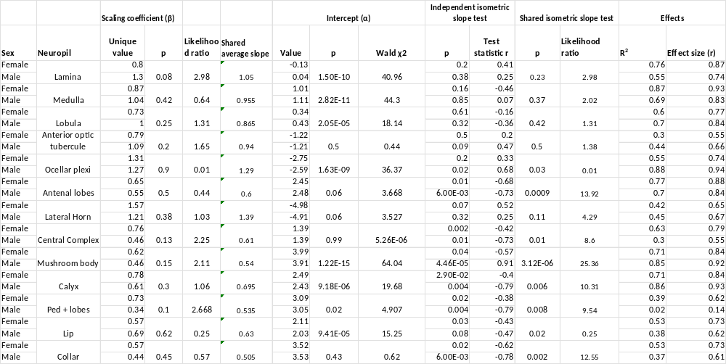

Supplemental Table 2-Relative increased investment of sexually dimorphic regions with fitted shared slope
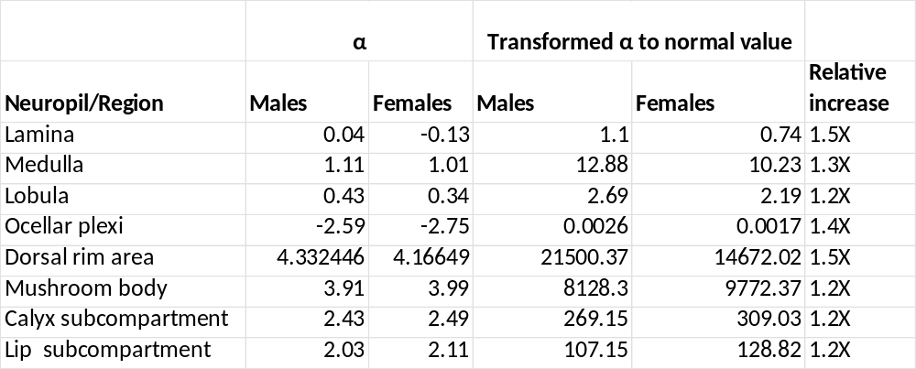

Supplemental Figure 2 A single micro-CT slice showing the cornea thickness of the compound eye dorsal most area (aquamarine) and its thinning threshold at the dorsal most margin with a subsequent protrusion corresponding to the start of dorsal rim area, which expands from the orange line onwards to the end of the eye (white arrow)

Supplemental Figure 3. Method testing on: Left panel: Megalopa sp .Right panel: Syrphid fly Eristalis arbostorum , commonly known as the European drone. Material was kindly donated by Javier Luque and Peter Coggan, respectively.

Supplemental Figure 4- Specimen mounting for optimized scanning times with set coordinates and automatic stage movement along the y axis

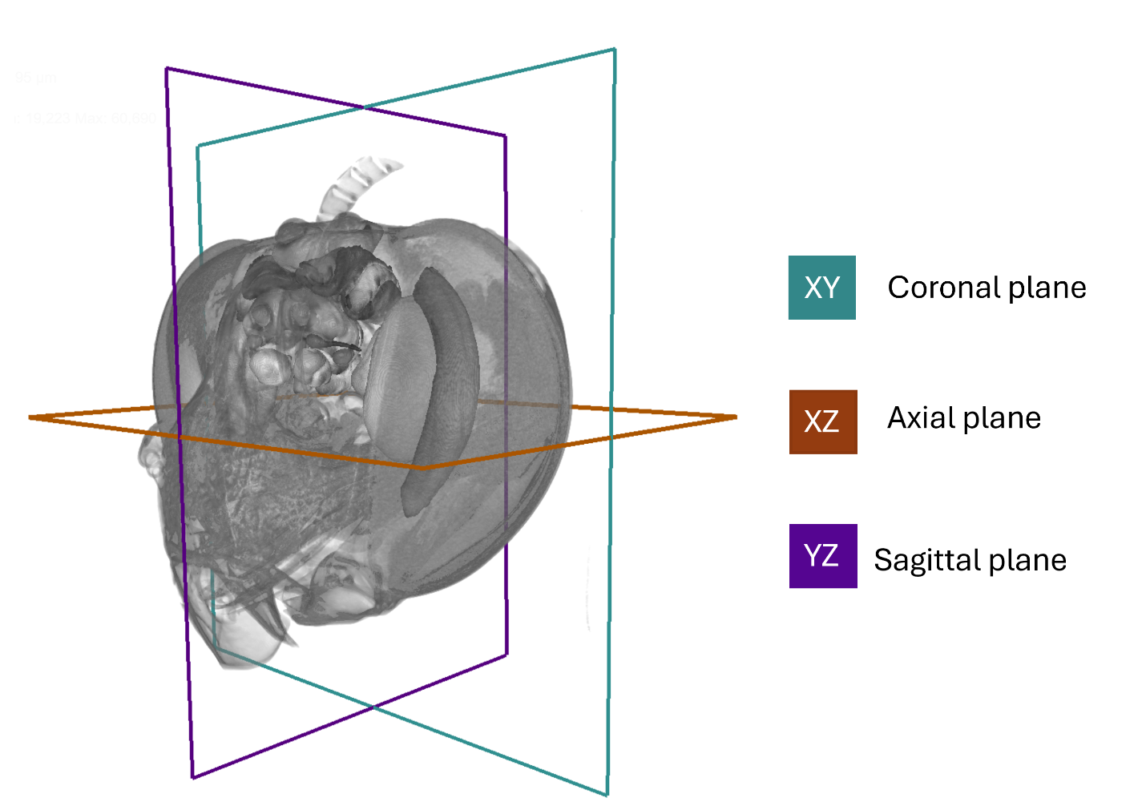
Supplemental Figure 5- Visible planes on each micro-CT scans volume acquisition

Supplemental Figure 6- Image alignment and registration prior to segmentation. Upper panel shows the fixed female scan template (amber color pallet), with a raw scan not yet aligned (grey color pallet). Lower panel shows the result after image alignment and rigid registration.

Supplemental Figure 7- Partial correlation matrices for Euglossa dilemma A) males and B) females. Non-significant correlations are crossed-out and asterisks indicate p.values close to 0.05, showing a trend towards significance

