Supplemental document

Table S1. Percentage of Variance Explained by cognitive domain principal component analysis factors at ARIC midlife and late-life
 | Memory | Executive Function | Global Cognitive Function
ARIC midlife (N=4,783) | 74% | 54% | 48%
ARIC late-life (N=5,123) | 74% | 55% | 49%

Table S2. Top (based on effect estimates) overlapping* proteins between midlife and late-life

uniprot_id | Protein Name | Mechanisms of action | Midlife effect estimates | Late-life effect estimates
P41222 | Prostaglandin-H2 D-isomerase (HPGDS) | Catalyzes both the conversion of PGH2 to PGD2, a prostaglandin involved in smooth muscle contraction/relaxation and a potent inhibitor of platelet aggregation, and the conjugation of glutathione with a wide range of aryl halides and organic isothiocyanates. Also exhibits low glutathione-peroxidase activity towards cumene hydroperoxide. | 1.09 | 0.36
P51884 | Lumican (LUM) | Belongs to the small leucine-rich proteoglycan (SLRP) family. | 1.48 | 0.31
Q01995 | Transgelin (TAGLN) | Involved in calcium interactions and contractile properties of the cell that may contribute to replicative senescence; Belongs to the calponin family. | 1.60 | 1.38
Q9H5V8 | CUB domain-containing protein 1 (CDCP1) | Belongs to the tetraspanin web involved in tumor progression and metastasis. | 0.75 | 0.51
P21246 | Pleiotrophin (PTN) | Regulates many processes like cell proliferation, cell survival, cell growth, cell  differentiation, and cell migration in several  tissues, namely neurons and bone. | 1.68 | 2.16
Q76M96 | Coiled-coil domain-containing protein 80 (CCDC80) | Promotes cell adhesion and matrix assembly. | 1.00 | 0.43
Q9BU40 | Chordin-like protein 1 (CHRDL1) | Antagonizes the function of BMP4 by binding to it and preventing its interaction with receptors. Alters the fate commitment of neural stem cells from gliogenesis to neurogenesis. Contributes to neuronal differentiation of neural stem cells in the brain by preventing the adoption of a glial fate. | 1.95 | 2.25
Q99988 | Growth/differentiation  factor 15 (GDF15) | Regulates food intake, energy expenditure,  and body weight in response to metabolic  and toxin-induced stresses. | 1.01 | 0.06
Q9UM47 | Neurogenic locus notch homolog protein 3 (NOTCH3) | Functions as a receptor for membrane-bound ligands Jagged1, Jagged2 and Delta1 to regulate cell-fate determination. Upon ligand activation through the released notch intracellular domain (NICD). It forms a transcriptional activator complex with RBPJ/RBPSUH and activates genes of the enhancer of split locus. Affects the implementation of differentiation, proliferation and apoptotic programs (By similarity). | 0.93 | 1.33
Q9NQ79 | Cartilage acidic protein 1 (CRTAC1) | Inhibits cell proliferation, migration, invasion and epithelial-mesenchymal transition (EMT) process in bladder cancer by downregulating Yin Yang 1 (YY1) to inactivate the TGF-beta pathway. | 0.97 | 0.76
O76076 | WNT1-inducible-signaling pathway protein 2 (CCN5) | Promotes the adhesion of osteoblast cells and inhibits the binding of fibrinogen to integrin receptors. | 1.58 | 1.83
Q2I0M5 | R-spondin-4 (RSPO4) | Activator of the canonical Wnt signaling pathway by acting as a ligand for LGR4-6 receptors. Also regulates the canonical Wnt/beta-catenin-dependent pathway and non-canonical Wnt signaling by acting as an inhibitor of ZNRF3. | 0.59 | 0.58
Q12805 | EGF-containing fibulin-like extracellular matrix protein 1 (EFEMP1) | Binds EGFR, the EGF receptor, inducing EGFR autophosphorylation and the activation of downstream signaling pathways. May play a role in cell adhesion and migration. | 0.51 | 0.62
Q96GP6 | Scavenger receptor class F member 2 (SCARF2) | Mediates homophilic and heterophilic interactions. | 2.37 | 1.21
*From 270 overlapping proteins between midlife and late-life, top 10 proteins based on effect estimates were selected at both midlife and late-life. Among them 6 were both at midlife and late-life which ended in 14 proteins presented here.

Table S3. Average PAC in ARIC and MESA stratified by race.

 | Black | White | Chinese | Hispanic
ARIC
 | N=1322 | N=4098
Mean (SD) PAC ARIC midlife | 57.0 (4.4) | 58.0 (4.5) | NA | NA
Pearson correlation with chronological age | 0.80 | 0.84
 | N=420 | N=1696
Mean (SD) PAC ARIC late-life | 75.2 (3.4) | 76.5 (3.7) | NA | NA
Pearson correlation with chronological age | 0.70 | 0.80
MESA
 | N=1042 | N=1703 | N=446 | N=866
Mean (SD) PAC using ARIC midlife PAC | 54.6 (6.0) | 55.5 (6.5) | 56.4 (6.2) | 55.5 (6.4)
Pearson correlation with chronological age | 0.90 | 0.93 | 0.92 | 0.92
 | N=1042 | N=1703 | N=446 | N=866
Mean (SD) PAC using ARIC late-life PAC | 66.9 (3.5) | 66.8 (4.0) | 67.5 (3.7) | 66.9 (4.0)
Pearson correlation with chronological age | 0.85 | 0.89 | 0.88 | 0.87

Table S4A. Characteristics at ARIC midlife and late-life by dementia incidence – dementia as an outcome sample size.
 | ARIC Midlife |  |  | ARIC Late-life
Characteristics | Total  (N=5,420) | Dementia-free (N=3,169) | Develop Dementia (N=2,251) | Total  (N=2,116) | Dementia-free (N=1,409) | Develop Dementia (N=707)
Demographics
Mean age, years (SD) | 58.3 (5.7) | 57.0 (5.6) | 60.1 (5.3) | 76.8 (5.3) | 75.5 (4.8) | 79.3 (5.4)
Gender (N Female, %) | 3,088 (57.0) | 1,744 (55.0) | 1,344 (59.7) | 1,196 (56.5) | 805 (57.1) | 391 (55.3)
Race Group (N, %)
Black | 1,322 (24.4) | 695 (21.9) | 627 (27.9) | 420 (19.8) | 239 (17.0) | 181 (25.6)
White | 4,098 (75.6) | 2,474 (78.1) | 1,624 (72.1) | 1,696 (80.2) | 1,170 (83.0) | 526 (74.4)
Education (N, %)
Less than High School | 1,283 (23.7) | 639 (20.2) | 644 (28.6) | 324 (15.3) | 174 (12.4) | 150 (21.2)
High School Equivalent | 2,264 (41.8) | 1,346 (42.5) | 918 (40.8) | 914 (43.3) | 597 (42.5) | 317 (44.8)
Greater than High School | 1,866 (34.5) | 1,179 (37.3) | 687 (30.5) | 874 (41.4) | 634 (45.1) | 240 (33.9)
Lifestyle/Comorbidity Factors
Mean BMI, kg/m2 (SD) | 28.1 (5.4) | 28.0 (5.4) | 28.2 (5.3) | 28.5 (5.7) | 28.6 (5.6) | 28.4 (6.1)
Smoking Status (N, %)
Current Smoker | 1,147 (21.2) | 721 (22.8) | 426 (19.0) | 128 (6.7) | 90 (7.0) | 38 (6.1)
Former Smoker | 1,995 (36.9) | 1,183 (37.4) | 812 (36.1) | 978 (51.5) | 655 (51.2) | 323 (52.1)
Never Smoked | 2,270 (41.9) | 1,261 (39.8) | 1,009 (44.9) | 794 (41.8) | 535 (41.8) | 259 (41.8)
Hypertension (N, %) | 2,052 (38.0) | 1,129 (35.7) | 923 (41.1) | 1,585 (75.7) | 1,033 (73.7) | 552 (79.5)
Diabetes (N, %) | 868 (16.1) | 491 (15.5) | 377 (16.8) | 685 (33.2) | 430 (31.0) | 255 (37.7)
Mean eGFR, ml/min/1.73 m² (SD) | 96.2 (13.7) | 97.0 (14.6) | 95.1 (13.1) | 70.8 (17.7) | 72.6 (17.0) | 67.1 (18.5)
Mean Cholesterol, mg/dL (SD) | 211.8 (40.9) | 210.3 (41.0) | 213.9 (40.6) | 180.2 (41.2) | 181.0 (40.7) | 178.6 (42.1)

Table S4B. Characteristics at MESA Exam 1 by dementia incidence – dementia as an outcome sample size
Characteristics | Total  (N=5,829) | Dementia-free  (N=5,321) | Develop Dementia  (N=508)
Demographics
Mean age, years (SD) | 62.1 (10.3) | 61.2 (9.9) | 72.3 (7.8)
Gender (N Female, %) | 3,033 (52.0) | 2,777 (52.2) | 256 (50.4)
Race Group (N, %)
White | 2301 (39.5) | 2,066 (38.8) | 235 (46.2)
Chinese | 698 (12.0) | 662 (12.4) | 36 (7.1)
Black | 1525 (26.1) | 1,396 (26.3) | 129 (25.4)
Hispanic/Latino | 1305 (22.4) | 1,197 (22.5) | 108 (21.3)
Education (N, %)
Less than High School | 1,045 (18.0) | 929 (17.5) | 116 (22.9)
High School Equivalent | 1,068 (18.4) | 944 (17.8) | 124 (24.5)
Greater than High School | 3,698 (63.6) | 3,431 (64.7) | 267 (52.6)
Lifestyle/Comorbidity Factors
Mean BMI, kg/m2 (SD) | 28.4 (5.5) | 28.4 (5.5) | 28.1 (4.9)
Smoking Status (N, %)
Current Smoker | 762 (13.1) | 713 (13.4) | 49 (9.7)
Former Smoker | 2,154 (37.1) | 1,951 (36.8) | 203 (40.0)
Never Smoked | 2,896 (49.8) | 2,641 (49.8) | 255 (50.3)
Hypertension (N, %) | 2,590 (44.4) | 2,260 (42.5) | 330 (65.0)
Diabetes (N, %) | 1,572 (27.0) | 1,396 (26.3) | 176 (34.7)
Mean eGFR, ml/min/1.73 m2 (SD) | 74.4 (16.6) | 74.9 (16.6) | 69.7 (15.8)
Mean Cholesterol, mg/dL (SD) | 194.3 (35.9) | 194.4 (36.1) | 192.8 (32.9)

Table S5. Characteristics at ARIC midlife and late-life and MESA Exam 1– cognitive function as an outcome sample size.
 |  | ARIC Midlife | ARIC Late-life | MESA Exam 1
Characteristics |  | (N=4,783) | (N= 5,123) | (N=4,057)
Demographics
Mean age, years (SD) |  | 55.0 (5.1) | 75.7 (5.2) | 60.3 (9.5)
Gender (N Female, %) |  | 2,776 (58.0) | 2,930 (57.2) | 2,139 (52.7)
Race Group (N, %)
Black |  | 929 (19.4) | 972 (19.0) | 1,042 (25.7)
White |  | 3,854 (80.6) | 4,151 (81.0) | 1,703 (42.0)
Hispanic/Latino |  | - | - | 866 (21.3)
Chinese |  | - | - | 446 (11.0)
Education (N, %)
Less than High School |  | 630 (13.2) | 682 (13.3) | 570 (14.1)
High School Equivalent |  | 2,065 (43.2) | 2,171 (42.4) | 715 (17.6)
Greater than High School |  | 2,080 (43.6) | 2,262 (44.2) | 2,765 (68.3)
Lifestyle/Comorbidity Factors
Mean BMI, kg/m2 (SD) |  | 27.6 (4.9) | 28.7 (5.6) | 28.4 (5.4)
Smoking Status (N, %)
Current Smoker |  | 744 (15.6) | 281 (6.1) | 507 (12.5)
Former Smoker |  | 1,862 (39.0) | 2,397 (52.3) | 1,502 (37.1)
Never Smoked |  | 2,170 (45.4) | 1,903 (41.5) | 2,041 (50.4)
Hypertension (N, %) |  | 1,260 (26.4) | 3,726 (73.6) | 1,640 (40.4)
Diabetes (N, %) |  | 399 (8.4) | 1,640 (32.9) | 967 (23.9)
Mean eGFR, ml/min/1.73 m2 (SD) |  | 101.6 (14.1) | 68.5 (19.0) | 74.8 (15.0)
Mean Cholesterol, mg/dL (SD) |  | 207.3 (37.2) | 180.7 (41.6) | 194.5 (35.4)

Table S6. Association between age acceleration (calculated using ARIC late-life proteins and coefficients) per 5 years and Dementia incidence – MESA.

 | Age acceleration | N cases | Age acceleration Range | Model 1 HR (95% CI)** | Model 2 HR  (95% CI)***
MESA | Age acceleration (Exam 1)* | 506 | -9.6 to 12.9 | 1.59 (1.28, 1.98) | 1.61 (1.29, 2.01)
*Exam 1 age acceleration is calculated using proteins and coefficients from ARIC late-life.
**Model 1 adjusted for chronological age, sex, race/ethnicity, and study center
***Model 2 additionally adjusted for education, BMI, smoking status, systolic blood pressure, diabetes status, cholesterol, and estimated glomerular filtration rate.

Table S7. Association between 5-year age acceleration at MESA Exam 1 (calculated using ARIC late-life proteins and coefficients) and cognitive function Z-scores at MESA Exam 5 - MESA.
MESA Exam 1 age acceleration* and cognitive function at Exam 5
(N=4,057)
Cognitive Function Measures | Model 1**  Estimate (95% CI) | Model 2***  Estimate (95% CI) | Model 2  P-value
CASI Score | -0.11 (-0.19, -0.03) | -0.10 (-0.18, -0.03) | 0.007
Individual Tests
Digit Span Forward | -0.06 (-0.13, 0.01) | -0.05 (-0.12, 0.03) | 0.2134
Digit Span Backward | -0.11 (-0.18, -0.03) | -0.09 (-0.16, -0.01) | 0.0224
Digit Symbol Substitution | -0.12 (-0.19, -0.05) | -0.14 (-0.20, -0.07) | <0.0001
*Exam 1 age acceleration is calculated using proteins and coefficients from ARIC late-life.
*Model 1 adjusted for chronological age, sex, race/ethnicity, and study center
**Model 2 additionally adjusted for education, BMI, smoking status, systolic blood pressure, diabetes status, cholesterol, and estimated glomerular filtration rate.

Table S8. Association between age acceleration (calculated in ARIC late-life using ARIC midlife proteins and coefficients) per 5 years and Dementia incidence – ARIC.

 | Age acceleration | N cases | Age acceleration Range | Model 1 HR (95% CI)* | Model 2 HR  (95% CI)**
ARIC | Age acceleration in late-life using midlife proteins and coefficients | 707 | -9.11 to 12.15 | 1.27 (1.08, 1.49) | 1.38 (1.14, 1.67)
*Adjusted for age at late-life, gender, and race-center
**Adjusted for model 1 + education level, BMI, cigarette smoking status, hypertension, diabetes, estimated glomerular filtration rate, and total cholesterol

Table S9. Association between age acceleration per 5 years and Dementia incidence stratified by race– ARIC.

 | Midlife age acceleration |  |  | Late-life age acceleration
 | N cases | Model 1  HR (95% CI)* | Model 2  HR (95% CI)** | N cases | Model 1  HR (95% CI)* | Model 2  HR (95% CI)**
White participants | 1624 | 1.28 (1.10, 1.49) | 1.28 (1.10, 1.49) | 526 | 2.24 (1.75, 2.87) | 2.46 (1.84, 3.28)
Black participants | 627 | 1.22 (0.97, 1.54) | 1.22 (0.96, 1.56) | 181 | 1.71 (1.10, 2.67) | 1.42 (0.87, 2.31)
P for interaction |  | 0.41 | 0.22 |  | 0.29 | 0.07
*Adjusted for age at late-life, gender, and race-center
**Adjusted for model 1 + education level, BMI, cigarette smoking status, hypertension, diabetes, estimated glomerular filtration rate, and total cholesterol
Table S10. Association between age acceleration per 5 years and Dementia incidence stratified by carrying 1 or 2 APOE ε4 allele– ARIC.

 | Midlife age acceleration |  |  | Late-life age acceleration
 | N cases | Model 1  HR (95% CI)* | Model 2  HR (95% CI)** | N cases | Model 1  HR (95% CI)* | Model 2  HR (95% CI)**
Non ε4 carries | 1244 | 1.25 (1.06, 1.47) | 1.26 (1.07, 1.49) | 411 | 2.07 (1.56, 2.73) | 2.03 (1.46, 2.82)
ε4 carries | 928 | 1.36 (1.09, 1.69) | 1.30 (1.03, 1.63) | 258 | 1.89 (1.32, 2.71) | 2.03 (1.34, 3.06)
P for interaction |  | 0.87 | 0.64 |  | 0.36 | 0.58
*Adjusted for age at late-life, gender, and race-center
**Adjusted for model 1 + education

Figure S1A. Participant flow chart for age acceleration and dementia incidence analysis – ARIC midlife
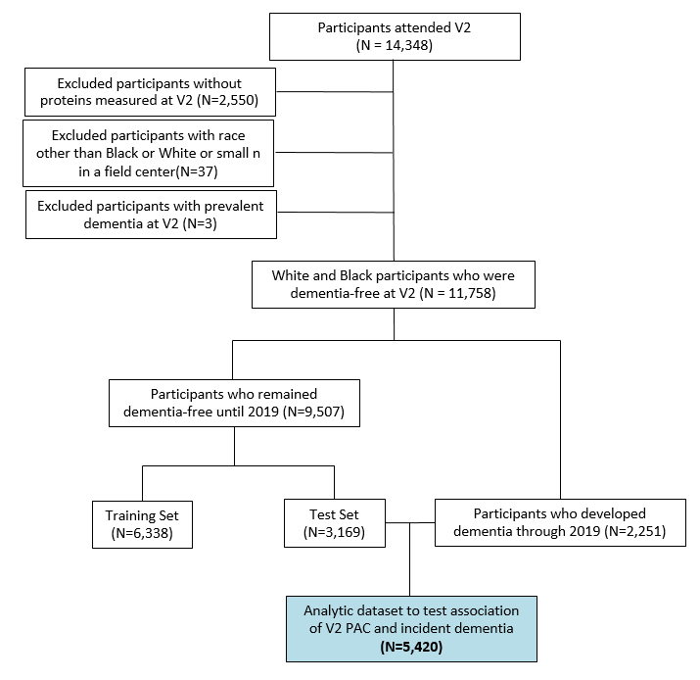

Figure S1B. Participant flow chart for age acceleration and dementia incidence analysis – ARIC late-life

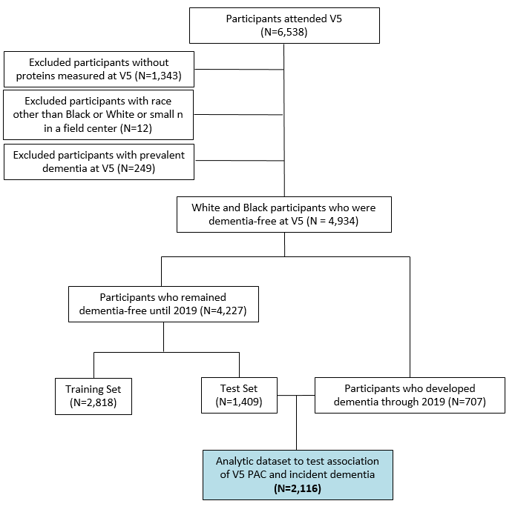

Figure S2. Participant flow chart for age acceleration and cognitive function analysis – ARIC midlife and late-life

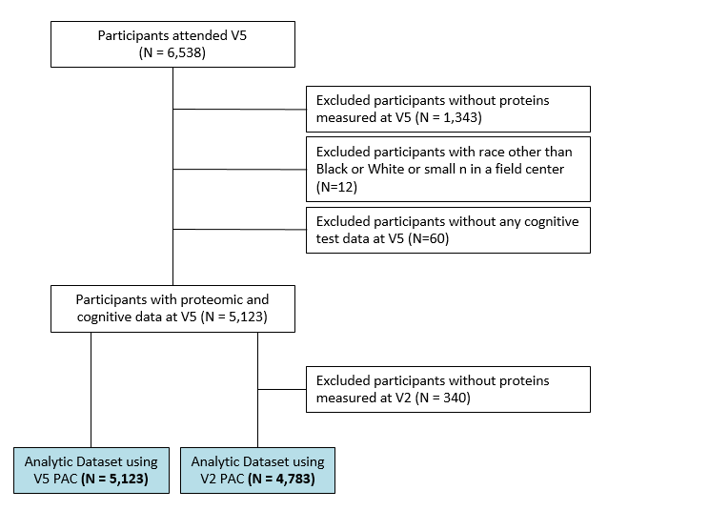

Figure S3. Participant flow chart for age acceleration and dementia and cognitive function analysis – MESA
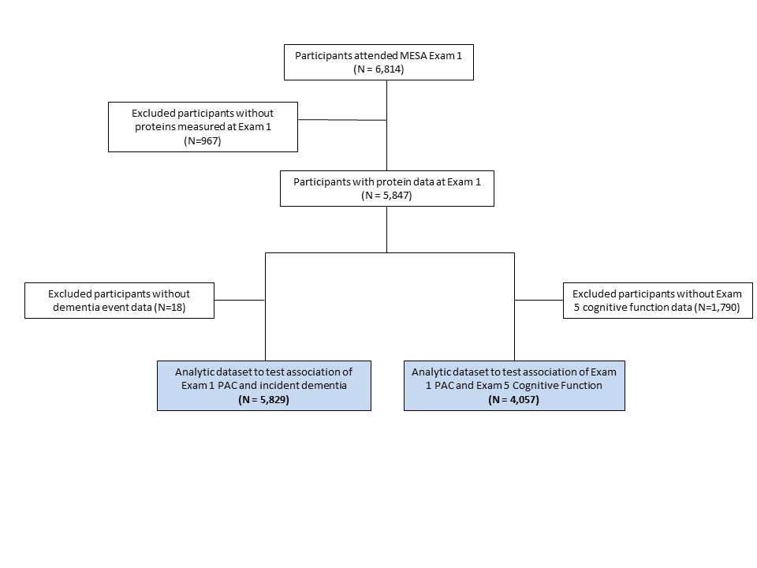

Figure S4. Comparison of distribution and average of some aptamers between MESA and ARIC midlife (Visit 2)cohort.

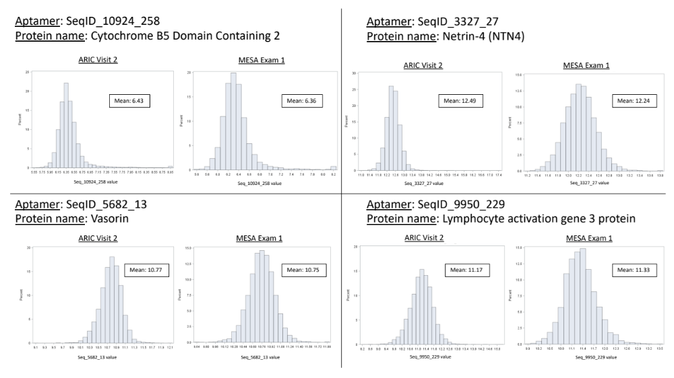

Figure S5. Overlap of number of aptamers (protein units) used for creating midlife and late-life PACs.

