Supplementary Information

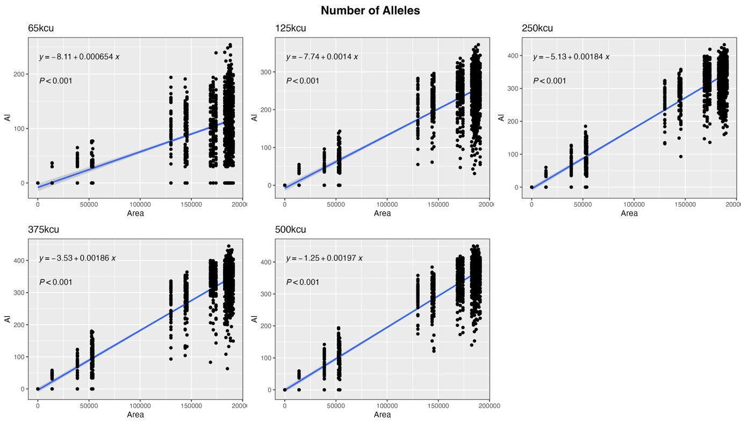 Figure S1. Linear regression of the number of alleles against the area of the scenario after 100 generations for each dispersal threshold. In all cases, the relationship is significantly positive, with the gradient increasing as the dispersal threshold rises.

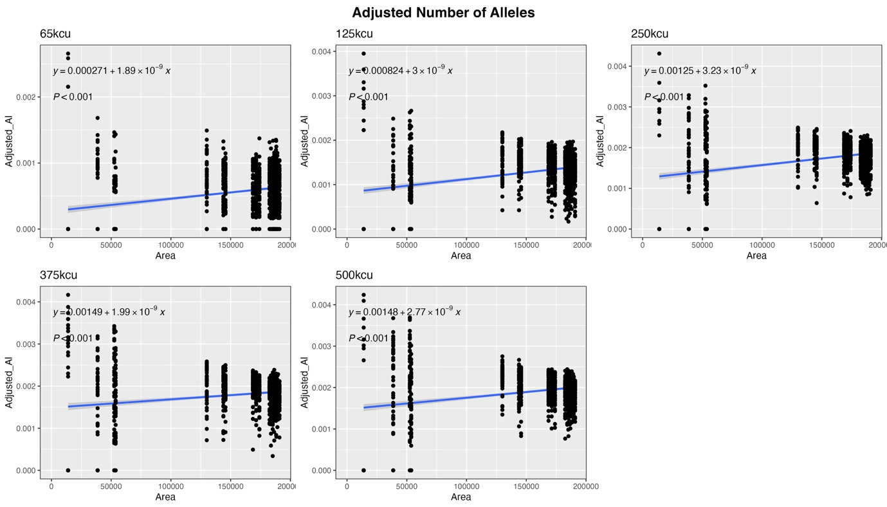 Figure S2. Linear regression of the adjusted number of alleles against the area of the scenario after 100 generations for each dispersal threshold. In all cases, the relationship is significantly positive.

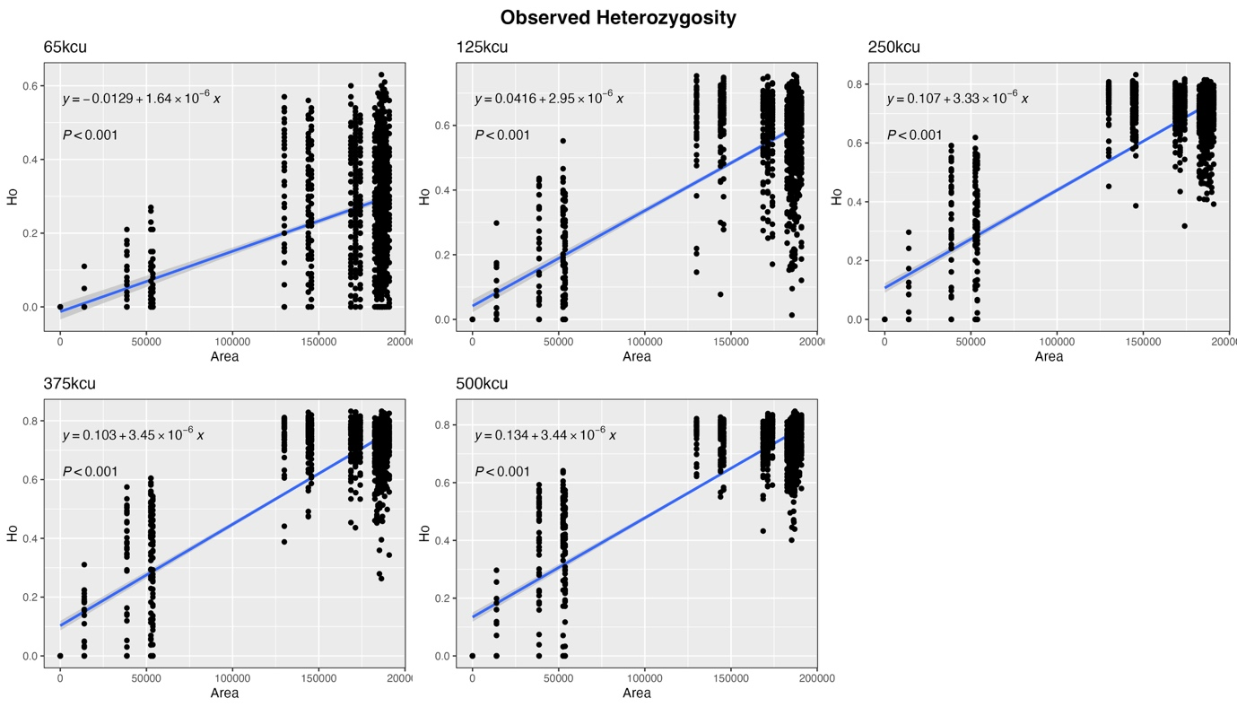 Figure S3. Linear regression of observed heterozygosity against the area of the scenario after 100 generations for each dispersal threshold. In all cases, the relationship is significantly positive, with the gradient increasing as the dispersal threshold rises.

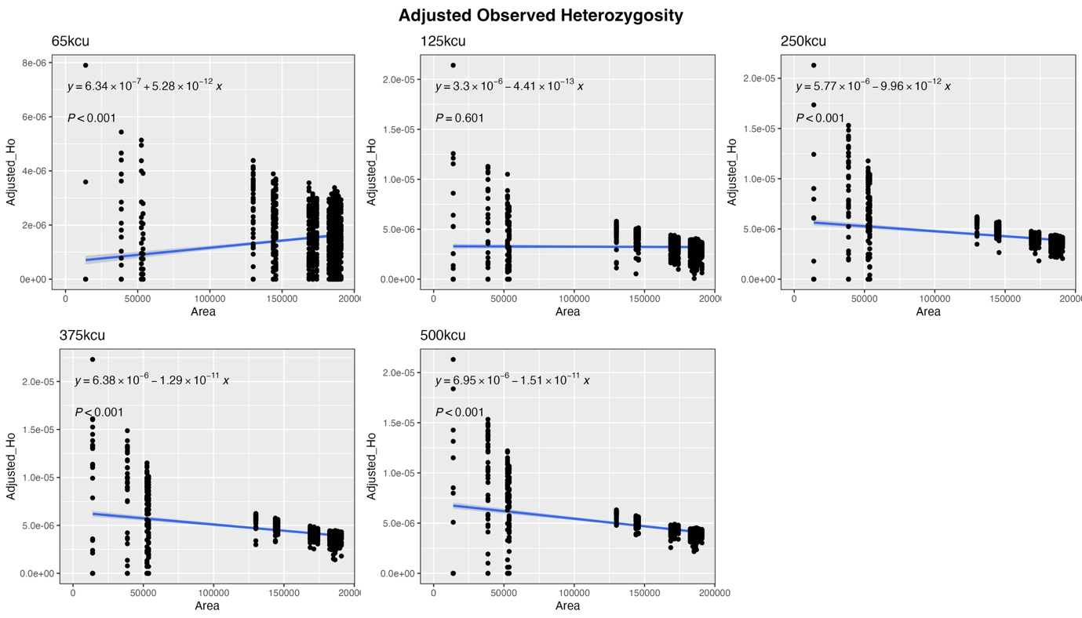 Figure S4. Linear regression of adjusted observed heterozygosity against the area of the scenario after 100 generations for each dispersal threshold. At 65kcu the relationship is significantly positive, at 125kcu there is no significant relationship, and at dispersal thresholds above 250kcu the relationship is significantly negative.

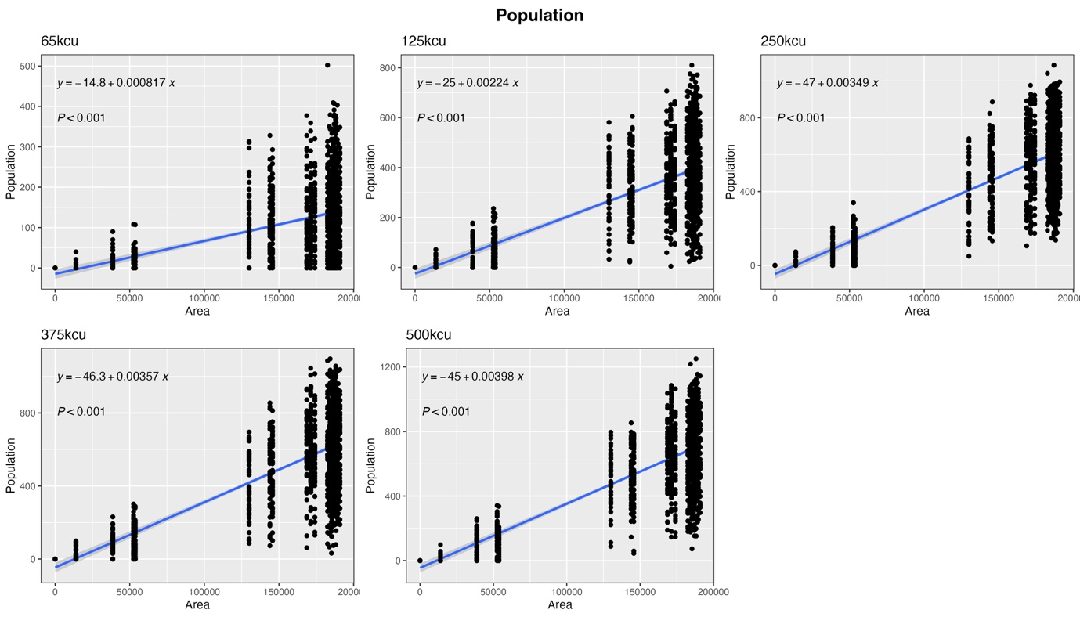 Figure S5. Linear regression of population size against the area of the scenario after 100 generations for each dispersal threshold. In all cases, the relationship is significantly positive, with the gradient increasing as the dispersal threshold rises.

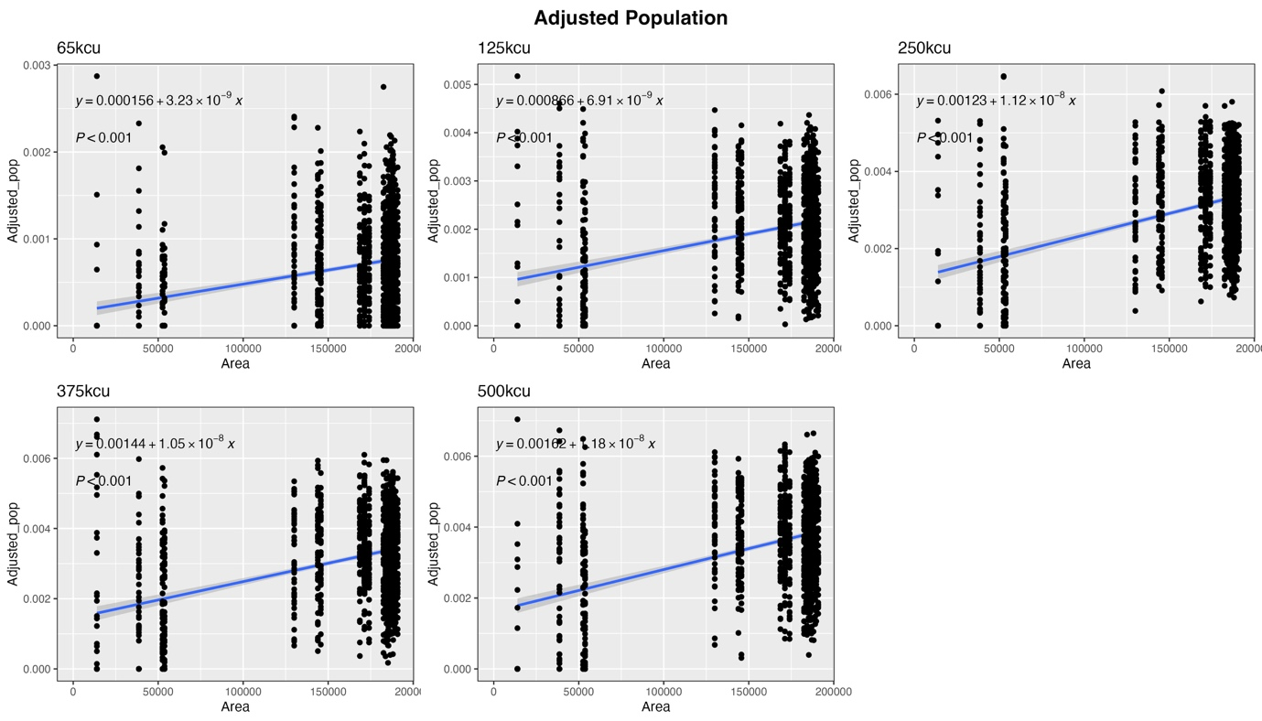 Figure S6. Linear regression of adjusted population size against the area of the scenario after 100 generations for each dispersal threshold. In all cases, the relationship is significantly positive, with the gradient increasing as the dispersal threshold rises.

Number of Alleles
Hypothesis | Sub hypothesis | Specific comparison | Dispersal Threshold
Hypothesis | Sub hypothesis | Specific comparison | 65kcu | 125kcu | 250kcu | 375kcu | 500kcu
1. Corridors enhance measures of population and genetic diversity | 1.01 | 1 > 22 | 0.44006 | 0.20108 | 0.14251 | 0.98545 | 0.07283
 | 1.02 | 8 > 22 | 0.19850 | 0.87840 | 0.00494 | 0.00438 | 0.00004
 | 1.03 | 9 > 22 | 0.68504 | 0.84757 | 0.04439 | 0.32976 | 0.00778
 | 1.04 | 10 > 22 | 0.81984 | 0.09218 | 0.06215 | 0.89200 | 0.00153
 | 1.05 | 11 > 22 | 0.29291 | 0.50113 | 0.46195 | 0.82833 | 0.02138
 | 1.06 | 12 > 22 | 0.68663 | 0.19493 | 0.15406 | 0.09352 | 0.02467
 | 1.07 | 13 > 22 | 0.97059 | 0.90943 | 0.08463 | 0.16771 | 0.01189
 | 1.08 | 14 >22 | 0.65658 | 0.64485 | 0.11428 | 0.44976 | 0.09082
 | 1.09 | 15 > 22 | 0.19774 | 0.03126 | 0.03796 | 0.31296 | 0.00099
 | 1.10 | 16 > 22 | 0.61026 | 0.36907 | 0.36900 | 0.37919 | 0.12090
 | 1.11 | 17 > 22 | 0.16001 | 0.00066 | 0.00297 | 0.10644 | 0.00009
 | 1.12 | 18 > 22 | 0.34771 | 0.20455 | 0.59044 | 0.95798 | 0.25454
 | 1.13 | 19 > 22 | 0.10303 | 0.32200 | 0.57112 | 0.18053 | 0.58679
 | 1.14 | 20 > 22 | 0.29490 | 0.86913 | 0.05632 | 0.70021 | 0.05153
 | 1.15 | 21 >22 | 0.09810 | 0.21020 | 0.86899 | 0.12172 | 0.06295
 | 1.16 | 4 > 27 | 0.68823 | 0.42134 | 0.12193 | 0.12123 | 0.00016
 | 1.17 | 2 > 25 | 0.29490 | 0.84757 | 0.41455 | 0.09195 | 1.00000
 | 1.18 | 23 > 25 | 0.71395 | 0.81088 | 0.75630 | 0.51539 | 0.08085
 | 1.19 | 24 > 25 | 0.74000 | 0.16329 | 0.07355 | 0.18319 | 0.47769
 | 1.20 | 3 > 26 | 0.58170 | 0.35361 | 0.20825 | 0.95152 | 0.93188
2. The largest patch of core area in a network dominates | 2.01 | 4 < rest x 6, 7, 27 | 0.00000 | 0.00000 | 0.00000 | 0.00000 | 0.00000
2. The largest patch of core area in a network dominates | 2.02 | 6 < rest x 4, 7, 27 | 0.00000 | 0.00000 | 0.00000 | 0.00000 | 0.00000
2. The largest patch of core area in a network dominates | 2.03 | 7 < rest x 4, 6, 27 | 0.00000 | 0.00000 | 0.00000 | 0.00000 | 0.00000
2. The largest patch of core area in a network dominates | 2.04 | 27 < rest x 4, 6, 7 | 0.00000 | 0.00000 | 0.00000 | 0.00000 | 0.00000
3. Conserving the full network is best | 3.01 | 1 > rest | 0.01937 | 0.00332 | 0.00000 | 0.00000 | 0.00000
4. Overall area of the network dominates | 4.01 | 25 > 26 | 0.29191 | 0.06094 | 0.00177 | 0.00000 | 0.00004
4. Overall area of the network dominates | 4.02 | 26 > 27 | 0.00000 | 0.00000 | 0.00000 | 0.00000 | 0.00000
4. Overall area of the network dominates | 4.03 | 25 > 27 | 0.00000 | 0.00000 | 0.00000 | 0.00000 | 0.00000
4. Overall area of the network dominates | 4.04 | 5 > 6 | 0.00000 | 0.00000 | 0.00000 | 0.00000 | 0.00000
4. Overall area of the network dominates | 4.05 | 5 > 7 | 0.00000 | 0.00000 | 0.00000 | 0.00000 | 0.00000
4. Overall area of the network dominates | 4.06 | 6 > 7 | 0.07691 | 0.02789 | 0.00000 | 0.00004 | 0.00000
5. Corridors do not mitigate for the loss of core areas | 5.01 | 22 > 2 | 0.39645 | 0.43390 | 0.64235 | 0.01795 | 0.79932
5. Corridors do not mitigate for the loss of core areas | 5.02 | 22 > 3 | 0.01656 | 0.05474 | 0.00000 | 0.00000 | 0.00002
5. Corridors do not mitigate for the loss of core areas | 5.03 | 22 > 4 | 0.00000 | 0.00000 | 0.00000 | 0.00000 | 0.00000
5. Corridors do not mitigate for the loss of core areas | 5.04 | 22 > 23 | 0.02381 | 0.46205 | 0.50805 | 0.97413 | 0.13572
5. Corridors do not mitigate for the loss of core areas | 5.05 | 22 > 24 | 0.02604 | 0.67468 | 0.15034 | 0.51670 | 0.64850
Table S1. Significance of contrast tests between levels of the sub-hypotheses for the response variable, “number of alleles”. Contrasts significant at α < 0.05 are highlighted in green.

Adjusted Number of Alleles
Description | Sub hypothesis | Specific comparison | Dispersal Threshold
Description | Sub hypothesis | Specific comparison | 65kcu | 125kcu | 250kcu | 375kcu | 500kcu
1. Corridors enhance measures of population and genetic diversity | 1.01 | 1 > 22 | 0.31768 | 0.15492 | 0.94970 | 0.44751 | 0.96186
 | 1.02 | 8 > 22 | 0.49651 | 0.72567 | 0.34072 | 0.35819 | 0.11652
 | 1.03 | 9 > 22 | 0.99266 | 0.73464 | 0.61577 | 0.96632 | 0.43329
 | 1.04 | 10 > 22 | 0.60999 | 0.62031 | 0.74001 | 0.58654 | 0.34073
 | 1.05 | 11 > 22 | 0.24829 | 0.32981 | 0.25930 | 0.43869 | 0.66437
 | 1.06 | 12 > 22 | 0.64437 | 0.57380 | 0.63230 | 0.56127 | 0.38102
 | 1.07 | 13 > 22 | 0.86453 | 0.81334 | 0.58283 | 0.28916 | 0.35750
 | 1.08 | 14 >22 | 0.57116 | 0.94282 | 0.68503 | 0.42544 | 0.67603
 | 1.09 | 15 > 22 | 0.44030 | 0.31578 | 0.46844 | 0.88781 | 0.18846
 | 1.10 | 16 > 22 | 0.53324 | 0.36058 | 0.98528 | 0.38249 | 0.74327
 | 1.11 | 17 > 22 | 0.43709 | 0.10053 | 0.29192 | 0.75862 | 0.14120
 | 1.12 | 18 > 22 | 0.38748 | 0.31317 | 0.99629 | 0.81220 | 0.76206
 | 1.13 | 19 > 22 | 0.16589 | 0.40925 | 0.97120 | 0.34928 | 0.56602
 | 1.14 | 20 > 22 | 0.36920 | 0.96688 | 0.38408 | 0.97612 | 0.39684
 | 1.15 | 21 >22 | 0.18137 | 0.38191 | 0.97570 | 0.36299 | 0.38474
 | 1.16 | 4 > 27 | 0.24291 | 0.04809 | 0.00085 | 0.00194 | 0.00000
 | 1.17 | 2 > 25 | 0.56705 | 0.71863 | 0.86596 | 0.13379 | 0.50162
 | 1.18 | 23 > 25 | 0.65354 | 0.92482 | 0.60180 | 0.95503 | 0.51508
 | 1.19 | 24 > 25 | 0.67992 | 0.48990 | 0.45583 | 0.65272 | 0.93963
 | 1.20 | 3 > 26 | 0.67402 | 0.59988 | 0.25124 | 0.85208 | 0.83054
2. The largest patch of core area in a network dominates | 2.01 | 4 < rest x 6, 7, 27 | 0.00000 | 0.00000 | 0.00000 | 0.00000 | 0.00000
2. The largest patch of core area in a network dominates | 2.02 | 6 < rest x 4, 7, 27 | 0.01050 | 0.00000 | 0.01481 | 0.00001 | 0.02175
2. The largest patch of core area in a network dominates | 2.03 | 7 < rest x 4, 6, 27 | 0.00000 | 0.00000 | 0.00000 | 0.00000 | 0.00000
2. The largest patch of core area in a network dominates | 2.04 | 27 < rest x 4, 6, 7 | 0.00000 | 0.00005 | 0.09041 | 0.41028 | 0.02421
3. Conserving the full network is best | 3.01 | 1 > rest | 0.90410 | 0.22019 | 0.98285 | 0.58812 | 0.57250
4. Overall area of the network dominates | 4.01 | 25 > 26 | 0.60764 | 0.22789 | 0.17254 | 0.97606 | 0.36764
4. Overall area of the network dominates | 4.02 | 26 > 27 | 0.00001 | 0.00001 | 0.00128 | 0.10836 | 0.75332
4. Overall area of the network dominates | 4.03 | 25 > 27 | 0.00011 | 0.00114 | 0.06282 | 0.11510 | 0.22438
4. Overall area of the network dominates | 4.04 | 5 > 6 | 0.00332 | 0.00000 | 0.00023 | 0.00000 | 0.19948
4. Overall area of the network dominates | 4.05 | 5 > 7 | 0.00000 | 0.00000 | 0.00000 | 0.00000 | 0.00000
4. Overall area of the network dominates | 4.06 | 6 > 7 | 0.00000 | 0.05552 | 0.00000 | 0.02212 | 0.00000
5. Corridors do not mitigate for the loss of core areas | 5.01 | 22 > 2 | 0.83420 | 0.82102 | 0.22059 | 0.67124 | 0.39862
5. Corridors do not mitigate for the loss of core areas | 5.02 | 22 > 3 | 0.87891 | 0.02061 | 0.10734 | 0.35816 | 0.02772
5. Corridors do not mitigate for the loss of core areas | 5.03 | 22 > 4 | 0.00000 | 0.00000 | 0.00014 | 0.00032 | 0.00000
5. Corridors do not mitigate for the loss of core areas | 5.04 | 22 > 23 | 0.21859 | 0.62261 | 0.38314 | 0.25780 | 0.03036
5. Corridors do not mitigate for the loss of core areas | 5.05 | 22 > 24 | 0.23247 | 0.20171 | 0.03251 | 0.12730 | 0.11157
Table S2. Significance of contrast tests between levels of the sub-hypotheses for the response variable, “adjusted number of alleles”. Contrasts significant at α < 0.05 are highlighted in green.

Observed Heterozygosity
Description | Sub hypothesis | Specific comparison | Dispersal Threshold
Description | Sub hypothesis | Specific comparison | 65kcu | 125kcu | 250kcu | 375kcu | 500kcu
1. Corridors enhance measures of population and genetic diversity | 1.01 | 1 > 22 | 0.45918 | 0.91964 | 0.01801 | 0.23882 | 0.00004
 | 1.02 | 8 > 22 | 0.10812 | 0.10147 | 0.05756 | 0.27539 | 0.02581
 | 1.03 | 9 > 22 | 0.11771 | 0.32131 | 0.07889 | 0.01457 | 0.00001
 | 1.04 | 10 > 22 | 0.85456 | 0.03424 | 0.14630 | 0.05469 | 0.00005
 | 1.05 | 11 > 22 | 0.76715 | 0.64321 | 0.75232 | 0.20403 | 0.00010
 | 1.06 | 12 > 22 | 0.32027 | 0.44664 | 0.17102 | 0.47823 | 0.27769
 | 1.07 | 13 > 22 | 0.09631 | 0.54029 | 0.12774 | 0.31641 | 0.42530
 | 1.08 | 14 >22 | 0.04175 | 0.13144 | 0.21948 | 0.80191 | 0.25709
 | 1.09 | 15 > 22 | 0.04695 | 0.09053 | 0.01318 | 0.16599 | 0.00001
 | 1.10 | 16 > 22 | 0.16501 | 0.87615 | 0.03484 | 0.13009 | 0.00007
 | 1.11 | 17 > 22 | 0.02747 | 0.01141 | 0.01254 | 0.00066 | 0.00000
 | 1.12 | 18 > 22 | 0.69299 | 0.77594 | 0.08530 | 0.13902 | 0.00086
 | 1.13 | 19 > 22 | 1.00000 | 0.45829 | 0.70233 | 0.06753 | 0.72460
 | 1.14 | 20 > 22 | 0.84903 | 0.65014 | 0.23961 | 0.65284 | 0.13824
 | 1.15 | 21 >22 | 0.56321 | 0.77911 | 0.62885 | 0.51025 | 0.15570
 | 1.16 | 4 > 27 | 0.65185 | 0.02393 | 0.09136 | 0.00058 | 0.00000
 | 1.17 | 2 > 25 | 0.17599 | 0.65222 | 0.40363 | 0.26175 | 0.00080
 | 1.18 | 23 > 25 | 0.98875 | 0.84206 | 0.51447 | 0.05733 | 0.00002
 | 1.19 | 24 > 25 | 0.30012 | 0.35831 | 0.95562 | 0.24243 | 0.73167
 | 1.20 | 3 > 26 | 0.75641 | 0.86861 | 0.37006 | 0.78890 | 0.66953
2. The largest patch of core area in a network dominates | 2.01 | 4 < rest x 6, 7, 27 | 0.00000 | 0.00000 | 0.00000 | 0.00000 | 0.00000
2. The largest patch of core area in a network dominates | 2.02 | 6 < rest x 4, 7, 27 | 0.00000 | 0.00000 | 0.00000 | 0.00000 | 0.00000
2. The largest patch of core area in a network dominates | 2.03 | 7 < rest x 4, 6, 27 | 0.00000 | 0.00000 | 0.00000 | 0.00000 | 0.00000
2. The largest patch of core area in a network dominates | 2.04 | 27 < rest x 4, 6, 7 | 0.00000 | 0.00000 | 0.00000 | 0.00000 | 0.00000
3. Conserving the full network is best | 3.01 | 1 > rest | 0.06958 | 0.04352 | 0.00000 | 0.00000 | 0.00000
4. Overall area of the network dominates | 4.01 | 25 > 26 | 0.62166 | 0.20348 | 0.22928 | 0.42725 | 0.05847
4. Overall area of the network dominates | 4.02 | 26 > 27 | 0.00000 | 0.00000 | 0.00000 | 0.00000 | 0.00000
4. Overall area of the network dominates | 4.03 | 25 > 27 | 0.00000 | 0.00000 | 0.00000 | 0.00000 | 0.00000
4. Overall area of the network dominates | 4.04 | 5 > 6 | 0.00000 | 0.00000 | 0.00000 | 0.00000 | 0.00000
4. Overall area of the network dominates | 4.05 | 5 > 7 | 0.00000 | 0.00000 | 0.00000 | 0.00000 | 0.00000
4. Overall area of the network dominates | 4.06 | 6 > 7 | 0.12447 | 0.00000 | 0.00000 | 0.00000 | 0.00000
5. Corridors do not mitigate for the loss of core areas | 5.01 | 22 > 2 | 0.23916 | 0.27268 | 0.00221 | 0.04998 | 0.00004
5. Corridors do not mitigate for the loss of core areas | 5.02 | 22 > 3 | 0.53038 | 0.00802 | 0.01130 | 0.05750 | 0.02480
5. Corridors do not mitigate for the loss of core areas | 5.03 | 22 > 4 | 0.00000 | 0.00000 | 0.00000 | 0.00000 | 0.00000
5. Corridors do not mitigate for the loss of core areas | 5.04 | 22 > 23 | 0.87118 | 0.08078 | 0.11463 | 0.00620 | 0.00000
5. Corridors do not mitigate for the loss of core areas | 5.05 | 22 > 24 | 0.38978 | 0.01374 | 0.02238 | 0.04478 | 0.26158
Table S3. Significance of contrast tests between levels of the sub-hypotheses for the response variable, “observed heterozygosity”. Contrasts significant at α < 0.05 are highlighted in green.

Adjusted Observed Heterozygosity
Description | Sub hypothesis | Specific comparison | Dispersal Threshold
Description | Sub hypothesis | Specific comparison | 65kcu | 125kcu | 250kcu | 375kcu | 500kcu
1. Corridors enhance measures of population and genetic diversity | 1.01 | 1 > 22 | 0.80127 | 0.63436 | 0.83663 | 0.88952 | 0.57339
 | 1.02 | 8 > 22 | 0.29518 | 0.68750 | 0.81428 | 0.98925 | 0.80641
 | 1.03 | 9 > 22 | 0.31404 | 0.90463 | 0.85414 | 0.73892 | 0.40681
 | 1.04 | 10 > 22 | 0.90992 | 0.58302 | 0.96616 | 0.88194 | 0.50839
 | 1.05 | 11 > 22 | 0.60986 | 0.85656 | 0.74439 | 0.95703 | 0.56401
 | 1.06 | 12 > 22 | 0.49833 | 0.86394 | 0.81326 | 0.97690 | 0.91449
 | 1.07 | 13 > 22 | 0.24155 | 0.95183 | 0.81860 | 0.63709 | 0.98038
 | 1.08 | 14 >22 | 0.15013 | 0.68120 | 0.91634 | 0.86307 | 0.97838
 | 1.09 | 15 > 22 | 0.15523 | 0.60670 | 0.61324 | 0.87923 | 0.36074
 | 1.10 | 16 > 22 | 0.35799 | 0.75837 | 0.72011 | 0.87873 | 0.43553
 | 1.11 | 17 > 22 | 0.12748 | 0.43008 | 0.67460 | 0.54622 | 0.32628
 | 1.12 | 18 > 22 | 0.83808 | 0.78586 | 0.72650 | 0.80929 | 0.47191
 | 1.13 | 19 > 22 | 0.91642 | 0.85835 | 0.96602 | 0.52762 | 0.94316
 | 1.14 | 20 > 22 | 0.93437 | 0.91911 | 0.80348 | 0.82790 | 0.77321
 | 1.15 | 21 >22 | 0.60856 | 0.95266 | 0.93897 | 0.80977 | 0.75616
 | 1.16 | 4 > 27 | 0.18419 | 0.00028 | 0.03162 | 0.00042 | 0.00000
 | 1.17 | 2 > 25 | 0.36440 | 0.57288 | 0.89745 | 0.97474 | 0.57615
 | 1.18 | 23 > 25 | 0.90833 | 0.92536 | 0.67621 | 0.71526 | 0.29560
 | 1.19 | 24 > 25 | 0.43833 | 0.80133 | 0.85932 | 0.86971 | 0.92182
 | 1.20 | 3 > 26 | 0.84299 | 0.79366 | 0.59803 | 0.94281 | 0.73739
2. The largest patch of core area in a network dominates | 2.01 | 4 < rest x 6, 7, 27 | 0.00000 | 0.07211 | 0.00000 | 0.00011 | 0.00000
2. The largest patch of core area in a network dominates | 2.02 | 6 < rest x 4, 7, 27 | 0.00491 | 0.17887 | 0.00000 | 0.00000 | 0.00000
2. The largest patch of core area in a network dominates | 2.03 | 7 < rest x 4, 6, 27 | 0.00000 | 0.00000 | 0.00000 | 0.10425 | 0.00000
2. The largest patch of core area in a network dominates | 2.04 | 27 < rest x 4, 6, 7 | 0.00000 | 0.00121 | 0.00000 | 0.00000 | 0.00000
3. Conserving the full network is best | 3.01 | 1 > rest | 0.97154 | 0.05562 | 0.04625 | 0.03216 | 0.02048
4. Overall area of the network dominates | 4.01 | 25 > 26 | 0.06320 | 0.00735 | 0.00801 | 0.02722 | 0.00417
4. Overall area of the network dominates | 4.02 | 26 > 27 | 0.00000 | 0.34802 | 0.00058 | 0.00019 | 0.00000
4. Overall area of the network dominates | 4.03 | 25 > 27 | 0.00010 | 0.08106 | 0.00000 | 0.00000 | 0.00000
4. Overall area of the network dominates | 4.04 | 5 > 6 | 0.00000 | 0.00008 | 0.00000 | 0.00187 | 0.00000
4. Overall area of the network dominates | 4.05 | 5 > 7 | 0.00000 | 0.00000 | 0.00000 | 0.00243 | 0.00000
4. Overall area of the network dominates | 4.06 | 6 > 7 | 0.00000 | 0.00000 | 0.00000 | 0.00000 | 0.00000
5. Corridors do not mitigate for the loss of core areas | 5.01 | 22 > 2 | 0.17259 | 0.32158 | 0.12804 | 0.29121 | 0.07936
5. Corridors do not mitigate for the loss of core areas | 5.02 | 22 > 3 | 0.01203 | 0.00007 | 0.00016 | 0.00128 | 0.00020
5. Corridors do not mitigate for the loss of core areas | 5.03 | 22 > 4 | 0.00000 | 0.73278 | 0.00000 | 0.00048 | 0.00000
5. Corridors do not mitigate for the loss of core areas | 5.04 | 22 > 23 | 0.73228 | 0.14402 | 0.21742 | 0.14661 | 0.02506
5. Corridors do not mitigate for the loss of core areas | 5.05 | 22 > 24 | 0.21794 | 0.07095 | 0.14059 | 0.21092 | 0.27222
Table S4. Significance of contrast tests between levels of the sub-hypotheses for the response variable, “adjusted observed heterozygosity”. Contrasts significant at α < 0.05 are highlighted in green.

Population
Description | Sub hypothesis | Specific comparison | Dispersal Threshold
Description | Sub hypothesis | Specific comparison | 65kcu | 125kcu | 250kcu | 375kcu | 500kcu
1. Corridors enhance measures of population and genetic diversity | 1.01 | 1 > 22 | 0.76640 | 0.07468 | 0.40842 | 0.56474 | 0.00238
 | 1.02 | 8 > 22 | 0.31016 | 0.86590 | 0.16400 | 0.00197 | 0.00159
 | 1.03 | 9 > 22 | 0.81886 | 0.25490 | 0.92124 | 0.07099 | 0.00451
 | 1.04 | 10 > 22 | 0.69293 | 0.05150 | 0.60525 | 0.88911 | 0.00604
 | 1.05 | 11 > 22 | 0.29966 | 0.13877 | 0.59240 | 0.82022 | 0.02355
 | 1.06 | 12 > 22 | 0.79967 | 0.63424 | 0.41865 | 0.03619 | 0.05832
 | 1.07 | 13 > 22 | 0.52624 | 0.79210 | 0.51060 | 0.99912 | 0.04675
 | 1.08 | 14 >22 | 0.83816 | 0.63372 | 0.59881 | 0.53580 | 0.00633
 | 1.09 | 15 > 22 | 0.26217 | 0.08608 | 0.03256 | 0.14789 | 0.00004
 | 1.10 | 16 > 22 | 0.18058 | 0.13917 | 0.53048 | 0.79556 | 0.01596
 | 1.11 | 17 > 22 | 0.34372 | 0.02275 | 0.27360 | 0.00797 | 0.00001
 | 1.12 | 18 > 22 | 0.28436 | 0.40843 | 0.97509 | 0.92390 | 0.05526
 | 1.13 | 19 > 22 | 0.44210 | 0.04340 | 0.78538 | 0.43541 | 0.39617
 | 1.14 | 20 > 22 | 0.27230 | 0.95784 | 0.03404 | 0.49819 | 0.04437
 | 1.15 | 21 >22 | 0.11184 | 0.07337 | 0.27895 | 0.94792 | 0.02944
 | 1.16 | 4 > 27 | 0.94276 | 0.46285 | 0.41434 | 0.93525 | 0.08709
 | 1.17 | 2 > 25 | 0.62137 | 0.60319 | 0.57376 | 0.36659 | 0.38949
 | 1.18 | 23 > 25 | 0.43115 | 0.93972 | 0.45163 | 0.95972 | 0.02416
 | 1.19 | 24 > 25 | 0.90736 | 0.82337 | 0.13294 | 0.34909 | 0.45651
 | 1.20 | 3 > 26 | 0.91522 | 0.23495 | 0.39127 | 0.92739 | 0.79383
2. The largest patch of core area in a network dominates | 2.01 | 4 < rest x 6, 7, 27 | 0.00000 | 0.00000 | 0.00000 | 0.00000 | 0.00000
2. The largest patch of core area in a network dominates | 2.02 | 6 < rest x 4, 7, 27 | 0.00000 | 0.00000 | 0.00000 | 0.00000 | 0.00000
2. The largest patch of core area in a network dominates | 2.03 | 7 < rest x 4, 6, 27 | 0.00000 | 0.00000 | 0.00000 | 0.00000 | 0.00000
2. The largest patch of core area in a network dominates | 2.04 | 27 < rest x 4, 6, 7 | 0.00000 | 0.00000 | 0.00000 | 0.00000 | 0.00000
3. Conserving the full network is best | 3.01 | 1 > rest | 0.07075 | 0.31019 | 0.00000 | 0.00016 | 0.00000
4. Overall area of the network dominates | 4.01 | 25 > 26 | 0.65945 | 0.03056 | 0.01873 | 0.00102 | 0.03463
4. Overall area of the network dominates | 4.02 | 26 > 27 | 0.00000 | 0.00000 | 0.00000 | 0.00000 | 0.00000
4. Overall area of the network dominates | 4.03 | 25 > 27 | 0.00000 | 0.00000 | 0.00000 | 0.00000 | 0.00000
4. Overall area of the network dominates | 4.04 | 5 > 6 | 0.00000 | 0.00000 | 0.00000 | 0.00000 | 0.00000
4. Overall area of the network dominates | 4.05 | 5 > 7 | 0.00000 | 0.00000 | 0.00000 | 0.00000 | 0.00000
4. Overall area of the network dominates | 4.06 | 6 > 7 | 0.44800 | 0.22164 | 0.07251 | 0.13628 | 0.00936
5. Corridors do not mitigate for the loss of core areas | 5.01 | 22 > 2 | 0.46144 | 0.16204 | 0.93825 | 0.51611 | 0.62404
5. Corridors do not mitigate for the loss of core areas | 5.02 | 22 > 3 | 0.07563 | 0.06370 | 0.00012 | 0.00325 | 0.04510
5. Corridors do not mitigate for the loss of core areas | 5.03 | 22 > 4 | 0.00000 | 0.00000 | 0.00000 | 0.00000 | 0.00000
5. Corridors do not mitigate for the loss of core areas | 5.04 | 22 > 23 | 0.04377 | 0.33990 | 0.16382 | 0.76104 | 0.00870
5. Corridors do not mitigate for the loss of core areas | 5.05 | 22 > 24 | 0.26534 | 0.51206 | 0.38809 | 0.23412 | 0.26488
Table S5. Significance of contrast tests between levels of the sub-hypotheses for the response variable, “population size”. Contrasts significant at α < 0.05 are highlighted in green.

Adjusted Population
Description | Sub hypothesis | Specific comparison | Dispersal Threshold
Description | Sub hypothesis | Specific comparison | 65kcu | 125kcu | 250kcu | 375kcu | 500kcu
1. Corridors enhance measures of population and genetic diversity | 1.01 | 1 > 22 | 0.55196 | 0.05510 | 0.96120 | 0.90078 | 0.05987
 | 1.02 | 8 > 22 | 0.50629 | 0.62842 | 0.47468 | 0.03807 | 0.02738
 | 1.03 | 9 > 22 | 0.97383 | 0.20545 | 0.61410 | 0.30036 | 0.05338
 | 1.04 | 10 > 22 | 0.93880 | 0.25640 | 0.94397 | 0.72770 | 0.07445
 | 1.05 | 11 > 22 | 0.23150 | 0.10549 | 0.33709 | 0.49768 | 0.17948
 | 1.06 | 12 > 22 | 0.91652 | 0.84232 | 0.65671 | 0.13820 | 0.17071
 | 1.07 | 13 > 22 | 0.68513 | 0.65057 | 0.79996 | 0.78790 | 0.16752
 | 1.08 | 14 >22 | 0.99931 | 0.91682 | 0.92049 | 0.42068 | 0.05151
 | 1.09 | 15 > 22 | 0.40579 | 0.25769 | 0.14655 | 0.37774 | 0.00183
 | 1.10 | 16 > 22 | 0.31914 | 0.14050 | 0.86441 | 0.59783 | 0.09499
 | 1.11 | 17 > 22 | 0.54148 | 0.13919 | 0.62822 | 0.08310 | 0.00123
 | 1.12 | 18 > 22 | 0.28394 | 0.39683 | 0.85339 | 0.90360 | 0.16150
 | 1.13 | 19 > 22 | 0.42581 | 0.07099 | 0.67212 | 0.41371 | 0.60380
 | 1.14 | 20 > 22 | 0.28963 | 0.87596 | 0.10532 | 0.67181 | 0.11857
 | 1.15 | 21 >22 | 0.13883 | 0.12417 | 0.32396 | 0.97622 | 0.08001
 | 1.16 | 4 > 27 | 0.78092 | 0.02662 | 0.01146 | 0.69191 | 0.00000
 | 1.17 | 2 > 25 | 0.80536 | 0.41058 | 0.96922 | 0.21979 | 0.22015
 | 1.18 | 23 > 25 | 0.38106 | 0.79352 | 0.36484 | 0.84810 | 0.07260
 | 1.19 | 24 > 25 | 0.99820 | 0.99153 | 0.26557 | 0.55196 | 0.65627
 | 1.20 | 3 > 26 | 0.82883 | 0.27990 | 0.28310 | 0.94370 | 0.64551
2. The largest patch of core area in a network dominates | 2.01 | 4 < rest x 6, 7, 27 | 0.00000 | 0.00000 | 0.00000 | 0.00000 | 0.00000
2. The largest patch of core area in a network dominates | 2.02 | 6 < rest x 4, 7, 27 | 0.00000 | 0.00000 | 0.00000 | 0.00000 | 0.00000
2. The largest patch of core area in a network dominates | 2.03 | 7 < rest x 4, 6, 27 | 0.00000 | 0.00000 | 0.00000 | 0.00000 | 0.00000
2. The largest patch of core area in a network dominates | 2.04 | 27 < rest x 4, 6, 7 | 0.00000 | 0.00000 | 0.00000 | 0.00000 | 0.00005
3. Conserving the full network is best | 3.01 | 1 > rest | 0.60488 | 0.25029 | 0.18265 | 0.52660 | 0.08871
4. Overall area of the network dominates | 4.01 | 25 > 26 | 0.46612 | 0.85565 | 0.98123 | 0.35768 | 0.77815
4. Overall area of the network dominates | 4.02 | 26 > 27 | 0.00000 | 0.00004 | 0.00000 | 0.00000 | 0.00341
4. Overall area of the network dominates | 4.03 | 25 > 27 | 0.00001 | 0.00002 | 0.00000 | 0.00000 | 0.00811
4. Overall area of the network dominates | 4.04 | 5 > 6 | 0.00000 | 0.00000 | 0.00000 | 0.00000 | 0.00000
4. Overall area of the network dominates | 4.05 | 5 > 7 | 0.00000 | 0.00000 | 0.00000 | 0.00000 | 0.00000
4. Overall area of the network dominates | 4.06 | 6 > 7 | 0.01371 | 0.00831 | 0.00000 | 0.01980 | 0.00000
5. Corridors do not mitigate for the loss of core areas | 5.01 | 22 > 2 | 0.74910 | 0.53269 | 0.53446 | 0.92761 | 0.82419
5. Corridors do not mitigate for the loss of core areas | 5.02 | 22 > 3 | 0.95727 | 0.27236 | 0.64022 | 0.74312 | 0.20410
5. Corridors do not mitigate for the loss of core areas | 5.03 | 22 > 4 | 0.00000 | 0.00000 | 0.00000 | 0.00000 | 0.00000
5. Corridors do not mitigate for the loss of core areas | 5.04 | 22 > 23 | 0.14937 | 0.94998 | 0.74621 | 0.25996 | 0.00120
5. Corridors do not mitigate for the loss of core areas | 5.05 | 22 > 24 | 0.57278 | 0.83396 | 0.09001 | 0.05589 | 0.05843
Table S6. Significance of contrast tests between levels of the sub-hypotheses for the response variable, “adjusted population size”. Contrasts significant at α < 0.05 are highlighted in green.

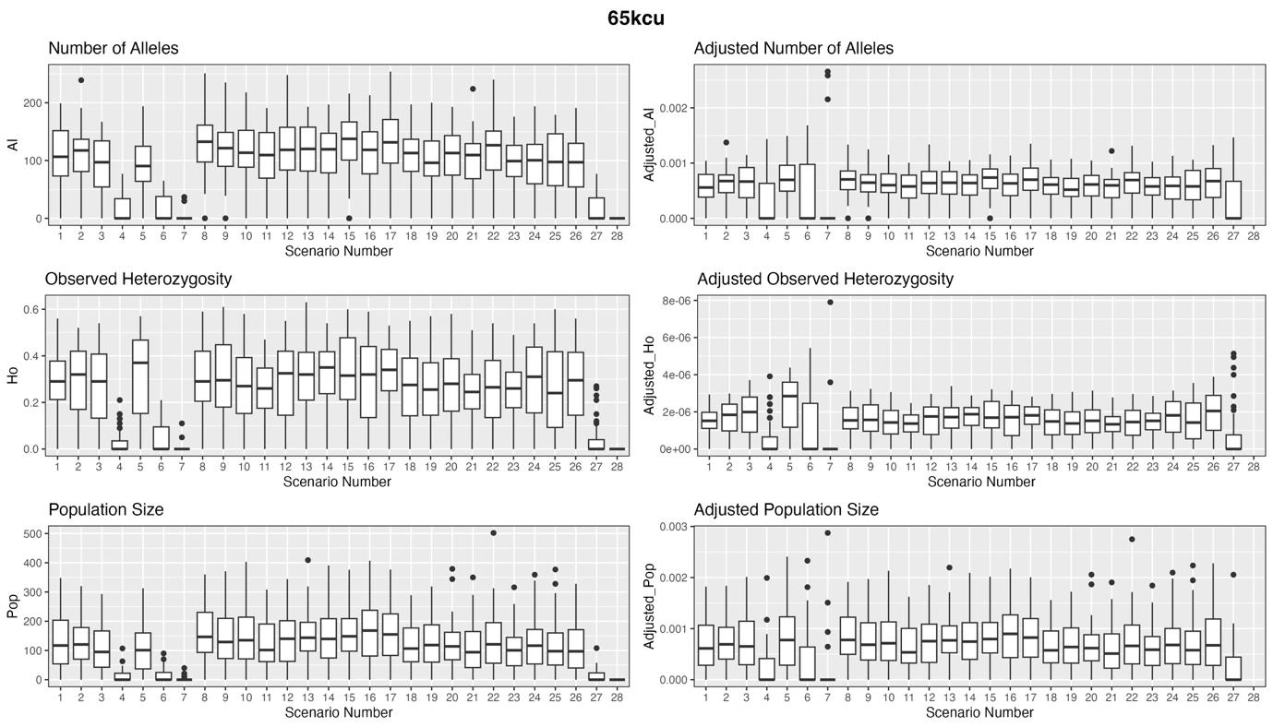
Figure S7. Boxplots showing the number of alleles, observed heterozygosity, and population size for clouded leopards in each of the 28 scenarios after 100 generations at the 65kcu dispersal threshold. Plots on the left show the raw measures, while plots on the right show the measures adjusted for the area of that scenario.

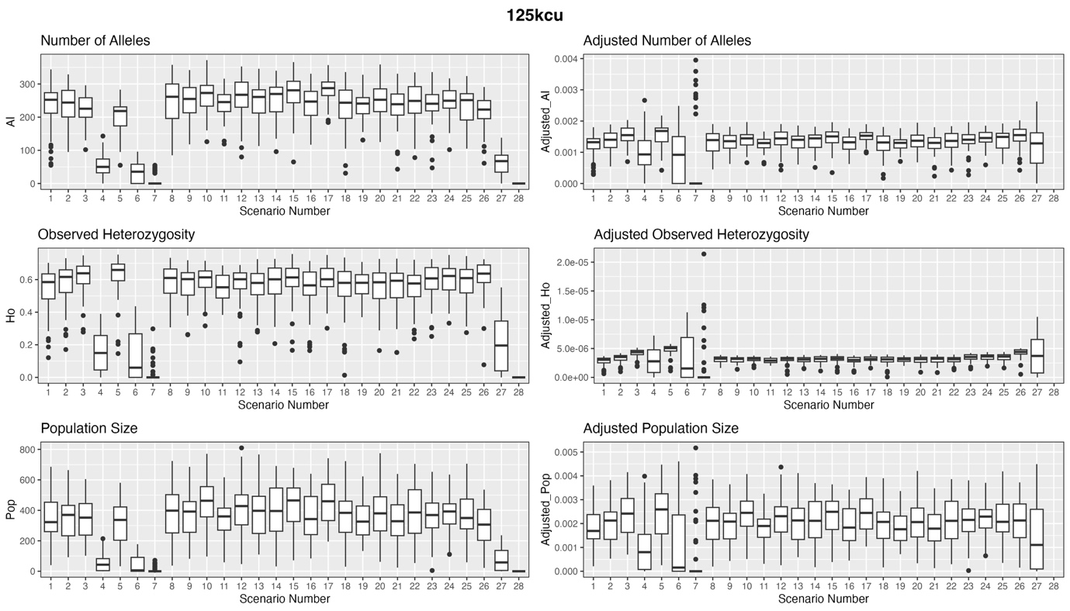
Figure S8. Boxplots showing the number of alleles, observed heterozygosity, and population size for clouded leopards in each of the 28 scenarios after 100 generations at the 125kcu dispersal threshold. Plots on the left show the raw measures, while plots on the right show the measures adjusted for the area of that scenario. This figure is reproduced in the main manuscript as Figure 2.
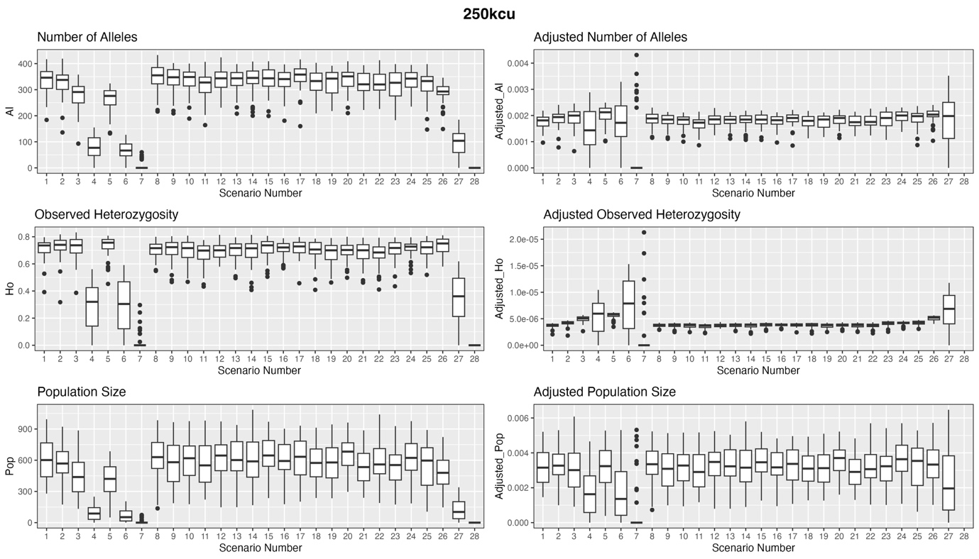
Figure S9. Boxplots showing the number of alleles, observed heterozygosity, and population size for clouded leopards in each of the 28 scenarios after 100 generations at the 250kcu dispersal threshold. Plots on the left show the raw measures, while plots on the right show the measures adjusted for the area of that scenario.

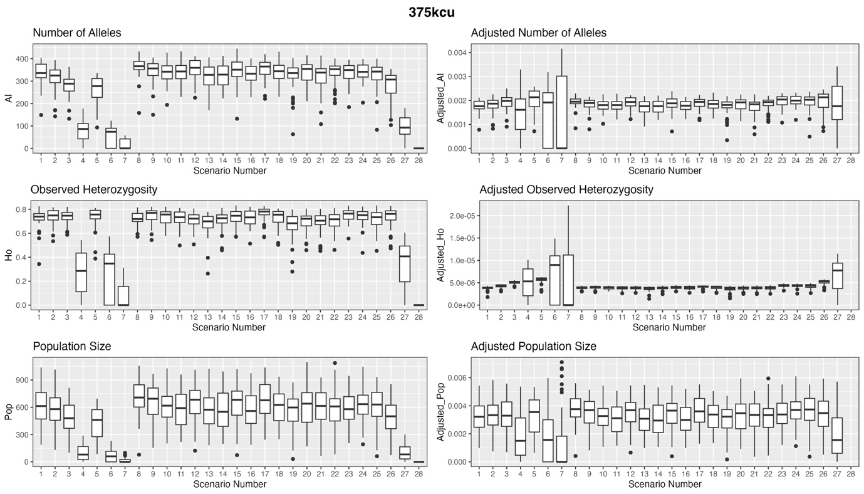
Figure S10. Boxplots showing the number of alleles, observed heterozygosity, and population size for clouded leopards in each of the 28 scenarios after 100 generations at the 375kcu dispersal threshold. Plots on the left show the raw measures, while plots on the right show the measures adjusted for the area of that scenario.
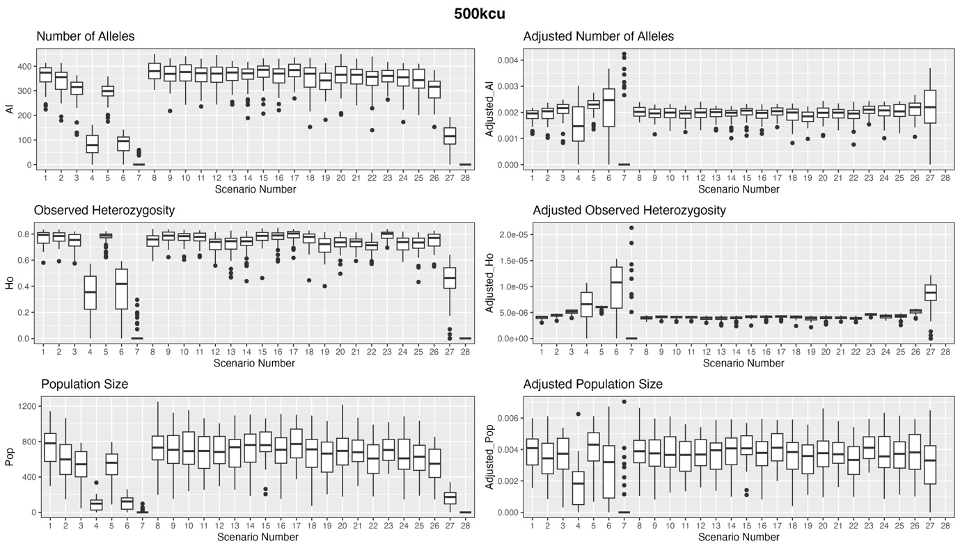
Figure S11. Boxplots showing the number of alleles, observed heterozygosity, and population size for clouded leopards in each of the 28 scenarios after 100 generations at the 500kcu dispersal threshold. Plots on the left show the raw measures, while plots on the right show the measures adjusted for the area of that scenario.
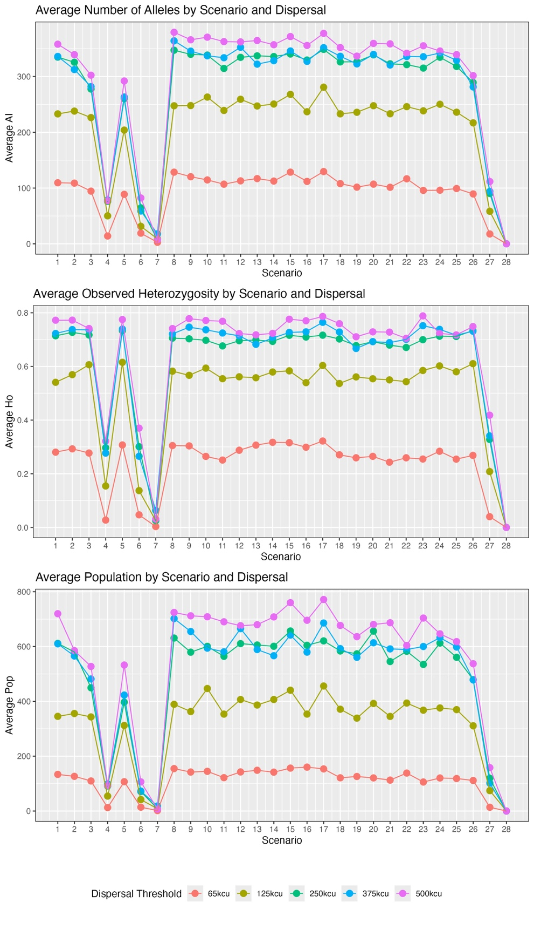
Figure S12. Plots showing how average number of alleles, observed heterozygosity and population vary with dispersal threshold across scenarios. In almost all cases, higher dispersal levels lead to higher measures for all metrics.

