Supplementary Tables
Supplementary Table 1. Details of sampling environmental conditions
Sample ID | Sample type | Detection time | Ambient temperature | Humidity | Sunlight (LUX) | Soil temperature | Sampling zone
LR-01 | Rock | 10:44 AM | 21.5 | 60 % | 256-260 | Nil | Outside cave
LS-01 | Soil | 10:44 AM | 21.5 | 60 % | 256-261 | 18.5 | Outside cave
LR-05 | Rock | 11:55 AM | 23.3 | 63 % | 0 | Nil | Inside cave
LS-05 | Soil | 11:55 AM | 23.3 | 63 % | 0 | 18.3 | Inside cave

LR-01, LS-01: outside the cave; LR-05, LS-05: inside the cave

Supplementary Table 2. Pearson’s correlation test against predominant bacteria phylum with environmental factors
Correlations
 |  | 1 | 2 | 3 | 4 | 5 | 6 | 7 | 8 | 9 | 10 | 11
1 | Planctomycetes
2 | Proteobacteria | 0.86
3 | Acidobacteria | -0.57 | -0.87
4 | Actinobacteria | -0.71 | -0.71 | 0.30
5 | Nitrospirae | 0.07 | -0.03 | 0.46 | -0.68
6 | Chloroflexi | -0.89 | -0.86 | 0.80 | 0.39 | 0.37
7 | Gemmatimonadetes | -0.83 | -0.86 | 0.86 | 0.32 | 0.46 | .99**
8 | Cyanobacteria | 0.77 | .98* | -0.95 | -0.58 | -0.19 | -0.85 | -0.88
9 | Temperature | 0.13 | -0.38 | 0.52 | 0.28 | -0.08 | -0.06 | 0.03 | -0.46
10 | Humidity | -0.91 | -0.89 | 0.54 | 0.93 | -0.38 | 0.70 | 0.64 | -0.78 | 0.19
11 | Sunlight | 0.91 | 0.89 | -0.54 | -0.93 | 0.39 | -0.70 | -0.64 | 0.78 | -0.19 | -1.00**
*. Correlation is significant at the 0.05 level (2-tailed).
**. Correlation is significant at the 0.01 level (2-tailed).

Supplementary Table 3. KEGG pathway normalized OTU reads for rock and soil samples collected outside and inside the cave.
Super pathway | Sub pathway | LR-01 | LS-01 | LR-05 | LS-05
Carbohydrate metabolism | Starch and sucrose metabolism | 0.0051 | 0.0082 | 0.0040 | 0.0062
Carbohydrate metabolism | Galactose metabolism | 0.0845 | 0.0731 | 0.0817 | 0.0809
Carbohydrate metabolism | Amino sugar and nucleotide sugar metabolism | 0.0004 | 0.0010 | 0.0004 | 0.0005
Carbohydrate metabolism | Fructose and mannose metabolism | 0.0003 | 0.0000 | 0.0000 | 0.0000
Carbohydrate metabolism | Pentose phosphate pathway | 0.0288 | 0.0162 | 0.0245 | 0.0245
Carbohydrate metabolism | Citrate cycle (TCA cycle) | 0.0420 | 0.0746 | 0.0685 | 0.0543
Carbohydrate metabolism | Ascorbate and aldarate metabolism | 0.0808 | 0.0700 | 0.0802 | 0.0791
Amino acid metabolism | Arginine and proline metabolism | 0.1093 | 0.0798 | 0.1075 | 0.1069
Amino acid metabolism | Phenylalanine metabolism | 0.0006 | 0.0021 | 0.0041 | 0.0014
Amino acid metabolism | Glycine, serine and threonine metabolism | 0.0499 | 0.0324 | 0.0368 | 0.0418
Other amino acid metabolism | Glutathione metabolism | 0.0014 | 0.0061 | 0.0045 | 0.0044
Lipid metabolism | Glycerophospholipid metabolism | 0.0047 | 0.0126 | 0.0037 | 0.0071
Xenobiotics biodegradation and metabolism | Bisphenol degradation | 0.0382 | 0.0321 | 0.0299 | 0.0359
Xenobiotics biodegradation and metabolism | Benzoate degradation | 0.0139 | 0.0163 | 0.0134 | 0.0136
Energy metabolism | Photosynthesis - antenna proteins | 0.0000 | 0.0000 | 0.0001 | 0.0000
Energy metabolism | Carbon fixation pathways in prokaryotes | 0.0027 | 0.0071 | 0.0044 | 0.0035
Energy metabolism | Methane metabolism | 0.0101 | 0.0135 | 0.0092 | 0.0054
Membrane transport | ABC transporters | 0.0319 | 0.0507 | 0.0282 | 0.0216

LR-01, LS-01: outside the cave; LR-05, LS-05: inside the cave

Supplementary Table 4. Primer information list.
Primer type | Primer name | Basepair sequence
Forward | 341F | CCTACGGGNGGCWGCAG
Reverse | 805R | GACTACHVGGGTATCTAATCC

Supplementary Figures
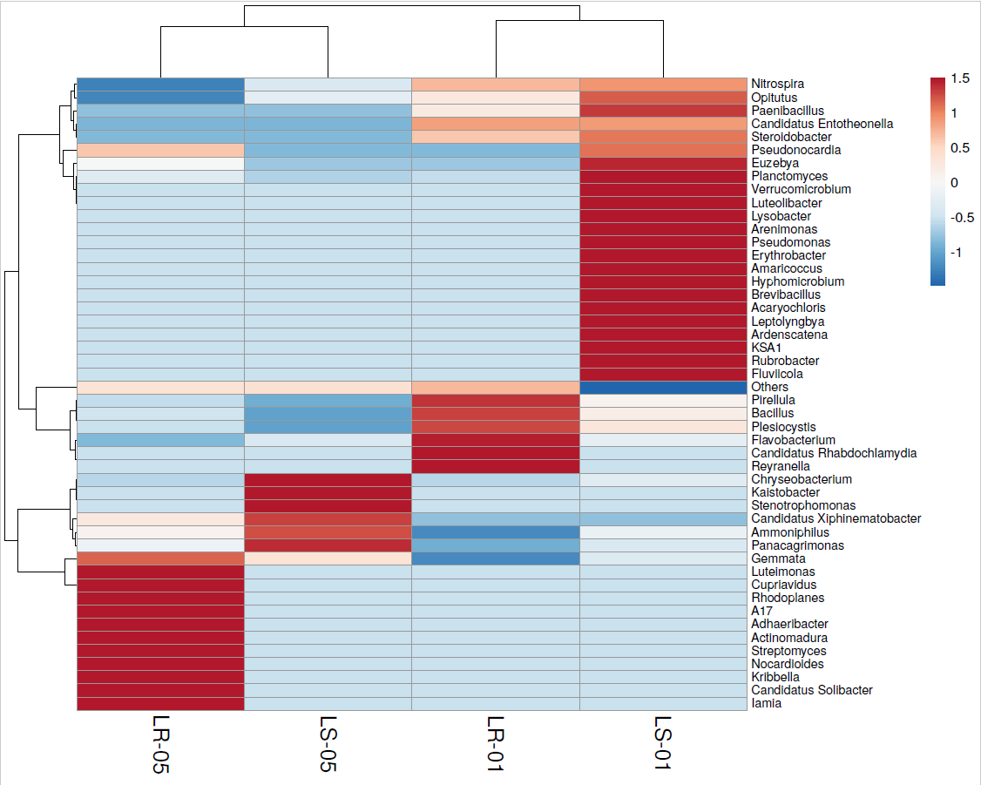

Supplementary Figure 1. Heatmap analysis with dendrogram plot at the genus level for all samples

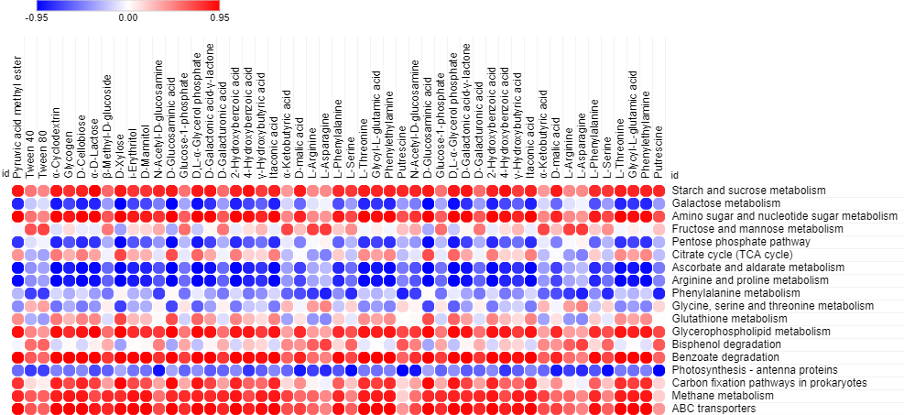

Supplementary Figure 2. Visualization of Pearson’s correlation statistical test with 31 Biolog EcoPlate™ carbon sources according to the functional KEGG pathway prediction data of the bacterial communities

