Prevalence and Risk Factors of Musculoskeletal Injuries Among Elite K1 Kickboxing Athletes: A Prospective Analysis

Name | Contact | Orcid
Alexandre Sabbag da Silva¹ | alexandre_sabbag@hotmail.com | https://orcid.org/0000-0002-4003-9001
Júlia Maria D’Andréa Greve¹ | jgreve@usp.br | https://orcid.org/0000-0003-1778-0448
Bruno Holanda Ferreira² | holanda19@hotmail.com | https://orcid.org/0000-0002-4203-2268
Paulo Sousa-e-Silva^{3,4} | paulomrss@hotmail.com | https://orcid.org/0000-0001-8642-5947
Francisco Rodrigues ⁵ | franciscobrodrigues@ipcb.pt | https://orcid.org/0000-0001-8405-4249
Ricardo Gomes^{3,6} | rimgomes@esec.pt | https://orcid.org/0000-0003-2310-1560
Mauro Fisberg⁷ | mauro.fisberg@gmail.com | https://orcid.org/0000-0003-2992-3215
Guilherme Eustáquio Furtado^{3,6,8} | guilherme.furtado@ipc.pt | https://orcid.org/0000-0001- 83271567
Angélica Castilho Alonso¹ | angelicacastilho@msn.cm | https://orcid.org/0000-0002-9644-5068

Affiliations
- Laboratory Study of Movement, Institute of Orthopedics and Traumatology, Hospital das Clínicas, Medical College, University of São Paulo, São Paulo, SP, Brazil.
- Department of Public Health, Medical College, University of São Paulo, São Paulo, SP, Brazil.
- Polytechnic University of Coimbra, Rua da Misericórdia, Lagar dos Cortiços – S. Martinho do Bispo, 3045-093 Coimbra, Portugal
- CIPER, Universidade de Coimbra, 3040-248 Coimbra, Portugal.
- IPCB/ESALD— Polytechnic University of Castelo Branco, Escola Superior de Saúde Dr. Lopes Dias, SPRINT-IPCB—Sport Physical Activity and Health Research & Innovation Center, 6000-767 Castelo Branco, Portugal
- SPRINT - Sport Physical activity and health Research & INnovation center, Polytechnic University of Coimbra, Rua Dom Joao III – Solum, 3030-329, Coimbra, Portugal
- Coordinator of the Nutrition and Feeding Difficulties Center, Pensi Institute and Sabara Children’s Hospital
- Center for Studies on Natural Resources, Environment, and Society (CERNAS), Polytechnic University of Coimbra, Bencanta, 3045-601 Coimbra, Portugal

Correspondent authors:

Dr. Guilherme Eustáquio Furtado
Prof. Dr. Francisco Rodrigues
ORCID: https://orcid.org/0000-0001-8405-4249
Email: franciscobrodrigues@ipcb.pt

ORCID: 0000-0001-8327-1567
Email: Guilherme.furtado@ipc.pt

Abstract

Background: Musculoskeletal injuries are prevalent in combat sports due to their intense physical demands and high-impact nature. However, data on injury patterns and associated factors in professional K1 kickboxing athletes remain limited. Objective: To determine the incidence and associated factors of musculoskeletal injuries in professional K1 kickboxing athletes. Materials and Methods: A total of 102 Brazilian male athletes (aged 18–43 years) were prospectively evaluated before and after 212 matches held at K1 events between 2021 and 2022. Data on injury occurrence, mechanisms, anatomical regions, and recovery times were collected. Statistical analyses included descriptive statistics, chi-square tests, and multiple correspondence analysis to identify patterns and associations. Results: A total of 317 injuries were recorded, corresponding to an incidence rate of 149.52 injuries per 100 fights. Contusions were the most frequent injuries, primarily affecting the lower limbs. Receiving a strike was the predominant injury mechanism, with the roundhouse kick responsible for the highest injury rates for both attacking and defending athletes. Head trauma was the main cause of knockouts, frequently resulting from knee strikes and hook punches. While most injuries were classified as mild, fractures led to longer recovery times and extended physiotherapy. Younger athletes had higher injury rates, whereas older athletes required longer recovery durations. Heavyweight athletes showed both a higher frequency of injuries and longer recovery periods compared to lighter weight categories. Conclusion: The incidence of musculoskeletal injuries in professional K1 kickboxing is high, with lower limb contusions being the most prevalent diagnosis and the roundhouse kick identified as a key injury mechanism. These findings highlight the need for targeted injury prevention strategies and improved post-injury management protocols to enhance athlete safety and career longevity.

Keywords: Epidemiology, Athletic Injuries, Martial Arts, Physiotherapy, Combat sports, Traumatic Brain Injuries

Introduction

Kickboxing is a striking combat sport characterized by standing physical confrontations between two athletes. It is divided into two primary categories: tatami and ring sports [1]. The World Association of Kickboxing Organizations (WAKO), the sport’s main governing body [2], received full recognition from the International Olympic Committee (IOC) on July 20, 2021 [3], becoming a member of the Association of IOC Recognized International Sports Federations (ARISF) [2, 3]. In tatami competitions, strikes are controlled to limit impact, while in ring sports there are no such restrictions, allowing fights to end by knockout [4]. Ring sports are further subdivided into three modalities—full-contact, low-kick, and K1 rules—each with distinct characteristics and regulations [4, 5].
Among the three modalities, K1 rules stands out for its higher physical intensity. It allows a broader range of striking techniques—including knee strikes, which are prohibited in full-contact and low-kick—and targets a wider array of anatomical regions [6]. These characteristics make K1 the most comprehensive and dynamic form of kickboxing, but also the one associated with the greatest injury risk [7]. Such injuries can lead to extended time away from competition, reduced athletic performance, and in some cases, career-threatening consequences [7–9].
Under professional K1 rules, matches consist of three-minute rounds with one-minute rest intervals [10]. In championship bouts, the number of rounds increases to five [2, 3]. Athletes are required to wear mouthguards and groin protectors (for men), and their hands must be taped beneath gloves weighing 8 ounces (for those under 66.8 kg) or 10 ounces for heavier fighters [5]. These regulations are intended to enhance both hand protection and striking effectiveness [9]. Nonetheless, the combination of intense training regimens, frequent competitions, and performance pressures significantly increases athletes' susceptibility to injuries [11].
Despite the sport’s growing global popularity, recent epidemiological data on kickboxing injuries remain limited. Most available studies date back to 2003 and 2015 [8, 11], and may no longer reflect current realities. Over the years, K1 kickboxing has undergone significant evolution in its technical, physiological, and psychological demands, with athletes employing faster, more explosive techniques [6, 9]. These developments may have altered the injury landscape, potentially increasing the frequency and severity of certain injuries.
This knowledge gap limits the ability to design effective prevention, treatment, and rehabilitation strategies [12]. While some studies address injuries in combat sports, many are outdated or do not distinguish between different kickboxing styles [13]. Only a few specifically examine the K1 rules format [7, 8, 11], which hinders a precise understanding of injury mechanisms and prevalence unique to this discipline [7, 14].
Currently, the World Association of Kickboxing Organizations (WAKO)—the sole international federation recognized by the International Olympic Committee—includes 135 affiliated nations across five continents. With over 4 million practitioners training in more than 40,000 clubs worldwide [9, 15], competitive participation continues to grow. As a result, injury incidence is also expected to rise [2]. Understanding the specific epidemiology of injuries in K1-rules kickboxing is therefore critical for improving athlete care, optimizing rehabilitation protocols, and informing evidence-based safety policies.
This study aimed to investigate the incidence and associated factors of musculoskeletal injuries in professional athletes competing under K1 kickboxing rules. By identifying injury patterns and their potential risk factors, the findings may support the development of targeted prevention strategies and evidence-based interventions. Ultimately, this knowledge can contribute to minimizing injury risks, enhancing performance, and promoting the longevity of athletes' careers at the professional level.

Methods
Study Design and Location
This cross-sectional, quantitative, and prospective study aimed to assess the incidence and associated factors of musculoskeletal injuries among professional athletes competing under K1 kickboxing rules. Data were collected at professional kickboxing competition venues in Brazil between January 2021 and December 2022. The study design and reporting adhered to the Strengthening the Reporting of Observational Studies in Epidemiology (STROBE) guidelines, ensuring methodological rigor and transparency [16].

Participants and sample size calculation
The study included 102 male professional K1 kickboxing athletes registered with the Brazilian Kickboxing Confederation (BKC) [17]. The sample size was calculated to ensure adequate statistical power for estimating the incidence of musculoskeletal injuries. Based on previous research in similar combat sports indicating an injury incidence rate of approximately 50% [11, 18], a 95% confidence level, and a margin of error of ±10%, the minimum sample size required was 97 athletes.

Selection criteria and recruitment process
To be eligible for participation in the study, athletes had to meet the following criteria: (i) be at least 18 years old at the time of data collection; (ii) be registered as professional athletes with the BKC; (iii) be actively competing under K1 kickboxing rules, which allow strikes using fists, feet, and knees to multiple anatomical areas; and (iv) voluntarily agree to participate by signing an informed consent form (ICF). Exclusion criteria were: (i) failure to complete all pre- and post-fight assessments or questionnaires; (ii) presence of injuries or musculoskeletal conditions requiring treatment within three months prior to the competition; and (iii) withdrawal from the study after initially providing consent.

Datta collection procedures
Data collection occurred on competition days at professional K1 kickboxing events. Athletes were interviewed twice: before their fight to gather sociodemographic and sport-related information, and after their fight to document any injuries sustained and their mechanisms. All interviews and assessments took place in a room exclusively designated for the medical team, ensuring privacy and optimal conditions for evaluation. The data were collected by a single trained evaluator—a sports physiotherapist and official member of the BKC—in collaboration with a Confederation-appointed physician.

Ethics
The study was approved by the Mackenzie University Research Ethics Committee under protocol number 5.150.583. All participants received detailed information regarding the study objectives, procedures, and confidentiality measures. Participation was entirely voluntary, and all athletes provided written informed consent prior to inclusion. This study was conducted in accordance with the ethical standards set forth in Resolution 196/1996 of the Brazilian National Health Council and the Declaration of Helsinki [19, 20].

Instruments
Data collection was performed through pre- and post-participation questionnaires aimed at obtaining comprehensive information about the athletes and any injuries sustained.

Pre-Participation assessment
The questionnaire gathered demographic information and detailed data on each athlete’s sports history, including: (a) years of practice, team affiliation, and training location; (b) competition category and fight record; (c) physical and technical training routines and frequency; and (d) access to health support, whether individual or team-based.

Post-Participation Assessment
Following each fight, injury data were collected through a structured interview with the athlete and a thorough physical examination performed by the health team. All information was documented in the athlete’s individual questionnaire to ensure accuracy and traceability.

Injury Definition and Severity Classification
In accordance with the International Olympic Committee consensus statement on injury and illness epidemiology in sports [21], an injury was defined as any physical damage caused by a sport-related incident, regardless of whether it resulted in disability, required medical attention, or caused absence from sports activities. Injury severity was classified based on time lost from training or competition following established criteria [22, 23]: i) Mild: 1–7 days of absence; ii) Moderate: 8–28 days of absence; iii) Severe: more than 28 days of absence. Injured athletes were monitored through video analysis or phone follow-ups post-event, documenting treatment, recovery progress, and timelines for return to sport to ensure accurate injury severity classification.

Calculation of Exposure and Injury Incidence
Exposure time to injury risk was calculated based on the total fight duration in minutes, considering the number of rounds and fights contested. Among 67 fights that ended by knockout (KO), 27 finished in the first round, 17 in the second, 22 in the third, and one in the fifth round, totaling 396 minutes of combat. For fights decided by judges, nine were five-round bouts and 136 were three-round bouts, corresponding to 1,359 minutes of exposure. Therefore, the total exposure time to injury risk was 1,755 minutes.
Injury incidence per 1,000 minutes of exposure was calculated using the formula proposed by Lystad (2015), resulting in 180.62 injuries per 1,000 minutes of fighting [11]. Injury incidence per fight was also calculated, considering exposure per 100 fights, totaling 149.52 injuries per 100 fights. Within the same event, the number of injuries per athlete ranged from one to ten, with athletes participating in 1 to 12 events during the study period.

Injury Data Collection and Validation
Injury data were systematically collected through structured interviews and detailed physical examinations conducted by the health team immediately after each fight. This approach ensured accurate identification and documentation of injury types, locations, and mechanisms. To enhance reliability, all injury records were cross-checked and confirmed by a sports physiotherapist in collaboration with a medical doctor affiliated with the BKC. Moreover, injured athletes were followed up post-competition through video review and telephone contact to track treatment progress, recovery timelines, and return-to-sport status. This follow-up process contributed to precise injury severity classification and data completeness.

Statistical analysis
Descriptive statistics summarized the frequency distribution of all variables, including anatomical regions affected by injuries, injury mechanisms by diagnosis and anatomical region, as well as injury severity stratified by diagnosis, anatomical region, weight division, and age.
Associations between categorical variables were assessed using the chi-square test with a significance level set at 0.05. For variables showing significant associations, Multiple Correspondence Analysis (MCA) was performed to identify clustering patterns among injury types, severity levels, and other factors. MCA, a multivariate technique similar to factor analysis, facilitates visualization of relationships between categorical variables via perceptual maps, where category proximity indicates the strength of association. The analyses were conducted using SPSS version 24. Sample size calculation was performed with G*Power [24].

Results
Table 1 summarizes the participants' key demographic, training, and competitive characteristics. The Age Range demonstrates a majority of athletes between the ages of 20 and 30, as is characteristic of high-performance athletes. The majority athletes carrying a Black Belt. Participants were divided into three weight categories, with the Middleweight division having the most representation.

Table 1. Demographic and Training Characteristics of Elite Kickboxing K1 Athletes

 | Min | Max | M | SD | n | %
Age (years) | 18 | 43 | 27.3 | ± 5.6 | 102 | 100
Years Practicing the Sport | 2 | 26 | 11.3 | ± 6.1
Professional Experience (years) | 0 | 19 | 5.2 | ± 4.3
Weekly Training Frequency (days) | 3 | 7 | 5.6 | ± 0.9
Daily Training Duration (hours) | 1 | 8 | 3.8 | ± 1.4
Professional Fights | 1 | 160 | 28.3 | ± 32.1
Age Range
Under 20 years old |  |  |  |  | 8 | 3.77%
20 - 25 years old |  |  |  |  | 83 | 39.15%
26 - 30 years old |  |  |  |  | 65 | 30.66%
Over 30 years old |  |  |  |  | 56 | 26.42%
Belt Level
Black Belt |  |  |  |  | 169 | 79.71%
Colored Belt |  |  |  |  | 43 | 20.29%
Weight Division
Lightweight |  |  |  |  | 70 | 33.02%
Middleweight |  |  |  |  | 103 | 48.58%
Heavyweight |  |  |  |  | 39 | 18.40%
Notes: Min = minimum; Max = Maximum; SD = standard deviation; n = sample size; % = percentage.

Table 2 shows that the majority of athletes (74.53%) sustained injuries during competition. The most frequent injury mechanism was receiving a strike (62.77%), with the roundhouse kick being the predominant technique involved in both offensive and defensive contexts. Most injuries were classified as mild (53.31%), followed by moderate injuries (42.27%). Contusions were by far the most common injury type, accounting for 82.33% of all reported cases. Regarding anatomical distribution, the leg (26.18%) and thigh (17.98%) were the most affected regions. The analysis of injury mechanisms further reinforces the central role of the roundhouse kick in injury occurrence, whether the athlete was delivering or receiving the strike. A total of 317 injuries were recorded throughout the study
Table 2. Characteristics of Elite Kickboxing K1 Athletes Fights and Injuries

Characteristics of injuries | Category | Frequency  (n) | Percentage  (%)
Injury Frequency | Yes | 158 | 74.53
 | No | 54 | 25.47
 | Total | 212 | 100.00
Injury Mechanism | Receiving a strike | 199 | 62.77
 | Attacking a strike | 115 | 36.27
 | Floor contact | 2 | 0.63
 | Undefined | 1 | 0.31
 | Total | 317 | 100.00
Injury Severity | Mild | 169 | 53.31
 | Moderate | 134 | 42.27
 | Severe | 14 | 4.41
 | Total | 317 | 100.00
Injury Diagnosis | Concussion | 10 | 3.15
 | Contusion | 261 | 82.33
 | Sprain | 3 | 0.95
 | Fracture | 10 | 3.15
 | Laceration/Abrasion | 29 | 9.15
 | Muscle strain | 2 | 0.63
 | Dislocation | 1 | 0.32
 | Tendinopathy | 1 | 0.32
 | Total | 317 | 100.00
Injury Site | Arm/Forearm | 6 | 1.89
 | Head | 11 | 3.47
 | Rib | 13 | 4.10
 | Elbow | 8 | 2.52
 | Thigh | 57 | 17.98
 | Face | 49 | 15.46
 | Knee | 13 | 4.10
 | Wrist/Hand | 5 | 1.58
 | Shoulder | 2 | 0.63
 | Foot | 51 | 16.09
 | Leg | 83 | 26.18
 | Pelvis/Lower Back | 6 | 1.89
 | Thorax/Abdomen | 4 | 1.26
 | Ankle | 9 | 2.84
 | Total | 317 | 100.00
Injury Mechanism - Attacking a Strike | Roundhouse Kick | 96 | 83.47
 | Knee Strike | 7 | 6.08
 | Cross Punch | 5 | 4.34
 | Front Kick | 3 | 2.60
 | Spinning Back Kick | 2 | 1.73
 | Hook Punch in the Head | 2 | 1.73
 | Total | 115 | 100.00
Injury Mechanism - Receiving a Strike | Roundhouse Kick | 125 | 62.81
 | Knee Strike | 16 | 8.04
 | Cross Punch | 24 | 12.06
 | Front Kick | 6 | 3.01
 | Hook Punch in the Head | 8 | 4.02
 | Headbutt Blow | 8 | 4.02
 | Hook Punch in the Body | 4 | 2.01
 | Others | 8 | 4.02
 | Total | 199 | 100.00

The results of the Multiple Correspondence Analysis (MCA), shown in Figure 1, revealed distinct associations between injury diagnoses and anatomical regions, forming four main clusters. Group 1 included contusions, predominantly associated with the forearm, leg, foot, rib, knee, and thigh. Group 2 consisted of cerebral concussions, which were strongly linked to head injuries. Group 3 grouped together lacerations/abrasions and fractures, both frequently related to facial injuries. Group 4 identified muscle strains, specifically associated with shoulder injuries. Dimension 1 explained 56.0% of the variance and Dimension 2 explained 44.0%, resulting in a cumulative explained variance of 100.0%. Categories with the highest contribution scores included Contusion and Face, indicating strong influence on the dimensional structure and clustering patterns observed.

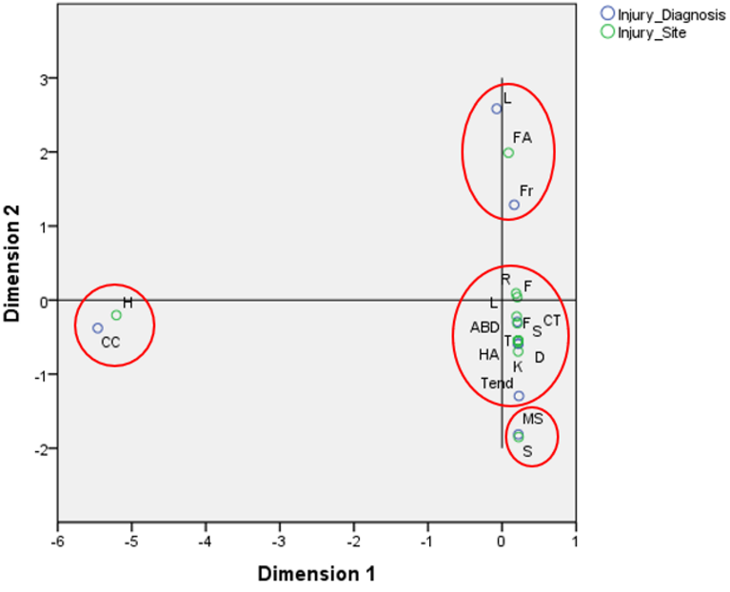
Laceration/abrasion and fracture were associated with the face
Cerebral concussion was associated with the head
Muscle strain was associated with the shoulder.
Contusion was associated with the forearm, leg, foot, rib, knee, and thigh

Figure 1: Simple Correspondence Analysis between Injury Site and Injury Diagnosis. Legend: CT – Contusion; MS – Muscle Strain; L – Laceration/Abrasion; S – Sprain; FR – Fracture; CC – Concussion; D – Dislocation; F – Foot; K – Knee; T – Thigh; R – Rib; FA – Face; L – Leg; S – Shoulder; H – Head; HA – Hand; ABD – Abdomen; F – Forearm; A – Arm; E – Elbow; W – Wrist; LB – Lower Back; P – Pelvis; T – Thorax; AN – Ankle.

Figure 2 presents the results of the MCA examining the association between injury mechanisms and anatomical regions. Negative values along the MCA dimensions highlighted strong associations between both attacking and receiving a roundhouse kick and injuries to the rib, thigh, knee, foot, ankle, and leg. In contrast, positive dimension values associated receiving a cross punch, knee strike, or hook punch with injuries to the head and face. Additionally, attacking a cross punch was associated with injuries to the shoulder and wrist, while attacking a hook punch corresponded primarily with hand injuries. Dimension 1 explained 18.84% and Dimension 2 explained 18.27% of the total variance, with a cumulative explained variance of 37.1%. The most influential categories included receiving a roundhouse kick, applying a roundhouse kick, and receiving a direct punch, as indicated by their high contribution scores.
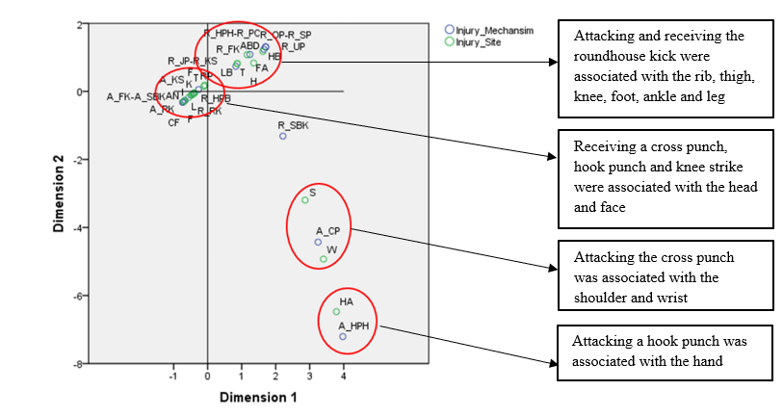

Figure 2. Simple correspondence analysis between injury mechanism and injury site. Legend: I – Indefinite; A_RK – Attacking a roundhouse kick; A_FK – Attacking a front kick; A_SBK – Attacking a spinning back kick; A_HPH – Attacking a hook punch to the head; A_CP – Attacking a cross punch; A_KS – Attacking a knee strike; CF – Contact with the floor; R_RK – Receiving a roundhouse kick; HB – Headbutt blow; R_FK – Receiving a front kick; R_SBK – Receiving a spinning back kick; R_HPH – Receiving a hook punch to the head; R_PC – Receiving a cross punch; R_HPB – Receiving a hook punch to the body; R_JP – Receiving a jab punch; R_KS – Receiving a knee strike; R_OP – Receiving an overhand punch; R_SP – Receiving a spinning punch; R_UP – Receiving an uppercut punch; F – Foot; K – Knee; T – Thigh; R – Rib; FA – Face; L – Leg; S – Shoulder; H – Head; HA – Hand; ABD – Abdomen; F – Forearm; A – Arm; E – Elbow; W – Wrist; LB – Lower back; P – Pelvis; T – Thorax; AN – Ankle.

The MCA results depicted in Figure 3 reveal clear associations between injury severity levels and injury diagnoses. Mild and moderate injuries were predominantly associated with diagnoses such as contusions, lacerations/abrasions, and cerebral concussions. In contrast, severe injuries were strongly linked to fractures. Dimension 1 accounted for 55.5% of the total variance, while Dimension 2 explained the remaining 44.5%, resulting in a cumulative explained variance of 100.0%. Fractures showed a strong positive loading on Dimension 1, aligning closely with the severe category. Meanwhile, contusions and lacerations clustered around mild and moderate severity on Dimension 2, indicating their relatively lower clinical impact and shorter recovery periods.

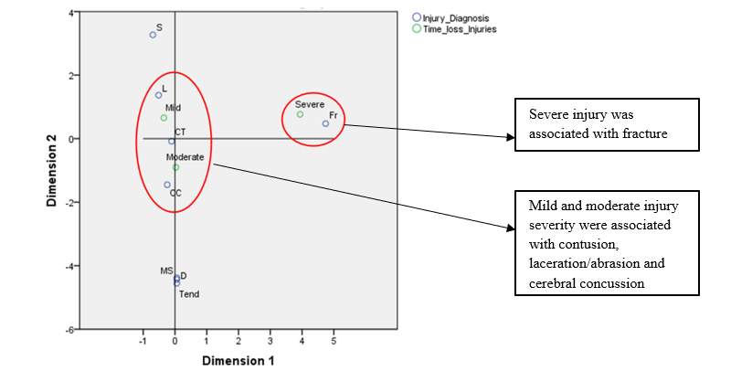
Figure 3. Simple correspondence analysis between injury diagnosis and injury severity. Legend: CT – Contusion; MS – Muscle strain; L – Laceration/abrasion; S – Sprain; FR – Fracture; CC – Concussion; D – Dislocation.

The MCA results illustrated in Figure 4 demonstrate distinct associations between injury severity and the anatomical regions affected. Mild injuries were primarily linked to regions such as the thigh, face, abdomen, wrist, pelvis, and thorax. Moderate injuries showed strong associations with the head, ankle, hand, rib, leg, and foot. Severe injuries were most closely related to the forearm and elbow. Dimension 1 explained 53.8% of the total variance, while Dimension 2 accounted for 46.2%, resulting in a cumulative explained variance of 100.0%. These patterns suggest that injuries to central or upper-limb regions, particularly the forearm and elbow, are more likely to result in prolonged recovery times, whereas lower-limb and facial injuries tend to be less severe.

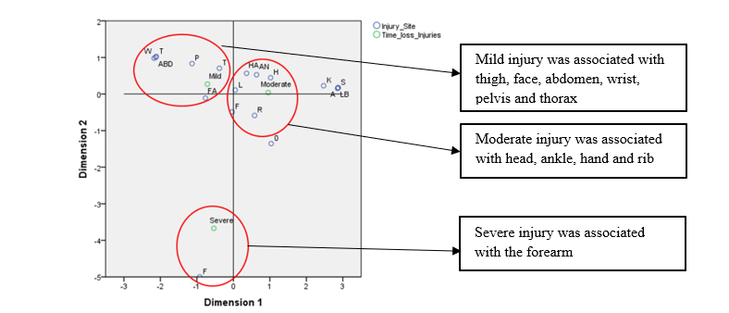
Figure 4. Simple Correspondence Analysis Between Injury Severity and Injury Site. Legend: F - Foot; K - Knee; T - Thigh; R - Rib; FA - Face; L - Leg; S - Shoulder; H - Head; HA - Hand; ABD - Abdomen; F - Forearm; A - Arm; E - Elbow; W - Wrist; LB – Lower Back; P - Pelvis; T - Thorax; AN – Ankle

The correspondence analysis results displayed in Figure 5 indicate a notable association between moderate injury severity and the heavyweight division. The proximity of these categories on the perceptual map suggests that athletes competing in the heavyweight category were more frequently affected by moderately severe injuries. Although detailed inertia values for this analysis were not reported, the spatial clustering supports the interpretation that the force and intensity typical of heavyweight bouts may contribute to a higher likelihood of moderate injury outcomes.
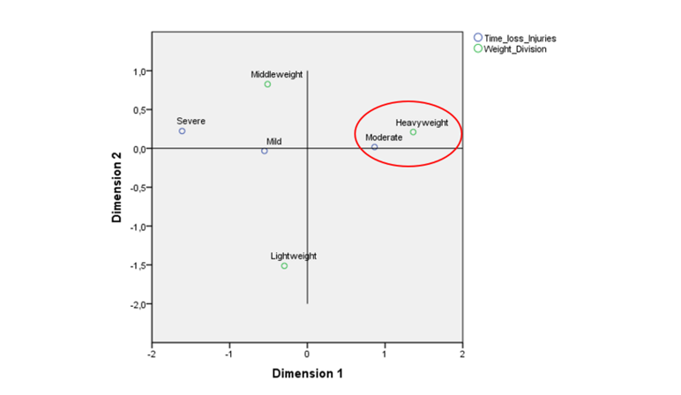
Figure 5 - Correspondence analysis between injury severity and weight division.

Discussion
The main findings highlight a high incidence of injuries in elite K1 kickboxing, with contusions predominating, particularly in the lower limbs. The roundhouse kick was identified as the most injurious strike. Biomechanically, the roundhouse kick is characterized by rapid hip rotation, knee extension, and momentum transfer through the leg, producing foot velocities of up to 18.3 m/s and substantial impact forces [25]. These forces are sufficient to cause significant mechanical stress on soft tissues and underlying bone structures, which helps explain the high frequency of contusions and musculoskeletal injuries associated with this technique.
Head injuries, including cerebral concussions, were frequently associated with knee strikes and hook punches. These impacts transmit substantial linear and rotational accelerations to the brain, disrupting neural tissues and leading to concussive injuries. The threshold forces and biomechanical responses underlying these trauma mechanisms are consistent with patterns reported in biomechanical studies of combat sports. An injury rate of 180.62 per 1000 minutes of exposure, higher than rates reported in retrospective analyses [8, 11, 18], may result from the real-time data collection and inclusion of minor injuries often underreported in previous research.
In the CMA analysis (Figure 1), contusions were significantly associated with multiple anatomical regions, including the forearm, ribs, leg, foot, knee, and thigh. This widespread distribution is consistent with the high overall prevalence of contusions (82.33%) in this cohort and aligns with findings from previous K1 and combat sport studies [8, 26]. The permissiveness of K1 rules—allowing low kicks, knee strikes, and combinations targeting both upper and lower body regions—likely contributes to the dispersion of blunt trauma across the limbs and torso [27]. Biomechanically, these strikes involve substantial kinetic energy transferred over relatively broad contact surfaces, favoring contusion over laceration or fracture.
The upper limbs sustained fewer injuries in this sample, possibly due to protective equipment such as gloves and wraps. These devices absorb and redistribute impact forces, reducing localized stress on bone and soft tissue in the striker’s hands and wrists, while still enabling transmission of damaging force to the opponent. This mechanical trade-off may partially explain the lower incidence of forearm and hand injuries observed, a pattern also noted in other combat sport cohorts [8, 28].
Lacerations and fractures were predominantly associated with the facial region, while concussions were mostly observed in the head. These findings reflect the high incidence of direct craniofacial trauma resulting from attempts to achieve knockouts through high-velocity strikes such as hook punches, uppercuts, and knee strikes [29, 30]. Biomechanically, the face is particularly vulnerable due to its limited soft tissue coverage, sharp bone contours, and lack of natural deflection mechanisms, making it prone to cuts and fractures upon impact.
Concussions, in turn, result from rapid angular or linear acceleration of the brain within the skull following impact, often without visible external injury. This mechanism is common in combat sports, where repeated strikes to the head are not only permitted but strategically employed [31, 32]. Unlike in most contact sports, where concussions are treated as exceptional events, in combat sports they represent an inherent risk due to the offensive nature of the activity [33]. This cultural and regulatory acceptance of head trauma contributes to its higher prevalence among these athletes.
In the analysis of injury mechanism by anatomical region (Figure 2), the roundhouse kick was the most frequently implicated strike and was associated with injuries to multiple sites, including the thigh, leg, foot, ankle, knee, and ribs. Widely used across various striking martial arts—such as kickboxing, Muay Thai, Karate, and Taekwondo—the roundhouse kick is versatile and can target different levels depending on tactical intent: low (thigh), middle (torso), or high (head) [34, 35]
From a mechanical standpoint, the roundhouse kick is a complex, high-velocity movement that involves rapid pelvic axial rotation, hip abduction and flexion, knee extension, and dynamic shifting of the center of mass toward the target [36]. It is typically executed through coordinated phases, including hip rotation, pivoting of the support foot, counter-rotation of the arms, and impact with the lower shin or instep. These combined elements enable the generation of substantial kinetic energy, which is transferred over a relatively broad contact surface—especially in low kicks—making the technique both effective and injury-inducing [37]. The prevalence of lower limb and rib injuries observed in this study can be explained by the frequent use of this strike at close and mid-range, where impact forces are maximized due to minimal time for defensive reaction.
While direct studies measuring the impact force of the roundhouse kick in kickboxing remain limited, recent research supports and expands upon the classic findings by Sidthilaw (1997) and Patrick et al. (1967) [38, 39]. Sidthilaw reported forces ranging from 2071 N to 14,024 N in Muay Thai athletes [39], whereas Patrick and colleagues identified that facial fractures can occur with forces around 11,743 N applied to padded bony structures [38]. Recent studies show that roundhouse kick velocity and force vary widely, influenced by technique, strength, and experience. A systematic review reported velocities up to 18.3 m/s and impact forces up to 9,000 N (~918 kgf), enough to cause serious injuries, including fractures [25]. Biomechanical analyses emphasize that rapid pelvic rotation, hip flexion, and knee extension significantly affect force magnitude.
Studies on injury mechanics show trained athletes can produce peak forces surpassing fracture thresholds in the face and ribs, particularly when striking vulnerable areas like the skull and thorax [40]. These findings underscore the critical importance of adequate protective equipment and technical training to reduce the risk of severe injury during competition. Thus, recent evidence not only confirms the classical data but also broadens the understanding of biomechanical determinants underlying impact forces, providing a stronger foundation for interpreting injury patterns observed in professional kickboxing athletes.
Upper limb strikes, such as hook and cross punches, were strongly associated with injuries to the head and face. These findings are consistent with recent research identifying these strikes as among the most common, particularly targeting the head region [41]. The high injury rate from these techniques may be due to the anatomical vulnerability of the head, face, and abdomen—areas with limited soft tissue protection to absorb impact.
Knee strikes and hook punches were the main contributors to knockouts in this study, most often targeting the head and face. While these findings reflect common tactical choices in K-1, they are underrepresented in the literature. Notably, K-1 kickboxing is the only major rule set that permits knee strikes to the head, yet most studies do not differentiate between kickboxing styles, limiting direct comparison.
Analysis of severity, injury type, and anatomical location (Figures 3 and 4) confirmed that fractures represent severe injuries requiring extended recovery periods. Bone healing can span several weeks to months and typically involves a structured rehabilitation process to restore function and prevent recurrence. In contrast, mild to moderate injuries—such as contusions, lacerations/abrasions, and concussions—generally result in shorter time away from training and competition [42]. Though contusions and abrasions can impair performance [8], they typically resolve quickly with minimal intervention. Cerebral concussions, despite being classified as moderate, can have variable recovery timelines [43], though they are usually shorter than those for fractures when managed appropriately [42].
Injury severity also varied by weight division (Figure 5), with heavier athletes experiencing a greater number of total injuries. This trend is consistent with findings from Muay Thai [32] and Taekwondo [44]., and likely reflects the greater force output from heavier fighters [45]. The heavyweight division, in particular, showed a stronger association with moderate injuries, underscoring the role of strike magnitude in injury severity.

Strengths and Limitations
This study provides valuable insights into the incidence and characteristics of injuries in professional K-1 kickboxing, reporting a high injury rate and identifying key injury mechanisms and anatomical regions through multiple correspondence analysis (MCA). Real time data gathering during sanctioned events and a concentration on professional male athletes only provide a comprehensive and ecologically sound understanding of injury trends at the highest level.
However, several limitations must be acknowledged: (i) all data were collected by a single evaluator—a licensed sports physiotherapist and official member of the BKC—with support from a medical doctor, which may introduce observer bias despite clinical expertise; (ii) the study focused solely on acute injuries, without evaluating potential long-term consequences or chronic conditions; (iii) no biomechanical instrumentation (e.g., motion capture, force plates) was used to objectively confirm injury mechanisms; (iv) the sample included only male athletes, limiting the generalizability of the findings to female competitors.
Finally, the limited number of epidemiological studies focused specifically on kickboxing—particularly under K-1 rules—constrains broader comparisons, underscoring the need for further research across different regions, rule sets, and athlete populations.

Practical Applications and Future Directions
The findings of this study offer valuable guidance for developing targeted injury prevention strategies in professional kickboxing. These may include sport-specific conditioning programs, refinement of striking techniques, implementation of evidence-based recovery protocols, and advancements in protective equipment design. Insights into injury severity and mechanisms can help coaches and medical staff tailor training loads and rehabilitation plans to reduce downtime and enhance athlete longevity.
Future research should expand to include female athletes and examine differences in injury patterns across experience levels and weight categories. Longitudinal studies investigating the cumulative effects of repeated trauma—particularly head injuries—are crucial to understanding their long-term impact on neurological health, performance, and career sustainability. Integrating biomechanical assessments in future studies will also strengthen the understanding of injury mechanisms and inform safer practice standards in combat sports.

Conclusion
Injury incidence in professional K-1 kickboxing is considerably high, with athletes frequently sustaining multiple injuries per fight. Contusions—particularly in the lower limbs—were the most common and generally of mild severity. The roundhouse kick was identified as the primary mechanism of injury across multiple anatomical regions. Less experienced athletes were more prone to injury, while older competitors required longer recovery times. Heavyweight athletes sustained a higher number of injuries, likely due to the greater force of impacts in this category. Head trauma, including cerebral concussions, was prevalent and strongly associated with knee strikes and hook punches. Fractures, although less frequent, were consistently linked to severe injuries requiring prolonged rehabilitation.

Acknowledgments
Our research team would like to express our sincere gratitude to the BKC for their invaluable support and cooperation throughout this study. We also appreciate the contribution of all athletes involved in the study, whose dedication and commitment made this research possible. The author Guilherme Furtado thanks the National funding by FCT- Foundation for Science and Technology, P.I., through the institutional scientific employment program-contract (CEECINST/00077/2021).

Conflict of Interest
The authors declare that the research was conducted in the absence of any commercial or financial relationships that could be construed as a potential conflict of interest.

Authors' Contributions
Alexandre Sabbag da Silva: Contributed to the study design, data collection, and manuscript preparation. Júlia Maria D’Andréa Greve: Assisted in data collection and analysis, and contributed to the writing of the manuscript. Bruno Holanda Ferreira: Provided expertise in data analysis and contributed to the interpretation of the results. Paulo Sousa-e-Silva: Participated in the study design and provided technical support during data collection. Francisco Rodrigues: Contributed to the data analysis and manuscript revision. Mauro Fisberg: Participated in the study design and provided critical insights on the manuscript. Guilherme Eustáquio Furtado: Revised the manuscript and contributed to the interpretation of the data, along with other tasks. Angélica Castilho Alonso: Coordinated the study and contributed to data analysis and manuscript writing.

Funding
There was no external funding for this study.

Data Availability
The datasets used and/or analyzed during the current study are available from the corresponding author upon reasonable request.

Ethics Approval and Consent to Participate
This study was approved by the Ethics Committee of Mackenzie University Research Ethics Committee under protocol number 5.150.583.

Consent for Publication
Not applicable.

Competing Interests
The authors declare no competing interests.

References

1. El-Ashker S, Chaabene H, Prieske O. Maximal isokinetic elbow and knee flexor–extensor strength measures in combat sports athletes: the role of movement velocity and limb side. BMC Sports Sci Med Rehabil. 2022;14.
2. WAKO - World Association of Kickboxing Organizations. https://olympics.com/ioc/recognised-international-federations/world-association-of-kickboxing-organizations. Accessed 18 Nov 2024.
3. Wako - World Association of Kickboxing Organizations. https://wako.sport/news/ioc-executive-board-approved-wako-application-for-full-recognition/. Accessed 18 Nov 2024.
4. Kędra AP, Ambroży T, Rydzik Ł, Kędra A, Ambroży D, Niewczas M, et al. The effectiveness of kickboxing techniques and its relation to fights won by knockout. 2020.
5. Ambroży AT, Kwiatkowski A, Dariusz Mucha A, Wrześniewski K, Piwowarski AJ. Training load and Training effecTiveness in The PreParaTory Phase by The case of kickboxing fighTers of uks gladiaTor club.
6. Rydzik Ł, Ambroży T. Physical Fitness and the Level of Technical and Tactical Training of Kickboxers. Int J Environ Res Public Health. 2021;18:3088.
7. Goes RA, Lopes LR, Cossich VRA, De Miranda VAR, Coelho ON, Do Carmo Bastos R, et al. Musculoskeletal injuries in athletes from five modalities: a cross-sectional study. BMC Musculoskelet Disord. 2020;21.
8. Zazryn TR, Finch CF. A 16 year study of injuries to professional kickboxers in the state of Victoria, Australia. 2003.
9. M S, H C, B M, E F, K C, F C. Kickboxing review: anthropometric, psychophysiological and activity profiles and injury epidemiology. Biol Sport. 2017;34:185–96.
10. Rydzik Ł, Wąsacz W, Ambroży T, Pałka T, Sobiło-Rydzik E, Kopańska M. Comparison of Head Strike Incidence under K1 Rules of Kickboxing with and without Helmet Protection—A Pilot Study. International Journal of Environmental Research and Public Health 2023, Vol 20, Page 4713. 2023;20:4713.
11. Lystad RP. Injuries to Professional and Amateur Kickboxing Contestants: A 15-Year Retrospective Cohort Study. Orthop J Sports Med. 2015;3.
12. Romaine LJ, Davis SE, Casebolt K, Harrison KA. Incidence of injury in kickboxing participation. J Strength Cond Res. 2003;17:580–6.
13. Bickley RJ, Hazim NY, Sy JW, Nute DW. An epidemiological study of martial arts injuries in patients presenting to US emergency rooms. Injury. 2023;54.
14. Štyriak R, Hadža R, Arriaza R, Augustovičová D, Zemková E. Effectiveness of Protective Measures and Rules in Reducing the Incidence of Injuries in Combat Sports: A Scoping Review. Journal of Functional Morphology and Kinesiology. 2023;8.
15. Shimoyama T, Masuda I, Numa T, Horie N. Mandibular fracture with a mouth formed mouthguard in kickboxing. Dental Traumatology. 2009;25:242–4.
16. STROBE statement - Checklist of items that should be included in reports of observational studies (?? STROBE Initiative). Int J Public Health. 2008;53:3–4.
17. Confederação Brasileira de KickBoxing. https://www.cbkb.com.br/. Accessed 19 Nov 2024.
18. Strotmeyer S, Lystad RP. Perception of injury risk among amateur Muay Thai fighters. Inj Epidemiol. 2017;4:1–6.
19. Novoa PCR. What changes in Research Ethics in Brazil: Resolution no. 466/12 of the National Health Council. Einstein (São Paulo). 2014;12:vii–vix.
20. Review C, Communication S, Principles G. World Medical Association Declaration of Helsinki: ethical principles for medical research involving human subjects. J Am Coll Dent. 2014;81:14–8.
21. Bahr R, Clarsen B, Derman W, Dvorak J, Emery CA, Finch CF, et al. International Olympic Committee Consensus Statement: Methods for Recording and Reporting of Epidemiological Data on Injury and Illness in Sports 2020 (Including the STROBE Extension for Sports Injury and Illness Surveillance (STROBE-SIIS)). Orthop J Sports Med. 2020;8.
22. Maffulli N, Buono A Del, Oliva F, Via AG, Frizziero A, Barazzuol M, et al. Muscle Injuries: A Brief Guide to Classification and Management. Transl Med UniSa. 2014;12:14.
23. Murray A, Junge A, Robinson PG, Bizzini M, Bossert A, Clarsen B, et al. International consensus statement: methods for recording and reporting of epidemiological data on injuries and illnesses in golf. Br J Sports Med. 2020;54:1136–41.
24. Kang H. Sample size determination and power analysis using the G*Power software. J Educ Eval Health Prof. 2021;18:17.
25. Corcoran D, Climstein M, Whitting J, Del Vecchio L. Impact Force and Velocities for Kicking Strikes in Combat Sports: A Literature Review. Sports. 2024;12:74.
26. Noh JW, Park BS, Kim MY, Lee LK, Yang SM, Lee WD, et al. Analysis of combat sports players’ injuries according to playing style for sports physiotherapy research. J Phys Ther Sci. 2015;27:2425.
27. Niewczas M, Wąsacz W, Chwała W, Pałka T, Sobiło-Rydzik E, Ambroży T, et al. Comprehensive technical analysis of a kickboxing fight in K1 format based on observation. Balt J Health Phys Act. 2024;16:Article1–Article1.
28. Thomas RE, Thomas BC. Systematic review of injuries in mixed martial arts. Phys Sportsmed. 2018;46:155–67.
29. Hutchison MG, Lawrence DW, Cusimano MD, Schweizer TA. Head Trauma in Mixed Martial Arts. Am J Sports Med. 2014;42:1352–8.
30. Shirani G, Motamedi MHK, Ashuri A, Eshkevari P. Prevalence and patterns of combat sport related maxillofacial injuries. J Emerg Trauma Shock. 2010;3:314.
31. Shirani G, Motamedi MHK, Ashuri A, Eshkevari P. Prevalence and patterns of combat sport related maxillofacial injuries. J Emerg Trauma Shock. 2010;3:314.
32. Gartland S, Malik MHA, Lovell ME. Injury and injury rates in Muay Thai kick boxing. Br J Sports Med. 2001;35:308–13.
33. Follmer B, Dellagrana RA, Zehr EP. Head Trauma Exposure in Mixed Martial Arts Varies According to Sex and Weight Class. Sports Health. 2019;11:280–5.
34. Chinnasee C, Mohamad NI, Nadzalan AM, Sazili AHA, Hemapandha W, Pimjan L, et al. Lower limb kinematics analysis during roundhouse kick among novices in muay thai. Journal of Fundamental and Applied Sciences. 2017;9:1002–10.
35. Diniz R, Del Vecchio FB, Schaun GZ, Oliveira HB, Portella EG, Da Silva ES, et al. Kinematic Comparison of the Roundhouse Kick Between Taekwondo, Karate, and Muaythai. J Strength Cond Res. 2021;35:198–204.
36. Gavagan CJ, Sayers MGL. A biomechanical analysis of the roundhouse kicking technique of expert practitioners: A comparison between the martial arts disciplines of Muay Thai, Karate, and Taekwondo. PLoS One. 2017;12:e0182645.
37. Lenetsky S, Harris N, Brughelli M. Assessment and contributors of punching forces in combat sports athletes: Implications for strength and conditioning. Strength Cond J. 2013;35:1–7.
38. Patrick LM, Mertz HJ, Kroell CK. Cadaver Knee, Chest and Head Impact Loads. SAE Transactions. 1968;76:2932–40.
39. Sidthilaw, Suwat. Kinetic and kinematic analysis of Thai boxing roundhouse kicks. 1996.
40. Romero-Morales C, López-López D, Almazán-Polo J, Mogedano-Cruz S, Sosa-Reina MD, García-Pérez-de-Sevilla G, et al. Prevalence, diagnosis and management of musculoskeletal disorders in elite athletes: A mini-review. Disease-a-Month. 2024;70:101629.
41. Beranek V, Stastny P, Novacek V, Votapek P, Formanek J. Upper Limb Strikes Reactive Forces in Mix Martial Art Athletes during Ground and Pound Tactics. Int J Environ Res Public Health. 2020;17:7782.
42. Romero-Morales C, López-López D, Almazán-Polo J, Mogedano-Cruz S, Sosa-Reina MD, García-Pérez-de-Sevilla G, et al. Prevalence, diagnosis and management of musculoskeletal disorders in elite athletes: A mini-review. Disease-a-Month. 2024;70:101629.
43. Ntikas M, Binkofski F, Shah NJ, Ietswaart M. Repeated Sub-Concussive Impacts and the Negative Effects of Contact Sports on Cognition and Brain Integrity. International Journal of Environmental Research and Public Health. 2022;19.
44. Jeong HS, Ha S, Jeong DH, O’sullivan DM, Lee SY. Injury and Illness in World Taekwondo Junior Athletes: An Epidemiological Study. Int J Environ Res Public Health. 2021;18:2134.
45. Walilko TJ, Viano DC, Bir CA. Biomechanics of the head for Olympic boxer punches to the face. Br J Sports Med. 2005;39:710–9.

