Covalent-fragment screening identifies selective inhibitors of multiple Staphylococcus aureus serine hydrolases important for biofilm formation
Tulsi Upadhyay¹, Emily C. Woods¹, Stephen D. Ahator³, Kjersti Julin³, Franco Faucher², Marijn J. Hollander¹, Nichole J. Pedowitz¹, Daniel Abegg⁴, Isabella Hammond¹, Ifeanyichukwu E Eke¹, Sijie Wang¹, Shiyu Chen¹, John Bennett², Jeyun Jo¹, Christian S. Lentz³, Alex Adibekian⁴, Matthias Fellner⁵ and Matthew Bogyo^{1,6*}

¹Department of Pathology, Stanford School of Medicine, Department of Pathology, Stanford University School of Medicine, Stanford, CA, USA
²Department of Chemistry, Stanford University, Stanford, CA, USA
³Research Group for Host-Microbe Interactions, Department of Medical Biology and Centre for New Antibacterial Strategies (CANS) UiT, The Arctic University of Norway, 9037 Tromsø, Norway
⁴Department of Chemistry, University of Illinois Chicago, Chicago, Illinois, 60607 USA
⁵Biochemistry Department, School of Biomedical Sciences, University of Otago, Dunedin, New Zealand
⁶Department of Microbiology and Immunology, Stanford University School of Medicine, Stanford, CA, USA

*Corresponding author: Matthew Bogyo, E-mail: mbogyo@stanford.edu

Table S1: Electrophile classes in the 1,600 covalent fragment library
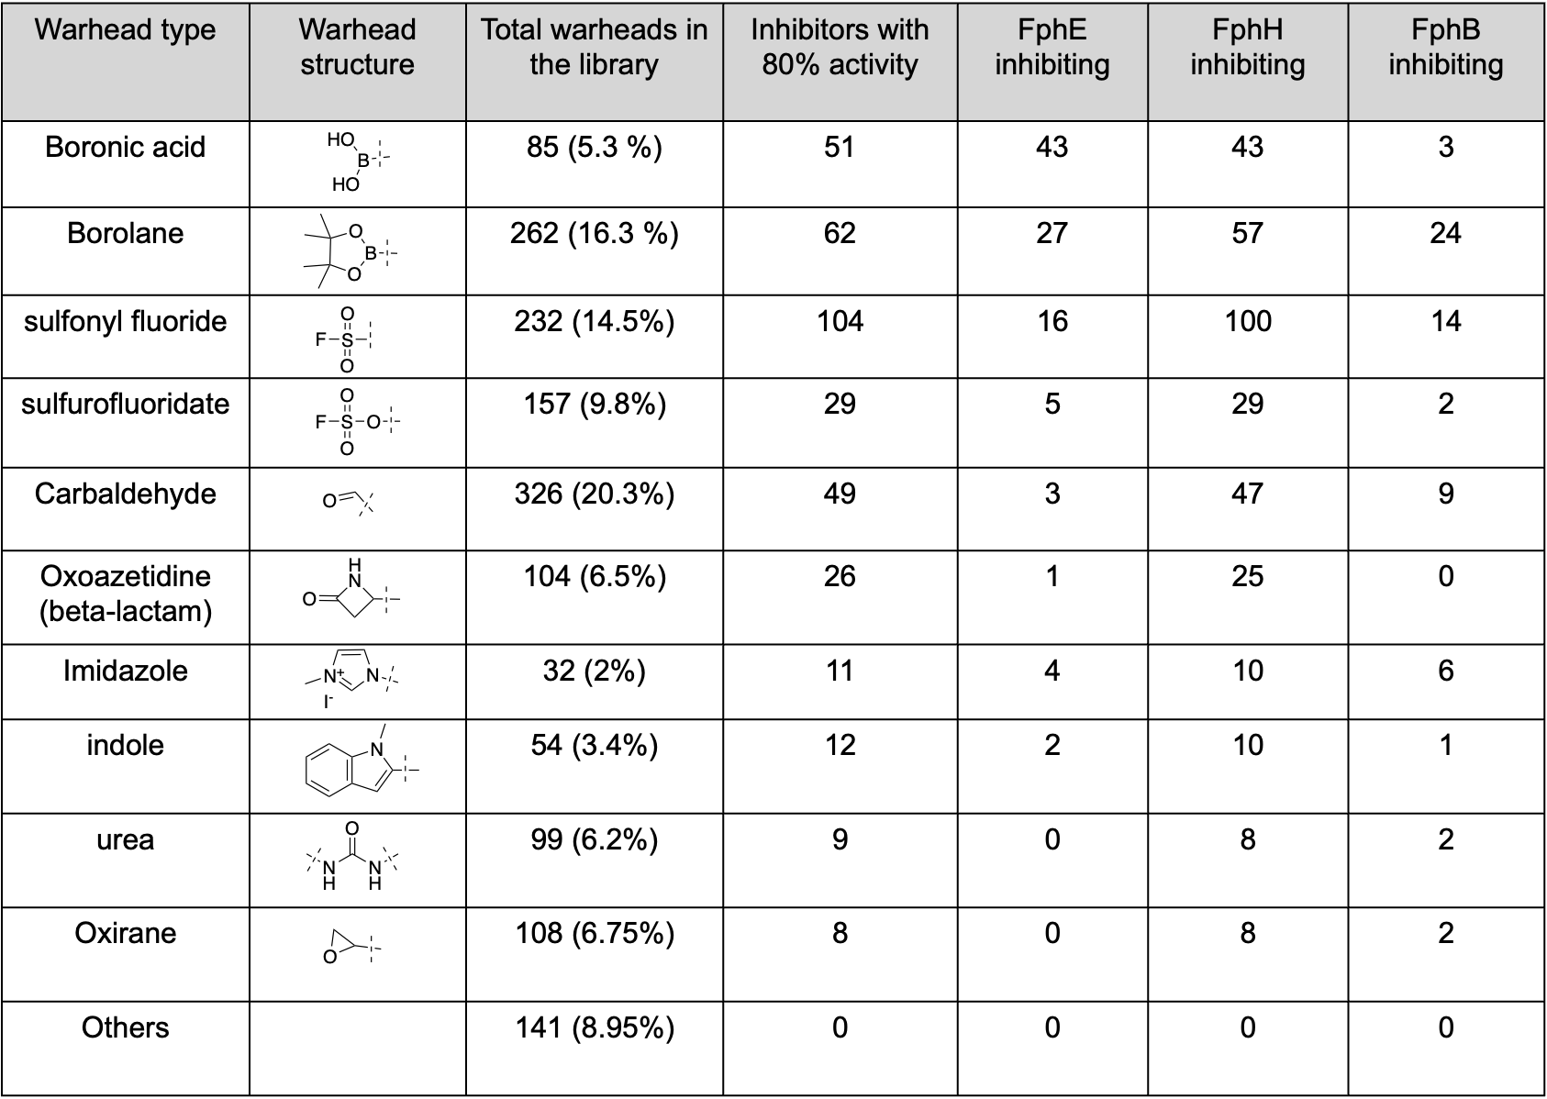

Table S2: Top hits with IC₅₀ and K_{i} against each target protein. Calculated molecular weight and ClogP values for each compound.
 | FphE (IC₅₀/ K_{i}) | FphH (IC₅₀/ K_{i}) | FphB (IC₅₀/ K_{i}) | Molecular weight | ClogP
X13 | 1.79 ± 0.32  /2.34 ± 0.21 | 0.035 ± 0.01  / 0.016 ± 0.003 | >50/ 418 | 310,  290 (cyclized) | 1.223  0.0076 (cyclized)
X13a | 0.96 ± 0.24  /2.34 ± 0.31 | 0.03 ± 0.01  /0.012 ± 0.004 | >50/283 | 296,  276 (cyclized) | -0.423  0.724 (cyclized)
X20 | >50 / N.D. | N.D./ N.D. | 10.1 ± 0.7  /2.80 ± 0.08 | 273 | 1.007
D17 | >50 /155.9 | 2.16 ± 0.55  /0.76 ± 0.15 | 6.15 ± 0.15  /1.89 ± 0.04 | 202 | 2.359
L17 | >50 / 117.7 | 2.97 ± 1.05  /1.02 ± 0.34 | 6.12 ± 0.26  /1.85 ± 0.06 | 348 | 3.019
Z27 | 0.051 ± 0.004  /0.012 ± 0.001 | 0.73 ± 0.03  /2.88 ± 0.16 | >50/ N.D. | 178 | 2.56
N34 | 8.41 ± 0.35  /0.179 ± 0.007 | 0.051 ± 0.016  /0.023 ± 0.008 | >50/ N.D. | 196 | 2.124
W41 | 0.54 ± 0.03  /0.137 ± 0.008 | 41.8 ± 13.9  /9.63 ± 1.79 | >50/ N.D. | 182 | 1.43
Q41 | 10.78 ± 1.04  /4.62 ± 0.91 | 0.014 ± 0.016  /0.134 ± 0.088 | >50/ N.D. | 297 | 2.332
AF22 | >50/ N.D. | 3.73 ± 0.14  /1.273 ± 0.048 | 60.61 ± 12.83  /7.61 ± 0.73 | 260 | 0.738
S31 | >50/ N.D. | 0.011 ± 0.003  /0.004 ± 0.001 | >50/ N.D. | 307 | -4.332
T09 | >50/ N.D. | 0.001 ± 0.002  /0.0005 ± 0.00003 | >50/ N.D. | 393 | -3.61
H08 | >50/ N.D. | 3.31 ± 1.6  /1.75 ± 1.01 | >50/ N.D. | 288 | 1.99
AF26 | >50/ N.D. | 2.25 ± 0.23  /0.84 ± 0.08 | >50/ N.D. | 306 | -0.171
Z08 | >50/ N.D. | 1.93 ± 0.43  /0.71 ± 0.12 | >50/ N.D. | 302 | 1.736
Y05 | >50/ N.D. | 7.99 ± 0.26  /3.11 ± 0.18 | >50/ N.D. | 163 | 0.876

Table S3: Bacterial strains used in this study.
Strain | Description | Reference/Source
S. aureus USA 300 LAC | Wild-type USA300 Los Angeles County (LAC) clone; multilocus sequence type 8, SCCmec type IV, cured of antibiotic resistance plasmid | ¹
S. aureus USA 300 fphE::Tn | Transposon insertion mutant in  SAUSA300_2518; Ery^{R}, Linc^{R} | Nebraska Transposon Mutant Library
S. aureus USA300 fphH::Tn | Transposon insertion mutant in  SAUSA300_0763; Ery^{R}, Linc^{R} | Nebraska Transposon Mutant Library
S. aureus USA 300 fphB::Tn | Transposon insertion mutant in  SAUSA300_2473; Ery^{R}, Linc^{R} | Nebraska Transposon Mutant Library
‍S. aureus USA300 + pALC | empty vector control, Cap^{R} | This work
S. aureus USA 300 fphE::Tn + pALC | empty vector control, Cm^{R} | This work
S. aureus USA300 fphH::Tn+ pALC | empty vector control, CmR | This work
S. aureus USA 300 fphB::Tn+ pALC | empty vector control, CmR | This work
S. aureus USA 300 fphE::Tn+ pALC- fphE | complemented fphE: pALC-SAUSA300_2518; Cm^{R} | This work
S. aureus USA300 fphH::Tn+ pALC- fphH | complemented fphH: pALC-SAUSA300_0763; Cm^{R} | This work
S. aureus USA 300 fphB::Tn+ pALC- fphB | complemented fphB: pALC-SAUSA300_2473; Cm^{R} | This work
Staphylococcus epidermidis ATCC 12228 | Wild-type strain | Elizabeth Joyce, UCSF
Streptococcus pyogenes ATCC 12384 | Wild-type strain | Niaz Banaei, Stanford University
Listeria monocytogenes | Wild-type strain | Michael Howitt, Stanford University
Pseudomonas aeruginosa ATCC 27853 | Wild-type strain | Niaz Banaei, Stanford University
Escherichia coli BW25113 | Wild-type strain | Coli Genetic Stock Center
Abbreviations: Ery^{R} - erythromycin resistant, Linc^{R} - lincosamide resistant, Cm^{R} - chloramphenicol resistant

Table S4. Primers used for cloning.
Primer description | Sequence ( 5' - 3')
Forward primer for fphB | TATGATGGTACCGTTAACAGATCTGAGCTCAGAGGAGTGACGACAAATGCGTAAA
Reverse primer for fphB | CGACGTTGTAAAACGACGGCCAGTGAATTCTTAGTTAATAATATTTTTCACTTGGTATAAAAAGC
Forward primer for fphE | TATGATGGTACCGTTAACAGATCTGAGCTCATGGAGGTCATTGAATATGGAAACTTTA
Reverse primer for fphE | CGACGTTGTAAAACGACGGCCAGTGAATTCTTAACCCCACATATTTAATAATACATCAGC
Forward primer for fphH | TATGATGGTACCGTTAACAGATCTGAGCTCAGGGAGCGTTAGATTTATGCAG
Reverse primer for fphH | CGACGTTGTAAAACGACGGCCAGTGAATTCTTATTCTGACCAGTCTAATGACTCTA
Forward verification primer for recombinant pALC | TATGATGGTACCGTTAACAGATCTGAGCTC
Reverse verification primer for recombinant pALC | CGACGTTGTAAAACGACGGCCAG
Forward primer for pALC amplification | GAATTCACTGGCCGTCGTTTTACAACGTCG
Reverse primer for pALC amplification | GAGCTCAGATCTGTTAACGGTACCATCATA
Forward primer for fphB | TATGATGGTACCGTTAACAGATCTGAGCTCAGAGGAGTGACGACAAATGCGTAAA

Table S5. Potencies of vaious antibiotics against Staphylococcus aureus in the absence or presence of N34-pretreatment.
Antibiotic | EC₅₀ (μM) after pretreatment with DMSO | EC₅₀ (μM) after pretreatment with N34
Ampicillin | 0.294 | 0.227
Penicillin | < 0.020 | < 0.020
Erythromycin | 0.294 | 0.806
Carbenicillin | 0.475 | 0.347
Vancomycin | 1.402 | 1.457
Streptomycin | 16.320 | 14.22
Kanamycin | 16.84 | 18.91
Puromycin | 25.31 | 23.19

Table S6: FphE and FphH ligand bound datasets - data collection and processing
Values for the outer shell are given in parentheses.
 | FphE-Z27 | FphE-W41 | FphE-Q41 | FphE-N34 | FphH-N34
PDB ID | 8UGM | 8UIX | 8UWM | 8TFW | 8TAV
Diffraction source | Australian synchrotron MX2 | Australian synchrotron MX2 | Australian synchrotron MX2 | Australian synchrotron MX1 | Australian synchrotron MX1
Wavelength (Å) | 0.954 | 0.954 | 0.954 | 0.954 | 0.954
Detector | DECTRIS EIGER X 16M | DECTRIS EIGER X 16M | DECTRIS EIGER X 16M | DECTRIS EIGER X 9M | DECTRIS EIGER X 9M
Space group | P 1 2₁ 1 | C 1 2 1 | P 2₁ 2₁ 2₁ | P 1 2₁ 1 | P 4₃
a, b, c (Å) | 46.7 74.0 73.2 | 165.3 47.0 70.8 | 65.9 78.0 110.5 | 47.0 76.4 73.4 | 67.4 67.4 55.5
α, β, γ (°) | 90.0 91.4 90.0 | 90.0 96.5 90.0 | 90.0 90.0 90.0 | 90.0 90.9 90.0 | 90.0 90.0 90.0
Resolution range (Å) | 46.71 – 1.65 (1.68 – 1.65) | 45.19 – 2.39 (2.48 – 2.39) | 45.80 – 1.97 (2.02 – 1.97) | 46.97 – 1.93 (1.97 – 1.93) | 47.65 – 1.39 (1.41 – 1.39)
Total No. of reflections | 350545 (59687) | 147924 (15162) | 329625 (23058) | 199549 (13197) | 682622 (31278)
No. of unique reflections | 11116 (2508) | 21675 (2181) | 41115 (2810) | 38831 (2582) | 50414 (2430)
Completeness (%) | 99.1 (84.3) | 99.6 (96.7) | 99.9 (98.5) | 99.3 (98.7) | 99.9 (97.9)
Redundancy | 5.9 (4.4) | 6.8 (7.0) | 8.0 (8.2) | 5.1 (5.1) | 13.5 (12.9)
〈I/σ(I)〉 | 9.4 (1.7) | 11.4 (1.7) | 13.9 (2.0) | 9.0 (1.3) | 23.0 (1.6)
CC_{1/2} | 0.996 (0.536) | 0.999 (0.625) | 0.999 (0.704) | 0.997 (0.650) | 1.000 (0.640)
R_{merge.} | 0.103 (0.870) | 0.087 (1.080) | 0.080 (1.024) | 0.124 (1.081) | 0.057 (1.735)
R_{p.i.m.} | 0.070 (0.661) | 0.054 (0.661) | 0.044 (0.558) | 0.089 (0.770) | 0.023 (0.725)

Table S7: FphE and FphH ligand bound datasets - structure solution and refinement
Values for the outer shell are given in parentheses.
 | FphE-Z27 | FphE-W41 | FphE-Q41 | FphE-N34 | FphH-N34
PDB ID | 8UGM | 8UIX | 8UWM | 8TFW | 8TAV
Resolution range (Å) | 39.82 – 1.65 (1.67 – 1.65) | 45.19 – 2.39 (2.50 – 2.39) | 45.80 – 1.97 (2.01 – 1.97) | 40.01 – 1.93 (1.98 – 1.93) | 47.65 – 1.39 (1.41 – 1.39)
Final R-work | 0.150 (0.232) | 0.199 (0.307) | 0.168 (0.277) | 0.213 (0.314) | 0.160 (0.295)
Final R-free | 0.189 (0.302) | 0.272 (0.388) | 0.204 (0.339) | 0.260 (0.394) | 0.183 (0.332)
Protein residues | 554 | 556 | 554 | 554 | 241
Ligands | 4 (Z27*) | 2 (Y43) | 2 (Q41) | 2 (N34) | 3* (N34)
Water | 483 | 36 | 239 | 147 | 227
Elemental ions | 3 (Ca) | 0 | 4 (Ca) | 1 (Mg) | 5 (Ca)
R.m.s. deviations
Bonds (Å) | 0.010 | 0.009 | 0.012 | 0.009 | 0.009
Angles (°) | 1.128 | 1.035 | 1.195 | 1.055 | 1.113
Average B factors (Å²) | 25.9 | 67.7 | 47.8 | 29.6 | 23.3
Ligands | 25.8 | 50.2 | 35.5 | 23.5 | 22.8
Water | 31.4 | 56.2 | 45.3 | 27.5 | 33.6
Elemental ions | 21.4 | - | 58.1 | 34.9 | 24.3
Ramachandran plot
Most favored (%) | 98.9 | 97.1 | 98.2 | 98.4 | 98.3
Outlier (%) | 0.18 | 0 | 0 | 0 | 0

*FphE-Z27 and FphH-N34 structures contain reacted (covalently attached to active site serine and histidine residues) and not reacted forms of the ligand. All other structures contain only reacted.

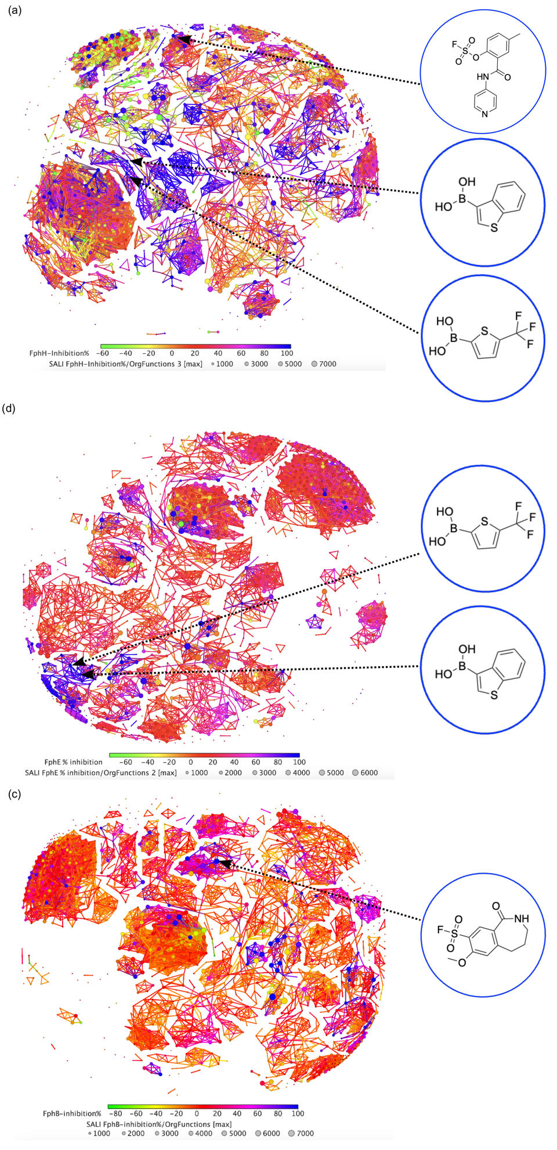
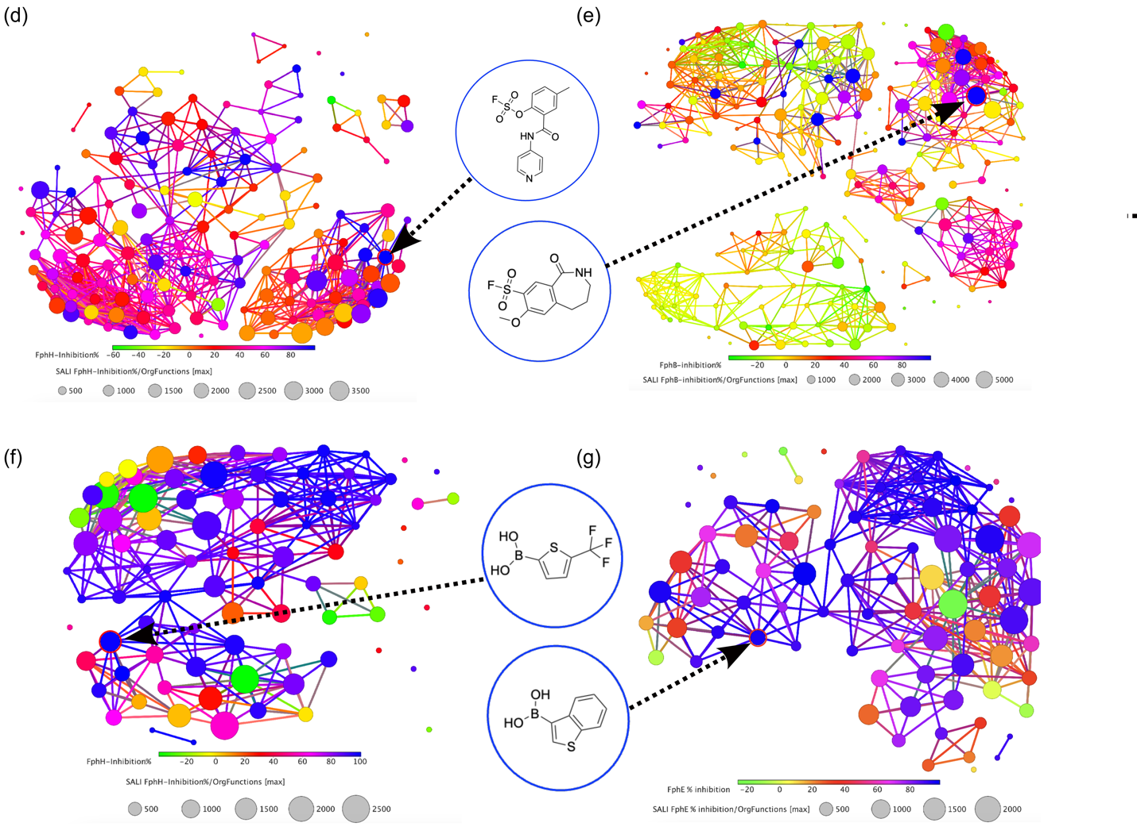Figure S1. Structure-activity relationship (SAR) data for the top hits using DataWarrior². (a-c) SALI plot for 1,600 compounds in the library showing the clusters of similar structures based on calculating the OrgFunction descriptor for each compound and arranging it according to inhibition percentage for each enzyme. (d-g) SALI plot showing the clusters of similar structures based on calculating the OrgFunction descriptor for each electrophile and arranging it according to inhibition percentage for each enzyme for fluorosulfate (d), sulfonyl fluoride (e), Boronic acid (f-g).
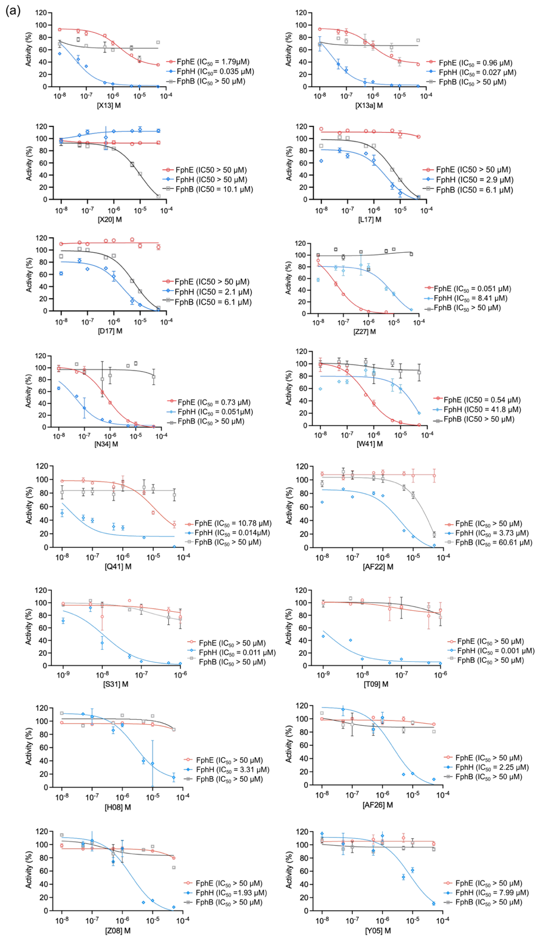
Figure S2. Dose response curves for the hit compounds. (a) The IC₅₀ values determined for the hit compounds against FphB, FphE and FphH. All experiments were performed in triplicate, and all data are expressed as the mean ± standard deviation.
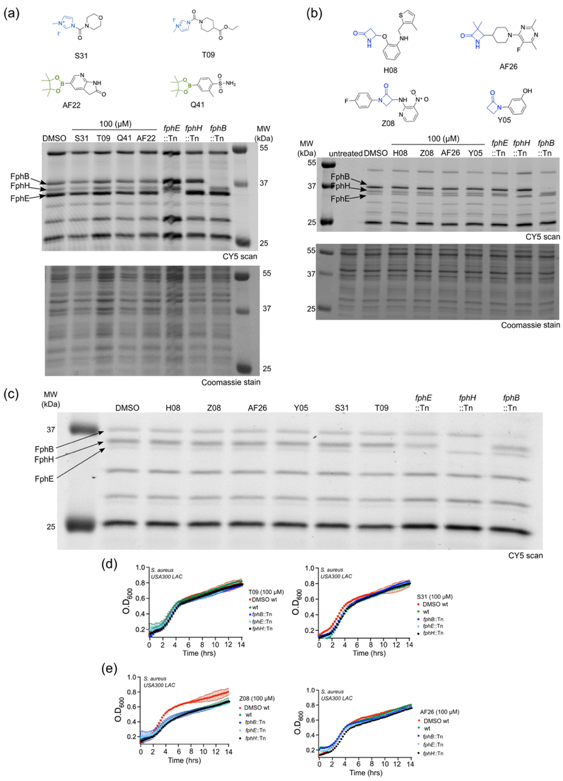
Figure S3. Biochemical characterization of Borolane, imidazole and β-lactam based inhibitors. (a-b) Structures of borolane, imidazole and β-lactam inhibitors. Competition of FP-Cy5 labeling of S. aureus live cells, S. aureus USA300 WT or the individual transposon mutants of fphE, fphH and fphB were preincubated with 100 μM of the said inhibitor for 120 min, incubated with clickable 1μM FP, lysed and labelled with Cy5 probe and analyzed by SDS-PAGE and fluorescence scan. (c) Competition of FP-Cy5 labeling of S. aureus lysates. S. aureus USA300 WT were lysed prior to preincubation with 100 μM of inhibitor for 120 min, labelled with clickable FP-CY5, and analyzed by SDS-PAGE and fluorescence scan. Indicated Fph transposon mutants (::Tn) lysates are included to highlight the location of the three enzymes in the gel. (d) Growth curves of wild-type S. aureus 100 μM of inhibitors, cultured in Mueller-Hinton Broth (MHB2).
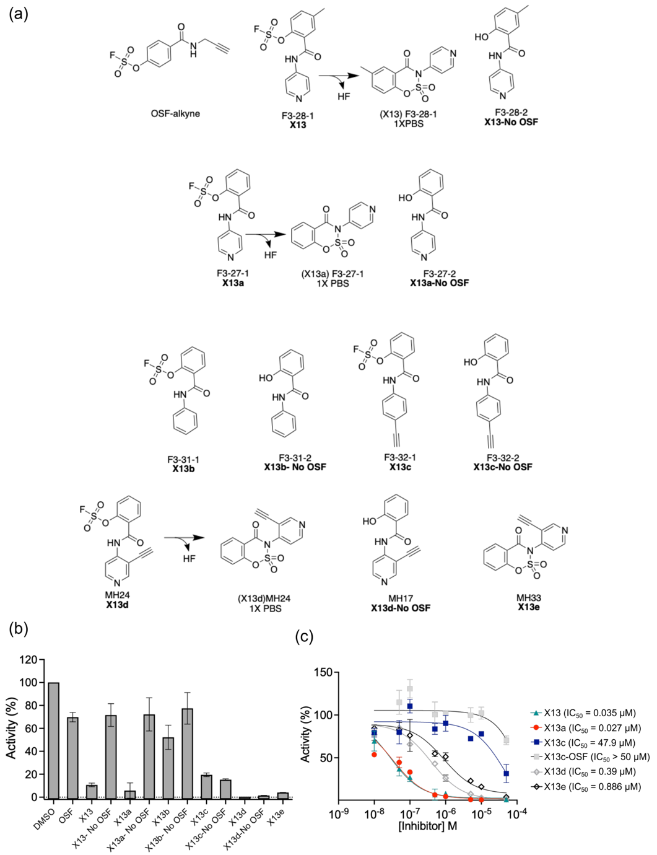
Figure S4. Structure activity relationship study for X13 analogs. (a) The structure of analogs generated in this study. (b) FphH enzyme activity measured in the presence of each analog at 50 μM concentration. (c) Dose response curve for the analogs. In the inhibition assay, compounds were incubated for 1 hr at room temperature followed with addition of 4MUB substrate and fluorescence (λ_{ex} = 365 nm and λ_{em} = 455 nm) was measured at 30 °C.
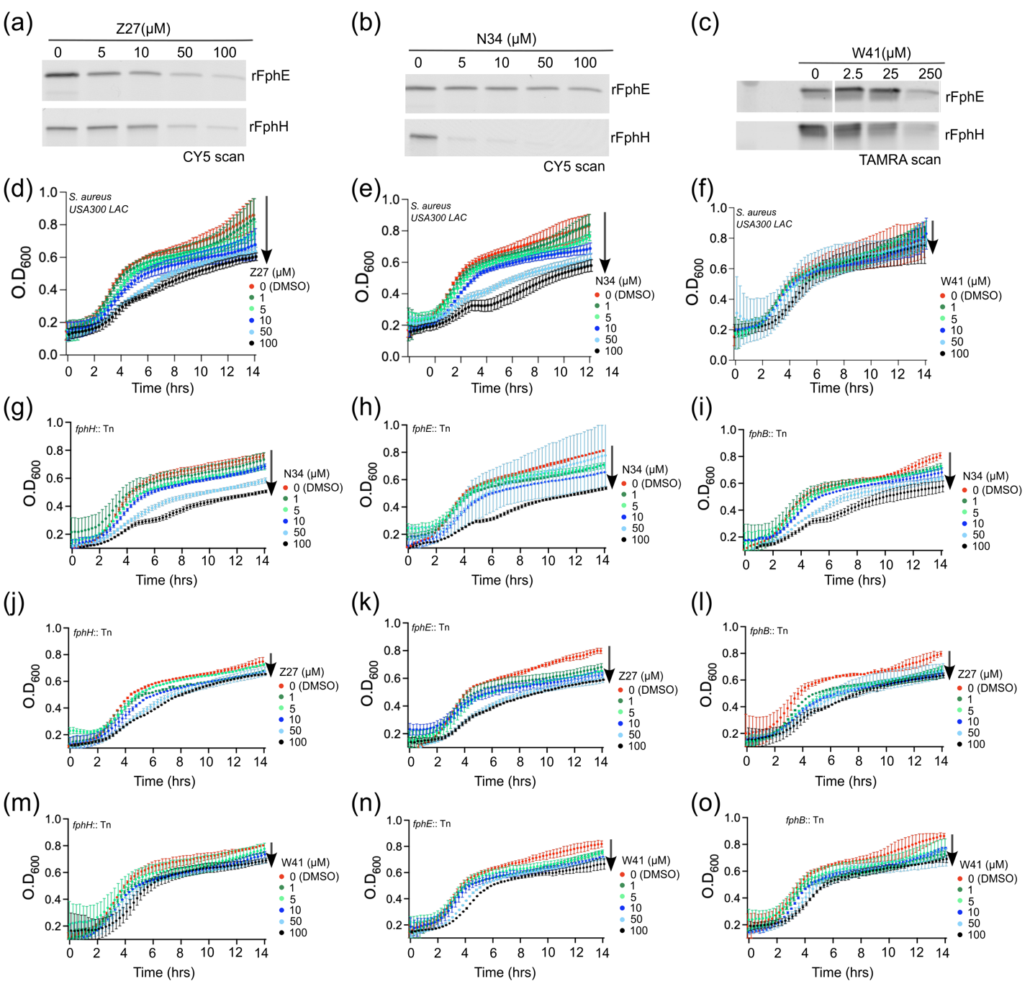
Figure S5. Competition of boron based inhibitors against FphE and FphH by in-gel fluorescence and in bacterial growth assays. (a-c) Fluorescent SDS-PAGE gel image showing the competition of FP-Cy5 labelling of rFphE and rFphH preincubated with the indicated doses of Z27, N34 and W41 and subsequently labelled with clickable 500 nM FP-Cy5 probe. (d-f) S. aureus wild type growth measured in the presence of the indicated concentrations of Z27, N34 and W41. (g-o) Bacterial growth measured for transposon mutants in the presence of the indicated concentrations of Z27, N34 and W41. Arrows indicate the comparison of the level of decrease in growth for each panel. All growth curves are plotted as mean ± standard deviation (n = 4).

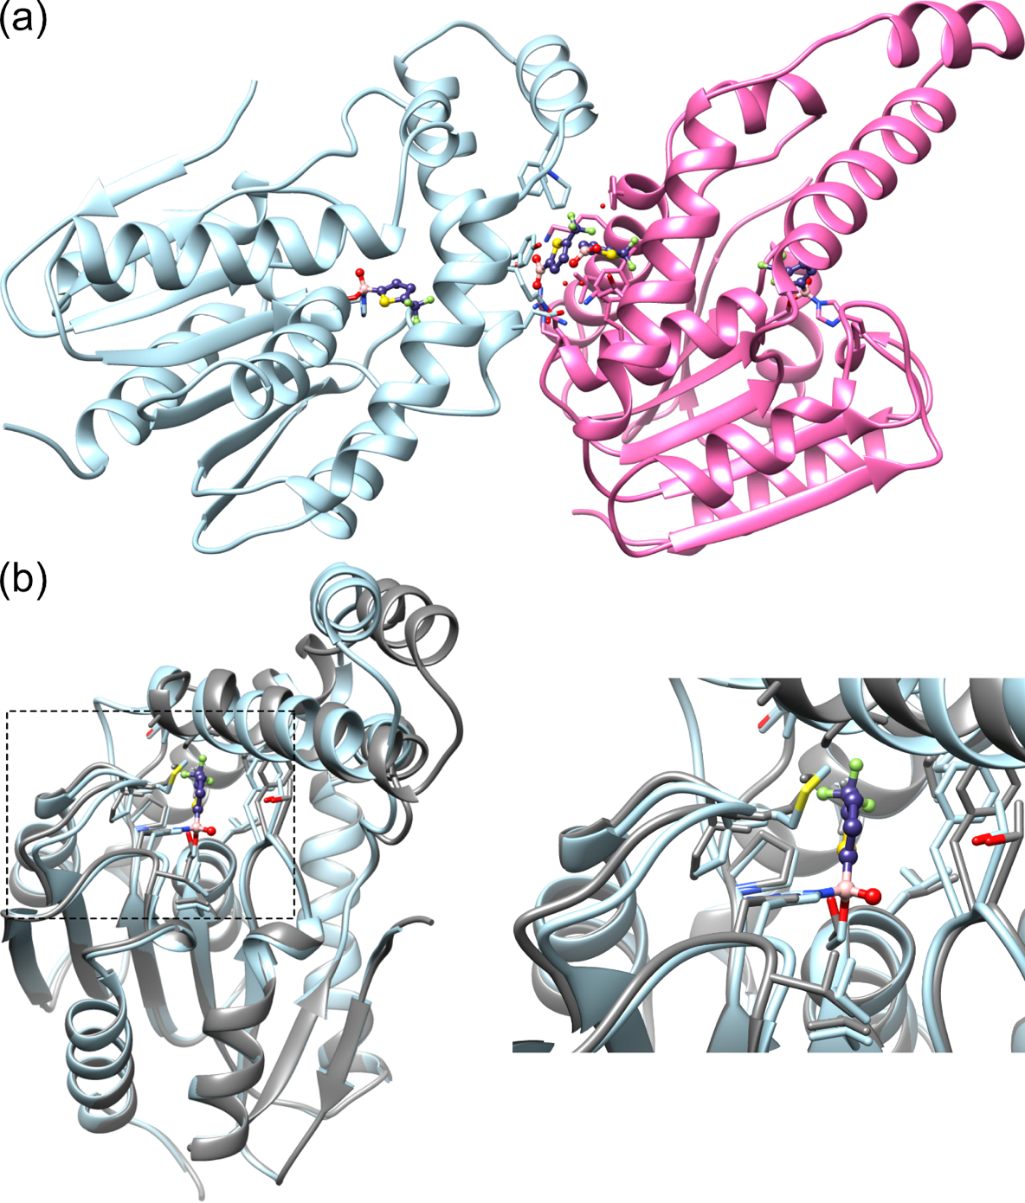
Figure S6: Images from structure of the FphH-N34 complex. (a) FphH-N34 (PDB ID 8TAV) crystal interface facilitated by two unreacted N34 molecules. Ribbon structure in light blue and crystal symmetry related FphH in pink. Two unreacted N34 molecules depicted at the crystal interface with surrounding residues and water molecules also displayed. Reacted active site serine-histidine bound N34 also illustrated for each FphH copy. (b) FphH-N34 (8TAV) in light blue compared to unbound FphH (8FTP)³ in grey. Overall structural alignment and closeup of active site.

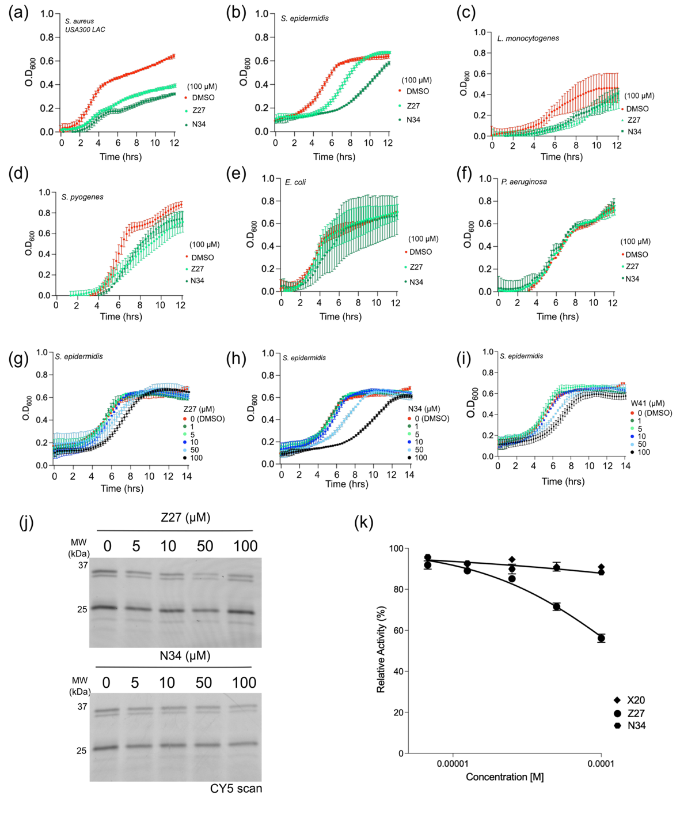
Figure S7. Influence of inhibitors on the growth of Gram-positive and Gram-negative bacteria. (a-d) Growth measured in the presence of 100 μM of Z27 and N34 for Gram-positive bacteria: S. aureus, S. epidermidis, Listeria monocytogenes, Streptococcus pyogenes. (e-f) Growth measured in the presence of 100 μM of Z27 and N34 for Gram-negative bacteria: Escherichia coli (E. coli) and Pseudomonas aeruginosa. (g-i) S. epidermidis growth measured in the presence of varied concentration of Z27, N34 and W41. (j) Fluorescent SDS-PAGE gel image for live S. epidermidis cell labeling with the FP probe. Cells were incubated with the indicated concentrations of Z27 and N34, followed by incubation with the clickable FP-alkyne, lysed and labelled with Cy5-azide and analyzed by fluorescence scanning. (k) Cytotoxicity assay to measure the toxicity of varied doses of inhibitors against HFF cells. All growth curves are plotted as mean ± standard deviation of technical duplicates.
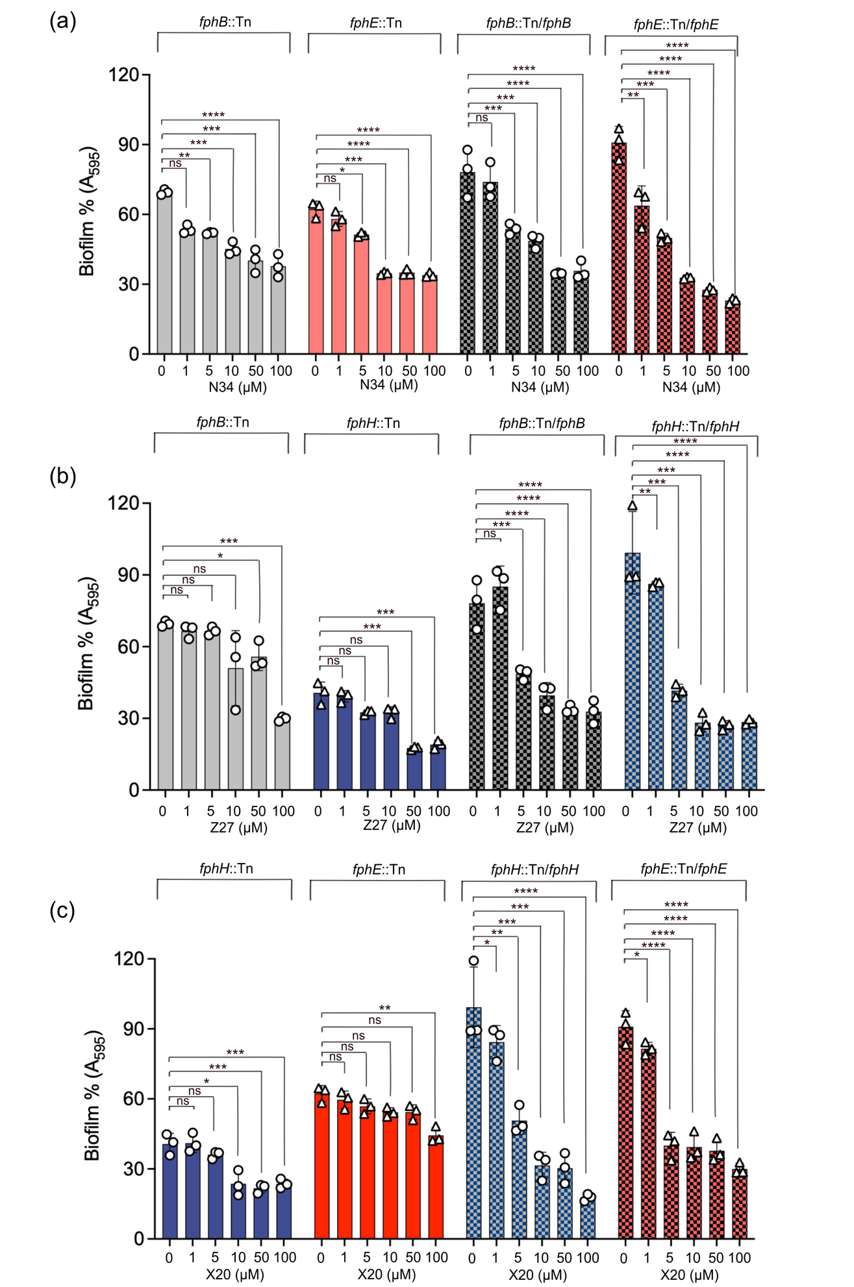
Figure S8. Antibiofilm activity measurement of inhibitors. (a) Percentage biofilm inhibition by Z27 measured for fphB, fphH mutants, and their complement strains. (b) Percentage biofilm inhibition by N34 measured for fphB, fphE mutants, and their complement strains. (c) Percentage biofilm inhibition by X20 measured for fphH, fphE mutants, and their complement strains. 100% biofilm is defined as the amount of biofilm formed from wild type in DMSO control. Bars represent means ± standard deviation. P values were determined using ordinary one-way ANOVA multiple comparisons. *P < 0.05, **P < 0.01, ***P < 0.001 and ****P < 0.0001.

Synthesis of X13 and its analogs

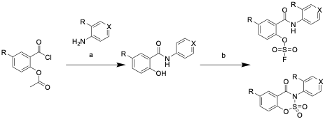

General Scheme 1. Synthesis of X-13 and its analogues starting from the acid chloride starting material or intermediate. General reagents and conditions: (a) (1) 3-ethynylpyridin-4-amine, Et₃N, CH₃Cl, 0 °C to rt, (2) 4M HCl, rt, 41%; (b) [4-(acetylamino) phenyl]imidodisulfuryl difluoride, K₂CO₃, DMSO, rt or [4-(acetylamino)phenyl]imidodisulfuryl difluoride, 1,8-Diazabicyclo(5.4.0)undec-7-ene, THF, rt.
The following procedures were adapted from various publications^{4,5}.

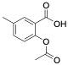
F3-28 acetyl, 2-acetoxy-5-methylbenzoic acid
2-hydroxy-5-methylbenzoic acid (2.0 g, 15 mmol, 1 eq.) and acetic anhydride (5 mL, 50 mmol, 3.33 eq.) was added to a flask with stirring at room temperature. To this mixture phosphoric acid (5–7 drops) was dropped in under stirring. The mixture was stirred for 10 min at 90 °C. The mixture was returned to room temperature and briefly rotovapped to remove excess acetic anhydride. To the mixture was added cold water (~100 mL) until precipitation occurred. The solid was then filtered. The solid was then extracted with ethyl acetate, washed with brine, dried over Na₂SO₄, and the solvent was removed under reduced pressure to give the white solid as the crude product. (1.25 g, 7.67 mmol, yield 49%). ¹H NMR (500 MHz, Chloroform-d) δ 7.95 – 7.90 (m, 1H), 7.41 (ddd, J = 8.3, 2.3, 0.8 Hz, 1H), 7.02 (d, J = 8.2 Hz, 1H), 2.40 (s, 3H), 2.33 (s, 3H).

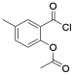
F3-28-chloride, (chlorocarbonyl)-4-methylphenyl acetate

Thionyl chloride (4.9 g, 41 mmol, 6.4 eq.) was added dropwise to the mixture of F3-28 acetyl (1.25 g, 6.44 mmol, 1 eq.) and pyridine (3 drops) under stirring in an ice bath. The solution was stirred for 30 min at the same temperature, warmed to room temperature and then stirred at 90 °C for further 4 hours. The mixture was then rotovapped dry and used crude in the next step.
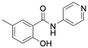
F3-28-2 (X13-No OSF), 2-hydroxy-5-methyl-N-(pyridin-4-yl) benzamide

To a solution of F3-28 chloride (1.37g, 6.44 mmol, 1 eq.) in chloroform (5 mL) was added triethylamine (988 µL, 7.09 mmol, 1.1 eq.) at 0 °C. The mixture was stirred for 15 minutes, followed by addition of pyridin-4-amine (758 mg, 8.05 mmol, 1.25 eq.), portion wise at 0 °C. After warming to ambient temperature, the reaction mixture was stirred until completion (TLC, 48 h) and then quenched by addition of 1 M aqueous hydrochloric acid (1 mL). The mixture was extracted with 4 M hydrochloric acid (3x 10 mL) and the combined aqueous phases was basified to pH 7-9 with 4 M sodium hydroxide solution. The resulting precipitate was filtered and dried over vacuum to afford a solid (0.6 g, 3 mmol, 40% yield).
¹H NMR (500 MHz, DMSO-d₆) δ 10.69 (s, 1H), 8.48 (d, J = 5.4 Hz, 2H), 7.73 (d, J = 5.4 Hz, 2H), 7.70 (s, 1H), 7.26 (d, J = 8.3 Hz, 1H), 6.91 (d, J = 8.3 Hz, 1H), 2.28 (s, 3H). LC-MS: m/z calcd. [M+H]⁺ for C₁₃H₁₂N₂O₂ 229.09, found 229.1.

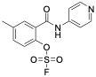
F3-28-1 (X13), 4-methyl-2-(pyridin-4-ylcarbamoyl) phenyl sulfurofluoridate

A one-dram vial was charged with F3-28-2 (25 mg, 110 µmol, 1.0 eq.) and [4-(acetylamino) phenyl] imidodisulfuryl difluoride (AISF; 41.3 mg, 131 µmol, 1.2 eq.). The solids were dissolved in dimethyl sulfoxide (2 mL) and solid potassium carbonate (45.3 mg, 329 µmol, 3.0 eq.) was added over 30 seconds, while stirring. After stirring for 5 minutes, the reaction mixture was purified by reverse-phase flash chromatography using a reverse phase Combiflash with a gradient of 5% MeCN: H2O (0.1% TFA) for 0-2 min, 5-95% for 2-18 min, 95% for 18-20 min. The product fraction was lyophilized to afford the product of X13 as a solid (5.6 mg, 18 µmol, yield 16%). ¹H NMR (500 MHz, DMSO-d₆) δ 11.73 (s, 1H), 8.75 – 8.70 (m, 2H), 8.11 – 8.06 (m, 2H), 7.79 (d, J = 2.1 Hz, 1H), 7.70 (d, J = 8.4 Hz, 1H), 7.65 (dd, J = 8.6, 2.2 Hz, 1H), 2.46 (s, 3H). ¹⁹F NMR (471 MHz, DMSO-d₆) δ 40.83. LC-MS: m/z calcd. [M+H]⁺ for C₁₃H₁₁FN₂O₄S 311.05, found 311.0.
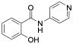

F3-27-2 (X13a-No OSF), 2-hydroxy-N-(pyridin-4-yl) benzamide
To a solution of 2-(chlorocarbonyl) phenyl acetate (purchased) (1.0 g, 5.04 mmol, 1 eq.) in chloroform (10 mL) was added triethylamine (772 µL, 5.54 mmol, 1.1 eq.) at 0 °C. The mixture was stirred for 15 minutes, followed by addition of pyridin-4-amine (592 mg, 6.29 mmol, 1.25 eq.), portionwise at 0 °C. After warming to ambient temperature, the reaction mixture was stirred until completion (TLC, 48 h) and then quenched by addition of 1 M aqueous hydrochloric acid (1 mL). The mixture was extracted with 4 M hydrochloric acid (3x 10 mL) and the combined aqueous phases was basified to pH 7-9 with 4 M sodium hydroxide solution. The resulting precipitate was filtered, and dried over vacuum to afford a solid (333 mg, 1.55 mmol, 30% yield). ¹H NMR (500 MHz, DMSO-d₆) δ 10.68 (s, 1H), 8.49 (d, J = 5.6 Hz, 2H), 7.88 (d, J = 7.8 Hz, 1H), 7.74 (d, J = 5.4 Hz, 2H), 7.45 (t, J = 7.7 Hz, 1H), 7.02 (d, J = 8.2 Hz, 1H), 6.97 (t, J = 7.5 Hz, 1H). LC-MS: m/z calcd. [M+H]⁺ for C₁₂H₁₀N₂O₂ 215.08, found 215.1.

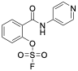
F3-27-1 (X13a), 2-(pyridin-4-ylcarbamoyl) phenyl sulfurofluoridate,

A one-dram vial was charged with F3-27-2 (62 mg, 289 µmol, 1.0 eq.) and [4-(acetylamino) phenyl]imidodisulfuryl difluoride (AISF; 109 mg, 347 µmol, 1.2 eq.). The solids were dissolved in dimethyl sulfoxide (2 mL) and solid potassium carbonate (92 mg, 868 µmol, 3.0 eq.) was added over 30 seconds, while stirring. After stirring for 5 minutes, the reaction mixture was purified by reverse-phase flash chromatography using a reverse phase Combiflash with a gradient of 5% MeCN:H2O (0.1% TFA) for 0-2 min, 5-95% for 2-18 min, 95% for 18-20 min. The product fraction was lyophilized to afford the product of X13a as a solid (23 mg, 78 µmol, yield 27%). ¹H NMR (500 MHz, DMSO-d₆) δ 11.83 (s, 1H), 8.76 – 8.70 (m, 2H), 8.13 – 8.08 (m, 2H), 7.98 (dd, J = 7.7, 1.7 Hz, 1H), 7.85 (ddd, J = 8.8, 7.2, 1.7 Hz, 1H), 7.81 (d, J = 8.1 Hz, 1H), 7.74 (td, J = 7.5, 1.3 Hz, 1H). ¹⁹F NMR (471 MHz, DMSO-d₆) δ 41.24. LC-MS: m/z calcd. [M+H]⁺ for C₁₂H₉FN₂O₄S 297.03, found 297.0.
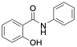
F3-31-2 (X13b-No OSF), 2-hydroxy-N-phenylbenzamide

To a solution of 2-(chlorocarbonyl)phenyl acetate (purchased) (1.0 g, 5.04 mmol, 1 eq.) in chloroform (10 mL) was added triethylamine (772 µL, 5.54 mmol, 1.1 eq.) at 0 °C. The mixture was stirred for 15 minutes, followed by addition of aniline (586 mg, 6.29 mmol, 1.25 eq.), portion wise at 0 °C. After warming to ambient temperature, the reaction mixture was stirred until completion (TLC, 48 h) and then quenched by addition of 1 M aqueous hydrochloric acid (1 mL).The mixture was extracted with DCM (3x 10 mL), washed with water, washed with saturated sodium bicarbonate, then brine. The DCM was removed under reduced vacuum and the resulting solid was dissolved in MeOH into which minimal sodium bicarbonate was added as to keep the mixture well dissolved. This mixture was heated to 80°C and stirred for 1 hour. The resulting mixture was then acidified with 1 M aqueous hydrochloric acid to form a precipitate. The resulting precipitate was filtered, washed with water, and dried over vacuum to afford a solid (230 mg, 1.1 mmol, 21% yield). ¹H NMR (500 MHz, Chloroform-d) δ 8.08 (s, 1H), 7.86 (dd, J = 7.8, 1.7 Hz, 1H), 7.62 (d, J = 7.9 Hz, 2H), 7.54 (ddd, J = 8.1, 7.4, 1.7 Hz, 1H), 7.38 (tdd, J = 7.6, 5.7, 1.5 Hz, 3H), 7.21 – 7.14 (m, 2H), 2.35 (s, 3H). LC-MS: m/z calcd. [M+H]⁺ for C₁₃H₁₁NO₂ 214.08, found 214.1.
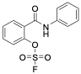
F3-31-1 (X13b) 2-(phenylcarbamoyl)phenyl sulfurofluoridate

A one-dram vial was charged with F3-31-2 (25 mg, 117 µmol, 1.0 eq.) and [4-(acetylamino) phenyl]imidodisulfuryl difluoride (AISF; 44.2 mg, 141 µmol, 1.2 eq.). The solids were dissolved in THF (1 mL) and 1,8-Diazabicyclo (5.4.0)undec-7-ene (39.3 mg, 258 µmol, 2.2 eq.) was added over 30 seconds, while stirring. After stirring for 5 minutes, the reaction mixture was purified by reverse-phase flash chromatography using a reverse phase Combiflash with a gradient of 5% MeCN: H2O (0.1% TFA) for 0-2 min, 5-95% for 2-18 min, 95% for 18-20 min. The product fraction was lyophilized to afford the product of X13b as a solid (22.5 mg, 76.2 µmol, yield 65%). ¹H NMR (500 MHz, DMSO-d₆) δ 10.63 (s, 1H), 7.88 – 7.83 (m, 1H), 7.79 – 7.63 (m, 5H), 7.40 – 7.34 (m, 2H), 7.13 (tt, J = 7.4, 1.2 Hz, 1H).¹⁹F NMR (471 MHz, DMSO-d₆) δ 41.18. ¹³C NMR (126 MHz, DMSO-d₆) δ 162.79, 146.82, 139.11, 133.17, 130.88, 130.38, 129.83, 129.29, 124.61, 122.60, 120.44. LC-MS: m/z calcd. [M+H]⁺ for C₁₃H₁₀FNO₄S 296.03, found 296.0.
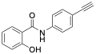
F3-32-2 (X13c-No OSF), N-(4-ethynylphenyl)-2-hydroxybenzamide
To a solution of 2-(chlorocarbonyl)phenyl acetate (purchased) (700 mg, 3.5 mmol, 1 eq.) in chloroform (10 mL) was added triethylamine (540 µL, 3.9 mmol, 1.1 eq.) at 0 °C. The mixture was stirred for 15 minutes, followed by addition of 4-ethynylaniline (520 mg, 4.4 mmol, 1.25 eq.), portion wise at 0 °C. After warming to ambient temperature, the reaction mixture was stirred until completion (TLC, 48 h) and then quenched by addition of 1 M aqueous hydrochloric acid (1 mL). The mixture was extracted with DCM (3x 10 mL), washed with water, washed with saturated sodium bicarbonate, then brine. The DCM was removed under reduced vacuum and the resulting solid was dissolved in MeOH into which minimal sodium bicarbonate was added as to keep the mixture well dissolved. This mixture was heated to 80°C and stirred for for 1 hour. The resulting mixture was then acidified with 1 M aqueous hydrochloric acid to form a precipitate. The resulting precipitate was filtered, washed with water, and dried over vacuum to afford solid (356 mg, 1.5 mmol, 43% yield). ¹H NMR (500 MHz, DMSO-d₆) δ 11.62 (s, 1H), 10.50 (s, 1H), 7.94 (dd, J = 7.9, 1.7 Hz, 1H), 7.83 – 7.74 (m, 2H), 7.52 – 7.46 (m, 2H), 7.47 (d, J = 8.7 Hz, 1H), 7.04 – 6.94 (m, 2H), 4.13 (s, 1H). ¹³C NMR (126 MHz, DMSO-d₆) δ 166.91, 158.53, 139.34, 134.14, 132.80, 129.72, 121.01, 119.59, 118.42, 117.64, 117.43, 83.94, 80.65. LC-MS: m/z calcd. [M+H]⁺ for C₁₅H₁₁NO₂ 238.08, found 238.1.
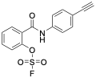
F3-32-1 (X13c), 2-((4-ethynylphenyl) carbamoyl)phenyl sulfurofluoridate

A one-dram vial was charged with F3-32-2 (25 mg, 105 µmol, 1.0 eq.) and [4-(acetylamino) phenyl]imidodisulfuryl difluoride (AISF; 39.7 mg, 126 µmol, 1.2 eq.). The solids were dissolved in THF (1 mL) and 1,8-Diazabicyclo (5.4.0)undec-7-ene (35.3 mg, 232 µmol, 2.2 eq.) was added over 30 seconds, while stirring. After stirring for 5 minutes, the reaction mixture was purified by reverse-phase flash chromatography using a reverse phase Combiflash with a gradient of 5% MeCN: H2O (0.1% TFA) for 0-2 min, 5-95% for 2-18 min, 95% for 18-20 min. The product fraction was lyophilized to afford the product of X13c as a solid (14.6 mg, 45.7 µmol, yield 43%). ¹H NMR (500 MHz, DMSO-d₆) δ 10.81 (s, 1H), 7.87 (dd, J = 7.5, 1.6 Hz, 1H), 7.77 – 7.71 (m, 4H), 7.70 – 7.65 (m, 1H), 7.51 – 7.47 (m, 2H), 4.42 (s, 0H), 4.13 (s, 1H). ¹⁹F NMR (471 MHz, DMSO-d₆) δ 41.19. ¹³C NMR (126 MHz, DMSO-d₆) δ 162.94, 146.82, 139.63, 133.75, 133.39, 132.91, 130.93, 129.87, 122.66, 120.23, 117.55, 83.88, 80.69. LC-MS: m/z calcd. [M+H]⁺ for C₁₅H₁₀FNO₄S 320.03, found 320.0.

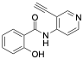
MH17 (X13d-No OSF), N-(3-ethynylpyridin-4-yl)-2-hydroxybenzamide
To a solution of O-acetylsalicyloyl chloride (99.6 mg, 500 µmol, 1 eq.) in chloroform (2.5 mL) was added triethylamine (76.7 µL, 550 µmol, 1.1 eq.) at 0 °C. The mixture was stirred for 15 minutes, followed by addition of 3-ethynylpyridin-4-amine (74.3 mg, 625 µmol, 1.25 eq.), portion wise at 0 °C. After warming to ambient temperature, the reaction mixture was stirred until completion (TLC, 48 h) and then quenched by addition of 1 M aqueous hydrochloric acid (1 mL). The mixture was extracted with 4 M hydrochloric acid (3x 5 mL) and the combined aqueous phases were stirred for 24 h to allow for complete deacetylation of the phenol group. The solution was basified to pH 8 with 4 M sodium hydroxide solution. The resulting precipitate was filtered, redissolved in acetonitrile/water and lyophilized to afford X13d-No OSF as a red-brown solid (48.8 mg, 20.5 µmol, yield 41%). ¹H NMR (500 MHz, DMSO) δ 11.96 (s, 1H), 11.35 (s, 1H), 8.64 (s, 1H), 8.50 (d, J = 1.4 Hz, 2H), 8.02 (dd, J = 8.0, 1.8 Hz, 1H), 7.47 (ddd, J = 8.7, 7.1, 1.8 Hz, 1H), 7.13 – 6.93 (m, 2H), 4.76 (s, 1H). ¹³C NMR (126 MHz, DMSO) δ 153.41, 150.89, 134.84, 131.74, 118.47, 117.61, 113.43, 90.62, 77.01. ¹³C NMR (126 MHz, DMSO) δ 164.75, 153.41, 150.89, 147.42, 134.84, 131.74, 120.34, 118.47, 117.61, 113.43, 108.19, 90.62, 77.01. LC-MS: m/z calcd. [M+H]⁺ for C₁₄H₁₁N₂O₂ 239.1, found 239.0.
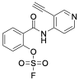
MH24 (X13d), 2-((3-ethynylpyridin-4-yl)carbamoyl)phenyl sulfurofluoridate
A one-dram vial was charged with X13d-No OSF (19.6 mg, 82.3 µmol, 1.0 eq.) and [4-(acetylamino)phenyl]imidodisulfuryl difluoride (AISF; 34.2 mg, 109 µmol, 1.3 eq.). The solids were dissolved in dimethyl sulfoxide (2 mL) and solid potassium carbonate (34.6 mg, 250 µmol, 3.0 eq.) was added over 30 seconds, while stirring. After stirring for 5 minutes, the reaction mixture was purified by reverse-phase flash chromatography using a reverse phase Combiflash with a gradient of 5% MeCN:H2O (0.1% TFA) for 0-2 min, 5-95% for 2-18 min, 95% for 18-20 min. The product fraction was lyophilized to afford 4.4 mg of X13d as a brown solid (13.7 µmol, yield 17%). ¹H NMR (500 MHz, DMSO) δ 10.48 (s, 1H), 8.73 (s, 1H), 8.59 (d, J = 5.7 Hz, 1H), 8.01 (d, J = 5.7 Hz, 1H), 7.91 (dd, J = 7.6, 1.7 Hz, 1H), 7.81 (ddd, J = 8.9, 7.2, 1.7 Hz, 1H), 7.77 (d, J = 8.2 Hz, 1H), 7.69 (td, J = 7.4, 1.4 Hz, 1H), 4.74 (s, 1H); ¹³C NMR (126 MHz, DMSO) δ 163.61, 153.31, 149.76, 146.95, 146.75, 134.04, 131.21, 129.92, 129.01, 122.79, 116.92, 111.94, 90.61, 76.85; ¹⁹F NMR (471 MHz, DMSO) δ 41.2; LC-MS: m/z calcd. [M+H]⁺ for C₁₄H₁₀FN₂O₄S 321.0, found 320.9.
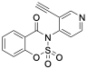
MH33 (X13e), 3-(3-ethynylpyridin-4-yl)benzo[e][1,2,3]oxathiazin-4(3H)-one 2,2-dioxide
X13d-No OSF (23.0 mg, 96.5 µmol, 1.0 eq.) afforded X13e(10.5 mg, 35 µmol, 36%) as a brown solid following the procedure described above for compound X13d, with reaction time increased from 5 to 15 minutes. ¹H NMR (500 MHz, DMSO) δ 9.00 (d, J = 0.8 Hz, 1H), 8.86 (d, J = 5.3 Hz, 1H), 8.20 (dd, J = 7.8, 1.7 Hz, 1H), 8.02 (ddd, J = 8.3, 7.5, 1.7 Hz, 1H), 7.84 – 7.73 (m, 2H), 7.70 (td, J = 7.6, 1.0 Hz, 1H), 4.69 (s, 1H); LC-MS: m/z calcd. [M+H]⁺ for C₁₄H₉N₂O₄S 301.0, found 300.9.

LC-MS traces for X13 and its analogs
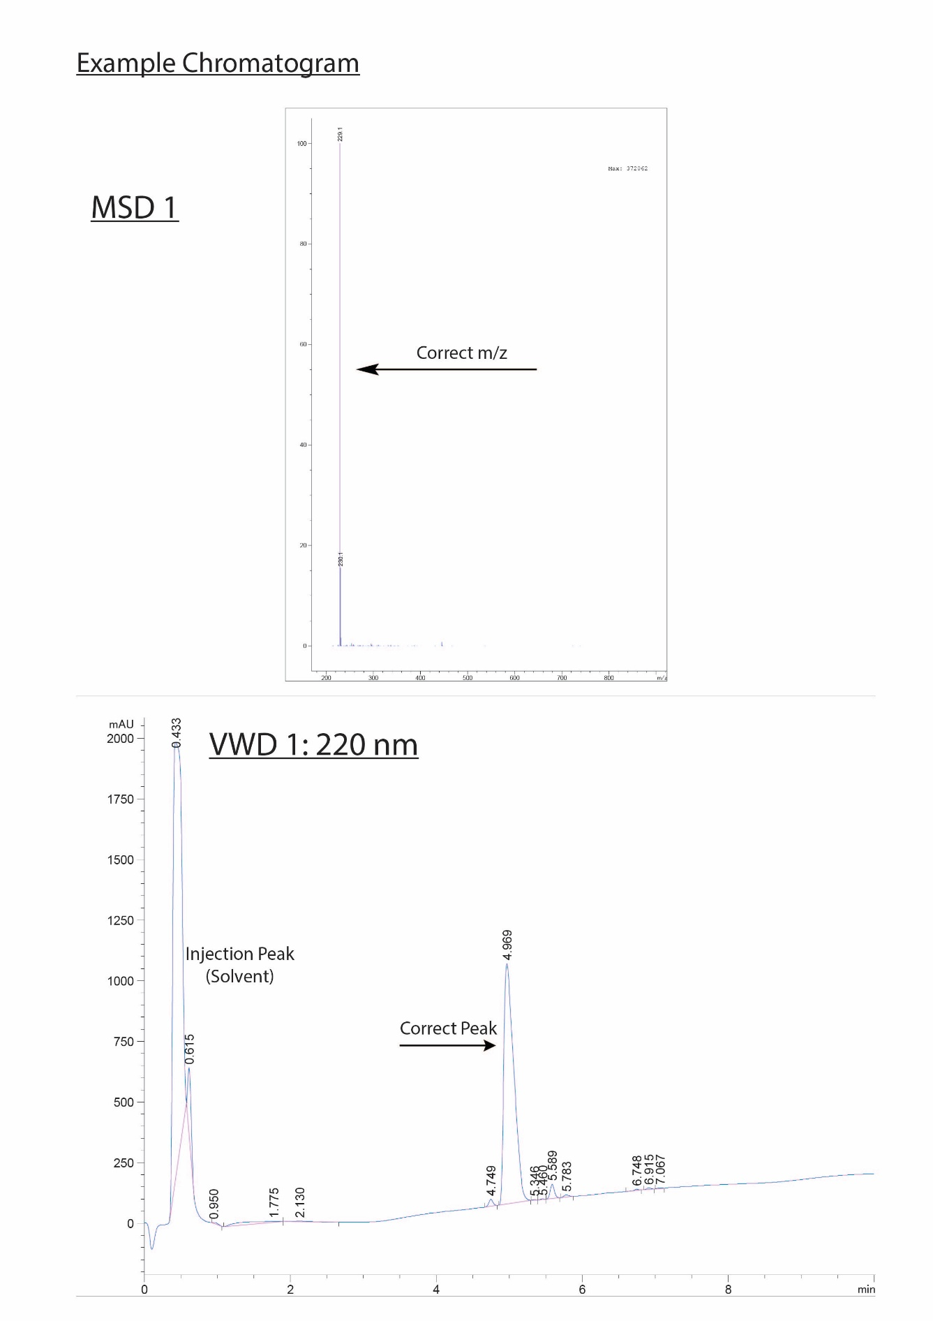
F3-28-2 (X13-No OSF)
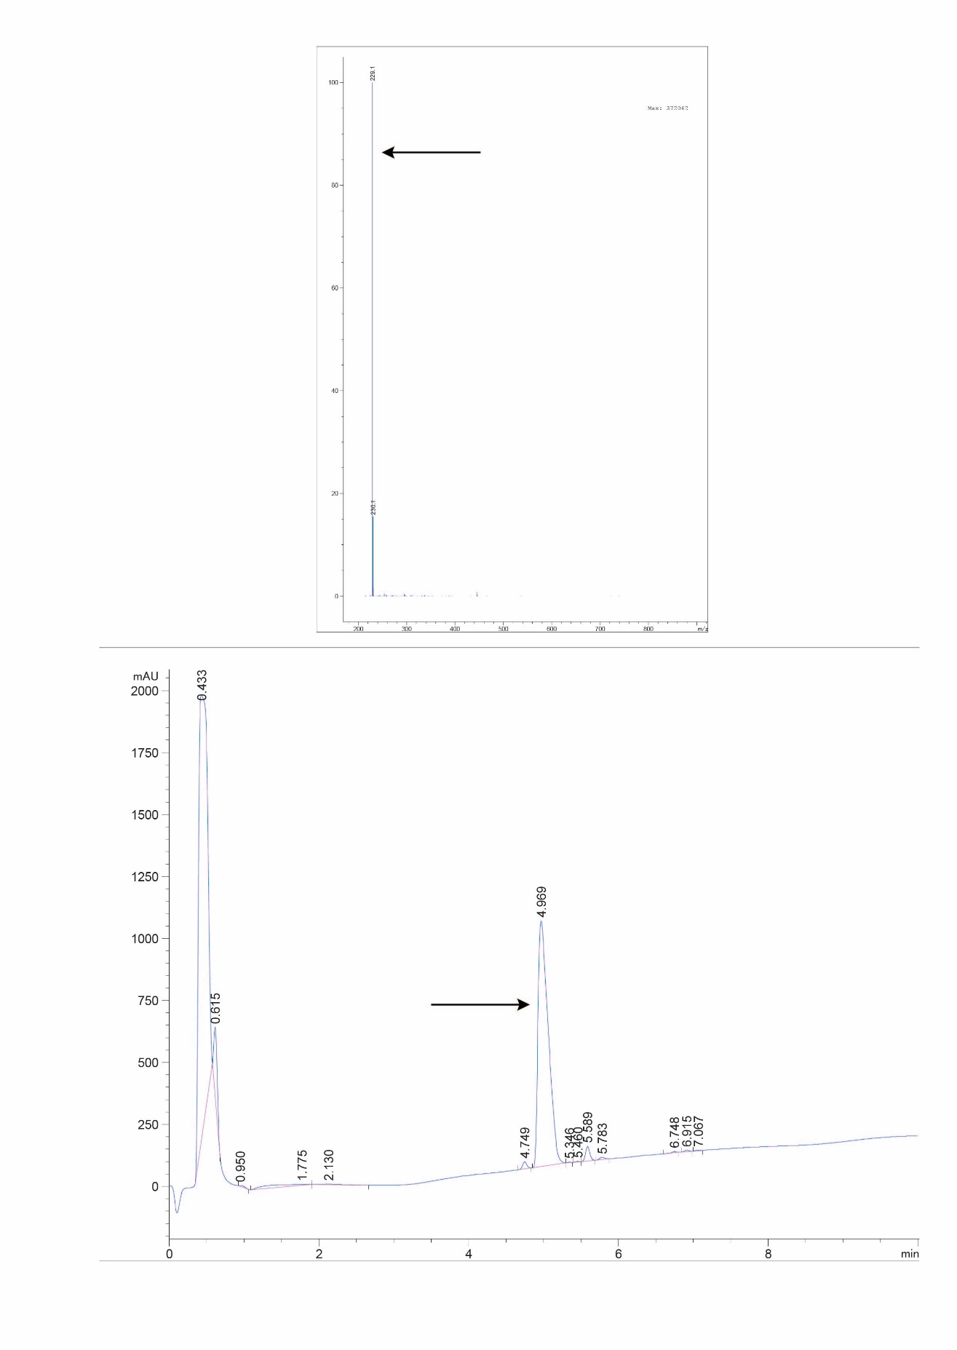
F3-28-1 (X13)
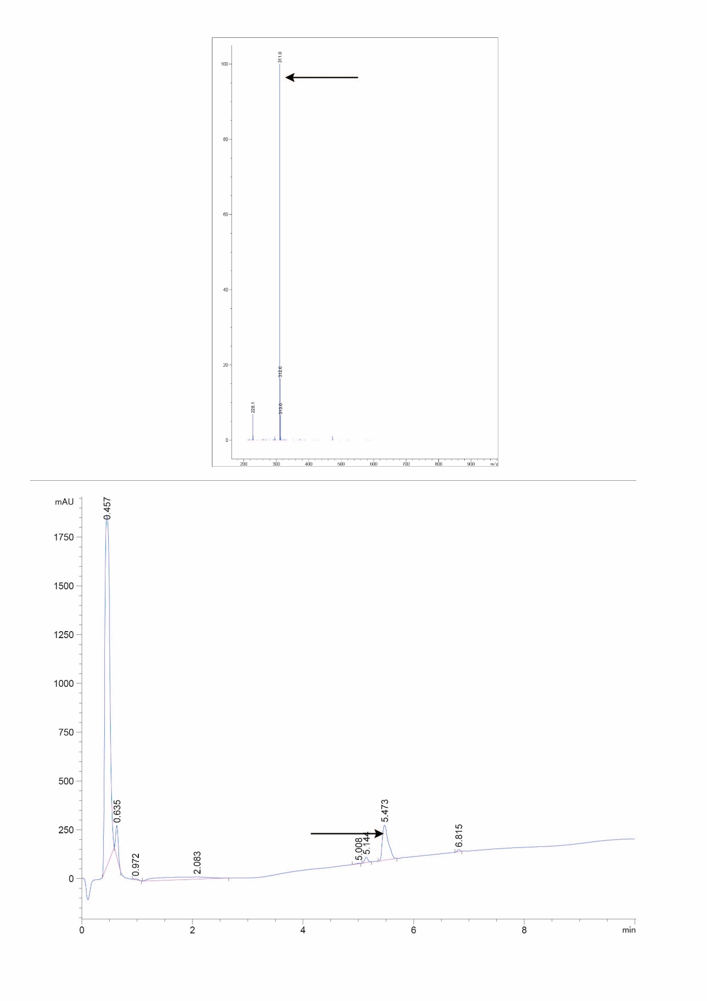
F3-27-2 (X13a-No OSF)
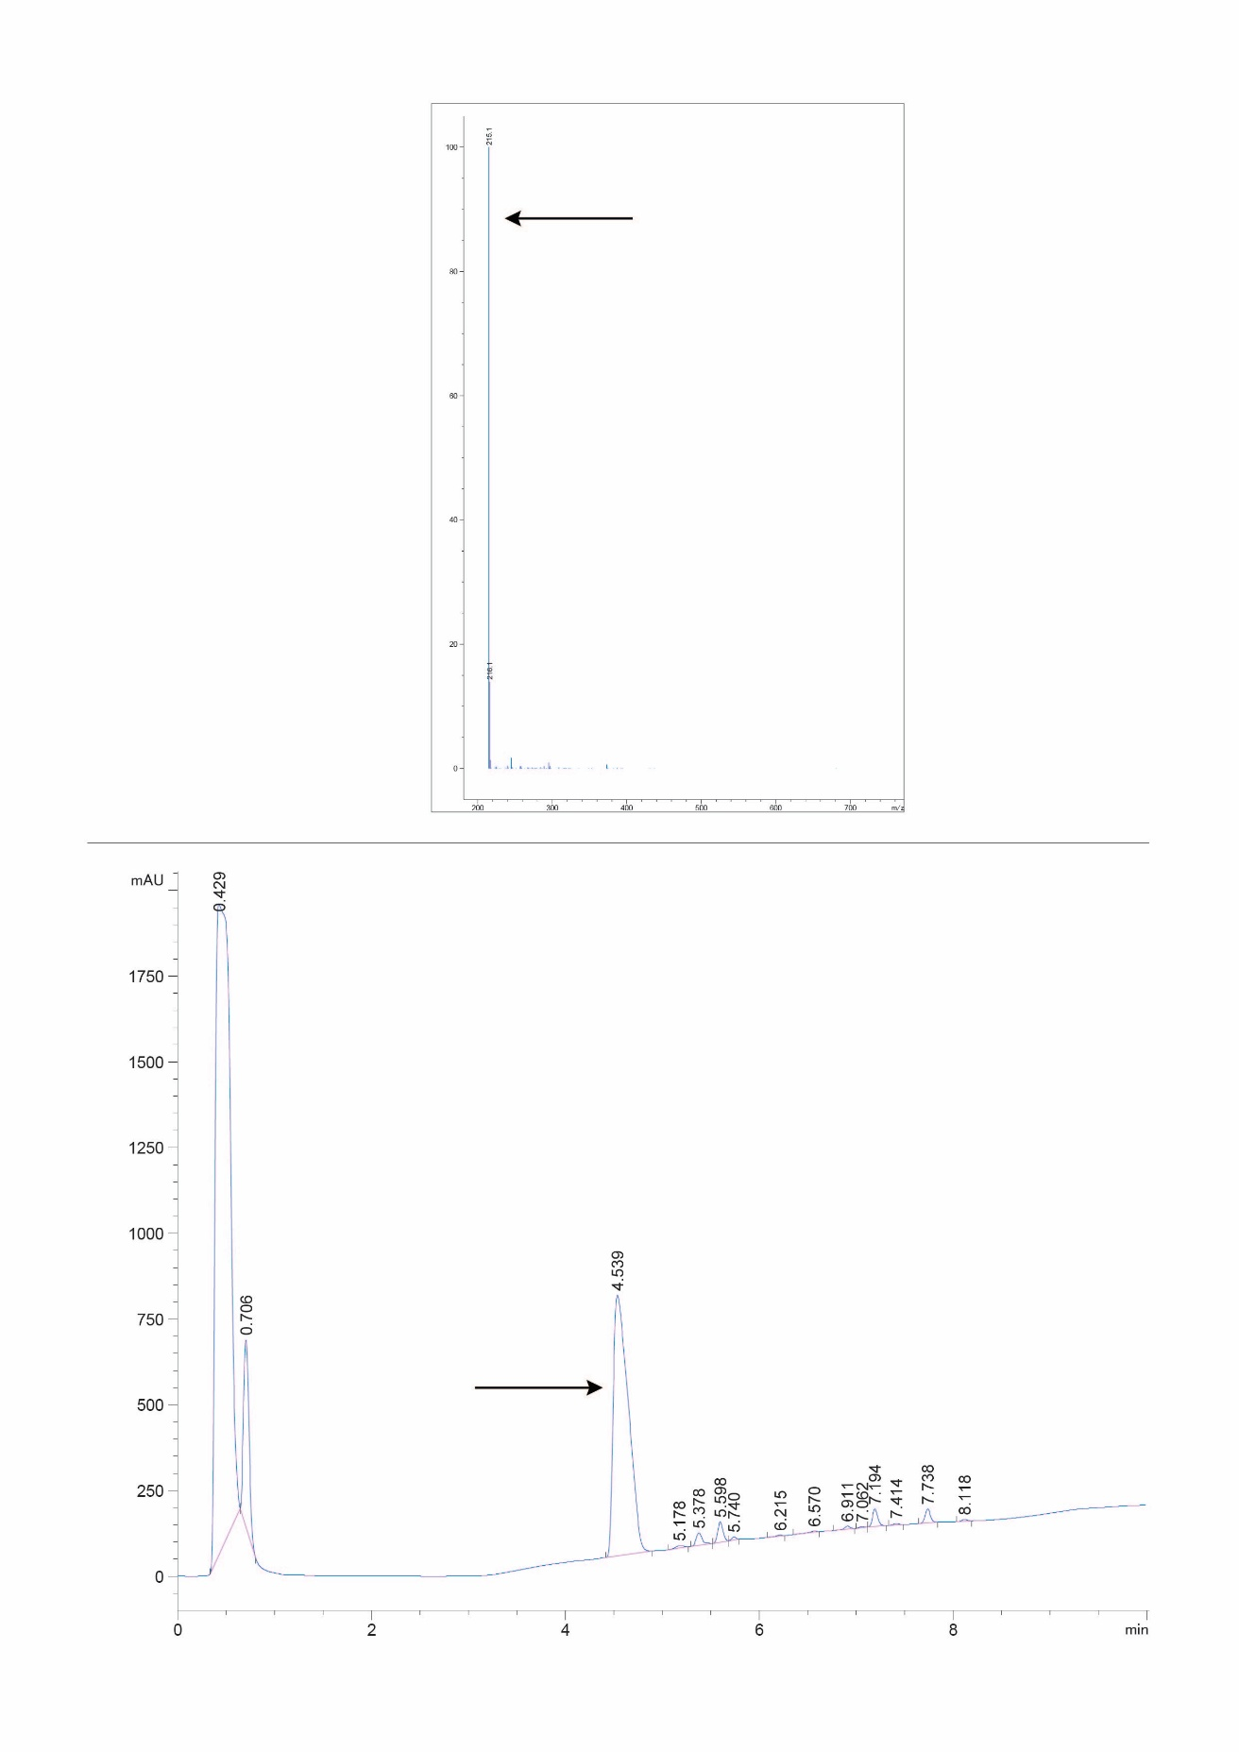
F3-27-1 (X13a)
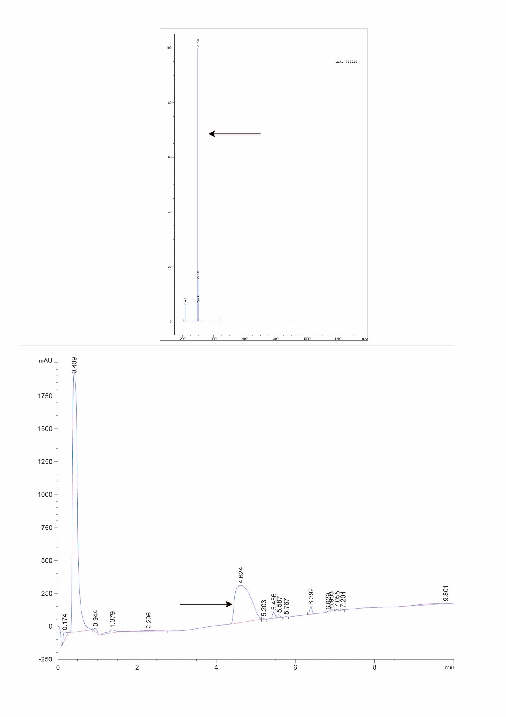
F3-31-2 (X13b-No OSF)
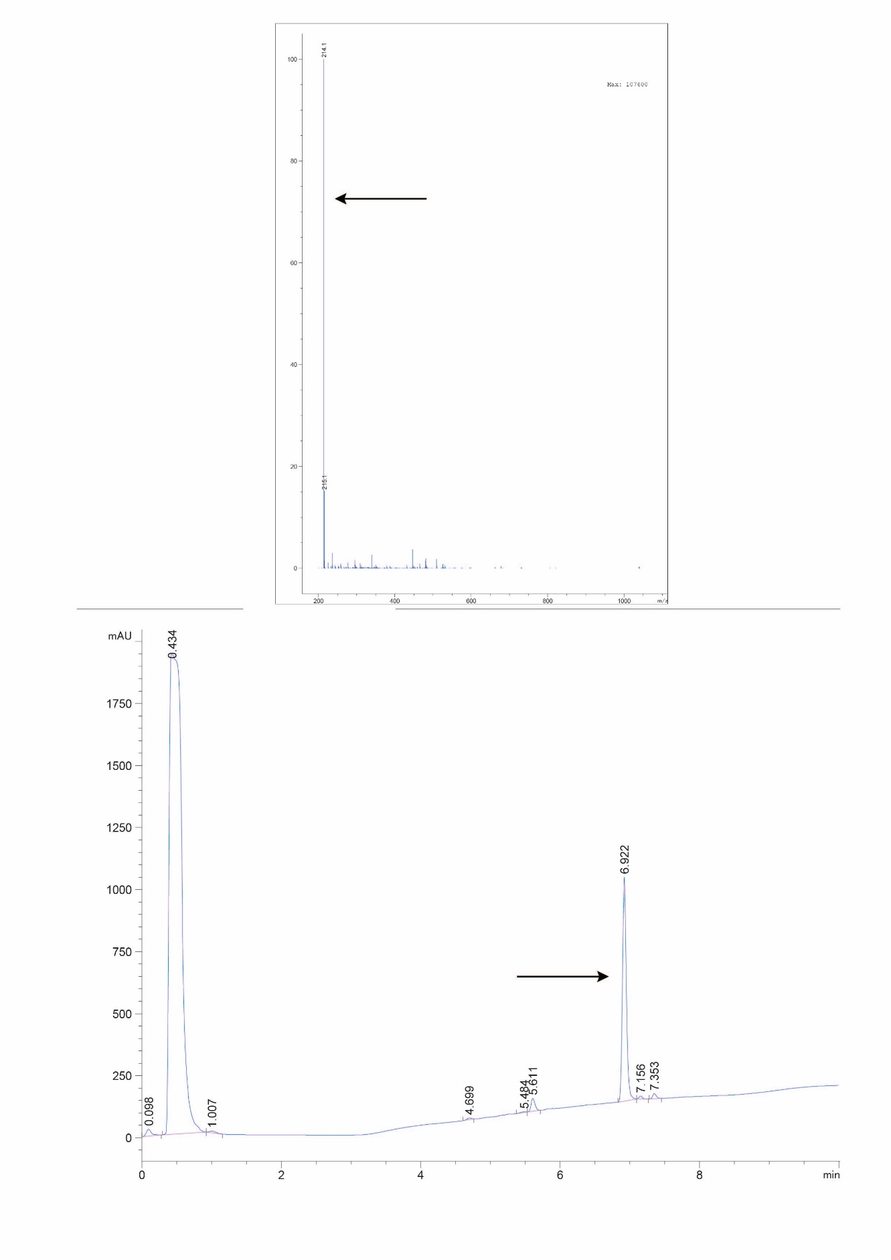
F3-31-1 (X13b)
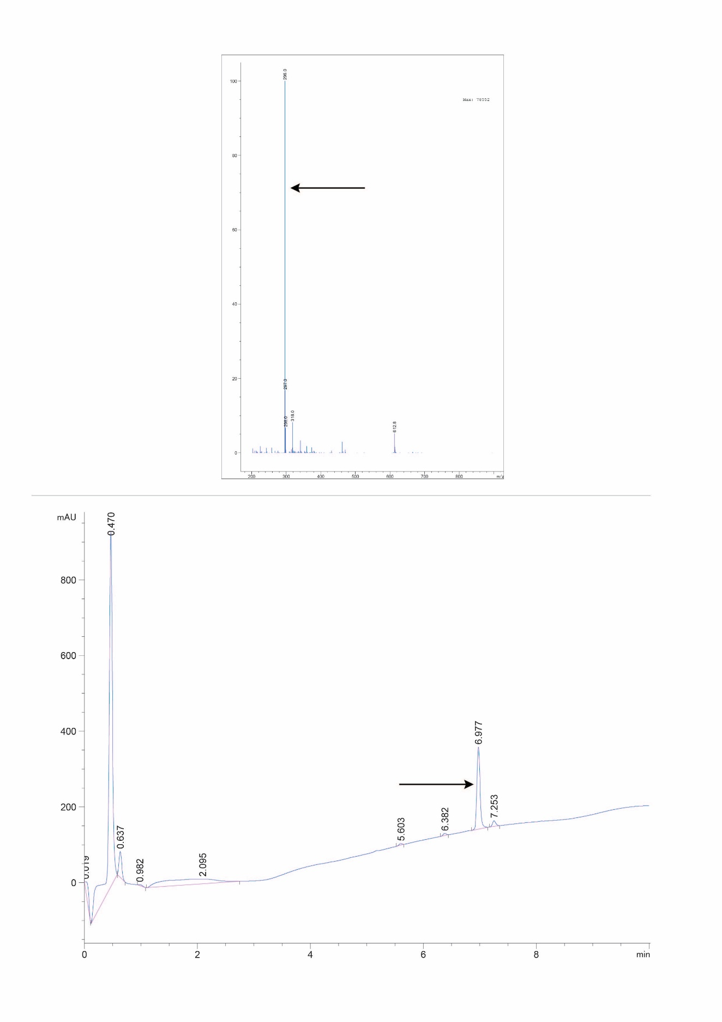
F3-32-2 (X13c-No OSF)
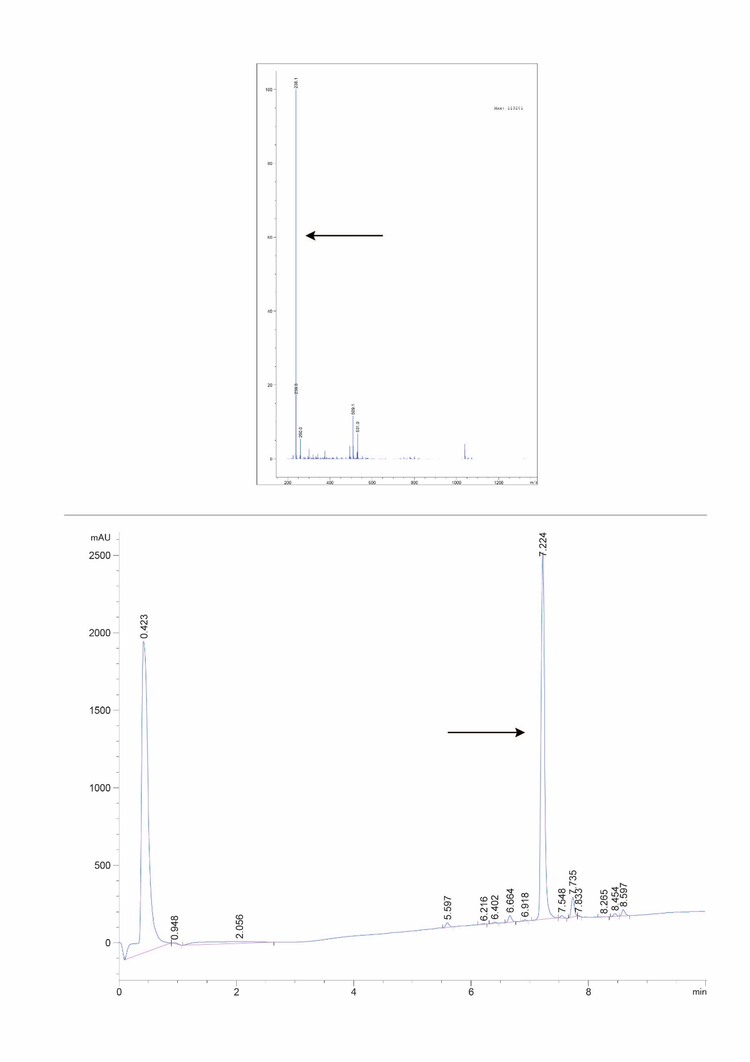
F3-32-1 (X13c)
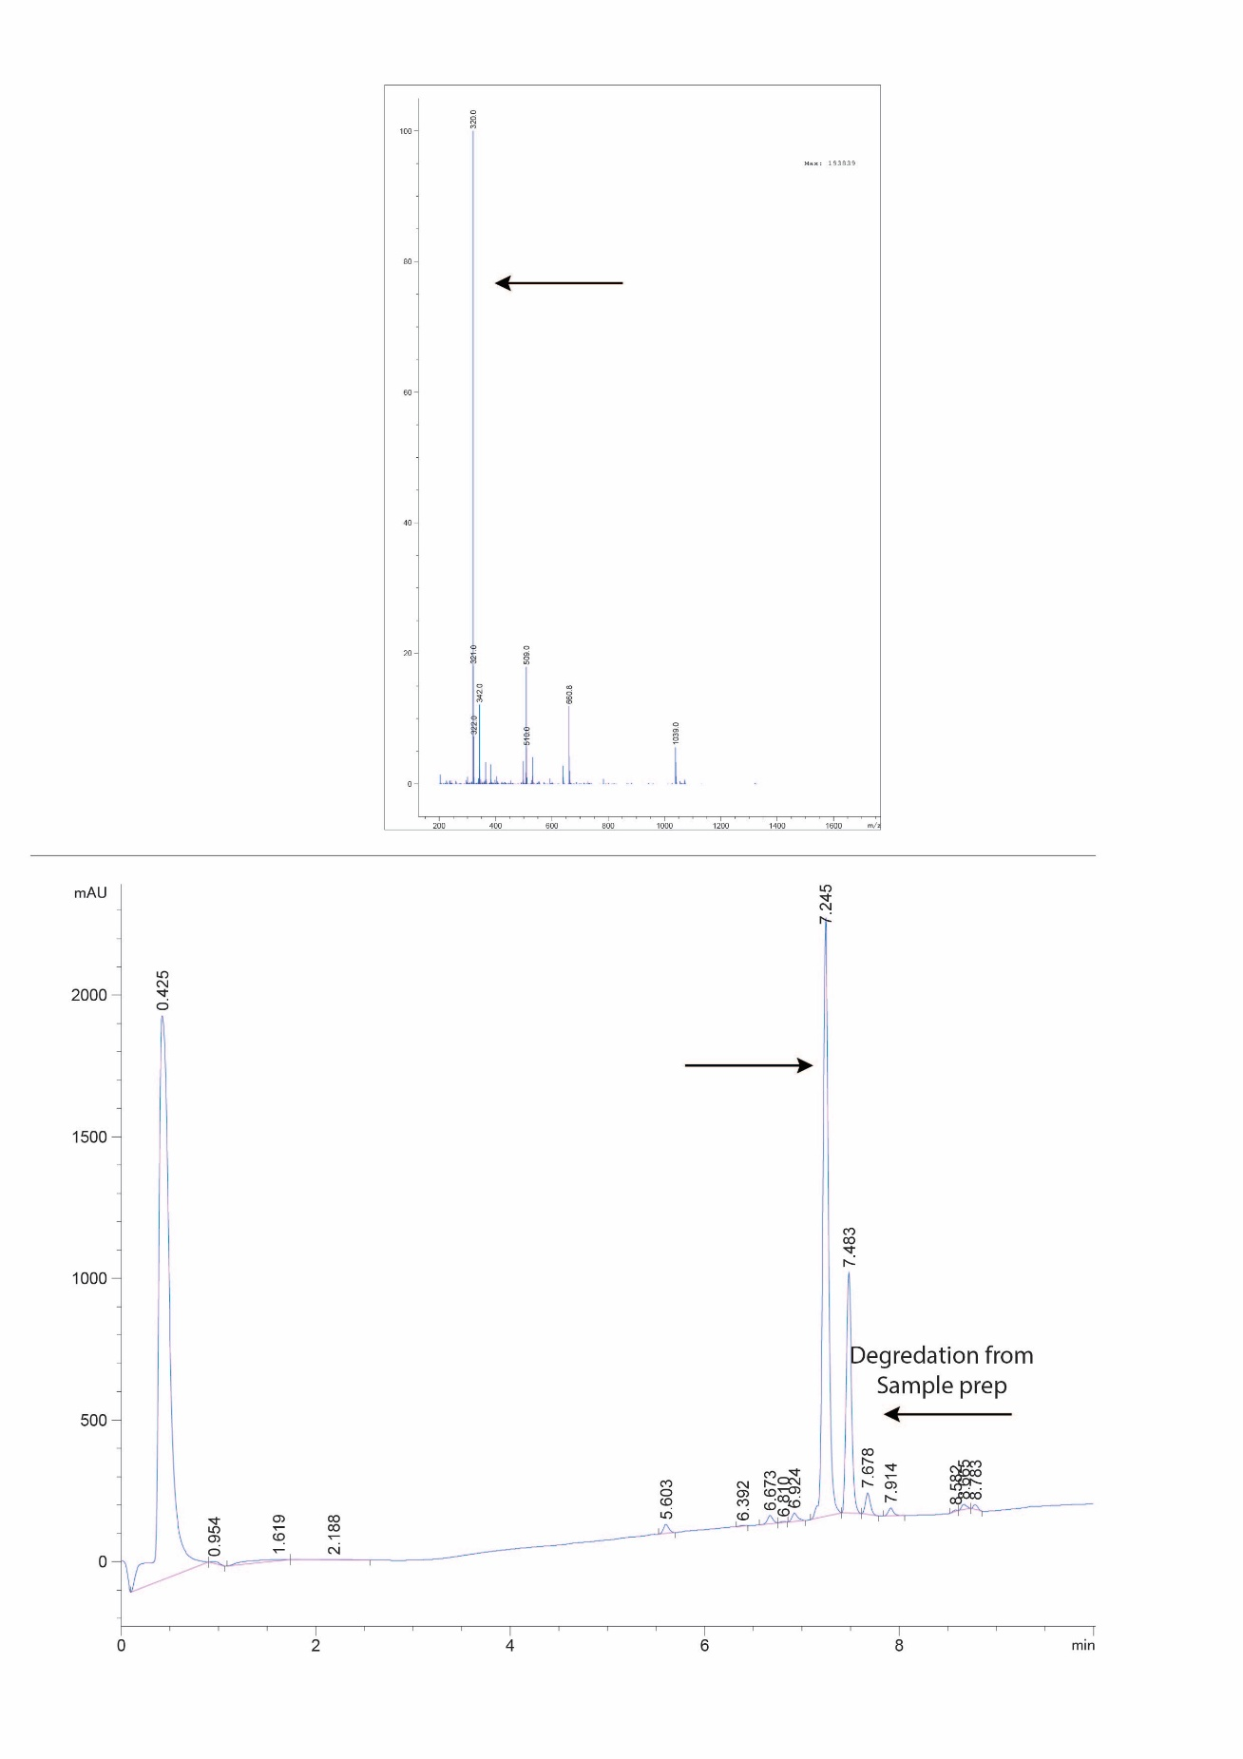
MH17 (X13d-No OSF)
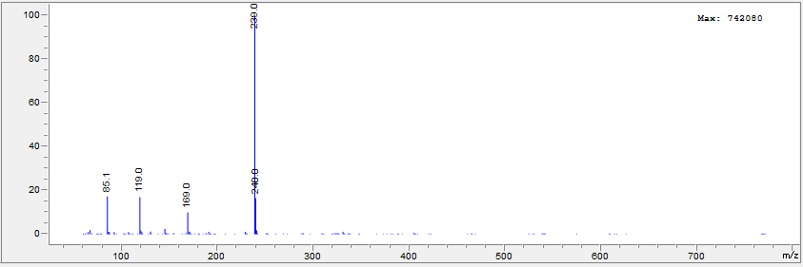
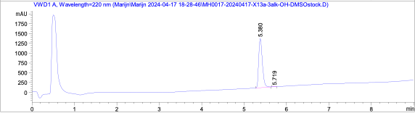

MH24 (X13d)
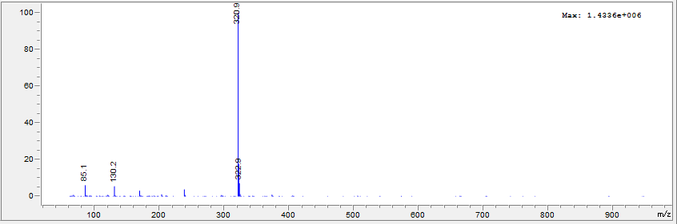
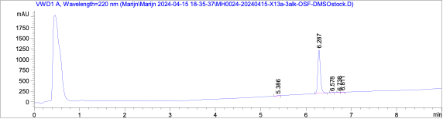

MH33 (X13e)
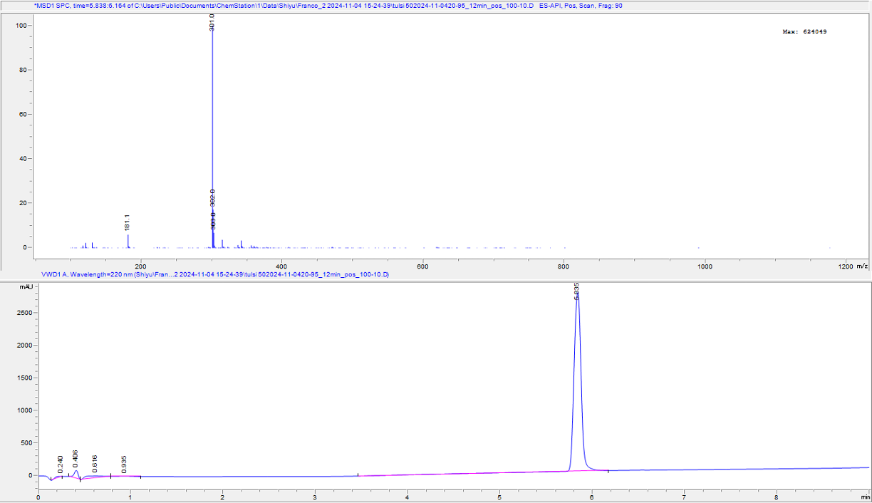

¹H NMR Spectra

¹H NMR spectrum of compound F3-28 acetyl , 2-acetoxy-5-methylbenzoic acid
(500 MHz, Chloroform-d)

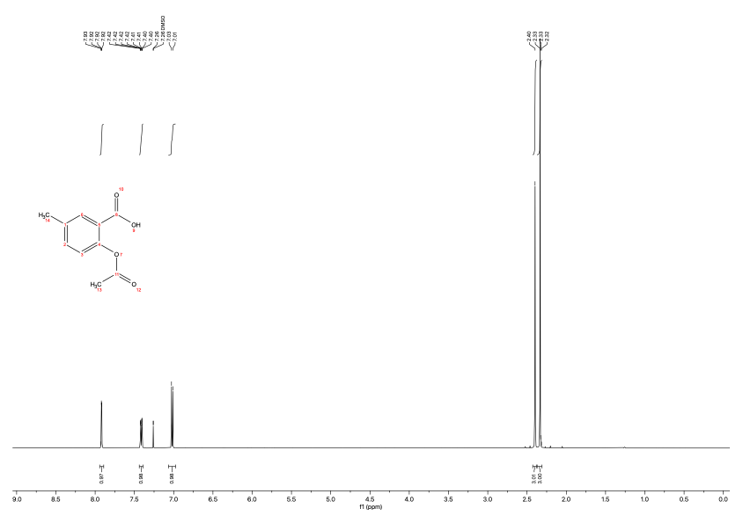

¹H NMR spectrum of compound F3-28-2 (X13-No-OSF), 2-hydroxy-5-methyl-N-(pyridin-4-yl)benzamide
¹H NMR (500 MHz, DMSO-d₆)

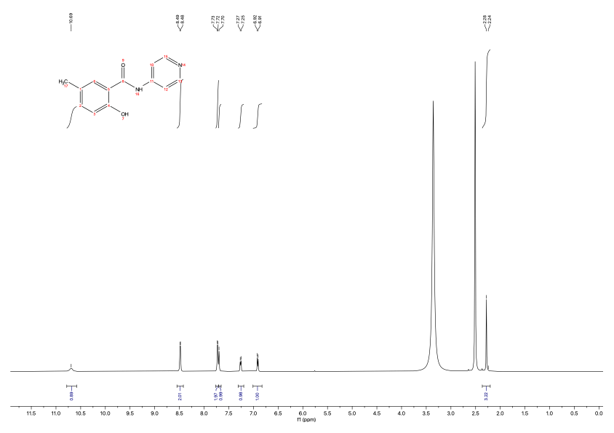

¹H NMR spectrum of compound F3-28-1 (X-13), 4-methyl-2-(pyridin-4-ylcarbamoyl)phenyl sulfurofluoridate
¹H NMR (500 MHz, DMSO-d₆)

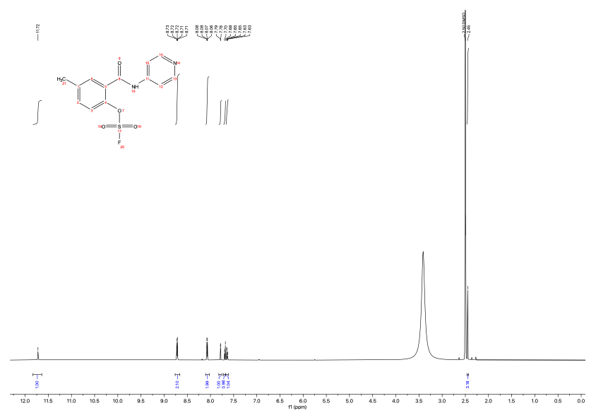

¹H NMR spectrum of compound F3-27-2 (X13a-no OSF), 2-hydroxy-N-(pyridin-4-yl)benzamide
¹H NMR (500 MHz, DMSO-d₆)
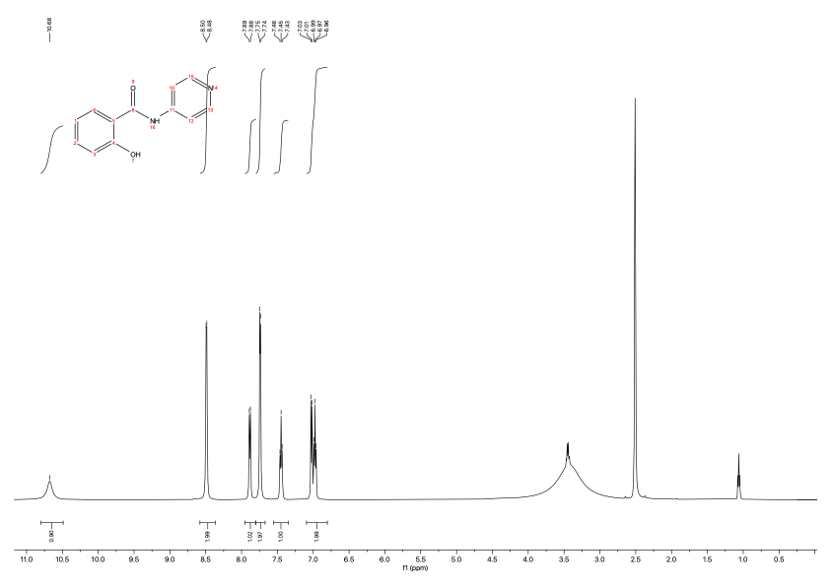

¹H NMR spectrum of compound F3-27-1 (X-13a), 2-(pyridin-4-ylcarbamoyl)phenyl sulfurofluoridate
¹H NMR (500 MHz, DMSO-d₆)

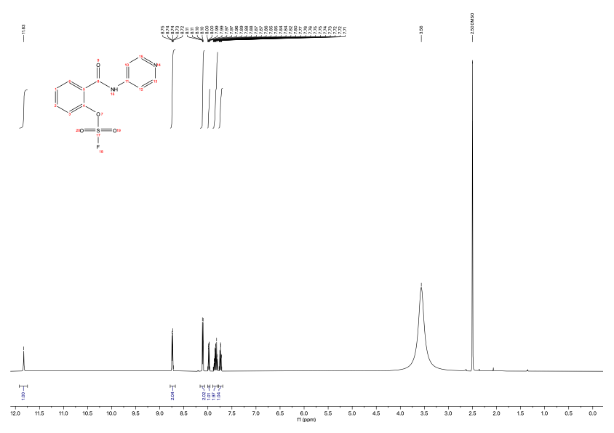

¹H NMR spectrum of compound F3-31-2 (X13b-No OSF), 2-hydroxy-N-phenylbenzamide
¹H NMR (500 MHz, Chloroform-d)
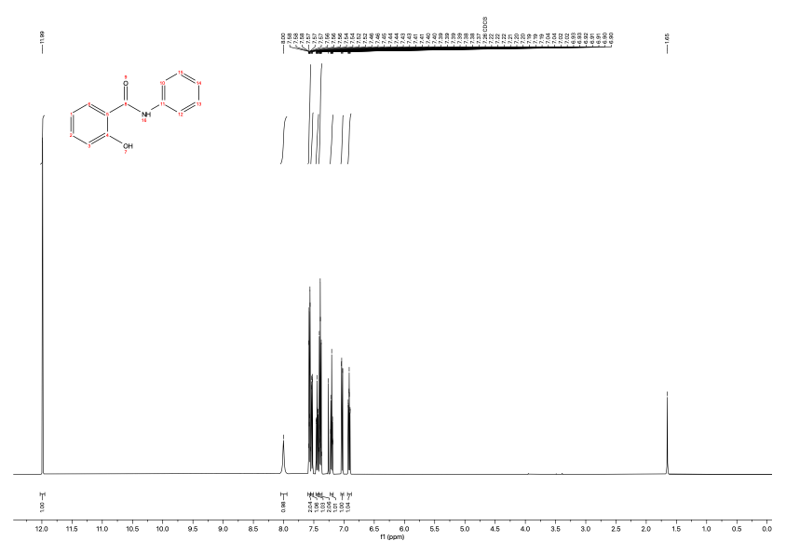

¹H NMR spectrum of compound F3-31-1 (X13b), 2-(phenylcarbamoyl)phenyl sulfurofluoridate
(DMSO-d6, 500 MHz)

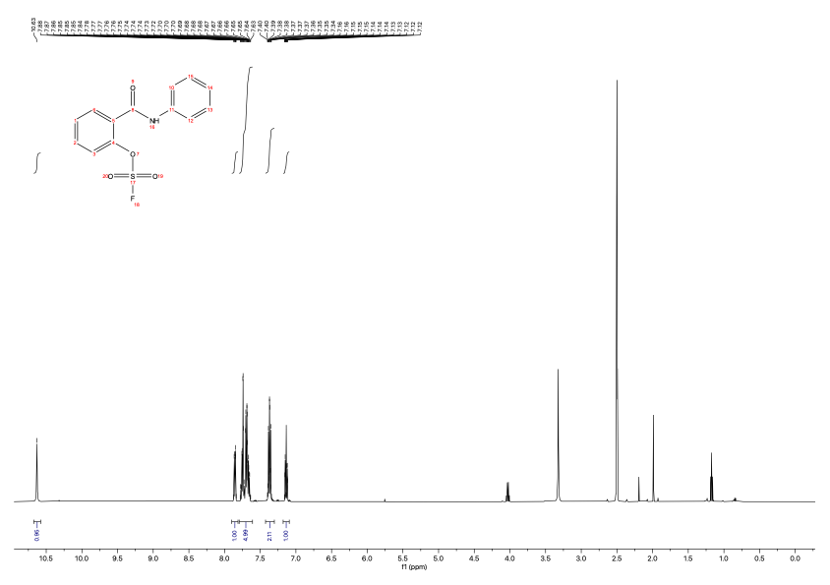

¹H NMR spectrum of compound F3-32-2 (X13c-No OSF) N-(4-ethynylphenyl)-2-hydroxybenzamide
(DMSO-d6, 500 MHz)

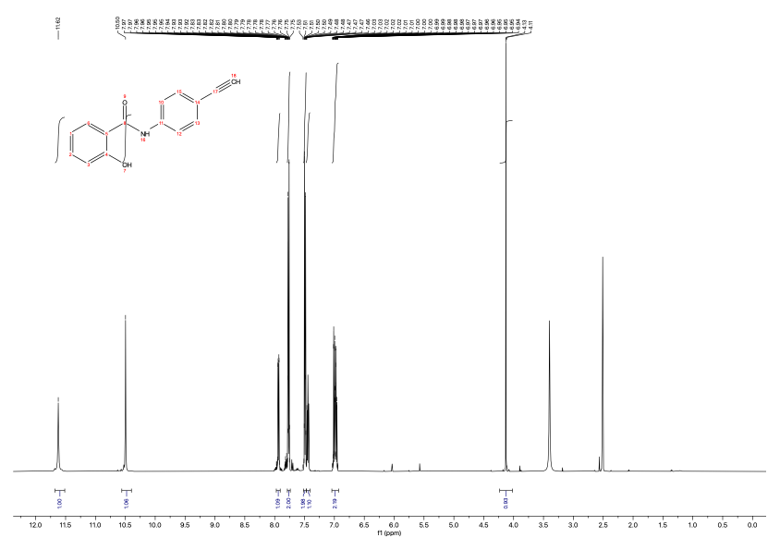

¹H NMR spectrum of compound F3-32-1 (X13c), 2-((4-ethynylphenyl)carbamoyl)phenyl sulfurofluoridate
(DMSO-d6, 500 MHz)

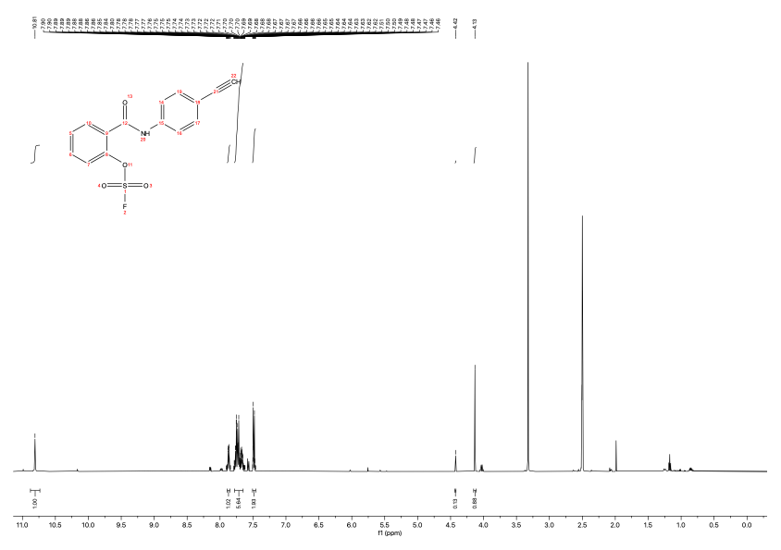

¹H NMR spectrum of compound MH17 (X13d-No OSF) (DMSO-d6, 500 MHz)
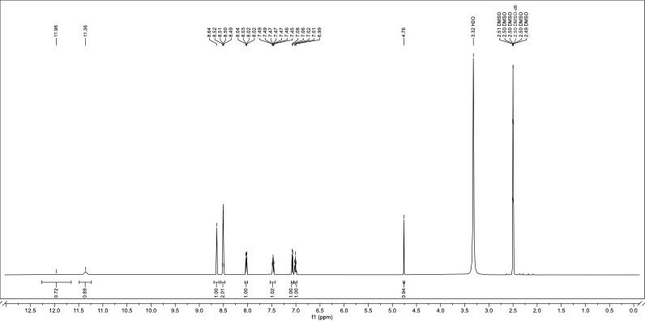

¹H NMR spectrum of compound MH24 (X13d) (DMSO-d6, 500 MHz)
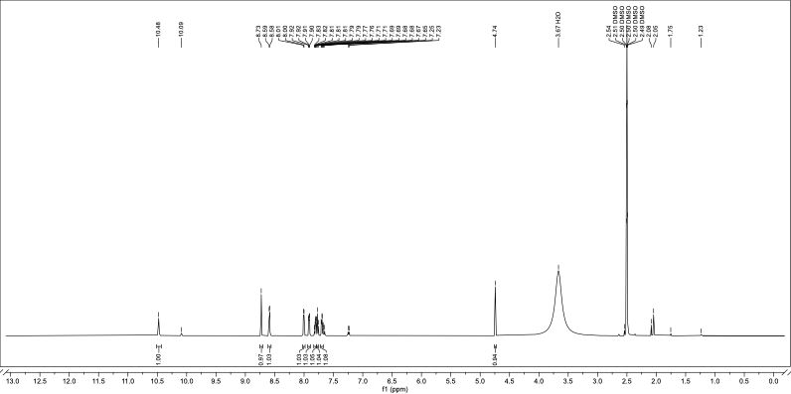

¹H NMR spectrum of compound MH33 (X13e) (DMSO-d6, 500 MHz)
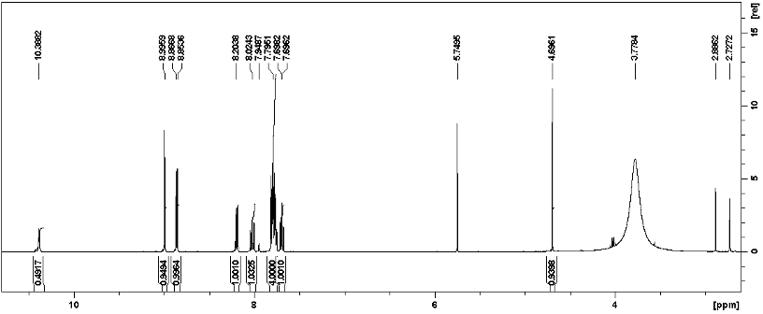

¹³C NMR Spectra X13 and its analogs
¹³C NMR spectrum of compound F3-31-2 (X13b-No OSF), 2-hydroxy-N-phenylbenzamide
¹³C NMR (500 MHz, Chloroform-d)
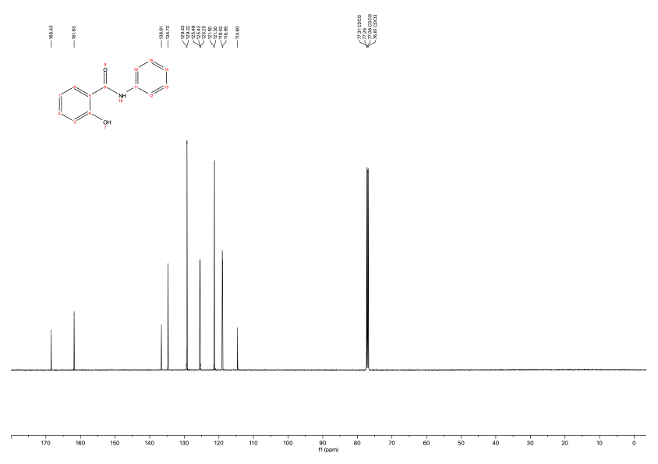

¹³C NMR spectrum of compound F3-31-1 (X13b), 2-(phenylcarbamoyl)phenyl sulfurofluoridate
(DMSO-d6, 126 MHz)
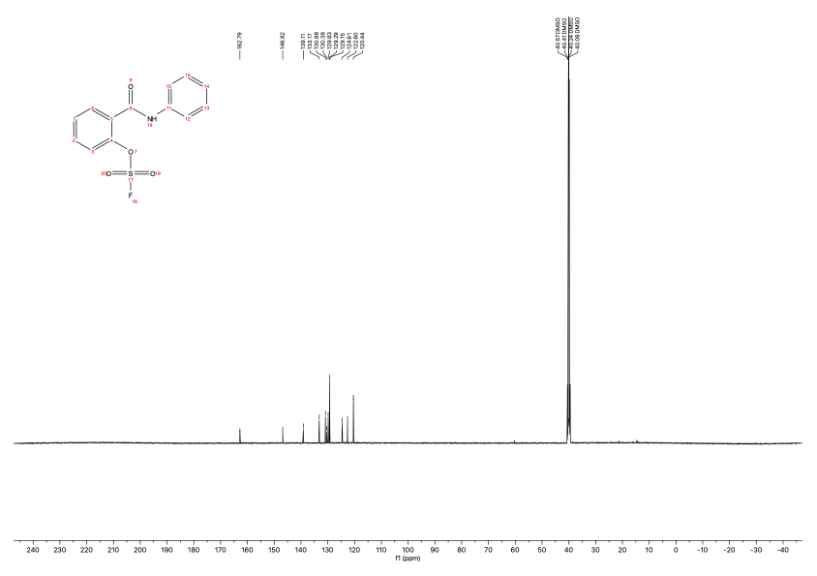

¹³C NMR spectrum of compound F3-32-2 (X13c-No OSF), N-(4-ethynylphenyl)-2-hydroxybenzamide
(DMSO-d6, 126 MHz)

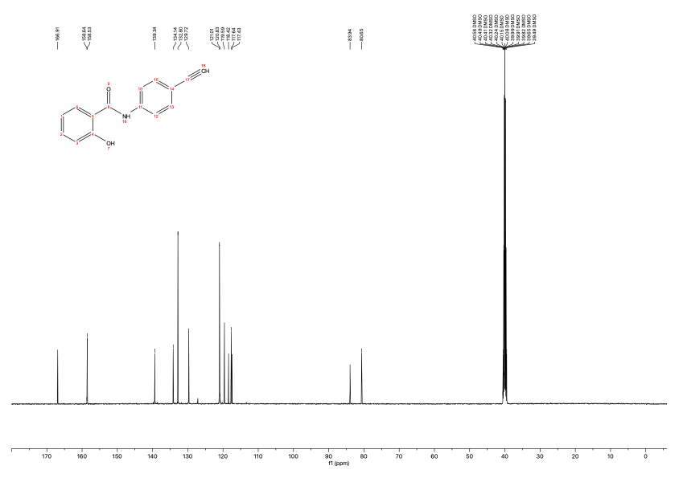

¹³C NMR spectrum of compound F3-32-1 (X13c), 2-((4ethynylphenyl)carbamoyl)phenyl sulfurofluoridate
(DMSO-d6, 126 MHz)

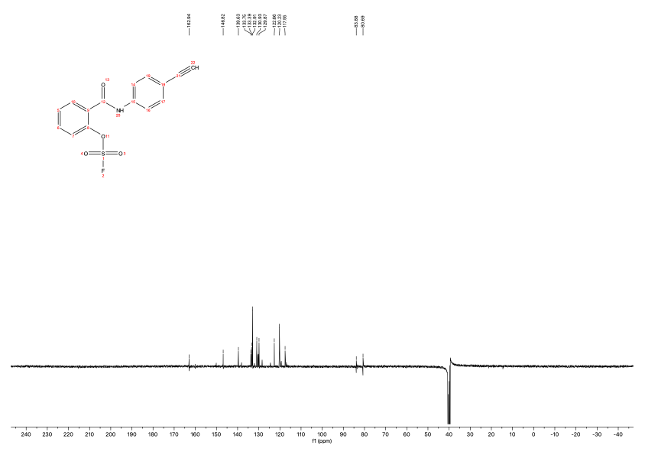

¹³C NMR spectrum of compound MH17 (X13d-No OSF) (DMSO-d6, 126 MHz)

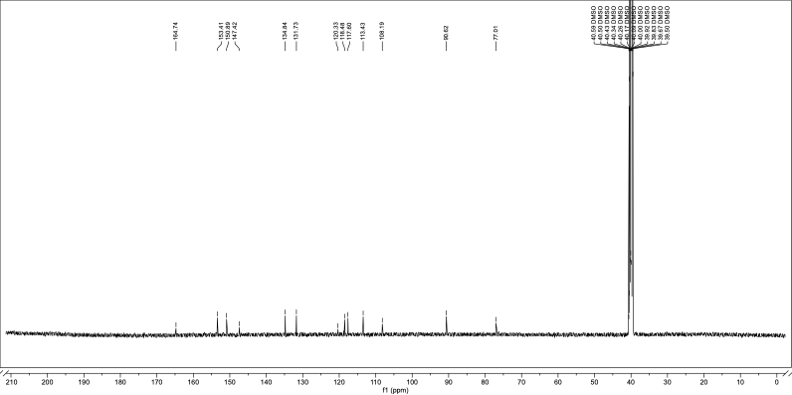

¹³C NMR spectrum of compound MH24 (X13d) (DMSO-d6, 126 MHz)

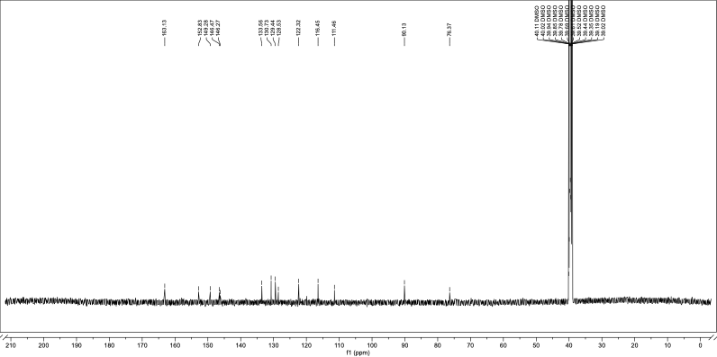

¹⁹F NMR Spectra

¹⁹F NMR spectrum of compound F3-28-1 (X-13), 4-methyl-2-(pyridin-4-ylcarbamoyl)phenyl sulfurofluoridate
(DMSO-d6, 471 MHz)
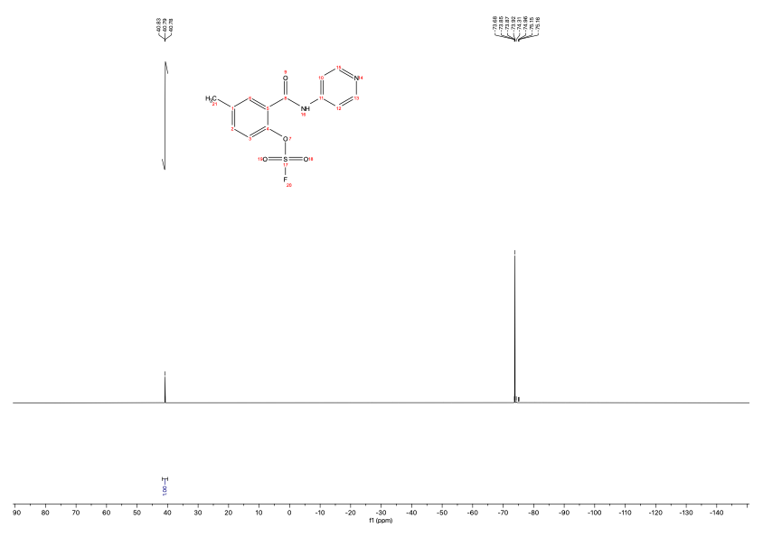

¹⁹F NMR spectrum of compound F3-27-1 (X-13a), 2-(pyridin-4-ylcarbamoyl)phenyl sulfurofluoridate (DMSO-d6, 471 MHz)

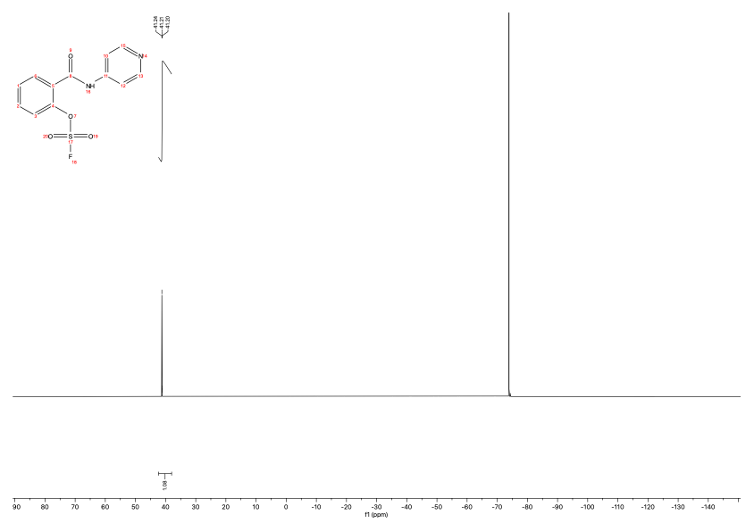

¹⁹F NMR spectrum of compound F3-31-1 (X-13b), 2-(phenylcarbamoyl)phenyl sulfurofluoridate
(DMSO-d6, 471 MHz)

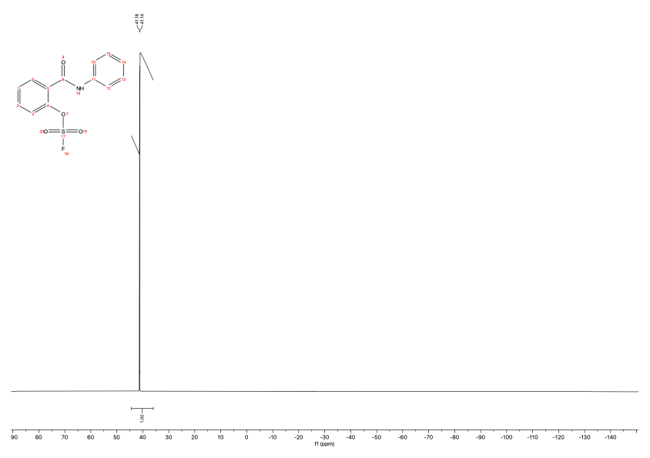

¹⁹F NMR spectrum of compound F3-32-1 (X-13c), 2-((4-ethynylphenyl)carbamoyl)phenyl sulfurofluoridate
(DMSO-d6, 471 MHz)

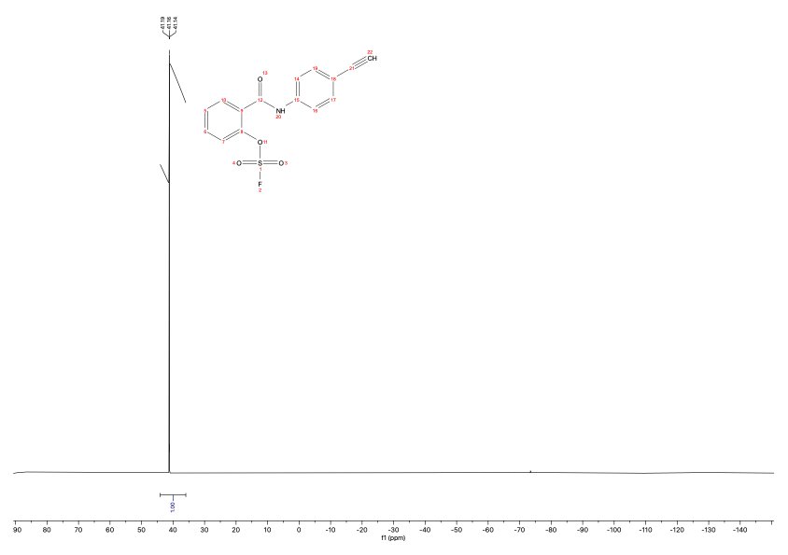

¹⁹F NMR spectrum of compound MH24 (X13d) (DMSO-d6, 471 MHz)
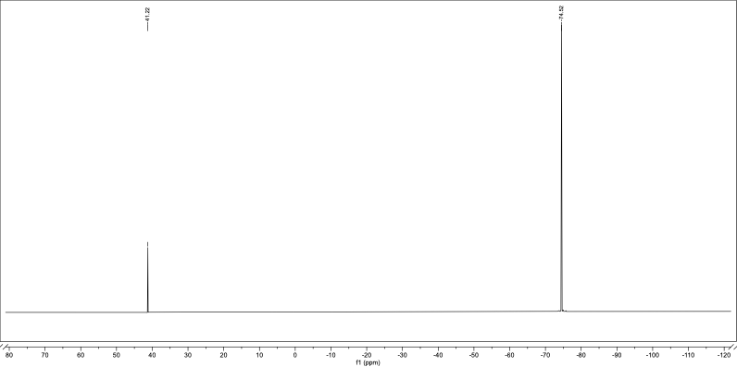

Stability of compound X13d in aqueous buffer

To assess the stability of compound X13, X13a, X13d under experimental conditions, 10 µL X13, X13a, X13d from a 10 mM stock in DMSO was added to 90 µL of either an acidic LCMS mobile phase (acetonitrile/water 1:1 with 0.1% formic acid (v/v)) or 1X PBS (pH = 7.4) to obtain a final concentration of 1 mM. After 1 minute at room temperature, 20 µL aliquots of both samples were added to 20 µL of the LC-MS mobile phase and analyzed by LC-MS.

Results:
X13, X13a, X13d kept in DMSO, and acidic LC-MS mobile phase gives the expected UV peak and mass for the compound. However, after dilution in slightly basic 1X PBS, a longer retention time is observed. The mass difference of 20 Da indicates loss of a proton and fluoride ion (HF), which could be explained by an intramolecular reaction involving nucleophilic attack of the amide nitrogen on the fluorosulfate, yielding a six-membered benz-1,2,3-oxathiazin-4(3H)-one 2,2-dioxide ring. This reaction would more favorable under basic conditions than in acidic solution. The same molecule was also observed as a side product during synthesis of X13, X13a, X13d in the presence of potassium carbonate as base.
F3-28-1 (X13), LCMS mobile phase. 1 minute: Rt = 5.473; m/z = 311.0.
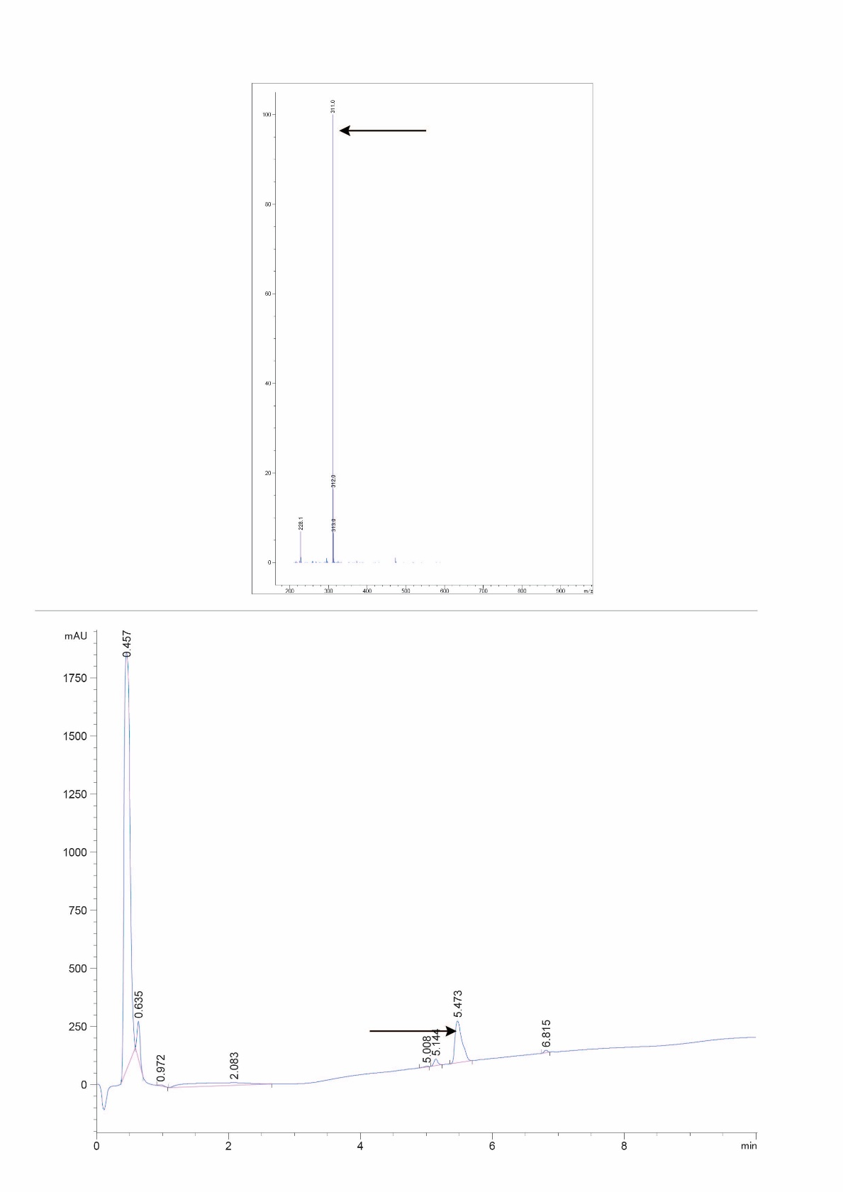
F3-27-1 (X13), 1X PBS buffer – 1 minute: Rt = 6.819; m/z = 291.0.
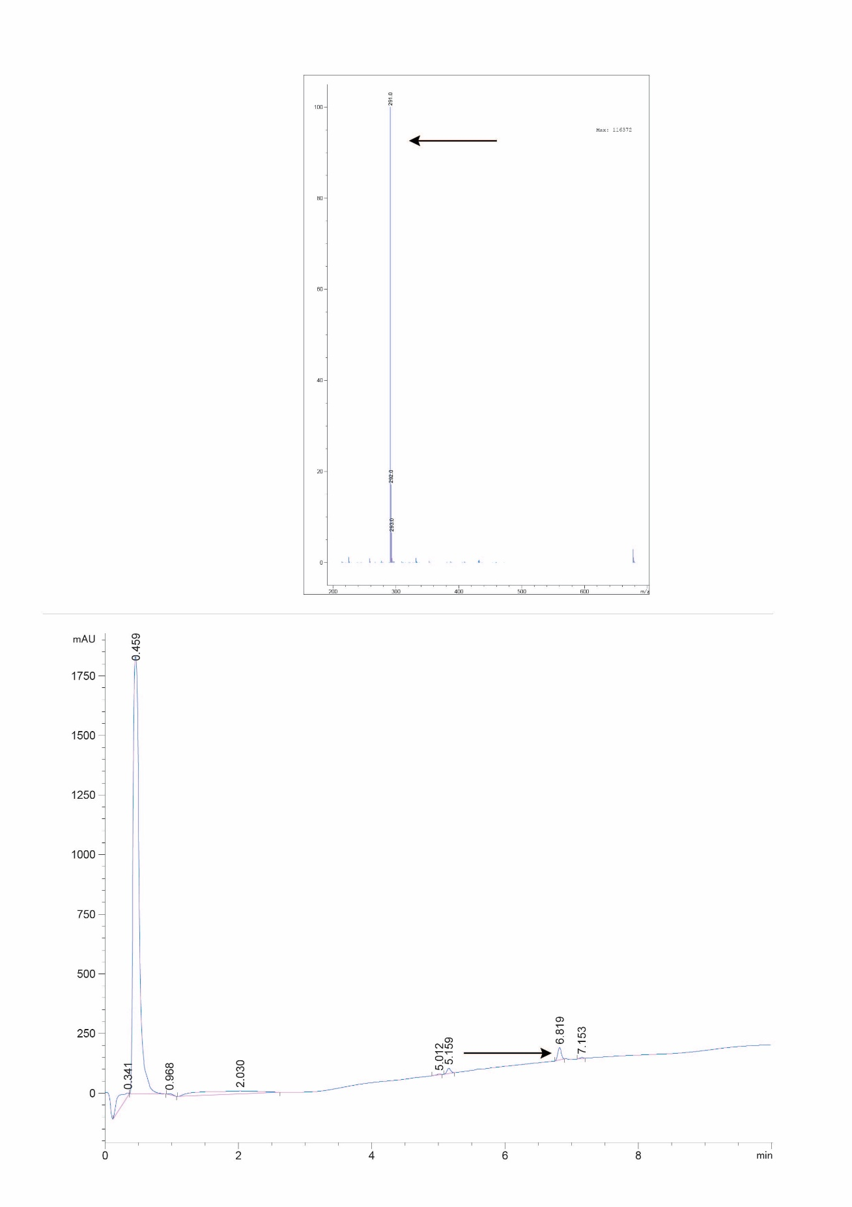
F3-27-1 (X13a), LCMS mobile phase – 1 minute: Rt = 4.623; m/z = 297.0.
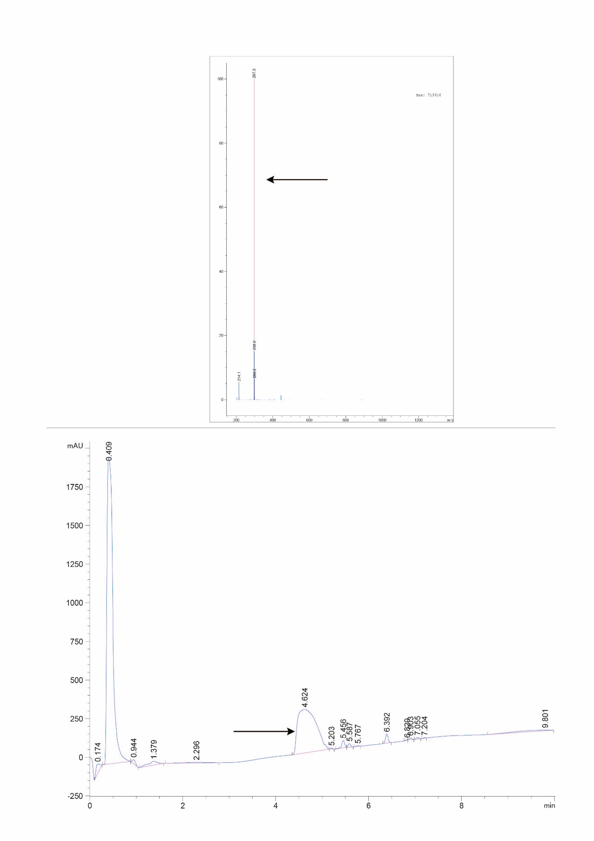
F3-27-1 (X13a),1X PBS buffer – 1 minute: Rt = 6.819; m/z = 291.0.
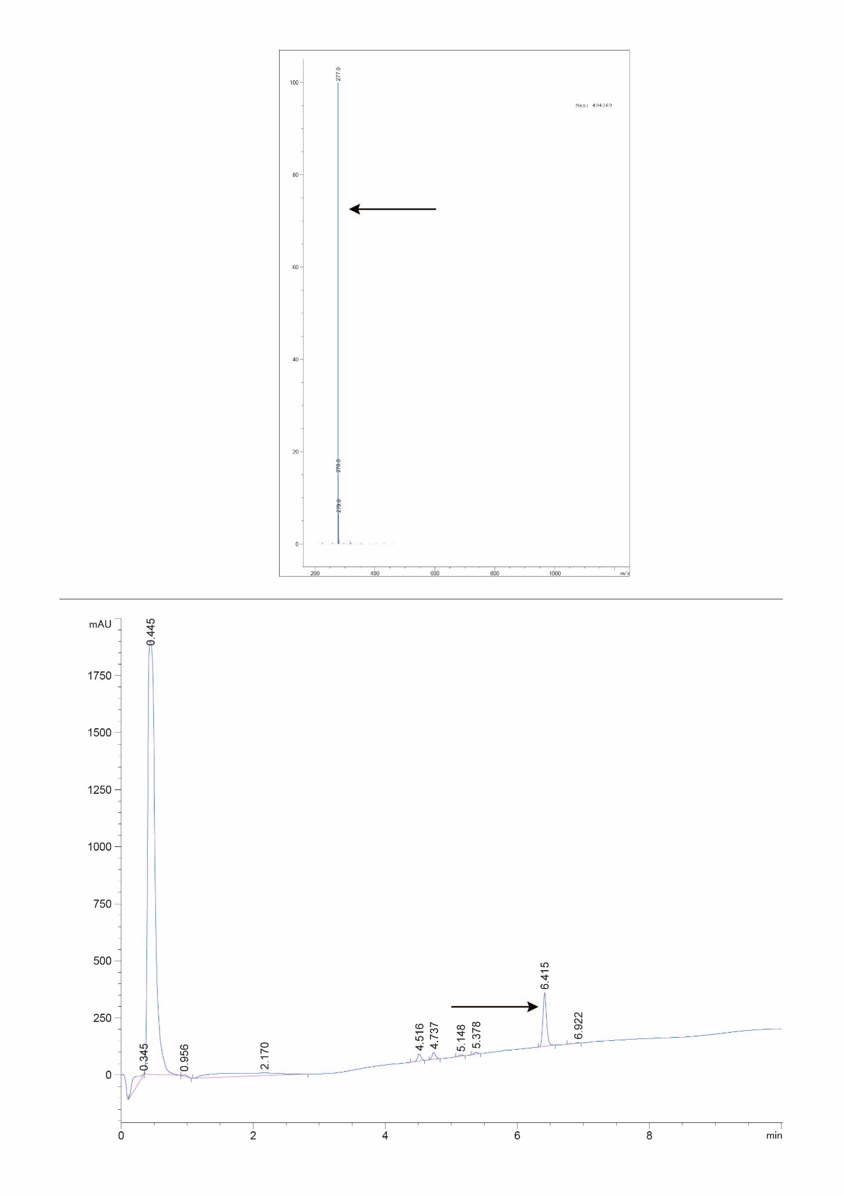
X13d – LCMS mobile phase – 1 minute: Rt = 6.293; m/z = 320.9.
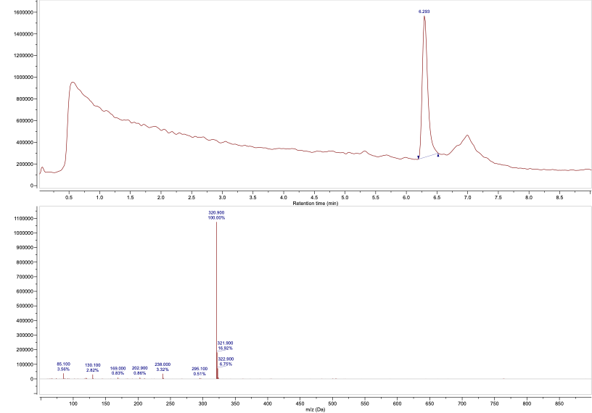

X13d – 1X PBS buffer – 1 minute: Rt = 6.728; m/z = 300.9.
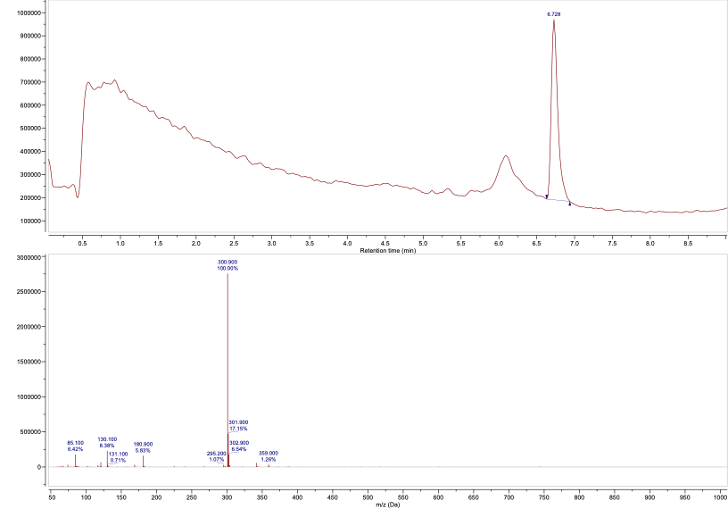

References
(1) Arsic, B.; Zhu, Y.; Heinrichs, D. E.; McGavin, M. J. Induction of the Staphylococcal Proteolytic Cascade by Antimicrobial Fatty Acids in Community Acquired Methicillin Resistant Staphylococcus Aureus. PLOS ONE 2012, 7 (9), e45952. https://doi.org/10.1371/journal.pone.0045952.
(2) Sander, T.; Freyss, J.; von Korff, M.; Rufener, C. DataWarrior: An Open-Source Program For Chemistry Aware Data Visualization And Analysis. J. Chem. Inf. Model. 2015, 55 (2), 460–473. https://doi.org/10.1021/ci500588j.
(3) Fellner, M.; Walsh, A.; Dela Ahator, S.; Aftab, N.; Sutherland, B.; Tan, E. W.; Bakker, A. T.; Martin, N. I.; van der Stelt, M.; Lentz, C. S. Biochemical and Cellular Characterization of the Function of Fluorophosphonate-Binding Hydrolase H (FphH) in Staphylococcus Aureus Support a Role in Bacterial Stress Response. ACS Infect. Dis. 2023, 9 (11), 2119–2132. https://doi.org/10.1021/acsinfecdis.3c00246.
(4) Liu, Y.; Long, S.; Zhang, S.; Tan, Y.; Wang, T.; Wu, Y.; Jiang, T.; Liu, X.; Peng, D.; Liu, Z. Synthesis and Antioxidant Activities of Berberine 9-O-Benzoic Acid Derivatives. RSC Adv. 2021, 11 (29), 17611–17621. https://doi.org/10.1039/D1RA01339D.
(5) Zhou, H.; Mukherjee, P.; Liu, R.; Evrard, E.; Wang, D.; Humphrey, J. M.; Butler, T. W.; Hoth, L. R.; Sperry, J. B.; Sakata, S. K.; Helal, C. J.; am Ende, C. W. Introduction of a Crystalline, Shelf-Stable Reagent for the Synthesis of Sulfur(VI) Fluorides. Org. Lett. 2018, 20 (3), 812–815. https://doi.org/10.1021/acs.orglett.7b03950.

