Supplementary Information

- Supplementary material and methods

- Database, cohorts, covariates, and outcome definition

- Supplementary table

- Supplementary figure

(E) STROBE Statement

Database

Data Source and Ethical Considerations

We conducted this cohort study using the TriNetX Global and US Collaborative Networks, a federated health research platform. This platform provides access to de-identified electronic health records (EHRs) from over 100 million patients across 62 healthcare organizations (HCOs) in the United States. The database encompasses a comprehensive range of clinical information, including demographics, diagnoses (ICD-10-CM), procedures (ICD-10-PCS and CPT), medications (VA Drug Classification and RxNorm), laboratory results (LOINC), and healthcare utilization records.
Our institutional review board approved this study by Chung Shan Medical University Hospital (CS2-24100) and waived the requirement for informed consent due to the use of de-identified data. We adhered strictly to the principles outlined in the Declaration of Helsinki and followed the STROBE guidelines for reporting observational studies.

Socioeconomic Status and Demographic Information

The TriNetX platform primarily derives socioeconomic status (SES) from area-level measures rather than individual income data. It uses census tract-level information, including median household income, education level, and employment rates, as proxies for individual SES. While this approach provides valuable contextual information, we acknowledge its limitations in fully capturing individual-level socioeconomic variability within neighborhoods.
Race and ethnicity categories in TriNetX adhere to U.S. Office of Management and Budget (OMB) standards, which include:

- Race: White, Black or African American, Asian, American Indian or Alaska Native, Native Hawaiian or Other Pacific Islander, and Some Other Race.
- Ethnicity: Hispanic or Latino, and Not Hispanic or Latino.
We recognize that these categories may not fully represent the diversity of a multinational cohort. For non-U.S. data sources, race and ethnicity information may be mapped to these categories or classified as "Unknown" if direct equivalents are not available.

Data Collection and Processing

TriNetX employs a hub-and-spoke model, where HCOs contribute de-identified patient data to a secure, HIPAA-compliant cloud infrastructure. The platform uses advanced extract-transform-load processes to harmonize data from various sources, including i2b2 research repositories and other common data models.
To ensure data quality and comparability across diverse sources, TriNetX implements a comprehensive framework based on four key principles: cleanliness, consistency, correctness, and completeness. This approach involves rigorous data cleaning, deduplication, and semantic mapping processes. We paid particular attention to harmonizing diagnostic codes, medication classifications, and laboratory test results across different healthcare systems and countries.

Controlling for Confounding Factors

We utilized several methods provided by TriNetX to control for potential confounding factors:
1. Propensity Score Matching: This technique balances cohorts based on observed covariates, including demographics, comorbidities, and baseline medications.
2. Stratification: We stratified analyses by key variables such as age groups, sex, race/ethnicity, and SES proxies to examine potential effect modifications.
3. Multivariate Regression: We employed adjustment for multiple covariates in regression models.
4. Standardized Differences: We used the Absolute Standardized Mean Difference (ASMD) method to calculate standardized differences. For continuous variables, we applied the following formula:
ASMD = |mean difference| / √[(sd1^2 + sd2^2) / 2]
For binary variables (such as the proportion with HbA1c), we used:
ASMD = |p1 - p2| / √[(p1(1-p1) + p2(1-p2)) / 2]
5. Time-to-Event Analysis: We incorporated time-varying covariates in Cox proportional hazards models to account for changes in patient status over time.
6. Sensitivity Analyses: We conducted multiple analyses with different sets of covariates to assess the robustness of our findings.

Security and Privacy Measures

TriNetX maintains stringent security protocols, including deployment on a HIPAA-compliant virtual private cloud hosted by Amazon Web Services (AWS). The platform meets industry-standard security certifications such as FedRAMP and NIST 800-53. All communications are secured using Transport Layer Security (TLS) with a 2048-bit security certificate.

Data Analysis Capabilities

We leveraged various analytical tools provided by the TriNetX platform, including Measure of Association Analysis, Survival Analysis, Number of Instances Analysis, and Laboratory Results Analysis. These tools provided comprehensive statistical outputs while maintaining patient privacy through aggregated results.

Limitations and Considerations

While TriNetX offers robust analytical capabilities, we acknowledge several limitations:
1. Access to individual-level data is restricted; we worked with aggregated counts and statistical summaries.
2. The platform may not capture all aspects of a patient's medical history, especially if care was received at non-participating HCOs.
3. The severity and duration of diagnoses can be challenging to assess using EHR data alone.
4. There may be variations in data quality and completeness across different HCOs, countries, and time periods.
5. While area-level SES measures provide valuable context, they may not fully capture individual socioeconomic circumstances.
6. Race and ethnicity categories may not fully represent the diversity of multinational cohorts, potentially limiting generalizability across different populations.

Despite these limitations, we believe that the large sample size and diverse patient population enhance the generalizability of our findings. The use of propensity score matching helped minimize baseline differences between treatment groups, reducing potential confounding. Our comprehensive assessment of multiple ocular outcomes provides a holistic view of the ocular effects of these medications.

Demographic, diagnostic, procedural, medication, visit, and laboratory codes used in the definition of the cohorts.
Category | Code |  | Description
Tirzapide group
#1: Individuals with obesity treated with tirzepatide but not anti-obesity medications or GLP-1 receptor agonists (# 1.2 and 1.3 must be fulfilled any time after #1.1)
#1.1: Individuals with obesity (must have both of the following)
Date constraint: The terms in this group occurred between Jan 1, 2017 and Jul 31, 2024
Diagnosis | UMLS:ICD10CM:E66 |  | Overweight and obesity
Laboratory | TNX:9083 |  | BMI (at least 30.00 kg/m2)
#1.2: Receiving tirzepatide (must have the following)
Medication | NLM:RXNORM:2601723 |  | tirzepatide
#1.3: Not receiving other anti-obesity medications or GLP-1 receptor agonists (cannot have the following)
Medication | NLM:ATC:A10BJ |  | Glucagon-like peptide-1 (GLP-1) analogues
Medication | NLM:RXNORM:38404 |  | topiramate
Medication | NLM:RXNORM:8152 |  | phentermine
Medication | NLM:RXNORM:7243 |  | naltrexone
Medication | NLM:RXNORM:42347 |  | bupropion
#2: Keep taking tirzepatide (must have the following) #2 must be fulfilled within 1 month and 6 months after #1.2
Medication | NLM:RXNORM:2601723 |  | tirzepatide
#3: Without T1D, T2D, HIV, ESRD (cannot have any of the following) #3 must be fulfilled before #1.1
Diagnosis | UMLS:ICD10CM:E10 |  | Type 1 diabetes mellitus
Diagnosis | UMLS:ICD10CM:E11 |  | Type 2 diabetes mellitus
Diagnosis | UMLS:ICD10CM:B20 |  | Human immunodeficiency virus [HIV] disease
Diagnosis | UMLS:ICD10CM:N18.6 |  | End stage renal disease
#4: Without transplant surgery (cannot have any of the following) #4 must be fulfilled before or up to 2 years after #1.1
Procedure |  | UMLS:ICD10PCS:0TY00Z2 |  | Transplantation of Right Kidney, Zooplastic, Open Approach
Procedure |  | UMLS:SNOMED:113127005 |  | Kidney transplant evaluation
Procedure |  | UMLS:ICD10PCS:0TY00Z0 |  | Transplantation of Right Kidney, Allogeneic, Open Approach
Procedure |  | UMLS:ICD10PCS:0TY10Z0 |  | Transplantation of Left Kidney, Allogeneic, Open Approach
Procedure |  | UMLS:ICD10PCS:0TY10Z1 |  | Transplantation of Left Kidney, Syngeneic, Open Approach
Procedure |  | UMLS:ICD10PCS:0TY10Z2 |  | Transplantation of Left Kidney, Zooplastic, Open Approach
Procedure |  | UMLS:ICD10PCS:0TY00Z1 |  | Transplantation of Right Kidney, Syngeneic, Open Approach
#5: Without bariatric surgery (cannot have any of the following) #5 must be fulfilled before or up to 2 years after #1.1
Procedure |  | UMLS:CPT:43775 |  | Laparoscopy, surgical, gastric restrictive procedure; longitudinal gastrectomy (ie, sleeve gastrectomy)
Procedure |  | UMLS:SNOMED:427980007 |  | Sleeve gastrectomy with duodenal switch
Procedure |  | UMLS:SNOMED:427074001 |  | Laparoscopic sleeve gastrectomy
Procedure |  | UMLS:SNOMED:53442002 |  | Gastrectomy
Procedure |  | UMLS:SNOMED:49209004 |  | Subtotal gastrectomy
Procedure |  | UMLS:CPT:1007359 |  | Gastrectomy, total
Procedure |  | UMLS:SNOMED:26452005 |  | Total gastrectomy
Procedure |  | UMLS:ICD10PCS:0DT67ZZ |  | Resection of Stomach, Via Natural or Artificial Opening
Procedure |  | UMLS:ICD10PCS:0DT68ZZ |  | Resection of Stomach, Via Natural or Artificial Opening Endoscopic
Procedure |  | UMLS:ICD10PCS:0DT64ZZ |  | Resection of Stomach, Percutaneous Endoscopic Approach
Procedure |  | UMLS:ICD10PCS:0DT60ZZ |  | Resection of Stomach, Open Approach
Procedure |  | UMLS:ICD10PCS:0DB67ZZ |  | Excision of Stomach, Via Natural or Artificial Opening
Procedure |  | UMLS:ICD10PCS:0DB63ZZ |  | Excision of Stomach, Percutaneous Approach
Procedure |  | UMLS:ICD10PCS:0DB60ZZ |  | Excision of Stomach, Open Approach
Procedure |  | UMLS:ICD10PCS:0DB64Z3 |  | Excision of Stomach, Percutaneous Endoscopic Approach, Vertical
Procedure |  | UMLS:ICD10PCS:0DB40ZZ |  | Excision of Esophagogastric Junction, Open Approach
Procedure |  | UMLS:ICD10PCS:0DB44ZZ |  | Excision of Esophagogastric Junction, Percutaneous Endoscopic Approach
Procedure |  | UMLS:ICD10PCS:0DT40ZZ |  | Resection of Esophagogastric Junction, Open Approach
Procedure |  | UMLS:ICD10PCS:0DT44ZZ |  | Resection of Esophagogastric Junction, Percutaneous Endoscopic Approach
Procedure |  | UMLS:ICD10PCS:0DT48ZZ |  | Resection of Esophagogastric Junction, Via Natural or Artificial Opening Endoscopic
Procedure |  | UMLS:ICD10PCS:0D160ZA |  | Bypass Stomach to Jejunum, Open Approach
Procedure |  | UMLS:ICD10PCS:0D1607A |  | Bypass Stomach to Jejunum with Autologous Tissue Substitute, Open Approach
Procedure |  | UMLS:ICD10PCS:0D160KA |  | Bypass Stomach to Jejunum with Nonautologous Tissue Substitute, Open Approach
Procedure |  | UMLS:ICD10PCS:0D160JA |  | Bypass Stomach to Jejunum with Synthetic Substitute, Open Approach
Procedure |  | UMLS:ICD10PCS:0D168ZA |  | Bypass Stomach to Jejunum, Via Natural or Artificial Opening Endoscopic
Procedure |  | UMLS:ICD10PCS:0D1687A |  | Bypass Stomach to Jejunum with Autologous Tissue Substitute, Via Natural or Artificial Opening Endoscopic
Procedure |  | UMLS:ICD10PCS:0D168KA |  | Bypass Stomach to Jejunum with Nonautologous Tissue Substitute, Via Natural or Artificial Opening Endoscopic
Procedure |  | UMLS:ICD10PCS:0D168JA |  | Bypass Stomach to Jejunum with Synthetic Substitute, Via Natural or Artificial Opening Endoscopic
Procedure |  | UMLS:ICD10PCS:0612 |  | Lower Veins / Bypass / Gastric Vein
Procedure |  | UMLS:CPT:1014146 |  | Gastric restrictive procedure, with gastric bypass for morbid obesity
Procedure |  | UMLS:CPT:1007403 |  | Gastric restrictive procedure, without gastric bypass, for morbid obesity
Procedure |  | UMLS:SNOMED:7797006 |  | Gastric polypectomy
Procedure |  | UMLS:SNOMED:426738005 |  | Duodenal switch
Procedure |  | UMLS:SNOMED:427980007 |  | Sleeve gastrectomy with duodenal switch
Procedure |  | UMLS:CPT:43845 |  | Gastric restrictive procedure with partial gastrectomy, pylorus-preserving duodenoileostomy and ileoileostomy (50 to 100 cm common channel) to limit absorption (biliopancreatic diversion with duodenal switch)
#6: Without previous ophthalmic outcomes and events, including hepatic failure not elsewhere classified (cannot have any of the following) #6 must be fulfilled within 3 months on or before #1.1
Diagnosis | UMLS:ICD10CM:H25-H28 |  | Disorders of lens
Diagnosis | UMLS:ICD10CM:H40-H42 |  | Glaucoma
Diagnosis | UMLS:ICD10CM:H35.30 |  | Unspecified macular degeneration
Diagnosis | UMLS:ICD10CM:H35.31 |  | Nonexudative age-related macular degeneration
Diagnosis | UMLS:ICD10CM:H35.32 |  | Exudative age-related macular degeneration
Diagnosis | UMLS:ICD10CM:H33 |  | Retinal detachments and breaks
Diagnosis | UMLS:ICD10CM:E08.3 |  | Diabetes mellitus due to underlying condition with ophthalmic complications
Diagnosis | UMLS:ICD10CM:E09.3 |  | Drug or chemical induced diabetes mellitus with ophthalmic complications
Diagnosis | UMLS:ICD10CM:E13.3 |  | Other specified diabetes mellitus with ophthalmic complications
Diagnosis | UMLS:ICD10CM:H30-H36 |  | Disorders of choroid and retina
Diagnosis | UMLS:ICD10CM:H46-H47 |  | Disorders of optic nerve and visual pathways
Diagnosis | UMLS:ICD10CM:H49-H52 |  | Disorders of ocular muscles, binocular movement, accommodation and refraction
Diagnosis | UMLS:ICD10CM:H53-H54 |  | Visual disturbances and blindness
Diagnosis | UMLS:ICD10CM:K72 |  | Hepatic failure, not elsewhere classified

Semaglutide group
#1: Individuals with obesity treated with semaglutide but not anti-obesity medications or GLP-1 receptor agonists (# 1.2 and 1.3 must be fulfilled any time after #1.1)
#1.1: Individuals with obesity (must have both of the following)
Date constraint: The terms in this group occurred between Jan 1, 2017 and Jul 31, 2024
Diagnosis | UMLS:ICD10CM:E66 |  | Overweight and obesity
Laboratory | TNX:9083 |  | BMI (at least 30.00 kg/m2)
#1.2: Receiving semaglutide (must have the following)
Medication | NLM:ATC:A10BJ |  | Glucagon-like peptide-1 (GLP-1) analogues (Brand: Ozempic or Rybelsus or Wegovy)
#1.3: Not receiving other anti-obesity medications or GLP-1 receptor agonists (cannot have the following)
Medication | NLM:RXNORM:2601723 |  | tirzepatide
Medication | NLM:RXNORM:38404 |  | topiramate
Medication | NLM:RXNORM:8152 |  | phentermine
Medication | NLM:RXNORM:7243 |  | naltrexone
Medication | NLM:RXNORM:42347 |  | bupropion
#2: Keep taking semaglutide (must have the following) #2 must be fulfilled within 1 month and 6 months after #1.2
Medication | NLM:ATC:A10BJ |  | Glucagon-like peptide-1 (GLP-1) analogues
#3: Without T1D, T2D, HIV, ESRD (cannot have any of the following) #3 must be fulfilled before #1.1
Diagnosis | UMLS:ICD10CM:E10 |  | Type 1 diabetes mellitus
Diagnosis | UMLS:ICD10CM:E11 |  | Type 2 diabetes mellitus
Diagnosis | UMLS:ICD10CM:B20 |  | Human immunodeficiency virus [HIV] disease
Diagnosis | UMLS:ICD10CM:N18.6 |  | End stage renal disease
#4: Without transplant surgery (cannot have any of the following) #4 must be fulfilled before or up to 2 years after #1.1
Procedure |  | UMLS:ICD10PCS:0TY00Z2 |  | Transplantation of Right Kidney, Zooplastic, Open Approach
Procedure |  | UMLS:SNOMED:113127005 |  | Kidney transplant evaluation
Procedure |  | UMLS:ICD10PCS:0TY00Z0 |  | Transplantation of Right Kidney, Allogeneic, Open Approach
Procedure |  | UMLS:ICD10PCS:0TY10Z0 |  | Transplantation of Left Kidney, Allogeneic, Open Approach
Procedure |  | UMLS:ICD10PCS:0TY10Z1 |  | Transplantation of Left Kidney, Syngeneic, Open Approach
Procedure |  | UMLS:ICD10PCS:0TY10Z2 |  | Transplantation of Left Kidney, Zooplastic, Open Approach
Procedure |  | UMLS:ICD10PCS:0TY00Z1 |  | Transplantation of Right Kidney, Syngeneic, Open Approach
#5: Without bariatric surgery (cannot have any of the following) #5 must be fulfilled before or up to 2 years after #1.1
Procedure |  | UMLS:CPT:43775 |  | Laparoscopy, surgical, gastric restrictive procedure; longitudinal gastrectomy (ie, sleeve gastrectomy)
Procedure |  | UMLS:SNOMED:427980007 |  | Sleeve gastrectomy with duodenal switch
Procedure |  | UMLS:SNOMED:427074001 |  | Laparoscopic sleeve gastrectomy
Procedure |  | UMLS:SNOMED:53442002 |  | Gastrectomy
Procedure |  | UMLS:SNOMED:49209004 |  | Subtotal gastrectomy
Procedure |  | UMLS:CPT:1007359 |  | Gastrectomy, total
Procedure |  | UMLS:SNOMED:26452005 |  | Total gastrectomy
Procedure |  | UMLS:ICD10PCS:0DT67ZZ |  | Resection of Stomach, Via Natural or Artificial Opening
Procedure |  | UMLS:ICD10PCS:0DT68ZZ |  | Resection of Stomach, Via Natural or Artificial Opening Endoscopic
Procedure |  | UMLS:ICD10PCS:0DT64ZZ |  | Resection of Stomach, Percutaneous Endoscopic Approach
Procedure |  | UMLS:ICD10PCS:0DT60ZZ |  | Resection of Stomach, Open Approach
Procedure |  | UMLS:ICD10PCS:0DB67ZZ |  | Excision of Stomach, Via Natural or Artificial Opening
Procedure |  | UMLS:ICD10PCS:0DB63ZZ |  | Excision of Stomach, Percutaneous Approach
Procedure |  | UMLS:ICD10PCS:0DB60ZZ |  | Excision of Stomach, Open Approach
Procedure |  | UMLS:ICD10PCS:0DB64Z3 |  | Excision of Stomach, Percutaneous Endoscopic Approach, Vertical
Procedure |  | UMLS:ICD10PCS:0DB40ZZ |  | Excision of Esophagogastric Junction, Open Approach
Procedure |  | UMLS:ICD10PCS:0DB44ZZ |  | Excision of Esophagogastric Junction, Percutaneous Endoscopic Approach
Procedure |  | UMLS:ICD10PCS:0DT40ZZ |  | Resection of Esophagogastric Junction, Open Approach
Procedure |  | UMLS:ICD10PCS:0DT44ZZ |  | Resection of Esophagogastric Junction, Percutaneous Endoscopic Approach
Procedure |  | UMLS:ICD10PCS:0DT48ZZ |  | Resection of Esophagogastric Junction, Via Natural or Artificial Opening Endoscopic
Procedure |  | UMLS:ICD10PCS:0D160ZA |  | Bypass Stomach to Jejunum, Open Approach
Procedure |  | UMLS:ICD10PCS:0D1607A |  | Bypass Stomach to Jejunum with Autologous Tissue Substitute, Open Approach
Procedure |  | UMLS:ICD10PCS:0D160KA |  | Bypass Stomach to Jejunum with Nonautologous Tissue Substitute, Open Approach
Procedure |  | UMLS:ICD10PCS:0D160JA |  | Bypass Stomach to Jejunum with Synthetic Substitute, Open Approach
Procedure |  | UMLS:ICD10PCS:0D168ZA |  | Bypass Stomach to Jejunum, Via Natural or Artificial Opening Endoscopic
Procedure |  | UMLS:ICD10PCS:0D1687A |  | Bypass Stomach to Jejunum with Autologous Tissue Substitute, Via Natural or Artificial Opening Endoscopic
Procedure |  | UMLS:ICD10PCS:0D168KA |  | Bypass Stomach to Jejunum with Nonautologous Tissue Substitute, Via Natural or Artificial Opening Endoscopic
Procedure |  | UMLS:ICD10PCS:0D168JA |  | Bypass Stomach to Jejunum with Synthetic Substitute, Via Natural or Artificial Opening Endoscopic
Procedure |  | UMLS:ICD10PCS:0612 |  | Lower Veins / Bypass / Gastric Vein
Procedure |  | UMLS:CPT:1014146 |  | Gastric restrictive procedure, with gastric bypass for morbid obesity
Procedure |  | UMLS:CPT:1007403 |  | Gastric restrictive procedure, without gastric bypass, for morbid obesity
Procedure |  | UMLS:SNOMED:7797006 |  | Gastric polypectomy
Procedure |  | UMLS:SNOMED:426738005 |  | Duodenal switch
Procedure |  | UMLS:SNOMED:427980007 |  | Sleeve gastrectomy with duodenal switch
Procedure |  | UMLS:CPT:43845 |  | Gastric restrictive procedure with partial gastrectomy, pylorus-preserving duodenoileostomy and ileoileostomy (50 to 100 cm common channel) to limit absorption (biliopancreatic diversion with duodenal switch)
#6: Without previous ophthalmic outcomes and events, including hepatic failure not elsewhere classified (cannot have any of the following) #6 must be fulfilled within 3 months on or before #1.1
Diagnosis | UMLS:ICD10CM:H25-H28 |  | Disorders of lens
Diagnosis | UMLS:ICD10CM:H40-H42 |  | Glaucoma
Diagnosis | UMLS:ICD10CM:H35.30 |  | Unspecified macular degeneration
Diagnosis | UMLS:ICD10CM:H35.31 |  | Nonexudative age-related macular degeneration
Diagnosis | UMLS:ICD10CM:H35.32 |  | Exudative age-related macular degeneration
Diagnosis | UMLS:ICD10CM:H33 |  | Retinal detachments and breaks
Diagnosis | UMLS:ICD10CM:E08.3 |  | Diabetes mellitus due to underlying condition with ophthalmic complications
Diagnosis | UMLS:ICD10CM:E09.3 |  | Drug or chemical induced diabetes mellitus with ophthalmic complications
Diagnosis | UMLS:ICD10CM:E13.3 |  | Other specified diabetes mellitus with ophthalmic complications
Diagnosis | UMLS:ICD10CM:H30-H36 |  | Disorders of choroid and retina
Diagnosis | UMLS:ICD10CM:H46-H47 |  | Disorders of optic nerve and visual pathways
Diagnosis | UMLS:ICD10CM:H49-H52 |  | Disorders of ocular muscles, binocular movement, accommodation and refraction
Diagnosis | UMLS:ICD10CM:H53-H54 |  | Visual disturbances and blindness
Diagnosis | UMLS:ICD10CM:K72 |  | Hepatic failure, not elsewhere classified

Qsymia group
#1: Individuals with obesity treated with qsymia but not anti-obesity medications or GLP-1 receptor agonists (# 1.2 and 1.3 must be fulfilled any time after #1.1)
#1.1: Individuals with obesity (must have both of the following)
Date constraint: The terms in this group occurred between Jan 1, 2017 and Jul 31, 2024
Diagnosis | UMLS:ICD10CM:E66 |  | Overweight and obesity
Laboratory | TNX:9083 |  | BMI (at least 30.00 kg/m2)
#1.2: Receiving qsymia (must have the following)
Medication | NLM:RXNORM:38404 |  | topiramate
Medication | NLM:RXNORM:8152 |  | phentermine
#1.3: Not receiving other anti-obesity medications or GLP-1 receptor agonists (cannot have the following)
Medication | NLM:ATC:A10BJ |  | Glucagon-like peptide-1 (GLP-1) analogues
Medication | NLM:RXNORM:42347 |  | bupropion
Medication | NLM:RXNORM:7243 |  | naltrexone
Medication | NLM:RXNORM:2601723 |  | tirzepatide
#2: Without T1D, T2D, HIV, ESRD (cannot have any of the following) #3 must be fulfilled before #1.1
Diagnosis | UMLS:ICD10CM:E10 |  | Type 1 diabetes mellitus
Diagnosis | UMLS:ICD10CM:E11 |  | Type 2 diabetes mellitus
Diagnosis | UMLS:ICD10CM:B20 |  | Human immunodeficiency virus [HIV] disease
Diagnosis | UMLS:ICD10CM:N18.6 |  | End stage renal disease
#3: Without transplant surgery (cannot have any of the following) #4 must be fulfilled before or up to 2 years after #1.1
Procedure |  | UMLS:ICD10PCS:0TY00Z2 |  | Transplantation of Right Kidney, Zooplastic, Open Approach
Procedure |  | UMLS:SNOMED:113127005 |  | Kidney transplant evaluation
Procedure |  | UMLS:ICD10PCS:0TY00Z0 |  | Transplantation of Right Kidney, Allogeneic, Open Approach
Procedure |  | UMLS:ICD10PCS:0TY10Z0 |  | Transplantation of Left Kidney, Allogeneic, Open Approach
Procedure |  | UMLS:ICD10PCS:0TY10Z1 |  | Transplantation of Left Kidney, Syngeneic, Open Approach
Procedure |  | UMLS:ICD10PCS:0TY10Z2 |  | Transplantation of Left Kidney, Zooplastic, Open Approach
Procedure |  | UMLS:ICD10PCS:0TY00Z1 |  | Transplantation of Right Kidney, Syngeneic, Open Approach
#4: Without bariatric surgery (cannot have any of the following) #5 must be fulfilled before or up to 2 years after #1.1
Procedure |  | UMLS:CPT:43775 |  | Laparoscopy, surgical, gastric restrictive procedure; longitudinal gastrectomy (ie, sleeve gastrectomy)
Procedure |  | UMLS:SNOMED:427980007 |  | Sleeve gastrectomy with duodenal switch
Procedure |  | UMLS:SNOMED:427074001 |  | Laparoscopic sleeve gastrectomy
Procedure |  | UMLS:SNOMED:53442002 |  | Gastrectomy
Procedure |  | UMLS:SNOMED:49209004 |  | Subtotal gastrectomy
Procedure |  | UMLS:CPT:1007359 |  | Gastrectomy, total
Procedure |  | UMLS:SNOMED:26452005 |  | Total gastrectomy
Procedure |  | UMLS:ICD10PCS:0DT67ZZ |  | Resection of Stomach, Via Natural or Artificial Opening
Procedure |  | UMLS:ICD10PCS:0DT68ZZ |  | Resection of Stomach, Via Natural or Artificial Opening Endoscopic
Procedure |  | UMLS:ICD10PCS:0DT64ZZ |  | Resection of Stomach, Percutaneous Endoscopic Approach
Procedure |  | UMLS:ICD10PCS:0DT60ZZ |  | Resection of Stomach, Open Approach
Procedure |  | UMLS:ICD10PCS:0DB67ZZ |  | Excision of Stomach, Via Natural or Artificial Opening
Procedure |  | UMLS:ICD10PCS:0DB63ZZ |  | Excision of Stomach, Percutaneous Approach
Procedure |  | UMLS:ICD10PCS:0DB60ZZ |  | Excision of Stomach, Open Approach
Procedure |  | UMLS:ICD10PCS:0DB64Z3 |  | Excision of Stomach, Percutaneous Endoscopic Approach, Vertical
Procedure |  | UMLS:ICD10PCS:0DB40ZZ |  | Excision of Esophagogastric Junction, Open Approach
Procedure |  | UMLS:ICD10PCS:0DB44ZZ |  | Excision of Esophagogastric Junction, Percutaneous Endoscopic Approach
Procedure |  | UMLS:ICD10PCS:0DT40ZZ |  | Resection of Esophagogastric Junction, Open Approach
Procedure |  | UMLS:ICD10PCS:0DT44ZZ |  | Resection of Esophagogastric Junction, Percutaneous Endoscopic Approach
Procedure |  | UMLS:ICD10PCS:0DT48ZZ |  | Resection of Esophagogastric Junction, Via Natural or Artificial Opening Endoscopic
Procedure |  | UMLS:ICD10PCS:0D160ZA |  | Bypass Stomach to Jejunum, Open Approach
Procedure |  | UMLS:ICD10PCS:0D1607A |  | Bypass Stomach to Jejunum with Autologous Tissue Substitute, Open Approach
Procedure |  | UMLS:ICD10PCS:0D160KA |  | Bypass Stomach to Jejunum with Nonautologous Tissue Substitute, Open Approach
Procedure |  | UMLS:ICD10PCS:0D160JA |  | Bypass Stomach to Jejunum with Synthetic Substitute, Open Approach
Procedure |  | UMLS:ICD10PCS:0D168ZA |  | Bypass Stomach to Jejunum, Via Natural or Artificial Opening Endoscopic
Procedure |  | UMLS:ICD10PCS:0D1687A |  | Bypass Stomach to Jejunum with Autologous Tissue Substitute, Via Natural or Artificial Opening Endoscopic
Procedure |  | UMLS:ICD10PCS:0D168KA |  | Bypass Stomach to Jejunum with Nonautologous Tissue Substitute, Via Natural or Artificial Opening Endoscopic
Procedure |  | UMLS:ICD10PCS:0D168JA |  | Bypass Stomach to Jejunum with Synthetic Substitute, Via Natural or Artificial Opening Endoscopic
Procedure |  | UMLS:ICD10PCS:0612 |  | Lower Veins / Bypass / Gastric Vein
Procedure |  | UMLS:CPT:1014146 |  | Gastric restrictive procedure, with gastric bypass for morbid obesity
Procedure |  | UMLS:CPT:1007403 |  | Gastric restrictive procedure, without gastric bypass, for morbid obesity
Procedure |  | UMLS:SNOMED:7797006 |  | Gastric polypectomy
Procedure |  | UMLS:SNOMED:426738005 |  | Duodenal switch
Procedure |  | UMLS:SNOMED:427980007 |  | Sleeve gastrectomy with duodenal switch
Procedure |  | UMLS:CPT:43845 |  | Gastric restrictive procedure with partial gastrectomy, pylorus-preserving duodenoileostomy and ileoileostomy (50 to 100 cm common channel) to limit absorption (biliopancreatic diversion with duodenal switch)
#5: Without previous ophthalmic outcomes and events, including hepatic failure not elsewhere classified (cannot have any of the following) #6 must be fulfilled within 3 months on or before #1.1
Diagnosis | UMLS:ICD10CM:H25-H28 |  | Disorders of lens
Diagnosis | UMLS:ICD10CM:H40-H42 |  | Glaucoma
Diagnosis | UMLS:ICD10CM:H35.30 |  | Unspecified macular degeneration
Diagnosis | UMLS:ICD10CM:H35.31 |  | Nonexudative age-related macular degeneration
Diagnosis | UMLS:ICD10CM:H35.32 |  | Exudative age-related macular degeneration
Diagnosis | UMLS:ICD10CM:H33 |  | Retinal detachments and breaks
Diagnosis | UMLS:ICD10CM:E08.3 |  | Diabetes mellitus due to underlying condition with ophthalmic complications
Diagnosis | UMLS:ICD10CM:E09.3 |  | Drug or chemical induced diabetes mellitus with ophthalmic complications
Diagnosis | UMLS:ICD10CM:E13.3 |  | Other specified diabetes mellitus with ophthalmic complications
Diagnosis | UMLS:ICD10CM:H30-H36 |  | Disorders of choroid and retina
Diagnosis | UMLS:ICD10CM:H46-H47 |  | Disorders of optic nerve and visual pathways
Diagnosis | UMLS:ICD10CM:H49-H52 |  | Disorders of ocular muscles, binocular movement, accommodation and refraction
Diagnosis | UMLS:ICD10CM:H53-H54 |  | Visual disturbances and blindness
Diagnosis | UMLS:ICD10CM:K72 |  | Hepatic failure, not elsewhere classified

Phentermine group
#1: Individuals with obesity treated with phentermine but not anti-obesity medications or GLP-1 receptor agonists (# 1.2 and 1.3 must be fulfilled any time after #1.1)
#1.1: Individuals with obesity (must have both of the following)
Date constraint: The terms in this group occurred between Jan 1, 2017 and Jul 31, 2024
Diagnosis | UMLS:ICD10CM:E66 |  | Overweight and obesity
Laboratory | TNX:9083 |  | BMI (at least 30.00 kg/m2)
#1.2: Receiving phentermine (must have the following)
Medication | NLM:RXNORM:8152 |  | phentermine
#1.3: Not receiving other anti-obesity medications or GLP-1 receptor agonists (cannot have the following)
Medication | NLM:ATC:A10BJ |  | Glucagon-like peptide-1 (GLP-1) analogues
Medication | NLM:RXNORM:38404 |  | topiramate
Medication | NLM:RXNORM:42347 |  | bupropion
Medication | NLM:RXNORM:7243 |  | naltrexone
Medication | NLM:RXNORM:2601723 |  | tirzepatide
#2: Without T1D, T2D, HIV, ESRD (cannot have any of the following) #3 must be fulfilled before #1.1
Diagnosis | UMLS:ICD10CM:E10 |  | Type 1 diabetes mellitus
Diagnosis | UMLS:ICD10CM:E11 |  | Type 2 diabetes mellitus
Diagnosis | UMLS:ICD10CM:B20 |  | Human immunodeficiency virus [HIV] disease
Diagnosis | UMLS:ICD10CM:N18.6 |  | End stage renal disease
#3: Without transplant surgery (cannot have any of the following) #4 must be fulfilled before or up to 2 years after #1.1
Procedure |  | UMLS:ICD10PCS:0TY00Z2 |  | Transplantation of Right Kidney, Zooplastic, Open Approach
Procedure |  | UMLS:SNOMED:113127005 |  | Kidney transplant evaluation
Procedure |  | UMLS:ICD10PCS:0TY00Z0 |  | Transplantation of Right Kidney, Allogeneic, Open Approach
Procedure |  | UMLS:ICD10PCS:0TY10Z0 |  | Transplantation of Left Kidney, Allogeneic, Open Approach
Procedure |  | UMLS:ICD10PCS:0TY10Z1 |  | Transplantation of Left Kidney, Syngeneic, Open Approach
Procedure |  | UMLS:ICD10PCS:0TY10Z2 |  | Transplantation of Left Kidney, Zooplastic, Open Approach
Procedure |  | UMLS:ICD10PCS:0TY00Z1 |  | Transplantation of Right Kidney, Syngeneic, Open Approach
#4: Without bariatric surgery (cannot have any of the following) #5 must be fulfilled before or up to 2 years after #1.1
Procedure |  | UMLS:CPT:43775 |  | Laparoscopy, surgical, gastric restrictive procedure; longitudinal gastrectomy (ie, sleeve gastrectomy)
Procedure |  | UMLS:SNOMED:427980007 |  | Sleeve gastrectomy with duodenal switch
Procedure |  | UMLS:SNOMED:427074001 |  | Laparoscopic sleeve gastrectomy
Procedure |  | UMLS:SNOMED:53442002 |  | Gastrectomy
Procedure |  | UMLS:SNOMED:49209004 |  | Subtotal gastrectomy
Procedure |  | UMLS:CPT:1007359 |  | Gastrectomy, total
Procedure |  | UMLS:SNOMED:26452005 |  | Total gastrectomy
Procedure |  | UMLS:ICD10PCS:0DT67ZZ |  | Resection of Stomach, Via Natural or Artificial Opening
Procedure |  | UMLS:ICD10PCS:0DT68ZZ |  | Resection of Stomach, Via Natural or Artificial Opening Endoscopic
Procedure |  | UMLS:ICD10PCS:0DT64ZZ |  | Resection of Stomach, Percutaneous Endoscopic Approach
Procedure |  | UMLS:ICD10PCS:0DT60ZZ |  | Resection of Stomach, Open Approach
Procedure |  | UMLS:ICD10PCS:0DB67ZZ |  | Excision of Stomach, Via Natural or Artificial Opening
Procedure |  | UMLS:ICD10PCS:0DB63ZZ |  | Excision of Stomach, Percutaneous Approach
Procedure |  | UMLS:ICD10PCS:0DB60ZZ |  | Excision of Stomach, Open Approach
Procedure |  | UMLS:ICD10PCS:0DB64Z3 |  | Excision of Stomach, Percutaneous Endoscopic Approach, Vertical
Procedure |  | UMLS:ICD10PCS:0DB40ZZ |  | Excision of Esophagogastric Junction, Open Approach
Procedure |  | UMLS:ICD10PCS:0DB44ZZ |  | Excision of Esophagogastric Junction, Percutaneous Endoscopic Approach
Procedure |  | UMLS:ICD10PCS:0DT40ZZ |  | Resection of Esophagogastric Junction, Open Approach
Procedure |  | UMLS:ICD10PCS:0DT44ZZ |  | Resection of Esophagogastric Junction, Percutaneous Endoscopic Approach
Procedure |  | UMLS:ICD10PCS:0DT48ZZ |  | Resection of Esophagogastric Junction, Via Natural or Artificial Opening Endoscopic
Procedure |  | UMLS:ICD10PCS:0D160ZA |  | Bypass Stomach to Jejunum, Open Approach
Procedure |  | UMLS:ICD10PCS:0D1607A |  | Bypass Stomach to Jejunum with Autologous Tissue Substitute, Open Approach
Procedure |  | UMLS:ICD10PCS:0D160KA |  | Bypass Stomach to Jejunum with Nonautologous Tissue Substitute, Open Approach
Procedure |  | UMLS:ICD10PCS:0D160JA |  | Bypass Stomach to Jejunum with Synthetic Substitute, Open Approach
Procedure |  | UMLS:ICD10PCS:0D168ZA |  | Bypass Stomach to Jejunum, Via Natural or Artificial Opening Endoscopic
Procedure |  | UMLS:ICD10PCS:0D1687A |  | Bypass Stomach to Jejunum with Autologous Tissue Substitute, Via Natural or Artificial Opening Endoscopic
Procedure |  | UMLS:ICD10PCS:0D168KA |  | Bypass Stomach to Jejunum with Nonautologous Tissue Substitute, Via Natural or Artificial Opening Endoscopic
Procedure |  | UMLS:ICD10PCS:0D168JA |  | Bypass Stomach to Jejunum with Synthetic Substitute, Via Natural or Artificial Opening Endoscopic
Procedure |  | UMLS:ICD10PCS:0612 |  | Lower Veins / Bypass / Gastric Vein
Procedure |  | UMLS:CPT:1014146 |  | Gastric restrictive procedure, with gastric bypass for morbid obesity
Procedure |  | UMLS:CPT:1007403 |  | Gastric restrictive procedure, without gastric bypass, for morbid obesity
Procedure |  | UMLS:SNOMED:7797006 |  | Gastric polypectomy
Procedure |  | UMLS:SNOMED:426738005 |  | Duodenal switch
Procedure |  | UMLS:SNOMED:427980007 |  | Sleeve gastrectomy with duodenal switch
Procedure |  | UMLS:CPT:43845 |  | Gastric restrictive procedure with partial gastrectomy, pylorus-preserving duodenoileostomy and ileoileostomy (50 to 100 cm common channel) to limit absorption (biliopancreatic diversion with duodenal switch)
#5: Without previous ophthalmic outcomes and events, including hepatic failure not elsewhere classified (cannot have any of the following) #6 must be fulfilled within 3 months on or before #1.1
Diagnosis | UMLS:ICD10CM:H25-H28 |  | Disorders of lens
Diagnosis | UMLS:ICD10CM:H40-H42 |  | Glaucoma
Diagnosis | UMLS:ICD10CM:H35.30 |  | Unspecified macular degeneration
Diagnosis | UMLS:ICD10CM:H35.31 |  | Nonexudative age-related macular degeneration
Diagnosis | UMLS:ICD10CM:H35.32 |  | Exudative age-related macular degeneration
Diagnosis | UMLS:ICD10CM:H33 |  | Retinal detachments and breaks
Diagnosis | UMLS:ICD10CM:E08.3 |  | Diabetes mellitus due to underlying condition with ophthalmic complications
Diagnosis | UMLS:ICD10CM:E09.3 |  | Drug or chemical induced diabetes mellitus with ophthalmic complications
Diagnosis | UMLS:ICD10CM:E13.3 |  | Other specified diabetes mellitus with ophthalmic complications
Diagnosis | UMLS:ICD10CM:H30-H36 |  | Disorders of choroid and retina
Diagnosis | UMLS:ICD10CM:H46-H47 |  | Disorders of optic nerve and visual pathways
Diagnosis | UMLS:ICD10CM:H49-H52 |  | Disorders of ocular muscles, binocular movement, accommodation and refraction
Diagnosis | UMLS:ICD10CM:H53-H54 |  | Visual disturbances and blindness
Diagnosis | UMLS:ICD10CM:K72 |  | Hepatic failure, not elsewhere classified

Contrave group
#1: Individuals with obesity treated with contrave but not anti-obesity medications or GLP-1 receptor agonists (# 1.2 and 1.3 must be fulfilled any time after #1.1)
#1.1: Individuals with obesity (must have both of the following)
Date constraint: The terms in this group occurred between Jan 1, 2017 and Jul 31, 2024
Diagnosis | UMLS:ICD10CM:E66 |  | Overweight and obesity
Laboratory | TNX:9083 |  | BMI (at least 30.00 kg/m2)
#1.2: Receiving contrave (must have the following)
Medication | NLM:RXNORM:42347 |  | bupropion
Medication | NLM:RXNORM:7243 |  | naltrexone
#1.3: Not receiving other anti-obesity medications or GLP-1 receptor agonists (cannot have the following)
Medication | NLM:ATC:A10BJ |  | Glucagon-like peptide-1 (GLP-1) analogues
Medication | NLM:RXNORM:38404 |  | topiramate
Medication | NLM:RXNORM:8152 |  | phentermine
Medication | NLM:RXNORM:2601723 |  | tirzepatide
#2: Without T1D, T2D, HIV, ESRD (cannot have any of the following) #3 must be fulfilled before #1.1
Diagnosis | UMLS:ICD10CM:E10 |  | Type 1 diabetes mellitus
Diagnosis | UMLS:ICD10CM:E11 |  | Type 2 diabetes mellitus
Diagnosis | UMLS:ICD10CM:B20 |  | Human immunodeficiency virus [HIV] disease
Diagnosis | UMLS:ICD10CM:N18.6 |  | End stage renal disease
#3: Without transplant surgery (cannot have any of the following) #4 must be fulfilled before or up to 2 years after #1.1
Procedure |  | UMLS:ICD10PCS:0TY00Z2 |  | Transplantation of Right Kidney, Zooplastic, Open Approach
Procedure |  | UMLS:SNOMED:113127005 |  | Kidney transplant evaluation
Procedure |  | UMLS:ICD10PCS:0TY00Z0 |  | Transplantation of Right Kidney, Allogeneic, Open Approach
Procedure |  | UMLS:ICD10PCS:0TY10Z0 |  | Transplantation of Left Kidney, Allogeneic, Open Approach
Procedure |  | UMLS:ICD10PCS:0TY10Z1 |  | Transplantation of Left Kidney, Syngeneic, Open Approach
Procedure |  | UMLS:ICD10PCS:0TY10Z2 |  | Transplantation of Left Kidney, Zooplastic, Open Approach
Procedure |  | UMLS:ICD10PCS:0TY00Z1 |  | Transplantation of Right Kidney, Syngeneic, Open Approach
#4: Without bariatric surgery (cannot have any of the following) #5 must be fulfilled before or up to 2 years after #1.1
Procedure |  | UMLS:CPT:43775 |  | Laparoscopy, surgical, gastric restrictive procedure; longitudinal gastrectomy (ie, sleeve gastrectomy)
Procedure |  | UMLS:SNOMED:427980007 |  | Sleeve gastrectomy with duodenal switch
Procedure |  | UMLS:SNOMED:427074001 |  | Laparoscopic sleeve gastrectomy
Procedure |  | UMLS:SNOMED:53442002 |  | Gastrectomy
Procedure |  | UMLS:SNOMED:49209004 |  | Subtotal gastrectomy
Procedure |  | UMLS:CPT:1007359 |  | Gastrectomy, total
Procedure |  | UMLS:SNOMED:26452005 |  | Total gastrectomy
Procedure |  | UMLS:ICD10PCS:0DT67ZZ |  | Resection of Stomach, Via Natural or Artificial Opening
Procedure |  | UMLS:ICD10PCS:0DT68ZZ |  | Resection of Stomach, Via Natural or Artificial Opening Endoscopic
Procedure |  | UMLS:ICD10PCS:0DT64ZZ |  | Resection of Stomach, Percutaneous Endoscopic Approach
Procedure |  | UMLS:ICD10PCS:0DT60ZZ |  | Resection of Stomach, Open Approach
Procedure |  | UMLS:ICD10PCS:0DB67ZZ |  | Excision of Stomach, Via Natural or Artificial Opening
Procedure |  | UMLS:ICD10PCS:0DB63ZZ |  | Excision of Stomach, Percutaneous Approach
Procedure |  | UMLS:ICD10PCS:0DB60ZZ |  | Excision of Stomach, Open Approach
Procedure |  | UMLS:ICD10PCS:0DB64Z3 |  | Excision of Stomach, Percutaneous Endoscopic Approach, Vertical
Procedure |  | UMLS:ICD10PCS:0DB40ZZ |  | Excision of Esophagogastric Junction, Open Approach
Procedure |  | UMLS:ICD10PCS:0DB44ZZ |  | Excision of Esophagogastric Junction, Percutaneous Endoscopic Approach
Procedure |  | UMLS:ICD10PCS:0DT40ZZ |  | Resection of Esophagogastric Junction, Open Approach
Procedure |  | UMLS:ICD10PCS:0DT44ZZ |  | Resection of Esophagogastric Junction, Percutaneous Endoscopic Approach
Procedure |  | UMLS:ICD10PCS:0DT48ZZ |  | Resection of Esophagogastric Junction, Via Natural or Artificial Opening Endoscopic
Procedure |  | UMLS:ICD10PCS:0D160ZA |  | Bypass Stomach to Jejunum, Open Approach
Procedure |  | UMLS:ICD10PCS:0D1607A |  | Bypass Stomach to Jejunum with Autologous Tissue Substitute, Open Approach
Procedure |  | UMLS:ICD10PCS:0D160KA |  | Bypass Stomach to Jejunum with Nonautologous Tissue Substitute, Open Approach
Procedure |  | UMLS:ICD10PCS:0D160JA |  | Bypass Stomach to Jejunum with Synthetic Substitute, Open Approach
Procedure |  | UMLS:ICD10PCS:0D168ZA |  | Bypass Stomach to Jejunum, Via Natural or Artificial Opening Endoscopic
Procedure |  | UMLS:ICD10PCS:0D1687A |  | Bypass Stomach to Jejunum with Autologous Tissue Substitute, Via Natural or Artificial Opening Endoscopic
Procedure |  | UMLS:ICD10PCS:0D168KA |  | Bypass Stomach to Jejunum with Nonautologous Tissue Substitute, Via Natural or Artificial Opening Endoscopic
Procedure |  | UMLS:ICD10PCS:0D168JA |  | Bypass Stomach to Jejunum with Synthetic Substitute, Via Natural or Artificial Opening Endoscopic
Procedure |  | UMLS:ICD10PCS:0612 |  | Lower Veins / Bypass / Gastric Vein
Procedure |  | UMLS:CPT:1014146 |  | Gastric restrictive procedure, with gastric bypass for morbid obesity
Procedure |  | UMLS:CPT:1007403 |  | Gastric restrictive procedure, without gastric bypass, for morbid obesity
Procedure |  | UMLS:SNOMED:7797006 |  | Gastric polypectomy
Procedure |  | UMLS:SNOMED:426738005 |  | Duodenal switch
Procedure |  | UMLS:SNOMED:427980007 |  | Sleeve gastrectomy with duodenal switch
Procedure |  | UMLS:CPT:43845 |  | Gastric restrictive procedure with partial gastrectomy, pylorus-preserving duodenoileostomy and ileoileostomy (50 to 100 cm common channel) to limit absorption (biliopancreatic diversion with duodenal switch)
#5: Without previous ophthalmic outcomes and events, including hepatic failure not elsewhere classified (cannot have any of the following) #6 must be fulfilled within 3 months on or before #1.1
Diagnosis | UMLS:ICD10CM:H25-H28 |  | Disorders of lens
Diagnosis | UMLS:ICD10CM:H40-H42 |  | Glaucoma
Diagnosis | UMLS:ICD10CM:H35.30 |  | Unspecified macular degeneration
Diagnosis | UMLS:ICD10CM:H35.31 |  | Nonexudative age-related macular degeneration
Diagnosis | UMLS:ICD10CM:H35.32 |  | Exudative age-related macular degeneration
Diagnosis | UMLS:ICD10CM:H33 |  | Retinal detachments and breaks
Diagnosis | UMLS:ICD10CM:E08.3 |  | Diabetes mellitus due to underlying condition with ophthalmic complications
Diagnosis | UMLS:ICD10CM:E09.3 |  | Drug or chemical induced diabetes mellitus with ophthalmic complications
Diagnosis | UMLS:ICD10CM:E13.3 |  | Other specified diabetes mellitus with ophthalmic complications
Diagnosis | UMLS:ICD10CM:H30-H36 |  | Disorders of choroid and retina
Diagnosis | UMLS:ICD10CM:H46-H47 |  | Disorders of optic nerve and visual pathways
Diagnosis | UMLS:ICD10CM:H49-H52 |  | Disorders of ocular muscles, binocular movement, accommodation and refraction
Diagnosis | UMLS:ICD10CM:H53-H54 |  | Visual disturbances and blindness
Diagnosis | UMLS:ICD10CM:K72 |  | Hepatic failure, not elsewhere classified

Demographic, diagnostic, laboratory, and medication codes used in the definition of covariates.
Category | Code | Description
Demographics | AI | Age at index
Demographics | D | Divorced
Demographics | F | Female
Demographics | M | Male
Demographics | 2054-5 | Black or African American
Demographics | UN | Unknown Gender
Demographics | M | Married
Demographics | 2106-3 | White
Demographics | 1002-5 | American Indian or Alaska Native
Demographics | UNK | Unknown Race
Demographics | W | Widowed
Demographics | 2076-8 | Native Hawaiian or Other Pacific Islander
Demographics | UN | Unknown Ethnicity
Demographics | 2186-5 | Not Hispanic or Latino
Demographics | 2135-2 | Hispanic or Latino
Demographics | 2131-1 | Other Race
Demographics | 2028-9 | Asian
Diagnosis | I10-I1A | Hypertensive diseases
Diagnosis | E55 | Vitamin D deficiency
Diagnosis | E78.5 | Hyperlipidemia, unspecified
Diagnosis | J45 | Asthma
Diagnosis | I20-I25 | Ischemic heart diseases
Diagnosis | I30-I5A | Other forms of heart disease
Diagnosis | Z55-Z65 | Persons with potential health hazards related to socioeconomic and psychosocial circumstances
Diagnosis | K70 | Alcoholic liver disease
Diagnosis | F17 | Nicotine dependence
Diagnosis | F32 | Depressive episode
Diagnosis | F10-F19 | Mental and behavioral disorders due to psychoactive substance use
Diagnosis | G47 | Sleep disorders
Diagnosis | N17 | Acute kidney failure
Diagnosis | N18 | Chronic kidney disease (CKD)
Diagnosis | H25 | Age-related cataract
Diagnosis | H26 | Other cataract
Diagnosis | H40-H42 | Glaucoma
Diagnosis | G31.83 | Neurocognitive disorder with Lewy bodies
Diagnosis | Z55 | Problems related to education and literacy
Diagnosis | Z56 | Problems related to employment and unemployment
Diagnosis | Z59 | Problems related to housing and economic circumstances
Diagnosis | Z60 | Problems related to social environment
Diagnosis | Z62 | Problems related to upbringing
Diagnosis | Z63 | Other problems related to primary support group, including family circumstances
Diagnosis | Z64 | Problems related to certain psychosocial circumstances
Diagnosis | Z65 | Problems related to other psychosocial circumstances
Diagnosis | Z71.3 | Dietary counseling and surveillance
Diagnosis | Z71.4 | Alcohol abuse counseling and surveillance
Diagnosis | Z71.5 | Drug abuse counseling and surveillance
Diagnosis | Z71.82 | Exercise counseling
Diagnosis | Z72 | Problems related to lifestyle
Diagnosis | Z72.3 | Lack of physical exercise
Diagnosis | Z72.4 | Inappropriate diet and eating habits
Diagnosis | Z81 | Family history of mental and behavioral disorders
Diagnosis | Z98.84 | Bariatric surgery status
Diagnosis | Z79 | Long term (current) drug therapy
Diagnosis | Z79.4 | Long term (current) use of insulin
Diagnosis | Z79.82 | Long term (current) use of aspirin
Diagnosis | Z79.84 | Long term (current) use of oral hypoglycemic drugs
Diagnosis | E00-E89 | Endocrine, nutritional and metabolic diseases
Diagnosis | A00-B99 | Certain infectious and parasitic diseases
Diagnosis | C00-D49 | Neoplasms
Diagnosis | D50-D89 | Diseases of the blood and blood-forming organs and certain disorders involving the immune mechanism
Diagnosis | D80-D89 | Certain disorders involving the immune mechanism
Diagnosis | E00-E07 | Disorders of thyroid gland
Diagnosis | E10 | Type 1 diabetes mellitus
Diagnosis | E65-E68 | Overweight, obesity and other hyperalimentation
Diagnosis | E70-E88 | Metabolic disorders
Diagnosis | E78 | Disorders of lipoprotein metabolism and other lipidemias
Diagnosis | E87 | Other disorders of fluid, electrolyte and acid-base balance
Diagnosis | E88.81 | Metabolic syndrome and other insulin resistance
Diagnosis | F01 | Vascular dementia
Diagnosis | F01-F99 | Mental, Behavioral and Neurodevelopmental disorders
Diagnosis | F02 | Dementia in other diseases classified elsewhere
Diagnosis | F03 | Unspecified dementia
Diagnosis | F05 | Delirium due to known physiological condition
Diagnosis | F06.8 | Other specified mental disorders due to known physiological condition
Diagnosis | F10 | Alcohol related disorders
Diagnosis | F11 | Opioid related disorders
Diagnosis | F12 | Cannabis related disorders
Diagnosis | F14 | Cocaine related disorders
Diagnosis | F15 | Other stimulant related disorders
Diagnosis | F19 | Other psychoactive substance related disorders
Diagnosis | F20-F29 | Schizophrenia, schizotypal, delusional, and other non-mood psychotic disorders
Diagnosis | F30 | Manic episode
Diagnosis | F30-F39 | Mood [affective] disorders
Diagnosis | F31 | Bipolar disorder
Diagnosis | F33 | Major depressive disorder, recurrent
Diagnosis | F34 | Persistent mood [affective] disorders
Diagnosis | F39 | Unspecified mood [affective] disorder
Diagnosis | F40-F48 | Anxiety, dissociative, stress-related, somatoform and other nonpsychotic mental disorders
Diagnosis | F50 | Eating disorders
Diagnosis | F50-F59 | Behavioral syndromes associated with physiological disturbances and physical factors
Diagnosis | F51 | Sleep disorders not due to a substance or known physiological condition
Diagnosis | F60-F69 | Disorders of adult personality and behavior
Diagnosis | F90 | Attention-deficit hyperactivity disorders
Diagnosis | F90-F98 | Behavioral and emotional disorders with onset usually occurring in childhood and adolescence
Diagnosis | G00-G99 | Diseases of the nervous system
Diagnosis | G04 | Encephalitis, myelitis and encephalomyelitis
Diagnosis | G05 | Encephalitis, myelitis and encephalomyelitis in diseases classified elsewhere
Diagnosis | G20-G26 | Extrapyramidal and movement disorders
Diagnosis | G30 | Alzheimer's disease
Diagnosis | G31.0 | Frontotemporal dementia
Diagnosis | G31.1 | Senile degeneration of brain, not elsewhere classified
Diagnosis | G31.2 | Degeneration of nervous system due to alcohol
Diagnosis | G31.84 | Mild cognitive impairment of uncertain or unknown etiology
Diagnosis | G40 | Epilepsy and recurrent seizures
Diagnosis | G43 | Migraine
Diagnosis | G89.2 | Chronic pain, not elsewhere classified
Diagnosis | G93.40 | Encephalopathy, unspecified
Diagnosis | H00-H59 | Diseases of the eye and adnexa
Diagnosis | H46-H47 | Disorders of optic nerve and visual pathways
Diagnosis | H60-H95 | Diseases of the ear and mastoid process
Diagnosis | I00-I99 | Diseases of the circulatory system
Diagnosis | I12 | Hypertensive chronic kidney disease
Diagnosis | I60-I69 | Cerebrovascular diseases
Diagnosis | I70-I79 | Diseases of arteries, arterioles and capillaries
Diagnosis | J00-J99 | Diseases of the respiratory system
Diagnosis | K00-K95 | Diseases of the digestive system
Diagnosis | K70-K77 | Diseases of liver
Diagnosis | L00-L99 | Diseases of the skin and subcutaneous tissue
Diagnosis | L40 | Psoriasis
Diagnosis | M00-M99 | Diseases of the musculoskeletal system and connective tissue
Diagnosis | M05 | Rheumatoid arthritis with rheumatoid factor
Diagnosis | M06 | Other rheumatoid arthritis
Diagnosis | M32 | Systemic lupus erythematosus (SLE)
Diagnosis | N00-N99 | Diseases of the genitourinary system
Diagnosis | N17-N19 | Acute kidney failure and chronic kidney disease
Diagnosis | N40-N53 | Diseases of male genital organs
Diagnosis | N80-N98 | Noninflammatory disorders of female genital tract
Diagnosis | O00-O9A | Pregnancy, childbirth and the puerperium
Diagnosis | R40 | Somnolence, stupor and coma
Diagnosis | R41 | Other symptoms and signs involving cognitive functions and awareness
Diagnosis | R41.81 | Age-related cognitive decline
Diagnosis | R45.851 | Suicidal ideations
Diagnosis | R45.88 | Nonsuicidal self-harm
Diagnosis | R56 | Convulsions, not elsewhere classified
Diagnosis | R63.5 | Abnormal weight gain
Diagnosis | S06 | Intracranial injury
Diagnosis | T14.91 | Suicide attempt
Diagnosis | U07.1 | COVID-19
Diagnosis | U09 | Post COVID-19 condition
Diagnosis | X71-X83 | Intentional self-harm
Diagnosis | Z20.822 | Contact with and (suspected) exposure to COVID-19
Diagnosis | Z72.82 | Problems related to sleep
Diagnosis | Z86.5 | Personal history of mental and behavioral disorders
Diagnosis | Z91.4 | Personal history of psychological trauma, not elsewhere classified
Diagnosis | Z91.5 | Personal history of self-harm
Procedure | 91300 | Severe acute respiratory syndrome coronavirus 2 (SARS-CoV-2) (coronavirus disease [COVID-19]) vaccine, mRNA-LNP, spike protein, preservative free, 30 mcg/0.3 mL dosage, diluent reconstituted, for intramuscular use
Procedure | 0001A | Immunization administration by intramuscular injection of severe acute respiratory syndrome coronavirus 2 (SARS-CoV-2) (coronavirus disease [COVID-19]) vaccine, mRNA-LNP, spike protein, preservative free, 30 mcg/0.3 mL dosage, diluent reconstituted; first dose
Procedure | 0002A | Immunization administration by intramuscular injection of severe acute respiratory syndrome coronavirus 2 (SARS-CoV-2) (coronavirus disease [COVID-19]) vaccine, mRNA-LNP, spike protein, preservative free, 30 mcg/0.3 mL dosage, diluent reconstituted; second dose
Procedure | 91301 | Severe acute respiratory syndrome coronavirus 2 (SARS-CoV-2) (coronavirus disease [COVID-19]) vaccine, mRNA-LNP, spike protein, preservative free, 100 mcg/0.5 mL dosage, for intramuscular use
Procedure | 0011A | Immunization administration by intramuscular injection of severe acute respiratory syndrome coronavirus 2 (SARS-CoV-2) (coronavirus disease [COVID-19]) vaccine, mRNA-LNP, spike protein, preservative free, 100 mcg/0.5 mL dosage; first dose
Procedure | 0012A | Immunization administration by intramuscular injection of severe acute respiratory syndrome coronavirus 2 (SARS-CoV-2) (coronavirus disease [COVID-19]) vaccine, mRNA-LNP, spike protein, preservative free, 100 mcg/0.5 mL dosage; second dose
Medication | BL110 | ANTICOAGULANTS
Medication | CV100 | BETA BLOCKERS/RELATED
Medication | CV150 | ALPHA BLOCKERS/RELATED
Medication | CV200 | CALCIUM CHANNEL BLOCKERS
Medication | CV250 | ANTIANGINALS
Medication | CV300 | ANTIARRHYTHMICS
Medication | CV350 | ANTILIPEMIC AGENTS
Medication | CV400 | ANTIHYPERTENSIVE COMBINATIONS
Medication | CV700 | DIURETICS
Medication | CV800 | ACE INHIBITORS
Medication | CV900 | CARDIOVASCULAR AGENTS,OTHER
Medication | 1191 | aspirin
Medication | 4832 | glucagon
Medication | 5640 | ibuprofen
Medication | A08 | ANTIOBESITY PREPARATIONS, EXCL. DIET PRODUCTS
Medication | A10A | INSULINS AND ANALOGUES
Medication | A10BA | Biguanides
Medication | A10BB | Sulfonylureas
Medication | A10BG | Thiazolidinediones
Medication | A10BH | Dipeptidyl peptidase 4 (DPP-4) inhibitors
Medication | A10BK | Sodium-glucose co-transporter 2 (SGLT2) inhibitors
Medication | C01B | ANTIARRHYTHMICS, CLASS I AND III
Medication | C02 | ANTIHYPERTENSIVES
Medication | C03 | DIURETICS
Medication | C07 | BETA BLOCKING AGENTS
Medication | C08 | CALCIUM CHANNEL BLOCKERS
Medication | C09 | AGENTS ACTING ON THE RENIN-ANGIOTENSIN SYSTEM
Medication | C10 | LIPID MODIFYING AGENTS
Medication | H02 | CORTICOSTEROIDS FOR SYSTEMIC USE
Medication | H03 | THYROID THERAPY
Medication | J | ANTIINFECTIVES FOR SYSTEMIC USE
Medication | L01 | ANTINEOPLASTIC AGENTS
Medication | L02AA | Estrogens
Medication | L02AB | Progestogens
Medication | L04 | IMMUNOSUPPRESSANTS
Medication | M01 | ANTIINFLAMMATORY AND ANTIRHEUMATIC PRODUCTS
Medication | N02A | OPIOIDS
Medication | N02B | OTHER ANALGESICS AND ANTIPYRETICS
Medication | N02C | ANTIMIGRAINE PREPARATIONS
Medication | N03 | ANTIEPILEPTICS
Medication | N04 | ANTI-PARKINSON DRUGS
Medication | N05A | ANTIPSYCHOTICS
Medication | N05AN | Lithium
Medication | N05C | HYPNOTICS AND SEDATIVES
Medication | N06AA | Non-selective monoamine reuptake inhibitors
Medication | N06AB | Selective serotonin reuptake inhibitors
Medication | N06AF | Monoamine oxidase inhibitors, non-selective
Medication | N06AX | Other antidepressants
Medication | N06B | PSYCHOSTIMULANTS, AGENTS USED FOR ADHD AND NOOTROPICS
Medication | N06D | ANTI-DEMENTIA DRUGS
Medication | N07B | DRUGS USED IN ADDICTIVE DISORDERS
Medication | P | ANTIPARASITIC PRODUCTS, INSECTICIDES AND REPELLENTS
Medication | R06 | ANTIHISTAMINES FOR SYSTEMIC USE
Medication | V03AB | Antidotes
Medication | 208 | COVID-19, mRNA, LNP-S, PF, 30 mcg/0.3 mL dose
Medication | 212 | COVID-19 vaccine, vector-nr, rS-Ad26, PF, 0.5 mL
Medication | 2468231 | SARS-CoV-2 (COVID-19) vaccine, mRNA spike protein
Laboratory | 9083 | BMI
Laboratory | 9000 | Cholesterol [Mass/volume] in Serum or Plasma
Laboratory | 9001 | Cholesterol in HDL [Mass/volume] in Serum or Plasma
Laboratory | 9002 | Cholesterol in LDL [Mass/volume] in Serum or Plasma
Laboratory | 9004 | Triglyceride [Mass/volume] in Serum, Plasma or Blood
Laboratory | 9063 | C reactive protein [Mass/volume] in Serum, Plasma or Blood
Laboratory | 9037 | Hemoglobin A1c/Hemoglobin.total in Blood

Diagnostic codes used in the definition of outcomes.
Category |  | Code |  | Description
#1: Cataract (have the following)
Diagnosis |  | UMLS:ICD10CM:H25-H28 |  | Disorders of lens
#2: Glaucoma (have any of the following)
Diagnosis |  | UMLS:ICD10CM:H40-H42 |  | Glaucoma
Diagnosis |  | UMLS:ICD10CM:H40 |  | Glaucoma
#3: Retinal disorders (have the following)
Diagnosis |  | UMLS:ICD10CM:H30-H36 |  | Disorders of choroid and retina
#4. Optic neuropathic syndromes (have the following)
Diagnosis | UMLS:ICD10CM:H46-H47 |  | Disorders of optic nerve and visual pathways
#5: Oculomotor binocular dysfunction (have the following)
Diagnosis |  | UMLS:ICD10CM:H49-H52 |  | Disorder of ocular muscles, binocular movement, accommodation and refraction
#6: Visual issues blindness (have the following)
Diagnosis |  | UMLS:ICD10CM:H53-H54 |  | Visual disturbances and blindness
#7: Papilledema (have the following)
Diagnosis |  | UMLS:ICD10CM:H47.1 |  | Papilledema
#8: Idiopathic intracranial hypertension (have the following)
Diagnosis |  | UMLS:ICD10CM:G93.2 |  | Benign intracranial hypertension
#9: Retinal vein occlusion (have the following)
Diagnosis |  | UMLS:ICD10CM:H34.8 |  | Other retinal vascular occlusions
#10: NAION (have any of the following)
Diagnosis |  | UMLS:ICD10CM:H47.0 |  | Disorders of optic nerve, not elsewhere classified
#11: Macular diseases (have the following)
Diagnosis |  | UMLS:ICD10CM:H35 |  | Other retinal disorders
#12: Retinal artery occlusion (have any of the following)
Diagnosis |  | UMLS:ICD10CM:H34.1 |  | Central retinal artery occlusion
Diagnosis |  | UMLS:ICD10CM:H34.2 |  | Other retinal artery occlusions
#13: Diabetic retinopathy (have any of the following)
Diagnosis |  | UMLS:ICD10CM:E10.3 |  | Type 1 diabetes mellitus with ophthalmic complications
Diagnosis |  | UMLS:ICD10CM:E11.3 |  | Type 2 diabetes mellitus with ophthalmic complications
#14: dry eye disease (have the following)
Diagnosis |  | UMLS:ICD10CM:H04.12 |  | Dry eye syndrome
#15: Age-related cataract (have the following)
Diagnosis |  | UMLS:ICD10CM:H25 |  | Age-related cataract
#16: Other cataract (have the following)
Diagnosis |  | UMLS:ICD10CM:H26 |  | Other cataract
#17: Other disorders of lens (have the following)
Diagnosis |  | UMLS:ICD10CM:H27 |  | Other disorders of lens
#18: Cataract in diseases classified elsewhere (have the following)
Diagnosis |  | UMLS:ICD10CM:H28 |  | Cataract in diseases classified elsewhere
#19: Glaucoma in diseases classified elsewhere (have the following)
Diagnosis |  | UMLS:ICD10CM:H42 |  | Glaucoma in diseases classified elsewhere
#20: Chorioretinal inflammation (have the following)
Diagnosis | UMLS:ICD10CM:H30 |  | Chorioretinal inflammation
#21: Other choroidal disorders (have the following)
Diagnosis | UMLS:ICD10CM:H31 |  | Other disorders of choroid
#22: Chorioretinal disorders in diseases classified elsewhere (have the following)
Diagnosis | UMLS:ICD10CM:H32 |  | Chorioretinal disorders in diseases classified elsewhere
#23: Retinal tears damage (have the following)
Diagnosis | UMLS:ICD10CM:H33 |  | Retinal detachments and breaks
#24: Retinal vascular occlusions (have the following)
Diagnosis | UMLS:ICD10CM:H34 |  | Retinal vascular occlusions
#25: Other retinal disorders (have the following)
Diagnosis | UMLS:ICD10CM:H35 |  | Other retinal disorders
#26: Retinal disorders in diseases classified elsewhere (have the following)
Diagnosis | UMLS:ICD10CM:H36 |  | Retinal disorders in diseases classified elsewhere
#27: Optic neuritis (have the following)
Diagnosis | UMLS:ICD10CM:H46 |  | Optic neuritis
#28: Secondary optic neuropathies (have the following)
Diagnosis | UMLS:ICD10CM:H47 |  | Other disorders of optic [2nd] nerve and visual pathways
#29: Paralytic strabismus (have the following)
Diagnosis | UMLS:ICD10CM:H49 |  | Paralytic strabismus
#30: Other strabismus (have the following)
Diagnosis | UMLS:ICD10CM:H50 |  | Other strabismus
#31: Other disorders of binocular movement (have the following)
Diagnosis | UMLS:ICD10CM:H51 |  | Other disorders of binocular movement
#32: Ametropic accommodative dysfunction (have the following)
Diagnosis | UMLS:ICD10CM:H52 |  | Disorders of refraction and accommodation
#33: Visual disturbances (have the following)
Diagnosis | UMLS:ICD10CM:H53 |  | Visual disturbances
#34: Vision loss blindness (have the following)
Diagnosis | UMLS:ICD10CM:H54 |  | Blindness and low vision
#35:Negative control outcomes
Diagnosis | UMLS:ICD10CM:W54.0 |  | Bitten by dog
Diagnosis | UMLS:ICD10CM:L60.0 |  | Ingrowing nail
Diagnosis | UMLS:ICD10CM:M67.4 |  | Ganglion
Diagnosis | UMLS:ICD10CM:S93.4 |  | Sprain of ankle
Diagnosis | UMLS:ICD10CM:H60 |  | Otitis externa
Diagnosis | UMLS:ICD10CM:L82 |  | Seborrheic keratosis
Diagnosis | UMLS:ICD10CM:M65.3 |  | Trigger finger
Diagnosis | UMLS:ICD10CM:M75.0 |  | Adhesive capsulitis of shoulder
Diagnosis | UMLS:ICD10CM:H01.0 |  | Blepharitis
Diagnosis | UMLS:ICD10CM:S62 |  | Fracture at wrist and hand level
Diagnosis | UMLS:ICD10CM:M77.1 |  | Lateral epicondylitis

Table S1. Comparison of Tirzepatide vs Contrave for Ocular Outcomes.
Outcomes |  | Events, n/N (%) |  |  |  |  |  | E-value (E-value for  the upper limit of CI)
 | Tirzepatide |  | Contrave |  | HR (95% CI) |  | P value | E-value (E-value for  the upper limit of CI)
Cataract |  | 10/5607 (0.2) | 53/5594 (0.9) |  | 0.16 (0.06, 0.42) |  | <0.001 | 11.98 (4.19)
Oculomotor binocular dysfunction |  | 13/5478 (0.2) | 53/5432 (0.9) |  | 0.47 (0.25, 0.89) |  | 0.02 | 3.68 (1.50)
Visual issues blindness |  | 24/5367 (0.4) | 62/5299 (1.2) |  | 0.91 (0.56, 1.50) |  | 0.72 | 1.43 (1.00)
Dry eye disease |  | 17/5632 (0.3) | 32/5618 (0.6) |  | 1.00 (0.54, 1.85) |  | 0.99 | 1.00 (1.00)
Age-related cataract |  | 10/5632 (0.2) | 50/5628 (0.9) |  | 0.17 (0.07, 0.43) |  | <0.001 | 11.24 (4.08)
Ametropic accommodative dysfunction |  | 13/5499 (0.2) | 49/5452 (0.9) |  | 0.53 (0.28, 1.01) |  | 0.05 | 3.18 (1.00)
Visual disturbances |  | 22/5390 (0.4) | 54/5325 (1.0) |  | 0.94 (0.56, 1.58) |  | 0.81 | 1.32 (1.00)
NCOs |  | 120/4661 (2.6) | 204/4686 (4.4) |  | 1.00 (0.79, 1.26) |  | 0.99 | 1.00 (1.00)

Table S2. Comparison of Tirzepatide vs Phentermine for Ocular Outcomes.
Outcomes |  | Events, n/N (%) |  |  |  |  |  | E-value (E-value for  the upper limit of CI)
 | Tirzepatide |  | Phentermine |  | HR (95% CI) |  | P value | E-value (E-value for  the upper limit of CI)
Cataract |  | 10/7335 (0.1) | 33/7330 (0.5) |  | 0.38 (0.16, 0.87) |  | 0.02 | 4.70 (1.56)
Oculomotor binocular dysfunction |  | 25/7160 (0.3) | 50/7176 (0.7) |  | 0.94 (0.57, 1.54) |  | 0.80 | 1.32 (1.00)
Visual issues blindness |  | 25/7025 (0.4) | 63/7002 (0.9) |  | 0.80 (0.49, 1.29) |  | 0.36 | 1.81 (1.00)
Dry eye disease |  | 22/7368 (0.3) | 30/7337 (0.4) |  | 1.23 (0.69, 2.19) |  | 0.47 | 1.76 (1.00)
Age-related cataract |  | 10/7370 (0.1) | 24/7374 (0.3) |  | 0.39 (0.15, 0.96) |  | 0.03 | 4.57 (1.25)
Ametropic accommodative dysfunction |  | 24/7183 (0.3) | 45/7195 (0.6) |  | 0.99 (0.59, 1.66) |  | 0.97 | 1.11 (1.00)
Visual disturbances |  | 23/7056 (0.3) | 53/7040 (0.8) |  | 0.84 (0.51, 1.39) |  | 0.50 | 1.67 (1.00)
NCOs |  | 166/6114 (2.7) | 250/6244 (4.0) |  | 1.08 (0.88, 1.32) |  | 0.48 | 1.37 (1.00)

Table S3. Comparison of Tirzepatide vs Qsymia for Ocular Outcomes.
Outcomes |  | Events, n/N (%) |  |  |  |  |  | E-value (E-value for  the upper limit of CI)
 | Tirzepatide |  | Qsymia |  | HR (95% CI) |  | P value | E-value (E-value for  the upper limit of CI)
Cataract |  | 10/5244 (0.2) | 36/5232 (0.7) |  | 0.16 (0.05, 0.53) |  | <0.001 | 11.98 (3.18)
Oculomotor binocular dysfunction |  | 15/5079 (0.3) | 32/5103 (0.6) |  | 0.89 (0.47, 1.69) |  | 0.73 | 1.50 (1.00)
Visual issues blindness |  | 17/4992 (0.3) | 56/4983 (1.1) |  | 0.67 (0.38, 1.18) |  | 0.16 | 2.35 (1.00)
Dry eye disease |  | 17/5240 (0.3) | 37/5231 (0.7) |  | 0.76 (0.42, 1.39) |  | 0.38 | 1.96 (1.00)
Age-related cataract |  | 10/5260 (0.2) | 31/5259 (0.6) |  | 0.20 (0.06, 0.65) |  | 0.003 | 9.47 (2.45)
Ametropic accommodative dysfunction |  | 15/5099 (0.3) | 31/5113 (0.6) |  | 0.95 (0.50, 1.80) |  | 0.87 | 1.29 (1.00)
Visual disturbances |  | 17/5012 (0.3) | 52/5017 (1.0) |  | 0.75 (0.42, 1.32) |  | 0.32 | 2.00 (1.00)
NCOs |  | 113/4382 (2.6) | 175/4382 (4.0) |  | 1.11 (0.87, 1.42) |  | 0.40 | 1.46 (1.00)

Table S4. Comparison of Semaglutide vs Contrave for Ocular Outcomes.
Outcomes |  | Events, n/N (%) |  |  |  |  |  | E-value (E-value for  the upper limit of CI)
 | Semaglutide |  | Contrave |  | HR (95% CI) |  | P value | E-value (E-value for  the upper limit of CI)
Cataract |  | 34/9285 (0.4) | 76/9284 (0.8) |  | 0.54 (0.36, 0.81) |  | 0.003 | 3.11 (1.77)
Oculomotor binocular dysfunction |  | 35/9026 (0.4) | 84/9006 (0.9) |  | 0.52 (0.35, 0.77) |  | <0.001 | 3.26 (1.92)
Visual issues blindness |  | 46/8806 (0.5) | 115/8764 (1.3) |  | 0.55 (0.39, 0.78) |  | <0.001 | 3.04 (1.88)
Dry eye disease |  | 23/9292 (0.2) | 51/9289 (0.5) |  | 0.58 (0.35, 0.95) |  | 0.03 | 2.84 (1.29)
Age-related cataract |  | 29/9341 (0.3) | 71/9348 (0.8) |  | 0.49 (0.32, 0.76) |  | 0.001 | 3.50 (1.96)
Ametropic accommodative dysfunction |  | 33/9051 (0.4) | 77/9039 (0.9) |  | 0.54 (0.36, 0.81) |  | 0.003 | 3.11 (1.77)
Visual disturbances |  | 44/8863 (0.5) | 105/8807 (1.2) |  | 0.57 (0.40, 0.81) |  | 0.002 | 2.90 (1.77)
NCOs |  | 265/7648 (3.5) | 314/7729 (4.1) |  | 1.04 (0.88, 1.23) |  | 0.66 | 1.24 (1.00)

Table S5. Comparison of Semaglutide vs Phentermine for Ocular Outcomes.
Outcomes |  | Events, n/N (%) |  |  |  |  |  | E-value (E-value for  the upper limit of CI)
 | Semaglutide |  | Phentermine |  | HR (95% CI) |  | P value | E-value (E-value for  the upper limit of CI)
Cataract |  | 55/18709 (0.2) | 84/18727 (0.5) |  | 0.83 (0.59, 1.17) |  | 0.29 | 1.70 (1.00)
Oculomotor binocular dysfunction |  | 78/18308 (0.3) | 110/18279 (0.8) |  | 0.87 (0.65, 1.16) |  | 0.34 | 1.56 (1.00)
Visual issues blindness |  | 77/17924 (0.5) | 165/17914 (1.3) |  | 0.62 (0.47, 0.81) |  | <0.001 | 2.61 (1.77)
Dry eye disease |  | 58/18730 (0.3) | 75/18708 (0.6) |  | 0.95 (0.67, 1.34) |  | 0.76 | 1.29 (1.00)
Age-related cataract |  | 49/18797 (0.2) | 70/18809 (0.4) |  | 0.86 (0.60, 1.25) |  | 0.43 | 1.60 (1.00)
Ametropic accommodative dysfunction |  | 73/18356 (0.3) | 101/18316 (0.8) |  | 0.88 (0.65, 1.20) |  | 0.42 | 1.53 (1.00)
Visual disturbances |  | 69/18018 (0.4) | 148/18019 (1.2) |  | 0.62 (0.46, 0.82) |  | <0.001 | 2.61 (1.74)
NCOs |  | 513/16032 (3.4) | 619/16210 (3.9) |  | 1.02 (0.91, 1.15) |  | 0.72 | 1.16 (1.00)

Table S6. Comparison of Semaglutide vs Qsymia for Ocular Outcomes.
Outcomes |  | Events, n/N (%) |  |  |  |  |  | E-value (E-value for  the upper limit of CI)
 | Semaglutide |  | Qsymia |  | HR (95% CI) |  | P value | E-value (E-value for  the upper limit of CI)
Cataract |  | 23/ 9219 (0.2) | 47/ 9223 (0.5) |  | 0.65 (0.39, 1.07) |  | 0.09 | 2.45 (1.00)
Oculomotor binocular dysfunction |  | 31/ 8929 (0.3) | 74/ 8913 (0.8) |  | 0.51 (0.33, 0.78) |  | 0.002 | 3.33 (1.88)
Visual issues blindness |  | 40/ 8717 (0.5) | 111/ 8721 (1.3) |  | 0.48 (0.33, 0.69) |  | <0.001 | 3.59 (2.26)
Dry eye disease |  | 28/ 9190 (0.3) | 58/ 9182 (0.6) |  | 0.60 (0.38, 0.94) |  | 0.03 | 2.72 (1.32)
Age-related cataract |  | 19/ 9258 (0.2) | 41/ 9263 (0.4) |  | 0.61 (0.35, 1.06) |  | 0.08 | 2.66 (1.00)
Ametropic accommodative dysfunction |  | 28/ 8961 (0.3) | 69/ 8945 (0.8) |  | 0.50 (0.32, 0.78) |  | 0.002 | 3.41 (1.88)
Visual disturbances |  | 39/ 8778 (0.4) | 106/ 8779 (1.2) |  | 0.49 (0.34, 0.71) |  | <0.001 | 3.50 (2.17)
NCOs |  | 263/ 7726 (3.4) | 302/ 7808 (3.9) |  | 1.10 (0.93, 1.30) |  | 0.27 | 1.43 (1.00)

Table S7. Subgroup analysis of hazard ratios with 95% confidence intervals for Oculomotor
binocular dysfunction incidence during 2-year follow-up, comparing tirzepatide to semaglutide
treatment.
Subgroups | Tirzepatide vs Semaglutide | P for interaction
Overall | 1.10 (0.67-1.81)
eGFR, mL/min/1.73m² |  | N/A
≥45 | 1.24 (0.67-2.28)
<45 | N.D.
HbA1c, % |  | N/A
≥7 | N.D.
<7 | 0.70 (0.28-1.71)
Hypertension |  | 0.13
HTN (＋) | 1.51 (0.64-3.56)
HTN (－) | 0.26 (0.03-2.18)
Ischemic heart disease |  | 0.72
IHD (＋) | 4.64 (0.88-24.51)
IHD (－) | 3.20 (1.05-9.70)
Heart failure |  | N/A
HF (＋) | N.D.
HF (－) | 1.06 (0.45-2.48)
Proteinuria |  | N/A
Proteinuria (＋) | N.D.
Proteinuria (－) | 0.24 (0.08-0.70)
Metformin |  | 0.23
Metformin (＋) | 0.89 (0.22-3.65)
Metformin (－) | 0.30 (0.10-0.88)
Insulin |  | 0.38
Insulin (＋) | 0.38 (0.04-3.51)
Insulin (－) | 1.08 (0.48-2.43)
SGLT2i |  | N/A
SGLT2i (＋) | N.D.
SGLT2i (－) | 0.83 (0.35-1.96)
ACEi/ARBs |  | N/A
ACEi/ARBs (＋) | N.D.
ACEi/ARBs (－) | 0.32 (0.09-1.10)
Previous GLP-1 RA |  | N/A
Ever user | N.D.
Never use | 0.92 (0.44-1.94)

Table S8. Subgroup analysis of hazard ratios with 95% confidence intervals for Visual issues
blindness incidence during 2-year follow-up, comparing tirzepatide to semaglutide treatment.
Subgroups | Tirzepatide vs Semaglutide | P for interaction
Overall | 1.40 (0.83-2.38)
eGFR, mL/min/1.73m² |  | N/A
≥45 | 1.71 (0.91-3.20)
<45 | N.D.
HbA1c, % |  | N/A
≥7 | N.D.
<7 | 1.79 (0.91-3.52)
Hypertension |  | 0.25
HTN (＋) | 1.85 (0.89-3.84)
HTN (－) | 0.93 (0.37-2.31)
Ischemic heart disease |  | 0.52
IHD (＋) | 1.36 (0.35-5.19)
IHD (－) | 2.44 (0.73-8.13)
Heart failure |  | N/A
HF (＋) | N.D.
HF (－) | 1.64 (0.92-2.93)
Proteinuria |  | N/A
Proteinuria (＋) | N.D.
Proteinuria (－) | 0.65 (0.40-1.08)
Metformin |  | 0.34
Metformin (＋) | 0.71 (0.18-2.74)
Metformin (－) | 1.46 (0.80-2.66)
Insulin |  | 0.18
Insulin (＋) | 0.56 (0.11-2.88)
Insulin (－) | 1.85 (0.99-3.44)
SGLT2i |  | 0.49
SGLT2i (＋) | 0.74 (0.07-8.34)
SGLT2i (－) | 1.79 (0.97-3.30)
ACEi/ARBs |  | N/A
ACEi/ARBs (＋) | N.D.
ACEi/ARBs (－) | 1.12 (0.57-2.21)
Previous GLP-1 RA |  | N/A
Ever user | N.D.
Never use | 1.08 (0.65-1.82)

Table S9. Subgroup analysis of hazard ratios with 95% confidence intervals for Dry eye disease
incidence during 2-year follow-up, comparing tirzepatide to semaglutide treatment.
Subgroups | Tirzepatide vs Semaglutide | P for interaction
Overall | 1.33 (0.71-2.48)
eGFR, mL/min/1.73m² |  | N/A
≥45 | 1.22 (0.63-2.38)
<45 | N.D.
HbA1c, % |  | N/A
≥7 | N.D.
<7 | 2.18 (0.86-5.51)
Hypertension |  | 0.25
HTN (＋) | 2.11 (0.90-4.90)
HTN (－) | 0.87 (0.26-2.96)
Ischemic heart disease |  | N/A
IHD (＋) | N.D.
IHD (－) | 1.32 (0.62-2.80)
Heart failure |  | N/A
HF (＋) | N.D.
HF (－) | 1.31 (0.65-2.65)
Proteinuria |  | N/A
Proteinuria (＋) | N.D.
Proteinuria (－) | 0.94 (0.47-1.88)
Metformin |  | 0.81
Metformin (＋) | 1.76 (0.29-10.57)
Metformin (－) | 1.39 (0.66-2.96)
Insulin |  | 0.57
Insulin (＋) | 3.21 (0.27-37.85)
Insulin (－) | 1.52 (0.74-3.14)
SGLT2i |  | N/A
SGLT2i (＋) | N.D.
SGLT2i (－) | 1.58 (0.78-3.21)
ACEi/ARBs |  | N/A
ACEi/ARBs (＋) | N.D.
ACEi/ARBs (－) | 1.28 (0.50-3.31)
Previous GLP-1 RA |  | N/A
Ever user | N.D.
Never use | 1.62 (0.82-3.20)

Table S10. Subgroup analysis of hazard ratios with 95% confidence intervals for Ametropic
accommodative dysfunction incidence during 2-year follow-up, comparing tirzepatide to
semaglutide treatment.
Subgroups | Tirzepatide vs Semaglutide | P for interaction
Overall | 1.11 (0.67-1.85)
eGFR, mL/min/1.73m² |  | N/A
≥45 | 1.30 (0.70-2.42)
<45 | N.D.
HbA1c, % |  | N/A
≥7 | N.D.
<7 | 0.69 (0.28-1.71)
Hypertension |  | 0.15
HTN (＋) | 1.62 (0.68-3.88)
HTN (－) | 0.29 (0.04-2.49)
Ischemic heart disease |  | 0.03
IHD (＋) | 8.62 (0.99-75.12)
IHD (－) | 0.65 (0.25-1.68)
Heart failure |  | N/A
HF (＋) | N.D.
HF (－) | 1.18 (0.49-2.84)
Proteinuria |  | N/A
Proteinuria (＋) | N.D.
Proteinuria (－) | 0.29 (0.10-0.85)
Metformin |  | 0.26
Metformin (＋) | 0.88 (0.22-3.62)
Metformin (－) | 0.32 (0.11-0.95)
Insulin |  | 0.80
Insulin (＋) | 0.76 (0.06-9.09)
Insulin (－) | 1.08 (0.48-2.43)
SGLT2i |  | N/A
SGLT2i (＋) | N.D.
SGLT2i (－) | 0.87 (0.36-2.07)
ACEi/ARBs |  | N/A
ACEi/ARBs (＋) | N.D.
ACEi/ARBs (－) | 0.34 (0.10-1.21)
Previous GLP-1 RA |  | N/A
Ever user | N.D.
Never use | 0.92 (0.44-1.94)

Table S11. Subgroup analysis of hazard ratios with 95% confidence intervals for Visual
disturbances incidence during 2-year follow-up, comparing tirzepatide to semaglutide treatment.
Subgroups | Tirzepatide vs Semaglutide | P for interaction
Overall | 1.40 (0.80-2.45)
eGFR, mL/min/1.73m² |  | N/A
≥45 | 1.95 (0.98-3.86)
<45 | N.D.
HbA1c, % |  | N/A
≥7 | N.D.
<7 | 1.85 (0.89-3.86)
Hypertension |  | 0.18
HTN (＋) | 1.98 (0.88-4.44)
HTN (－) | 0.84 (0.32-2.22)
Ischemic heart disease |  | 0.90
IHD (＋) | 1.80 (0.44-7.44)
IHD (－) | 1.63 (0.81-3.27)
Heart failure |  | N/A
HF (＋) | N.D.
HF (－) | 1.46 (0.79-2.70)
Proteinuria |  | N/A
Proteinuria (＋) | N.D.
Proteinuria (－) | 0.63 (0.37-1.08)
Metformin |  | 0.41
Metformin (＋) | 0.71 (0.18-2.75)
Metformin (－) | 1.34 (0.70-2.55)
Insulin |  | 0.11
Insulin (＋) | 0.31 (0.04-2.76)
Insulin (－) | 2.03 (1.03-3.98)
SGLT2i |  | 0.52
SGLT2i (＋) | 0.74 (0.06-8.33)
SGLT2i (－) | 1.67 (0.87-3.20)
ACEi/ARBs |  | N/A
ACEi/ARBs (＋) | N.D.
ACEi/ARBs (－) | 1.05 (0.52-2.11)
Previous GLP-1 RA |  | N/A
Ever user | N.D.
Never use | 1.03 (0.59-1.79)

Table S12. Subgroup analysis of hazard ratios with 95% confidence intervals for Cataract incidence during 2-year follow-up, comparing Tirzepatide to Qsymia, Tirzepatide to Contrave, and Tirzepatide to
Phentermine treatment.
Subgroups | Tirzepatide vs Qsymia | P for interaction | Tirzepatide vs Contrave | P for interaction | Tirzepatide vs Phentermine | P for interaction
Overall | 0.16 (0.05-0.53) |  | 0.16 (0.06-0.42) |  | 0.38 (0.16-0.87)
eGFR, mL/min/1.73m² |  | N/A |  | N/A |  | N/A
≥45 | 0.31 (0.07-1.36) |  | 0.20 (0.05-0.87) |  | 0.22 (0.08-0.64)
<45 | N.D. |  | N.D. |  | N.D.
HbA1c, % |  | N/A |  | N/A |  | N/A
≥7 | N.D. |  | N.D. |  | N.D.
<7 | 0.39 (0.09-1.77) |  | 0.26 (0.08-0.90) |  | 0.48 (0.15-1.48)
Hypertension |  | 0.40 |  | 0.84 |  | 0.74
HTN (＋) | 0.49 (0.10-2.34) |  | 0.21 (0.06-0.70) |  | 0.41 (0.15-1.11)
HTN (－) | 0.16 (0.02-1.26) |  | 0.16 (0.02-1.28) |  | 0.57 (0.11-2.92)
Ischemic heart disease |  | N/A |  | 0.89 |  | 0.96
IHD (＋) | N.D. |  | 0.32 (0.04-2.76) |  | 0.33 (0.04-2.87)
IHD (－) | 0.13 (0.02-0.98) |  | 0.38 (0.14-1.00) |  | 0.35 (0.13-0.94)
Heart failure |  | N/A |  | N/A |  | N/A
HF (＋) | N.D. |  | N.D. |  | N.D.
HF (－) | 0.46 (0.15-1.37) |  | 0.19 (0.06-0.53) |  | 0.22 (0.08-0.62)
Proteinuria |  | N/A |  | N/A |  | N/A
Proteinuria (＋) | N.D. |  | N.D. |  | N.D.
Proteinuria (－) | 0.33 (0.10-1.14) |  | 0.28 (0.11-0.74) |  | 0.33 (0.14-0.80)
Metformin |  | N/A |  | N/A |  | 0.79
Metformin (＋) | N.D. |  | N.D. |  | 0.41 (0.04-4.07)
Metformin (－) | 0.35 (0.10-1.23) |  | 0.21 (0.07-0.61) |  | 0.29 (0.11-0.77)
Insulin |  | N/A |  | N/A |  | 0.62
Insulin (＋) | N.D. |  | N.D. |  | 0.67 (0.06-7.79)
Insulin (－) | 0.22 (0.05-0.98) |  | 0.15 (0.04-0.49) |  | 0.35 (0.13-0.92)
SGLT2i |  | N/A |  | N/A |  | 0.12
SGLT2i (＋) | N.D. |  | N.D. |  | 3.04 (0.13-69.62)
SGLT2i (－) | 0.24 (0.06-1.05) |  | 0.13 (0.04-0.42) |  | 0.23 (0.08-0.65)
ACEi/ARBs |  | N/A |  | N/A |  | N/A
ACEi/ARBs (＋) | N.D. |  | N.D. |  | N.D.
ACEi/ARBs (－) | N.D. |  | 0.09 (0.01-0.68) |  | 0.33 (0.10-1.17)
Previous GLP-1 RA |  | N/A |  | N/A |  | N/A
Ever user | N.D. |  | N.D. |  | N.D.
Never use | 0.21 (0.05-0.92) |  | 0.13 (0.04-0.42) |  | 0.40 (0.16-0.99)

Table S13. Subgroup analysis of hazard ratios with 95% confidence intervals for Oculomotor binocular dysfunction incidence during 2-year follow-up, comparing Tirzepatide to Qsymia, Tirzepatide to Contrave,
and Tirzepatide to Phentermine treatment.
Subgroups | Tirzepatide vs Qsymia | P for interaction | Tirzepatide vs Contrave | P for interaction | Tirzepatide vs Phentermine | P for interaction
Overall | 0.89 (0.47-1.69) |  | 0.47 (0.25-0.89) |  | 0.94 (0.57-1.54)
eGFR, mL/min/1.73m² |  | N/A |  | N/A |  | N/A
≥45 | 0.81 (0.31-2.14) |  | 0.52 (0.21-1.31) |  | 0.36 (0.14-0.88)
<45 | N.D. |  | N.D. |  | N.D.
HbA1c, % |  | N/A |  | N/A |  | N/A
≥7 | N.D. |  | N.D. |  | N.D.
<7 | 0.36 (0.10-1.26) |  | 0.46 (0.15-1.38) |  | 0.66 (0.23-1.88)
Hypertension |  | 0.15 |  | N/A |  | 0.08
HTN (＋) | 0.65 (0.17-2.42) |  | 0.39 (0.13-1.19) |  | 0.90 (0.31-2.64)
HTN (－) | 0.11 (0.01-0.84) |  | N.D. |  | 0.12 (0.02-0.91)
Ischemic heart disease |  | N/A |  | 0.09 |  | 0.56
IHD (＋) | N.D. |  | 4.36 (0.76-25.06) |  | 1.49 (0.36-6.11)
IHD (－) | 0.81 (0.24-2.74) |  | 0.66 (0.17-2.54) |  | 0.90 (0.32-2.47)
Heart failure |  | N/A |  | N/A |  | N/A
HF (＋) | N.D. |  | N.D. |  | N.D.
HF (－) | 0.33 (0.11-0.98) |  | 0.29 (0.11-0.76) |  | 0.29 (0.12-0.70)
Proteinuria |  | N/A |  | N/A |  | N/A
Proteinuria (＋) | N.D. |  | N.D. |  | N.D.
Proteinuria (－) | 0.30 (0.10-0.88) |  | 0.28 (0.10-0.80) |  | 0.24 (0.08-0.70)
Metformin |  | N/A |  | 0.76 |  | 0.60
Metformin (＋) | N.D. |  | 0.30 (0.03-2.64) |  | 0.63 (0.12-3.38)
Metformin (－) | 1.64 (0.52-5.22) |  | 0.20 (0.06-0.68) |  | 1.06 (0.40-2.79)
Insulin |  | N/A |  | N/A |  | N/A
Insulin (＋) | N.D. |  | N.D. |  | N.D.
Insulin (－) | 0.64 (0.27-1.53) |  | 0.45 (0.20-1.05) |  | 0.48 (0.22-1.01)
SGLT2i |  | N/A |  | N/A |  | N/A
SGLT2i (＋) | N.D. |  | N.D. |  | N.D.
SGLT2i (－) | 0.29 (0.08-1.01) |  | 0.27 (0.09-0.77) |  | 0.19 (0.07-0.54)
ACEi/ARBs |  | N/A |  | N/A |  | N/A
ACEi/ARBs (＋) | N.D. |  | N.D. |  | N.D.
ACEi/ARBs (－) | 0.89 (0.21-3.73) |  | 0.24 (0.07-0.82) |  | 0.29 (0.08-1.01)
Previous GLP-1 RA |  | N/A |  | N/A |  | N/A
Ever user | N.D. |  | N.D. |  | N.D.
Never use | 0.54 (0.23-1.28) |  | 0.40 (0.18-0.86) |  | 0.45 (0.21-0.96)

Table S14. Subgroup analysis of hazard ratios with 95% confidence intervals for Visual issues blindness incidence during 2-year follow-up, comparing Tirzepatide to Qsymia, Tirzepatide to Contrave,
and Tirzepatide to Phentermine treatment.
Subgroups | Tirzepatide vs Qsymia | P for interaction | Tirzepatide vs Contrave | P for interaction | Tirzepatide vs Phentermine | P for interaction
Overall | 0.67 (0.38-1.18) |  | 0.91 (0.56-1.50) |  | 0.80 (0.49-1.29)
eGFR, mL/min/1.73m² |  | N/A |  | N/A |  | N/A
≥45 | 0.54 (0.26-1.16) |  | 0.76 (0.38-1.48) |  | 0.76 (0.39-1.48)
<45 | N.D. |  | N.D. |  | N.D.
HbA1c, % |  | N/A |  | N/A |  | N/A
≥7 | N.D. |  | N.D. |  | N.D.
<7 | 0.60 (0.28-1.31) |  | 0.78 (0.38-1.59) |  | 0.95 (0.46-1.93)
Hypertension |  | 0.12 |  | 0.88 |  | 0.57
HTN (＋) | 0.91 (0.42-1.99) |  | 0.81 (0.40-1.61) |  | 0.57 (0.30-1.09)
HTN (－) | 0.34 (0.13-0.90) |  | 0.88 (0.39-1.99) |  | 0.42 (0.18-0.98)
Ischemic heart disease |  | 0.08 |  | 0.30 |  | 0.96
IHD (＋) | 4.21 (0.35-50.30) |  | 0.88 (0.17-4.58) |  | 0.58 (0.11-3.00)
IHD (－) | 0.44 (0.23-0.86) |  | 0.27 (0.06-1.23) |  | 0.61 (0.21-1.74)
Heart failure |  | N/A |  | N/A |  | N/A
HF (＋) | N.D. |  | N.D. |  | N.D.
HF (－) | 0.55 (0.30-1.01) |  | 0.98 (0.56-1.72) |  | 0.54 (0.32-0.93)
Proteinuria |  | N/A |  | N/A |  | N/A
Proteinuria (＋) | N.D. |  | N.D. |  | N.D.
Proteinuria (－) | 0.66 (0.37-1.18) |  | 0.97 (0.57-1.66) |  | 0.65 (0.40-1.08)
Metformin |  | N/A |  | 0.62 |  | 0.62
Metformin (＋) | N.D. |  | 0.39 (0.04-3.36) |  | 0.85 (0.22-3.25)
Metformin (－) | 0.56 (0.28-1.12) |  | 0.68 (0.38-1.24) |  | 0.58 (0.34-0.99)
Insulin |  | N/A |  | 0.34 |  | 0.47
Insulin (＋) | N.D. |  | 2.36 (0.34-16.49) |  | 0.99 (0.22-4.50)
Insulin (－) | 0.49 (0.26-0.91) |  | 0.89 (0.52-1.51) |  | 0.55 (0.32-0.94)
SGLT2i |  | N/A |  | N/A |  | N/A
SGLT2i (＋) | N.D. |  | N.D. |  | N.D.
SGLT2i (－) | 0.60 (0.33-1.08) |  | 0.92 (0.55-1.57) |  | 0.69 (0.40-1.18)
ACEi/ARBs |  | 0.54 |  | 0.85 |  | 0.66
ACEi/ARBs (＋) | 1.13 (0.09-14.42) |  | 0.73 (0.06-8.56) |  | 1.24 (0.20-7.81)
ACEi/ARBs (－) | 0.50 (0.25-0.98) |  | 0.92 (0.48-1.77) |  | 0.80 (0.42-1.52)
Previous GLP-1 RA |  | N/A |  | N/A |  | N/A
Ever user | N.D. |  | N.D. |  | N.D.
Never use | 0.55 (0.30-1.02) |  | 0.75 (0.44-1.29) |  | 0.48 (0.29-0.79)

Table S15. Subgroup analysis of hazard ratios with 95% confidence intervals for Dry eye disease incidence during 2-year follow-up, comparing Tirzepatide to Qsymia, Tirzepatide to Contrave,
and Tirzepatide to Phentermine treatment.
Subgroups | Tirzepatide vs Qsymia | P for interaction | Tirzepatide vs Contrave | P for interaction | Tirzepatide vs Phentermine | P for interaction
Overall | 0.76 (0.42-1.39) |  | 1.00 (0.54-1.85) |  | 1.23 (0.70-2.18)
eGFR, mL/min/1.73m² |  | N/A |  | N/A |  | N/A
≥45 | 1.06 (0.43-2.60) |  | 1.35 (0.57-3.18) |  | 0.90 (0.41-1.99)
<45 | N.D. |  | N.D. |  | N.D.
HbA1c, % |  | N/A |  | N/A |  | N/A
≥7 | N.D. |  | N.D. |  | N.D.
<7 | 0.52 (0.19-1.46) |  | 0.76 (0.27-2.16) |  | 1.18 (0.48-2.89)
Hypertension |  | 0.64 |  | 0.82 |  | 0.23
HTN (＋) | 0.87 (0.28-2.71) |  | 1.12 (0.38-3.34) |  | 0.98 (0.42-2.34)
HTN (－) | 0.61 (0.23-1.61) |  | 0.94 (0.33-2.69) |  | 2.38 (0.77-7.38)
Ischemic heart disease |  | N/A |  | N/A |  | 0.45
IHD (＋) | N.D. |  | N.D. |  | 0.41 (0.04-4.04)
IHD (－) | 0.80 (0.39-1.63) |  | 1.57 (0.75-3.30) |  | 1.03 (0.55-1.93)
Heart failure |  | N/A |  | N/A |  | N/A
HF (＋) | N.D. |  | N.D. |  | N.D.
HF (－) | 0.56 (0.24-1.27) |  | 1.23 (0.58-2.61) |  | 0.87 (0.46-1.64)
Proteinuria |  | N/A |  | N/A |  | N/A
Proteinuria (＋) | N.D. |  | N.D. |  | N.D.
Proteinuria (－) | 0.68 (0.29-1.60) |  | 1.27 (0.58-2.80) |  | 0.94 (0.47-1.88)
Metformin |  | N/A |  | 0.41 |  | 0.76
Metformin (＋) | N.D. |  | 3.92 (0.40-38.35) |  | 1.11 (0.16-7.89)
Metformin (－) | 0.87 (0.40-1.93) |  | 1.44 (0.69-2.99) |  | 1.53 (0.73-3.22)
Insulin |  | N/A |  | N/A |  | 0.72
Insulin (＋) | N.D. |  | N.D. |  | 0.91 (0.08-10.22)
Insulin (－) | 0.91 (0.43-1.96) |  | 1.44 (0.71-2.95) |  | 1.44 (0.74-2.83)
SGLT2i |  | N/A |  | N/A |  | N/A
SGLT2i (＋) | N.D. |  | N.D. |  | N.D.
SGLT2i (－) | 0.68 (0.30-1.51) |  | 1.56 (0.73-3.34) |  | 1.07 (0.56-2.04)
ACEi/ARBs |  | N/A |  | N/A |  | N/A
ACEi/ARBs (＋) | N.D. |  | N.D. |  | N.D.
ACEi/ARBs (－) | 0.51 (0.20-1.32) |  | 1.04 (0.44-2.45) |  | 0.92 (0.42-2.04)
Previous GLP-1 RA |  | N/A |  | N/A |  | N/A
Ever user | N.D. |  | N.D. |  | N.D.
Never use | 0.69 (0.33-1.43) |  | 1.27 (0.64-2.52) |  | 1.65 (0.86-3.15)

Table S16. Subgroup analysis of hazard ratios with 95% confidence intervals for Age-related cataract incidence during 2-year follow-up, comparing Tirzepatide to Qsymia, Tirzepatide to Contrave,
and Tirzepatide to Phentermine treatment.
Subgroups | Tirzepatide vs Qsymia | P for interaction | Tirzepatide vs Contrave | P for interaction | Tirzepatide vs Phentermine | P for interaction
Overall | 0.20 (0.06-0.65) |  | 0.17 (0.07-0.43) |  | 0.39 (0.16-0.96)
eGFR, mL/min/1.73m² |  | N/A |  | N/A |  | N/A
≥45 | 0.38 (0.08-1.73) |  | 0.22 (0.05-0.98) |  | 0.19 (0.06-0.65)
<45 | N.D. |  | N.D. |  | N.D.
HbA1c, % |  | N/A |  | N/A |  | N/A
≥7 | N.D. |  | N.D. |  | N.D.
<7 | 0.43 (0.10-1.96) |  | 0.29 (0.08-1.01) |  | 0.42 (0.12-1.55)
Hypertension |  | 0.49 |  | 0.89 |  | 0.51
HTN (＋) | 0.55 (0.11-2.65) |  | 0.21 (0.06-0.71) |  | 0.67 (0.23-1.94)
HTN (－) | 0.22 (0.03-1.74) |  | 0.18 (0.02-1.43) |  | 0.30 (0.03-2.65)
Ischemic heart disease |  | N/A |  | 0.81 |  | 0.86
IHD (＋) | N.D. |  | 0.38 (0.04-3.56) |  | 0.41 (0.04-3.73)
IHD (－) | 0.17 (0.02-1.35) |  | 0.28 (0.10-0.83) |  | 0.33 (0.11-0.99)
Heart failure |  | N/A |  | N/A |  | N/A
HF (＋) | N.D. |  | N.D. |  | N.D.
HF (－) | 0.60 (0.20-1.81) |  | 0.19 (0.07-0.54) |  | 0.26 (0.09-0.76)
Proteinuria |  | N/A |  | N/A |  | N/A
Proteinuria (＋) | N.D. |  | N.D. |  | N.D.
Proteinuria (－) | 0.36 (0.10-1.24) |  | 0.31 (0.12-0.80) |  | 0.43 (0.18-1.07)
Metformin |  | N/A |  | N/A |  | 0.88
Metformin (＋) | N.D. |  | N.D. |  | 0.52 (0.05-5.69)
Metformin (－) | 0.41 (0.12-1.45) |  | 0.23 (0.08-0.66) |  | 0.42 (0.16-1.15)
Insulin |  | N/A |  | N/A |  | 0.49
Insulin (＋) | N.D. |  | N.D. |  | 1.01 (0.06-16.17)
Insulin (－) | 0.30 (0.07-1.33) |  | 0.15 (0.05-0.50) |  | 0.35 (0.12-1.06)
SGLT2i |  | N/A |  | N/A |  | 0.20
SGLT2i (＋) | N.D. |  | N.D. |  | 3.04 (0.13-69.62)
SGLT2i (－) | 0.27 (0.06-1.20) |  | 0.14 (0.04-0.46) |  | 0.35 (0.12-1.04)
ACEi/ARBs |  | N/A |  | N/A |  | N/A
ACEi/ARBs (＋) | N.D. |  | N.D. |  | N.D.
ACEi/ARBs (－) | N.D. |  | 0.10 (0.01-0.72) |  | 0.42 (0.12-1.54)
Previous GLP-1 RA |  | N/A |  | N/A |  | N/A
Ever user | N.D. |  | N.D. |  | N.D.
Never use | 0.28 (0.06-1.22) |  | 0.13 (0.04-0.42) |  | 0.37 (0.14-0.99)

Table S17. Subgroup analysis of hazard ratios with 95% confidence intervals for Ametropic accommodative dysfunction incidence during 2-year follow-up, comparing Tirzepatide to Qsymia, Tirzepatide to Contrave,
and Tirzepatide to Phentermine treatment.
Subgroups | Tirzepatide vs Qsymia | P for interaction | Tirzepatide vs Contrave | P for interaction | Tirzepatide vs Phentermine | P for interaction
Overall | 0.95 (0.50-1.80) |  | 0.53 (0.28-1.01) |  | 0.99 (0.59-1.66)
eGFR, mL/min/1.73m² |  | N/A |  | N/A |  | N/A
≥45 | 0.89 (0.33-2.35) |  | 0.55 (0.22-1.38) |  | 0.35 (0.14-0.87)
<45 | N.D. |  | N.D. |  | N.D.
HbA1c, % |  | N/A |  | N/A |  | N/A
≥7 | N.D. |  | N.D. |  | N.D.
<7 | 0.39 (0.11-1.37) |  | 0.52 (0.17-1.60) |  | 0.70 (0.24-2.00)
Hypertension |  | 0.22 |  | N/A |  | 0.23
HTN (＋) | 0.78 (0.20-3.06) |  | 0.45 (0.14-1.41) |  | 0.48 (0.19-1.21)
HTN (－) | 0.17 (0.02-1.29) |  | N.D. |  | 0.12 (0.02-0.95)
Ischemic heart disease |  | N/A |  | 0.01 |  | 0.02
IHD (＋) | N.D. |  | 4.36 (0.76-25.06) |  | 1.50 (0.37-6.15)
IHD (－) | 0.35 (0.12-1.02) |  | 0.22 (0.08-0.64) |  | 0.18 (0.06-0.52)
Heart failure |  | N/A |  | N/A |  | N/A
HF (＋) | N.D. |  | N.D. |  | N.D.
HF (－) | 0.37 (0.12-1.09) |  | 0.31 (0.12-0.82) |  | 0.29 (0.12-0.71)
Proteinuria |  | N/A |  | N/A |  | N/A
Proteinuria (＋) | N.D. |  | N.D. |  | N.D.
Proteinuria (－) | 0.39 (0.13-1.16) |  | 0.31 (0.11-0.92) |  | 0.29 (0.10-0.85)
Metformin |  | 0.89 |  | 0.79 |  | 0.18
Metformin (＋) | 0.36 (0.04-3.25) |  | 0.30 (0.03-2.61) |  | 0.62 (0.12-3.35)
Metformin (－) | 0.43 (0.12-1.52) |  | 0.21 (0.06-0.71) |  | 0.15 (0.04-0.50)
Insulin |  | N/A |  | N/A |  | N/A
Insulin (＋) | N.D. |  | N.D. |  | N.D.
Insulin (－) | 0.79 (0.32-1.93) |  | 0.54 (0.23-1.27) |  | 0.52 (0.24-1.10)
SGLT2i |  | N/A |  | N/A |  | N/A
SGLT2i (＋) | N.D. |  | N.D. |  | N.D.
SGLT2i (－) | 0.31 (0.09-1.09) |  | 0.29 (0.10-0.85) |  | 0.20 (0.07-0.58)
ACEi/ARBs |  | N/A |  | N/A |  | N/A
ACEi/ARBs (＋) | N.D. |  | N.D. |  | N.D.
ACEi/ARBs (－) | 0.38 (0.11-1.37) |  | 0.28 (0.08-0.96) |  | 0.30 (0.09-1.07)
Previous GLP-1 RA |  | N/A |  | N/A |  | N/A
Ever user | N.D. |  | N.D. |  | N.D.
Never use | 0.66 (0.27-1.60) |  | 0.44 (0.20-0.98) |  | 0.46 (0.21-0.97)

Table S18. Subgroup analysis of hazard ratios with 95% confidence intervals for Visual disturbances incidence during 2-year follow-up, comparing Tirzepatide to Qsymia, Tirzepatide to Contrave,
and Tirzepatide to Phentermine treatment.
Subgroups | Tirzepatide vs Qsymia | P for interaction | Tirzepatide vs Contrave | P for interaction | Tirzepatide vs Phentermine | P for interaction
Overall | 0.75 (0.42-1.32) |  | 0.94 (0.56-1.58) |  | 0.84 (0.51-1.39)
eGFR, mL/min/1.73m² |  | N/A |  | N/A |  | N/A
≥45 | 0.56 (0.26-1.19) |  | 0.75 (0.38-1.48) |  | 0.93 (0.47-1.84)
<45 | N.D. |  | N.D. |  | N.D.
HbA1c, % |  | N/A |  | N/A |  | N/A
≥7 | N.D. |  | N.D. |  | N.D.
<7 | 0.62 (0.28-1.35) |  | 0.82 (0.40-1.68) |  | 1.20 (0.57-2.54)
Hypertension |  | 0.09 |  | 0.83 |  | 0.45
HTN (＋) | 1.06 (0.47-2.37) |  | 0.91 (0.45-1.85) |  | 0.61 (0.31-1.19)
HTN (－) | 0.35 (0.13-0.93) |  | 0.81 (0.34-1.93) |  | 0.40 (0.16-0.97)
Ischemic heart disease |  | 0.09 |  | 0.71 |  | 0.97
IHD (＋) | 4.27 (0.36-51.14) |  | 0.88 (0.17-4.56) |  | 0.67 (0.13-3.46)
IHD (－) | 0.46 (0.24-0.90) |  | 0.63 (0.34-1.15) |  | 0.69 (0.38-1.24)
Heart failure |  | N/A |  | N/A |  | N/A
HF (＋) | N.D. |  | N.D. |  | N.D.
HF (－) | 0.52 (0.28-0.97) |  | 0.95 (0.53-1.68) |  | 0.52 (0.29-0.91)
Proteinuria |  | N/A |  | N/A |  | N/A
Proteinuria (＋) | N.D. |  | N.D. |  | N.D.
Proteinuria (－) | 0.62 (0.34-1.13) |  | 0.93 (0.52-1.66) |  | 0.63 (0.37-1.08)
Metformin |  | 0.40 |  | 0.73 |  | 0.38
Metformin (＋) | 0.23 (0.03-1.90) |  | 0.50 (0.06-4.62) |  | 1.12 (0.27-4.64)
Metformin (－) | 0.60 (0.30-1.20) |  | 0.76 (0.41-1.37) |  | 0.57 (0.33-1.00)
Insulin |  | N/A |  | 0.87 |  | 0.99
Insulin (＋) | N.D. |  | 1.12 (0.10-12.86) |  | 0.57 (0.11-3.04)
Insulin (－) | 0.49 (0.26-0.94) |  | 0.91 (0.52-1.59) |  | 0.56 (0.32-1.00)
SGLT2i |  | N/A |  | N/A |  | N/A
SGLT2i (＋) | N.D. |  | N.D. |  | N.D.
SGLT2i (－) | 0.54 (0.29-1.02) |  | 0.92 (0.53-1.60) |  | 0.70 (0.40-1.23)
ACEi/ARBs |  | 0.52 |  | 0.92 |  | 0.56
ACEi/ARBs (＋) | 1.13 (0.09-14.43) |  | 0.77 (0.06-9.31) |  | 1.24 (0.20-7.86)
ACEi/ARBs (－) | 0.47 (0.23-0.96) |  | 0.88 (0.45-1.72) |  | 0.70 (0.36-1.35)
Previous GLP-1 RA |  | N/A |  | N/A |  | N/A
Ever user | N.D. |  | N.D. |  | N.D.
Never use | 0.54 (0.29-1.02) |  | 0.82 (0.47-1.42) |  | 0.49 (0.29-0.83)

Table S19. Subgroup analysis of hazard ratios with 95% confidence intervals for Cataract incidence during 2-year follow-up, comparing Semaglutide to Qsymia, Semaglutide to Contrave,
and Semaglutide to Phentermine treatment.
Subgroups | Semaglutide vs Qsymia | P for interaction | Semaglutide vs Contrave | P for interaction | Semaglutide vs Phentermine | P for interaction
Overall | 0.64 (0.39-1.07) |  | 0.54 (0.36, 0.81) |  | 0.83 (0.59-1.17)
eGFR, mL/min/1.73m² |  | N/A |  | N/A |  | N/A
≥45 | 0.86 (0.48-1.57) |  | 0.60 (0.36-1.00) |  | 0.73 (0.48-1.11)
<45 | N.D. |  | N.D. |  | N.D.
HbA1c, % |  | N/A |  | N/A |  | N/A
≥7 | N.D. |  | N.D. |  | N.D.
<7 | 0.59 (0.30-1.17) |  | 0.56 (0.33-0.98) |  | 0.81 (0.50-1.32)
Hypertension |  | 0.75 |  | 0.86 |  | 0.98
HTN (＋) | 0.93 (0.47-1.86) |  | 0.50 (0.29-0.86) |  | 0.99 (0.64-1.53)
HTN (－) | 0.76 (0.28-2.07) |  | 0.55 (0.23-1.33) |  | 1.00 (0.45-2.21)
Ischemic heart disease |  | 0.68 |  | 0.80 |  | 0.44
IHD (＋) | 0.54 (0.10-2.79) |  | 0.50 (0.22-1.13) |  | 0.60 (0.27-1.35)
IHD (－) | 0.78 (0.43-1.41) |  | 0.44 (0.25-0.75) |  | 0.86 (0.57-1.31)
Heart failure |  | N/A |  | 0.99 |  | 0.33
HF (＋) | N.D. |  | 0.49 (0.13-1.88) |  | 2.68 (0.23-30.68)
HF (－) | 0.75 (0.42-1.32) |  | 0.49 (0.31-0.78) |  | 0.79 (0.55-1.15)
Proteinuria |  | N/A |  | 0.13 |  | 0.87
Proteinuria (＋) | N.D. |  | 2.95 (0.27-32.68) |  | 0.99 (0.06-15.91)
Proteinuria (－) | 0.79 (0.46-1.34) |  | 0.45 (0.29-0.71) |  | 0.78 (0.55-1.11)
Metformin |  | 0.37 |  | 0.83 |  | 0.96
Metformin (＋) | 1.53 (0.26-9.14) |  | 0.47 (0.12-1.83) |  | 0.78 (0.22-2.79)
Metformin (－) | 0.64 (0.34-1.18) |  | 0.55 (0.34-0.89) |  | 0.81 (0.55-1.18)
Insulin |  | 0.66 |  | 0.58 |  | 0.26
Insulin (＋) | 0.52 (0.05-5.19) |  | 0.36 (0.07-1.79) |  | 1.49 (0.39-5.66)
Insulin (－) | 0.88 (0.52-1.51) |  | 0.58 (0.38-0.88) |  | 0.68 (0.47-0.98)
SGLT2i |  | N/A |  | N/A |  | 0.63
SGLT2i (＋) | N.D. |  | N.D. |  | 0.52 (0.05-5.80)
SGLT2i (－) | 0.95 (0.56-1.61) |  | 0.58 (0.38-0.88) |  | 0.95 (0.66-1.36)
ACEi/ARBs |  | N/A |  | 0.49 |  | 0.31
ACEi/ARBs (＋) | N.D. |  | 0.98 (0.21-4.54) |  | 1.75 (0.38-8.20)
ACEi/ARBs (－) | 0.96 (0.47-1.96) |  | 0.55 (0.30-1.01) |  | 0.75 (0.46-1.24)
Previous GLP-1 RA |  | N/A |  | N/A |  | N/A
Ever user | N.D. |  | N.D. |  | N.D.
Never use | 0.75 (0.42-1.33) |  | 0.53 (0.34-0.83) |  | 0.77 (0.53-1.11)

Table S20. Subgroup analysis of hazard ratios with 95% confidence intervals for Oculomotor binocular dysfunction incidence during 2-year follow-up, comparing Semaglutide to Qsymia, Semaglutide to Contrave,
and Semaglutide to Phentermine treatment.
Subgroups | Semaglutide vs Qsymia | P for interaction | Semaglutide vs Contrave | P for interaction | Semaglutide vs Phentermine | P for interaction
Overall | 0.51 (0.33-0.78) |  | 0.52 (0.35-0.77) |  | 0.87 (0.65-1.16)
eGFR, mL/min/1.73m² |  | N/A |  | N/A |  | N/A
≥45 | 0.44 (0.27-0.73) |  | 0.46 (0.28-0.75) |  | 0.82 (0.58-1.15)
<45 | N.D. |  | N.D. |  | N.D.
HbA1c, % |  | N/A |  | N/A |  | N/A
≥7 | N.D. |  | N.D. |  | N.D.
<7 | 0.56 (0.35-0.92) |  | 0.43 (0.25-0.74) |  | 0.71 (0.49-1.03)
Hypertension |  | 0.37 |  | 0.11 |  | 0.19
HTN (＋) | 0.53 (0.26-1.06) |  | 0.40 (0.20-0.79) |  | 0.64 (0.39-1.03)
HTN (－) | 0.33 (0.16-0.69) |  | 0.14 (0.05-0.41) |  | 0.39 (0.22-0.68)
Ischemic heart disease |  | 0.80 |  | 0.66 |  | 0.08
IHD (＋) | 0.56 (0.10-3.10) |  | 0.24 (0.05-1.09) |  | 0.19 (0.04-0.84)
IHD (－) | 0.72 (0.28-1.86) |  | 0.34 (0.20-0.56) |  | 0.80 (0.43-1.47)
Heart failure |  | 0.47 |  | 0.04 |  | 0.19
HF (＋) | 0.91 (0.15-5.43) |  | 3.12 (0.32-30.05) |  | 2.80 (0.24-32.02)
HF (－) | 0.45 (0.27-0.75) |  | 0.26 (0.15-0.46) |  | 0.53 (0.38-0.75)
Proteinuria |  | N/A |  | 0.23 |  | 0.27
Proteinuria (＋) | N.D. |  | 2.44 (0.22-27.19) |  | 2.42 (0.22-27.02)
Proteinuria (－) | 1.12 (0.53-2.38) |  | 0.54 (0.34-0.86) |  | 0.61 (0.43-0.86)
Metformin |  | 0.78 |  | 0.87 |  | 0.52
Metformin (＋) | 0.25 (0.05-1.19) |  | 0.40 (0.13-1.26) |  | 0.68 (0.28-1.65)
Metformin (－) | 0.32 (0.17-0.63) |  | 0.45 (0.26-0.77) |  | 0.50 (0.34-0.73)
Insulin |  | 0.89 |  | 0.69 |  | 0.90
Insulin (＋) | 0.47 (0.05-4.65) |  | 0.46 (0.09-2.37) |  | 0.55 (0.16-1.83)
Insulin (－) | 0.40 (0.23-0.70) |  | 0.32 (0.19-0.53) |  | 0.50 (0.35-0.72)
SGLT2i |  | N/A |  | N/A |  | N/A
SGLT2i (＋) | N.D. |  | N.D. |  | N.D.
SGLT2i (－) | 0.35 (0.20-0.60) |  | 0.45 (0.27-0.73) |  | 0.57 (0.40-0.82)
ACEi/ARBs |  | N/A |  | 0.72 |  | 0.37
ACEi/ARBs (＋) | N.D. |  | 0.23 (0.03-2.05) |  | 1.22 (0.20-7.48)
ACEi/ARBs (－) | 0.32 (0.17-0.58) |  | 0.35 (0.20-0.63) |  | 0.52 (0.34-0.80)
Previous GLP-1 RA |  | N/A |  | N/A |  | N/A
Ever user | N.D. |  | N.D. |  | N.D.
Never use | 0.29 (0.16-0.53) |  | 0.46 (0.28-0.74) |  | 0.48 (0.26-0.87)

Table S21. Subgroup analysis of hazard ratios with 95% confidence intervals for Visual issues blindness incidence during 2-year follow-up, comparing Semaglutide to Qsymia, Semaglutide to Contrave,
and Semaglutide to Phentermine treatment.
Subgroups | Semaglutide vs Qsymia | P for interaction | Semaglutide vs Contrave | P for interaction | Semaglutide vs Phentermine | P for interaction
Overall | 0.48 (0.33-0.68) |  | 0.55 (0.39-0.78) |  | 0.62 (0.47-0.81)
eGFR, mL/min/1.73m² |  | N/A |  | N/A |  | N/A
≥45 | 0.38 (0.24-0.59) |  | 0.43 (0.28-0.64) |  | 0.43 (0.30-0.62)
<45 | N.D. |  | N.D. |  | N.D.
HbA1c, % |  | N/A |  | N/A |  | 0.14
≥7 | N.D. |  | N.D. |  | 2.70 (0.23-31.13)
<7 | 0.36 (0.22-0.59) |  | 0.38 (0.24-0.62) |  | 0.41 (0.28-0.60)
Hypertension |  | 0.86 |  | 0.50 |  | 0.64
HTN (＋) | 0.39 (0.22-0.72) |  | 0.55 (0.33-0.91) |  | 0.51 (0.34-0.76)
HTN (－) | 0.42 (0.25-0.71) |  | 0.42 (0.23-0.75) |  | 0.58 (0.37-0.92)
Ischemic heart disease |  | 0.12 |  | 0.57 |  | 0.54
IHD (＋) | 0.80 (0.26-2.40) |  | 0.33 (0.11-0.98) |  | 0.60 (0.31-1.17)
IHD (－) | 0.19 (0.04-0.83) |  | 0.46 (0.30-0.70) |  | 0.48 (0.35-0.66)
Heart failure |  | 0.84 |  | N/A |  | 0.15
HF (＋) | 0.34 (0.04-3.07) |  | N.D. |  | 1.49 (0.39-5.70)
HF (－) | 0.43 (0.30-0.62) |  | 0.52 (0.36-0.76) |  | 0.55 (0.41-0.73)
Proteinuria |  | N/A |  | 0.72 |  | 0.50
Proteinuria (＋) | N.D. |  | 0.90 (0.06-14.37) |  | 0.93 (0.20-4.20)
Proteinuria (－) | 0.18 (0.05-0.59) |  | 0.54 (0.38-0.78) |  | 0.55 (0.42-0.72)
Metformin |  | 0.26 |  | 0.09 |  | 0.84
Metformin (＋) | 0.27 (0.10-0.72) |  | 0.81 (0.38-1.76) |  | 0.55 (0.27-1.08)
Metformin (－) | 0.49 (0.33-0.74) |  | 0.38 (0.24-0.59) |  | 0.59 (0.44-0.80)
Insulin |  | 0.14 |  | 0.54 |  | 0.06
Insulin (＋) | 1.18 (0.34-4.12) |  | 0.69 (0.21-2.33) |  | 1.05 (0.47-2.36)
Insulin (－) | 0.44 (0.30-0.64) |  | 0.46 (0.32-0.68) |  | 0.46 (0.34-0.62)
SGLT2i |  | N/A |  | N/A |  | 0.42
SGLT2i (＋) | N.D. |  | N.D. |  | 1.26 (0.18-9.03)
SGLT2i (－) | 0.47 (0.32-0.67) |  | 0.47 (0.32-0.68) |  | 0.56 (0.42-0.75)
ACEi/ARBs |  | N/A |  | N/A |  | 0.16
ACEi/ARBs (＋) | N.D. |  | N.D. |  | 0.13 (0.02-1.01)
ACEi/ARBs (－) | 0.43 (0.29-0.65) |  | 0.43 (0.26-0.70) |  | 0.56 (0.40-0.78)
Previous GLP-1 RA |  | N/A |  | N/A |  | N/A
Ever user | N.D. |  | N.D. |  | N.D.
Never use | 0.43 (0.29-0.63) |  | 0.46 (0.32-0.66) |  | 0.56 (0.43-0.74)

Table S22. Subgroup analysis of hazard ratios with 95% confidence intervals for Dry eye disease incidence during 2-year follow-up, comparing Semaglutide to Qsymia, Semaglutide to Contrave,
and Semaglutide to Phentermine treatment.
Subgroups | Semaglutide vs Qsymia | P for interaction | Semaglutide vs Contrave | P for interaction | Semaglutide vs Phentermine | P for interaction
Overall | 0.60 (0.38-0.94) |  | 0.58 (0.35-0.95) |  | 0.95 (0.67-1.34)
eGFR, mL/min/1.73m² |  | N/A |  | N/A |  | N/A
≥45 | 0.36 (0.19-0.67) |  | 0.61 (0.34-1.12) |  | 0.87 (0.56-1.36)
<45 | N.D. |  | N.D. |  | N.D.
HbA1c, % |  | N/A |  | N/A |  | N/A
≥7 | N.D. |  | N.D. |  | N.D.
<7 | 0.51 (0.29-0.91) |  | 0.57 (0.32-1.04) |  | 1.20 (0.77-1.87)
Hypertension |  | 0.15 |  | 0.03 |  | 0.26
HTN (＋) | 0.76 (0.38-1.53) |  | 1.41 (0.73-2.72) |  | 1.14 (0.68-1.90)
HTN (－) | 0.36 (0.17-0.76) |  | 0.42 (0.18-0.98) |  | 0.71 (0.38-1.34)
Ischemic heart disease |  | 0.49 |  | 0.59 |  | 0.56
IHD (＋) | 0.80 (0.19-3.40) |  | 0.42 (0.12-1.52) |  | 0.61 (0.21-1.78)
IHD (－) | 0.46 (0.26-0.82) |  | 0.62 (0.35-1.08) |  | 0.86 (0.57-1.29)
Heart failure |  | N/A |  | 0.97 |  | 0.66
HF (＋) | N.D. |  | 0.67 (0.11-4.03) |  | 0.55 (0.05-6.10)
HF (－) | 0.57 (0.35-0.93) |  | 0.69 (0.43-1.13) |  | 0.94 (0.66-1.36)
Proteinuria |  | N/A |  | 0.39 |  | N/A
Proteinuria (＋) | N.D. |  | 1.98 (0.18-21.96) |  | N.D.
Proteinuria (－) | 0.45 (0.26-0.78) |  | 0.68 (0.41-1.14) |  | 0.74 (0.49-1.10)
Metformin |  | N/A |  | 0.72 |  | 0.22
Metformin (＋) | N.D. |  | 0.54 (0.10-2.95) |  | 0.33 (0.09-1.22)
Metformin (－) | 0.62 (0.35-1.10) |  | 0.75 (0.43-1.30) |  | 0.78 (0.52-1.18)
Insulin |  | 0.67 |  | 0.43 |  | 0.57
Insulin (＋) | 0.28 (0.03-2.49) |  | 1.94 (0.12-31.32) |  | 0.56 (0.10-3.06)
Insulin (－) | 0.45 (0.27-0.77) |  | 0.63 (0.38-1.03) |  | 0.93 (0.64-1.34)
SGLT2i |  | N/A |  | N/A |  | N/A
SGLT2i (＋) | N.D. |  | N.D. |  | N.D.
SGLT2i (－) | 0.42 (0.25-0.71) |  | 0.93 (0.58-1.49) |  | 0.90 (0.62-1.31)
ACEi/ARBs |  | 0.53 |  | 0.19 |  | 0.12
ACEi/ARBs (＋) | 0.98 (0.06-15.64) |  | 2.01 (0.37-10.99) |  | 1.80 (0.47-6.86)
ACEi/ARBs (－) | 0.40 (0.22-0.73) |  | 0.61 (0.33-1.13) |  | 0.58 (0.36-0.95)
Previous GLP-1 RA |  | N/A |  | N/A |  | N/A
Ever user | N.D. |  | N.D. |  | N.D.
Never use | 0.57 (0.35-0.93) |  | 0.92 (0.56-1.49) |  | 0.88 (0.61-1.27)

Table S23. Subgroup analysis of hazard ratios with 95% confidence intervals for Age-related cataract incidence during 2-year follow-up, comparing Semaglutide to Qsymia, Semaglutide to Contrave,
and Semaglutide to Phentermine treatment.
Subgroups | Semaglutide vs Qsymia | P for interaction | Semaglutide vs Contrave | P for interaction | Semaglutide vs Phentermine | P for interaction
Overall | 0.61 (0.35-1.06) |  | 0.49 (0.32-0.76) |  | 0.86 (0.60-1.25)
eGFR, mL/min/1.73m² |  | N/A |  | N/A |  | N/A
≥45 | 0.70 (0.37-1.35) |  | 0.63 (0.37-1.08) |  | 0.88 (0.56-1.39)
<45 | N.D. |  | N.D. |  | N.D.
HbA1c, % |  | N/A |  | N/A |  | N/A
≥7 | N.D. |  | N.D. |  | N.D.
<7 | 0.60 (0.29-1.23) |  | 0.50 (0.27-0.91) |  | 0.79 (0.46-1.36)
Hypertension |  | 0.60 |  | 0.70 |  | 0.86
HTN (＋) | 0.88 (0.40-1.91) |  | 0.41 (0.23-0.74) |  | 1.10 (0.67-1.80)
HTN (－) | 0.61 (0.19-1.94) |  | 0.51 (0.20-1.32) |  | 1.01 (0.42-2.44)
Ischemic heart disease |  | 0.39 |  | 0.43 |  | 0.78
IHD (＋) | 0.26 (0.03-2.25) |  | 0.53 (0.22-1.28) |  | 0.74 (0.31-1.79)
IHD (－) | 0.71 (0.37-1.37) |  | 0.34 (0.19-0.62) |  | 0.86 (0.54-1.35)
Heart failure |  | N/A |  | 0.59 |  | 0.88
HF (＋) | N.D. |  | 0.62 (0.11-3.47) |  | 1.03 (0.06-16.43)
HF (－) | 0.65 (0.35-1.20) |  | 0.38 (0.22-0.63) |  | 0.82 (0.54-1.24)
Proteinuria |  | N/A |  | N/A |  | 0.91
Proteinuria (＋) | N.D. |  | N.D. |  | 0.98 (0.06-15.74)
Proteinuria (－) | 0.68 (0.39-1.21) |  | 0.41 (0.25-0.66) |  | 0.84 (0.57-1.23)
Metformin |  | 0.32 |  | 0.26 |  | 0.80
Metformin (＋) | 1.53 (0.26-9.14) |  | 0.16 (0.02-1.30) |  | 0.94 (0.25-3.54)
Metformin (－) | 0.58 (0.30-1.11) |  | 0.55 (0.33-0.92) |  | 0.78 (0.51-1.20)
Insulin |  | 0.99 |  | 0.30 |  | 0.31
Insulin (＋) | 0.91 (0.08-10.48) |  | 0.18 (0.02-1.52) |  | 1.62 (0.35-7.44)
Insulin (－) | 0.93 (0.53-1.63) |  | 0.57 (0.36-0.89) |  | 0.72 (0.48-1.08)
SGLT2i |  | N/A |  | N/A |  | N/A
SGLT2i (＋) | N.D. |  | N.D. |  | N.D.
SGLT2i (－) | 0.81 (0.45-1.47) |  | 0.51 (0.33-0.81) |  | 0.96 (0.64-1.44)
ACEi/ARBs |  | N/A |  | 0.46 |  | 0.13
ACEi/ARBs (＋) | N.D. |  | 0.96 (0.21-4.43) |  | 4.32 (0.48-38.72)
ACEi/ARBs (－) | 0.93 (0.43-2.00) |  | 0.51 (0.27-0.98) |  | 0.77 (0.46-1.30)
Previous GLP-1 RA |  | N/A |  | N/A |  | N/A
Ever user | N.D. |  | N.D. |  | N.D.
Never use | 0.69 (0.38-1.27) |  | 0.49 (0.30-0.79) |  | 0.85 (0.56-1.28)

Table S24. Subgroup analysis of hazard ratios with 95% confidence intervals for Ametropic accommodative dysfunction incidence during 2-year follow-up, comparing Semaglutide to Qsymia, Semaglutide to
Contrave, and Semaglutide to Phentermine treatment.
Subgroups | Semaglutide vs Qsymia | P for interaction | Semaglutide vs Contrave | P for interaction | Semaglutide vs Phentermine | P for interaction
Overall | 0.50 (0.32-0.78) |  | 0.54 (0.36-0.81) |  | 0.88 (0.65-1.20)
eGFR, mL/min/1.73m² |  | N/A |  | N/A |  | N/A
≥45 | 0.48 (0.29-0.80) |  | 0.43 (0.26-0.72) |  | 0.80 (0.57-1.14)
<45 | N.D. |  | N.D. |  | N.D.
HbA1c, % |  | N/A |  | N/A |  | N/A
≥7 | N.D. |  | N.D. |  | N.D.
<7 | 0.58 (0.35-0.96) |  | 0.40 (0.23-0.71) |  | 0.68 (0.47-1.00)
Hypertension |  | 0.47 |  | 0.13 |  | 0.14
HTN (＋) | 0.52 (0.25-1.10) |  | 0.38 (0.18-0.76) |  | 0.66 (0.40-1.09)
HTN (－) | 0.35 (0.16-0.78) |  | 0.14 (0.05-0.40) |  | 0.37 (0.21-0.66)
Ischemic heart disease |  | 0.94 |  | 0.71 |  | 0.19
IHD (＋) | 0.57 (0.10-3.10) |  | 0.27 (0.06-1.24) |  | 0.22 (0.05-1.01)
IHD (－) | 0.53 (0.31-0.91) |  | 0.36 (0.22-0.60) |  | 0.63 (0.43-0.91)
Heart failure |  | 0.53 |  | N/A |  | 0.20
HF (＋) | 0.89 (0.15-5.33) |  | N.D. |  | 2.80 (0.24-31.97)
HF (－) | 0.49 (0.29-0.82) |  | 0.25 (0.14-0.44) |  | 0.57 (0.40-0.81)
Proteinuria |  | N/A |  | 0.24 |  | 0.29
Proteinuria (＋) | N.D. |  | 2.44 (0.22-27.19) |  | 2.39 (0.21-26.68)
Proteinuria (－) | 0.53 (0.30-0.92) |  | 0.56 (0.35-0.89) |  | 0.64 (0.44-0.92)
Metformin |  | 0.92 |  | 0.99 |  | 0.45
Metformin (＋) | 0.28 (0.06-1.36) |  | 0.44 (0.14-1.42) |  | 0.74 (0.30-1.83)
Metformin (－) | 0.31 (0.15-0.64) |  | 0.45 (0.26-0.78) |  | 0.51 (0.34-0.76)
Insulin |  | 0.90 |  | 0.52 |  | 0.76
Insulin (＋) | 0.47 (0.05-4.64) |  | 0.57 (0.10-3.15) |  | 0.63 (0.18-2.16)
Insulin (－) | 0.41 (0.22-0.74) |  | 0.32 (0.19-0.54) |  | 0.52 (0.36-0.75)
SGLT2i |  | N/A |  | N/A |  | N/A
SGLT2i (＋) | N.D. |  | N.D. |  | N.D.
SGLT2i (－) | 0.36 (0.20-0.63) |  | 0.46 (0.28-0.76) |  | 0.60 (0.42-0.86)
ACEi/ARBs |  | N/A |  | 0.67 |  | 0.26
ACEi/ARBs (＋) | N.D. |  | 0.24 (0.03-2.06) |  | 1.73 (0.24-12.58)
ACEi/ARBs (－) | 0.36 (0.20-0.68) |  | 0.38 (0.21-0.68) |  | 0.54 (0.35-0.84)
Previous GLP-1 RA |  | N/A |  | N/A |  | N/A
Ever user | N.D. |  | N.D. |  | N.D.
Never use | 0.30 (0.16-0.56) |  | 0.47 (0.29-0.78) |  | 0.55 (0.37-0.79)

Table S25. Subgroup analysis of hazard ratios with 95% confidence intervals for Visual disturbances incidence during 2-year follow-up, comparing Semaglutide to Qsymia, Semaglutide to Contrave, and
Semaglutide to Phentermine treatment.
Subgroups | Semaglutide vs Qsymia | P for interaction | Semaglutide vs Contrave | P for interaction | Semaglutide vs Phentermine | P for interaction
Overall | 0.49 (0.34-0.70) |  | 0.57 (0.40-0.81) |  | 0.62 (0.46-0.82)
eGFR, mL/min/1.73m² |  | N/A |  | N/A |  | N/A
≥45 | 0.38 (0.24-0.60) |  | 0.44 (0.29-0.67) |  | 0.46 (0.31-0.66)
<45 | N.D. |  | N.D. |  | N.D.
HbA1c, % |  | N/A |  | N/A |  | 0.15
≥7 | N.D. |  | N.D. |  | 2.69 (0.23-31.19)
<7 | 0.40 (0.24-0.66) |  | 0.41 (0.25-0.66) |  | 0.43 (0.29-0.64)
Hypertension |  | 0.85 |  | 0.48 |  | 0.60
HTN (＋) | 0.40 (0.21-0.75) |  | 0.63 (0.37-1.05) |  | 0.52 (0.34-0.80)
HTN (－) | 0.43 (0.26-0.73) |  | 0.47 (0.27-0.84) |  | 0.62 (0.39-0.99)
Ischemic heart disease |  | 0.15 |  | 0.45 |  | 0.93
IHD (＋) | 0.87 (0.28-2.68) |  | 0.33 (0.11-0.98) |  | 0.51 (0.24-1.05)
IHD (－) | 0.36 (0.23-0.56) |  | 0.52 (0.34-0.79) |  | 0.49 (0.35-0.68)
Heart failure |  | 0.81 |  | N/A |  | 0.05
HF (＋) | 0.34 (0.04-3.06) |  | N.D. |  | 2.58 (0.56-11.78)
HF (－) | 0.45 (0.31-0.66) |  | 0.55 (0.37-0.80) |  | 0.55 (0.41-0.74)
Proteinuria |  | N/A |  | 0.75 |  | 0.51
Proteinuria (＋) | N.D. |  | 0.90 (0.06-14.37) |  | 0.93 (0.20-4.20)
Proteinuria (－) | 0.60 (0.42-0.85) |  | 0.57 (0.39-0.83) |  | 0.55 (0.41-0.73)
Metformin |  | 0.29 |  | 0.10 |  | 0.73
Metformin (＋) | 0.28 (0.10-0.75) |  | 0.87 (0.40-1.90) |  | 0.65 (0.32-1.31)
Metformin (－) | 0.50 (0.33-0.75) |  | 0.41 (0.26-0.64) |  | 0.56 (0.41-0.77)
Insulin |  | 0.15 |  | 0.49 |  | 0.05
Insulin (＋) | 1.19 (0.34-4.13) |  | 0.76 (0.22-2.61) |  | 1.07 (0.47-2.40)
Insulin (－) | 0.45 (0.31-0.66) |  | 0.47 (0.32-0.71) |  | 0.45 (0.33-0.61)
SGLT2i |  | N/A |  | N/A |  | 0.41
SGLT2i (＋) | N.D. |  | N.D. |  | 1.27 (0.18-9.07)
SGLT2i (－) | 0.45 (0.31-0.66) |  | 0.47 (0.32-0.70) |  | 0.56 (0.41-0.75)
ACEi/ARBs |  | N/A |  | N/A |  | N/A
ACEi/ARBs (＋) | N.D. |  | N.D. |  | N.D.
ACEi/ARBs (－) | 0.42 (0.28-0.63) |  | 0.45 (0.28-0.74) |  | 0.57 (0.41-0.81)
Previous GLP-1 RA |  | N/A |  | N/A |  | N/A
Ever user | N.D. |  | N.D. |  | N.D.
Never use | 0.42 (0.28-0.62) |  | 0.51 (0.35-0.74) |  | 0.54 (0.40-0.72)

Table S26. Duration of Use for anti-obesity medications in Study Cohort.
Cohorts | Day ± SD
Tirzepatide (prescribed with 6-month refill duration) | 128.54 ± 44.53
Tirzepatide (no refill restriction) | 390.29 ± 92.69
Semaglutide (prescribed with 6-month refill duration) | 133.71 ± 44.98
Semaglutide (no refill restriction) | 428.51 ± 138.74
Contrave (no refill restriction) | 408.26 ± 117.97
Phentermine (no refill restriction) | 444.29 ± 151.22
Qsymia (no refill restriction) | 434.97 ± 143.68
In examining medication persistence patterns, we constructed survival estimates
through Kaplan-Meier analysis, which yielded time-to-discontinuation curves for
our patient cohort. This analytical approach enabled us to derive mean medication
usage periods from the resultant survival distributions. The computation of standard
deviations incorporated both censored and uncensored data points, reflecting patients
who maintained therapy and those who discontinued.

Figure S1. Pairwise absolute standardized mean differences of baseline characteristics. The balance between groups was assessed using pairwise absolute standardized mean differences for baseline characteristics, comparing values before and after statistical adjustment. A well-balanced comparison was defined as having a post-adjustment ASMD below the threshold of 0.1 (indicated by the reference line). Each dot in the visualization represents an individual pairwise comparison.
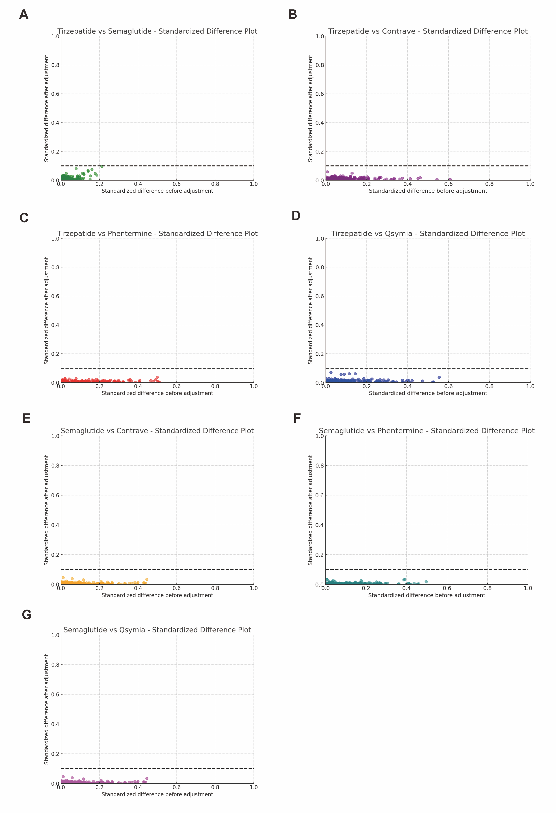

Figure S2. Ocular Outcome Incidence of Tirzepatide vs Contrave. Kaplan–Meier curves depicting the cumulative incidence of ocular events over time, with accompanying time-dependent hazard ratios comparing Tirzepatide and Contrave treatment groups.
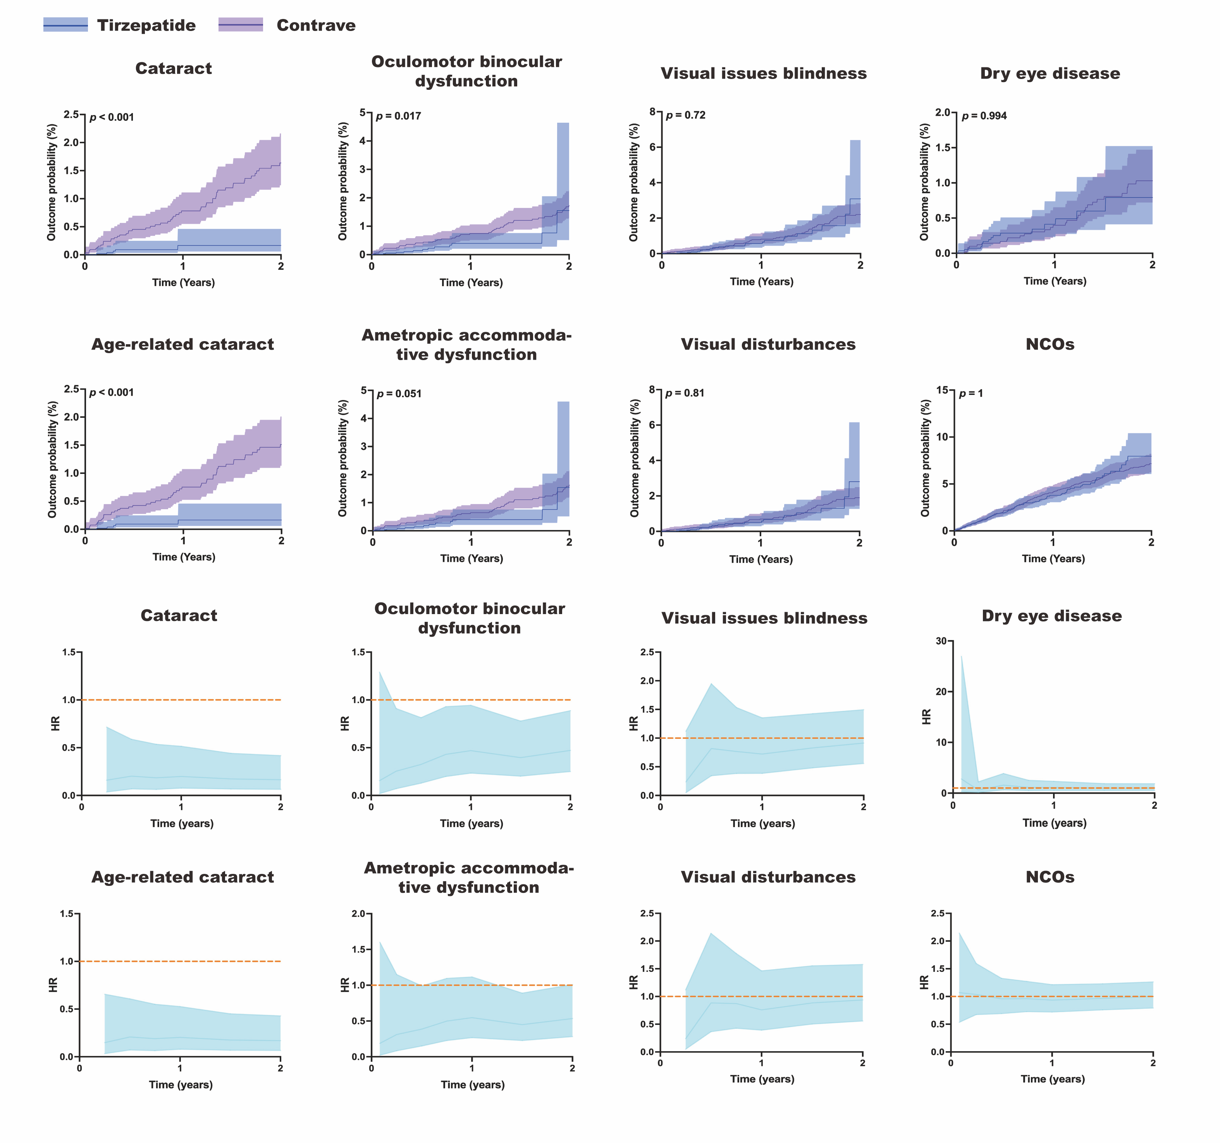

Figure S3. Ocular Outcome Incidence of Tirzepatide vs Phentermine. Kaplan–Meier curves depicting the cumulative incidence of ocular events over time, with accompanying time-dependent hazard ratios comparing Tirzepatide and Phentermine treatment groups.
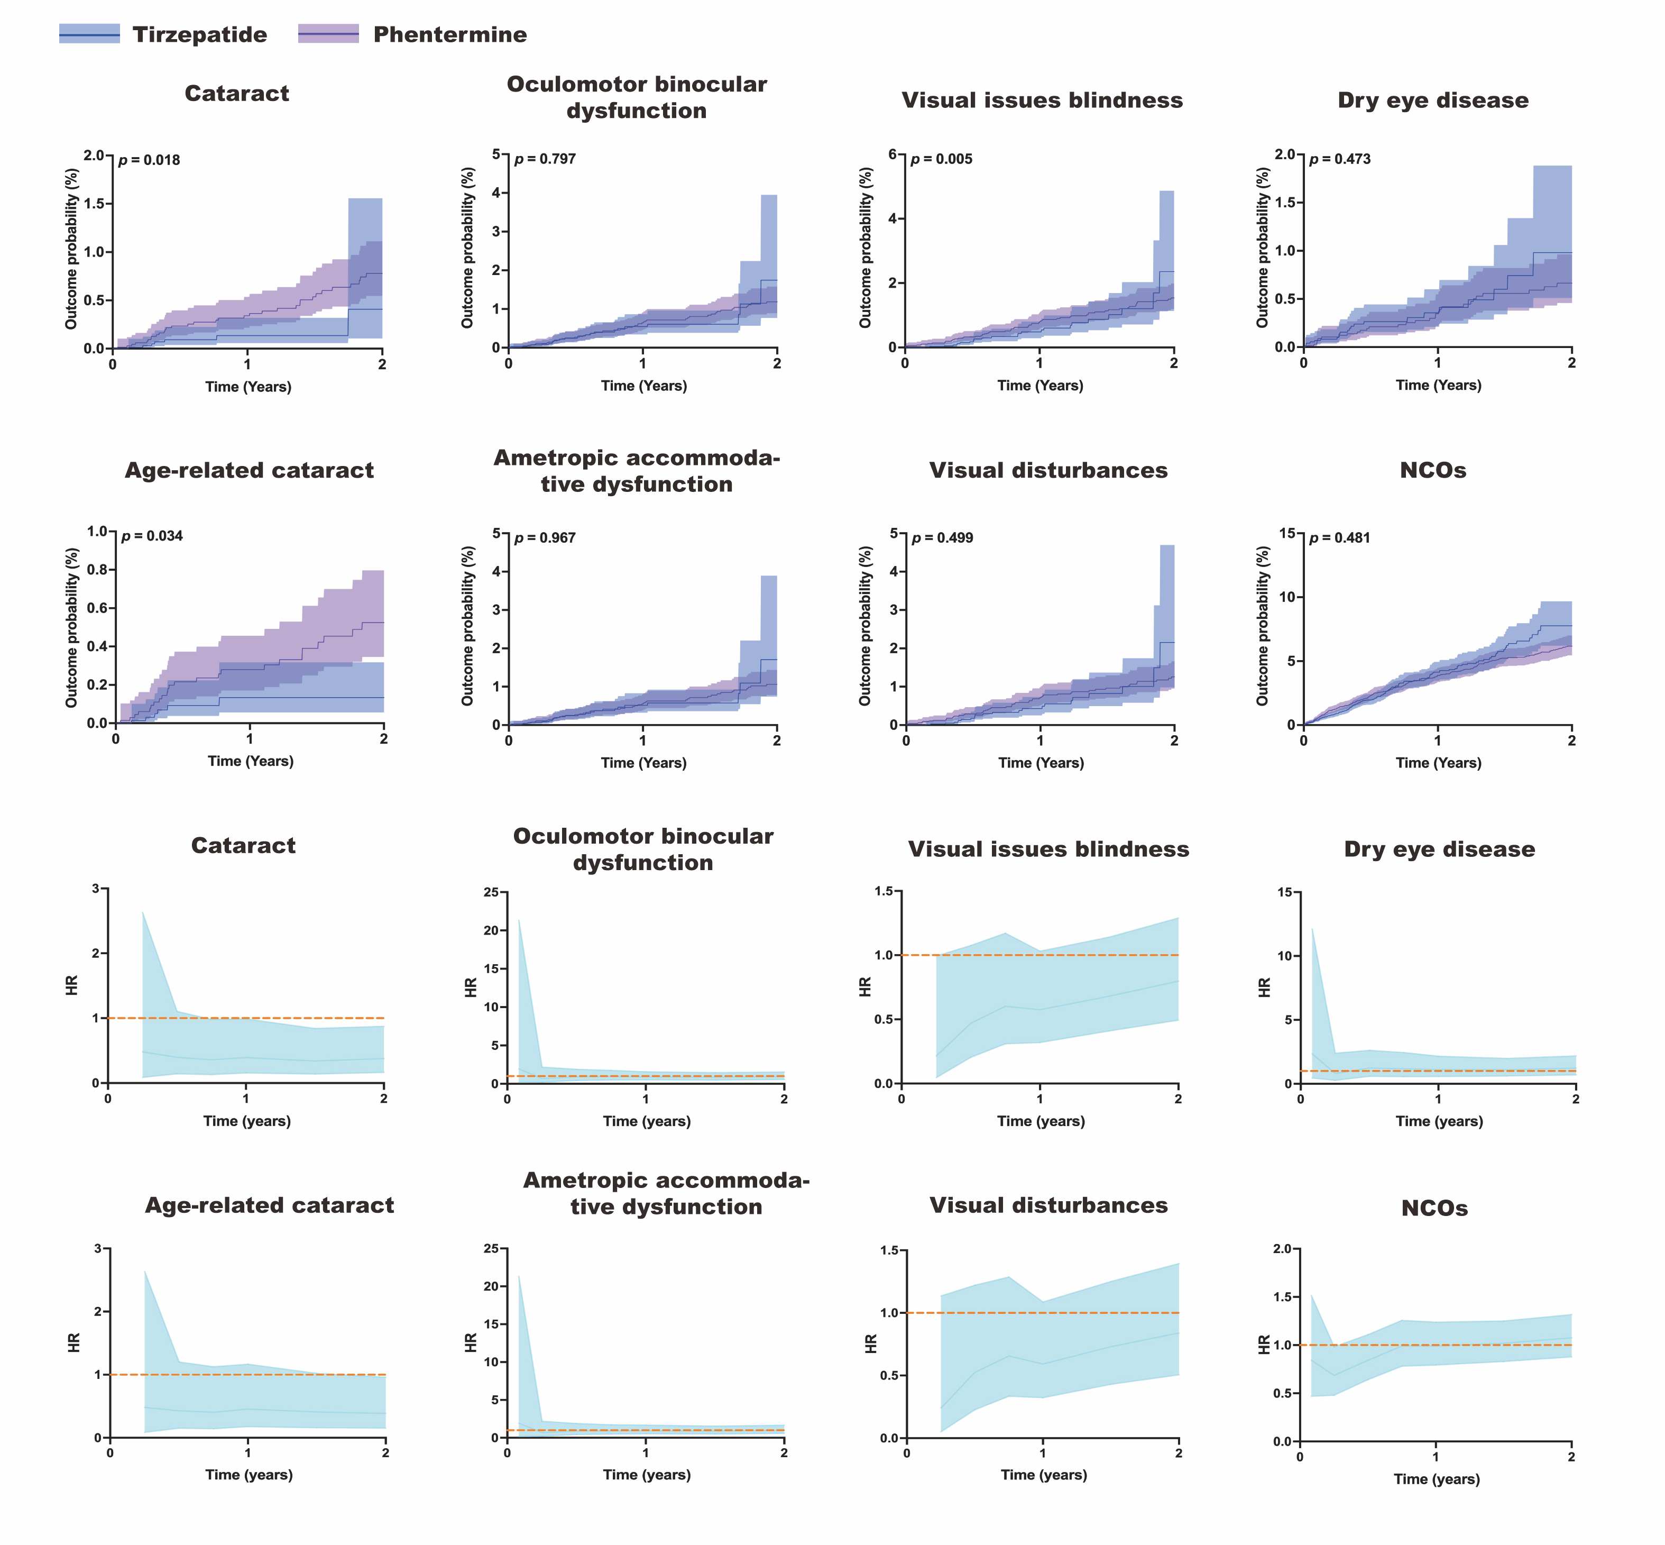

Figure S4. Ocular Outcome Incidence of Tirzepatide vs Qsymia. Kaplan–Meier curves depicting the cumulative incidence of ocular events over time, with accompanying time-dependent hazard ratios comparing Tirzepatide and Qsymia treatment groups.
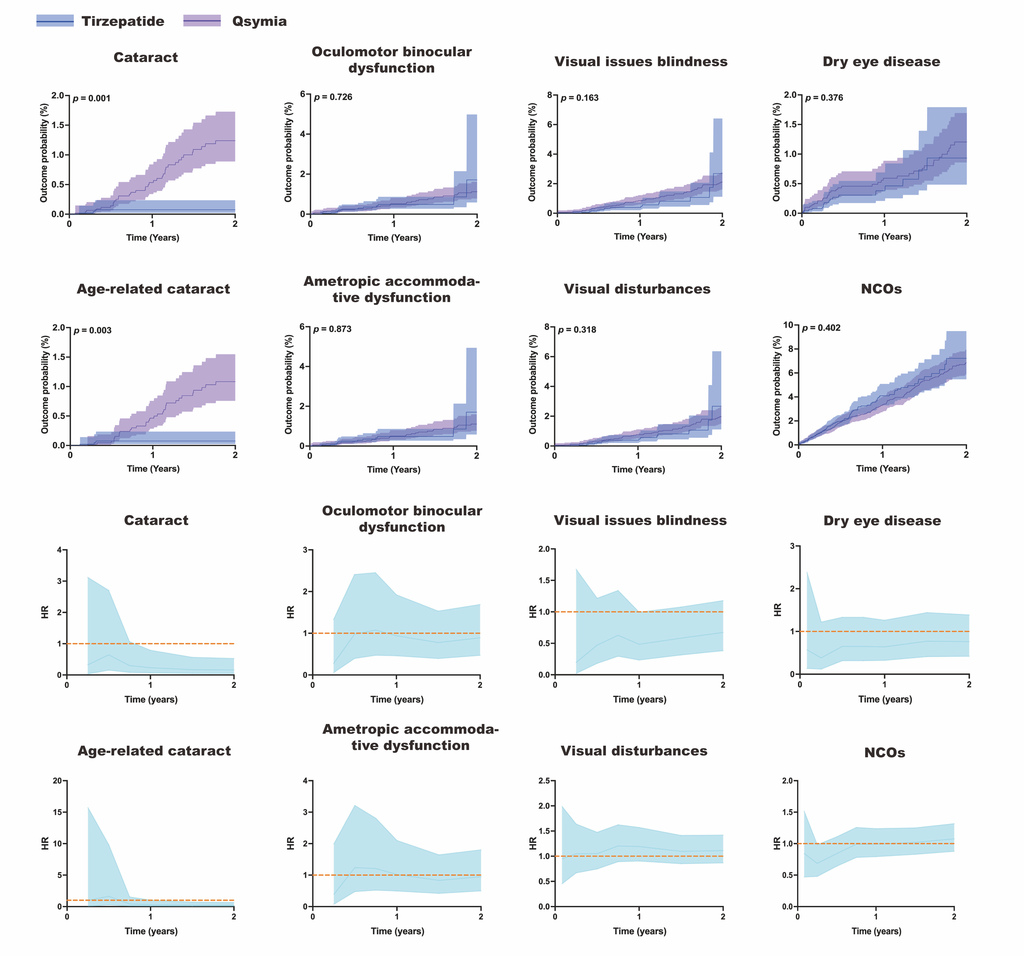

Figure S5. Ocular Outcome Incidence of Semaglutide vs Contrave. Kaplan–Meier curves depicting the cumulative incidence of ocular events over time, with accompanying time-dependent hazard ratios comparing Semaglutide vs Contrave treatment groups.
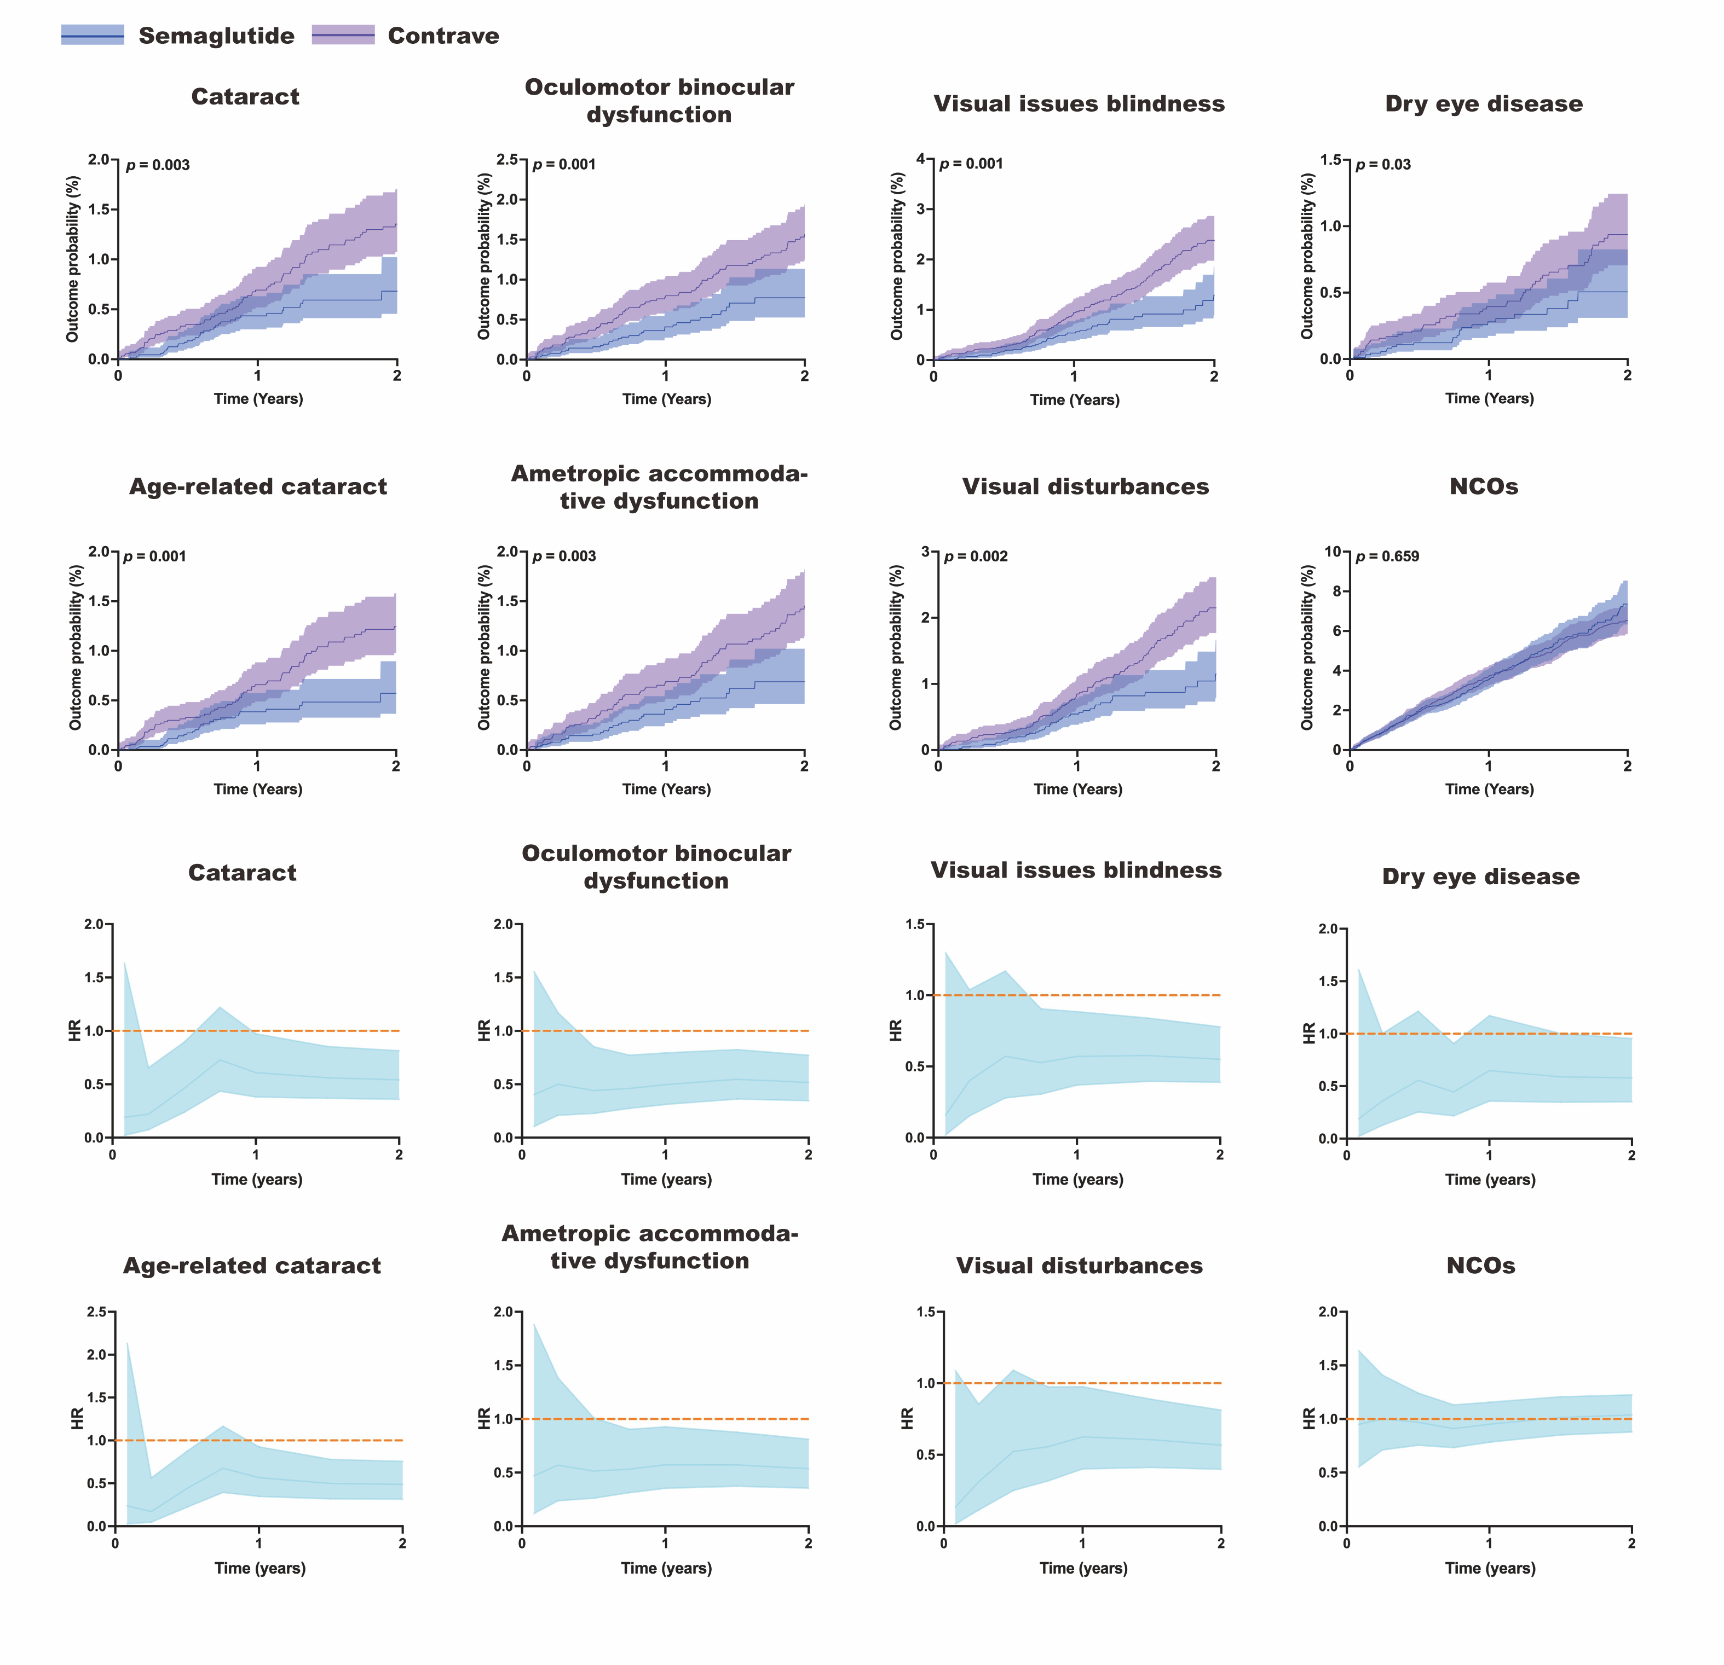

Figure S6. Ocular Outcome Incidence of Semaglutide vs Phentermine. Kaplan–Meier curves depicting the cumulative incidence of ocular events over time, with accompanying time-dependent hazard ratios comparing Semaglutide vs Phentermine treatment groups.
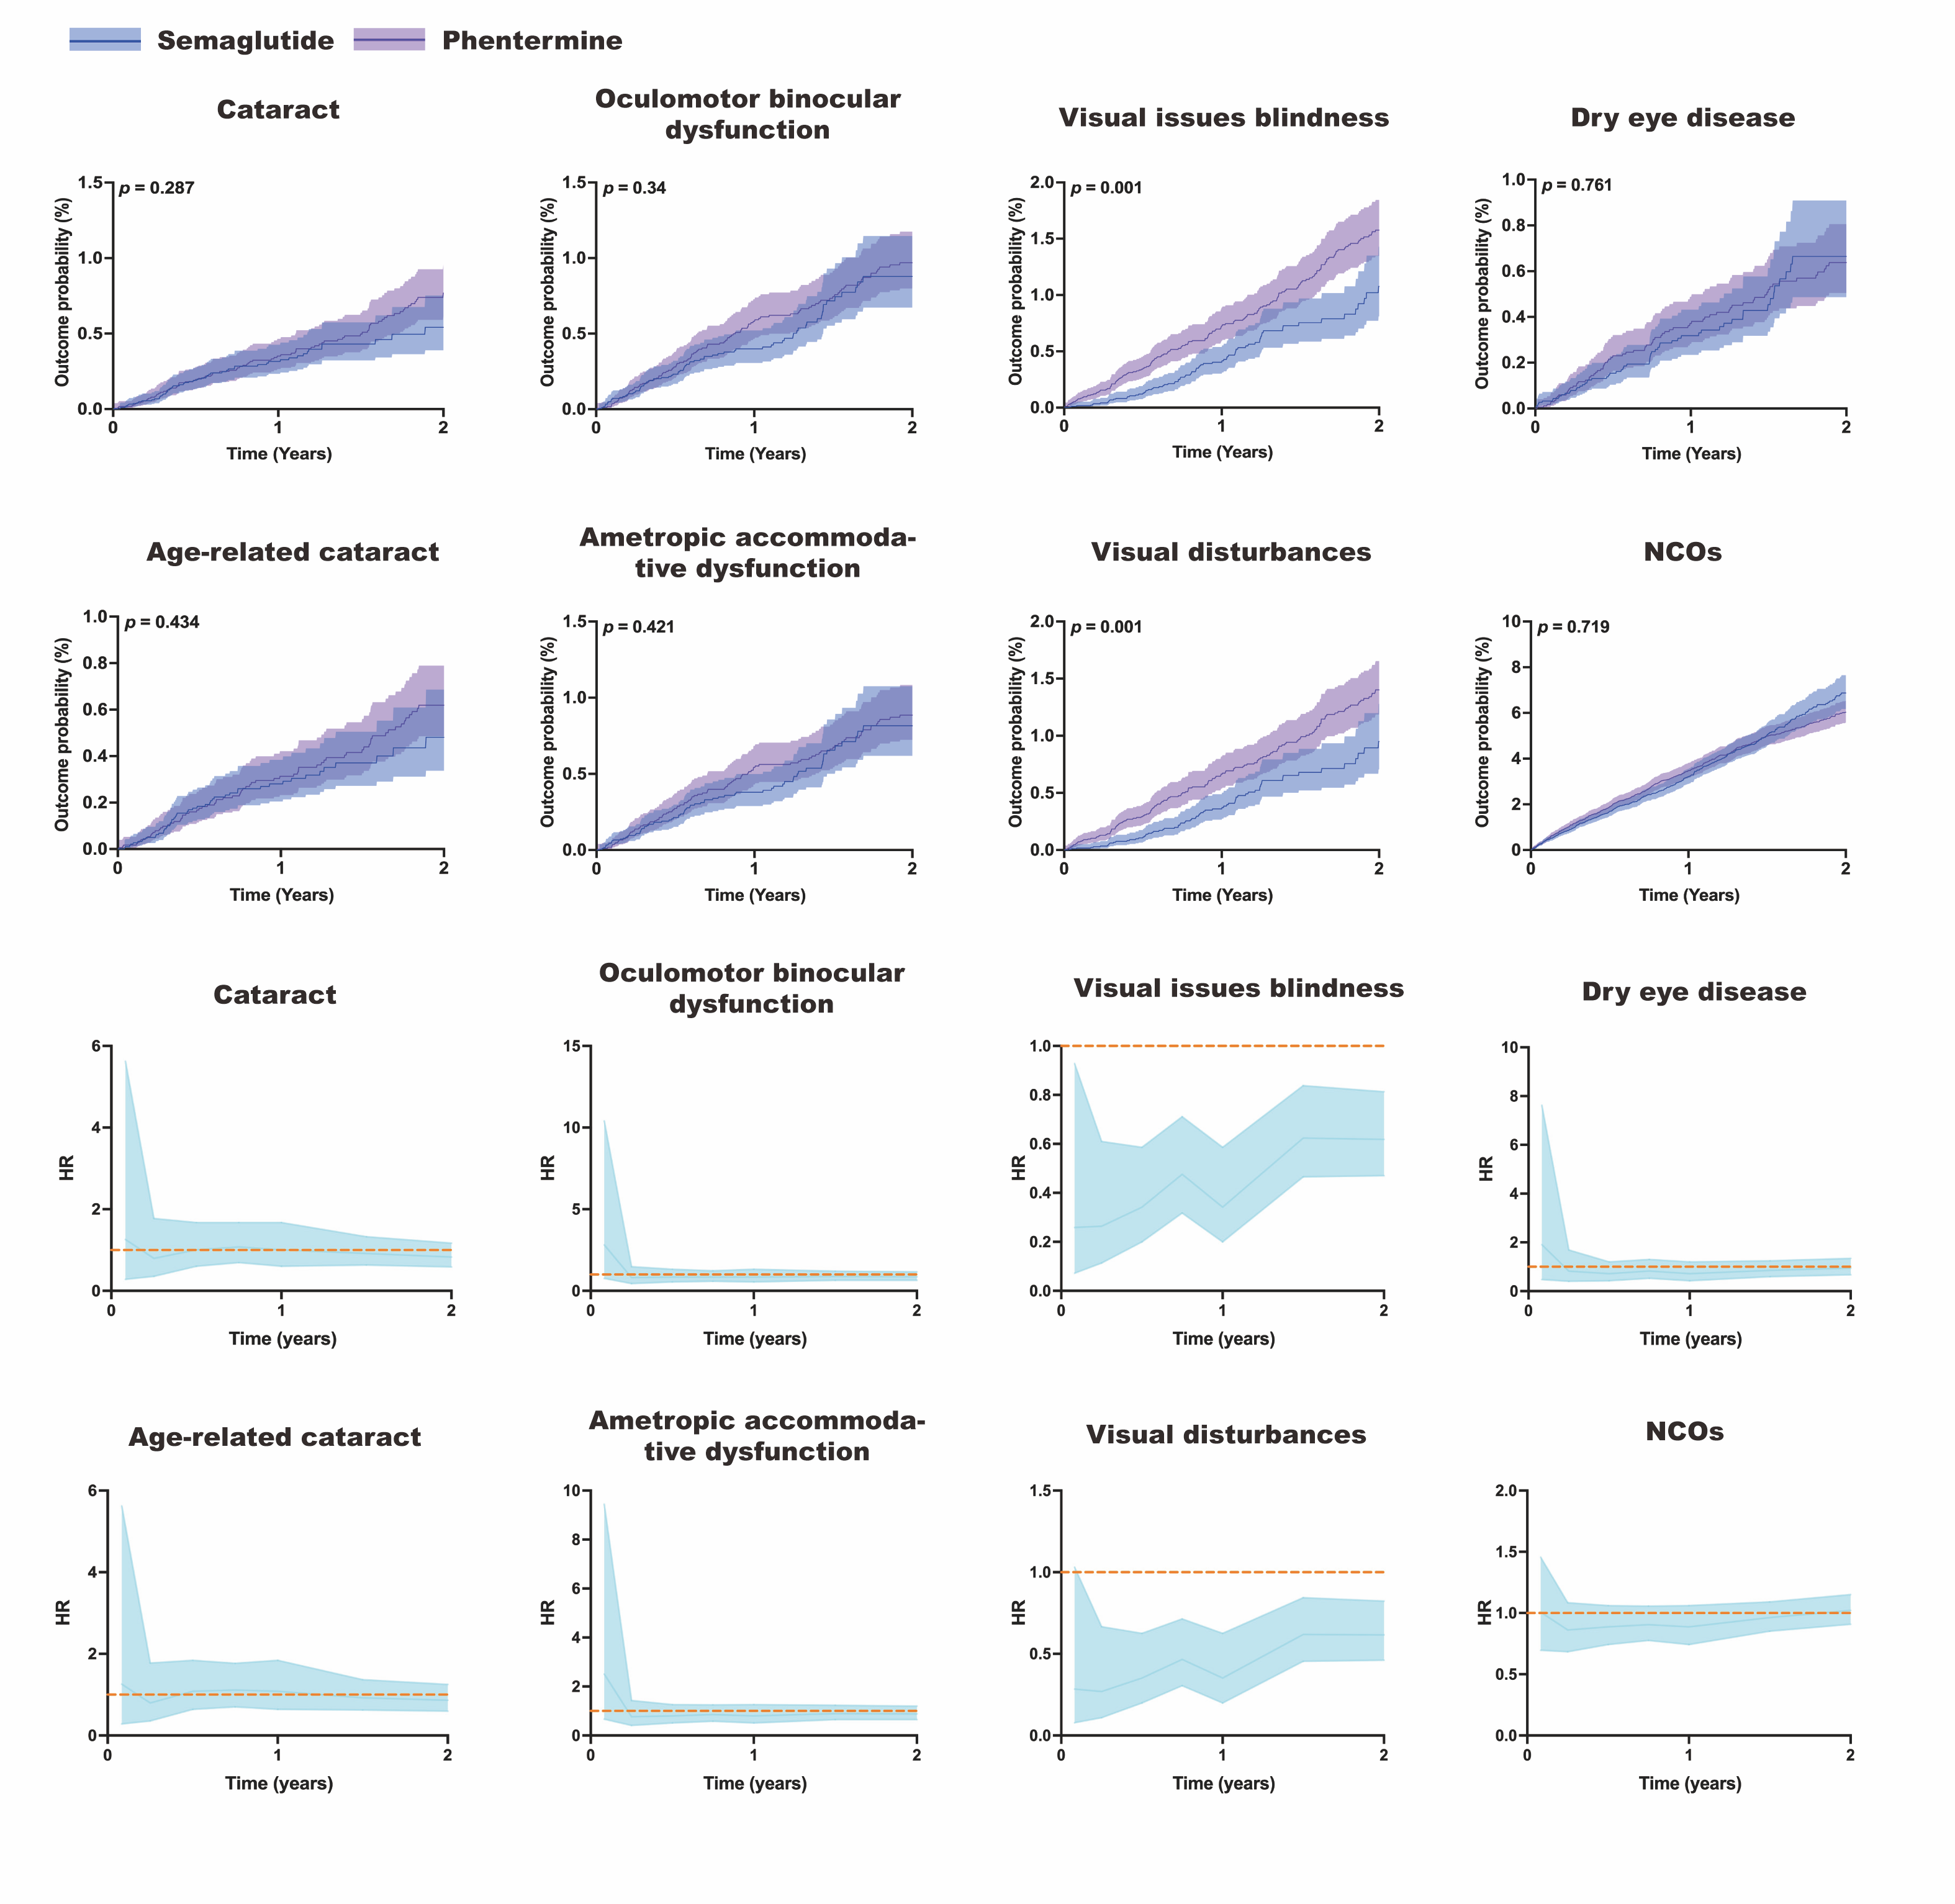

Figure S7. Ocular Outcome Incidence of Semaglutide vs Qsymia. Kaplan–Meier curves depicting the cumulative incidence of ocular events over time, with accompanying time-dependent hazard ratios comparing Semaglutide vs Qsymia treatment groups.
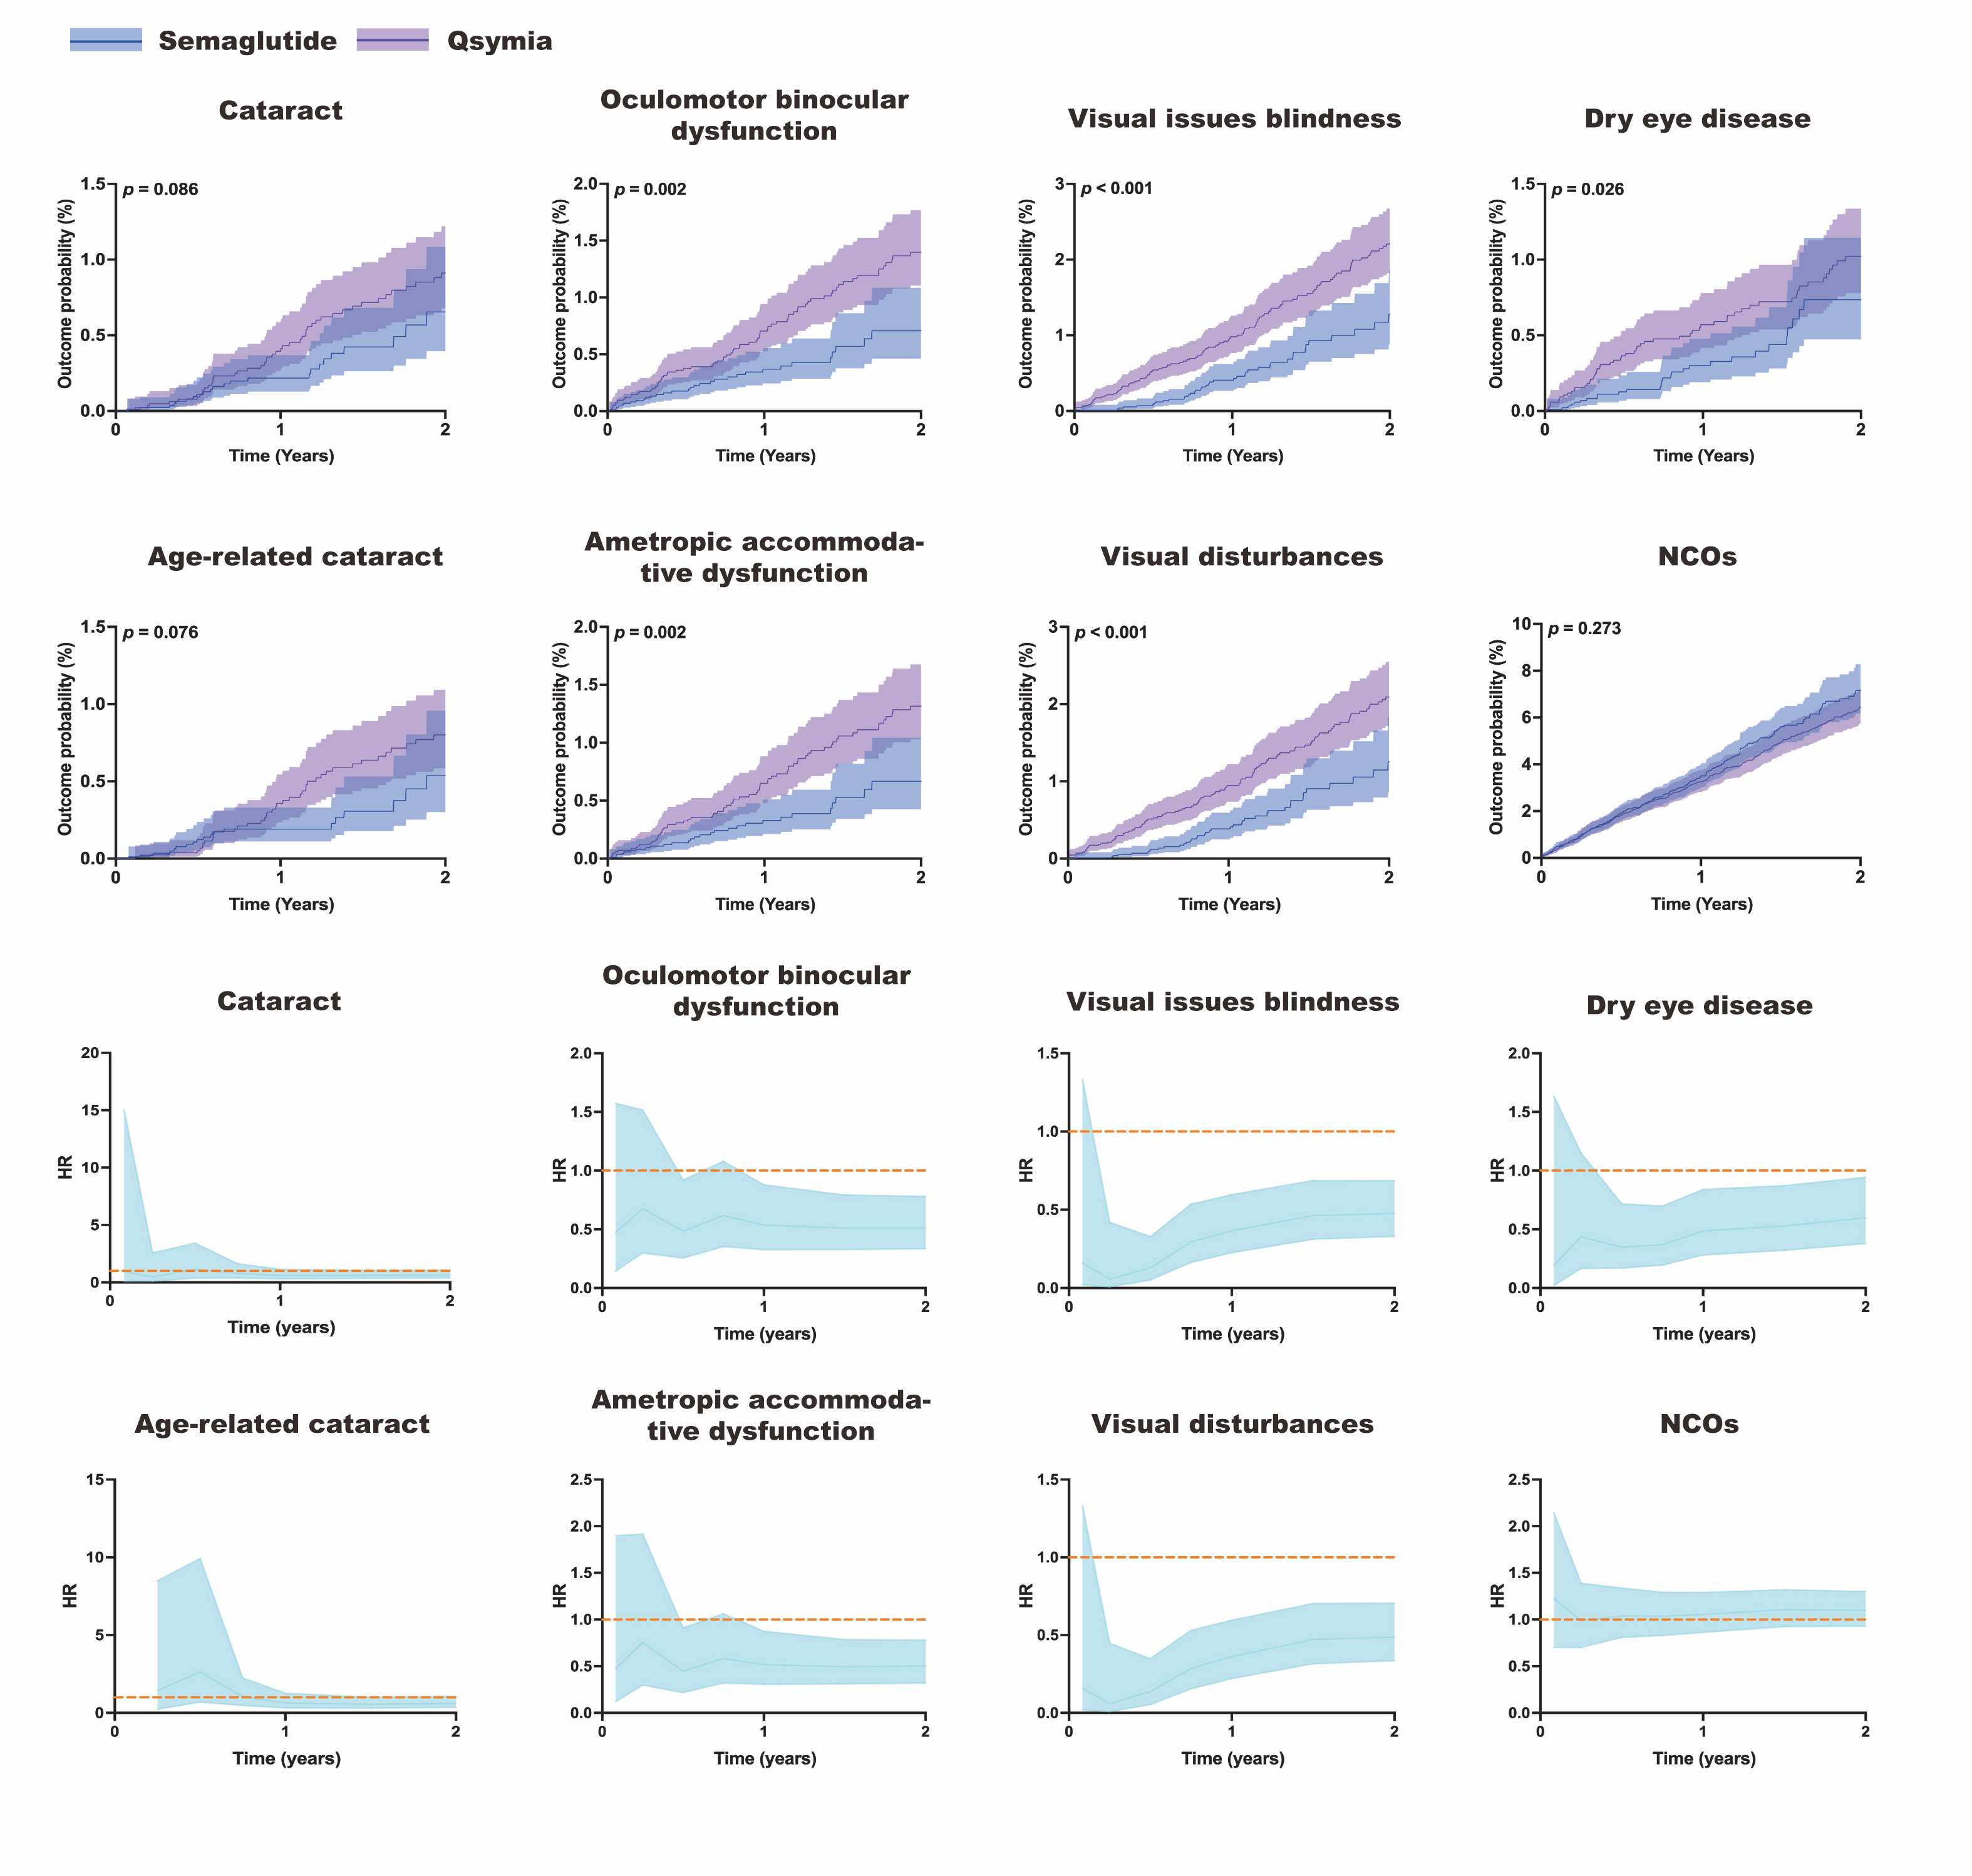

Figure S8. Sensitivity analysis of all-cause mortality for ophthalmic events.

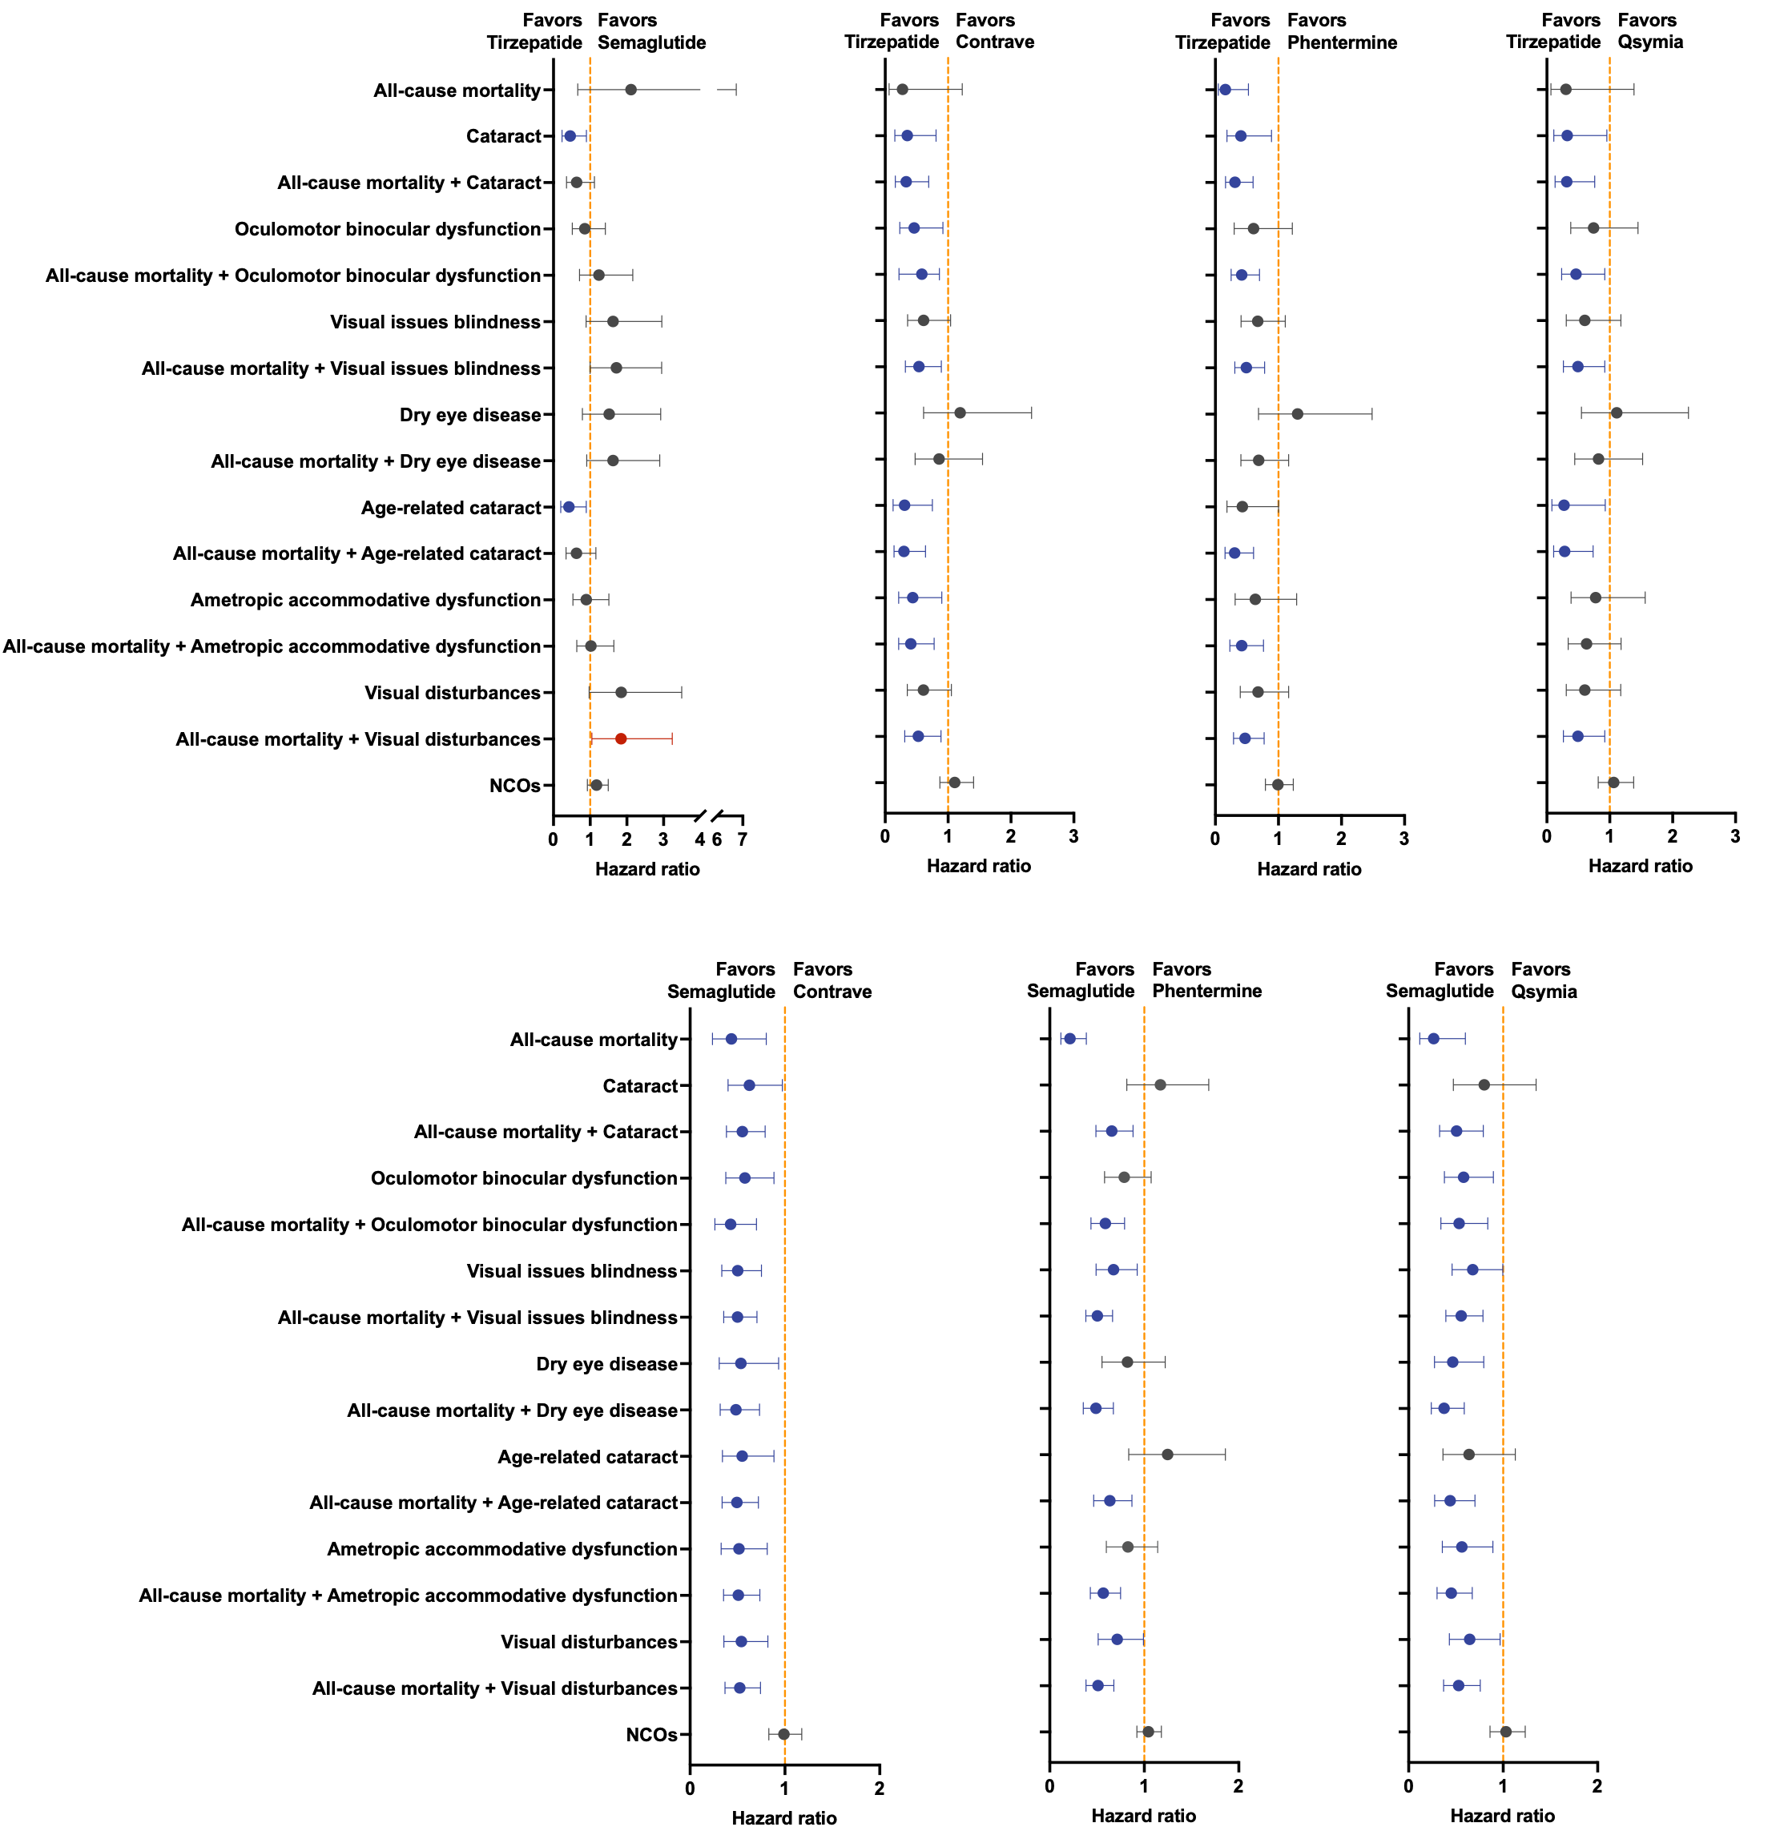
Figure S9. Sensitivity analysis for extension to 2.5 years.
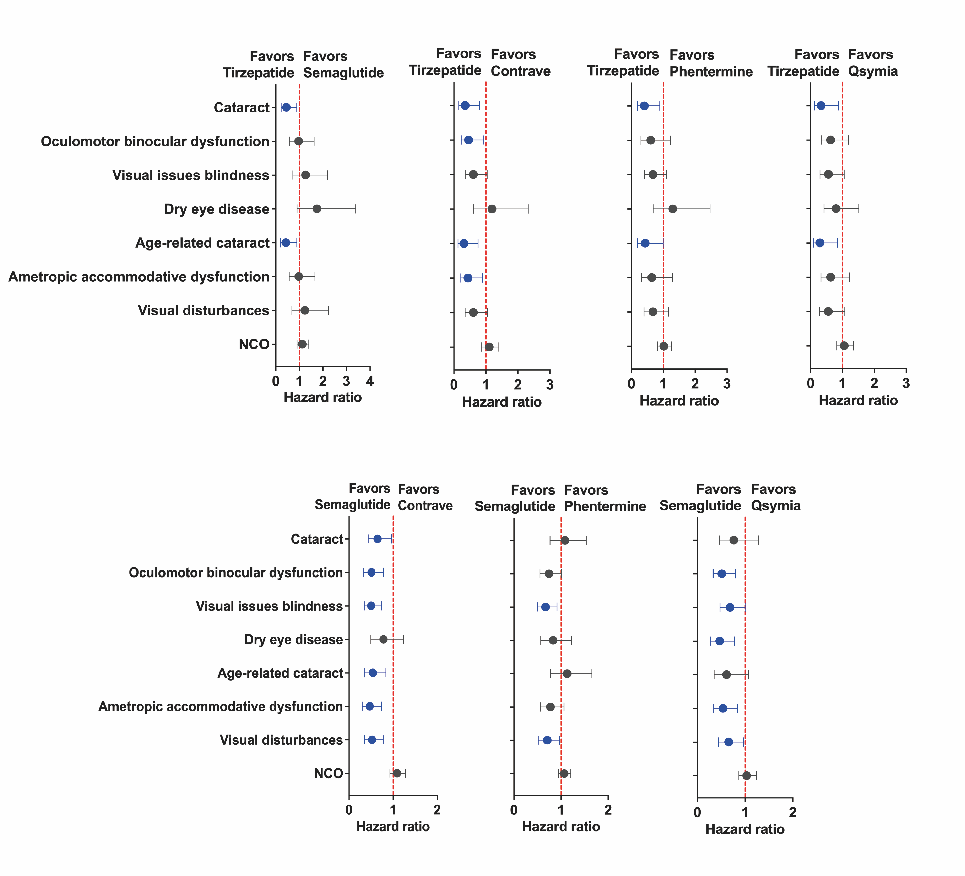

Figure S10. Changes in body weight from baseline over time.
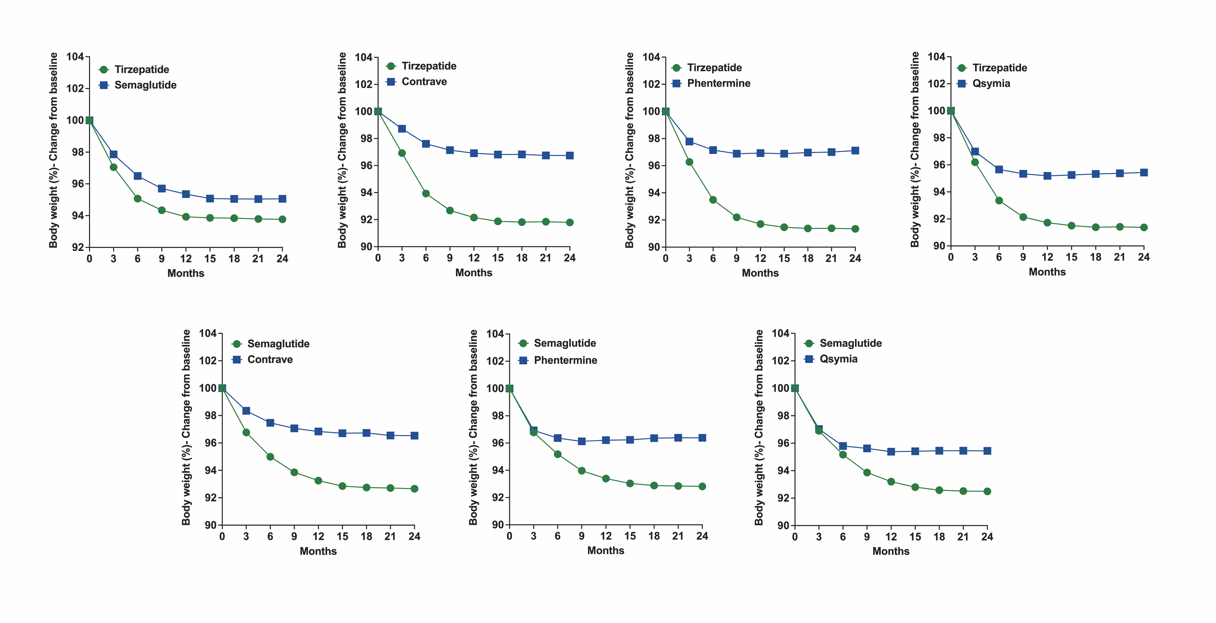

Figure S11. Changes in HbA1c levels from baseline over time.

Figure S12. Comparative analysis of ocular outcomes between weight loss medications and common preventive supplements.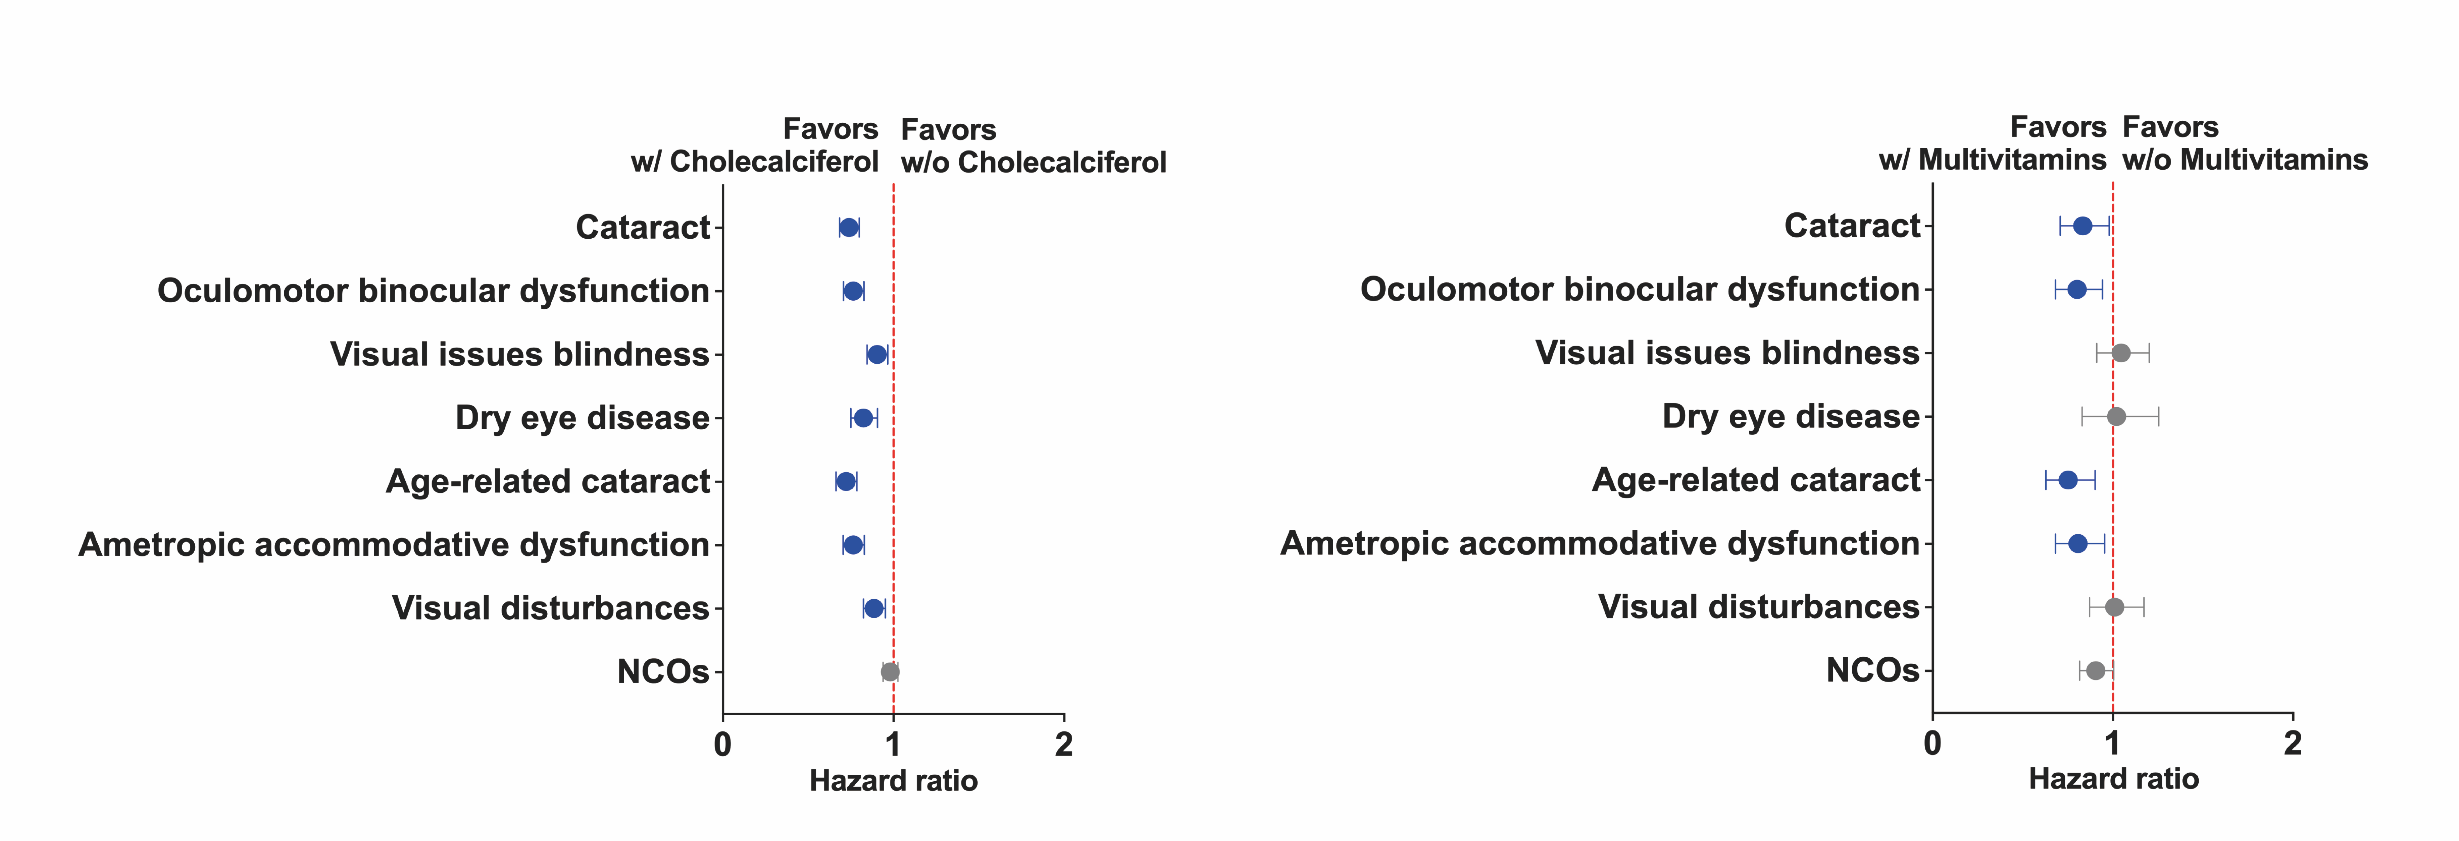

Figure S13. Comparative analysis of cataract surgery rates across anti-obesity treatment groups.

Figure S14. BMI-stratified analysis of ocular outcomes across different anti-obesity medications.

STROBE Statement—Checklist of items that should be included in reports of cohort studies
 | Item No | Recommendation
Title and abstract | 1 | (a) Indicate the study’s design with a commonly used term in the title or the abstract  Provided in title
Title and abstract | 1 | (b) Provide in the abstract an informative and balanced summary of what was done and what was found  Provided in abstract
Introduction
Background/rationale | 2 | Explain the scientific background and rationale for the investigation being reported  Provided in introduction: paragraphs 1-3
Objectives | 3 | State specific objectives, including any prespecified hypotheses  Provided in introduction final paragraph
Methods
Study design | 4 | Present key elements of study design early in the paper  Provided in METHODS section
Setting | 5 | Describe the setting, locations, and relevant dates, including periods of recruitment, exposure, follow-up, and data collection  Provided in METHODS section (Data Source)
Participants | 6 | (a) Give the eligibility criteria, and the sources and methods of selection of participants. Describe methods of follow-up  METHODS (Study Design and Cohorts)
Participants | 6 | (b) For matched studies, give matching criteria and number of exposed and unexposed  METHODS (Study Design and Cohorts)
Variables | 7 | Clearly define all outcomes, exposures, predictors, potential confounders, and effect modifiers. Give diagnostic criteria, if applicable  Given in METHODS section (Outcomes and Covariates), further details including diagnostic codes in supplementary material
Data sources/ measurement | 8* | For each variable of interest, give sources of data and details of methods of assessment (measurement). Describe comparability of assessment methods if there is more than one group  Given in METHODS section (Data Source) further details in supplementary material
Bias | 9 | Describe any efforts to address potential sources of bias  Methods (Covariates and Statistical analysis) further details in supplementary material
Study size | 10 | Explain how the study size was arrived at  Methods (Study Design and Cohorts)
Quantitative variables | 11 | Explain how quantitative variables were handled in the analyses. If applicable, describe which groupings were chosen and why  Methods (Statistical Analysis)
Statistical methods | 12 | (a) Describe all statistical methods, including those used to control for confounding  METHODS (Covariates and Statistical Analysis)
Statistical methods | 12 | (b) Describe any methods used to examine subgroups and interactions  METHODS (Statistical Analysis)
Statistical methods | 12 | (c) Explain how missing data were addressed  In the Methods section, it's mentioned that the TriNetX platform rounds counts less than 10 to the nearest 10 to protect patient privacy.
Statistical methods | 12 | (d) If applicable, explain how loss to follow-up was addressed  Participants without follow-up encounters were excluded from the analysis, effectively addressing loss to follow-up.
Statistical methods | 12 | (e) Describe any sensitivity analyses  METHODS (Statistical Analysis)
Results
Participants | 13* | (a) Report numbers of individuals at each stage of study—eg numbers potentially eligible, examined for eligibility, confirmed eligible, included in the study, completing follow-up, and analysed  RESULTS (First paragraph, Table 1, Figure S1, and supplementary material)
Participants | 13* | (b) Give reasons for non-participation at each stage  In the Figure 1 and Methods section, we list several exclusion criteria, such as co-prescription of other weight-lowering drugs, use of Tirzepatide or Semaglutide for less than 6 months, prior bariatric or transplant surgery, and specific health conditions.
Participants | 13* | (c) Consider use of a flow diagram  Figure. 1
Descriptive data | 14* | (a) Give characteristics of study participants (eg demographic, clinical, social) and information on exposures and potential confounders  RESULTS (First paragraph, Table 1, Figure S1, and supplementary material)
Descriptive data | 14* | (b) Indicate number of participants with missing data for each variable of interest  RESULTS (First paragraph, Table 1, Figure S1, and supplementary material)
Descriptive data | 14* | (c) Summarise follow-up time (eg, average and total amount)  RESULTS (Follow-up of 2-years)
Outcome data | 15* | Report numbers of outcome events or summary measures over time  RESULTS (Second paragraph)
Main results | 16 | (a) Give unadjusted estimates and, if applicable, confounder-adjusted estimates and their precision (eg, 95% confidence interval). Make clear which confounders were adjusted for and why they were included  RESULTS (Second paragraph, Figure 3, Figure 4, and supplementary material)
Main results | 16 | (b) Report category boundaries when continuous variables were categorized  RESULTS (First Paragraph, Table 1, Figure S1 and supplementary material)
Main results | 16 | (c) If relevant, consider translating estimates of relative risk into absolute risk for a meaningful time period  RESULTS (Figure 2)
Other analyses | 17 | Report other analyses done—eg analyses of subgroups and interactions, and sensitivity analyses  RESULTS (Subgroup analysis, competitive risk analysis, sensitivity analysis, and negative control outcomes)
Discussion
Key results | 18 | Summarise key results with reference to study objectives  DISCUSSION (First Paragraph)
Limitations | 19 | Discuss limitations of the study, taking into account sources of potential bias or imprecision. Discuss both direction and magnitude of any potential bias  DISCUSSION (Third last paragraph)
Interpretation | 20 | Give a cautious overall interpretation of results considering objectives, limitations, multiplicity of analyses, results from similar studies, and other relevant evidence  DISCUSSION (From Second to seventh Paragraph)
Generalisability | 21 | Discuss the generalisability (external validity) of the study results  DISCUSSION (First and Second last paragraph)
Other information
Funding | 22 | Give the source of funding and the role of the funders for the present study and, if applicable, for the original study on which the present article is based  Funding

*Give information separately for exposed and unexposed groups.

