Supporting Information
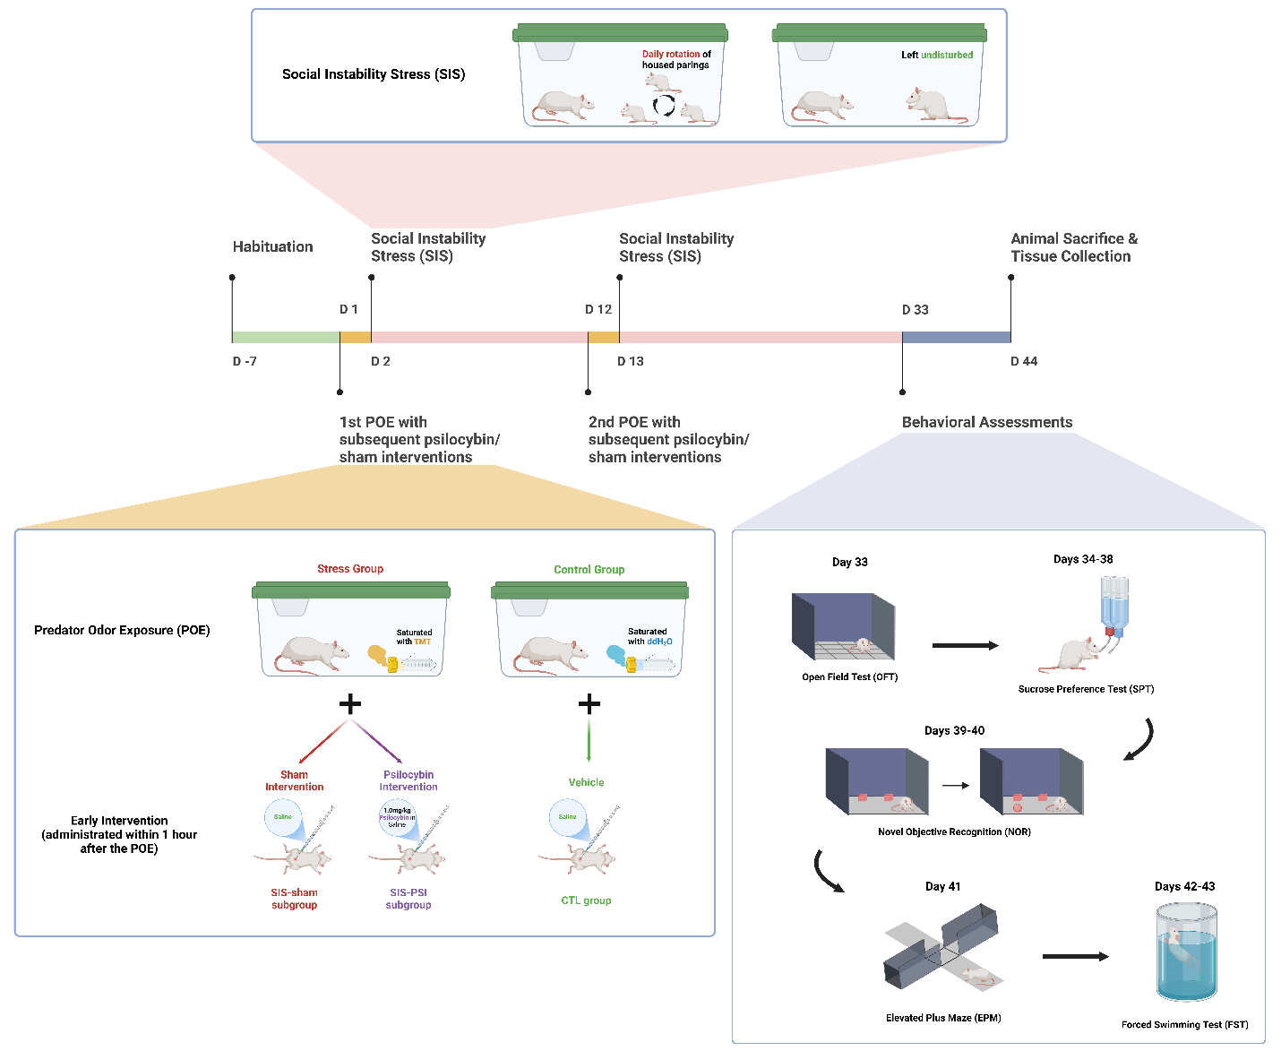
Figure S1 Experimental design. All animals underwent a 7-day acclimation period prior to the experiment. Animals in all groups were subjected to two separate predator odor exposure (POE) sessions, which occurred between 6:00-18:00 on Day 1 and between 18:00-6:00 on Day 12. During the POE, animals in the SIS groups encountered 2,5-dihydro-2,4,5-trimethylthiazoline (TMT) while the control (CTL) group was exposed to distilled water. Rats in the stress groups received intraperitoneal injections of either sterile saline (0.9% NaCl) (SIS-Sham) or 1.0 mg/kg psilocybin (SIS-PSI) one hour following each POE session. From days (Ds) 2-11 and 13-32, rats in the stress groups were subjected to chronic social instability stress (SIS) paradigms, while CTL rats remained undisturbed. Behavioral assessments were performed between Ds 33–43, including evaluations of the general activity levels (D 33), anhedonia-like behavior (Ds 34-38), recognition memory (Ds 39-40), anxiety-like behaviors (D 41), and behavioral despair (Ds 42-43). Cardiac blood and brain tissue samples were collected on D 44 for further analysis. Created in BioRender. Wang, Z. (2025) https://BioRender.com/w29s555
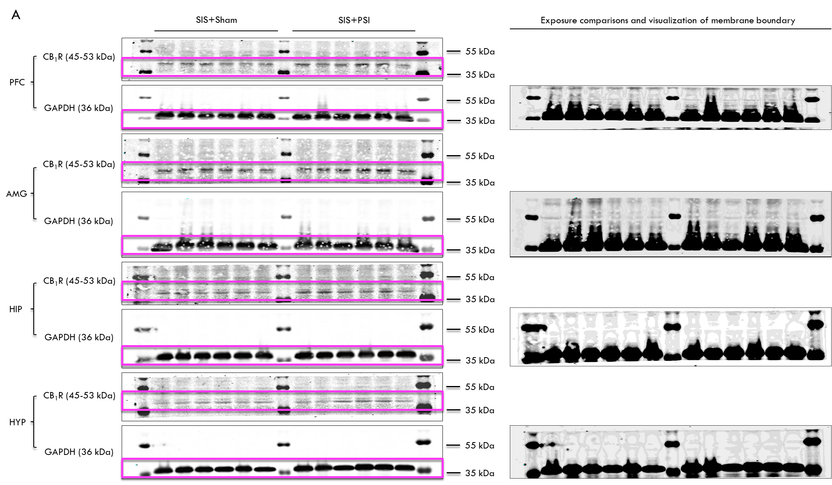
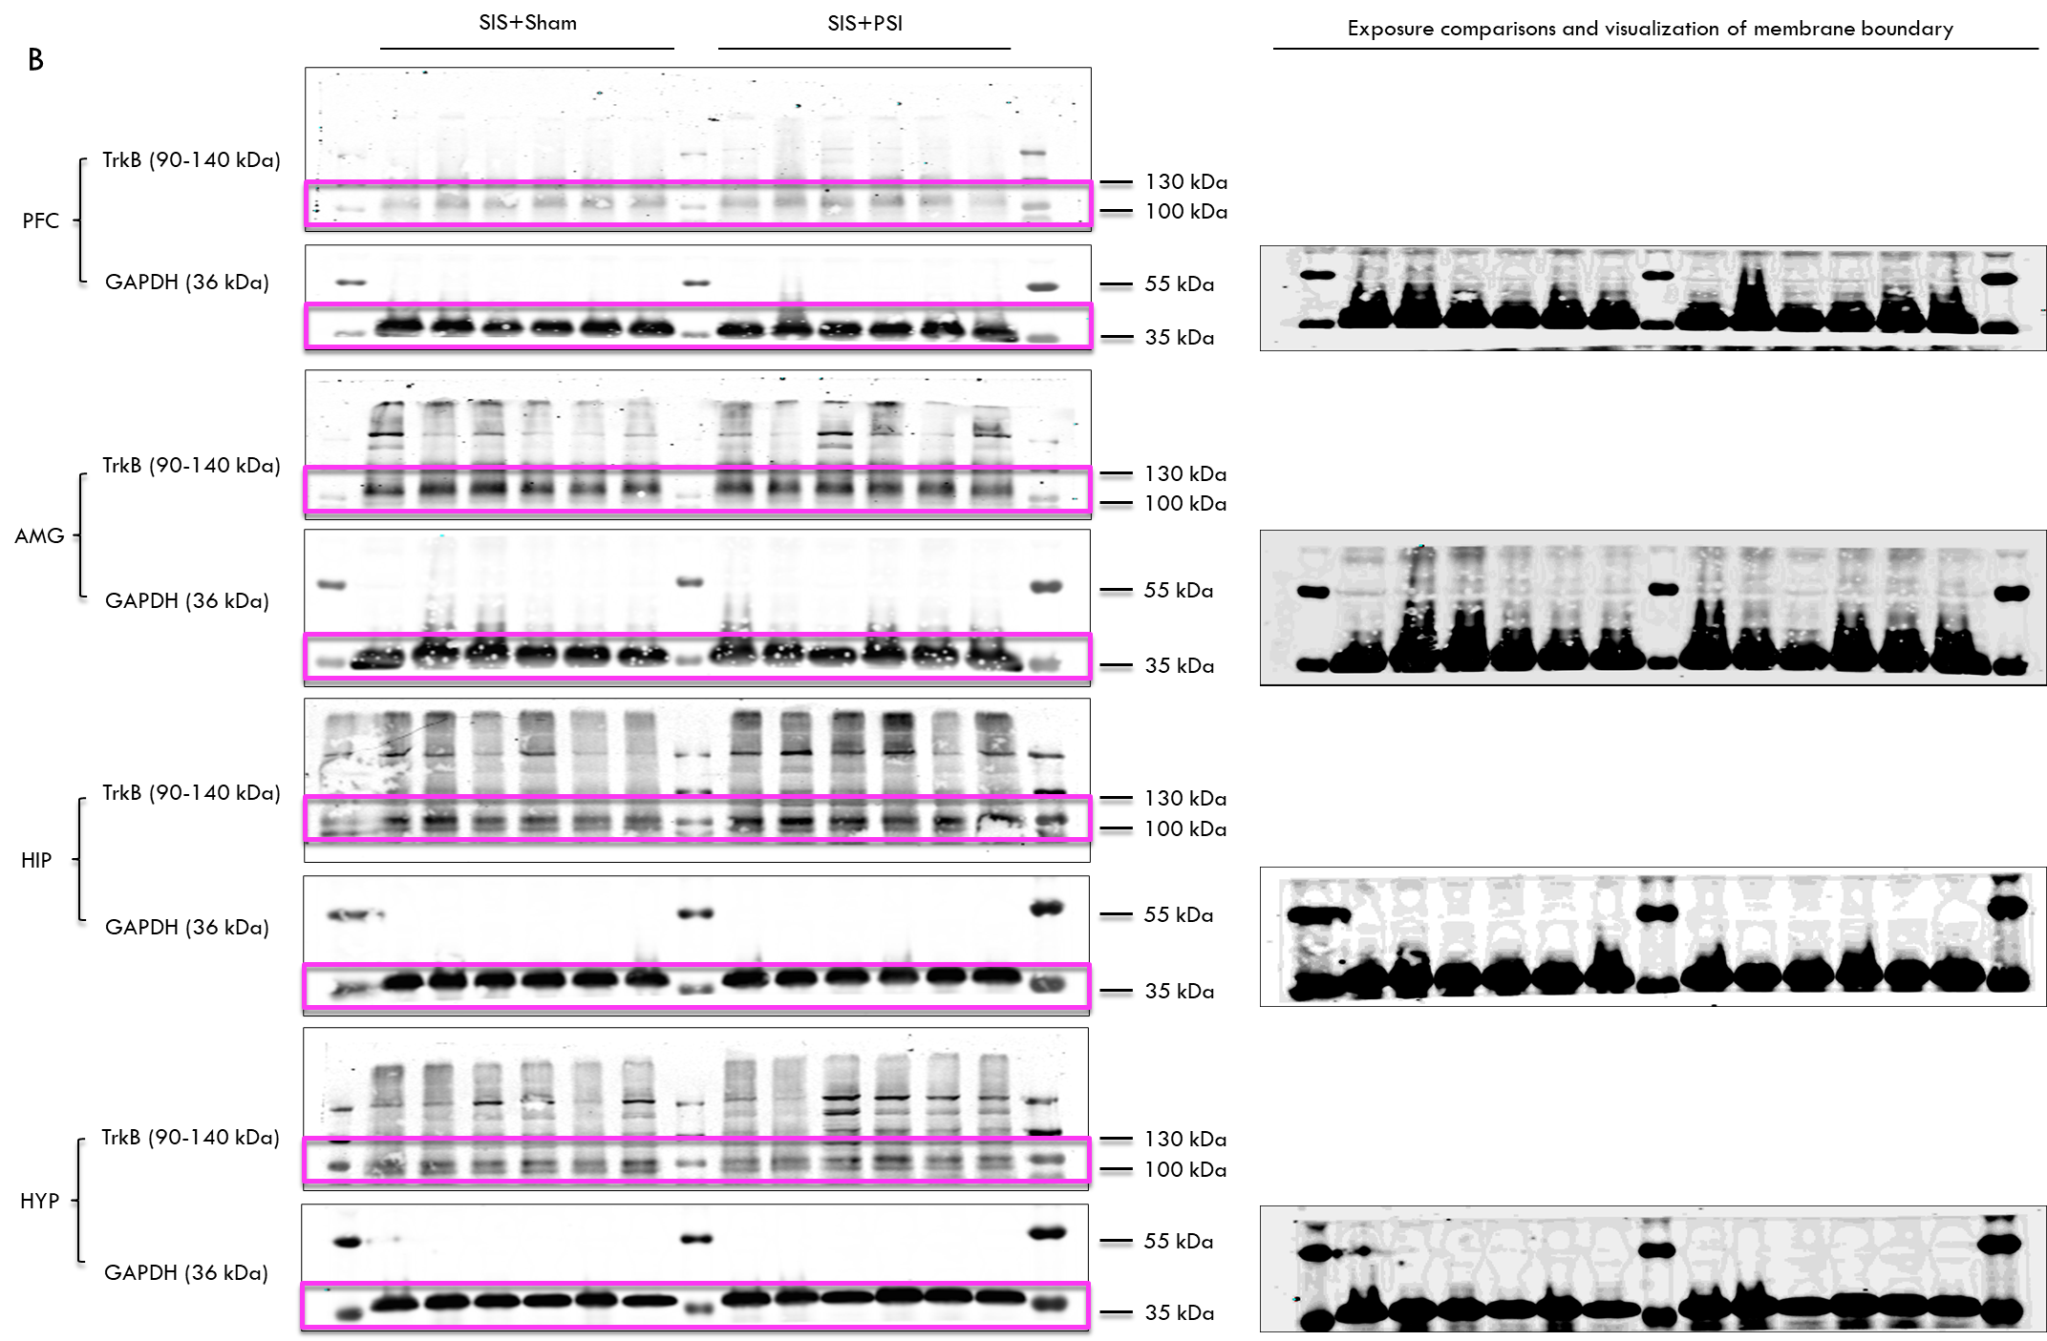

Figure S2 Western blot results for CB₁R and TrkB expression. (A) Full WB images illustrating the expression of CB₁R in the prefrontal cortex (PFC), amygdala (AMG), hippocampus (HIP), and hypothalamus (HYP) of WKY rats exposed to SIS, with GAPDH serving as loading control. The bands of interest are boxed in purple. (B) WB images illustrating the expression of TrkB in the prefrontal cortex (PFC), amygdala (AMG), hippocampus (HIP), and hypothalamus (HYP) of WKY rats exposed to SIS, with GAPDH serving as a loading control. The blots were trimmed before hybridization with antibodies, and the bands of interest are highlighted in purple. The provided images show the full bands with membrane edges visible.

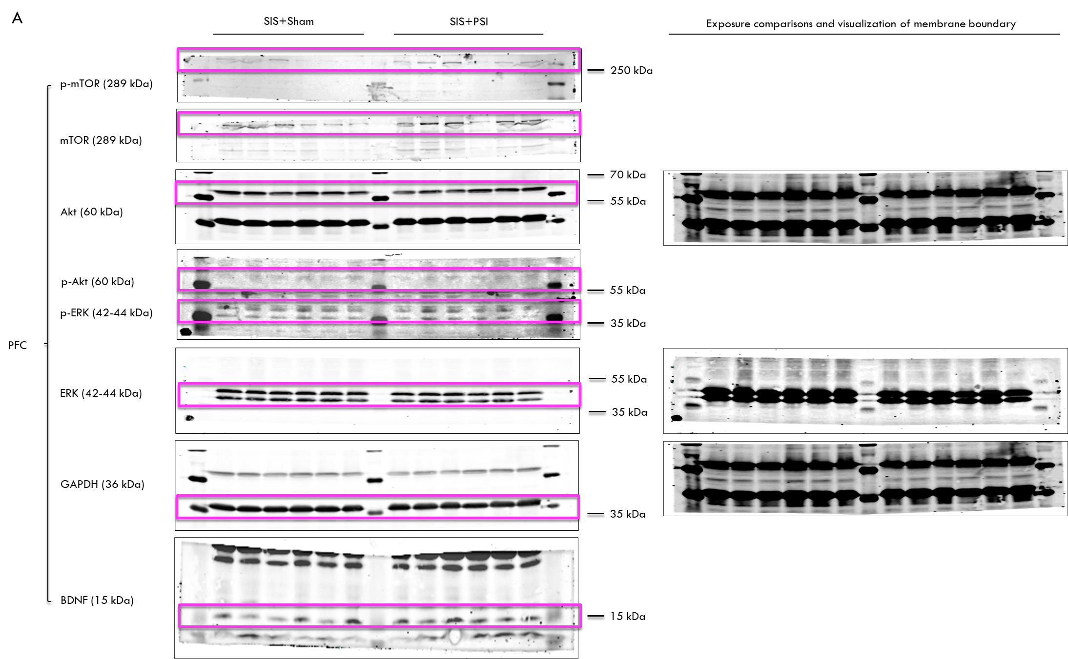
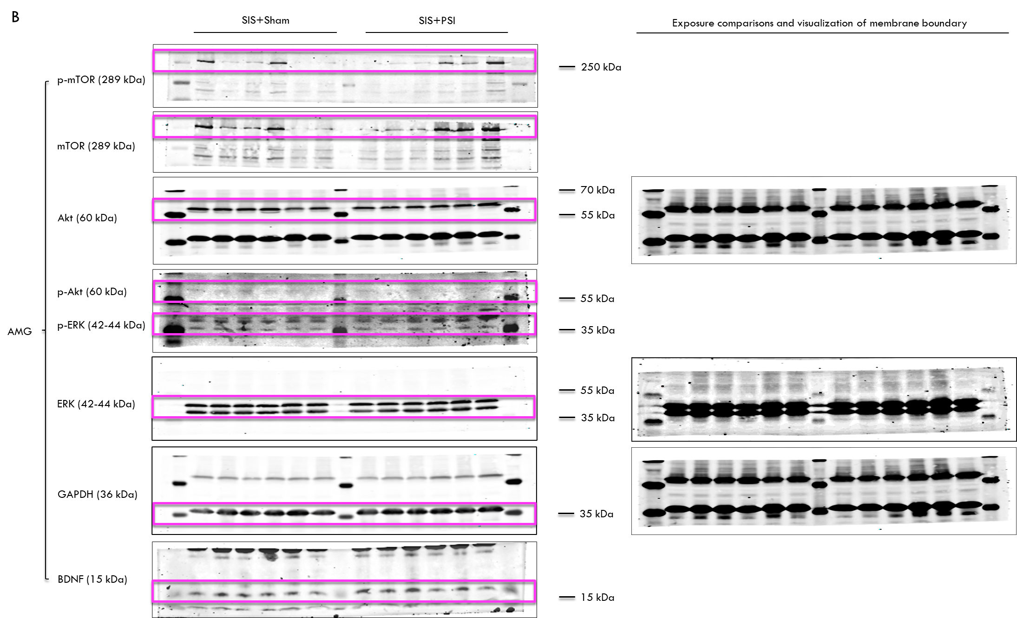
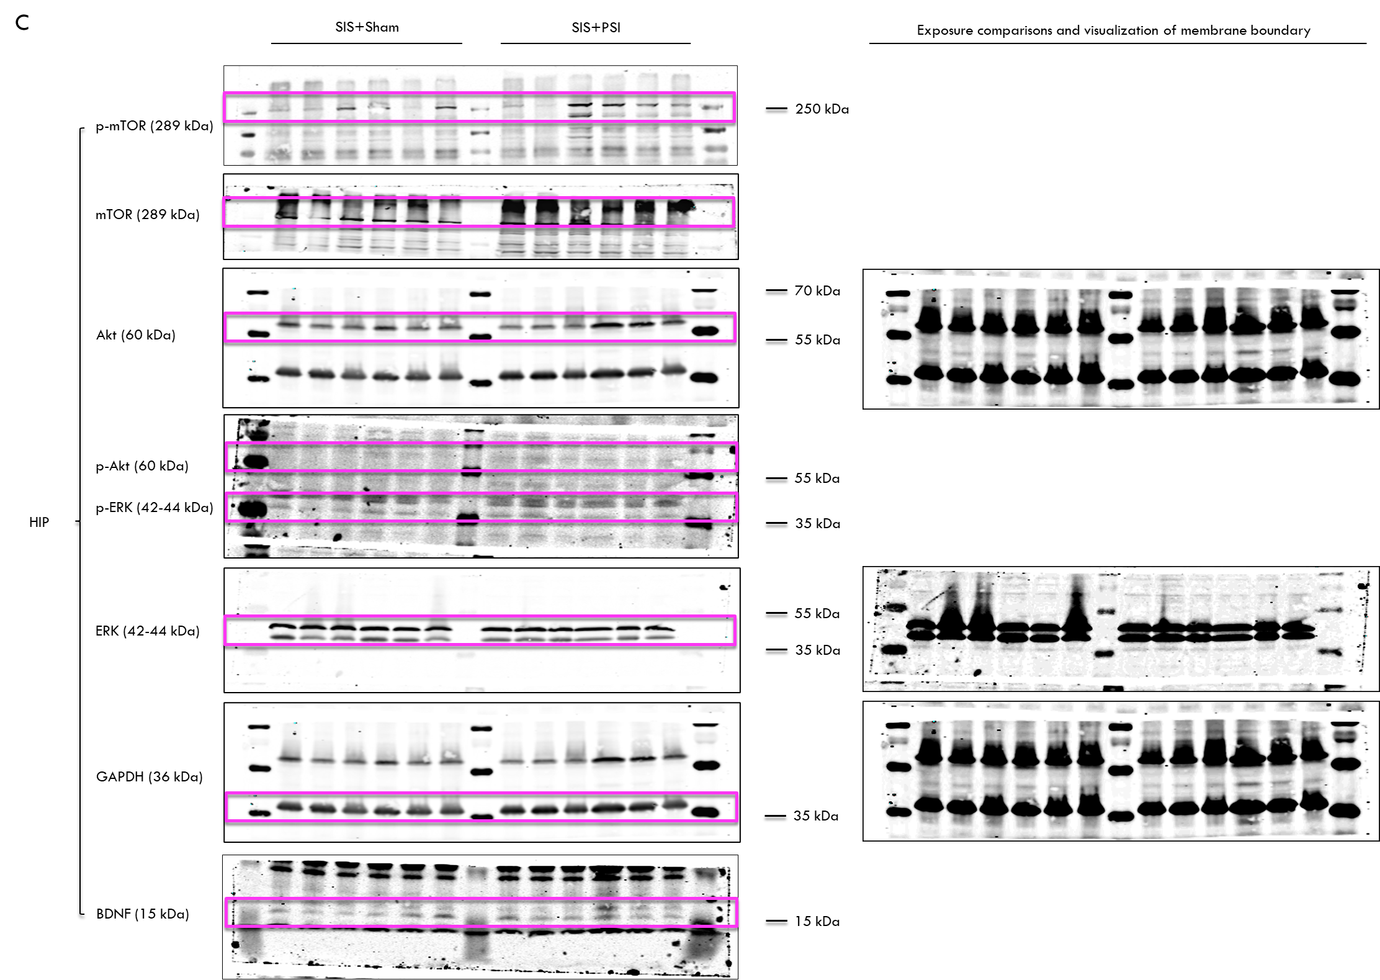
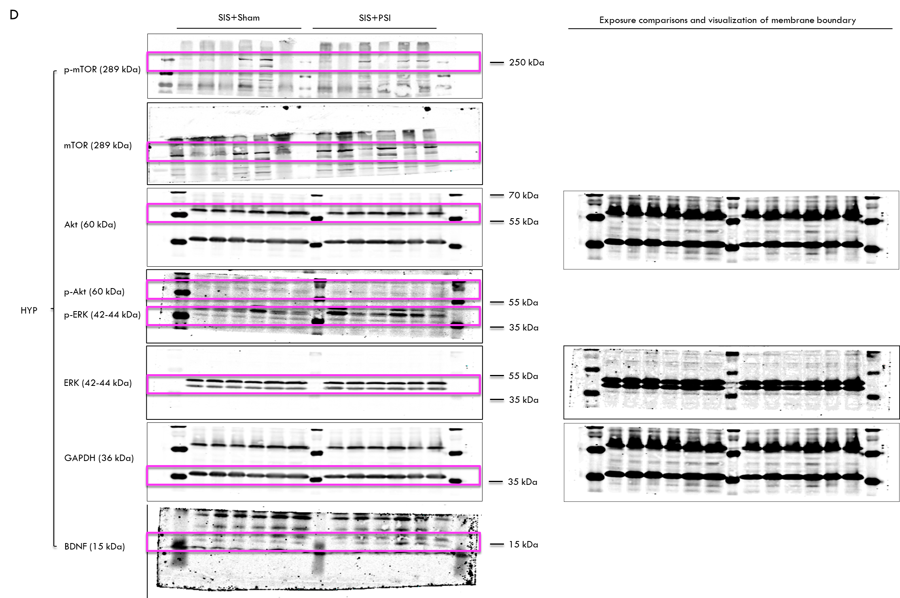
Figure S3 Western blot results for the expression of BDNF, p-ERK/ERK, p-Akt/Akt, and p-mTOR/mTOR in (A) the prefrontal cortex (PFC), (B) the amygdala (AMG), (C) hippocampus (HIP), and (D) hypothalamus (HYP) of WKY rats exposes to SIS, with GAPDH serving as loading control. The blots were trimmed before hybridization with antibodies, and the bands of interest are highlighted in purple. The provided images show the full bands with membrane edges visible.

