Materials and methods
In silico analysis of pHGG secretome
We used normalized (TPM) RNAseq data from 133 pHGG tumors (CBTN, pedcbio.org) and normal cortex (GTEX database, gtexportal.org) to analyze the pHGG secretome involved in migration. First, we selected all genes that were known to be secreted (1891 genes, The Human Protein Atlas secreted proteins, https://www.proteinatlas.org/search/protein_class%3APredicted+secreted+proteins). Next, we determined the median TPM value in normal cortex and the 80th percentile expression across the 133 pHGG samples (which corresponds to the expression level of a specific gene in the tumor that has the 20% highest expression) and determined the fold change between the 80th percentile pHGG expression and median expression in cortex. We used the 80th percentile expression to cast a wide net and because we considered chemoattraction to 1/5 tumors worthwhile pursuing. We only considered a gene of interest when the determined fold change was at least 3. Finally, we manually curated the resulting gene list for known genes involved in chemoattraction and resulted in the 38 genes listed in Extended Data Table 1.

Reagents
Antibodies: LHX6 (Sc-271433, SCBT), SOX6 (AB5805, Millipore), anti-GFP (Ab13970, Abcam), NKX2.1 (Ab76013, Abcam), MAP2 (Ab5392, Abcam), CXCL12 (MAB350, R&D systems).
BiTEs: EGFR and CD19 bi-specific T-cell engagers were generated as previously described¹ by the gene synthesis service of Genscript and cloned in a lentiviral construct under the CAG promotor.
The CXCL12 chemokine was purchased from R&D Systems (350-NS-050).

Glioma cell culture
Human pediatric high-grade glioma stem cell lines (7316-24, 7316-195, 7316-913, 7316-1746, 7316-1763, 7316-1769, 7316-3058, 7316-5335, and 7316-6949) were acquired from the Children’s Brain Tumor Network and were characterized as previously described². Cells were maintained in glioma stem cell media (DMEM/F12 medium supplemented with 1% GlutaMAX (Gibco, Billings, MT), 20 ng/mL basic fibroblast growth factor (PeproTech, Rocky Hill, NJ), 20 ng/mL epidermal growth factor (StemCell Technologies, Vancouver, Canada), 1X B-27 supplement (Thermo-Fisher Scientific, Waltham, MA), 1X N-2 supplement (Thermo-Fisher Scientific, Waltham, MA), 4 µg/mL heparin (StemCell Technologies, Vancouver, Canada), and 100 U/mL penicillin-streptomycin (Life Technologies, Carlsbad, CA). Adult glioblastoma lines were maintained in DMEM supplemented with 10% FBS (Gemini Bio-Products, West Sacramento, CA), and 100U/mL penicillin-streptomycin (LN229, LN319, U87). The human adult glioblastoma TM31 HGG was dedifferentiated from the serum grown TM31 cell line (Received from the RiKEN biorepository) by propagating it in the glioma stem cell media described above. All glioma lines were stably transduced with a lentivirus expressing nuclear red-fluorescent protein (NucLight Red, Sartorius) or with lentivirus expressing green-fluorescent protein and luciferase for imaging purposes.

MIP culture and differentiation
MIPs were differentiated from human embryonic stem cells (NKX2.1-GFP and LHX6 Citrine)^{3,4} using a modified version of the protocol from Ni et al. 2019 and 2020^{5,6} The stem cells were cultured on Matrigel (Corning 1:50) coated plated in StemMACS™ iPS-Brew XF media (Miltenyi Biotec) supplemented with 10 µM Y27632 ROCK inhibitor (ApexBio).
Stem cells were dissociated with Accutase (Sigma-Aldrich) and replated, on low attachment plates (Corning) for 3D cultures or 6 well plates coated with 1/50 Matrigel for 2D cultures, into SRM media consisting of DMEM (Invitrogen),15% knockout serum replacement (Invitrogen), 2 mM L-glutamine (Gibco), β-mercaptoethanol (Gibco) and 10 µM Y27632 ROCK inhibitor (ApexBio).

NKX2.1 Line (3D): From day 2-7 cells were cultured in SRM media supplemented with 0.1 µM LDN193189 (Tocris Biosciences), 10 µM SB431452(Tocris Biosciences), 0.1 µM SAG (Tocris Biosciences), and 5 µM IWP2 (Selleckchem). Media was changed every other day. From day 8-14 cells were cultured in SRM media supplemented with 0.1 µM LDN193189 (Tocris Biosciences) and 0.1 µM SAG (Tocris Biosciences). From day 15-21 the cells were cultured in N2AA media consisting of DMEM/F12 media supplemented with 0.5% N2 supplement (Sigma-Aldrich), 200 µM AA-ascorbic acid (Sigma-Aldrich), 0.1 µM SAG (Tocris Biosciences), and 50 ng/mL FGF8 (Prospec Bio). After day 21 cells were cultured in N2AA media supplemented with 2 U/mL Turbo DNase (Thermo Fisher), 10 µg/mL GDNF (Thermo Fisher), 50 µg/mL BDNF (Thermo Fisher), B27 (Thermo Fisher) and 2uM MEK inhibitor (PD-0325901 Tocris Biosciences). One week prior to dissociation cells were treated with mitotic inhibitors 10 mM DAPT, 5 mM PD 0332991 and MEK inhibitor. The MIP organoids were dissociated using 0.05% trypsin (Thermo Fisher) and 100 mM trehalose (Thermo Fisher) and were fully triturated. Trypsin was neutralized with N2AA media supplemented with 2 U/mL Turbo DNase (Thermo Fisher) 10 µg/mL GDNF (Thermo Fisher), 50 µg/mL BDNF (Thermo Fisher), B27 (Thermo Fisher), and MEK inhibitor (PD0325901 2uM; 4192 Tocris). Dissociated cells were plated on Matrigel (Corning) coated plates for 24 to 48 hours. Finally, cells were chemically dissociated to single cell mixtures with TrypLE (Thermo Fisher) and exposed to 5mL N2AA media 1:10,000 Benzoase (Sigma-Aldrich) for 5 minutes and replated using N2AA media.
LHX6 line (2D): Cells were differentiated using a modified version of the protocol from Bershteyn et al.⁷ Stem cells were plated on vitronectin (Life Technologies) coated 6 well plates at 100,000 cells per well in differentiation media comprised of Neurobasal-A (50%, Gibco) and DMEM/F12 (50%, Gibco) supplemented with Glutamax (1x, Gibco), B-27 without Vitamin A (1X, Life Technologies), N2 Supplement-B (1X, Stem Cell Technologies), Penicillin-Streptomycin (1X, Life Technologies), L-Ascorbic Acid (200 µM, Stem Cell Technologies), β-Mercaptoethanol (55M, Gibco), and MEM Non-Essential Amino Acids (1/2X, Gibco). MGE-patterning was induced via exposure to ROCK inhibitor (Y27623 10µM, Selleckchem), TGFβ inhibition (SB431542 10µM Selleckchem), BMP pathway inhibition (LDN193189 250nM, Selleckchem), WNT pathway inhibition (XAV939, Selleckchem), and SHH pathway activation (SAG 100nM, Selleckchem) from day 3 to day 14 of culture. Cells were replated at 2 million cells per well on growth-factor depleted Matrigel (1:50 dilution in DMEM, Corning) at 14 days and maintained in base media for at least 4 weeks. One week prior to use, cells were exposed to CDK 4/6 inhibitors (PD0332991 2µM, Selleckchem) and NOTCH inhibitors (DAPT 10µM, Selleckchem) to promote cell cycle exit. Cells were dissociated with TrypLE (Thermo Fisher) and exposed to base media with 1:10,000 Benzoase (Sigma-Aldrich) for 5 minutes.

For therapeutic assays, WA-09 (H9) ES cells were stably transduced with lentivirus constructs expressing an EGFR BiTE or CD19 control BiTE and differentiated as described above.

T-cells
Human CD8 T-cells were obtained from the University of Pennsylvania Human Immunology Core and used straight for in vitro assays or were expanded as previously described⁸.

IncuCyte™ Spheroid Migration Assay
Glioma cell lines were plated in triplicate at 5000 cells per well in 100 µL of N2AA media in 96-well ultra-low attachment plates (S-bio). Plates were then spun at 125g for 5 minutes to promote spheroid formation. The following day, 50,000 MIPs in 45 µL of N2AA media were mixed with 45 µL of growth factor reduced Matrigel (Corning) (4C). After cooling the glioma sphere plate to 4C for 5min, the 90 µL MIP mixture was gently added on top of each glioma sphere containing well and allowed to solidify for 30min at 37C. Plates were scanned in the Incucyte with the spheroid model every 8 hours for 5 days.

IncuCyte™ Transwell Migration Assay
Cells were plated in MIP base media supplemented with BDNF and GDNF. Transwell migration plates (Sartorius) were coated with growth factor depleted Matrigel (Corning) diluted 1:500 in DMEM. After a minimum of 3-hour incubation at 37C, dissociated MIPs were plated at 20,000 cells per filter in 60ul media and 200ul media was plated in the bottom well. The following day, 15ul of the top well was replaced with fresh BDNF/GDNF supplemented media. Next, 150uL the media in the lower chamber of the transwell migration plate was removed, 50ul fresh BDNF/GDNF supplemented media was added as well as 100ul MIP base media, glioma-conditioned base media, or CXCL12 conditioned media (100ng/ml final concentration). Plates were imaged using IncuCyte™ live imaging software every 4 hours for a total of 5 days. Glioma-conditioned media was generated by incubating two million HGG cells in 10mL of MIP base media for 48 hours. We calculated the fold change in migration by dividing the number of MIPs that reached the bottom well in conditioned versus control media. A four-fold increase in MIP migration to the bottom well was considered biologically relevant. Statistical significance was determined by an ANOVA test followed by Tukey Kramer correction. All conditions were evaluated in triplicate.

2-Dimensional IncuCyte™ Killing Assays
HGG cell lines and MIPs were plated at a ratio of 5:1 in 96 well plates and allowed to adhere overnight. The following day, human CD8 T-cells were introduced to each well at a ratio of 5 T-cells to 1 tumor cell. Plates were then monitored for 3 days using the IncuCyte software. All conditions were evaluated in triplicate. HGG killing was considered potent if >50% cell death was observed in 72h.

3-Dimensional IncuCyte™ Killing Assays
A total of 5,000 HGG cells and 1,000 MIPs were plated in ultra-low attachment round bottom 96-well plates (S-bio) and spun down at 125g for 5 minutes to promote spheroid formation. The following day, 20,000 human CD8 T-cells were introduced to each well. Plates were then scanned for 3 days using the IncuCyte software. All conditions were evaluated in triplicate. HGG killing was considered potent if >50% cell death was observed in 72h.

Animals
All in vivo experiments were approved by the Children’s Hospital of Philadelphia Institutional Care and Use Committee. Animals were housed per institution guidelines in a vivarium with ad libitum food and water access and a 12-hour light/dark cycle.

Medial Ganglionic Eminence Harvest
Donor MGE cells were generated by breeding homozygous GFP/RFP mice to wild type females on a C57BL/6J background. Embryonic day 0.5 (E0.5) was defined by the time at which vaginal sperm plug was detected. Embryonic MGE cells were dissected at E13.5 in Neurobasal media (Gibco) supplemented by 1% B27 (Thermo-Fisher Scientific, Waltham, MA). For dissociation, DNAse was added at 1U/uL and cells were mechanically dissociated to a single-cell suspension using a flamed Pasteur pipette, then collected by centrifugation (500 rpm for 5 minutes at 4 °C). These dissociated cells quickly differentiate to MIPs in culture.

Orthotopic MGE Allografts and Glioma Xenografts
At postnatal day 1, Nu/J mice (Jackson labs) were anesthetized by reducing their body temperature on ice and injected with 100,000 glioma cells. Pups are aged and a total of 50,000 donor murine MGE cells were injected in 20-day old pups using a Hamilton syringe. MGE cells were allowed to migrate over the course of 7 days prior to brain harvest for histology.

Glioma and Interneuron Xenografts
Eight to 10-week-old Nu/J mice were anesthetized with 2.5% isoflurane, placed into the stereotactic frame, then injected sequentially with 500,000 glioma cells. Tumors were allowed to establish for 1 week, then mice underwent a second surgical procedure with stereotactic injection of 100,000 MIPs a total of 2 mm apart from initial injection site. Stereotactic coordinates used to target the cortex for tumor or interneurons, respectively were: 1 mm anterior to bregma, 2 mm lateral to bregma and 1mm depth from pia (glioma) or -0.4 mm posterior to bregma, 3 mm lateral to bregma, and 1 mm depth from pia (MIPs). For striatal interneuron injections, stereotactic coordinates used were 1mm anterior to bregma, 2mm lateral to bregma, and 3.5 mm depth from pia (glioma) or 0.7mm posterior to bregma, 3mm lateral to bregma, and 3.5 mm depth from pia. MIPs were allowed to migrate for two weeks prior to harvesting brains for histology.

For in vivo killing assays, an admixture of 200,000 either CD19 control BiTE or EGFR-BiTE expressing MIPs and 500,000 glioma cells were co-injected at 1 mm posterior to bregma, 0.8 mm lateral to bregma, and 3.5 mm depth from skull (7816-3058, thalamus) or 0.8 mm posterior to bregma, 1.00 mm lateral to bregma, and 5 mm depth from skull (7816-6349, pons). CD8 T-cells were obtained and expanded as above for all in vivo experiments. All glioma cells were previously transduced with lentivirus expressing eGFP and firefly luciferase, thereby allowing tumor burden to be monitored using in vivo luminescence imaging (IVIS Spectrum, PerkinElmer).

Intraventricular cannula (PlasticsOne, Torrington, CT) were placed at -0.6 mm posterior from bregma, 1.2 mm lateral to bregma and -2mm depth after tumors were established based on in vivo luminescence signaling⁹. Mice were then treated with weekly infusions of 2.5 million CD8 T-cells for a total of 4 weeks and monitored via weekly IVIS imaging.

For all in vivo experiments, a total of 6-9 mice per arm were utilized. Differences in survival were assessed via log-rank testing.

Immunofluorescence
Mice were perfused with 4% PFA/PBS and brains were removed and post-fixed in 4% PFA/PBS overnight. Tissue was then sectioned on a vibratome at 50 µm thickness. Serial sections were stained overnight at 4C. Primary antibodies (anti-GFP antibody) were used according to manufacturer’s instructions.

Cells were plated on Matrigel and allowed to settle overnight, they were subsequently fixed in 4% PFA (Electron Microscopy Sciences) for 10 minutes and washed with PBS and PBS-T (3X 10 mins). Cells were blocked in 5% BSA with 0.1% Triton for 1 hour (Sigma-Aldrich), stained in primary antibody overnight at 4 degrees and washed with PBS-T (3x 10 mins). Finally, cells were incubated at room temperature for 1 hour in secondary antibody, washed in PBS-T, and mounted in ProLong Gold (Invitrogen).

RNA extraction and qPCR:
Total RNA was harvested according to the following protocol. Cells were harvested in 1ml Trizol (Invitrogen) and incubated at room temperature for 5min. Subsequently, 200ul of chloroform (Calbiochem) was added. Samples were vigorously shaken and spun down for 15 min at maximal speed at 4C. The supernatant was added to 600ul of 70% ethanol and mixed. This mixture was directly used and purified with the RNAeasy kit (Qiagen) per manufacturer’s instructions. We performed on-column digestion of DNA using DNAse I (Qiagen) according to manufacturer instructions.

Concentration and quality of the RNA were determined using the nanodrop and 1-3ug of total RNA was used to generate cDNA using the Superscript III First Strand Synthesis system (Invitrogen) in accordance with manufacturer’s instructions using random hexamers. Resulting cDNA was diluted 1/10 with water.

For the qPCR all samples were evaluated in duplicate using the Sybr green fast kit (Invitrogen) according to manufacturer’s instructions. Primers used are listed in Extended Data Table 3. Data is plotted in delta delta Ct values and compared to corresponding stem cells, GAPDH was used as a housekeeping gene. A difference of 1 in the delta Ct value denotes a 2-fold change in expression.

Statistical Analysis
All statistical analysis was performed using GraphPad Prism8 (GraphPad Software, La Jolla, CA) or Systat 13.0 (Systat software, Chicago, IL). Statistical analyses are detailed in each respective methods section. We used “ploty” to generate the violin plots (https://chart-studio.plotly.com/create/#/). All in vitro assays were replicated a minimum of three times.

Funding sources: DOD CDMRP Neurofibromatosis Program, Foerderer Award (CHOP), Matthew Larson Foundation, Rally Foundation, Kids Join the Fight Foundation, R25 NINDS, K12 NCI.

References
1 Choi, B. D. et al. CAR-T cells secreting BiTEs circumvent antigen escape without detectable toxicity. Nat Biotechnol 37, 1049-1058, doi:10.1038/s41587-019-0192-1 (2019).
2 Ijaz, H. et al. Pediatric high-grade glioma resources from the Children's Brain Tumor Tissue Consortium. Neuro Oncol 22, 163-165, doi:10.1093/neuonc/noz192 (2020).
3 Tyson, J. A. & Anderson, S. A. GABAergic interneuron transplants to study development and treat disease. Trends Neurosci 37, 169-177, doi:10.1016/j.tins.2014.01.003 (2014).
4 Maroof, A. M. et al. Directed differentiation and functional maturation of cortical interneurons from human embryonic stem cells. Cell Stem Cell 12, 559-572, doi:10.1016/j.stem.2013.04.008 (2013).
5 Ni, P. et al. Large-Scale Generation and Characterization of Homogeneous Populations of Migratory Cortical Interneurons from Human Pluripotent Stem Cells. Mol Ther Methods Clin Dev 13, 414-430, doi:10.1016/j.omtm.2019.04.002 (2019).
6 Ni, P. et al. iPSC-derived homogeneous populations of developing schizophrenia cortical interneurons have compromised mitochondrial function. Mol Psychiatry 25, 2873-2888, doi:10.1038/s41380-019-0423-3 (2020).
7 Bershteyn, M. et al. Human pallial MGE-type GABAergic interneuron cell therapy for chronic focal epilepsy. Cell Stem Cell 30, 1331-1350 e1311, doi:10.1016/j.stem.2023.08.013 (2023).
8 Carpenito, C. et al. Control of large, established tumor xenografts with genetically retargeted human T cells containing CD28 and CD137 domains. Proc Natl Acad Sci U S A 106, 3360-3365, doi:10.1073/pnas.0813101106 (2009).
9 Koo, J. W., Russo, S. J., Ferguson, D., Nestler, E. J. & Duman, R. S. Nuclear factor-kappaB is a critical mediator of stress-impaired neurogenesis and depressive behavior. Proc Natl Acad Sci U S A 107, 2669-2674, doi:10.1073/pnas.0910658107 (2010).

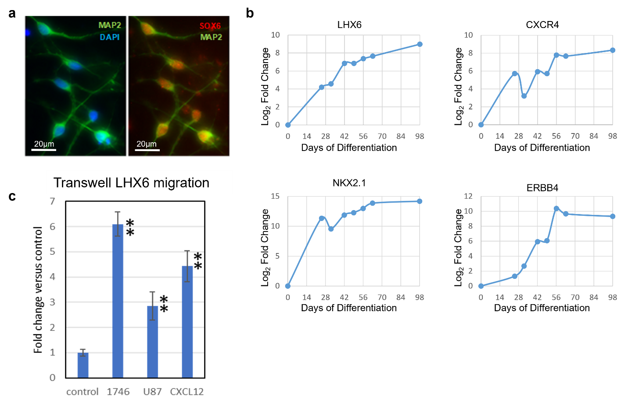
Extended Data Figure 1: (a) Immunofluorescent staining demonstrating MIP positivity for MAP2 (green) and SOX6 (red) at 4 weeks of differentiation. (b) Profiling of MIPs throughout their time course of differentiation using quantitative PCR for MIP lineage markers. (c) Transwell migration assay demonstrating potent LHX6 MIP chemoattraction to HGG-conditioned media.

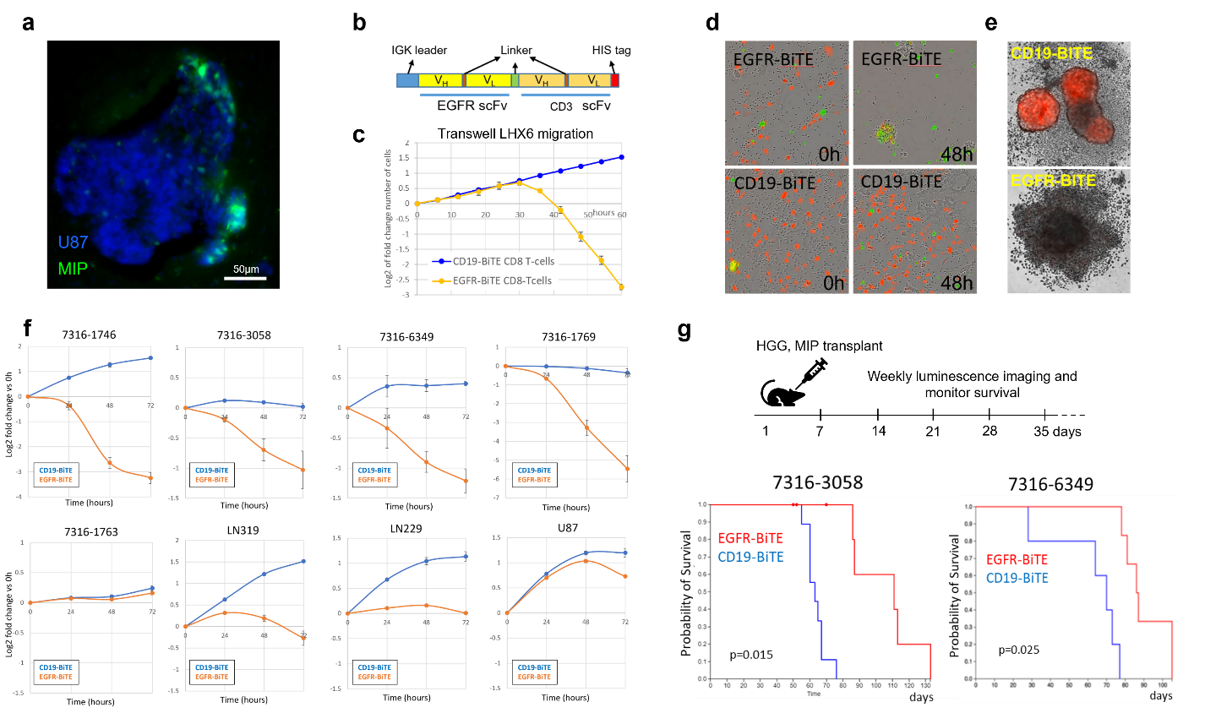
Extended Data Figure 2: (a) The glioblastoma line U87 (blue) chemoattracts NKX2.1 derived MIPs (green). (b) Schematic overview of the BiTE composition, with IGK leader sequence to stimulate secretion, anti-EGFR and anti-CD3 scFvs and linker sequences. (c-f). An EGFR BiTE potently eliminates glioblastoma line 7316-1746 in vitro: (c, d) 2D killing assay (0 and 48h) showing 1746 pHGG cells (red) mixed with targeting (EGFR) or control (CD19) BiTE expressing 293T cells and CD8 T-cells. A Cytotox agent stains dead cells green. (e) Images of 3058 pHGG sphere (red) mixed with BiTE expressing MIPs and CD8 T-cells (small cells surrounding sphere), show potent tumor killing with EGFR-BiTE at 48h. A CD19 control BiTE did not kill. (f) BiTE killing assay: Graphical representation of the survival of HGG cell lines mixed with targeting (EGFR) or control (CD19) BiTE expressing MIPs and CD8 T-cells. The log2 of the fold change compared to the number of cells present at hour 0 is plotted. Profound cell death was induced in 4/8 lines evaluated. All lines except 7316-1763 exhibit a statistically significant change (p<0.005, t-test). (g) Top: Schematic of demonstrating treatment plan, with initial co-injection of HGG (500k cells), MIPs (100K cells), and CD8 T-cells in a single location (1 million cells). Bottom: Survival curve of the 7316-3058 and 7316-6349 xenografts showing that the EGFR-BiTE treated mice have an extended survival (7316-3058: 9 mice per study arm, p=0.015; 7316-6349: 6 mice per study arm, p=0.025).

Extended Data Video 1: Human MIPs migrate to 7316-1746 RFP positive tumor spheres in a spheroid assay.
Extended Data Video 2: Control CD19-BiTE expressing 293Ts co-cultured CD8 T-cells fail to eliminate glioblastoma 7316-1746 (red).
Extended Data Video 3: Targeting EGFR-BiTE expressing 293Ts co-cultured CD8 T-cells potently eliminate glioblastoma 7316-1746 (red).

Extended Data Table 1: Expression analysis of genes involved in migration secreted by pediatric high-grade glioma
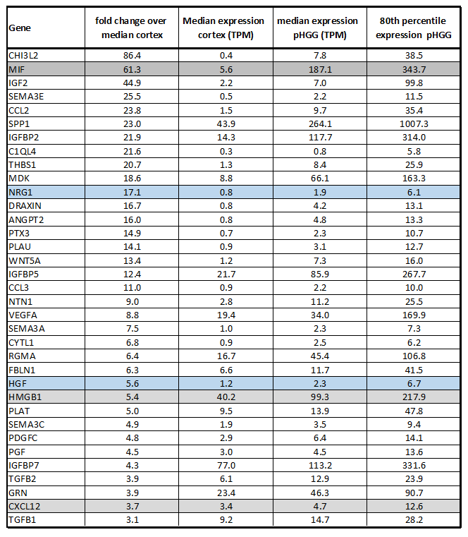

Grey: CXCR4 ligand
Blue: MIP chemoattractants, includes CXCL12

Extended Data Table 2: Fold change migration of NKX2.1 MIPs towards tumor conditioned media

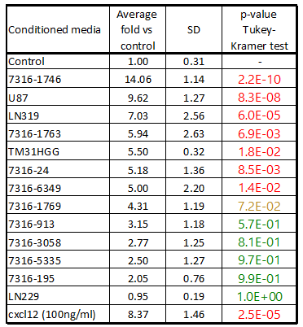

Extended Data Table 3: Primers utilized for qPCR experiments.
LHX6_f | AACCTGCTTCCTCTCCCTTC
LHX6_r | TGAGCTGTACTCACCACGTT
ERBB4_f | AGCTCTCTCTCTGACCTGGA
ERBB4_r | AGCCTGTGACTTCTCGAACA
CXCR4_f | TTCCTATGCAAGGCAGTCCA
CXCR4_r | GTAGCGGTCCAGACTGATGA
NKX2.1_f | CCGCGTTAGACCAAGGAAC
NKX2.1_r | TTGAGATTGGATGCGCTTGG
GAPDH_f | TTCGACAGTCAGCCGCATCTTCTT
GAPDH_r | CAGGCGCCCAATACGACCAAATC

