Supplementary Materials
Table 1 The results of echinococcosis subgroup analysis divided by study design
Risk factor | Number of studies included | study design | Type of Echinococcosis | Sample size | positive cases | Test of heterogeneity |  |  | OR | 95% CI | Test of overall effect
 |  |  |  |  |  | Q | P | I² (%) | OR | 95% CI | Z | P-value
Dog ownership | 4 | case-control | CE | 5793 | 456 | 3.52 | 0.319 | 14.7 | 1.37 | 1.33-1.83 | 2.19 | 0.029
Feeding viscera to dogs | 3 | case-control | CE | 840 | 343 | 1.46 | 0.481 | 0 | 2.76 | 2.00-3.83 | 6.12 | <0.001
Sex(Female/Male) | 13 | cross-sectional | CE | 130879 | 3102 | 18.48 | 0.102 | 35.10 | 1.37 | 1.23-1.53 | 5.75 | <0.001
Ethnicity(Tibetan/Han) | 3 | cross-sectional | CE | 27965 | 1329 | 7.23 | 0.027 | 72.30 | 3.71 | 1.60-8.59 | 3.06 | 0.002
Drinking nonboiled water | 3 | cross-sectional | CE | 14289 | 408 | 2.84 | 0.242 | 29.50 | 1.56 | 1.17-2.10 | 2.99 | 0.003
presence of stray dogs | 3 | cross-sectional | CE | 11374 | 398 | 3.74 | 0.154 | 46.50 | 1.56 | 1.02-2.38 | 2.06 | 0.039
Herder status | 6 | cross-sectional | CE | 154111 | 2900 | 33.3 | <0.001 | 85.00 | 2.30 | 1.74-3.04 | 5.8 | <0.001
Feeding viscera to dogs | 4 | cross-sectional | CE | 13684 | 497 | 3.94 | 0.268 | 23.80 | 2.15 | 1.65-2.81 | 5.61 | <0.001
Not washing hands before meals | 4 | cross-sectional | CE | 14570 | 470 | 15.63 | 0.001 | 80.80 | 2.37 | 1.40-4.00 | 3.22 | 0.001
CE: cystic echinococcosis.

Table 2 The results of echinococcosis subgroup analysis divided by region
Risk factor | Number of sub-studies included | Type of Echinococcosis | Region  (province) | Sample size | positive sample | Test of heterogeneity |  |  | OR | 95%CI | Test of overall effect
 |  |  |  |  |  | Q | P | I²(%) | OR | 95%CI | Z | P-value
Sex (Female/Male) | 3 | AE | Ningxia | 14008 | 257 | 1.69 | 0.429 | 0.00 | 1.44 | 1.11-1.86 | 2.73 | 0.006
Sex (Female/Male) | 3 | CE | Ningxia | 14008 | 236 | 1.02 | 0.600 | 0.00 | 1.34 | 1.03-1.751 | 2.18 | 0.029
Drinking nonboiled water | 3 | CE | Ningxia | 5463 | 305 | 22.78 | <0.001 | 91.20 | 3.28 | 0.96-11.19 | 1.9 | 0.058
Sex (Female/Male) | 4 | CE | Qinghai | 28565 | 1340 | 3.03 | 0.388 | 0.80 | 1.49 | 1.33-1.66 | 7.06 | <0.001
Sex (Female/Male) | 3 | CE | Xinjiang | 5092 | 90 | 9.97 | 0.007 | 79.90 | 1.02 | 0.43-2.42 | 0.05 | 0.964
Herder status | 4 | CE | Xinjiang | 51616 | 379 | 4.86 | 0.182 | 38.30 | 1.73 | 1.37-2.19 | 4.57 | <0.001
AE: alveolaris echinococcosis CE: cystic echinococcosis.

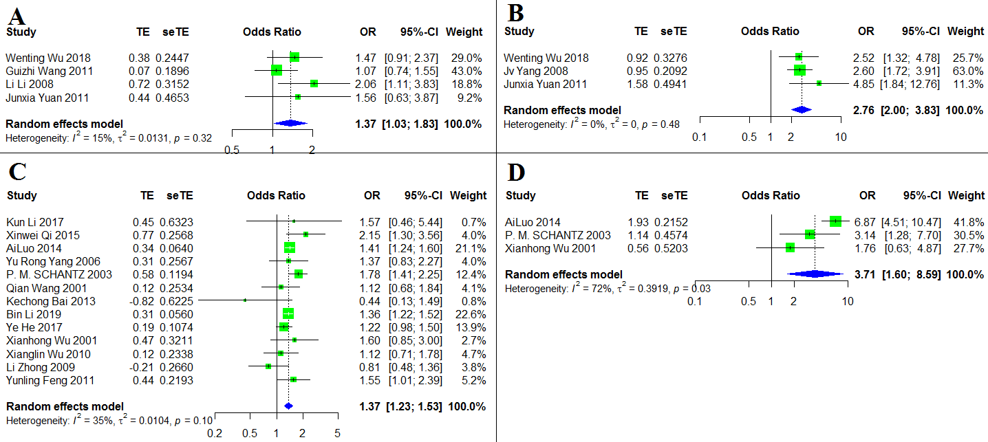

Figure 1 The forest chart of sub analysis for echinococcosis by study design.

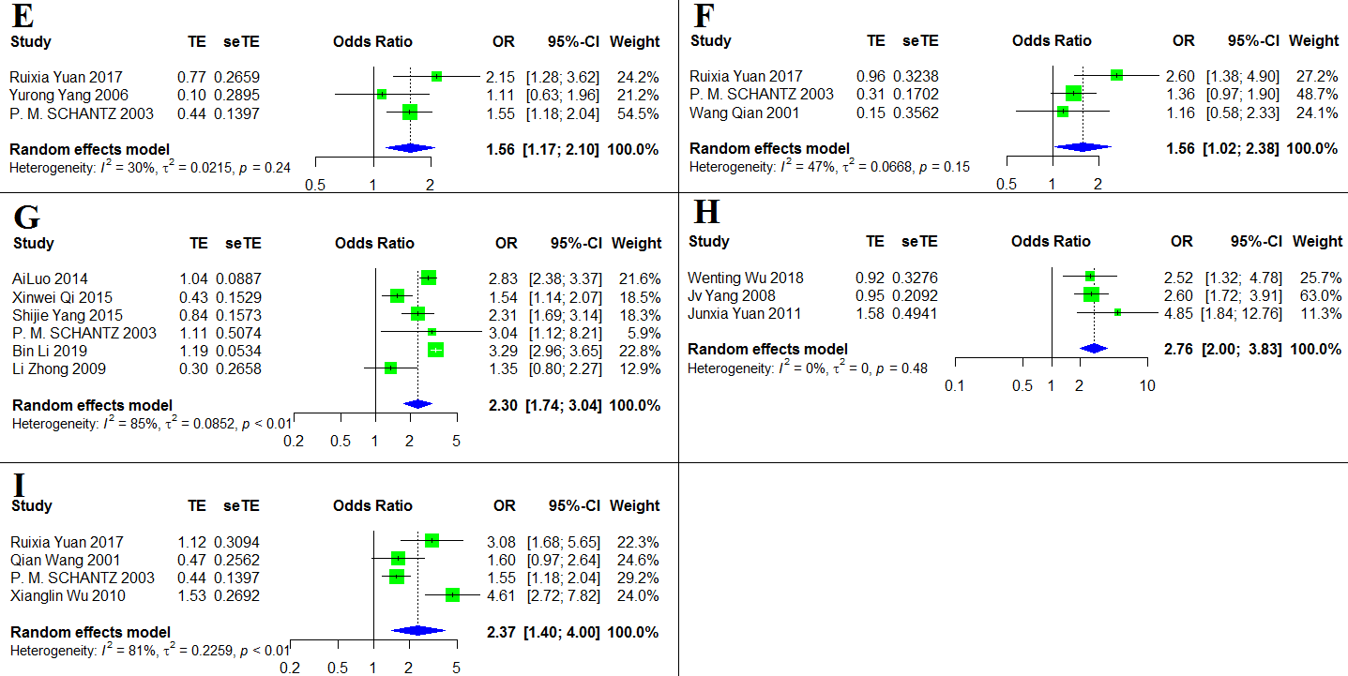

Figure 1 The forest chart of sub-analysis for echinococcosis by study design.(continue).
A: Dog ownership in case-control study; B: Feeding viscera to dogs in case-control study; C: Sex (Female/Male) in cross-sectional study; D: Ethnicity (Tibetan/Han) in cross-sectional study; E: Drinking nonboiled water in cross-sectional study; F: presence of stray dogs in cross-sectional study; G: Herder status in cross-sectional study; H: Feeding viscera to dogs in cross-sectional study; I: Not washing hands before meals in cross-sectional study.
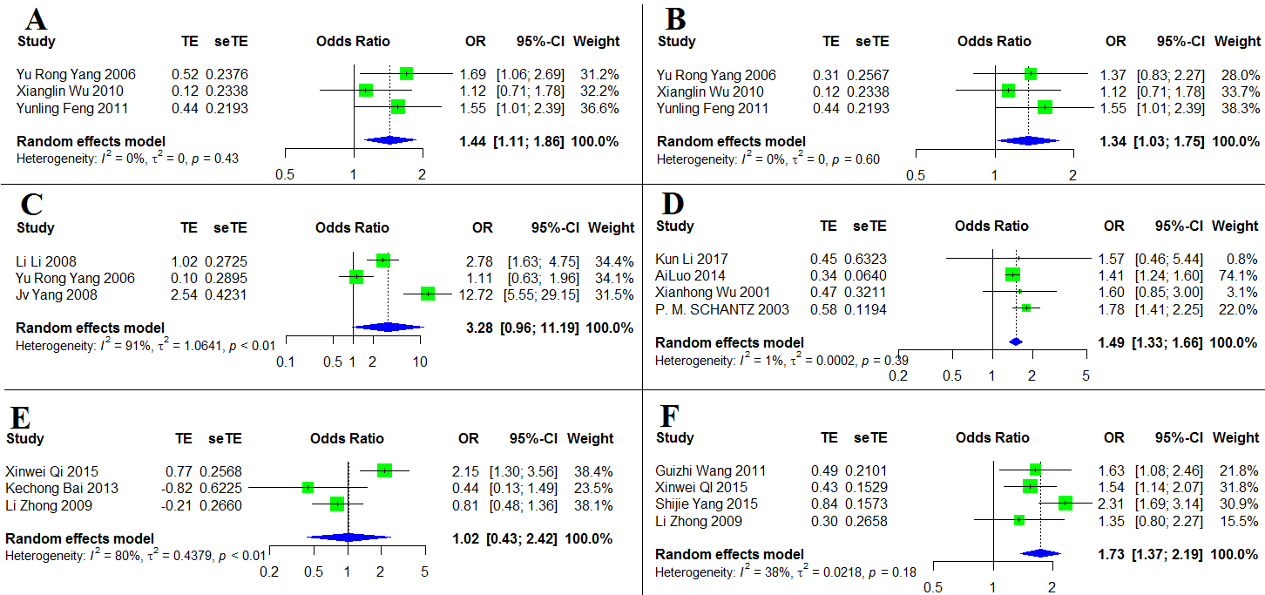

Figure 2 The forest chart of sub-analysis for echinococcosis by study region
A: Sex (Female/Male) for AE in Ningxia; B: Sex (Female/Male) for CE in Ningxia; C: Drinking nonboiled water for CE in Ningxia; D: Sex (Female/Male) for CE in Qinghai; E: Sex (Female/Male) for CE in Xinjiang; F: Herder status for CE in Xinjiang.

Table 3 The results of sensitivity analysis.
A. Sensitivity analysis for AE risk factor sex.
Omitting | OR | 95% CI | p-value | τ² | τ | I²
P.M.SCHANTZ 2003 | 1.34 | 1.20-1.50 | <0.001 | 0.000 | 0.008 | 0.2%
Patrick Giraudoux2013 | 1.50 | 1.25-1.80 | <0.001 | 0.020 | 0.142 | 37.1%
Qian Wang 2001 | 1.45 | 1.24-1.69 | <0.001 | 0.017 | 0.129 | 43.3%
Qian Wang 2006 | 1.41 | 1.27-1.60 | <0.001 | 0.007 | 0.085 | 24.9%
Xianglin Wu 2010 | 1.48 | 1.27-1.72 | <0.001 | 0.014 | 0.116 | 37.5%
Ye He 2017 | 1.51 | 1.30-1.76 | <0.001 | 0.010 | 0.102 | 25.7%
YuRong Yang 2006 | 1.43 | 1.30-1.67 | <0.001 | 0.015 | 0.122 | 39.9%
Yunling Feng 2011 | 1.44 | 1.23-1.69 | <0.001 | 0.017 | 0.129 | 42.3%
Pooled estimate | 1.45 | 1.26-1.66 | <0.001 | 0.012 | 0.112 | 33.9%
B. Sensitivity analysis for AE risk factor ethnicity.
Omitting | OR | 95% CI | p-value | τ² | τ | I²
P.M.SCHANTZ 2003 | 3.21 | 1.32-7.78 | 0.010 | 0.209 | 0.457 | 47.2%
Patrick Giraudoux2013 | 3.95 | 1.94-8.05 | <0.001 | 0.000 | 0.000 | 0.0%
Qian Wang 2006 | 2.55 | 1.50-4.32 | 0.001 | 0.000 | 0.000 | 0.0%
Pooled estimate | 2.93 | 1.81-4.75 | <0.001 | 0.000 | 0.000 | 0.0%
C. Sensitivity analysis for AE risk factor dog ownership.
Omitting | OR | 95% CI | p-value | τ² | τ | I²
P.S.Craig 2000 | 1.85 | 1.04-3.29 | 0.037 | 0.160 | 0.400 | 60.9%
Qian Wang 2001 | 1.55 | 0.88-2.74 | 0.133 | 0.186 | 0.431 | 75.5%
Qian Wang 2006 | 1.64 | 0.69-3.93 | 0.265 | 0.444 | 0.667 | 75.5%
Xianglin Wu 2010 | 1.31 | 1.01-1.70 | 0.043 | 0.014 | 0.119 | 17.5%
Pooled estimate | 1.52 | 0.96-2.39 | 0.075 | 0.128 | 0.358 | 63.2%

D. Sensitivity analysis for AE risk factor playing with dogs.
Omitting | OR | 95% CI | p-value | τ² | τ | I²
P.M.SCHANTZ 2003 | 3.25 | 1.73-6.12 | <0.001 | 0.011 | 0.103 | 4.9%
Qian Wang 2001 | 1.57 | 0.24-10.12 | 0.64 | 1.720 | 1.312 | 95.1%
Qian Wang 2006 | 1.07 | 0.32-3.55 | 0.92 | 0.637 | 0.798 | 82.5%
Pooled estimate | 1.72 | 0.45-6.52 | 0.42 | 1.247 | 1.117 | 91.8%
E. Sensitivity analysis for AE risk factor touch fox skin.
Omitting | OR | 95% CI | p-value | τ² | τ | I²
P.S.Craig 2000 | 1.30 | 0.50-3.35 | 0.591 | 0.366 | 0.605 | 77.9%
Qian Wang 2001 | 1.44 | 0.72-2.90 | 0.303 | 0.164 | 0.405 | 64.1%
Qian Wang 2006 | 0.93 | 0.63-1.38 | 0.728 | 0.000 | 0.000 | 0.0%
Pooled estimate | 1.19 | 0.70-2.02 | 0.523 | 0.129 | 0.359 | 58.5%
F. Sensitivity analysis for AE risk factor not washing hands before meals.
Omitting | OR | 95% CI | p-value | τ² | τ | I²
P.M.SCHANTZ 2003 | 2.97 | 1.72-5.12 | <0.001 | 0.148 | 0.384 | 63.8%
Qian Wang 2001 | 2.66 | 1.24-5.72 | 0.012 | 0.406 | 0.633 | 88.4%
Qian Wang 2006 | 2.22 | 1.07-4.62 | 0.033 | 0.358 | 0.598 | 86.4%
Xianglin Wu 2010 | 1.89 | 1.18-3.04 | 0.008 | 0.113 | 0.337 | 65.7%
Pooled estimate | 2.40 | 1.34-4.28 | 0.003 | 0.283 | 0.532 | 82.8%
G. Sensitivity analysis for AE risk factor herder status.
Omitting | OR | 95% CI | p-value | τ2 | τ | I2
P.M.SCHANTZ 2003 | 2.71 | 2.13-3.45 | <0.001 | 0.017 | 0.130 | 53.8%
Patrick Giraudoux 2013 | 3.14 | 2.38-4.15 | <0.001 | 0.000 | 0.000 | 0.0%
Wang qian 2006 | 2.45 | 2.05-2.93 | <0.001 | 0.000 | 0.000 | 0.0%
Pooled estimate | 2.66 | 2.25-3.14 | <0.001 | 0.003 | 0.050 | 8.0%

H. Sensitivity analysis for CE risk factor sex.
Omitting | OR | 95% CI | p-value | τ² | τ | I²
AiLuo 2014 | 1.29 | 1.09-1.53 | 0.003 | 0.051 | 0.226 | 82.3%
Kechong Bai 2013 | 1.32 | 1.13-1.55 | <0.001 | 0.050 | 0.223 | 86.3%
Bin Li 2019 | 1.29 | 1.09-1.54 | 0.004 | 0.057 | 0.240 | 82.2%
He Wei 2019 | 1.37 | 1.23-1.53 | <0.001 | 0.010 | 0.102 | 35.1%
Kun Li 2017 | 1.30 | 1.11-1.52 | 0.001 | 0.051 | 0.226 | 86.5%
Li Zhong 2009 | 1.34 | 1.14-1.58 | 0.001 | 0.051 | 0.226 | 86.4%
P.M.SCHANTZ 2003 | 1.26 | 1.07-1.47 | 0.004 | 0.042 | 0.204 | 82.9%
Xinwei Qi2 015 | 1.26 | 1.08-1.48 | 0.004 | 0.047 | 0.216 | 85.3%
Qian Wang 2001 | 1.31 | 1.11-1.55 | 0.001 | 0.052 | 0.228 | 86.6%
Xianglin Wu 2010 | 1.32 | 1.11-1.55 | 0.001 | 0.052 | 0.228 | 86.6%
Xianhong Wu 2001 | 1.29 | 1.10-1.52 | 0.002 | 0.050 | 0.225 | 86.3%
Ye He 2017 | 1.31 | 1.10-1.56 | 0.002 | 0.055 | 0.235 | 86.3%
YuRong Yang 2006 | 1.30 | 1.10-1.53 | 0.002 | 0.051 | 0.226 | 86.4%
Yunling Feng 2011 | 1.29 | 1.09-1.51 | 0.003 | 0.050 | 0.224 | 86.1%
Pooled estimate | 1.30 | 1.11-1.53 | 0.001 | 0.050 | 0.224 | 85.5%
I. Sensitivity analysis for CE risk factor ethnicity..
Omitting | OR | 95% CI | p-value | τ² | τ | I²
AiLuo 2014 | 2.26 | 1.50-3.41 | <0.001 | 0.000 | 0.000 | 0.0%
P.M.SCHANT Z2003 | 3.15 | 1.25-7.90 | 0.015 | 0.547 | 0.740 | 85.9%
Guizhi Wang 2011 | 3.71 | 1.60-8.59 | 0.002 | 0.392 | 0.626 | 72.3%
Xianhong Wu 2001 | 3.68 | 1.63-8.32 | 0.002 | 0.420 | 0.648 | 83.2%
Pooled estimate | 3.18 | 1.55-6.52 | 0.002 | 0.403 | 0.635 | 79.2%

J. Sensitivity analysis for CE risk factor dog ownership.
Omitting | OR | 95% CI | p-value | τ² | τ | I²
Junxia Yuan 2011 | 1.56 | 1.05-2.31 | 0.028 | 0.115 | 0.340 | 59.4%
Li Li 2008 | 1.46 | 0.99-2.15 | 0.055 | 0.096 | 0.309 | 51.8%
Qian Wang 2001 | 1.66 | 1.12-2.47 | 0.012 | 0.108 | 0.329 | 55.9%
Guizhi Wang 2011 | 1.73 | 1.19-2.52 | 0.004 | 0.063 | 0.252 | 35.5%
Wenting Wu 2018 | 1.59 | 1.02-2.50 | 0.042 | 0.150 | 0.387 | 59.5%
Xianglin Wu 2010 | 1.31 | 1.03-1.66 | 0.027 | 0.000 | 0.000 | 0.0%
Pooled estimate | 1.54 | 1.09-2.17 | 0.014 | 0.087 | 0.295 | 49.4%
K. Sensitivity analysis for CE risk factor not washing hands before meals
Omitting | OR | 95% CI | p-value | τ² | τ | I²
Xianglin Wu 2010 | 1.63 | 1.23-2.15 | 0.001 | 0.041 | 0.202 | 53.4%
Ruixia Yuan 2017 | 1.89 | 1.21-2.95 | 0.005 | 0.166 | 0.407 | 82.9%
P.M.SCHANTZ 2003 | 2.27 | 1.24-4.15 | 0.008 | 0.317 | 0.563 | 85.5%
Wenting Wu 2018 | 2.37 | 1.40-4.00 | 0.001 | 0.226 | 0.475 | 80.8%
Qian Wang 2001 | 2.20 | 1.32-3.66 | 0.003 | 0.223 | 0.472 | 86.0%
Pooled estimate | 2.05 | 1.35-3.10 | 0.001 | 0.173 | 0.416 | 81.3%
L. Sensitivity analysis for CE risk factor herder status.
Omitting | OR | 95% CI | p-value | τ² | τ | I²
Guizhi Wang 2011 | 2.30 | 1.74-3.04 | <0.001 | 0.085 | 0.292 | 85.0%
AiLuo 2014 | 2.05 | 1.41-2.98 | <0.001 | 0.171 | 0.413 | 87.6%
Xinwei Qi 2015 | 2.38 | 1.86-3.05 | <0.001 | 0.060 | 0.246 | 78.7%
Shijie Yang 2015 | 2.16 | 1.58-2.94 | <0.001 | 0.109 | 0.330 | 87.0%
P.M.SCHANTZ 2003 | 2.15 | 1.62-2.84 | <0.001 | 0.098 | 0.314 | 87.6%
Bin Li2 019 | 1.99 | 1.49-2.65 | <0.001 | 0.084 | 0.290 | 74.1%
Li Zhong 2009 | 2.34 | 1.79-3.05 | <0.001 | 0.080 | 0.283 | 84.6%
Pooled estimate | 2.19 | 1.67-2.86 | <0.001 | 0.094 | 0.307 | 85.1%

M. Sensitivity analysis for CE risk factor feeding viscera to dog.
Omitting | OR | 95% CI | p-value | τ² | τ | I²
DanLi2015 | 2.45 | 1.91-3.16 | <0.001 | 0.031 | 0.176 | 32.8%
JunxiaYuan2011 | 2.19 | 1.83-2.64 | <0.001 | 0.002 | 0.038 | 2.5%
JvYang2008 | 2.34 | 1.80-3.05 | <0.001 | 0.031 | 0.175 | 28.9%
P.M.SCHANTZ2003 | 2.68 | 2.11-3.39 | <0.001 | 0.000 | 0.000 | 0.0%
RuixiaYuan2017 | 2.24 | 1.79-2.80 | <0.001 | 0.014 | 0.119 | 17.5%
WentingWu2018 | 2.38 | 1.85-3.05 | <0.001 | 0.031 | 0.177 | 33.4%
XianglinWu2010 | 2.35 | 1.85-2.99 | <0.001 | 0.028 | 0.166 | 31.5%
Pooledestimate | 2.35 | 1.89-2.91 | <0.001 | 0.018 | 0.134 | 21.5%
N. Sensitivity analysis for CE risk factor drink nonboiled water.
Omitting | OR | 95% CI | p-value | τ² | τ | I²
Jv Yang 2008 | 1.77 | 1.26-2.49 | 0.001 | 0.065 | 0.255 | 54.8%
Li Li 2008 | 2.43 | 1.16-5.09 | 0.018 | 0.486 | 0.697 | 88.3%
P.M.SCHANTZ 2003 | 2.89 | 1.27-6.62 | 0.012 | 0.612 | 0.782 | 87.0%
Ruixia Yuan 2017 | 2.61 | 1.21-5.65 | 0.015 | 0.537 | 0.733 | 89.2%
YuRong Yang 2006 | 3.04 | 1.51-6.11 | 0.002 | 0.431 | 0.656 | 87.4%
Pooled estimate | 2.47 | 1.36-4.47 | 0.003 | 0.377 | 0.614 | 85.7%
O. Sensitivity analysis for CE risk factor presence of stray dogs
Omitting | OR | 95% CI | p-value | τ² | τ | I²
P.M.SCHANTZ 2003 | 2.04 | 1.17-3.56 | 0.012 | 0.115 | 0.338 | 47.3%
Ruixia Yuan 2017 | 1.54 | 1.00-2.38 | 0.052 | 0.065 | 0.256 | 42.2%
Qian Wang 2001 | 1.99 | 1.18-3.36 | 0.010 | 0.130 | 0.360 | 61.1%
Wenting Wu 2018 | 1.56 | 1.02-2.38 | 0.039 | 0.067 | 0.259 | 46.5%
Pooled estimate | 1.75 | 1.15-2.65 | 0.008 | 0.090 | 0.300 | 50.9%

P. Sensitivity analysis for CE risk factor number of household dogs.
Omitting | OR | 95% CI | p-value | τ² | τ | I²
Xiangman Zeng 2020 | 1.47 | 1.09-1.98 | 0.011 | 0.034 | 0.183 | 72.1%
Wei He 2019 | 1.84 | 0.78-4.35 | 0.165 | 0.322 | 0.567 | 81.8%
Wenting Wu 2018 | 2.08 | 1.21-3.53 | 0.008 | 0.099 | 0.314 | 58.2%
Pooled estimate | 1.66 | 1.17-2.35 | 0.004 | 0.062 | 0.249 | 73.2%
Q. Sensitivity analysis for CE risk factor nomadism.
Omitting | OR | 95% CI | p-value | τ² | τ | I²
Dan Li 2015 | 3.11 | 1.40-6.91 | 0.005 | 0.246 | 0.496 | 73.6%
Wei He 2019 | 2.12 | 1.45-3.11 | <0.001 | 0.000 | 0.000 | 0.0%
Qian Wang 2001 | 3.16 | 1.43-6.96 | 0.004 | 0.230 | 0.479 | 70.3%
Pooled estimate | 2.71 | 1.65-4.47 | <0.001 | 0.109 | 0.330 | 55.8%
R. Sensitivity analysis for CE risk factor eating raw vegetables.
Omitting | OR | 95% CI | p-value | τ² | τ | I²
Ruixia Yuan 2017 | 1.86 | 1.42-2.42 | <0.001 | 0.000 | 0.000 | 0.0%
Li Li 2008 | 2.05 | 1.32-3.19 | 0.001 | 0.000 | 0.000 | 0.0%
Jv Yang 2008 | 1.81 | 1.42-2.30 | <0.001 | 0.000 | 0.000 | 0.0%
Pooled estimate | 1.86 | 1.47-2.35 | <0.001 | 0.000 | 0.000 | 0.0%

Table 4 The result of sensitivity analysis for sub-analysis divided by study design
A. Sensitivity analysis for CE risk factor dog ownership by case-control study.
Omitting | OR | 95% CI | p-value | τ² | τ | I²
Wenting Wu 2018 | 1.40 | 0.90-2.18 | 0.130 | 0.063 | 0.251 | 40.2%
Guizhi Wang 2011 | 1.65 | 1.16-2.34 | 0.005 | 0.000 | 0.000 | 0.0%
Li Li 2008 | 1.24 | 0.93-1.63 | 0.139 | 0.000 | 0.000 | 0.0%
Junxia Yuan 2011 | 1.39 | 0.97-1.99 | 0.073 | 0.042 | 0.206 | 41.4%
Pooled estimate | 1.37 | 1.03-1.83 | 0.029 | 0.013 | 0.115 | 14.7%
B. Sensitivity analysis for CE risk factor feeding viscera to dogs by
case-control study.
Omitting | OR | 95% CI | p-value | τ² | τ | I²
Wenting Wu 2018 | 3.02 | 1.79-5.10 | <0.001 | 0.050 | 0.224 | 25.9%
Jv Yang 2008 | 3.15 | 1.71-5.79 | <0.001 | 0.039 | 0.198 | 18.3%
Junxia Yuan 2011 | 2.57 | 1.82-3.64 | <0.001 | 0.000 | 0.000 | 0.0%
Pooled estimate | 2.76 | 2.00-3.83 | <0.001 | 0.000 | 0.000 | 0.0%
C. Sensitivity analysis for CE risk factor sex by cross-sectional
study.
Omitting | OR | 95% CI | p-value | τ² | τ | I²
Kun Li 2017 | 1.37 | 1.23-1.54 | <0.001 | 0.012 | 0.110 | 40.3%
Xinwei Qi 2015 | 1.35 | 1.22-1.50 | <0.001 | 0.007 | 0.086 | 28.8%
AiLuo 2014 | 1.36 | 1.18-1.56 | <0.001 | 0.019 | 0.137 | 40.0%
YuRong Yang 2006 | 1.37 | 1.22-1.54 | <0.001 | 0.012 | 0.111 | 40.5%
P.M.SCHANTZ 2003 | 1.33 | 1.21-1.47 | <0.001 | 0.005 | 0.069 | 18.9%
Qian Wang 2001 | 1.39 | 1.24-1.55 | <0.001 | 0.011 | 0.106 | 38.2%
Kechong Bai 2013 | 1.39 | 1.26-1.53 | <0.001 | 0.007 | 0.081 | 27.1%
Bin L i2019 | 1.37 | 1.19-1.58 | <0.001 | 0.020 | 0.141 | 40.1%
Ye He 2017 | 1.40 | 1.24-1.58 | <0.001 | 0.011 | 0.106 | 34.9%
Xianhong Wu 2001 | 1.372 | 1.22-1.53 | <0.001 | 0.012 | 0.109 | 39.8%
Xianglin Wu 2010 | 1.39 | 1.24-1.55 | <0.001 | 0.011 | 0.106 | 37.8%
Li Zhong 2009 | 1.40 | 1.27-1.54 | <0.001 | 0.006 | 0.074 | 23.3%
Yunling Feng 2011 | 1.36 | 1.21-1.53 | <0.001 | 0.012 | 0.110 | 39.5%
Pooled estimate | 1.37 | 1.23-1.53 | <0.001 | 0.010 | 0.102 | 35.1%
D. Sensitivity analysis for CE risk factor ethnicity by cross-sectional
study.
Omitting | OR | 95% CI | p-value | τ² | τ | I²
AiLuo 2014 | 2.44 | 1.24-4.78 | 0.010 | 0.000 | 0.000 | 0.0%
P.M.SCHANTZ 2003 | 3.77 | 1.00-14.21 | 0.050 | 0.770 | 0.878 | 82.9%
Xianhong Wu 2001 | 5.15 | 2.46-10.80 | <0.001 | 0.179 | 0.423 | 58.3%
Pooled estimate | 3.7110 | 1.60-8.59 | 0.002 | 0.392 | 0.626 | 72.3%
E. Sensitivity analysis for CE risk factor drinking nonboiled water by
cross-sectional study.
Omitting | OR | 95% CI | p-value | τ² | τ | I²
RuixiaYuan2017 | 1.44 | 1.10-1.89 | 0.007 | 0.005 | 0.067 | 8.0%
YuRongYang2006 | 1.69 | 1.28-2.23 | <0.001 | 0.008 | 0.090 | 15.1%
P.M.SCHANTZ2003 | 1.56 | 0.82-2.98 | 0.178 | 0.141 | 0.376 | 64.6%
Pooled estimate | 1.56 | 1.17-2.10 | 0.003 | 0.022 | 0.147 | 29.5%
F. Sensitivity analysis for CE risk factor presence of stray dogs by
cross-sectional study.
Omitting | OR | 95% CI | p-value | τ² | τ | I²
RuixiaYuan2017 | 1.32 | 0.98-1.78 | 0.071 | 0.000 | 0.000 | 0.0%
P.M.SCHANTZ2003 | 1.76 | 0.80-3.88 | 0.162 | 0.211 | 0.459 | 64.5%
QianWang2001 | 1.77 | 0.95-3.31 | 0.072 | 0.143 | 0.378 | 68.1%
Pooled estimate | 1.56 | 1.02-2.38 | 0.039 | 0.067 | 0.259 | 46.5%

G. Sensitivity analysis for CE risk factor herder status by
cross-sectional study.
Omitting | OR | 95% CI | p-value | τ² | τ | I²
AiLuo 2014 | 2.15 | 1.42-3.24 | <0.001 | 0.171 | 0.413 | 88.0%
Bin Li 2019 | 2.07 | 1.50-2.85 | <0.001 | 0.090 | 0.300 | 76.1%
Li Zhong 2009 | 2.50 | 1.90-3.27 | <0.001 | 0.067 | 0.260 | 84.0%
P.M.SCHANTZ 2003 | 2.26 | 1.68-3.02 | <0.001 | 0.090 | 0.300 | 88.0%
Shijie Yang 2015 | 2.29 | 1.65-3.17 | <0.001 | 0.098 | 0.314 | 87.2%
Xinwei Qi 2015 | 2.60 | 2.06-3.28 | <0.001 | 0.041 | 0.203 | 73.7%
Pooled estimate | 2.30 | 1.74-3.04 | <0.001 | 0.085 | 0.292 | 85.0%
H. Sensitivity analysis for CE risk factor feeding viscera to dogs by
cross-sectional study.
Omitting | OR | 95% CI | p-value | τ² | τ | I²
Ruixia Yuan 2017 | 1.90 | 1.51-2.39 | <0.001 | 0.000 | 0.000 | 0.0%
Dan Li 2015 | 2.29 | 1.57-3.35 | <0.001 | 0.056 | 0.237 | 48.9%
P.M.SCHANTZ 2003 | 2.58 | 1.83-3.64 | <0.001 | 0.000 | 0.000 | 0.0%
Xianglin Wu 2010 | 2.11 | 1.54-2.89 | <0.001 | 0.032 | 0.178 | 38.6%
Pooled estimate | 2.15 | 1.65-2.81 | <0.001 | 0.019 | 0.138 | 23.8%
I.Sensitivity analysis for CE risk factor not washing hands before
meals by cross-sectional study.
Omitting | OR | 95% CI | p-value | τ² | τ | I²
P.M.SCHANTZ 2003 | 2.82 | 1.49-5.34 | 0.002 | 0.242 | 0.492 | 75.9%
Qian Wang 2001 | 2.72 | 1.32-5.61 | 0.007 | 0.347 | 0.589 | 86.4%
Ruixia Yuan 2017 | 2.20 | 1.16-4.18 | 0.016 | 0.269 | 0.519 | 85.1%
Xianglin Wu 2010 | 1.84 | 1.27-2.67 | 0.001 | 0.057 | 0.238 | 52.0%
Pooled estimate | 2.37 | 1.40-4.00 | 0.001 | 0.226 | 0.475 | 80.8%

Table 5 The result of sensitivity analysis for sub-analysis divided by region
A. Sensitivity analysis for AE risk factor sex in Ningxia.
Omitting | OR | 95% CI | p-value | τ² | τ | I²
YuRong Yang 2006 | 1.33 | 0.97-1.83 | 0.073 | 0.001 | 0.026 | 1.3%
Xianglin Wu 2010 | 1.61 | 1.18-2.21 | 0.003 | 0.000 | 0.000 | 0.0%
Yunling Feng 2011 | 1.38 | 0.92-2.05 | 0.118 | 0.028 | 0.166 | 33.2%
Pooled estimate | 1.44 | 1.11-1.86 | 0.006 | 0.000 | 0.000 | 0.0%
B. Sensitivity analysis for CE risk factor sex in Ningxia.
Omitting | OR | 95% CI | p-value | τ² | τ | I²
YuRong Yang2006 | 1.33 | 0.97-1.83 | 0.073 | 0.001 | 0.026 | 1.3%
Xianglin Wu2010 | 1.47 | 1.06-2.04 | 0.020 | 0.000 | 0.000 | 0.0%
Yunling Feng2011 | 1.23 | 0.888-1.76 | 0.232 | 0.000 | 0.000 | 0.0%
Pooled estimate | 1.34 | 1.03-1.75 | 0.029 | 0.000 | 0.000 | 0.0%
C. Sensitivity analysis for CE risk factor drink nonboiled water in Ningxia.
Omitting | OR | 95% CI | p-value | τ² | τ | I²
Li Li 2008 | 3.68 | 0.34-40.20 | 0.28 | 2.842 | 1.686 | 95.6%
YuRong Yang 2006 | 5.75 | 1.30-25.45 | 0.02 | 1.029 | 1.014 | 89.0%
JvYang 2008 | 1.77 | 0.72-4.35 | 0.22 | 0.343 | 0.586 | 81.3%
Pooled estimate | 3.28 | 0.96-11.19 | 0.06 | 1.064 | 1.032 | 91.2%
D. Sensitivity analysis for CE risk factor sex in Qinghai.
Omitting | OR | 95% CI | p-value | τ² | τ | I²
Kun Li 2017 | 1.53 | 1.30-1.82 | <0.001 | 0.008 | 0.090 | 33.7%
AiLuo 2014 | 1.75 | 1.41-2.17 | <0.001 | 0.000 | 0.000 | 0.0%
Xianhong Wu 2001 | 1.53 | 1.28-1.82 | <0.001 | 0.009 | 0.093 | 32.8%
P.M.SCHANTZ 2003 | 1.42 | 1.25-1.60 | <0.001 | 0.000 | 0.000 | 0.0%
Pooled estimate | 1.49 | 1.33-1.66 | <0.001 | 0.000 | 0.014 | 0.8%

E. Sensitivity analysis for CE risk factor sex in Xinjiang.
Omitting | OR | 95% CI | p-value | τ² | τ | I²
Xinwei Qi 2015 | 0.73 | 0.46-1.19 | 0.208 | 0.000 | 0.000 | 0.0%
Kechong Bai 2013 | 1.32 | 0.51-3.45 | 0.571 | 0.412 | 0.642 | 85.8%
Li Zhong 2009 | 1.08 | 0.23-5.03 | 0.926 | 1.032 | 1.016 | 82.0%
Pooled estimate | 1.02 | 0.43-2.42 | 0.964 | 0.438 | 0.662 | 79.9%
F. Sensitivity analysis for CE risk factor herder status in Xinjiang.
Omitting | OR | 95% CI | p-value | τ² | τ | I²
Guizhi Wang 2011 | 1.74 | 1.26-2.40 | 0.001 | 0.045 | 0.213 | 57.6%
Xinwei QI 2015 | 1.81 | 1.32-2.48 | ＜0.001 | 0.036 | 0.190 | 45.7%
Shijie Yang 2015 | 1.53 | 1.23-1.90 | ＜0.001 | 0.000 | 0.000 | 0.0%
Li Zhong 2009 | 1.81 | 1.39-2.36 | <0.001 | 0.026 | 0.160 | 46.8%
Pooled estimate | 1.73 | 1.37-2.19 | <0.001 | 0.022 | 0.148 | 38.3%

Table 6 Results of publication bias.
A. Results of Egger`s test
Risk factor | Type of echinococcosis | Egger`s test
Risk factor | Type of echinococcosis | t | P
Sex(Female/Male) | AE | 1.07 | 0.324
Ethnicity(Tibetan/Han) | AE | 6.26 | 0.101
Dog ownership | AE | 0.326 | 0.775
Playing with dogs | AE | 2.50 | 0.242
Touch fox skin | AE | 0.69 | 0.614
Not washing hands before meals | AE | 1.46 | 0.283
Herder status | AE | 0.40 | 0.757
Sex(Female/Male) | CE | 2.44 | 0.031
Ethnicity(Tibetan/Han) | CE | -1.07 | 0.396
Dog ownership | CE | 1.59 | 0.186
Not washing hands before meals | CE | 2.24 | 0.111
Herder status | CE | -2.72 | 0.042
Feeding viscera to dogs | CE | 2.87 | 0.035
Drinking nonboiled water | CE | 1.55 | 0.220
presence of stray dogs | CE | 1.08 | 0.392
Number of household dog (with each addition) | CE | 0.94 | 0.521
Nomadism | CE | 1.78 | 0.326
Eating raw vegetables | CE | 2.37 | 0.254

B. Results of Egger`s test for sub-analysis divided by study design
Risk factor | study design | Type of Echinococcosis | Egger`s test
Risk factor | study design | Type of Echinococcosis | t | P
Dog ownership | case-control | CE | 1.44 | 0.287
Feeding viscera to dogs | case-control | CE | 1.35 | 0.406
Sex(Female/Male) | cross-sectional | CE | -0.59 | 0.568
Ethnicity(Tibetan/Han) | cross-sectional | CE | -5.46 | 0.115
Drinking nonboiled water | cross-sectional | CE | -0.05 | 0.970
presence of stray dogs | cross-sectional | CE | 0.43 | 0.744
Herder status | cross-sectional | CE | -2.12 | 0.101
Feeding viscera to dogs | cross-sectional | CE | 1.53 | 0.265
Not washing hands before meals | cross-sectional | CE | 1.51 | 0.270

C. Results of Egger`s test for sub-analysis divided by study region.
Risk factor | Region (province) | Type of Echinococcosis | Egger`s test
Risk factor | Region (province) | Type of Echinococcosis | t | P
Sex(Female/Male) | Ningxia | AE | -0.16 | 0.898
Sex(Female/Male) | Ningxia | CE | -0.35 | 0.787
Drinking nonboiled water | Ningxia | CE | 1.33 | 0.411
Sex(Female/Male) | Qinghai | CE | 0.71 | 0.549
Sex(Female/Male) | Xinjiang | CE | -0.71 | 0.606
Herder status | Xinjiang | CE | -0.82 | 0.500

Table 7 Abbreviation table
Full name | Abbreviation
Chinese National Knowledge Infrastructure | CNKI
Chongqing VIP Information | VIP
Odds ratio | OR
Confidence interval | CI
Cystic echinococcosis | CE
Alveolar echinococcosis | AE
Echinococcus granulosus | E. granulosus
Echinococcus multilocularis | E. multilocularis
Disability-adjusted life years | DALYs
Newcastle-Ottawa Scale | NOS
Agency for Healthcare Research and Quality | AHRQ

