Supplemental material:

S1: Directed acyclic graphs
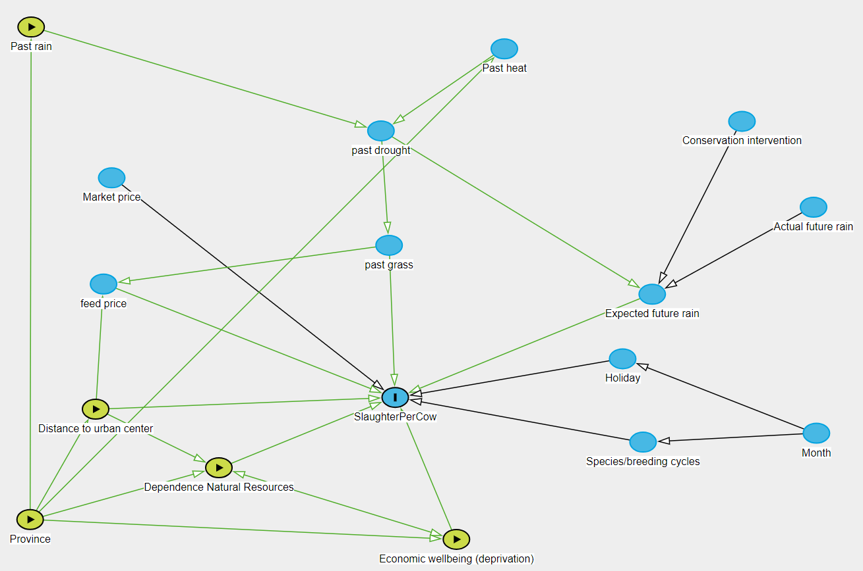
Figure S1A: Directed acyclic graph showing the assumed causal paths estimated in equation 1. Green nodes show predictors included in the statistical model as both estimands and controls. The outcome variable is the slaughtering rate in each province, in each month from January 2015 to December 2022 (“SlaughterPerCow”).

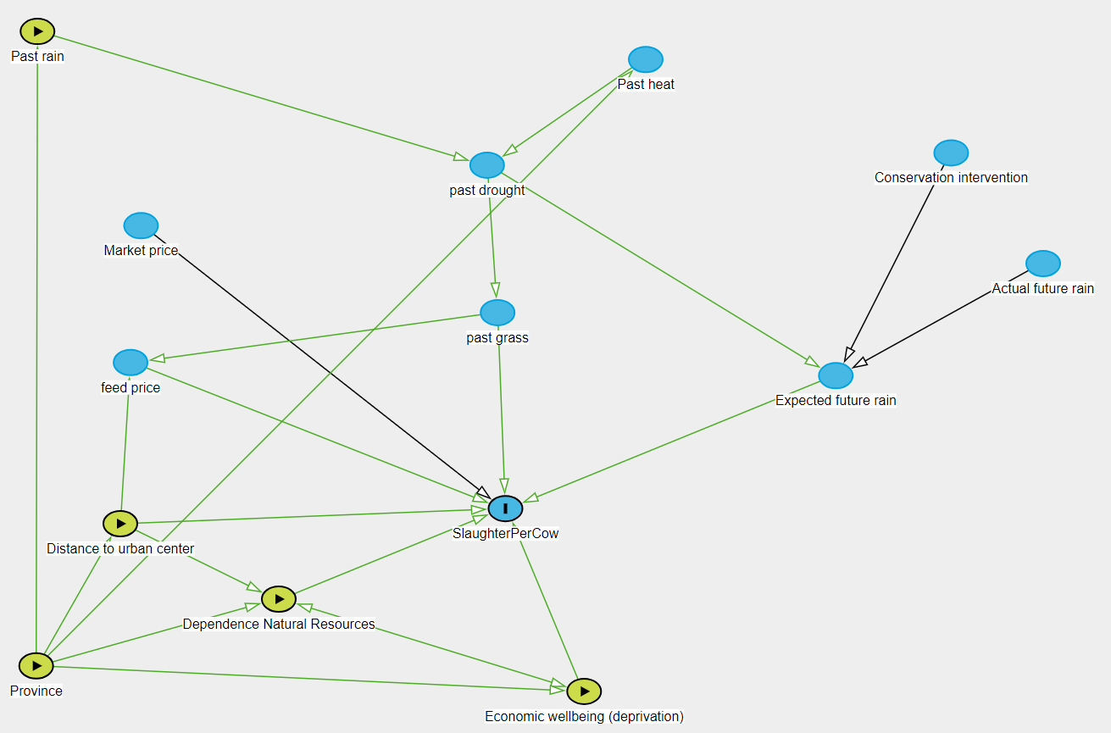
Figure S1B: Directed acyclic graph showing the assumed causal paths estimated in equations 2 and 3. Green nodes show predictors included in the statistical model as both estimands and controls. The outcome variable is the slaughtering rate in each 16-km pixel, in the year 2020 (“SlaughterPerCow”).

S2: Data sources

Table S2. Descriptions and sources of the variables and jurisdictional boundaries used in timeseries and disaggregation modelling to examine the causal links between community wellbeing and the adaptive use of cattle sales in response to changes in precipitation.
Variable | Description | Source
Past precipitation | Global average monthly precipitation from rain gauge and satellite observations from 2014, 2015, and 2019. | CHIRPS, 2024 (Climate Hazard Center) (https://www.chc.ucsb.edu/data/chirps)
Level of deprivation | Global index value that characterizes the levels of multidimensional deprivation, including infant mortality, human development, infrastructure, child dependency, nighttime lights | Deprivation Index 2010 (SEDAC) (https://doi.org/10.7927/3xxe-ap97)
Distance to city | Distance between every cell in the raster to the nearest city or town | Humanitarian Open Street Map (https://export.hotosm.org/v3/)
Nature Dependency | Proportion of human population dependent on locally available natural resources for their basic needs, including housing materials, water, energy, and occupation | Fedele et al., (2021) (https://doi.org/10.1016/j.gloenvcha.2021.102368)
Cattle population | Peer-reviewed spatial dataset on the global distribution and abundance of livestock species | Food and Agriculture Organization of the United Nations, 2024 (https://data.apps.fao.org/catalog/organization/gridded-livestock-of-the-world-glw)
South Africa provinces | Polygon shapefiles for administrative units at level 1 (e.g. Provinces, States) | Global Administrative Areas, v4.1 (https://gadm.org/)

S3: Model posterior checks

Timeseries model
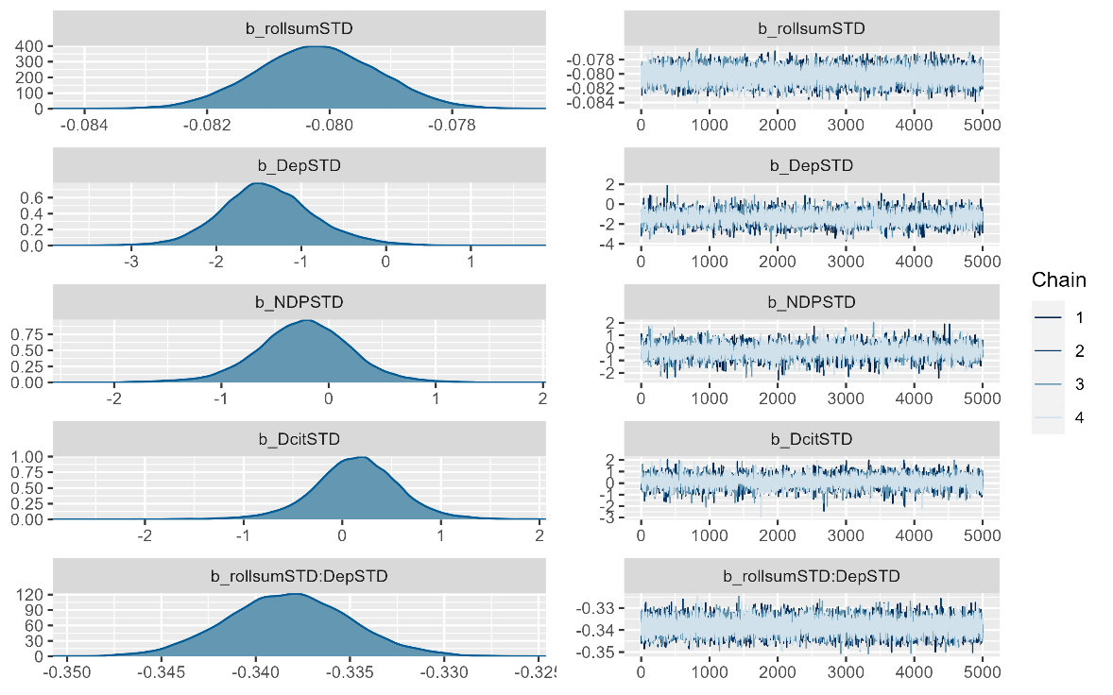
Figure S3A: Model convergence diagnostics for the timeseries model. The left panel shows the posterior distributions for each model parameter, including standardized cumulative precipitation from the previous 12 months (b_rollsumSTD), deprivation (b_DepSTD), proportion of the population dependent on nature (b_NDPSTD), distance to urban center (b_DcitSTD), and the interaction between precipitation and deprivation (b_rollsumSTD: b_DcitSTD). The right panel shows the trace plots for each parameter across four Markov Chain Monte Carlo (MCMC) chains.
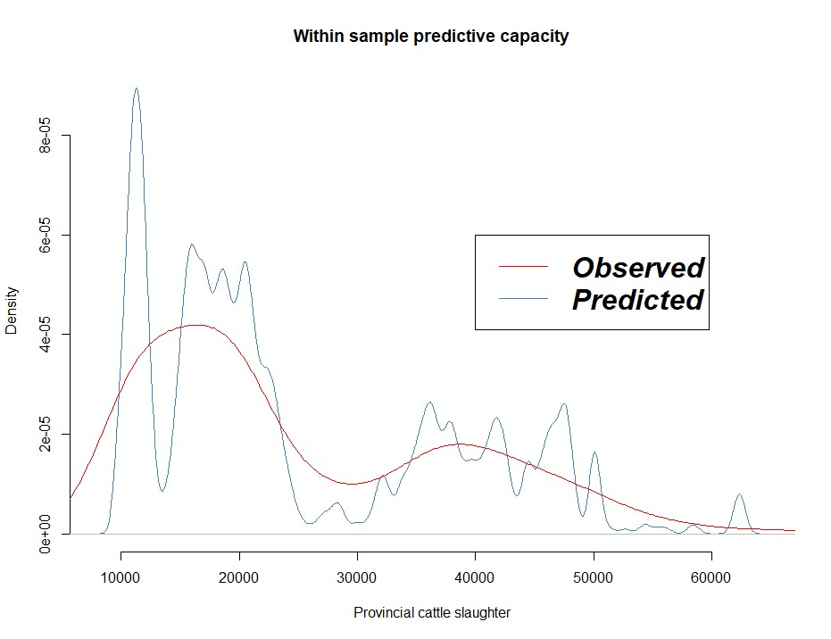
Figure S3B: Posterior predictive check for the timeseries model. Comparison between the observed provincial cattle slaughter data (red line) and the predicted values (blue line) generated by the model using estimated coefficient values for within-sample prediction across the data.

Disaggregation model
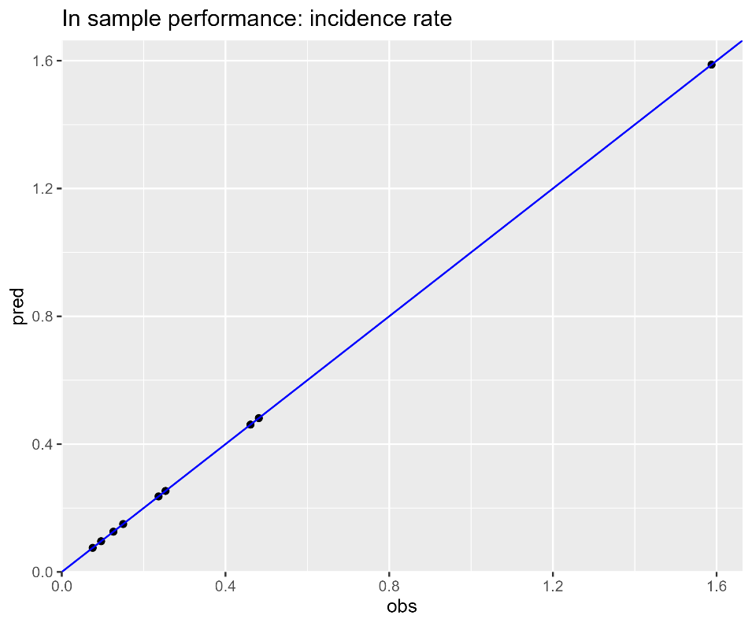
Figure S3C. Comparison of observed versus predicted incidence rates from the Bayesian spatial disaggregation regression model to assess its within-sample predictive capacity. The blue line represents the line of perfect agreement, where predicted values exactly match observed values. The dots represent the actual predicted values plotted against the observed incidence rates.

S4: Coefficient plots

Timeseries model

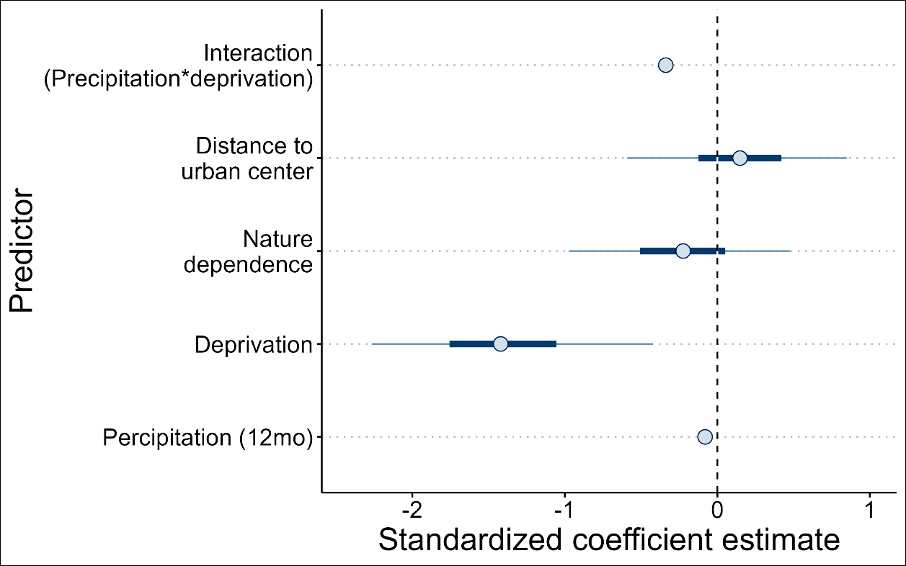
Figure S4A: Standardized coefficient estimates from the time-series model shown in equation 1 used to estimate the observed effect of these predictors on cattle slaughtering rates. Dots represent the posterior median estimate for each predictor. Thick bars represent the inner 50% of the posterior distribution; thin bars, the inner 90% of the posterior distribution (credible interval). The vertical dotted line at 0 indicates the point where the predictor has no effect on the response variable.

Disaggregation model
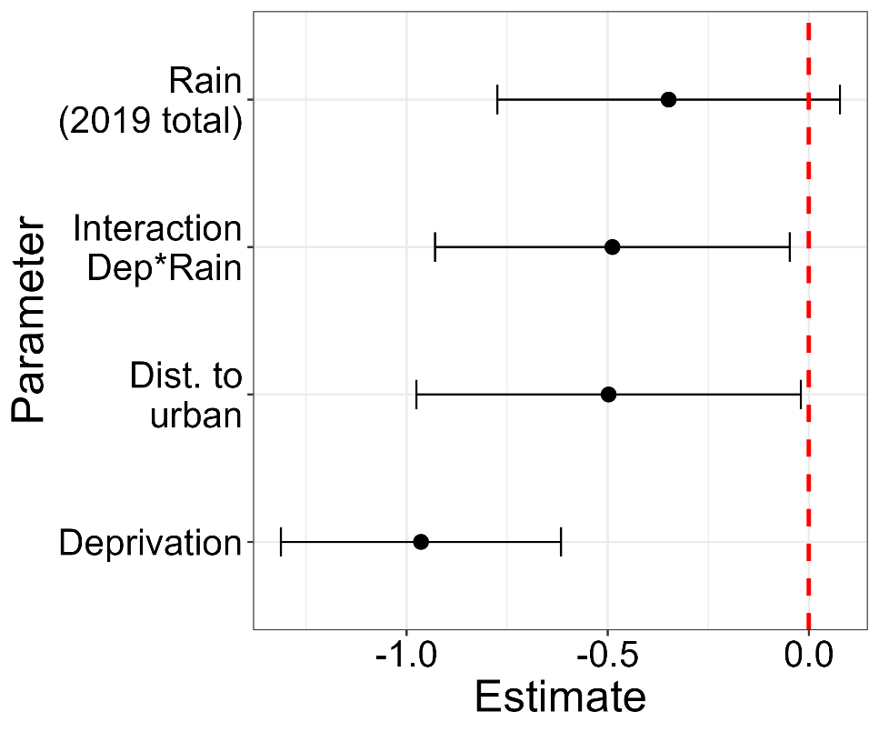
Figure S4B: Standardized coefficient estimates from the disaggregation regression shown in equation 2 used to estimate the observed effect of these predictors on the spatial distribution of cattle slaughtering in 2020 across South Africa. Dots represent the posterior mean estimate for each predictor. Error bars represent 95% credible interval. The red dashed line at 0 represents a null effect.

S5: Data and code
All data and code used in this manuscript can be found in the following repository: https://zenodo.org/records/13856119

